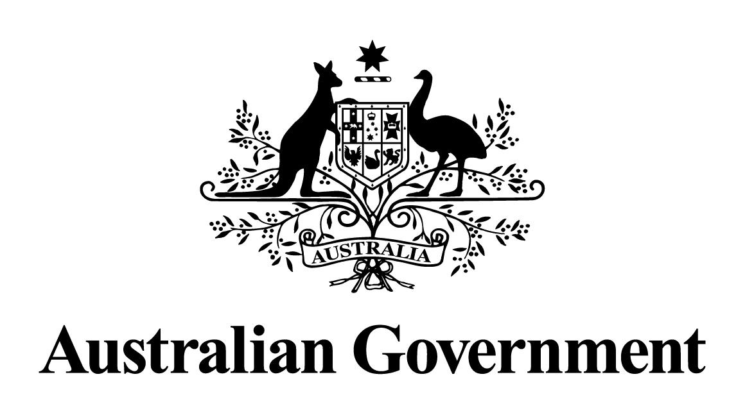
Australian Government response to the
Finance and Public Administration Legislation Committee report:
Report into the Public Governance, Performance and Accountability Amendment (Ban Unethical Contractors) Bill 2025

June 2026
Introduction
The Government welcomes the opportunity to respond to the Finance and Public Administration Legislation Committee (Committee) report titled Public Governance, Performance and Accountability Amendment (Ban Unethical Contractors) Bill 2025 (the Report).

The Government notes that the Committee recommended the Senate not pass the Ban Unethical Contractors Bill. The Committee noted that while it is essential to uphold ethical conduct in government contracting, they considered the existing, and enhanced mechanisms, in the Commonwealth procurement framework as adequate to achieve these aims.

The Government provides the following response to the recommendations arising out of the Australia Greens’ Dissenting Report.

Response to Recommendation
Australian Greens Recommendation 2
That, should the Senate not pass the bill, the government must bring Australia in line with other countries and develop and implement its own centralised debarment and suspension regime with a public register of excluded suppliers.

Response: The Government notes the recommendation.

The Commonwealth procurement framework provides robust and effective mechanisms to address supplier underperformance and unethical behaviour, including through contractual remedies, exclusion provisions, due diligence requirements, and the Commonwealth Supplier Code of Conduct. These arrangements enable entities to take proportionate and risk-based action, tailored to individual procurements and market conditions.

The Government recognises the need to continually review and refine these existing mechanisms and the Department of Finance (Finance) has implemented a number of enhancements to strengthen their effectiveness, including:

- The release of an updated Procurement Policy Note, Ethical conduct of tenderers and suppliers, which reminds entities of the requirement to consider, among other things, a potential supplier’s relevant experience and performance history when assessing value for money.
- The release of a Procurement Policy Note on Reporting of Consultancy contracts valued at $2 million or more. This requires entities to report to Finance each quarter on high value consultancy contracts at or above $2 million, to strengthen transparency and oversight of significant procurement activity.
- The expansion of the ‘Meet the Supplier’ program to include sessions on ethical standards and supplier expectations in government procurement.
- The Procurement and Contract Management Profession transitioned in March 2026 to the Members Community Platform (MCP), a central online hub that enables APS officials to connect, collaborate, and access guidance, training, and shared resources.
- Continuing to support and build capability in government procurement and delivering probity and integrity training to 925 procuring professionals, with 445 of those receiving the training this calendar year.
Finance has also commissioned a high-level, independent, arms-length review of KPMG’s future suitability for the delivery of work to the Australian Government, to be undertaken by Dr Ian Watt AC. The review is due to report by 30 September. The Government will consider the recommendations of that review and their broader application to the Commonwealth procurement framework.

