PORTFOLIO SUPPLEMENTARY ADDITIONAL ESTIMATES STATEMENTS 2025–26
APPROPRIATION BILL (NO. 5) 2025-2026
AND
APPROPRIATION BILL (NO. 6) 2025-2026
Finance Portfolio
EXPLANATIONS OF SUPPLEMENTARY ADDITIONAL ESTIMATES 2025–26
© Commonwealth of Australia 2026
ISBN 978-1-925205-79-4 (Print); 978-1-925205-80-0 (Online)
This publication is available for your use under a Creative Commons Attribution 4.0 International licence, with the exception of the Commonwealth Coat of Arms, third-party content and where otherwise stated. The full licence terms are available from http://creativecommons.org/licenses/by/4.0/legalcode.

Use of Commonwealth of Australia material under Creative Commons Attribution 4.0 International licence requires you to attribute the work (but not in any way that suggests that the Commonwealth of Australia endorses you or your use of the work).
Commonwealth of Australia material used ‘as supplied’
Provided you have not modified or transformed Commonwealth of Australia material in any way including, for example, by changing the Commonwealth of Australia text; calculating percentage changes; graphing or charting data; or deriving new statistics from published statistics – then the Commonwealth of Australia prefers the following attribution:
Source: The Commonwealth of Australia.
Derivative material
If you have modified or transformed Commonwealth of Australia material, or derived new material from those of the Commonwealth of Australia in any way, then the Commonwealth of Australia prefers the following attribution:
Based on Commonwealth of Australia data.
Use of the Coat of Arms
The terms under which the Coat of Arms can be used are set out on the Department of the Prime Minister and Cabinet website (see www.pmc.gov.au/
honours-and-symbols/commonwealth-coat-arms)
Other uses
Enquiries regarding this licence and any other use of this document are welcome at:
Copyright Coordinator
Department of Finance
One Canberra Avenue, FORREST ACT 2603
Email: publications@finance.gov.au

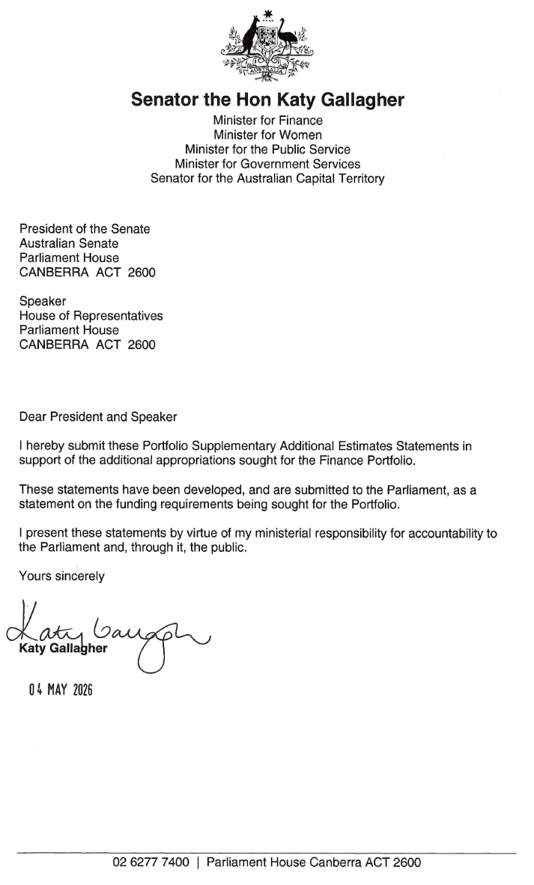
Abbreviations and conventions
The following notations may be used:
NEC/nec not elsewhere classified
- nil
.. not zero, but rounded to zero
na not applicable (unless otherwise specified)
nfp not for publication
$m $ million
Figures in tables and in the text may be rounded. Figures in text are generally rounded to one decimal place, whereas figures in tables are generally rounded to the nearest thousand. Discrepancies in tables between totals and sums of components are due to rounding.
Enquiries
Should you have any enquiries regarding this publication please contact the Chief Financial Officer, Department of Finance on (02) 6215 2222.
Links to Portfolio Budget Statements (including Portfolio Additional Estimates Statements and Portfolio Supplementary Additional Estimates Statements) can be located on the Australian Government Budget website at www.budget.gov.au.

User guide
to the
Portfolio Supplementary Additional Estimates
Statements

User guide
The purpose of the 2025–26 Portfolio Supplementary Additional Estimates Statements (PSAES) is to inform Senators, Members of Parliament and the public of the proposed allocation of additional resources to government outcomes by entities within the portfolio.
The PSAES facilitate understanding of the proposed appropriations in Appropriation Bill (No. 5) 2025-2026 and Appropriation Bill (No. 6) 2025-2026. In this sense the PSAES is declared by the Appropriation Acts to be a ‘relevant document’ to the interpretation of the Acts according to section 15AB of the Acts Interpretation Act 1901.
Appropriation Bill (No. 5) 2025-2026, which follows on from Appropriation Act (No. 1) tabled at Budget and Appropriation Act (No. 3) tabled at Additional Estimates, will provide additional expenditure authority for the ordinary annual services of government in respect of the 2025-26 financial year.
Appropriation Bill (No. 6) 2025-2026, which follows on from Appropriation Act (No. 2) tabled at Budget and Appropriation Act (No. 4) tabled at Additional Estimates, will provide additional expenditure authority in respect of the 2025-26 financial year for capital works and services, payments to or for the states, territories and local government authorities, and new administered outcomes not authorised in specific legislation.

Contents
Entity Supplementary Additional Estimates Statements xi
Services Australia 1

Services Australia

Entity Supplementary Additional Estimates Statements

Services Australia
Overview of additional appropriations 1
Entity measures table 2
Supplementary additional estimates and variations 3

Services Australia

Overview of additional appropriations
The document details additional funding provided to Services Australia through Appropriation Bills (No. 5) and (No. 6) 2025-26. The 2025-26 Portfolio Supplementary Additional Estimates Statements (PSAES) are a supplement to the 2025-26 Portfolio Additional Estimates Statements (PAES) and should be read in conjunction with the 2026-27 Portfolio Budget Statements (PBS).

Entity measures table
Table 1.1 summarises new Government measures taken since the 2025–26 Additional Estimates. The table is split into receipt and payment measures, with the affected program identified.
Table 1.1: Services Australia 2025–26 Supplementary additional estimates measures (a)
Prepared on a Government Financial Statistics (Underlying Cash) basis. Figures displayed as a negative (-) represent a decrease in funds and a positive (+) represent an increase in funds.
- Unless otherwise noted, measures are listed by lead entity and the full measure descriptions appear in Budget Paper No. 2 under the relevant portfolio.
- The financial implications for this measure are not for publication (nfp) due to commercial-in-confidence sensitivities.

Supplementary additional estimates and variations
The following table details the changes to the resourcing for Services Australia at Supplementary Additional Estimates, by outcome. The following table details the estimates and variations resulting from new measures and any other variations since the 2025–26 Additional Estimates sought through Appropriation Bills (No. 5 and No. 6).
Table 1.2: Supplementary additional estimates and variations to outcomes from measures and other variations (a)
Prepared on a resourcing (i.e. appropriations available) basis.
- Unless otherwise noted, the full measure descriptions appear in the 2026-27 Budget under the relevant portfolios, as detailed in Table 1.1.
- The financial implications for this measure are not for publication (nfp) due to commercial-in-confidence sensitivities.

The following tables detail the Supplementary Additional Estimates sought for Services Australia through Appropriation Bills (No. 5 and No. 6).
Table 1.3: Appropriation Bill (No. 5) 2025-2026

Table 1.4: Appropriation Bill (No. 6) 2025-2026

