User guide to the
Portfolio Budget Statements

User guide
The purpose of the 2026-27 Portfolio Budget Statements (PB Statements) is to inform Senators and Members of Parliament of the proposed allocation of resources to government outcomes by entities within the portfolio. Entities receive resources from the annual appropriations acts, special appropriations (including standing appropriations and special accounts), and revenue from other sources.
A key role of the PB Statements is to facilitate the understanding of proposed annual appropriations in Appropriation Bills (No. 1 and No. 2) 2026-27 (or Appropriation (Parliamentary Departments) Bill (No. 1) 2026-27 for the parliamentary departments) and related Supply Bills where they exist applicable to the 2026-27 Budget. In this sense, the PB Statements are Budget related papers and are declared by the Appropriation Acts to be ‘relevant documents’ to the interpretation of the Acts according to section 15AB of the Acts Interpretation Act 1901.
The PB Statements provide information, explanation and justification to enable Parliament to understand the purpose of each outcome proposed in the Bills.
As required under section 12 of the Charter of Budget Honesty Act 1998, only entities within the general government sector are included as part of the Commonwealth general government sector fiscal estimates and produce PB Statements where they receive funding (either directly or via portfolio departments) through the annual appropriation acts.

The Commonwealth performance framework
The following diagram outlines the key components of the Commonwealth performance framework. The diagram identifies the content of each of the publications and the relationship between them. Links to the publications for each entity within the portfolio can be found in the introduction to Section 2: Outcomes and planned performance.

User Guide | Page vii

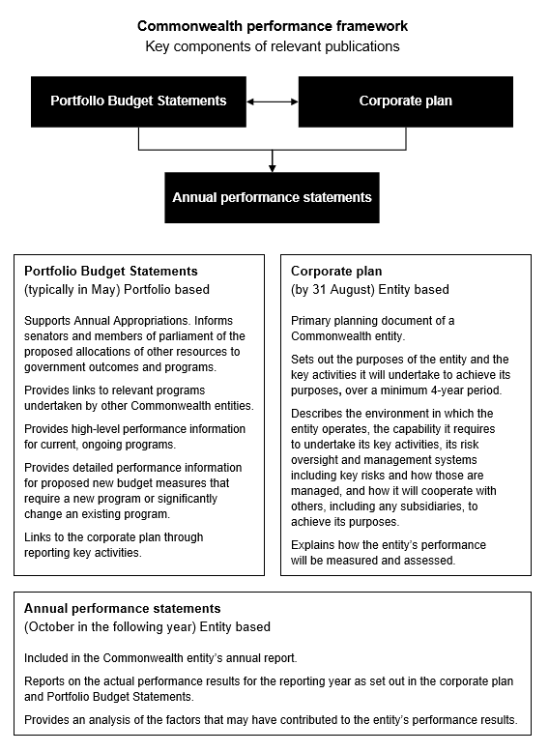

Page viii | User guide

Portfolio overview

Finance Portfolio overview

Minister(s) and portfolio responsibilities
The Minister for Finance has overall responsibility for the Finance portfolio, and particular responsibility for the following:
- budget policy and process, including advice on expenditure across all government programs
- government financial accountability, governance and financial management frameworks, and general policy guidelines for Commonwealth statutory authorities
- whole-of-Australian Government procurement policy and services
- whole-of-Australian Government grants policy framework and guidelines
- whole-of-Australian Government property policy and administration of property and land acquisition and related legislation, including non-Defence-owned property
- whole-of-Australian Government digital and data policy, including Digital ID policy
- whole-of-Australian Government enablement of safe, responsible artificial intelligence (AI) adoption
- regulatory reform policy
- Government Business Enterprises (GBEs) and commercial entities treated as GBEs
- overarching monitoring and advice on specialist investment vehicles
- commercial advice relating to significant Australian Government asset sales and purchases and other significant commercial matters
- policy and management of act of grace and waiver of debts requests
- administration of Comcover, the government’s self-managed insurance fund, and risk policy
- Australian Government Investment Funds policy, including the Future Fund, and authorisation of payments from Australian Government Investment Funds to entities
- superannuation arrangements for Australian Government civilian employees and parliamentarians, and retirement benefits for governors-general, federal judges and Federal Court judges
- government campaign advertising.

The Minister for Government Services has responsibility for the following:

- delivery of high quality, accessible and efficient services and payments relating to social security, child support, students, families, aged care and health programs (excluding health provider compliance) to individuals, families and communities, on behalf of Government.

Portfolio overview | Page 3

The Special Minister of State has particular responsibility for the following:

- the parliamentary business expenses framework and related legislation
- employment framework for members of parliament staff and related legislation
- electoral policy
- electoral matters (supported by the Australian Electoral Commission (AEC)).

For information on resourcing across the portfolio, please refer to Part 1: Agency Financial Resourcing in the Budget Paper No. 4: Agency Resourcing.

Page 4 | Portfolio overview

Portfolio Budget Statements |

Figure 1: Finance portfolio structure and outcomes

Minister for Finance Minister for Government Services
Senator the Hon Katy Gallagher
Special Minister of State
Senator the Hon Don Farrell
Department of Finance
Portfolio Secretary: Matt Yannopoulos PSM
Outcome 1: Support sustainable Australian Government finances through providing high-quality policy advice and operational support to the government and Commonwealth entities to maintain effective and efficient use of public resources.
Outcome 2: Support an efficient and high-performing public sector through providing leadership to Commonwealth entities in ongoing improvements to public sector governance, including through systems, frameworks, policy, advice, and service delivery, and managing, acquiring and divesting government investments.
Outcome 3: Support for parliamentarians and others as required by the Australian Government through the delivery of, and advice on, work expenses and allowances, entitlements and targeted programs.
Australian Electoral Commission
Electoral Commissioner: Jeff Pope APM
Outcome 1: Maintain an impartial and independent electoral system for eligible voters through active electoral roll management, efficient delivery of polling services, and targeted education and public awareness programs.
Commonwealth Superannuation Corporation
Chair: Janet Torney
Outcome 1: Retirement and insurance benefits for scheme members and beneficiaries, including past, present and future employees of the Australian Government and other eligible employers and members of the Australian Defence Force, through investment and administration of their superannuation funds and schemes.
Digital Transformation Agency
Chief Executive Officer: Chris Fechner
Outcome 1: Support the government's digital transformation, and simplify processes, reduce costs and generate reuse opportunities, through strategic and policy leadership, advice, strategic coordination and oversight of digital and ICT investment, and management of whole-of-government digital and ICT procurement.
Future Fund Management Agency
Chair: Greg Combet AO
Outcome 1: Strengthen the Commonwealth’s financial position for the benefit of the Australian people, by managing the investment activities of the Future Fund and certain other Australian Government Investment Funds in line with their Investment Mandates.

Portfolio overview | Page 5

| Portfolio Budget Statements

Figure 1: Finance portfolio structure and outcomes (continued)

Independent Parliamentary Expenses Authority
Chief Executive Officer: Christina Grant
Outcome 1: Support for current and former Parliamentarians and others as required by the Australian Government through the delivery of, independent oversight and advice on, work resources and travel resources.
Parliamentary Workplace Support Service
Chief Executive Officer: Leonie McGregor
Outcome 1: Support Commonwealth parliamentary workplace participants to build and maintain safe and respectful workplaces, including by supporting positive cultural change and providing human resource functions to parliamentarians and their staff.
ASC Pty Ltd
Chair: Jim McDowell
Purpose: The objectives of the company, as set out in the ASC’s Statement of Expectations are to:
- construct and sustain available and capable submarines, including through partnering in the build of the SSN-AUKUS fleet and sustainment all classes of Australia’s future nuclear-powered submarine fleet
- meet the highest standards of nuclear safety and comply with emerging nuclear safety duties and future naval nuclear power safety licence requirements
- continue to effectively and efficiently sustain Australia’s Collins class submarine fleet and support opportunities for Australia’s broader naval shipbuilding and repair industry
- develop and grow Australia’s sovereign workforce and domestic supply chain.
Australian Naval Infrastructure Pty Ltd
Chair: Ronald Finlay AM
Purpose: The objective of the company, as set out in its constitution, is to support the Commonwealth’s continuous naval shipbuilding program through:
- acquiring, holding, managing and developing the infrastructure, and related facilities used in connection with this program
- efficiently and effectively managing this infrastructure (including providing access) in a manner that ensures an integrated and co-ordinated approach to the delivery of all elements of this program.
CEA Technologies Pty Ltd
Chair: Joycelyn Morton
Purpose: Provide innovative technology solutions with commitment to strengthen Australia’s sovereign defence capability.
Services Australia
Chief Executive Officer: David Hazlehurst
Outcome 1: Deliver high-quality, accessible services and payments to individuals, families, businesses and partner agencies on behalf of Government; with a focus on contemporary service delivery and customer experience.

Page 6 | Portfolio overview

