A beginner’s guide to Climate Scenario Analysis
Commonwealth Climate Disclosure

Core Requirement S14 Climate-related scenario analysis
This document supports entities to disclose provisions against the Strategy pillar S14 - Climate-related scenario analysis. It explains the purpose of climate scenario analysis, and what to include in your climate scenario analysis, with examples on how to present your information.
We recommend that you use this document alongside the other Strategy resources published on the Application Guidance website.

Purpose of Climate Scenario Analysis
Climate scenario analysis is a strategic, forward-looking tool used to evaluate risk over longer time periods. It helps to highlight physical and transitional risks. This knowledge can be used to plan and maintain an entity’s climate resilience.
Note: Climate scenario analysis is a process for identifying and assessing a potential range of outcomes of future events under conditions of uncertainty, see key terms and definitions in the Requirements and IFRS Sustainability Disclosure Standards. See this ASIC resource for further information on scenario analysis.
Climate scenario analysis is a way to imagine different possible futures for our planet based on how many greenhouse gases we produce and how we respond to climate change. Climate scenarios are not predictions; rather, they illustrate plausible futures based on different sets of assumptions about human activity and policy choices (Figure 1).

Figure 1 Assumptions about human activities
Climate scenario analysis is a useful way of stress testing your entity’s activities. It acts as a structured way to see what happens to emissions over time and what different choices would mean for the future. They can be used to build strategies and net zero plans as well as set targets or see the impact on sectors.
Climate scenarios help entities plan for physical climate risks, such as extreme weather, rising sea levels, and changes in precipitation and temperature (these are called climate hazards).
Future greenhouse gas emissions depend on a range of complex factors like population growth, economic development, technology and energy mix. Scenario analysis is a useful tool to show how these factors could affect emissions and provide entities with insights into potential risks and opportunities over the short, medium- to long-term horizons.
Tip: Your entity’s exposure varies across different time horizons. Short-term scenarios can help to reveal immediate risks which may be significant, while medium- and long-term scenarios can be important for risks over time such as sea level rise or increasing frequency of severe storms.

Where to begin with Climate Scenario Analysis
An entity can begin their climate scenario analysis journey by using qualitative analysis techniques such as storylines, which are narratives to understand broad scale differences in outcomes from different emissions pathways. As an entity’s climate risk maturity develops, or functions require, an entity may progress to more detailed forms of quantitative scenario analysis (Figure 2).

Figure 2 Climate scenario analysis maturity pathway
How you move through the pathway above will depend on your entity type, size, profile, climate maturity and the decisions to be made from the analysis. Your entity’s operations and policies are unique. This will influence the approach you take and the level of detail you require. Your approach will also be shaped by your entity’s needs, resources, and capabilities.
Entities that are likely to be significantly impacted by certain climate-related transition and/or physical risks can consider some level of quantitative scenario analysis. Quantitative approaches may be achieved by using more rigorous analysis such as a tailored analysis of the entity’s operations or accessing more complex climate model data.
Tip: You may wish to begin your climate scenario analysis by providing qualitative descriptions of future climate but then extend to a more in-depth analysis involving a quantitative approach as your risk maturity develops.

Information about the key inputs in Climate Scenario Analysis for CCD
There are three main elements you should include in your disclosure to show how your climate scenario analysis was carried out (Figure 3).

S14 (a)(i)(1) Which climate-related scenarios the entity used
Entities should begin by identifying which climate scenario is appropriate for their entity. A climate scenario is a plausible description of how the future may develop based on a coherent and internally consistent set of assumptions about key driving forces and relationships.

Figure 3 Diagram to show what you need to disclose to carry out your climate scenario analysis

Emissions scenarios
- Emissions scenarios are a key input into a climate scenario. They help us explore possible futures under different greenhouse gas concentrations. Other inputs into climate scenarios include time horizons and macroeconomic trends (see Table 1).
- Low-emissions scenarios represent strong global climate action and highlight transition risks and opportunities as economies shift quickly toward cleaner energy.
- Moderate-emissions scenarios represent intermediate efforts of emissions reductions.
- High-emissions scenarios assumes limited emissions reduction and continued emissions intensive activity (such as heavy fossil-fuel use and continued deforestation).
There are many internationally agreed emissions scenarios available. There are two commonly known sets used by the International Panel on Climate Change (IPCC), which are included in the Climate Risk and Opportunity Management Program (CROMP):
- Representative Concentration Pathways (RCPs) - RCPs span a range of four plausible global warming scenarios from little curbing of emissions to ambitious emissions reduction scenarios.
- Shared Socioeconomic Pathways (SSPs) - SSPs are the latest version of the climate scenarios from the IPCC covering four main scenarios from a ‘Sustainability’ narrative to a ‘Fossil-fuelled development’ narrative.
Another way this has been articulated by organisations is through global warming levels. Framing the emissions scenario as a point in time globally averaged temperature rise, for example, 1.5 °C or 3 °C above the pre-industrial climate, can help decision makers visualise implications of climate change. More information on greenhouse gas scenarios is available at Greenhouse gas scenarios.
Other useful resources include:
- Data Explorer | Australian Climate Service Website
- NARCliM home page | AdaptNSW (NSW and ACT Governments)
- Climate Change in Australia (Australian Government)
- Queensland Future Climate (QLD Government)
- WA Climate Projections (WA Government)
- SA Climate projections (SA Government)
- Victoria’s Future Climate Tool (VIC Government)
- Note – new climate projections for Tasmania are in development (Grant program: Developing new fine-scale climate projections for Tasmania | ReCFIT)
- Note – for the Northern Territory, please see the report Climate Change in the Northern Territory – State of the science and climate change impacts which draws on Climate Change in Australia projections data.
- NGFS Scenarios Portal (Network of Central Banks and Supervisors for Greening the Financial System)
- NGFS_guide_scenario_analysis_final.pdf (Network of Central Banks and Supervisors for Greening the Financial System)
- Home | CoastAdapt (National Climate Change Adaption Research Facility)
The Department of Climate Change, Energy, the Environment and Water (DCCEEW) intends to release National Climate Scenario Guidance to provide an overview of good practice climate scenario analysis to support organisations at different levels of maturity in completing assessments of physical climate risks.
Note: Before conducting scenario analysis, an entity should understand the relevant climate-related scenarios and the risks and opportunities it may face.
As per CCD Requirement S14, entities shall perform climate scenario analysis against at least two plausible and distinct climate-related scenarios:
- a low global warming scenario which must align with the Climate Change Act 2022 (i.e. limiting global warming to 1.5°C), and
- a higher global warming scenario (i.e. an increase of 2.5°C or higher).
Using multiple scenarios ensures that planning and policies are more resilient and flexible in the face of a range of uncertain future climates.
Physical risks and transition risks, driven by policy and technological developments, may unfold across different possible futures.
Short-term scenarios focus on near-term economic and financial shocks, increasing their usefulness for climate risk assessments and policy design.
Longer term scenarios may explore how the global economy and financial system might evolve under different levels of climate policy ambition and physical climate impacts over the rest of the 21st century.
Tip: It is important to select appropriate climate scenarios. This can be guided by your entity’s specific priorities, functions, and strategic objectives.
For example, if transition risks over the short term are an important risk to your entity, you may need to consider choosing scenarios which look at these short-term changes to the economy, technology and energy use.
If long-term physical risks are material to your entity, incorporating longer-horizon scenarios will provide insight into how chronic climate impacts and future climate pathways may affect your organisation over time.
It is not always necessary for the same set of scenarios to be used for both physical and transition risk assessments, and any differences should be clearly articulated in your disclosures.

2. S14 (a)(i)(2) The time horizon the entity used
The time horizon you choose should align with the lifespan of your entity’s responsibilities, for example: a policy outcome or asset you’re assessing. Near-term horizons (2030–2040) are best for operational planning and understanding risks under current policies. Mid-century horizons (2050) are commonly used for strategic planning and net-zero alignment. For long-lived assets or long-term climate risk, horizons to 2100 capture a wider range of more extreme potential physical impacts.

3. S14 (a)(i)(3) What scope of operations the entity used in the analysis
For more information on your scope of operations refer to Risk Management Guidance.
Note: Climate scenario analysis will not show every possible future outcome. It only gives a limited picture, and there is uncertainty involved in how the future will unfold. As your organisation becomes more experienced with climate risk, you might find it helpful to sort the possible impacts into a clear hierarchy so you can focus on what matters most.

How to apply climate scenario analysis outputs
Outputs from the climate scenario analysis can:
- Be your entity’s material risks and opportunities.
- Highlight areas where your entity needs to strengthen its understanding of its exposure to physical and transitional risks and opportunities.
- Inform stress testing of your entity’s policy delivery or operational model material risks and opportunities.
- Improve your entity’s understanding of the implications of possible future structural changes to the economy or society for your entity and its delivery of policy (Year 2 reporting onwards).
- Help you to explore the implications for these risks regarding your financial position, cash flow and financial performance (Year 3 reporting onwards).
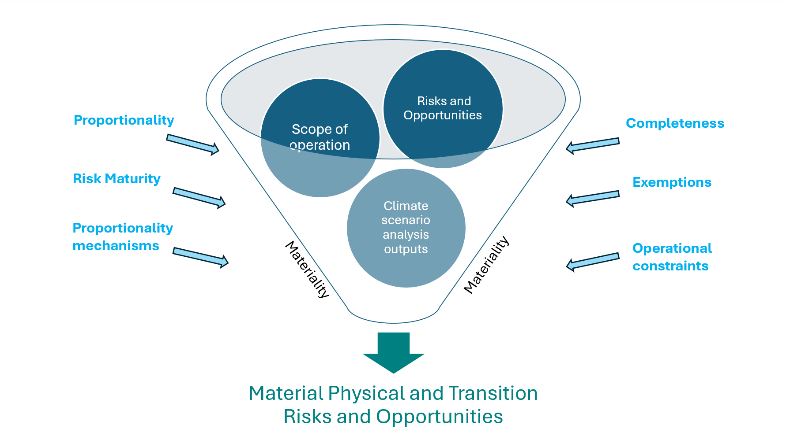
Figure 4 Factors influencing an entity’s final disclosure
There are multiple factors which can influence what your entity will disclose (Figure 4). These factors include:
- Guiding principles such as Proportionality, Completeness and Maturity. (See Guiding Principles in the General Requirements section of your CCD Requirements Commonwealth Climate Disclosure Requirements | Department of Finance)
- Proportionality Mechanisms (see application guidance Proportionality Mechanisms).
Exemptions for your entity and operational constraints (see the General Requirements of the CCD Requirements, as above).
This multi-faceted approach to climate risk and opportunity assessment helps your entity provide a meaningful assessment of the entity’s exposure to inform internal decision-making and annual report users.
See the examples of Tranche 1 entity approaches to Strategy criteria including climate scenario data section, at the end of this document, for more information on how entities have used climate scenario analysis to assess their material climate risks and opportunities.

Using CROMP Climate Scenarios outputs to disclose information
Tip: Entities using Australian Government’s Approach to Climate Risk and Opportunity Management in the Public Sector 2024-2026 (CROMP) can use climate scenario analysis information available through the CROMP assessment, see Climate Risk and Opportunity Management Program resources - DCCEEW. The use of CROMP is encouraged but not compulsory for CCD.
Users of CROMP can use outputs from the Climate risk digital tool to respond to disclosure requirements in S14. See Appendix A of Organisation Application Guide which provides data from emissions pathways from SSPs, RCPs, and the National Climate Risk Assessment (NCRA).
Note: The CROMP sets out the expectations for climate risk assessment and management for the public sector. It supports and enables entities to meet many of the CCD requirements, particularly in the Risk management and Strategy pillars.
Commonwealth entities and companies are encouraged to follow CROMP however it is not compulsory. Where an entity chooses to adopt an alternate methodology, they should ensure that methodology is robust and defensible.

S14 (a) (i) (1 and 2) – Key inputs the entity used
CROMP:
Time Horizons (2030, 2050, 2090)
Emissions Scenarios (Low Medium and High) *
CCD:
S14 (a) (i) (1 and 2)

*Present day emissions scenario also available
The CROMP documentation (including the digital tool) provides data on different physical and transition climate risk drivers. Figure 5 below demonstrates information on physical risk drivers.
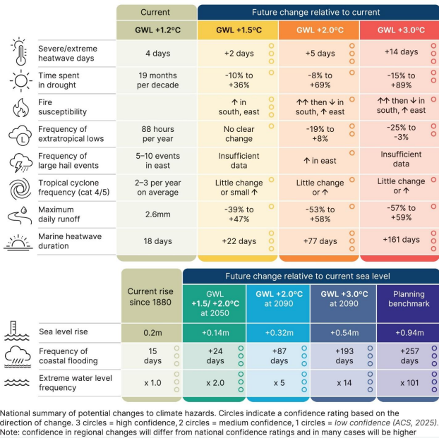
Figure 5 National summary of potential changes to climate hazards, Source: National Climate Risk Assessment 2025.
The CROMP Climate risk digital tool also provides physical risk drivers by hazard at national level:
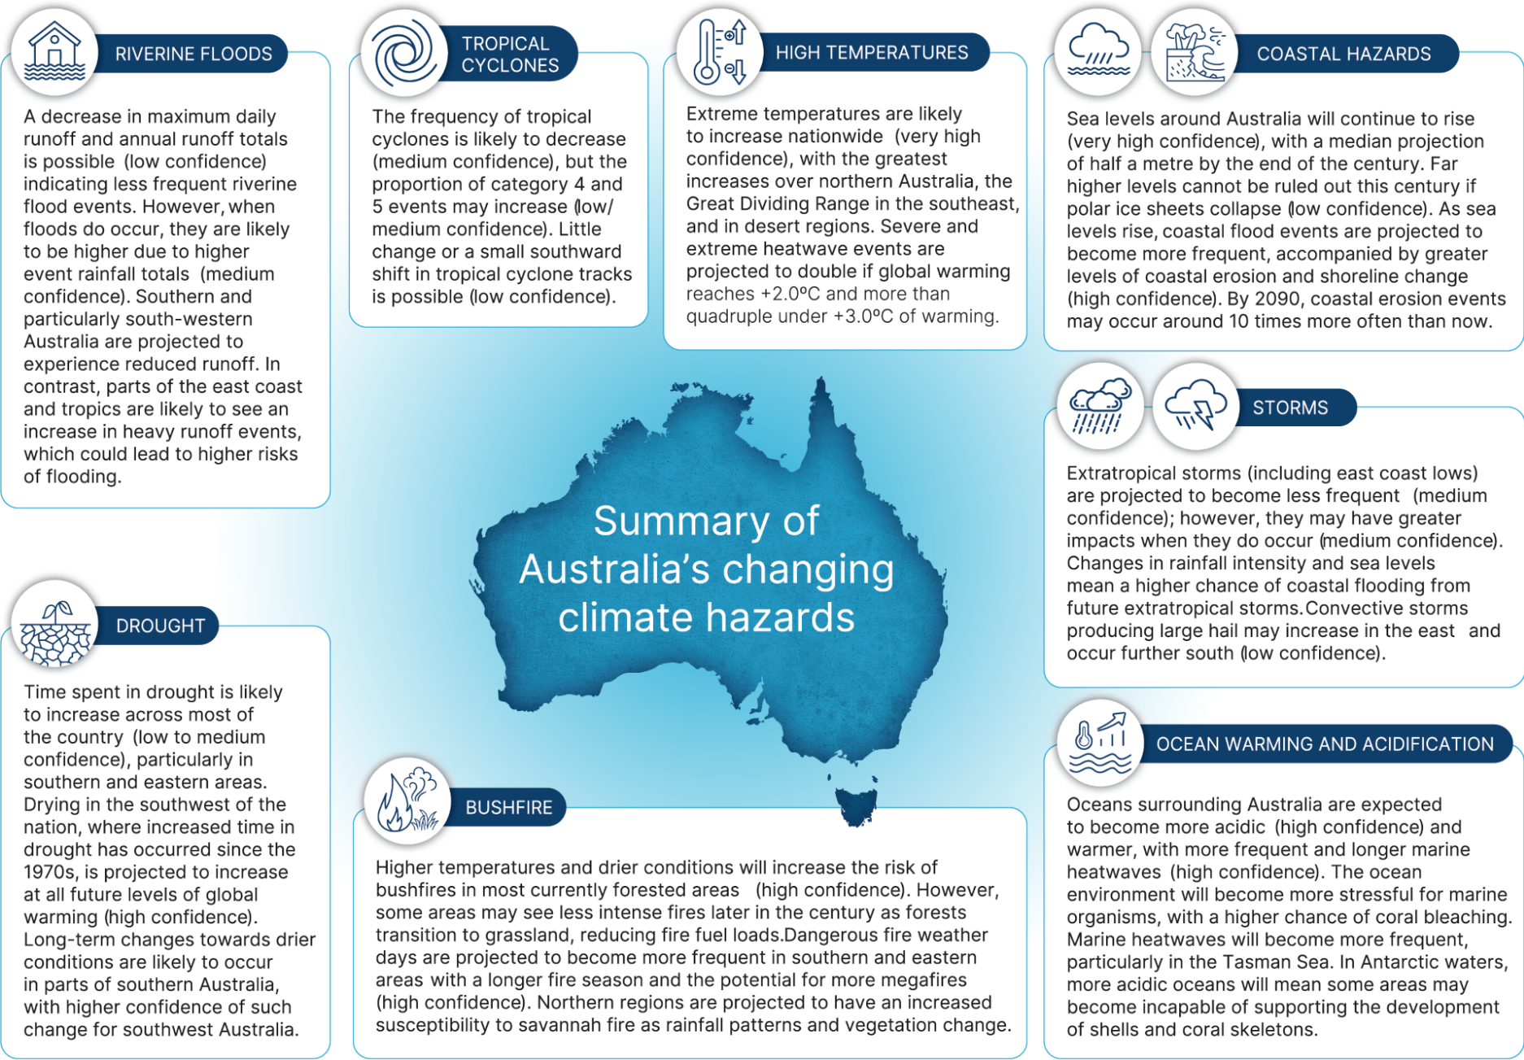
Figure 6 CROMP Digital Tool

S14 (a) (ii) (2,3,5,6) – Key assumptions the entity made in the analysis
Climate scenario analysis can be used to explore plausible futures, identify thresholds, test resilience, and understand where an entity’s strategies and decision-making may need to adapt. It relies on assumptions; understanding these underlying assumptions is essential for interpreting results and using them responsibly in decision-making.

All climate projections include some level of uncertainty due to climate model limitations, uncertainty about future socioeconomic conditions, natural climate variability and the choice of scenario. Uncertainty is also inherent in policy environments, technological change, markets and society.
Recognising uncertainties helps users to avoid overconfidence in any single projection. Instead, decision-makers should focus on interpreting ranges, comparing multiple scenarios, and considering the sensitivity of their conclusions to different assumptions.
Users of CROMP can use the information from the Climate Risk Management Technical Guidance to respond to disclosure requirements in S14 (a)(ii)(2)(3)(4)(5). See Table 2 for an example response to S14 (a)(ii)(1).
CCD:
S14 ((a)(ii) 2, 3, 4, 5)
CROMP: Macro-economic trends, national and regional variables, energy usage and mix, developments in technology
Scenarios (Low, Moderate and High)

Underpinning assumptions of climate scenarios as described in CROMP
Table 1 shows low and high emissions values and ranges have different assumptions associated with them. Refer to the CROMP Technical Guidance document for the assumptions on the moderate emissions scenario.
S14 Criteria | Low emissions | High emissions
Emissions pathways: IPCC Shared socioeconomic pathways (SSPs) | SSP1-2.6  limiting global average temperature to 1.5°C | SSP3-7.0  global average temperature exceeding 2.5°C
Emissions pathways: Representative Concentration pathways (RCPs) | RCP 2.6 | No RCP equivalent
Time horizons: Global warming level by 2090 | 1.8°C  [1.3 – 2.4°C] | 2.6°C  [2.8 – 4.6°C]
Time horizons: National Climate Risk Assessment (NCRA) Global Warming Level | 1.5°C ~2030  2.0°C ~2050-2090 | 3.0°C ~2050-2090
Scope of operations | Physical and transition risks considering operations and policy delivery
Climate-related policies | Australia’s climate change action - DCCEEW
Macroeconomic trends  GDP growth per capita  Globalisation | High  Connected markets | Uneven  Barriers to trade
Energy usage and mix  Fossil fuel constraints | Away from fossil fuels  High | Continued use of fossil fuels  Limited to none
Developments in technology | Rapid | Slow
Type of climate scenario analysis | Qualitative | Qualitative
Table 1 Key inputs and assumptions from CROMP climate scenarios. Source: Climate Risk Management Technical Guidance

S14 (a)(iii) Reporting period the analysis was carried out
Disclosures should identify the reporting period you conducted your climate scenario analysis. This may be your current reporting period, or a prior one.
It is not required that climate scenario analysis is conducted each year. The frequency of performing your entity’s climate scenario analysis can vary depending on:
- Your entity’s strategic planning cycle
- Release of new climate information or data
- Change to the current state of the entity i.e. changing components of the entity’s activities or operations, regulatory shifts
- Major climate event which brings new perspectives

Examples of Tranche 1 entity approaches including climate scenario data
The following examples are extracts from the FY 2024-25 annual reports showing how different entities have presented their climate scenario analysis.
Example 1: Defence Housing Australia Annual Report 2024-25
Defence Housing Australia has developed qualitative narratives to describe the scenarios applied across different time horizons.
Climate scenario | Overview | Timeframes | Key Outcomes
Present day | Represents current conditions under today’s climate | 2025 | Australia is already feeling the effects of a changing climate. Additionally, transition risks and opportunities are already being realised such as changing policy, regulation and markets.
Low emission | Represents a scenario where mitigation efforts to curb emissions are ambitious to limit warming at or below 1.5°C. It is likely that there will still be some physical impacts associated with this scenario that may be greater than those felt today | Near-term (2030)  Mid-term (2050) | Transition risk and opportunities dominate.  Globally coordinated effort to reduce emissions to net zero around 2070, and accelerated transition to renewables and electrification.
High emission | Represents a scenario where emissions are curbed based on existing policies and commitments with a global warming level of 2-3°C. In this scenario, there are moderate challenges to both mitigation and adaption. | Near-term (2030)  Mid-term (2050) | Physical risks dominate.  Emissions reduction policies are limited, with continued use of fossil fuels and energy intensive activities and lifestyles.
Table 2 Defence Housing Australia example from 2024-45 Annual Report

Example 2: Special Broadcasting Service (SBS Annual Report 2025)
SBS has provided a qualitative analysis that outlines the relevant time horizons and specifies whether the assessed risks are physical or transitional. The scenarios’ associated global warming temperature pathways are disclosed, along with an indication of the potential impacts on their financial position.
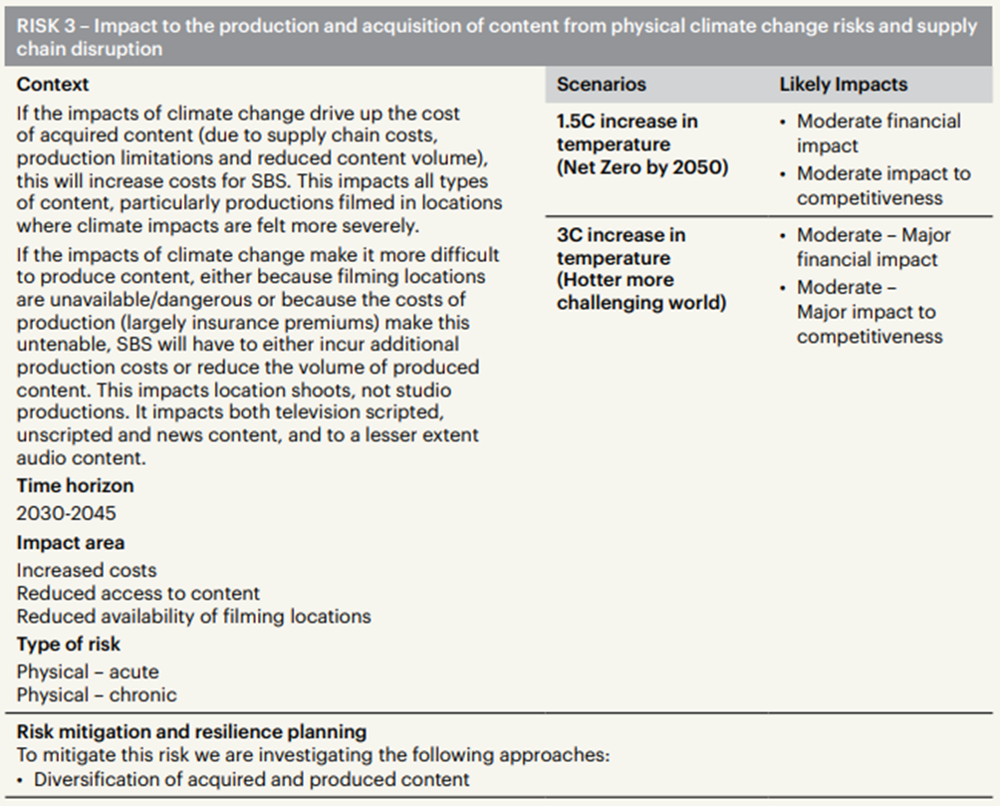

Example 3: Clean Energy Finance Corporation (CEFC) Annual Report 2024-25
The CEFC has presented its analysis clearly by outlining the relevant time horizons, temperature pathways, risk types, and the specific scenarios applied for both physical and transition risks. They use infographics to illustrate key risk drivers and show where these risks may materialise. Their disclosure also clearly defines the scope of the analysis undertaken.
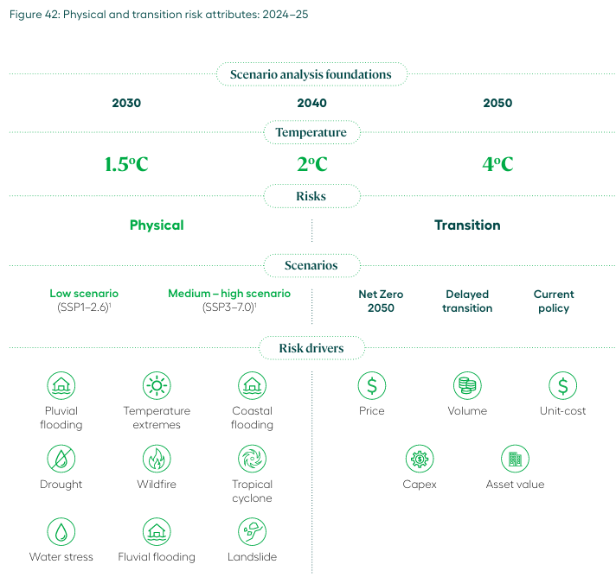

Example 4: Department of Climate Change, Energy, the Environment and Water Annual report 2024-25
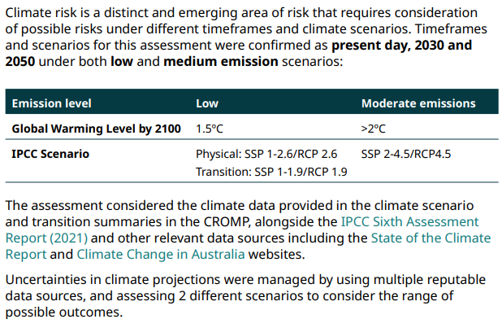

Document control
Version number | Date of issue | Brief description of change
1 | 31/03/2026 | Initial publication
Contact
Email: ClimateAction@finance.gov.au

