Commentary on the

Consolidated Financial Statements

Introduction
The 2024-25 Consolidated Financial Statements (CFS) for the Australian Government present the whole of government and general government sector (GGS) financial reports and are prepared in accordance with AASB 1049 Whole of Government and General Government Sector Financial Reporting (AASB 1049). They are required by section 48 of the Public Governance, Performance and Accountability Act 2013 (PGPA Act).
The CFS includes the consolidated results for all Australian Government controlled entities as well as disaggregated information on government sectors (GGS, public non-financial corporations (PNFC) and public financial corporations (PFC))1. Unless explicitly stated, the financial results reported in this commentary comprise consolidated amounts for the Australian Government as a whole, inclusive of the GGS, PNFC and PFC sectors2. The GGS results in the 2024-25 CFS materially align with the 2024-25 Final Budget Outcome.

At a glance

Table 1: Financial results for the year ended 30 June 2025
 | 2024-25 | 2023-24 | Change Change
 | $b | $b | $b %
Revenue | 757.4 | 727.6 | 29.8 4.1
Expenses | 798.6 | 717.5 | 81.1 11.3
Net operating balance(a) | (41.2) | 10.1 | (51.3) 507.9
Per cent of GDP | (1.5) | 0.4
Net capital investment | 13.7 | 12.9 | 0.8 6.2
Fiscal balance(b) | (54.9) | (2.8) | (52.1) 1,860.7
Per cent of GDP | (2.0) | (0.1)
Total assets | 1,073.4 | 989.6 | 83.8 8.5
Total liabilities | 1,705.8 | 1,563.3 | 142.5 9.1
Net worth(c) | (632.4) | (573.7) | (58.7) 10.2
Per cent of GDP | (22.8) | (21.5)
Net movement in cash | 0.7 | 1.4 | (0.7) 50.0
Cash at beginning of the year | 8.5 | 7.1 | 1.4 19.7
Cash at end of year | 9.2 | 8.5 | 0.7 8.2
Key fiscal aggregate
Net cash flows from operating activities | 11.6 | 29.7 | (18.1) 60.9
Net cash flows from investments in non-
financial assets | (28.3) | (24.6) | (3.7) 15.0
Cash surplus/(deficit) | (16.7) | 5.1 | (21.8) 427.5
- Net operating balance equals total revenue minus total expenses.
- Fiscal balance (or net lending/borrowing) is the net operating balance less net capital investment.
- Net worth is calculated as total assets minus total liabilities.

  - The institutional structure of the public sector is explained in Note 1.8 of the 2024-25 CFS. Note 15 of the 2024-25 CFS provides the list of Australian Government controlled reporting entities, including their sectoral classification.
  - The balances and movements detailed in the commentary have been rounded to the nearest tenth of a billion. Discrepancies between totals and sums of components are due to rounding.

Operating statement (net operating balance) Table 2: Operating statement
 | 2024-25 | 2023-24 | Change Change
 | $b | $b | $b %
Revenue | 757.4 | 727.6 | 29.8 4.1
Per cent of GDP | 27.3 | 27.2
Expenses | 798.6 | 717.5 | 81.1 11.3
Per cent of GDP | 28.8 | 26.9
Net operating balance | (41.2) | 10.1 | (51.3) 507.9
Per cent of GDP | (1.5) | 0.4
Net capital investment | 13.7 | 12.9 | 0.8 6.2
Per cent of GDP | 0.5 | 0.5
Fiscal balance | (54.9) | (2.8) | (52.1) 1,860.7
Per cent of GDP | (2.0) | (0.1)

Chart 1: Operating statement (per cent of GDP) since 2015-16

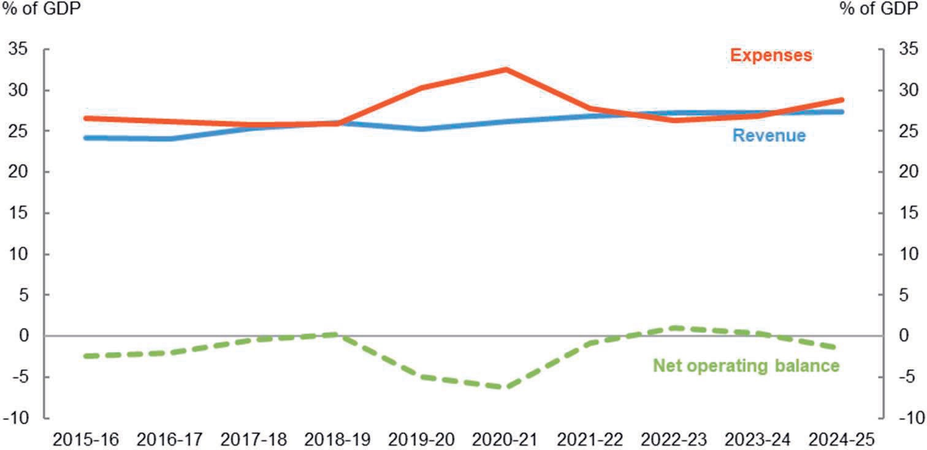

Balance sheet (net worth)
Table 3: Balance sheet
 | 30 June 2025 | 30 June 2024 | Change Change
 | $b | $b | $b %
Financial assets | 752.9 | 688.6 | 64.3 9.3
Non-financial assets | 320.5 | 301.0 | 19.5 6.5
Total assets | 1,073.4 | 989.6 | 83.8 8.5
Total liabilities | 1,705.8 | 1,563.3 | 142.5 9.1
Net worth | (632.4) | (573.7) | (58.7) 10.2
Per cent of GDP | (22.8) | (21.5)
Net financial worth(a) | (952.8) | (874.7) | (78.1) 8.9
Per cent of GDP | (34.4) | (32.8)
Net financial liabilities(b) | 952.8 | 874.7 | 78.1 8.9
Per cent of GDP | 34.4 | 32.8
Net debt(c) | 445.8 | 420.7 | 25.1 6.0
Per cent of GDP | 16.1 | 15.8
Net interest payments | (19.1) | (21.5) | 2.4 11.2
Per cent of GDP | (0.6) | (0.8)
- Net financial worth equals total financial assets minus total liabilities.
- Net financial liabilities equals total liabilities less financial assets other than investments in other public sector entities.
- Net debt is the sum of deposits held, government securities, loans and lease liabilities less the sum of selected financial assets (cash and deposits, advances paid and investments, loans and placements).

Chart 2: Balance sheet (per cent of GDP) since 2015-16
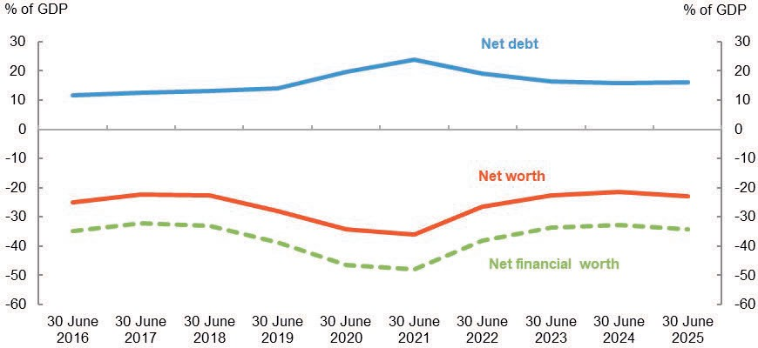

Discussion and Analysis
Net operating balance
The Australian Government’s net operating balance was a $41.2 billion deficit for the year ended 30 June 2025.

Table 4: Operating statement
 | 2024-25 | 2023-24 | Change Change
 | $b | $b | $b %
Revenue | 757.4 | 727.6 | 29.8 4.1
Expenses | 798.6 | 717.5 | 81.1 11.3
Net operating balance | (41.2) | 10.1 | (51.3) 507.9
Less Net acquisitions of non-financial assets | 13.7 | 12.9 | 0.8 6.2
Fiscal balance | (54.9) | (2.8) | (52.1) 1,860.7

Chart 3 shows the composition of the Australian Government’s net operating balance over the past decade.

Chart 3: Composition of net operating balance
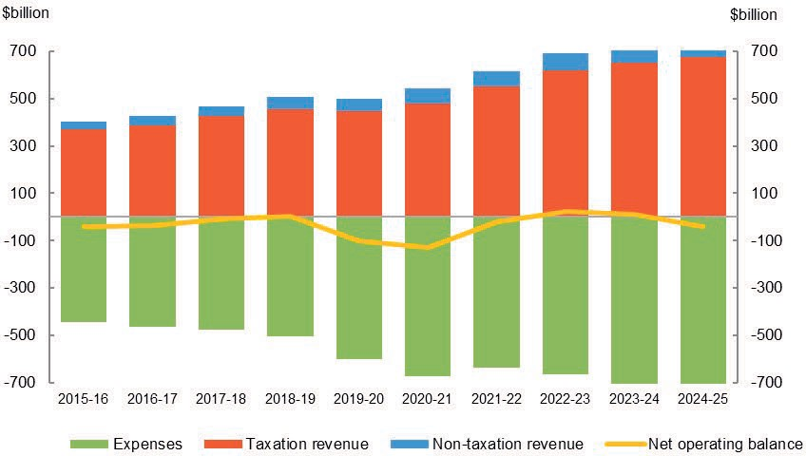

Revenue
The Australian Government’s total revenue for the year ended 30 June 2025 was
$757.4 billion.

Table 5: Revenue
 | 2024-25 | 2023-24 | Change Change
 | $b | $b | $b %
Taxation revenue | 676.1 | 649.4 | 26.7 4.1
Non-taxation revenue | 81.3 | 78.2 | 3.1 4.0
Total revenue | 757.4 | 727.6 | 29.8 4.1

Taxation revenue
The Australian Government’s total taxation revenue for the year ended 30 June 2025 was $676.1 billion. The composition of taxation revenue is shown in Chart 4.

Chart 4: Composition of taxation revenue, 2024-25
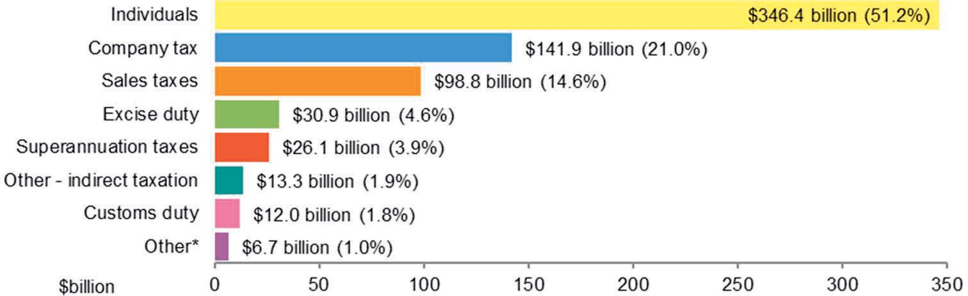

* Other includes: Fringe benefits tax ($5.2 billion) and Resource rent taxes ($1.5 billion).

Taxation revenue increased by $26.7 billion (4.1 per cent) in comparison to 2023-24. This increase is primarily driven by:
- a $13.4 billion increase in superannuation fund taxes reflecting growth in contributions and capital gains, and reduced foreign exchange losses;
- a $ 7.5 billion increase in individuals income taxes, due to growth in employment, wages, business and investment income;
- a $6.1 billion increase in sales tax revenue, underpinned by growth in nominal household consumption; and
- a $1.0 billion increase in excise duty revenue, attributable to both rising demand for fuel and higher excise rates.
See Note 2A of the 2024-25 CFS for further information.

Non-taxation revenue
The Australian Government’s total non-taxation revenue for the year ended 30 June 2025 was $81.3 billion. Further information is provided at Notes 2B, 2C and 2D of the 2024-25 CFS.

Expenses
The Australian Government’s total expenses for the year ended 30 June 2025 were
$798.6 billion.

Table 6: Expenses
 | 2024-25 | 2023-24 | Change Change
 | $b | $b | $b %
Gross operating expenses | 327.0 | 276.5 | 50.5 18.3
Interest expense | 51.3 | 52.6 | (1.3) 2.5
Grants and capital transfers | 238.8 | 216.9 | 21.9 10.1
Personal benefits | 163.7 | 153.2 | 10.5 6.9
Subsidies | 17.8 | 18.3 | (0.5) 2.7
Total expenses | 798.6 | 717.5 | 81.1 11.3

The Australian Government’s total expenses increased by $81.1 billion (11.3 per cent) since 2023-24. The composition of expenses is shown in Chart 5.

Chart 5: Composition of expenses, 2024-25
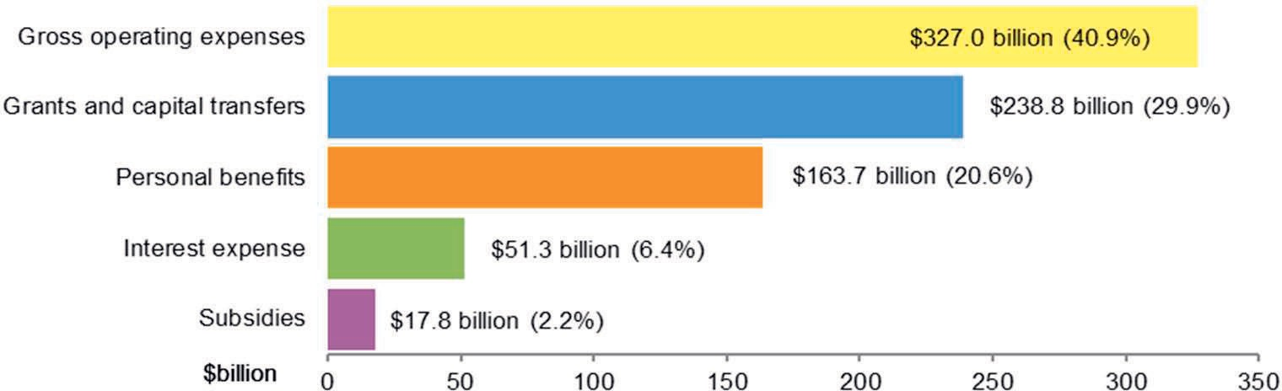

The key movements in expenses were:
- an increase in gross operating expenses of $50.5 billion, primarily due to a
$14.3 billion increase in benefit payments to households, driven by demand-led programs in the Health ($8.3 billion) and Education ($1.6 billion) portfolios; higher claims and average payments under the National Disability Insurance Scheme ($4.4 billion); a $27.8 billion increase in healthcare and other benefit expenses for veterans; and a $1.6 billion increase in payments related to the Nuclear-Powered Submarine program;
- an increase in grants expenses of $21.9 billion, primarily as a result of increased grants to state and territory governments ($19.8 billion); and
- increase in personal benefit expenses of $10.5 billion, reflecting higher demand across various social security programs; partially offset by
- $1.3 billion reduction in total interest expenses, primarily due to the conclusion of the Term Funding Facility program.

Chart 6 presents total expenses across the range of functions funded by the Australian Government.

Chart 6: Total expenses by function, 2024-25

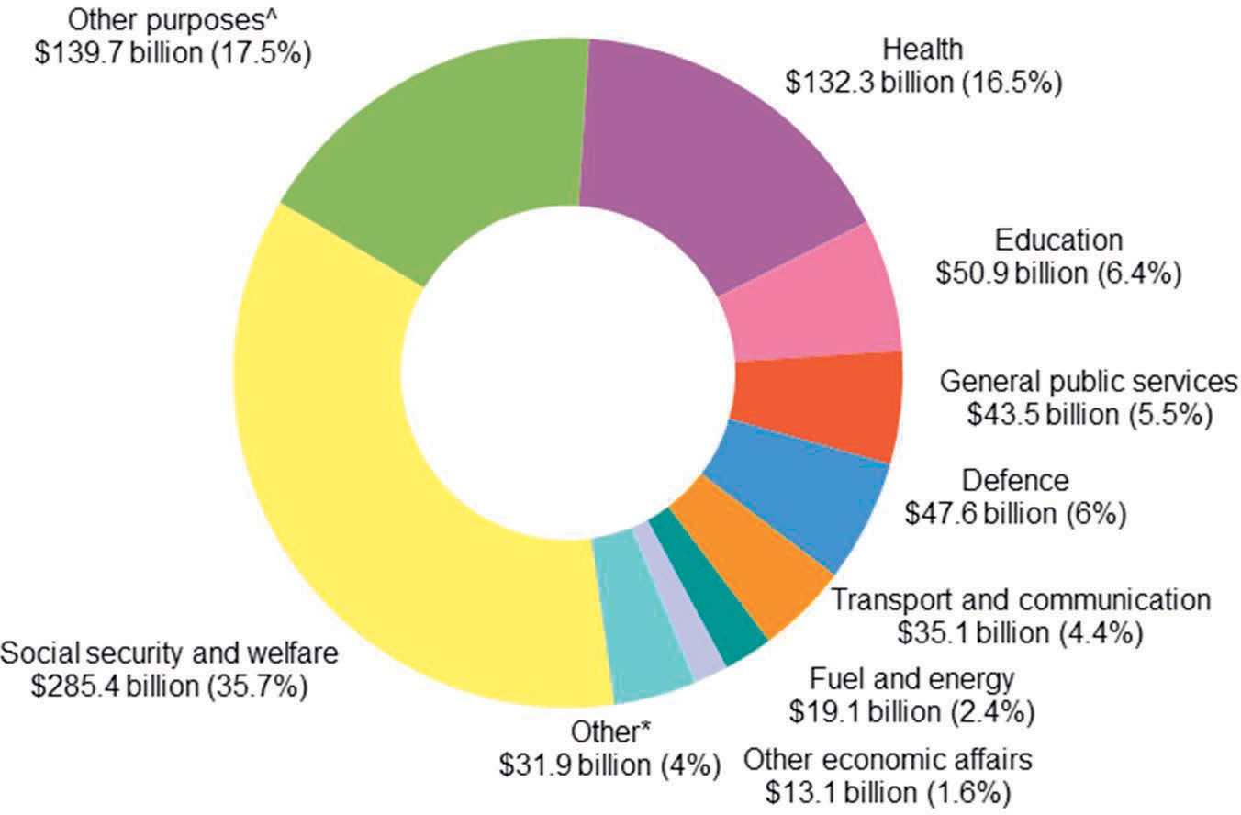

^ Other purposes includes public debt transactions, general purpose inter-government transactions and natural disaster relief. Grants to and through state and territory governments are recorded against the ‘other purposes’ function.

* Other includes: Public order and safety ($8.5 billion); Housing and community amenities ($8.5 billion); Mining, manufacturing and construction ($5.1 billion); Recreation and culture ($6.0 billion); and Agriculture, forestry and fishing ($3.8 billion).
See Note 3 of the 2024-25 CFS for further information on expenses.

Net worth
The Australian Government’s net worth decreased by $58.7 billion over the previous year to a negative net worth of $632.4 billion as at 30 June 2025.

Table 7: Balance sheet
 | 30 June 2025 | 30 June 2024 | Change Change
 | $b | $b | $b %
Financial assets | 752.9 | 688.6 | 64.3 9.3
Non-financial assets | 320.5 | 301.0 | 19.5 6.5
Total assets | 1,073.4 | 989.6 | 83.8 8.5
Interest bearing liabilities | 1,009.1 | 943.4 | 65.7 7.0
Provisions and payables | 696.7 | 619.9 | 76.8 12.4
Total liabilities | 1,705.8 | 1,563.3 | 142.5 9.1
Net worth | (632.4) | (573.7) | (58.7) 10.2

Chart 7 shows the composition of the Australian Government’s financial position over the past decade.

Chart 7: Balance sheet composition
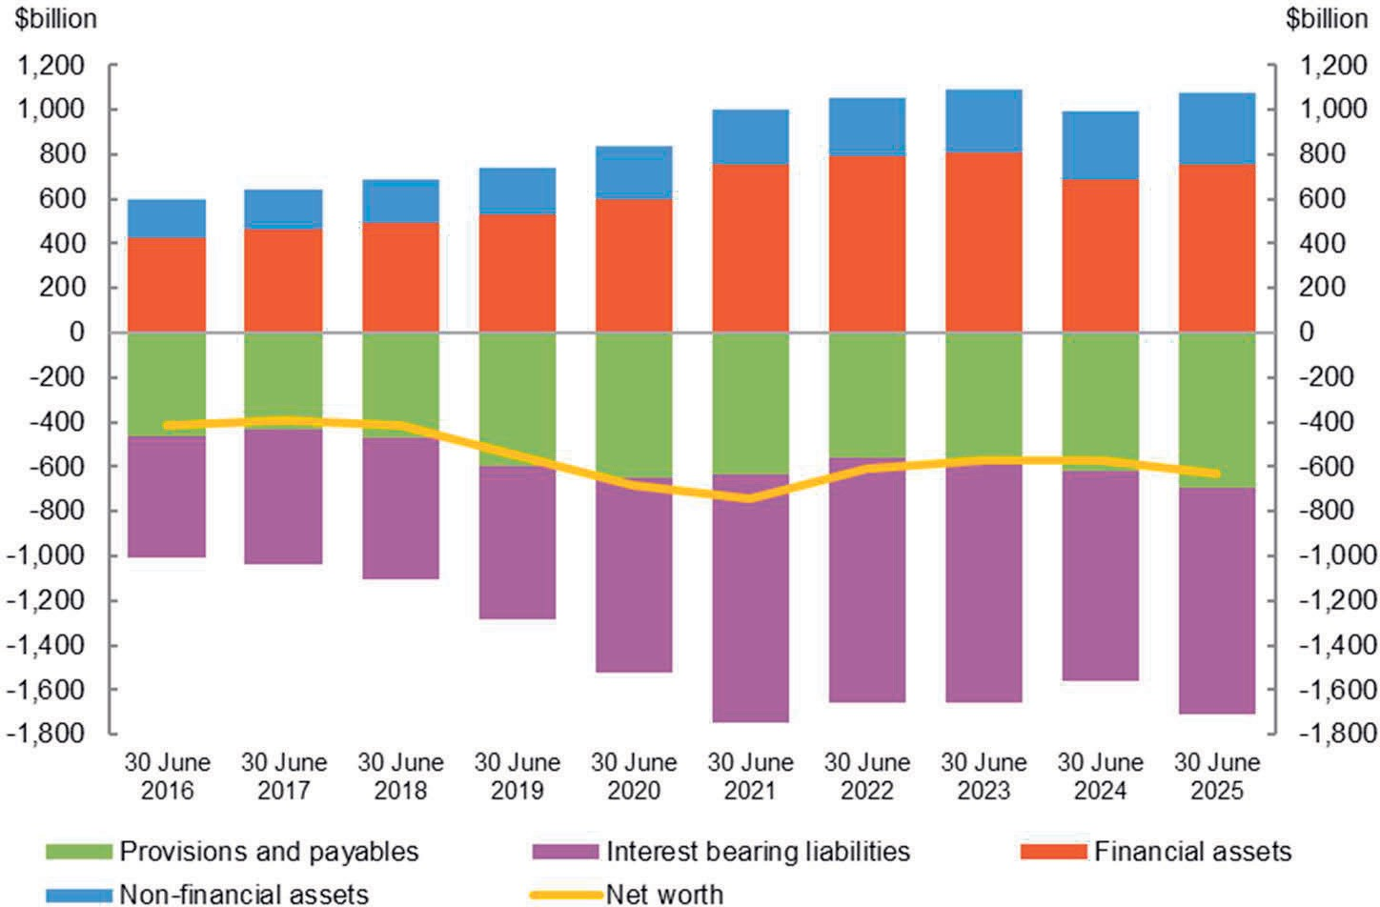

Assets
The Australian Government’s total assets as at 30 June 2025 were $1,073.4 billion.

Table 8: Assets
Financial assets Cash and deposits Advances paid  Other receivables and accrued  revenue  Investments, loans and placements Equity investments  Total financial assets Non-financial assets  Total assets | 30 June 2025 | 30 June 2024 | Change Change
 | $b | $b | $b %
 | 9.2 | 8.4 | 0.8 9.5
 | 82.3 | 77.0 | 5.3 6.9
 | 91.6 | 84.7 | 6.9 8.1
 | 449.5 | 416.9 | 32.6 7.8
 | 120.3 | 101.6 | 18.7 18.4
 | 752.9 | 688.6 | 64.3 9.3
 | 320.5 | 301.0 | 19.5 6.5
 | 1,073.4 | 989.6 | 83.8 8.5

The Australian Government’s total assets increased by $83.8 billion (8.5 per cent) since 30 June 2024. The composition of assets is shown in Chart 8.

Chart 8: Composition of assets, 30 June 2025
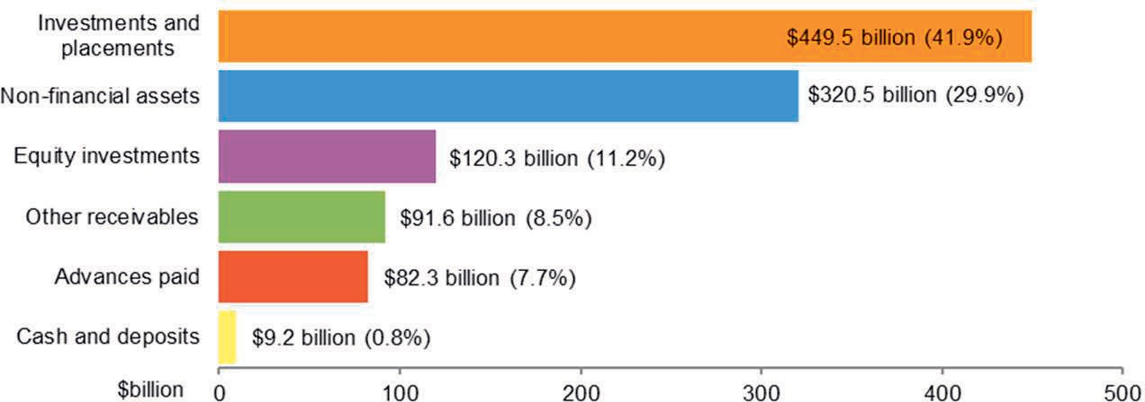

The key changes in financial assets were:
- an increase of $32.6 billion in investments, loans and placements largely due to higher deposits ($16.2 billion) and increased holdings in collective investment vehicles ($15.9 billion); and
- an increase of $18.7 billion in equity investments primarily due to an increase in investments in private funds and corporations ($18.4 billion).
The key changes in non-financial assets were:
- increases in plant, equipment and infrastructure ($8.1 billion), specialist military equipment ($5.1 billion), buildings ($3.7 billion), land ($0.7 billion), and other non-financial assets ($1.9 billion) as a result of additions and revaluation adjustments.
Note 5 of the 2024-25 CFS provides further information on assets.

Liabilities
The Australian Government’s total liabilities as at 30 June 2025 were
$1,705.8 billion.

Table 9: Liabilities
 | 30 June 2025 | 30 June 2024 | Change Change
 | $b | $b | $b %
Interest bearing liabilities | 1,009.1 | 943.4 | 65.7 7.0
Provisions and payables | 696.7 | 619.9 | 76.8 12.4
Total liabilities | 1,705.8 | 1,563.3 | 142.5 9.1

The Australian Government’s liabilities balance increased by $142.5 billion (9.1 per cent) since 30 June 2024. The composition of liabilities is shown in Chart 9.

Chart 9: Composition of liabilities, 30 June 2025
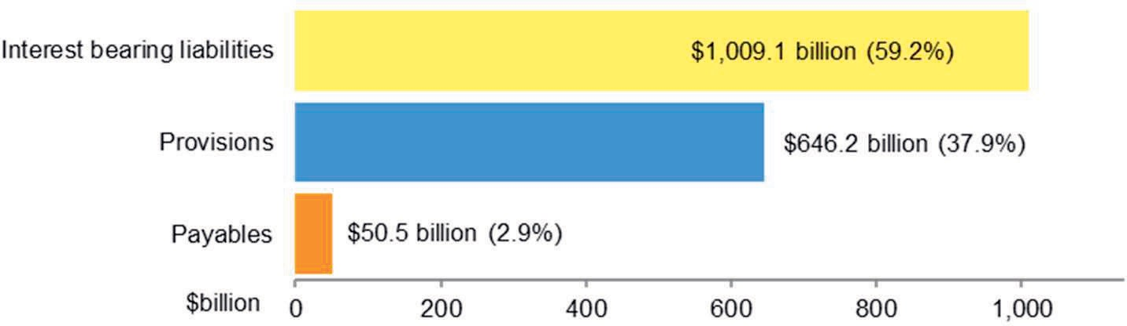

The increase of $65.7 billion in interest bearing liabilities is primarily due to:
- an increase of Government securities of $68.4 billion, largely due to Treasury bonds and notes by the Australian Office of Financial Management (AOFM) ($41.5 billion), and investments in government securities by the Reserve Bank of Australia (RBA) ($25.5 billion); partially offset by
- a decrease in exchange settlement funds ($11.1 billion).
The increase in provisions and payables of $76.8 billion is primarily driven by:
- increases in the health care military compensation ($33.6 billion) and personal benefit military compensation ($26.2 billion) provisions following a revised actuarial assessment reflecting growth in liability claims (refer to Note 1.6 for details regarding the restatement of the military compensation scheme);
- increases in the Disaster Recovery Funding provision ($6.1 billion), driven by updated actuarial valuation; and
- an increase in banknotes on issue ($3.0 billion), reflecting heightened demand for Australian currency.
Note 6 of the 2024-25 CFS provides further information on liabilities.

Cash flows
The Australian Government’s cash balance was $9.2 billion at 30 June 2025. For the year ended 30 June 2025, the Australian Government recorded a cash deficit of $16.7 billion compared to a cash surplus of $5.1 billion at 30 June 2024.

Table 10: Cash flows
Cash receipts Operating activities  Investing activities in non-financial  assets  Investing activities in financial assets for policy purposes  Financing activities (net)  Total cash receipts  Cash payments Operating activities  Investing activities in non-financial  assets  Investing activities in financial assets for policy purposes  Investing activities in financial assets for liquidity purposes (net)  Financing activities (net)  Total cash payments Net movement in cash  Cash at beginning of the year  Cash at end of year Key fiscal aggregate  Net cash flows from operating activities  Net cash flows from investments in non-financial assets  Cash surplus/(deficit) | 2024-25 | 2023-24 | Change Change
 | $b | $b | $b %
 | 739.9 | 708.6 | 31.3 4.4
 | 0.4 | 3.1 | (2.7) 87.1
 | 8.2 | 8.6 | (0.4) 4.7
 | 91.9 | 50.6 | 41.3 81.6
 | 840.4 | 770.9 | 69.5 9.0
 | 728.3 | 678.9 | 49.4 7.3
 | 28.6 | 27.7 | 0.9 3.2
 | 15.2 | 13.3 | 1.9 14.3
 | 7.8 | (150.4) | 158.2 105.2
 | 59.8 | 200.0 | (140.2) 70.1
 | 839.7 | 769.5 | 70.2 9.1
 | 0.7 | 1.4 | (0.7) 50.0
 | 8.5 | 7.1 | 1.4 19.7
 | 9.2 | 8.5 | 0.7 8.2
 | 11.6 | 29.7 | (18.1) 60.9
 | (28.3) | (24.6) | (3.7) 15.0
 | (16.7) | 5.1 | (21.8) 427.5

Receipts and payments
The following charts provide a detailed breakdown of Australian Government receipts and payments for 2024-25, showing the relative composition of each dollar received and paid.

Chart 10: Composition of each dollar of cash received in 2024-25
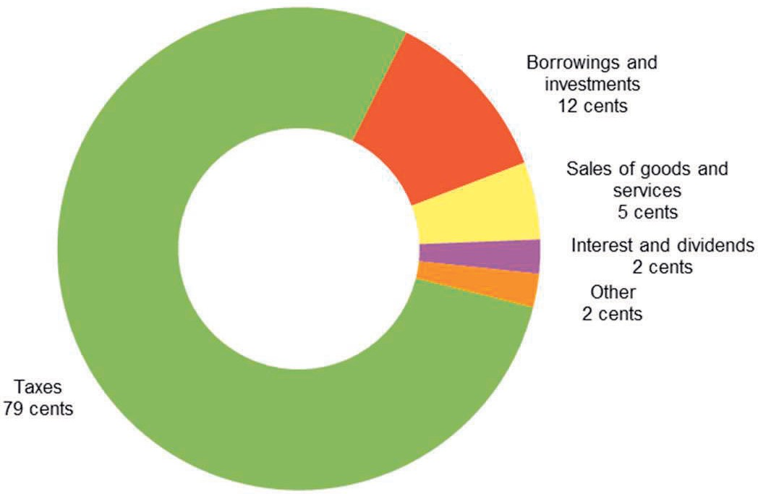

Chart 11: Composition of each dollar of cash paid in 2024-25
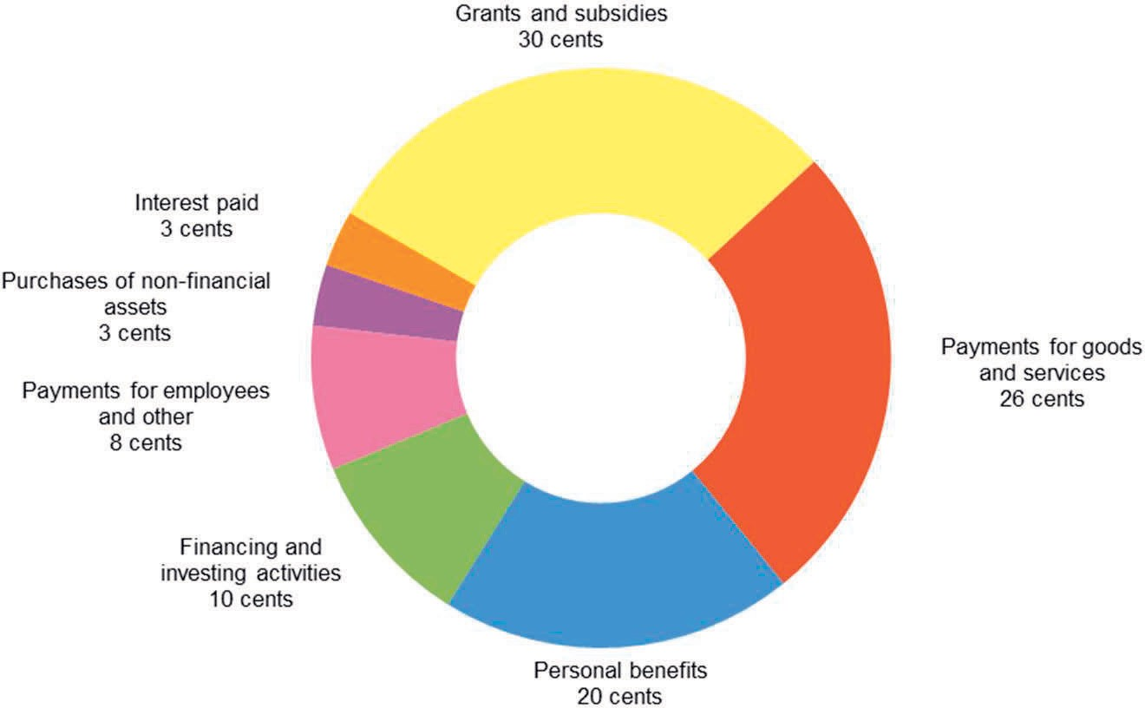

APPENDIX A

Previous years
The CFS since 1995-96 are available on the Department of Finance website at:
http://www.finance.gov.au/publications/commonwealth-consolidated-financial-statements.
The historical series datasets are available in electronic format at:
http://data.gov.au/data/dataset/australian-government-consolidated-financial-statements-tables-and-data.

Links to other publications
The Australian Government publishes a range of information about its projected and actual financial position. Links to some of these documents are set out below. The information in the following documents has been prepared for different purposes and therefore does not form part of the CFS. Further, the documents listed below are not subject to audit.

2024-25 Final Budget Outcome
The 2024-25 Final Budget Outcome (FBO) was prepared in a manner consistent with the Charter of Budget Honesty Act 1998 (the Charter). The Charter requires that the Government provide the FBO no later than three months after the end of the financial year. Consistent with these requirements, the FBO encompasses Australian Government GGS fiscal outcomes for the 2024-25 financial year and is based on external reporting standards.
The 2024-25 FBO was released on the 29 September 2025 and is available on the Australian Government website at:
https://archive.budget.gov.au/2024-25/.

Australian Government Monthly Financial Statements
The Australian Government GGS monthly financial statements (MFS) are prepared on a basis consistent with the Budget as required under section 47 of the PGPA Act. The statements are prepared in accordance with AASB 1049.
The Australian Government GGS MFS are available on the website of the Minister for Finance as well as the Department of Finance website: https://www.finance.gov.au/publications/commonwealth-monthly-financial-statements/previous#20242025.
The historical series datasets are available in electronic format at: http://data.gov.au/data/dataset/australian-government-general-government-sector-monthly-financial-statements-tables-and-data.

Budget Strategy and Outlook and Mid-Year Economic and Fiscal Outlook
The Budget Strategy and Outlook — Budget Paper No.1 — 2024-25, the Mid-Year Economic and Fiscal Outlook 2024-25, the Budget Strategy and Outlook — Budget Paper No.1 — 2025-26 have been prepared in accordance with the Charter.
These Budget papers are available on the Australian Government website at http://www.budget.gov.au/.

Tax Expenditures and Insights Statements
The Tax Expenditures and Insights Statement provides details of concessions, benefits, incentives and charges provided through the tax system (tax expenditures) to taxpayers by the Australian Government. Information is published on the Treasury website at: https://treasury.gov.au/publication/p2025-607085.

