PREFACE
I am pleased to present the Australian Government's Consolidated Financial Statements (CFS) for the financial year ended 30 June 2025. The CFS presents the whole of government and general government sector (GGS) financial reports, including the audited accounts of 202 entities across the public sector.
The CFS has been prepared in accordance with the regulations of the Public Governance, Performance and Accountability Act 2013 (PGPA Act) and applicable Australian Accounting Standards (AAS), including the requirements of AASB 1049 Whole of Government and General Government Sector Financial Reporting (AASB 1049). The CFS shows the results of the Australian Government's financial
performance and cash flows for the year ended 30 June 2025 and the Australian Government's financial position as at 30 June 2025.

Operating statement
The Australian Government's net operating balance for the year ended 30 June 2025 was a deficit of $41.2 billion. For the year ended 30 June 2024, the Australian Government reported a net operating balance surplus of $10.1 billion.
The change in the net operating balance is driven by an increase in revenue of
$29.8 billion (4.1 per cent), due to higher taxation collections, and an increase in expenditure of $81.1 billion (11.3 per cent).

Balance sheet

The Australian Government's net worth was negative $632.4 billion as at 30 June 2025. As at 30 June 2024, the Australian Government's net worth was negative $573.7 billion.
The Australian Government's total assets increased by $83.8 billion (8.5 per cent). Financial assets increased by $64.3 billion (9.3 per cent) for the year ended 30 June 2025. Total non-financial assets increased by $19.5 billion (6.5 per cent).
The Australian Government's liabilities increased by $142.5 billion (9.1 per cent) for the year ended 30 June 2025.


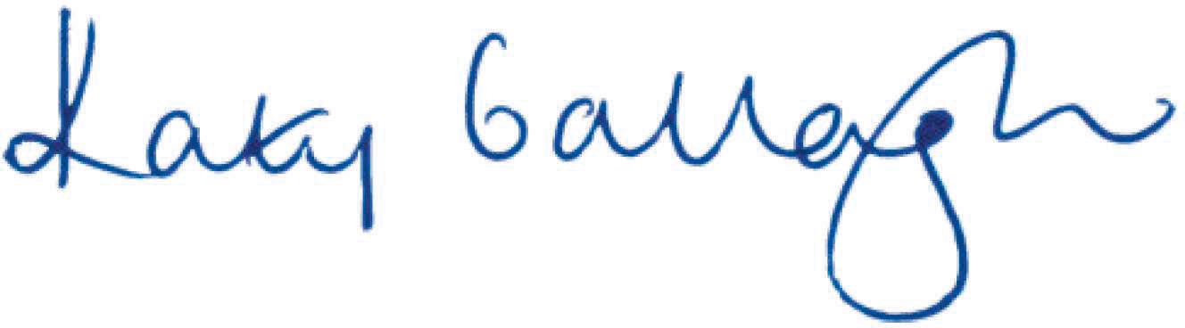

Cash flows
The Australian Government recorded a cash deficit of $16.7 billion for the year ended 30 June 2025 from operating activities and investing activities in non-financial assets. The cash position at the end of the year was $9.2 billion.

Contingent liabilities, contingent assets and risks
Contingent liabilities and contingent assets for the Australian Government are not disclosed in the balance sheet but are set out in detail in Note 10A of the CFS. Analysis of financial risks that could potentially impact on the Australian Government's financial position is included in Note 10B.

Final Budget Outcome
Under the Charter of Budget Honesty Act 1998 (the Charter), the Australian Government is required to publicly release and table a Final Budget Outcome (FBO) report no later than three months after the end of the financial year. The FBO for the 2024-25 financial year was released on 29 September 2025, presenting the fiscal outcomes for the Australian Government general sector.
Consistent with the requirements of the Charter, the FBO is prepared on an accrual basis that complies with both the Australian Bureau of Statistics' (ABS) accrual Government Finance Statistics (GFS) publication and the Australian Accounting Standards, except for the departures disclosed in the FBO. An explanation of the differences between the key fiscal aggregates reported in the CFS under AASB 1049 and the corresponding fiscal aggregates reported under the ABS GFS publication is included in Note 13A.
I would like to thank the many Australian Government employees whose efforts have contributed to the completion of the 2024-25 CFS.

Senator the Hon Katy Gallagher Minister for Finance

2

