Commonwealth

Climate Disclosure

Pilot Guidance

Departments of State

FY2023-24 Annual Reporting

Climate Disclosure Provisions

Contents

1. Summary of key features 1

Important information for departments 1

2. Overview 3

Introduction 3

Background 4

Pilot objectives and outcomes 4

Summary of Pilot criteria 5

Evaluation and auditing 6

Resources 6

3. Pilot Guidance 7

General expectations 7

Key policy parameters 7

Complementary policies 8

Guiding principles 10

Disclosure criteria and guidance 11

4. Key terms and definitions 22

# 1. Summary of key features

## Important information for departments

### Key points

* All [Departments of State (departments)](https://www.finance.gov.au/government/managing-commonwealth-resources/structure-australian-government-public-sector/types-australian-government-bodies) are to commence reporting on their climate risk management activities in their FY2023-24 (herein 2023-24) annual reports under the Commonwealth Climate Disclosure Pilot (the Pilot).
* The purpose of the Pilot is to assist departments in taking their first steps towards climate disclosure and prepare them for the commencement of the [Commonwealth Climate Disclosure Requirements](https://www.finance.gov.au/government/climate-action-government-operations/commonwealth-climate-disclosure) in 2024-25. In addition, the Pilot also serves to establish transparency on how departments manage their climate-related risks and opportunities and to demonstrate federal leadership on climate risk disclosure.
* Under the Pilot, departments are required to report against a limited range of criteria based on a subset of the Australian Accounting Standards Board’s [Exposure Draft of the Australian Sustainability Reporting Standards](https://aasb.gov.au/news/exposure-draft-ed-sr1-australian-sustainability-reporting-standards-disclosure-of-climate-related-financial-information/), with appropriate tailoring for Commonwealth entities and Commonwealth companies.
* The Pilot Guidance sets out the limited reporting criteria and provides guidance and suggestions on how departments should approach their disclosures. It is important to note that the ‘Criteria’ section sets out what departments are to report on, while the ‘Guide to making your disclosure’ section sets out how departments ought to prepare their report in order to satisfy the criteria. The guidance is not intended to be prescriptive, and departments should consider their own circumstances when responding to the criteria, as appropriate.

**Key messages**

* The Pilot has been designed to serve as a realistic stretch for departments preparing their first climate disclosures and takes into account the current baseline levels of climate maturity across departments. It achieves this by focussing on foundation governance, risk management and metrics and targets criteria that can be practically implemented this financial year. **Figure 1** provides a summary of the criteria departments will be required to report against under the Pilot in 2023-24, along with additional reporting expectations under the future Commonwealth Climate Disclosure Requirements from 2024-25 onwards.
* It is expected that disclosures made under the Pilot will not be comprehensive, but that they will evolve over time as maturity and capability develops across Commonwealth entities and Commonwealth companies. In view of this expectation, the Pilot also provides latitude for departments to disclose planned or interim arrangements where they have been unable to give entire effect to one or more of the criteria.
* The Department of Finance (Finance) is responsible for administering the Pilot and is here to support departments to meet their reporting obligations under the Pilot. Contact [climateaction@finance.gov.au](mailto:climateaction@finance.gov.au) for further information or to access support.

**Figure 1: Summary of Pilot criteria and future requirements**

The diagram shows the 3 Pilot pillars of Governance, Risk Management and Metrics and Targets. 
Governance: Departments are to set out the processes, controls and procedures their department uses to identify, prioritise, monitor, manage and oversee climate-related risks and opportunities. Note: All departments are to embed climate risk management into governance arrangements under the Climate Risk and Opportunity Management Program. The governance criteria requires entities to provide details of these arrangements, including any interim or planned arrangements.
Risk management: Departments are to describe their progress on implementing their organisation-wide climate risk and opportunity assessment under the Climate Risk and Opportunity Management Program. Note: All departments are to commence climate risk and opportunity assessments under the Climate Risk and Opportunity Management Program. The risk management criteria requires departments to provide a progress update on the implementation of their assessment. 
Metrics and targets: Departments are to identify their greenhouse gas emission profiles and the APS Net Zero by 2030 target they are working towards for emissions reduction. Note: All departments are subject to whole-of-Australian-Government emissions reporting and the APS Net Zero by 2030 target (noting certain exclusions apply). The metrics and targets criteria requires departments to provide information about these centrally driven policies and processes based on information supplied by Finance. 
Future criteria: From 2024-25 onwards, departments will be subject to additional criteria under the Commonwealth Climate Disclosure Requirements. This includes criteria on strategies for managing climate-related risks and opportunities, as well as criteria on risk management processes and cross-industry metrics. However, these are not requirements for disclosure under the Commonwealth Climate Disclosure Pilot this financial year. Departments can refer to the AASB's Exposure Draft of the Australian Sustainability Reporting Standards for an early indication of these requirements. 

The Pilot has been designed to draw on a range of existing policies to reduce duplication and compliance burden for departments. These include (but are not limited to) the: [Net Zero in Government Operations Strategy](https://www.finance.gov.au/government/climate-action-government-operations/aps-net-zero-emissions-2030), [APS Net Zero Emissions Reporting Framework](https://www.finance.gov.au/government/climate-action-government-operations/australian-government-emissions-reporting), [Climate Risk and Opportunity Management Program](https://www.dcceew.gov.au/climate-change/policy/adaptation/climate-risk-opportunity-management-program) and [Commonwealth Risk Management Policy](https://www.finance.gov.au/government/comcover/risk-services/management/commonwealth-risk-management-policy). Departments will be expected to draw upon these policies when preparing their disclosures. Refer to Complementary policies for further information.

**2. Overview**

## Introduction

The Pilot seeks to guide and assist departments in preparing for the commencement of the Commonwealth Climate Disclosure Requirements in 2024-25. The Pilot constitutes the first step along the pathway for departments to achieve transparent reporting of climate risk management activities across their organisations.

Finance is leading the development and implementation of the Pilot, as part of its broader responsibility for delivering the Commonwealth Climate Disclosure Reform (the Reform) and Requirements (see Background). Under the Pilot, all departments are to commence reporting on a limited range of climate risk management activities in their 2023-24 annual reports. The Pilot Guidance, set out in part 3 of this document, outlines the criteria departments will need to report against and provides suggestions on how departments ought to approach their disclosures.

It is important to note that the Pilot Guidance is only part of what departments will be required to disclose under the Reform when it is brought into full effect from 2024-25 onwards. From 2024-25 onwards, departments will be expected to report on additional criteria specified in the Commonwealth Climate Disclosure Requirements, which are currently slated for release in mid-2024 (see **Figure 1**).

The Pilot Guidance has been tailored from parts of the Australian Accounting Standards Board’s (AASB) [Exposure Draft of the Australian Sustainability Reporting Standards – Disclosure of Climate-related Financial Information](https://aasb.gov.au/news/exposure-draft-ed-sr1-australian-sustainability-reporting-standards-disclosure-of-climate-related-financial-information/), which was developed using the International Sustainability Standards Board’s (ISSB) [IFRS Sustainability Disclosure Standards](https://www.ifrs.org/projects/completed-projects/2023/climate-related-disclosures/#published-documents) as a basis. Tailoring has been made to reflect Commonwealth public sector considerations including certain legislative, regulatory and policy decisions that departments are subject to, for example, the APS Net Zero by 2030 emissions reduction target under the [Net Zero in Government Operations Strategy](https://www.finance.gov.au/government/climate-action-government-operations/aps-net-zero-emissions-2030).

In preparation for commencement of the Reform, other Commonwealth entities and Commonwealth companies may choose to make climate disclosures following the Pilot Guidance in their 2023-24 annual reports.

|  |
| --- |
| Note**:** The Pilot has been designed to cater for baseline levels of climate maturity and to serve as a realistic stretch for departments in taking their first steps towards making full climate disclosures. It is acknowledged that climate disclosures will evolve over time as maturity and capability develops across Commonwealth entities and Commonwealth companies. Finance and the Department of Climate Change, Energy, the Environment and Water are providing a range of tailored assistance (see Resources) to help departments undertake climate risk and opportunity assessments and prepare high-quality limited disclosures to meet their reporting obligations under the Pilot. |

## Background

[Commonwealth Climate Disclosure](https://www.finance.gov.au/government/climate-action-government-operations/commonwealth-climate-disclosure) is the Australian Government's policy for Commonwealth entities and Commonwealth companies identified in the [*Public Governance, Performance and Accountability Act 2013* (PGPA Act) Flipchart](https://www.finance.gov.au/government/managing-commonwealth-resources/structure-australian-government-public-sector/pgpa-act-flipchart-and-list) to publicly report on their exposure to   
climate-related risks and opportunities, as well as their actions to manage them.

Finance is responsible for implementing the Commonwealth Climate Disclosure Reform for Commonwealth entities and Commonwealth companies that do not meet the proposed thresholds for inclusion in the [mandatory climate-related financial disclosure reform for Australia’s large businesses and financial institutions](https://treasury.gov.au/consultation/c2024-466491) (Corporate Climate-related Financial Disclosure Reform).

The Commonwealth Climate Disclosure Reform serves to provide greater transparency, accountability and credibility in the way climate-related risks are managed across Commonwealth entities and Commonwealth companies, while also enhancing the climate resilience of Commonwealth assets and the delivery of public goods and services.

The Reform will be introduced in a phased manner over 4 years, commencing with a one-year limited disclosure for departments in 2023-24 under the Pilot. Under the Reform, departments will be required to report against the full Commonwealth Climate Disclosure Requirements from 2024-25 onwards, along with other larger, more prominent climate risk-exposed Commonwealth entities. The Reform will gradually expand its reach over time to encompass all smaller Commonwealth entities and Commonwealth companies by 2026-27.

This Reform is in line with the Government’s commitment to mandate climate-related financial disclosures for Australia’s large businesses and financial institutions under the Corporate Climate-related Financial Disclosure Reform. As markets and regulators demand more comprehensive disclosures by companies, it is important that similar requirements apply to Commonwealth entities and Commonwealth companies. This will engender greater market neutrality between the Commonwealth public and private sectors.

As is the case with the Pilot, the Commonwealth Climate Disclosure Requirements will closely align with the AASB’s Australian Sustainability Reporting Standards. Some tailoring will be required to reflect differences in operating environments between the private sector and the Commonwealth public sector, including policy directions provided by Government, such as the APS Net Zero by 2030 target.

The Commonwealth Climate Disclosure Requirements are expected to be finalised in mid-2024, following a period of consultation. Further information on the Reform is available on the [Commonwealth Climate Disclosure webpage](https://www.finance.gov.au/government/climate-action-government-operations/commonwealth-climate-disclosure).

## Pilot objectives and outcomes

The Pilot seeks to achieve 3 key objectives:

1. To enable annual report users, including the Australian public, businesses, investors, parliamentarians and other stakeholders, to understand how departments manage their climate-related risks and opportunities.
2. To test the application of some aspects of the Commonwealth Climate Disclosure Requirements.
3. To demonstrate department leadership in disclosing climate risk management activities and to pave the way for other Commonwealth entities and Commonwealth companies to follow.

Key outcomes and outputs from the Pilot include:

1. Improved transparency and accountability of climate risk management in departments, with all departments having prepared a limited climate disclosure as part of their 2023-24 annual reports.
2. Enhanced management of, and responsiveness to, climate-related risks and opportunities, with all departments having commenced institution of climate risk governance arrangements within their organisation and having commenced an organisation-wide climate risk and opportunity assessment in 2023-24.

## Summary of Pilot criteria

Under the Pilot, climate disclosures must address the below criteria at a minimum:

1. Governance structures in place to support climate risk management within departments.
2. Progress departments are making on undertaking their climate risk and opportunity assessment, as prescribed by the Climate Risk and Opportunity Management Program.
3. Departments’ greenhouse gas emissions profiles and information about the APS Net Zero by 2030 emissions reduction target they are contributing towards.

|  |
| --- |
| Note:   * Departments will not be required to prepare disclosures on strategy-related activities under the Pilot. Strategy-related activities refer indicatively to those set out under the strategy core content in the AASB’s Exposure Draft of the Australian Sustainability Reporting Standards. This approach reflects the need for departments to focus on establishing foundations to build comprehensive climate disclosures in the Pilot year. It also provides departments with additional time to develop more complex strategies to enhance their climate risk management before being required to report on those strategies in 2024-25, when the Commonwealth Climate Disclosure Requirements are brought into full effect. * Departments will not be required to report on climate-related activities that extend beyond their organisational boundaries under the Pilot (with the exception of certain scope 3 emissions required to fulfil APS Net Zero Emissions Reporting Framework obligations). It is expected that departments will, however, progressively extend their disclosures over time to include broader value chain climate-related considerations. This specifically includes considerations in relation to policy design and implementation, as well as the provision of public goods and services. * Departments will be expected to report on a range of additional criteria under the Commonwealth Climate Disclosure Requirements when they are brought into full effect in 2024-25. Additional criteria will closely reflect the AASB’s Australian Sustainability Reporting Standards, with appropriate tailoring for the Commonwealth public sector. For further information, refer to the [AASB’s website](https://www.aasb.gov.au/news/exposure-draft-ed-sr1-australian-sustainability-reporting-standards-disclosure-of-climate-related-financial-information/). |

## Evaluation and auditing

Finance will be conducting an evaluation of the Pilot in late 2024. Evaluation outcomes will be used to inform the implementation of the Commonwealth Climate Disclosure Requirements in 2024-25.

It is important to note that the Pilot will not be subject to a specific climate disclosure audit and assurance regime. Finance is designing an audit and assurance regime in consultation with the Australian National Audit Office (ANAO) and affected entities. The regime will come into effect in future reporting years of the Reform. The focus of the regime will be on improving the quality of climate disclosures, and the scope of auditable requirements will be considered as the regime is developed. The regime will be implemented at a future date to allow sufficient time for policy development and consultation, and to provide entities with time to build mature climate disclosures. Finance is seeking feedback on the timing and nature of the audit and assurance regime as part of its forthcoming consultation on the Commonwealth Climate Disclosure Requirements.

## Resources

Capability building support will be made available to help departments meet their climate disclosure obligations. The following tools, guidance and support will be made available to assist departments in their development of best-practice climate disclosure:

* A Pilot Metrics and Targets Factsheet that outlines the whole-of-Australian-Government approach and methodology for emissions reporting under the APS Net Zero Emissions Reporting Framework, as well as information about the APS Net Zero by 2030 target.
* An illustrative, hypothetical example of a limited climate disclosure indicative of the standard required to satisfy the Pilot criteria set out in part 3 of this document.
* A Community of Practice that provides a collaborative group learning environment for departments and other entities participating in Commonwealth Climate Disclosure and other Climate Action in Government Operations activities more broadly.

In addition to the above, Finance can also perform thematic reviews of departments’ climate disclosures made as part of the Pilot, prior to annual report publication. For further information, contact [climateaction@finance.gov.au](mailto:climateaction@finance.gov.au).

The Department of Climate Change, Energy, the Environment and Water has also developed a range of tools and guidance to support entities to identify, assess, prioritise and manage their climate-related risks and opportunities, as part of its [Climate Risk and Opportunity Management Program](https://www.dcceew.gov.au/climate-change/policy/adaptation/climate-risk-opportunity-management-program). These include (but are not limited to):

* Climate Risk and Opportunity learning and development modules on APS Academy.
* [Climate Risk Management Guides](https://www.dcceew.gov.au/climate-change/publications/climate-risk-opportunity-management-program-resources), including the Organisation Application Guide.

# 3. Pilot Guidance

## General expectations

Departments are to have regard to the following Pilot Guidance when preparing their limited disclosures under the Pilot. The Pilot Guidance comprises 3 key parts:

1. **Key policy parameters.** Key policy parameters set out the scope of the Pilot’s policy coverage, disclosure exemptions and locations, as well as related policy considerations. These parameters must be taken into account when preparing limited disclosures under the Pilot.
2. **Guiding** **principles.** Guiding principles are high-level maxims that departments should consider when preparing their limited climate disclosures under the Pilot. The principles are designed to support high-quality limited disclosures and may also be used as benchmarks to assist in the evaluation of the Pilot.
3. **Criteria and** **guidance.** The criteria and guidance are designed to be read in conjunction to facilitate limited climate disclosures under the Pilot. More specifically:
4. The ‘Criteria’ section sets out what departments are to report on under the Pilot. These are based on a subset of the AASB’s Exposure Draft of the Australian Sustainability Reporting Standards (namely, governance, risk management and metrics and targets core content), with specific tailoring to reflect the climate maturity of departments and the policy environment in which they operate. It is important to be aware that while the criteria are not comprehensive, they are indicative of the future reporting obligations departments will be subject to when the Commonwealth Climate Disclosure Requirements are brought into effect from 2024-25 onwards.
5. The ‘Guide to making your disclosure’ section sets out how departments ought to give effect to the criteria and meet their reporting obligations under the Pilot. This information is not intended to be prescriptive. Departments are to have regard to this guidance in preparing their disclosures but should consider their own circumstances when responding to individual criterion, as appropriate. It is important to note that the guidance also provides practical suggestions and tips to help departments prepare their disclosures.

To complement the Pilot Guidance, an illustrative, hypothetical example of a limited climate disclosure has been developed to serve as a practical benchmark for departments seeking to execute their disclosure obligations under the Pilot. The illustrative example is available on the [Commonwealth Climate Disclosure Pilot webpage](https://www.finance.gov.au/government/climate-action-government-operations/commonwealth-climate-disclosure-pilot) and should be referred to as a guide only.

## Key policy parameters

### Scope

All [Departments of State (departments)](https://www.finance.gov.au/government/managing-commonwealth-resources/structure-australian-government-public-sector/types-australian-government-bodies) are to follow the Pilot Guidance to support climate disclosures in their 2023-24 annual reports under the Pilot.

Other Commonwealth entities and Commonwealth companies may make voluntary climate disclosures following the Pilot Guidance in their 2023-24 annual reports. If your entity would like to voluntarily participate in the Pilot, contact [climateaction@finance.gov.au](mailto:climateaction@finance.gov.au) for further information.

### Exemptions

Departments are exempt from disclosing information if the law prohibits that information from being publicly reported. This specifically includes information that is likely to prejudice national security and confidential commercial information which, if disclosed, could reasonably be considered a secrecy offence under the *Criminal Code Act 1995*. Disclosures provided by the Department of Defence and the Department of Home Affairs will be subject to a security risk assessment prior to any public release. This is to be conducted as part of their usual annual report security review process.

Activities by departments that take place outside of Australia or its territories, including international air and marine travel, are also exempt from disclosure and are excluded from greenhouse gas emissions calculations.

### Location of disclosures

Disclosures are to be made in departments’ 2023-24 annual reports prepared for section 46 of the PGPA Act (due to be tabled October 2024). Disclosures can sit within a sustainability report as an appendix to the annual report or can be provided as a climate statement in the appendix to the annual report. Departments may, however, choose to disclose against some of the criteria in other appropriate areas of their annual report to avoid duplication. For example, departments may choose to disclose against some criteria in areas of the annual report related to their governance structure and/or risk management arrangements.

### Use of references

Departments are permitted to reference relevant information contained in other publicly available documents within their disclosures. However, these documents must be made publicly available at the time and on the same terms as the related annual report publication. Examples of relevant information departments may wish to reference in their annual reports includes information outlined in their Emissions Reduction Plans (under the Net Zero in Government Operations Strategy) or their Action Plans (developed through the Climate Risk and Opportunity Management Program).

When referencing documents, it is important for departments to ensure that the referenced material, when viewed holistically alongside the department’s annual report, clearly covers off on all criteria outlined in the Pilot Guidance.

## Complementary policies

The Pilot draws upon related polices and work underway across Government to build more climate resilient and sustainable Commonwealth entities and Commonwealth companies. This includes the [Net Zero in Government Operations Strategy](https://www.finance.gov.au/government/climate-action-government-operations/aps-net-zero-emissions-2030), [APS Net Zero Emissions Reporting Framework](https://www.finance.gov.au/government/climate-action-government-operations/australian-government-emissions-reporting), [Climate Risk and Opportunity Management Program](https://www.dcceew.gov.au/climate-change/policy/adaptation/climate-risk-opportunity-management-program) and [Commonwealth Risk Management Policy](https://www.finance.gov.au/government/comcover/risk-services/management/commonwealth-risk-management-policy).

To meet certain criteria under the Pilot, departments will be required to refer to these Government policies and frameworks and give effect to any specific obligations set out therein. This constitutes an important feature in policy design that seeks to minimise administrative duplication and compliance burden on departments when preparing disclosures under the Pilot. **Figure 2** sets out these expectations in more detail.

### Figure 2: Related policies and corresponding obligations for departments preparing disclosures under the Pilot

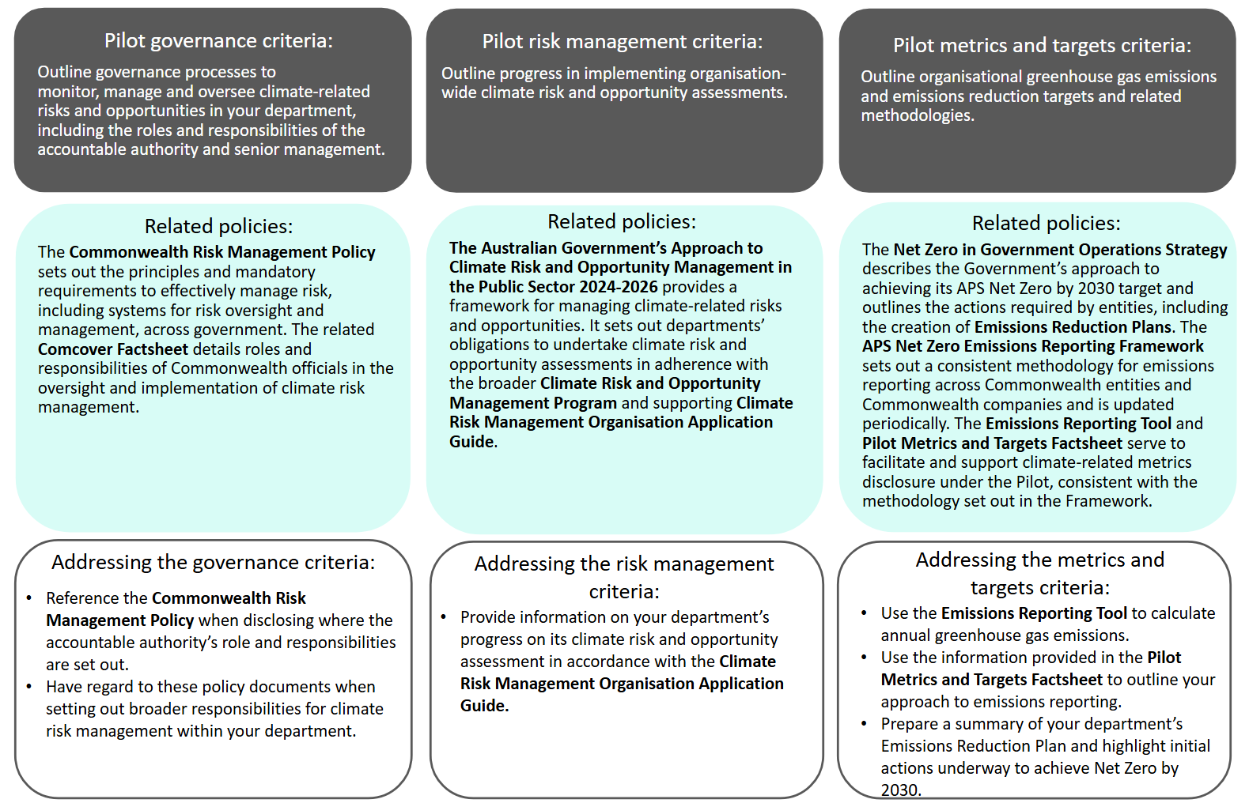

## Guiding principles

Set out below are the guiding principles that authors should consider when preparing climate disclosures under the Pilot.

### Comprehensibility and accuracy

Disclosures should be sufficiently detailed and clear to enable them to be widely understood by annual report users, including the Australian public, businesses, investors, parliamentarians and other stakeholders. Disclosures should also be relevant, verifiable and faithfully represent the status and particulars of climate-related actions and undertakings of departments, including any planned actions.

### Accountability

Disclosures should clearly identify the accountable authority responsible for ensuring climate‑related risks and opportunities are appropriately identified, prioritised, managed, monitored and disclosed.

### Completeness

Disclosures should provide a fair presentation of departments’ climate-related activities against the Pilot Guidance. All criteria set out under governance, risk management and metrics and targets should be addressed, or include an explanation of missing information and steps the department is undertaking to fulfil the criteria in the future (see ‘Maturity’ and ‘Forward-looking’).

### Maturity

The sophistication of disclosures will evolve over time, beginning with a basic level of maturity in the Pilot year. It is anticipated that disclosures will become increasingly detailed and comprehensive as maturity develops, and as the Commonwealth Climate Disclosure Requirements are brought into full effect from 2024-25 onwards.

### Forward-looking

In view of the time and capability constraints facing departments, it is acknowledged that it may not be possible for all departments to fully implement all the processes, protocols, arrangements and other particulars prescribed by the Pilot. In instances where only partial implementation has been achieved, disclosures should outline implementation status, timeframes and steps to completion.

## Disclosure criteria and guidance

### Governance

In making your disclosure, clearly set out the processes, controls and procedures your department uses to identify, prioritise, monitor, manage and oversee climate-related risks and opportunities.

|  |
| --- |
| **Interim Arrangements:** As governance arrangements take time to establish and are likely to evolve as departments develop their climate maturity, it is generally acknowledged that many departments may wish to establish interim governance arrangements in their initial year(s) of climate disclosure. Where this is the case, you should make this clear in your disclosure by stating that you expect your governance arrangements to develop over time in response to your department’s evolving risk profile (i.e. as climate-related risks and opportunities are identified in the future) and as internal climate capability builds. |

In making your disclosure, you should address each of the criteria outlined below.

##### Criteria

G1. Identification of the accountable authority, as defined under section 12 of the PGPA Act, responsible for the disclosure of the department’s climate-related risks and opportunities.

G2. Information about how the accountable authority executes their role in overseeing climate-related risks and opportunities, including:

1. how the accountable authority determines whether appropriate skills and competencies are available or will be developed to oversee and manage strategies designed to respond to climate-related risks and opportunities.
2. how and how often the accountable authority is informed about climate-related risks and opportunities.
3. how the accountable authority oversees the entity’s strategy and risk management processes and related policies, and how they make decisions in relation to major transactions. Departments must disclose whether and how the accountable authority considers trade-offs and Government policy constraints in relation to decisions made on climate-related risks and opportunities.
4. how the accountable authority oversees the setting of targets related to climate‑related risks and opportunities, and monitors progress towards those targets.
5. whether, and to what extent, risk oversight is deputised to a specific management‑level position or management level committee (herein principal assignee) and how oversight is exercised over that position or committee.

G3. Information about the role and responsibilities the principal assignee and other senior management and governance committees (herein assignees) play in the oversight and administration of governance processes, controls and procedures of climate-related risks and opportunities, including:

1. whether the principal assignee and/or assignees use controls and procedures to support the oversight and management of climate-related risks and opportunities, and if so, how these are integrated with other internal functions. In addressing the criteria, departments must have regard to The Australian Government’s Approach to Climate Risk and Opportunity Management in the Public Sector 2024-2026*.*

##### Guide to making your disclosure

|  |
| --- |
| Note: The information in this section is not intended to be prescriptive. Departments are to have regard to this guidance in preparing their disclosures, but should also consider their own circumstances when responding to the criteria above, as appropriate. |

**Step 1:** Include a governance structure diagram that clearly sets out the climate risk management hierarchy within your department. Note that:

* The diagram should identify the accountable authority and the relevant individuals and bodies with deputised responsibilities (assignees) for climate risk management in your department. Note that the accountable authority is defined under section 12 of the PGPA Act as the Secretary of your department.
* Include a short explanation of the role and function of the accountable authority and assignees responsible for overseeing and implementing governance processes, controls and procedures. Illustrative examples of governance structures for larger and smaller departments are provided in **Figure 3** and **Figure 4** respectively.

|  |
| --- |
| Tips:  * Refer to the Commonwealth Risk Management Policy that describes how risk management should be embedded into the culture and work practices of Commonwealth entities. * Refer to the [Climate Risk Management Organisation Application Guide](https://www.dcceew.gov.au/climate-change/publications/climate-risk-opportunity-management-program-resources) for further guidance on how to set out governance arrangements for organisational climate risk management. |

**Step 2:** Expanding on the detail provided in your governance structure diagram, describe the role and responsibilities of the accountable authority and the location in which the role and responsibilities are set out. In describing the role of the accountable authority, explain how they:

* Ensure your department meets its climate risk management obligations, as set out under [The Australian Government’s Approach to Climate Risk and Opportunity Management in the Public Sector 2024-2026](https://www.dcceew.gov.au/sites/default/files/documents/climate-risk-management.pdf). This includes obligations to embed climate considerations into the department’s enterprise risk management strategies and key corporate documentation (such as corporate plans).
* Oversee the development of the department’s Emissions Reduction Plan.
* Take climate considerations into account when making decisions.
* Manage trade-offs. This includes, for example, how the accountable authority balances the need to achieve positive climate outcomes against cost and timing considerations, policy constraints and the availability of resources, services, products and/or materials.
* Monitor performance and oversee the establishment of targets and goals. This includes any goals and targets set out in your department’s Emissions Reduction Plan, including contributions towards the overarching APS Net Zero by 2030 target, as well other department-specific goals or sub-targets (for example, in relation to particular emission sources).
* Ensure appropriate skills and competencies are available within your department. You may wish to outline any skills assessment, training and recruitment processes undertaken to identify and address skills gaps in your department, and the role the accountable authority performed in initiating and/or overseeing those processes.

|  |
| --- |
| Note: In instances where the accountable authority may have deputised risk oversight functions to an appropriate assignee (e.g. principal assignee), you should make that clear in your disclosure and governance structure diagram. |

**Step 3:** Expanding on the detail provided in your governance structure diagram, describe the role management plays in your organisation. Explain how climate risk management functions are deputised and how climate-related matters are managed and reported within your department, including the tools and approaches used. Ensure that your explanation:

* Expands upon the role and responsibilities of each assignee identified in your governance diagram.
* Describes how and how often the accountable authority is informed. This will vary from department to department; however, it is common practice for the accountable authority to be informed through the Risk and/or Audit Sub-Committee(s) of the Executive Board and/or the department’s Chief Risk Officer (CRO). In informing the accountable authority, you may wish to consider the timing and frequency of performance metric tracking, as set out in your Emissions Reduction Plan.
* Includes reference to the Climate Risk and Opportunity Management Program and the supporting tools and guidance used by your department to manage its climate-related risks and opportunities. You may wish to describe how your department has embedded the Climate Risk and Opportunity Management Program into its broader risk management approach and provide a link to the corresponding Guides available on the [Department of Climate Change, Energy, the Environment and Water website](https://www.dcceew.gov.au/climate-change/publications/climate-risk-opportunity-management-program-resources) to support your disclosure.

|  |
| --- |
| Tip: Risk management oversight functions are commonly assigned to the Executive Board or Risk and/or Audit Sub-Committee(s) of the Board (or equivalents thereof). The CRO may also have a supporting assignee role, where applicable. **Figure 3** and **Figure 4** provide illustrative examples of how climate risk functions may be deputised in a department and reflected in a governance structure. These examples are not intended to be prescriptive, but rather provide generic models of how climate risk governance structures may be established in different departments. |

|  |
| --- |
| Note**:** You are encouraged to consider appointing a Chief Sustainability Officer (CSO), as per the Net Zero in Government Operations Strategy. The role of the CSO is to champion initiatives that support climate action in government operations, such as emissions reporting, APS Net Zero (including implementation of emissions reduction actions), climate risk management and disclosure. The CSO could be the same person appointed to the CRO role, depending on your department’s circumstances. You may choose to have your existing risk and performance committee assist the CSO in their role, or you may choose to establish a separate sustainability and assessment team. Finance will be establishing a CSO network to support senior officials in championing climate-related risks and opportunities across the organisation. |

### Figure 3: Illustrative example of a possible governance structure with separate CRO and CSO functions

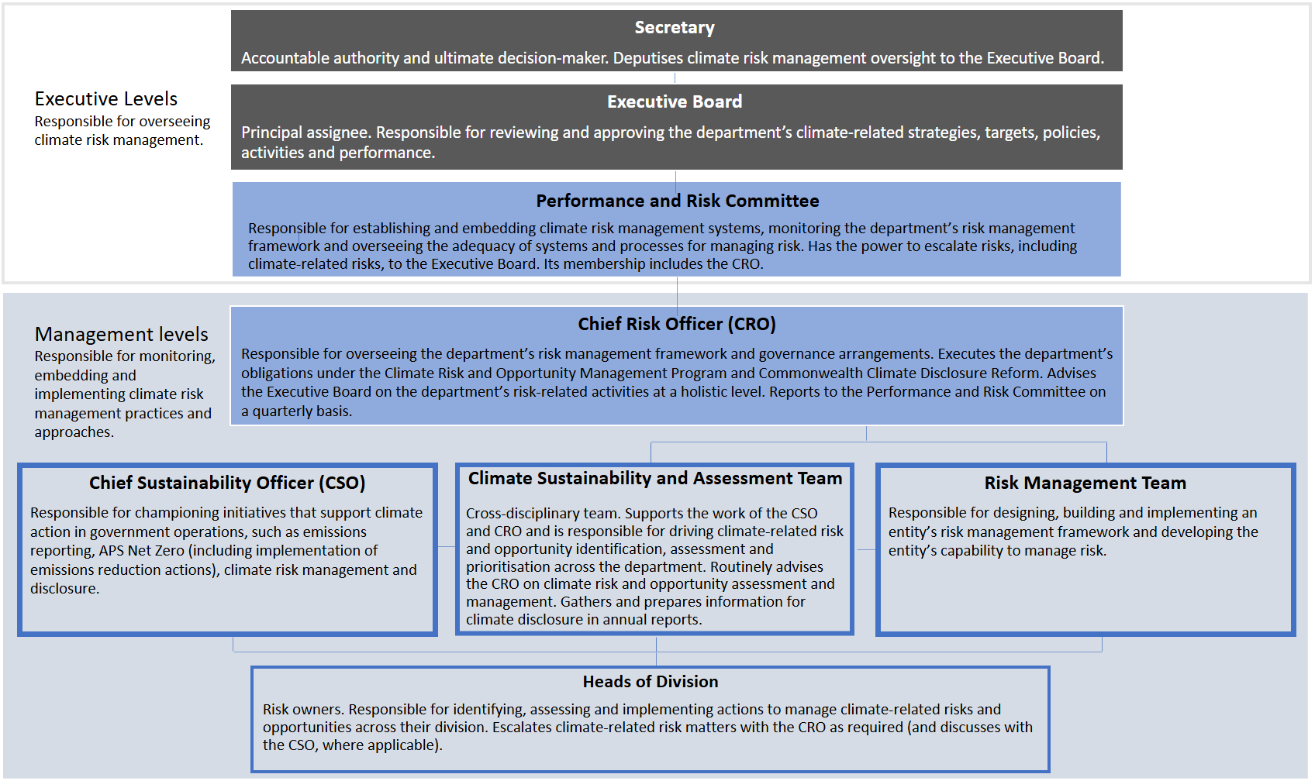

### Figure 4: Illustrative example of a possible governance structure with the CSO function incorporated into the CRO role

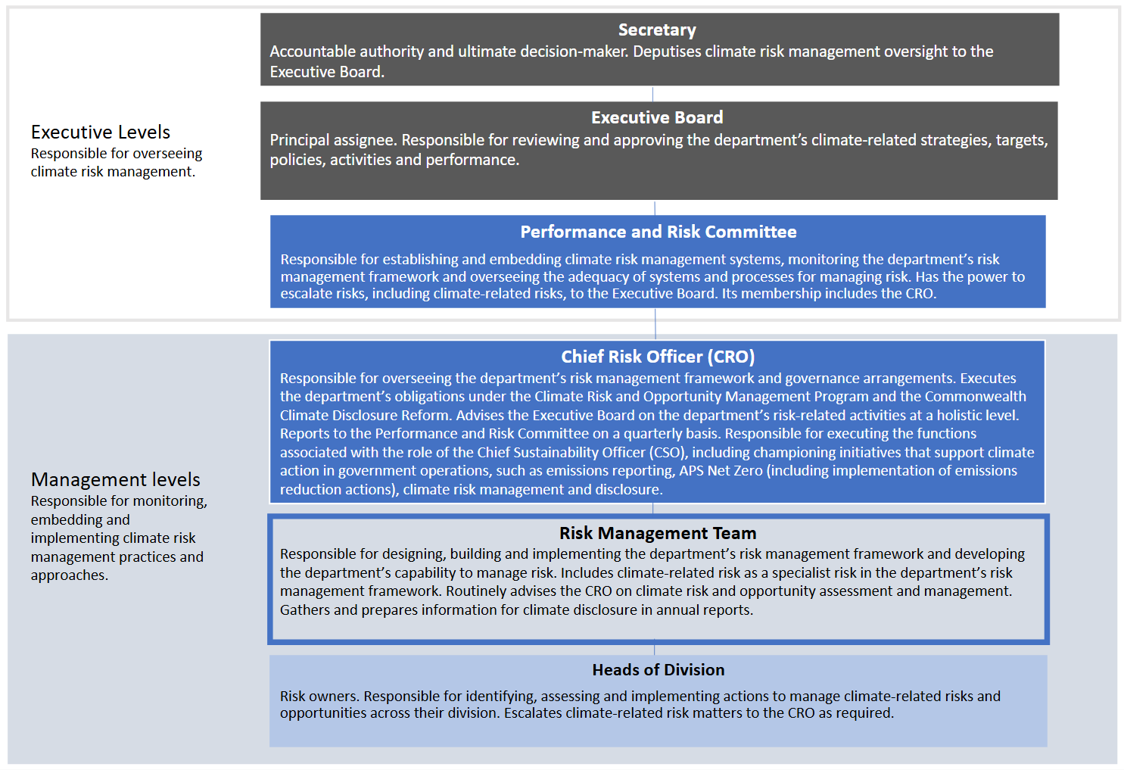

**Note:** The individual responsible for championing initiatives that support climate action in government operations may vary within departments (for example, the CFO, COO or CRO). In this illustrative example, the CSO function has been incorporated into the role of the CRO.

### Risk management

The Department of Climate Change, Energy, the Environment and Water has developed a range of tools and guidance as part of its Climate Risk and Opportunity Management Program to assist departments undertaking their organisation-wide climate risk and opportunity assessments. The Climate Risk Management Organisation Application Guide sets out the steps and minimum requirements needed to complete your organisation-wide climate risk and opportunity assessment, as well as key outputs for delivery.

In making your disclosure, clearly set out your department’s progress in implementing its organisation-wide climate risk and opportunity assessment in alignment with the Climate Risk Management Organisation Application Guide.

In making your disclosure, you should address the criteria outlined below.

##### Criteria

RM1. Information on the department’s progress in completing its organisation-wide climate risk and opportunity assessment.

##### Guide to making your disclosure

**Step 1:** Review your department’s obligations under The Australian Government’s Approach to Climate Risk and Opportunity Management in the Public Sector 2024-2026 and familiarise yourself with the supporting guidance and tools, noting that:

* Departments are to commence organisation-wide climate risk and opportunity assessments in 2023-24, with these assessments to be reviewed on an annual basis from 2024-25 onwards.

**Step 2:** Undertake or update your organisation-wide climate risk and opportunity assessment in line with the Climate Risk Management Organisation Application Guide.

**Step 3:** Provide a summary of the climate risk and opportunity assessment steps outlined in the Climate Risk Management Organisation Application Guide that you have completed or are currently undertaking. Detail the key outputs that you have achieved. Where applicable, briefly outline any steps that you have yet to implement and/or any actions that remain to be undertaken and intended timeframes for their completion.

|  |
| --- |
| Tip: The steps for completing your organisation-wide climate risk and opportunity assessment (as outlined in the Climate Risk Management Organisation Application Guide) include scoping, considering current and future state, identifying risks and opportunities, prioritising risks and opportunities, planning and taking action, monitoring and evaluating, and communicating.  **Note:** The risk management criteria for the Pilot requires you to provide a progress update on your organisation-wide climate risk and opportunity assessment in 2023-24. From 2024-25 onwards, you will be required to identify climate-related risks and opportunities relevant to your department, describe how you went about the identification process and explain how the climate-related risks and opportunities are being managed. For an early indication of the additional information you may be required to report upon in future reporting years, refer to the risk management and strategy core content in the AASB’s Exposure Draft of the Australian Sustainability Reporting Standards. |

### Metrics and targets

Climate-related targets and emissions reporting requirements for departments are set by centrally driven policy frameworks, including the Net Zero in Government Operations Strategy and the APS Net Zero Emissions Reporting Framework. The Framework is updated periodically over time to reflect expansions in emissions reporting.

In making your disclosure, clearly set out your department’s greenhouse gas emissions and reference the methodologies used to perform those calculations, in adherence with the APS Net Zero Emissions Reporting Framework. You must also provide information about the APS Net Zero by 2030 target, how it applies to your department and the initial actions your department will be taking to meet the 2030 target (as set out in your department’s Emissions Reduction Plan).

|  |
| --- |
| **Note:** To assist with disclosures against the metrics criteria, Finance has developed a Pilot Metrics and Targets Factsheet on the mandatory greenhouse gas emissions reporting method for non-corporate and corporate Commonwealth entities and Commonwealth companies. The Factsheet supplements the APS Net Zero Emissions Reporting Framework, which all departments must follow when reporting their greenhouse gas emissions. The Factsheet is available on the [Commonwealth Climate Disclosure Pilot webpage](https://www.finance.gov.au/government/climate-action-government-operations/commonwealth-climate-disclosure-pilot). |

In making your disclosure, you should address each of the criteria outlined below.

##### Climate-related metrics criteria

MT1. The annual greenhouse gas emissions produced by the department, as calculated by the Emissions Reporting Tool, including:

1. gross greenhouse gas emissions generated during the reporting year, expressed as metric tonnes of CO2 equivalent (CO2-e), classified as:
   * 1. scope 1 greenhouse gas emissions.
     2. scope 2 greenhouse gas emissions.
     3. scope 3 greenhouse gas emissions, for select scope 3 greenhouse gas emissions as per the APS Net Zero Emissions Reporting Framework.
2. for electricity-related greenhouse gas emissions, departments must include location-based and market-based scope 2 and scope 3 greenhouse gas emissions. Where relevant, departments should also provide information about any contractual instruments necessary to inform users’ understanding of its scope 2 and scope 3 electricity-related greenhouse gas emissions.

MT2. The approach used to measure greenhouse gas emissions, in line with the APS Net Zero Emissions Reporting Framework and Pilot Metrics and Targets Factsheet, including:

1. the measurement approach, inputs and assumptions the department uses to measure its greenhouse gas emissions.
2. the reason(s) why the measurement approach, inputs and assumptions were selected.
3. for scope 3 greenhouse gas emissions, disclose the categories included within the measurement of scope 3 greenhouse gas emissions and the characteristics of the data inputs used to measure scope 3 greenhouse gas emissions.

##### Guide to making your disclosure

**To disclose your department’s annual greenhouse gas emissions:**

**Step 1:** Review and complete the activity data within the Emissions Reporting Tool provided by Climate Action in Government Operations and submit this to [climateaction@finance.gov.au](mailto:climateaction@finance.gov.au). Refer to the guidance on the [Australian Government Emissions Reporting webpage](https://www.finance.gov.au/government/climate-action-government-operations/australian-government-emissions-reporting) for help on how to complete your activity data. Climate Action in Government Operations will review the activity data provided and use this data to calculate and finalise your greenhouse gas emissions inventory tables.

**Step 2:** Copy and paste your finalised greenhouse gas emissions inventory tables into your annual report. These tables will set out your scope 1, scope 2 and scope 3 greenhouse gas emissions in alignment with the MT1 disclosure criterion.

|  |
| --- |
| **Notes:**   * Your market-based scope 2 and scope 3 electricity-related greenhouse gas emissions will be calculated by Climate Action in Government Operations using the electricity-related activity data provided by your department. To support your disclosure, you should also include a brief explanation of any formal contractual arrangements you have in place with another entity to support deployment of low emissions electricity (for example, GreenPower), where applicable. * In instances where your emissions reporting data is incomplete or unavailable, you should include an explanation of the missing data and the actions you are undertaking to obtain this data in your disclosure. |

**To disclose your department’s emissions measurement approach:**

**Step 1:** Refer to the Pilot Metrics and Targets Factsheet provided on the [Commonwealth Climate Disclosure Pilot webpage](https://www.finance.gov.au/government/climate-action-government-operations/commonwealth-climate-disclosure-pilot). The Pilot Metrics and Targets Factsheet provides information and default text outlining the whole-of-Australian-Government emissions reporting measurement approach that is used by your department to calculate its emissions.

**Step 2:** In setting out your measurement approach and scope 3 greenhouse gas emissions characteristics, you can either include a reference to the Pilot Metrics and Targets Factsheet in your disclosure or copy and paste the default text provided in the Pilot Metrics and Targets Factsheet into your disclosure.

|  |
| --- |
| **Notes:**   * The scope 3 categories included within your measurement of scope 3 greenhouse gas emissions are automatically generated and set out in your greenhouse gas emissions inventory tables. * More detailed information will be required with the commencement of the Commonwealth Climate Disclosure Requirements in 2024-25. For an early indication of the additional cross-industry metrics you may be required to report upon in future reporting years, refer to the metrics and targets core content in the AASB’s Exposure Draft of the Australian Sustainability Reporting Standards. |
| **Tips:**   * Where applicable, explain any deviation in your emissions measurement approach from the APS Net Zero Emissions Reporting Framework and steps being taken to address the deviation. * For further information on how to use the Emissions Reporting Tool, contact the Emissions Reporting Help Desk at [ReportingHelpDeskAPSNetZero@finance.gov.au](mailto:ReportingHelpDeskAPSNetZero@finance.gov.au). You may also like to contact [climateaction@finance.gov.au](mailto:climateaction@finance.gov.au) to ask about becoming part of the Climate Action in Government Operations GovTEAMS community. |

##### Climate-related targets criteria

MT3. A summary of the department’s Emissions Reduction Plan, including initial actions underway to facilitate achievement of the APS Net Zero by 2030 target.

MT4. Information on the APS Net Zero by 2030 target, including:

1. the metric used to set the target.
2. the part of the department to which the target applies.
3. the period of time over which the target applies.
4. whether the target is a gross greenhouse gas emissions reduction target or a net greenhouse gas emissions reduction target.
5. whether it is an absolute target or an intensity target.
6. how the latest international agreement on climate change, including jurisdictional commitments that arise from the agreement, has informed the target.
7. which greenhouse gases are covered by the target.
8. whether scope 1, scope 2 or scope 3 greenhouse gas emissions are covered by the target.
9. whether the target was derived using a sectoral decarbonisation approach.

##### Guide to making your disclosure

**Step 1:** Review your department’s obligations under the Net Zero in Government Operations Strategy, noting that:

* The Net Zero in Government Operations Strategy requires departments to complete a long-term Emissions Reduction Plan by 30 June 2024 (timeframe extended to 31 August 2024). Your Emissions Reduction Plan will set out your department’s approach and specific actions to support the APS Net Zero by 2030 target. Finance has provided a template for Commonwealth entities to develop their Emissions Reduction Plan. Contact [climateaction@finance.gov.au](mailto:climateaction@finance.gov.au) if you have not received a copy of the template.

**Step 2:** Prepare a succinct summary of your Emissions Reduction Plan outlining the initial steps your department is taking, or has taken, to meet its obligations under the APS Net Zero by 2030 target. Include a reference to your Emissions Reduction Plan to support your disclosure.

**Step 3:** Include a brief statement about the APS Net Zero by 2030 target. The text provided below may be used as guidance, however, departments should have regard to any unique organisational circumstances that may apply (including exclusions):

* The APS Net Zero by 2030 target is a net emissions reduction target based on the metric CO2-e. It is an absolute target, rather than an intensity target, as it corresponds to a reduction in total emissions. The timeframe for achieving the APS Net Zero target is 2030. It applies at the aggregate level to all non-corporate Commonwealth entities and generally covers the entirety of the entity’s organisation. However, some exclusions may apply. The APS Net Zero by 2030 target forms part of Australia’s international climate commitments, including Australia’s Nationally Determined Contribution under the Paris Agreement. The APS Net Zero by 2030 target includes scope 1 and scope 2 greenhouse gas emissions, with decisions on scope 3 greenhouse gas emissions to be made in the future as further data becomes available. The types of greenhouse gas emissions covered by the target are set out in the APS Net Zero Emissions Reporting Framework. The APS Net Zero by 2030 target was not derived using a sectoral decarbonisation approach. Progress towards and the achievement of the Net Zero target is calculated at the aggregate level.

|  |
| --- |
| Notes:   * In most instances, the APS Net Zero by 2030 target will apply to the whole of your department, however, some security-related exclusions may apply. For example, the Government’s intention is that security agencies will set emissions reduction targets that incorporate as much of their activities as possible in the 2030 target, without compromising operational or capability requirements. Any exclusions must be clearly identified in your disclosure and are to be reported in general terms; neither too specific, nor so general as to lack information. * More detailed information will be required with the commencement of the Commonwealth Climate Disclosure Requirements in 2024-25. For an early indication of the additional information you may be required to report upon in future reporting years, refer to the metrics and targets core content in the AASB’s Exposure Draft of the Australian Sustainability Reporting Standards. |

# 4. Key terms and definitions

|  |  |
| --- | --- |
| AASB | The Australian Accounting Standards Board (AASB) is an independent non-corporate Commonwealth entity of the Australian Government that develops, issues and maintains accounting standards and develops sustainability standards applicable to entities in the private and public sectors of the Australian economy. |
| Absolute target | An absolute target is expressed as a total amount of greenhouse gas emissions or a change in the total amount of greenhouse gas emissions. |
| Accountable authority | Under section 12 of the *Public Governance, Performance and Accountability Act 2013* (PGPA Act), the accountable authority is the individual who is responsible for establishing and maintaining an appropriate system of risk oversight and management of risk for the entity. For the purpose of the Pilot, the accountable authority refers to the Secretary of the Department. |
| ANAO | The Australian National Audit Office (ANAO) is a statutory agency that provides audit and assurance services to the Parliament and Commonwealth entities and statutory bodies. The Auditor-General is an independent officer of the Australian Parliament whose main functions include financial statements audits, performance audits, performance statements audits and assurance reviews. |
| Annual report | Annual reports inform the Parliament and the public about the achievements, non-financial performance and financial position of Commonwealth entities and companies at the end of each reporting year. |
| Annual report users | For the purpose of the Pilot, annual report users refers to the Australian public, businesses, investors, parliamentarians and other stakeholders who may have an interest in departments’ annual reports. |
| APS | The Australian Public Service (APS) comprises entities that employ their staff under the *Public Service Act 1999* (PS Act). |
| Assignee  *Principal assignee* | The subordinate individual(s) or body(s) with deputised responsibilities for overseeing and/or implementing climate risk management, wherein said responsibilities have been deputised by the accountable authority.  The principal individual or body responsible for climate risk management oversight. |
| Climate-related opportunity | Climate-related opportunities refers to the potential positive effects arising from climate change for an entity. Efforts to mitigate and adapt to climate change can produce climate-related opportunities for an entity. |
| Climate-related risk  *Physical risk*  *Transition risk* | Climate-related risks refers to the potential negative effects of climate change on an entity. These risks are categorised as physical risks and transition risks.  Physical risks are risks resulting from climate change that can be event-driven (acute) or from longer-term shifts in climatic patterns (chronic). Acute physical risks arise from weather-related events such as storms, floods, droughts or heatwaves, which are increasing in severity and frequency. Chronic physical risks arise from longer-term shifts in climatic patterns including changes in precipitation and temperature which could lead to sea level rise, reduced water availability, biodiversity loss and changes in soil productivity.  Transition risks are risks that arise from efforts to transition to a lower-carbon economy. Transition risks include policy, legal, technological, market and reputational risks. |
| Climate Risk and Opportunity Management Program | The [Climate Risk and Opportunity Management Program](https://www.dcceew.gov.au/climate-change/policy/adaptation/climate-risk-opportunity-management-program) supports capability uplift in climate risk management across the Commonwealth. The Program provides tools, guidance and services to enable Commonwealth entities to assess and manage climate-related risks and opportunities, and achieve other deliverables outlined in [The Australian Government’s Approach to Climate Risk and Opportunity Management in the Public Sector 2024-2026](https://www.dcceew.gov.au/sites/default/files/documents/climate-risk-management.pdf). Further guidance on the Program implementation is set out in the following [Climate Risk Management Guides](https://www.dcceew.gov.au/climate-change/publications/climate-risk-opportunity-management-program-resources): Organisation Application Guide, Program, Project and Policy Application Guide, and the Technical Guidance. |
| CO2 equivalent  (CO2-e)  *Global warming potential* | The universal unit of measurement to indicate the global warming potential of each greenhouse gas, expressed in terms of the global warming potential of one unit of carbon dioxide. This unit is used to evaluate releasing (or avoiding releasing) different greenhouse gases against a common basis.  A factor describing the radiative forcing impact (degree of harm to the atmosphere) of one unit of a given greenhouse gas relative to one unit of CO2. |
| Commonwealth Risk Management Policy | The [Commonwealth Risk Management Policy](https://www.finance.gov.au/government/comcover/risk-services/management/commonwealth-risk-management-policy) sets out the principles and mandatory requirements for effectively managing risk. The policy supports section 16 of the PGPA Act which requires accountable authorities of all Commonwealth entities to establish and maintain appropriate systems of risk oversight, management and internal control for the entity. This policy is mandatory for all non-corporate Commonwealth entities and recommended as best practice for corporate Commonwealth entities. |
| Departments | [Departments of State](https://www.finance.gov.au/government/managing-commonwealth-resources/structure-australian-government-public-sector/types-australian-government-bodies) are the main bodies that reflect the structure of government. The Governor-General establishes Departments of State and appoints the ministers that administer them. The Administrative Arrangements Order, available on the [Department of the Prime Minister and Cabinet website](https://www.pmc.gov.au/), lists the matters dealt with by each Department of State and the legislation administered by each minister. Departments of State are a type of non-corporate Commonwealth entity. |
| Disclosure | Disclosure is the process of making information known to the public. Both positive and negative information is disclosed to assist investors and other stakeholders to make decisions. |
| Exposure Draft | Refers to the [Exposure Draft ED SR1 *Australian Sustainability Reporting Standards – Disclosure of Climate-related Financial Information*](https://aasb.gov.au/news/exposure-draft-ed-sr1-australian-sustainability-reporting-standards-disclosure-of-climate-related-financial-information/) comprised of [draft] ASRS 1 *General Requirements for Disclosure of Climate-related Financial Information* and [draft] ASRS 2 *Climate-related Financial Disclosures*. |
| Greenhouse gases | The seven greenhouse gases listed in the Kyoto Protocol—carbon dioxide (CO2); methane (CH4); nitrous oxide (N2O); hydrofluorocarbons (HFCs); nitrogen trifluoride (NF3); perfluorocarbons (PFCs) and sulphur hexafluoride (SF6). |
| GreenPower  *LGCs* | A government accredited renewable energy product offered by most electricity retailers to households and businesses in Australia. It requires GreenPower providers to voluntarily surrender large-scale generation certificates (LGCs) equivalent to GreenPower purchases made by customers.  Large-scale generation certificates (LGCs) may be created by power stations who generate electricity from renewable sources. Each certificate represents one megawatt hour of renewable energy generation. |
| Gross greenhouse gas emissions reduction target  *Defined scope* | Gross greenhouse gas emissions reduction targets reflect the total changes in greenhouse gas emissions planned within the defined scope of the entity’s value chain.  Defined scope are those greenhouse gas emission sources included in target where an entity or government can responsibly quantify and set achievable targets. This includes those within the Net Zero in Government Operations Strategythat form part of the APS Net Zero by 2030 target, and any additional greenhouse gas emission sources identified by an entity that form organisation-specific goals or sub-targets. |
| IFRS Foundation | The IFRS Foundation is a not-for-profit organisation established to develop globally accepted accounting and sustainability-related financial reporting standards. The standards are developed by their two standard-setting boards: the International Accounting Standards Board (IASB) and the International Sustainability Standards Board (ISSB). |
| Intensity target | An intensity target is expressed as a ratio of greenhouse gas emissions, or a change in the ratio of greenhouse gas emissions, to a business or economic metric. Emission intensity is expressed as the volume of greenhouse gas emissions per unit of GDP. |
| ISSB | The International Sustainability Standards Board (ISSB) was established in 2021 to develop a comprehensive global baseline of sustainability-related financial reporting for for-profit entities operating in capital markets. The IFRS Sustainability Disclosure Standards were issued in June 2023 and include [IFRS S2 Climate-related Disclosures](https://www.ifrs.org/projects/completed-projects/2023/climate-related-disclosures/#published-documents). |
| Location-based and market-based emissions | Location-based emissions refers to the emissions generated through the consumption of power at building and/or operational sites. These are calculated using the average emission intensity of the local power generation from which power is sourced. Market-based emissions are associated with the energy purchased through various instruments or contracts, including through whole-of-Australian-Government purchasing arrangements. Both location-based and market-based emissions reporting apply to scope 2 and scope 3 emission categories (see scope 1, 2 and 3 emissions below). |
| Nationally Determined Contribution (NDC) | Under the Paris Agreement, Australia must submit emissions reduction commitments known as Nationally Determined Contributions (NDCs). The latest NDC submission was made in 2022, committing Australia to a reduction in emissions to 43% below 2005 levels by 2030. The Australian Government has a specific NDC to reach net zero from government operations by 2030. |
| Net greenhouse gas emissions reduction target | Net greenhouse gas emissions reduction targets are the entity’s targeted gross greenhouse gas emissions minus any planned offsetting efforts (for example, the entity’s planned use of carbon credits to offset its greenhouse gas emissions). |
| Net Zero in Government Operations Strategy  *Emissions Reduction Plans*  *APS Net Zero Emissions Reporting Framework*  *Emissions Reporting Tool* | The [Net Zero in Government Operations Strategy](https://www.finance.gov.au/government/climate-action-government-operations/aps-net-zero-emissions-2030) describes the approach for implementing the Australian Government’s commitment to achieve net zero in government operations by 2030. It sets out the activities, emission sources and Commonwealth entities that are included in the APS Net Zero by 2030 target and reporting, and action required by entities.  The Net Zero in Government Operations Strategy outlines entities’ obligations to develop long-term Emissions Reduction Plans by June 2024 (timeframe extended to 31 August 2024). These plans will define the priorities and actions that each entity will take to support the APS Net Zero by 2030 target and are to be signed off by the accountable authority.  The [APS Net Zero Emissions Reporting Framework](https://www.finance.gov.au/government/climate-action-government-operations/australian-government-emissions-reporting) provides a consistent approach to emissions reporting across the APS. It is designed to help the Commonwealth meet its reporting obligations as outlined in Australia’s Nationally Determined Contribution under the Paris Agreement.  The Emissions Reporting Tool is designed to assist Commonwealth entities and Commonwealth companies to include emissions data in annual reports and enable whole-of-Australian-Government emissions reporting in the Net Zero in Government Operations Annual Progress Report. |
| PGPA Act | The *Public Governance, Performance and Accountability Act 2013* (PGPA Act) establishes governance and accountability requirements for Commonwealth entities. The PGPA Act applies to non-corporate Commonwealth entities, corporate Commonwealth entities and Commonwealth companies. It establishes rules for financial management and for the broader governance, performance and accountability of government entities. |
| RMG 135 | Resource Management Guide (RMG) 135 sets out the obligations for non‑corporate Commonwealth entities to prepare annual reports and provides guidance on fulfilling the mandatory requirements for the content of annual reports, as prescribed by the PGPA Act. |
| Scope 1, 2 and 3 emissions | As per the Net Zero in Government Operations Strategy:  Scope 1 emissions reflect emissions from sources owned or controlled by Government, including the stationary combustion of fuels (boilers, generators) and transportation (vehicle fleet).  Scope 2 emissions are indirect emissions which occur because of the activities that generate electricity, which is consumed by an entity, but is generated outside that entity’s boundaries. They are physically produced by the burning of fossil fuels by the generator of the electricity.  Scope 3 emissions reflect other indirect emissions produced through Government activities. |
| Sectoral decarbonisation approach | A sector-based target-setting methodology for entities to reduce greenhouse gas emissions in line with the latest scientific scenario that would limit global temperature rise to 2°C above pre-industrial levels. |

# Document control

|  |  |  |
| --- | --- | --- |
| **Version number** | **Date of issue** | **Brief description of change** |
| 1 | March 2024 | Initial release |
| 2 | April 2024 | Incorrect date rectified under ‘Key points’ dot point 1 (page 1)  Inclusion of APS Net Zero Emissions Reporting Framework hyperlink (page 2)  Alt text added to Figures 1-4 (pages 2, 9, 15 and 16)  Inclusion of GreenPower definition (page 23) |
| 3 | June 2024 | Reference to Comcover Factsheet in Governance criteria (G2a) removed and change of due date for Emissions Reduction Plans to 31 August 2024 |
| 4 | May 2025 | Resolved accessibility issues within document |

Contact us

Department of Finance

****Climate Action in Government Operations****

Commonwealth Climate Disclosure

[climateaction@finance.gov.au](mailto:climateaction@finance.gov.au)