# 

# Example disclosure for the Commonwealth Climate Disclosure Pilot

## Introduction

This document has been prepared as a hypothetical example of climate disclosure for inclusion in an entity’s Annual Report. This example has been prepared by the Department of Finance's Climate Action in Government Operations Unit to support Departments of State (departments) participating in the Commonwealth Climate Disclosure (CCD) Pilot in FY2023-24. The example disclosure can also be used by other entities opting into the Pilot.

The example disclosure has been prepared for **a fictional department**, the Department of Parks and Recreation.

The example disclosure is to be considered in conjunction with the [CCD Pilot Guidance](https://www.finance.gov.au/government/climate-action-government-operations/commonwealth-climate-disclosure-pilot) and [Resource Management Guide 135](https://www.finance.gov.au/government/managing-commonwealth-resources/annual-reports-non-corporate-commonwealth-entities-rmg-135) when preparing the departments’ FY2023-24 Annual Reports.

It is important to note this document should not be relied upon for the preparation of climate disclosures from FY2024-25 onwards as the requirements will be different from the Pilot. This example disclosure demonstrates the approach to climate disclosure expected in accordance with the CCD Pilot Guidance for a department at the start of their climate risk maturity journey. The example report aims to assist departments in preparing their first limited disclosure within the FY2023-24 Annual Report. It provides a stepping stone to expanded disclosures under the Commonwealth Climate Disclosure Requirements, which will be required in the following reporting period (FY2024-25).

Note: Where an opportunity exists for a department to disclose more detail and progress than outlined in the Pilot Guidance and this hypothetical example disclosure, additional information can be disclosed. This may include, for example, items such as:

* **governance**: the steps taken to enhance governance arrangements for climate risk management
* **risk management**: further detail on the organisation-wide climate risk and opportunity assessment method and outcomes
* **metrics and targets**: case studies of actions undertaken to reduce emissions.

The following convention structure is recommended for referencing relevant information contained in other publicly available documents outside of your Annual Report. The APS Net Zero Emissions Reporting Framework, for example, should be referenced:

* Department of Finance, Net Zero in Government Operations Strategy, Annex A, p. 27, available online: [https://www.finance.gov.au/government/climate-action-government-operations/aps-net-zero-emissions-2030](https://aus01.safelinks.protection.outlook.com/?url=https%3A%2F%2Fwww.finance.gov.au%2Fgovernment%2Fclimate-action-government-operations%2Faps-net-zero-emissions-2030&data=05%7C02%7CImogen.Austin%40finance.gov.au%7C56fb2f7c22374712ad7108dc4319f207%7C08954cee47824ff69ad51997dccef4b0%7C0%7C0%7C638459025939421039%7CUnknown%7CTWFpbGZsb3d8eyJWIjoiMC4wLjAwMDAiLCJQIjoiV2luMzIiLCJBTiI6Ik1haWwiLCJXVCI6Mn0%3D%7C0%7C%7C%7C&sdata=cHwQI5MLZPTUqhQMvUXi4dSTzdLvN9BUVR4Z4Bg%2BYQE%3D&reserved=0)

Please contact [climateaction@finance.gov.au](mailto:APSNetZero@finance.gov.au) should you have any questions regarding the Commonwealth Climate Disclosure Pilot, including the example below.

Climate disclosure

Commonwealth Climate Disclosure is the Government’s policy for Commonwealth entities to publicly disclose their exposure to climate risks and opportunities, as well as their actions to manage them. This is our first Annual Report which includes climate-related disclosures in accordance with the criteria in the [Commonwealth Climate Disclosure (CCD) Pilot Guidance](https://www.finance.gov.au/government/climate-action-government-operations/commonwealth-climate-disclosure-pilot).

Governance

## Climate risk governance and accountability

The Department of Parks and Recreation’s governance structures are underpinned by a robust enterprise risk management framework established in accordance with the requirements of the Commonwealth Risk Management Policy (2023) and the *Public Governance, Performance and Accountability Act 2013* (PGPA Act).

We use our existing governance and risk systems, policies and tools to manage risks, including climate-related risks and opportunities. We see climate-related risk as a priority action area, and climate-related risk and opportunity reporting has been included in existing risk reporting arrangements and key corporate documentation (such as corporate plans).

As defined under section 12 of the PGPA Act, the department’s Secretary is the accountable authority for all departmental risks, including climate-related risks.

The Secretary has assigned responsibility for risk management oversight to the Executive Board, or Principal Assignee. The Executive Board has worked closely with the Performance and Risk Committee to implement climate risk management practices and strategies aligned with the Climate Risk and Opportunity Management Program’s tools and resources within the organisation, and to ensure steps are being undertaken so that climate-related risks and opportunities are appropriately identified, prioritised and managed across the organisation.

Although the Secretary and Executive Board are ultimately responsible for leading the oversight of the Department of Parks and Recreation’s risk, including climate-related risk, we embed a culture that risk management is everyone’s business. All staff are responsible for climate-related risk and opportunity identification and management with consideration to their role and commensurate to their level.

The Secretary has commissioned an investigation into understanding how the department is placed in terms of skills of its workforce to oversee and manage climate-related risks and opportunities. The results of this investigation will be reported back to the Secretary in late 2024.

The Secretary has also requested the Risk Management Team review existing systems to assess their effectiveness in considering the trade-offs between climate-related risks and other Government policy constraints. For example, appropriate checks and balances are in place to ensure any new property management activities align with the emissions reduction articulated in the department’s Emissions Reduction Plan.

The *interim* governance structure associated with climate risk management is outlined in *Figure 1*, with risk responsibilities outlined in *Table 1*. The role and responsibilities of the accountable authority in managing climate risks and opportunities within the Department of Parks and Recreation, is summarised in *Table 1*. The governance arrangements reflected in *Figure 1* will be reviewed in the next reporting period and any changes made will be reported in our next disclosure.

Figure 1 Interim Department of Parks and Recreation Climate Risk Governance Structure

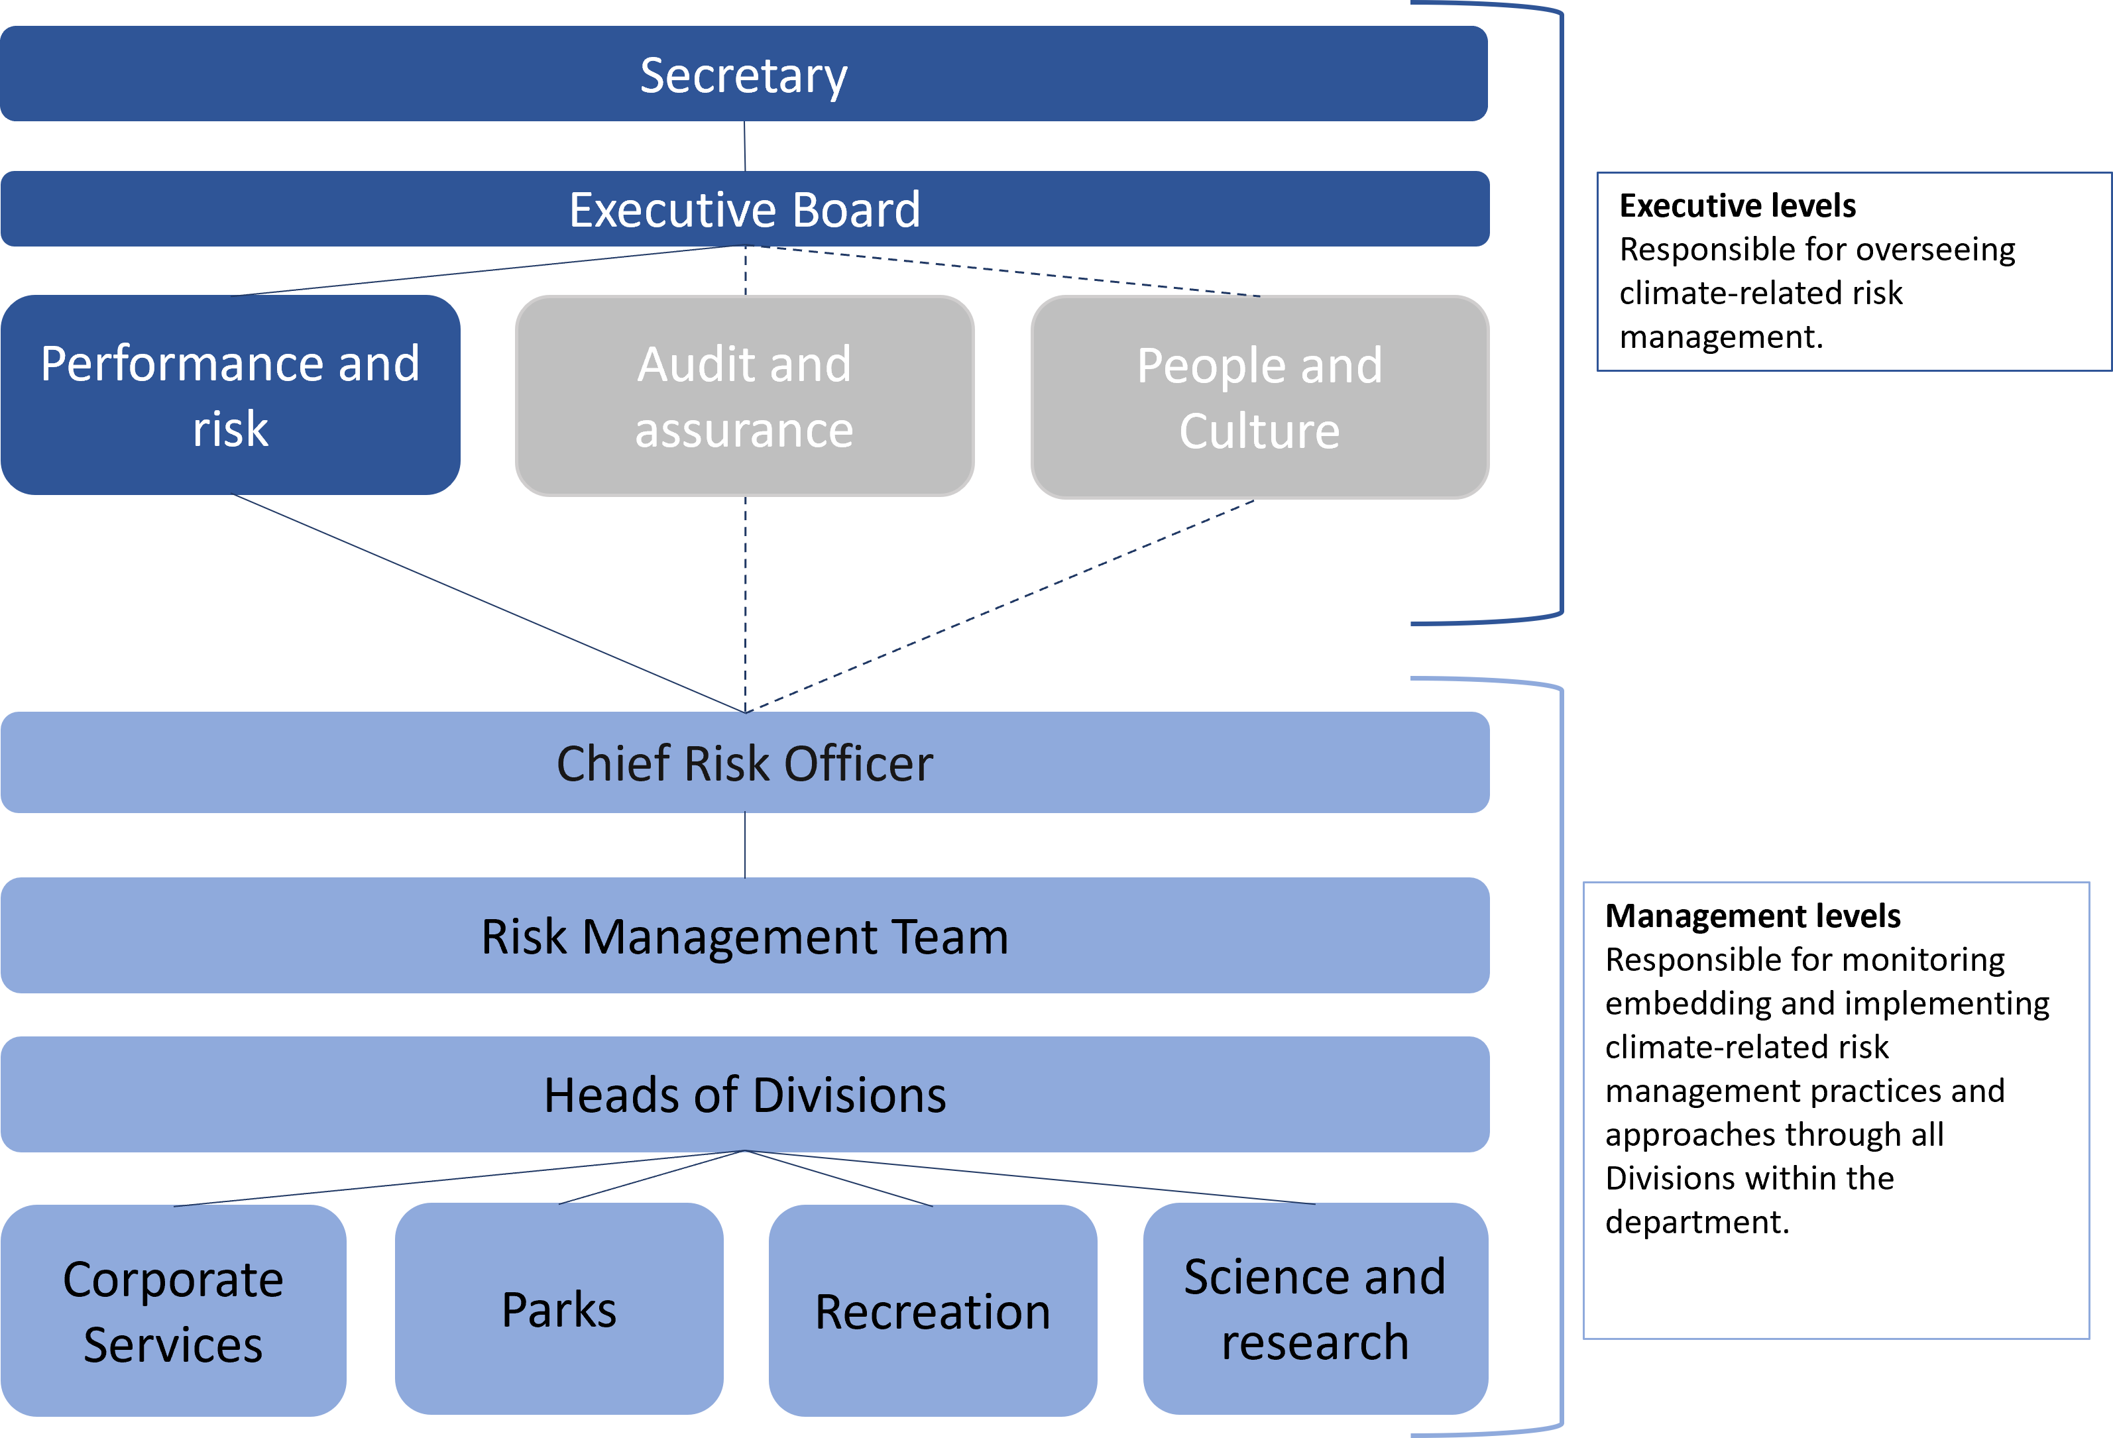

*Table 1 Roles and Responsibilities*

|  |  |
| --- | --- |
| Role | Risk Responsibilities |
| Secretary | Accountable authority with ultimate responsibility for having systems of risk management in place – this includes determining risk appetite, tolerance and a positive risk culture. Deputises climate risk management oversight to the Executive Board. This includes the establishment and oversight of climate-related risk assessment processes and performance targets, such as (but not limited to) the development of emissions reduction targets for inclusion in the department’s Emissions Reduction Plan. |
| Executive Board | Principle assignee responsible for overseeing climate-related risk and approving the department’s climate-related strategies, targets, policies, activities and performance. |
| Performance and Risk Committee | Responsible for implementing climate risk and opportunity management, and delegating roles and responsibilities to appropriate work areas. Meets quarterly and has the power to escalate risks, including climate-related risks, to the Executive Board and Secretary. Reports to the Secretary quarterly on the progress of climate risk management implementation, and as required, to bring urgent and/or critical risks to the attention of the Secretary. |
| Chief Risk Officer (CRO) | Responsible for overseeing the risk management framework and governance as well as advising the Secretary and Executive Board, including through their role on the Performance and Risk Committee. Executes department’s obligations under the Commonwealth Climate Disclosure Reform and CROMP, and contributes to the department’s implementation of the Net Zero in Government Operations Strategy (currently led by Business Enabling Branch).  Please note, the CRO is also currently holding the responsibilities of the Chief Sustainability Officer, the appointment of which is encouraged in the Net Zero in Government Operations Strategy. |
| Risk Management Team | Team responsible for designing, building and implementing the department’s risk management framework and developing capability internally to manage risk. Climate-related risk is included in the department’s enterprise risk management framework as a specialist risk category. |
| Heads of Division | Responsible for maintaining divisional risk registers that monitor climate-related risk identification, assessment and management actions. |

Risk management

This year was the first time this department has embarked upon an organisational-wide risk assessment in accordance with our obligations under the [Australian Government’s Approach to Climate Risk and Opportunity Management in the Public Sector 2024-2026](https://www.dcceew.gov.au/climate-change/policy/adaptation/climate-risk-opportunity-management-program)[1]. This reporting year, we focused on the first three steps of the [Climate Risk and Opportunity Management Program’s (CROMP)](https://www.dcceew.gov.au/climate-change/policy/adaptation/climate-risk-opportunity-management-program) organisation-wide climate risk and opportunity assessment[2]. In the next reporting year, we aim to complete all six steps of the organisation-wide climate risk and opportunity assessment.

## Our progress

Figure 2 CROMP Actions Completed

Metrics and targets

## Climate-related metrics

### 2023-24 Greenhouse gas emissions inventory

Emissions are required to be calculated in line with the APS Net Zero Emissions Reporting Framework provided by Department of Finance, consistent with the whole-of-Australian-Government approach as part of the APS Net Zero by 2030 policy. For the emissions calculation method, please see the [Pilot Metrics and Targets Factsheet](https://www.finance.gov.au/government/climate-action-government-operations/commonwealth-climate-disclosure-pilot). The Department of Parks and Recreation has not deviated from this methodology.

2023-24 includes the addition of the following emission categories as required by expansion two of the APS Net Zero Emissions Reporting Framework[3]:

* refrigerants (reported as scope 1)
* solid waste disposal and treatment (reported as scope 3)
* employee domestic business travel (hire car and accommodation) (reported as scope 3).

The greenhouse gas emissions inventory presents greenhouse gas emissions over the 2023–24 period. Results are presented as carbon dioxide equivalent (CO2-e) emissions and are based on the best available data at the time of reporting. Amendments to data may be required in future reports.

Electricity-related greenhouse gas emissions were calculated using the location-based approach in Table 2. When applying the market-based method, which accounts for factors such as GreenPower usage, purchased large-scale generation certificates, power purchasing agreements, the renewable power percentage and the jurisdictional renewable power percentage (ACT only), the total emissions for electricity are as shown in Table 3.

Table 2 Greenhouse Gas Emissions Inventory 2023-24 - Location-based Method

|  |  |  |  |  |
| --- | --- | --- | --- | --- |
| Emission Source | Scope 1  t CO2-e | Scope 2  t CO2-e | Scope 3  t CO2-e | Total  t CO2-e |
| Electricity (Location-based Approach) | N/A | 1,204.120 | 107.126 | 1,311.250 |
| Natural Gas | 390.194 | N/A | N/A | 390.194 |
| Solid Waste* | N/A | N/A | 229.952 | 229.952 |
| Refrigerants* | 1.924 | N/A | N/A | 1.924 |
| Fleet and Other Vehicles | 411.402 | N/A | 102.032 | 513.434 |
| Domestic Commercial Flights | N/A | N/A | 276.371 | 271.209 |
| Domestic Hire Car* | N/A | N/A | 5.162 | 5.162 |
| Domestic Travel Accommodation* | N/A | N/A | 73.440 | 73.440 |
| Other Energy | 25.74215 | N/A | 6.3441 | 32.086 |
| Total t CO2-e | 829.262 | 1,204.120 | 795.265 | 2,828.651 |

**Note**: the table above presents emissions related to electricity usage using the location-based accounting method. CO2-e = carbon dioxide equivalent.

* Indicates emission sources collected for the first time in 2023-24. The quality of data is expected to improve over time as emissions reporting matures.

Table 3 2023-24 Electricity Greenhouse Gas Emissions

|  |  |  |  |  |
| --- | --- | --- | --- | --- |
|  | Scope 2  t CO2-e | Scope 3  t CO2-e | Total  t CO2-e | Percentage of electricity use |
| Location-based electricity emissions | 1,204.120 | 107.126 | 1,311.250 | 100% |
| Market-based electricity emissions  (residual emissions) | 90.393 | 12.467 | 102.860 | 19.55% |
| Total renewable electricity | 0 | 0 | 0 | 80.45% |
| Mandatory renewables1 | 0 | 0 | 0 | 18.80% |
| Voluntary renewables2 | 0 | 0 | 0 | 61.65% |

***Note****: the table above presents emissions related to electricity usage using both the location-based and the market-based accounting methods. CO2-e = carbon dioxide equivalent.*

*1 Mandatory renewables are the portion of electricity consumed from the grid that is generated by renewable sources. This includes the renewable power percentage.*

*2 Voluntary renewables reflect the eligible carbon credit units surrendered by the entity. This may include purchased large-scale generation certificates, power purchasing agreements, GreenPower and the jurisdictional renewable power percentage (ACT only).*

The difference in carbon dioxide equivalent in location versus market-based emissions is due to the Department of Parks and Recreation having most of its operations within the ACT, which has a jurisdictional renewable power percentage.

## Climate-related targets

The Department of Parks and Recreation is making strong contributions towards the attainment of the Government’s APS Net Zero by 2030 target. The Department of Parks and Recreation is following the APS Net Zero by 2030 target in full, as per the [Net Zero Government Operations Strategy](https://www.finance.gov.au/government/climate-action-government-operations/aps-net-zero-emissions-2030)[4].

### About the APS Net Zero target

The APS Net Zero by 2030 target is a net emissions reduction target based on the metric CO2-e. It is an absolute target, rather than an intensity target, as it corresponds to a reduction in total emissions. The timeframe for achieving the APS Net Zero target is 2030 and it applies at the aggregate level to in-scope non-corporate Commonwealth entities. The target covers the entirety of our organisation’s operations, including scope 1 and scope 2 greenhouse gas emissions, with decisions on scope 3 greenhouse gas emissions to be made in the future as further data becomes available.

The APS Net Zero by 2030 target forms part of Australia’s international climate commitments, including Australia’s Nationally Determined Contribution under the Paris Agreement. The types of greenhouse gas emissions covered by the target are set out in the APS Net Zero Emissions Reporting Framework. The APS Net Zero by 2030 target was not derived using a sectoral decarbonisation approach.

### Emissions Reduction Plan

This year we published our first Emissions Reduction Plan (ERP). Our ERP sets out our planned activities to reduce emissions to net zero by 2030 and includes both planned and new initiatives to reduce emissions. The initiatives and targets within the ERP are signed off by the Secretary. The Department of Parks and Recreation is also developing a range of interim goals and metrics for tracking our performance against the ERP and APS Net Zero by 2030 target as part of our broader climate-related strategy.

#### Summary of progress

We have developed and published our ERP which outlines priorities and targeted actions that have been implemented, or committed to, within this reporting period, as well as those that will be delivered in the future.

Figure 3 Summary of Emissions Reduction Plan Actions

We will continue to monitor our progress towards net zero and report additional measures, if required, such as carbon modelling on emissions intensive assets.

Appendix 1: CCD Pilot Index (optional)

Guiding Principles Checklist

|  |  |
| --- | --- |
| Achieved | Guiding Principles |
|  | Comprehensibility and accuracy |
|  | Accountability |
|  | Completeness |
|  | Maturity |
|  | Forward-looking |

Criteria Checklist

|  |  |
| --- | --- |
| # | Location |
| G1 | Climate risk governance and accountability; Figure 1 Interim Department of Parks and Recreation Governance Structure |
| G2 | Climate risk governance and accountability; Figure 1 Interim Department of Parks and Recreation Governance Structure; Emissions Reduction Plan |
| G3 | Climate risk governance and accountability; Figure 1 Interim Department of Parks and Recreation Governance Structure |
| RM1 | Risk management |
| MT1 | Table 2 Greenhouse Gas Emissions Inventory 2023-24 – Location-based Method; Table 3 2023-24 Market-based Electricity Greenhouse Gas Emissions |
| MT2 | [Pilot Metrics and Targets Factsheet](https://www.finance.gov.au/government/climate-action-government-operations/commonwealth-climate-disclosure-pilot); Metrics and targets |
| MT3 | Emissions Reduction Plan |
| MT4 | [Pilot Metrics and Targets Factsheet](https://www.finance.gov.au/government/climate-action-government-operations/commonwealth-climate-disclosure-pilot); About the APS Net Zero target |

# Document control

|  |  |  |
| --- | --- | --- |
| **Version number** | **Date of issue** | **Brief description of change** |
| 1 | May 2024 | Initial release. |
| 2 | June 2024 | Reference to Comcover Factsheet in Governance criteria removed. |
| 3 | April 2025 | Format amendments to increase accessibility |

1. Department of Climate Change, Energy, the environment and Water, Australian Government’s Approach to Climate Risk Management in the Public Sector 2024-2026, available online: <https://www.dcceew.gov.au/climate-change/publications/climate-risk-opportunity-management-program-resources> (accessed 14/04/2024)
2. Department of Climate Change, Energy, the environment and Water, Climate Risk and Opportunity Management Program resources, available online: <https://www.dcceew.gov.au/climate-change/policy/adaptation/climate-risk-opportunity-management-program> (accessed3/5/2024)
3. Department of Finance, Net Zero in Government Operations Strategy, Annex A, p. 27, available online: [https://www.finance.gov.au/government/climate-action-government-operations/aps-net-zero-emissions-2030](https://aus01.safelinks.protection.outlook.com/?url=https%3A%2F%2Fwww.finance.gov.au%2Fgovernment%2Fclimate-action-government-operations%2Faps-net-zero-emissions-2030&data=05%7C02%7CImogen.Austin%40finance.gov.au%7C56fb2f7c22374712ad7108dc4319f207%7C08954cee47824ff69ad51997dccef4b0%7C0%7C0%7C638459025939421039%7CUnknown%7CTWFpbGZsb3d8eyJWIjoiMC4wLjAwMDAiLCJQIjoiV2luMzIiLCJBTiI6Ik1haWwiLCJXVCI6Mn0%3D%7C0%7C%7C%7C&sdata=cHwQI5MLZPTUqhQMvUXi4dSTzdLvN9BUVR4Z4Bg%2BYQE%3D&reserved=0) (accessed 18/04/2024)
4. Department of Finance, Net Zero in Government Operations Strategy, available online: [https://www.finance.gov.au/government/climate-action-government-operations/aps-net-zero-emissions-2030](https://aus01.safelinks.protection.outlook.com/?url=https%3A%2F%2Fwww.finance.gov.au%2Fgovernment%2Fclimate-action-government-operations%2Faps-net-zero-emissions-2030&data=05%7C02%7CImogen.Austin%40finance.gov.au%7C56fb2f7c22374712ad7108dc4319f207%7C08954cee47824ff69ad51997dccef4b0%7C0%7C0%7C638459025939421039%7CUnknown%7CTWFpbGZsb3d8eyJWIjoiMC4wLjAwMDAiLCJQIjoiV2luMzIiLCJBTiI6Ik1haWwiLCJXVCI6Mn0%3D%7C0%7C%7C%7C&sdata=cHwQI5MLZPTUqhQMvUXi4dSTzdLvN9BUVR4Z4Bg%2BYQE%3D&reserved=0) (accessed 18/04/2024)