Example Strategy Disclosure
Small Specialist Investment Vehicle

Introduction
This document has been prepared as a hypothetical example of disclosing the Strategy criteria in an entity’s Annual Report. This example has been prepared by the Department of Finance’s Climate Action in Government Operations Unit to support Commonwealth entities participating in Tranche 1 of the Commonwealth Climate Disclosure (CCD) Initiative in FY2024-25. The example disclosure can also be used by other entities opting into Tranche 1.
The example disclosure has been prepared for a fictional Commonwealth entity, the Bushfire Recovery Investment Corporation (BRIC), which is presented as a small corporate Commonwealth entity (CCE). and Specialist Investment Vehicle governed by an independent board. It demonstrates a possible approach entities could take when preparing their climate disclosure, and is tailored for entities at the start of their climate risk maturity journey.
This example Strategy disclosure should be considered in conjunction with the CCD Year 1 Requirements and either Resource Management Guide (RMG) 135 or 136 when preparing an entity’s FY2024-25 Annual Report.
Note: Commonwealth entities are encouraged to disclose more detail and progress than outlined in this example climate disclosure where they have the opportunity to do so.
Note: The example below has assumed the Bushfire Recovery Investment Corporation has voluntarily opted to use the Commonwealth Risk and Opportunity Management Program (CROMP) assessment framework. Where it is not practical for an entity to use CROMP, you should disclose your reasoning for deviating from CROMP within your disclosure.

Tip: Guidance on how to use this example is identified throughout in these boxes.
The following section provides an example of the Strategy component of the Commonwealth Climate Disclosure of the fictional entity, the Bushfire Recovery Investment Corporation, which would be included as an Appendix in the entity's Annual Report.
An index is recommended when cross-referencing information outside of the climate disclosure to enable readers to connect to all relevant information.

Appendix C: Climate Statement

Commonwealth Climate Disclosure
Commonwealth Climate Disclosure is the Government’s policy for Commonwealth entities to publicly disclose their exposure to climate-related risks and opportunities, as well as their actions to manage them, delivering transparent and consistent climate disclosures to the Australian public.
As the Bushfire Recovery Investment Corporation (BRIC) meets the thresholds of Tranche 1 in the CCD Policy Architecture, we are required to start including climate disclosures in our Annual Report from FY2024-25. This climate statement has been prepared in accordance with the Year 1 Reporting Provisions for Tranche 1 entities.

Risk Management
Note: The Risk Management and Strategy criteria are closely linked. While Risk Management looks at an entity’s framework for identifying and managing risks and opportunities (the process), Strategy examines how the entity is managing its identified risks and opportunities (the action taken). This example only meets the Strategy criteria, without the supporting information covered by meeting the Risk Management criteria. See the Risk Management example disclosure for a Specialist Investment Vehicle (SIV).

Climate action strategy
Through our climate risk assessment, we have identified and categorised our material climate-related risks and opportunities. Material organisational risks and opportunities are identified in the below table. In future years, our disclosure will expand in line with the progressive implementation schedule in the Commonwealth Climate Disclosure Requirements.
Table 1: Categorisation of material climate-related risks and opportunities
Risk or Opportunity Statement | Risk/Opportunity | Risk Type
Health and safety of staff in extreme weather events | Risk | Physical
Safe and reliable access to infrastructure and assets to enable business continuity in extreme weather events | Risk | Physical
Increasing cost of asset management and maintenance | Risk | Physical
Transitioning to new technology to support business continuity for hybrid working | Opportunity | Transition
Reputational opportunity associated with transitioning to net zero ahead of 2030 | Opportunity | Transition

These risks and opportunity statements have been assessed across a variety of timeframes and climate scenarios. The relevant timeframes include 2030 (short-term), 2050 (mid-term) and 2090 (long-term), as recommended within the CROMP Organisation Application Guide.
We expect the identified risks to increase in severity over time, with the likely increase in extreme weather events associated with climate change. Conversely, we anticipate the identified opportunities to reduce in benefit over time, reinforcing the value of early climate action. Our Emissions Reduction Plan sets out our proposed actions in the short term (2030) to act early and maximise the transitional opportunities of moving to net zero.
The current and anticipated effects on BRIC’s operational model include:
- reduced staff productivity associated with:
  - reduced access to offices and technology in extreme weather events such as cyclones, floods and bushfires; and
  - lower productivity in extreme heat events in northern Australia locations.
- increasing asset management and maintenance cost including electricity, insurance and repairs from extreme weather damage.
- supply chain delays or issues impacting access to materials or technology to support BRIC’s transition to renewable energy sources.
Although these impacts are relevant across our entity, we have identified a high concentration of risks in our Queensland office due to combination of aging infrastructure and the recent history of impacts associated with from extreme heat and cyclones.
Figure 1: Geographical Risk Concentration (remote worker concentration not included)
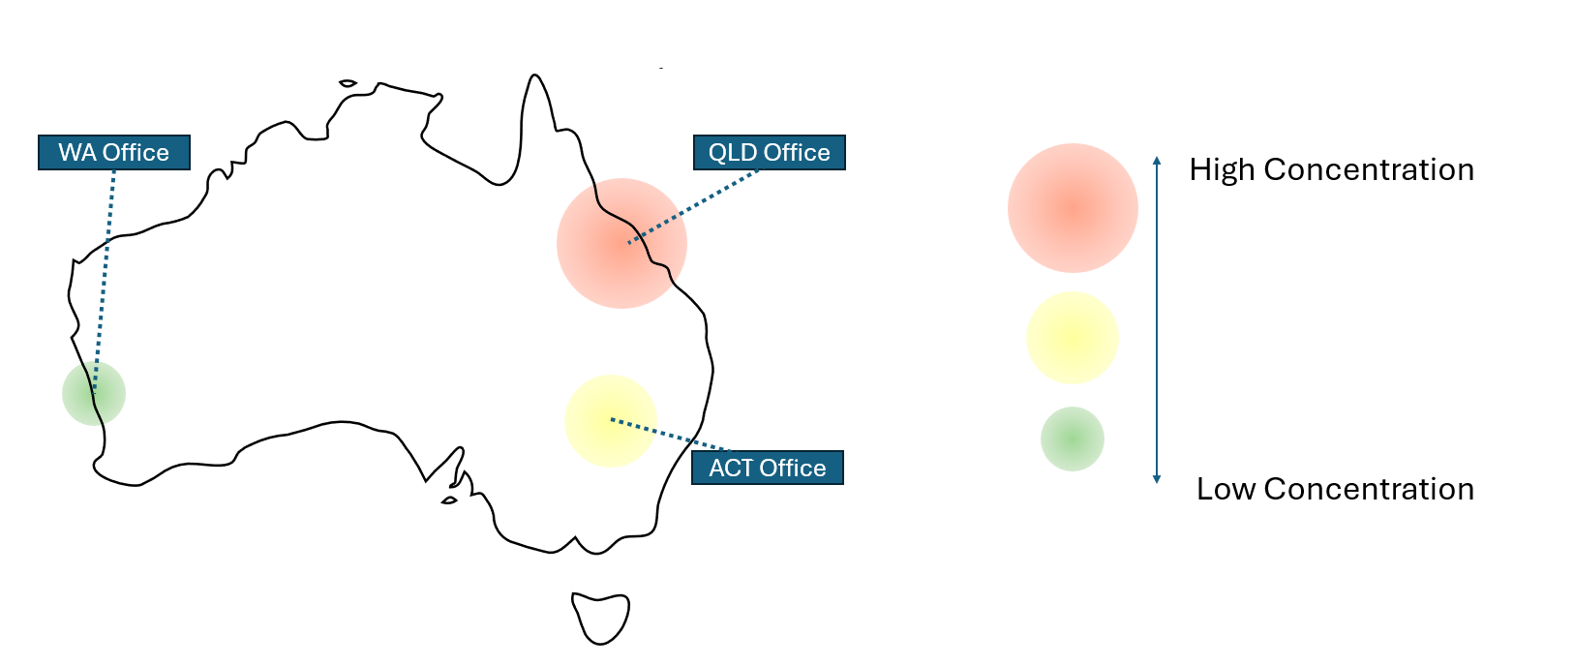

Commonwealth Climate Disclosure Index
Tip: Where information is provided across different sections of an annual report and/or external publications, it is recommended that an index is used to ensure readers to see that all requirements have been addressed. The index can also be used to respond to any disclosure gaps within the annual report.
Core Requirement | Overview |  |  | Disclosed
S1(a)-S1(b) | Disclosure of information of risks and opportunities and their effects. |  |  | Achieved through S2-S4
S2(a) | Identify the entity’s material organisation climate-related risks and opportunities. |  |  | See table 1, Appendix C, Climate Statement, page X
S2(b) | Categorise each of the material risks and opportunities identified above as ‘physical’ or ‘transition’ risks. |  |  | See table 1, Appendix C, Climate Statement, page X
S2(c) | Identify the horizon (short, medium or long-term) for which the effects of these risks and opportunities would be expected to occur. |  |  | See Appendix C, Climate Statement, page X
S2(d) | Define short, medium and long-term and disclose the reason these definitions were selected. |  |  | To align with the recommendations in the CROMP Organisation Application Guide, BRIC has identified the short term as 2030, the medium term as 2050 and the long term as 2090.
S3(a) | Climate Risk and Opportunity Management Program or alternative methodology |  |  | BRIC utilises CROMP methodology for climate risk and opportunity assessments in full
S4(a) | Description of current and anticipated effects of the risks and opportunities on the entity’s operational model. |  |  | See Appendix C, Climate Statement, Page X
S4(b) | A description of the concentration of the current and anticipated effects of the risks and opportunities. |  |  | See Appendix C, Climate Statement, Page X

Document control
Version number | Date of issue | Brief description of change
1 | 23/04/2025 | Initial publication

The Regional Investment Corporation’s Emissions Reduction Plan has been used as an example of how to cross-reference publicly available information.

