Intergovernmental agreement on data sharing fact sheet

Fast facts

The Intergovernmental Agreement on Data Sharing (IGA) sets out First Ministers commitment to more effective public sector data sharing.

The agreement was signed by the National Cabinet on 9 July 2021, and contains guidance and principles that governance agencies can apply to their data sharing activities.

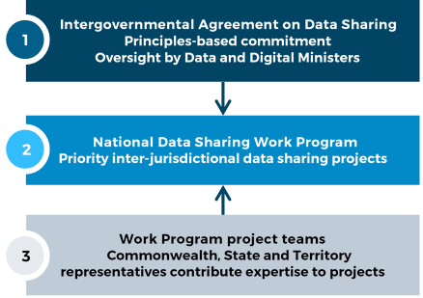

*Figure 1 | IGA and National Data Sharing Work Program*

## Overview

**The IGA commits all jurisdictions to share public sector data as a default position, where it can be done securely, safely, lawfully and ethically.**

## The agreement recognises data as a shared national asset and aims to maximise the value of data to deliver outstanding policies and services for Australians.

## Under the IGA, there is an expectation governments will share data with each other for the design, development, and delivery of policies, programs and services, and other activities in the public interest.

## The IGA doesn't change or override any existing data sharing agreements. It commits all parties to apply their best endeavours to share data across governments, including being responsive to requests and giving clear reasons for refusals.

## Applying the IGA

You can apply the IGA to cross-jurisdictional data sharing work. It can be used by data practitioners to help increase the volume and value of data sharing. Some ways to apply the IGA include:

* Use best endeavours to share data by default. Review any policies, processes and systems that could restrict this.
* Apply the guiding principles in the IGA to data sharing negotiations and incorporate relevant principles in data sharing agreements.
* Initiate a data request, and apply the schedules in the IGA which set out requirements for data requests (Schedule E) and what to consider when assessing a request (Schedule B).
* Talk to data custodians in your organisation about your data sharing policies and transfer mechanisms to ensure you are well prepared to respond to new data requests.
* Set up a central data request point in your organisation for other government officials to access, such as a portal, web form or email address.
* Participate in projects under the National Data Sharing Work Program. Projects can be nominated through your jurisdictions’ DDMM Data and Analytics Working Group member.

## Ensuring privacy and data security

Data shared under the IGA must be in accordance with established privacy and security standards and policies, including complaints handling processes.

For example, the Office of the Australian Information Commissioner (OAIC)’s [Data Breach Preparation and response Guide](https://www.oaic.gov.au/__data/assets/pdf_file/0017/1691/data-breach-preparation-and-response.pdf) outlines how you can comply with the Australian Privacy Principles and contains templates to help you prepare a data breach response plan.

Australian Government entities must also comply with the [Protective Security Policy Framework](https://www.protectivesecurity.gov.au/). The framework contains 16 policies that set out the core requirements for Australian Government entities to protect their people, information and assets.

## National data sharing work program under the IGA

As part of embedding the IGA into data sharing practice, the National Data Sharing Work Program seeks to uplift the national data sharing system by focusing on priority policy areas to deliver collaborative, inter-jurisdictional projects and drive broader data sharing system reforms.

Projects seek to achieve consistent data sharing, collaborative approaches to overcome data sharing barriers, and support data reuse and interoperability.

## More information

The IGA is available online at <https://federation.gov.au/about/agreements/intergovernmental-agreement-data-sharing>

If you have any questions about the Intergovernmental Agreement on Data Sharing, please contact the Department of Finance’s Data Policy Branch at ddmm@finance.gov.au

*NOTE: The information in this fact sheet is to be used as a guide only. Advice should be sought in relation to individual circumstances.*