Australian Government Property Register

2023 Office Data Collection Manual

15 June 2023

# Contents

1. Background

1.1. The Australian Government Property Register (AGPR)

1.2. Purpose

1.3. Further Assistance

1.4. Overview of the AGPR

1.5. Requesting AGPR Access

2. Updates since the 2022 Collection

2.1. Additional fields

2.2. Field changes

2.3. Field deletions

2.4. Validation changes

3. 2023 Office Data Collection

3.1. Role of PSPs

3.2. Role of Entities

3.3. 2023 AGPR Office Data Collection Timeframe – Key Dates

3.3.1. Data Supplier Agreement

3.3.2. Scope

3.3.3. Data Collation and Entry

3.3.4. Validation A & B

3.3.5. Sign-off

3.3.6. Extensions to Timeframes

4. Office Data Collection Participation

4.1. Entity Scope

4.2. Property Scope

4.3. Non-Office Space and Exemptions for Space

4.4. Inter-Entity Property Transfers – Machinery of Government Changes

1. Background
   1. The Australian Government Property Register (AGPR)

The Australian Government Property Register (AGPR) is a database that contains information on all of the Commonwealth's leased office accommodation and owned land. This information assists the Government identify opportunities for progressively improving the management of the Commonwealth property portfolio and informs Whole-of-Australian-Government property decision-making.

The AGPR was first implemented in 2016, with data being collected every year. Finance is responsible for maintaining the AGPR for leased and owned Commonwealth property, based on information reported by entities. The annual Office Data Collection includes information on Commonwealth buildings, leases, and subleases.

The property data collected in the AGPR is used to inform the annual Office Occupancy report and the Commonwealth Leasing Strategy to deliver a range of policies and outcomes.

All Non-corporate Commonwealth Entities (NCEs) are required to report their office accommodation data in line with the requirements set out in Section 7 of the [Commonwealth Property Framework (Resource Management Guide 500)](https://www.finance.gov.au/government/property-construction/commonwealth-property-management-framework). Property Service Providers (PSPs) must assist their NCEs to complete their reporting requirements for the AGPR.

* 1. Purpose

The purpose of this document is to provide guidance to Commonwealth Entities (Entities) and Property Service Providers (PSPs), on behalf of Entities under the Property Services Coordinated Procurement (PSCP) arrangements, on the 2023 Office Data Collection (the Collection). It includes details on the requirements of data fields in the AGPR, and information on the collection process.

* 1. Further Assistance

The Property Data Team at Finance manage the AGPR application and the 2023 Office Data Collection process on behalf of the Commonwealth and are available to provide guidance and advice on both systems.

Prior to the commencement of the Collection activity, the Property Data Team will provide information sessions for Entities and PSPs to support completion of the Collection. Additional training on the AGPR application is available upon request.

Email: [propertydata@finance.gov.au](mailto:propertydata@finance.gov.au).

The Property Services Coordinated Procurement team can be contacted about the Arrangements that cover leasing and facilities management services for Commonwealth properties to participating Entities, including the PSP Deed.

Email: [PSCP@finance.gov.au](mailto:PSCP@finance.gov.au)

* 1. Overview of the AGPR

The AGPR is a web-based application that Entities and PSPs use to enter property data. The data is then stored in the AGPR database to maintain a single source of truth for the Commonwealth’s property footprint. Feedback from Entities and PSPs has helped shape the way the AGPR data forms and fields are managed and updated.

AGPR: <https://agpr.woagpropertydata.gov.au/>

|  |  |
| --- | --- |
|  | Some modern browsers include plug-ins that refresh pages after a period of inactivity. It may be necessary to disable these plug-ins while entering data through the AGPR application in order to ensure unsaved changes are not lost where the browser auto-refreshed a page. Instructions for doing this are included in the Troubleshooting section of the manual. |

* 1. Requesting AGPR Access

Entities and PSP staff can request access to the AGPR Portal by contacting the Property Data Team. An AGPR User Access Request Form will then be sent to the user for completion.

Access to the AGPR requires a GovTEAMS account and utilises a multi-factor authenticator (MFA) identification process. As such, all users will be required to set up MFA.

AGPR troubleshooting is located in Attachment D.

|  |  |
| --- | --- |
|  | All user access requires require approval from the user’s manager.  For Commonwealth Entities this is a minimum of Director (EL2) level. |

1. Updates since the 2022 Collection

A number of changes have been made to the Collection process following the 2022 Collection. These have been made following feedback from PSPs, Entities and property specialists within Finance, and have been implemented to improve the quality of data collection, ensuring that it is fit-for-purpose.

* 1. Additional fields

|  |  |
| --- | --- |
| Field Name/Location | Reason for addition |
| Buildings, Leases and Subleases |  |
| PSP internal ID | This field enables PSPs to enter an identification code for the tenancy that matches the identification code in PSP-run systems. |
| NABERS Rating start date | This field captures the commencement date of the NABERS Rating for the tenancy. |
| NABERS Rating end date | This field captures the expiry date of the NABERS Rating for the tenancy. |
| Expiry of last assessment | Where there is no current NABERS Rating for the tenancy, this field captures the expiry date of the previous NABERS assessment. |
| Green Star Rating | This field captures the Green Star rating applied to a tenancy. |
| Green Star Rating Scope | This field captures the scope of the Green Star rating applied to a tenancy. |
| Buildings |  |
| Collection status | This field replaces the process for deleting expired or abolished tenancies.  This field also enables Entities to record data relating to out of scope and exempt tenancies on the AGPR, to capture a holistic property footprint.  Please Note: Changes to the Building *Collection Status* will automatically update the *Collection Status* of all associated leases to match. |
| Building owner ABN | This field has been added in addition to the field ‘Building owner name’ in order to ensure consistent data throughout the AGPR data set.  If there is no ABN associated with the group, enter two zeros followed by the ACN to meet the 11-digit requirement for this field in the AGPR.  This field is mandatory, and will be checked against the ‘Building owner name’ during Validation to identify any mismatches. |
| Leases |  |
| Collection status | This field replaces the process for deleting expired or abolished tenancies.  This field also enables Entities to record data relating to out of scope and exempt tenancies on the AGPR, to capture a holistic property footprint.  Please Note: Changes to the Lease *Collection Status* **won’t** automatically update the *Collection Status* of associated subleases. |
| Current Rent per sqm | This field replaces ‘Annual Lease Effective Rent’ and captures the gross lease rental rate per square metre of total net lettable area as at 30 June 2023. |
| Lease incentive rate | This field captures the lease incentive as a percentage of gross rent payable. |
| Make good requirement | This field captures the type of make good requirement included in the lease. |
| Current rent escalation rate | This field captures the escalation rate of the lease. |
| Market rent review | This field captures the type of market rent review included in the lease. |
| Subleases |  |
| Collection status | This field replaces the process for deleting expired or abolished tenancies.  This field also enables Entities to record data relating to out of scope and exempt tenancies on the AGPR, to capture a holistic property footprint.  Please Note: Changes to the Sublease *Collection Status* must be communicated to all affected entities. |

* 1. Field changes

|  |  |
| --- | --- |
| Field Name/Location | Change Type |
| Buildings, Leases and Subleases |  |
| NABERS Rating now mandatory | Reporting accurate details in the AGPR supports Finance and the government in reviewing and implementing property policy that is designed to improve the efficiency of Commonwealth property utilisation.  In 2023, the NABERS Rating fields in each of Buildings, Leases and Subleases has been made mandatory to help ensure the required data is reported. The fields within this section must be completed for all tenancies and while not marked as mandatory within the AGPR system, they will be reviewed in the Validation step and validation issues will be raised where this data is not supplied. |
| Leases |  |
| Sustainability details | Due to the addition of multiple new fields relating to the energy efficiency of tenancies, a new subsection ‘Sustainability details’ will be added to lease records. This section groups together data relating to NABERS Ratings, Green Star Ratings, and Green Lease Schedules.  The new subsection won’t impact the functionality of fields. |
| Last Major Fit-out Source | A new option ‘Legacy fit-out' will be added to this field. This option has been provided to enable entities to indicate where information cannot be sourced for the last major fit-out and may only be applied where the fit-out was conducted at least 10 years ago.  This new option is **not** to be used as a placeholder. All reasonable efforts must be made to ensure fit-out details reflect the actual source where possible. |
| Rent Review Mechanism | The option ‘Market Rent Review’ will be removed from this field, to be replaced by the new field *Market Rent Review*. |

* 1. Field deletions

|  |  |
| --- | --- |
| Field Name/Location | Reason for deletion |
| Leases |  |
| Annual Lease Effective Rent | Field has been replaced with Current Rent Per Sqm |

* 1. Validation changes

|  |  |
| --- | --- |
| Change | Description |
| Changes to validations for Occupational Density and Fit-out Density | The validation rules applied to Occupational Density and Fit-out Density will now be dependent on the Usable Office Area, with one set of validations appearing for tenancies under 500m2 and a different set of validations appearing for tenancies with at least 500m2 of Usable Office Area. |

1. 2023 Office Data Collection

The Office Data Collection (the Collection) is an annual activity to collect, update, and validate Commonwealth office data contained within the AGPR. The main Collection activity occurs between June and October, with the following sub-processes to guide Entities and PSPs to completion:

* Update of Data Supplier Agreement
* Scope
* Data Collation and Entry
* Validation
* Sign-off

PSPs and Entities have a shared responsibility to ensure the data entered into the AGPR is accurate and in accordance with the Data Supplier Agreement. Collaboration is an essential part to the collection process, with Entities and their PSPs contributing to the AGPR and working together to undertake quality assurance reviews of the data within the AGPR prior to submission.

* 1. Role of PSPs

Under the PSP Deed, PSPs are responsible to obtain and store a range of property data on behalf of the services provided to Entities, including the supply of the majority of data required to be reported in the Collection. For more information of PSP responsibilities at each step of the Collection, refer to sections 3.3.1 to 3.3.6 below.

* 1. Role of Entities

Entities with a PSP are responsible for working closely with their PSP to provide data they have agreed to supply in accordance with the Data Supplier Agreement, and addressing all validation issues.

Entities without a PSP are responsible for completing all elements of the 2023 AGPR Office Data Collection.

Entities are responsible and accountable for the quality and completeness of data reported in the AGPR.

* 1. 2023 AGPR Office Data Collection Timeframe – Key Dates

Entities required to complete the data collection must finalise their submission for the 2023 AGPR Office Data Collection by no later than close of business **29 September 2023**.

Key dates for the 2023 AGPR Office Data Collection are included in the table below:

| **Collection Activity** | **Duration (weeks)** | **Due Date** |
| --- | --- | --- |
| Update of Data Supplier Agreements | 8 | 30 June 2023 |
| Scope confirmation (buildings, leases and subleases) | 6 | 11 August 2023 |
| Data collation and entry | 7 | 15 September 2023 |
| Data validation (A&B) and issue of sign-off report | 6 | 22 September 2023 |
| Sign-off report approval | 2 | 29 September 2023 |
| **Collection closes\*** |  | **29 September 2023** |

* The collection close date is fixed and all data must be validated and signed off by this date.

* + 1. Data Supplier Agreement

The Data Supplier Agreement is list of data fields within the AGPR, including any new fields since the last reporting period, with a recommended data supplier listed against each field.

Entities and PSPs can use the 2022 Data Supplier Agreement as a starting point for the agreement in 2023, with a focus on confirming data suppliers for new fields.

A template for the data supplier agreement is included in Attachment A. Where PSP has been listed as the Data Supplier, this has been done in line with the expectations on the PSP as set out in *Section 17 of Schedule 1 of the Deed in relation to Property Services to the Commonwealth of Australia* (the Property Services Deed) and Section 7 of RMG500. However, there is scope for PSPs and Entities to agree to variations to the Data Suppliers listed in the attachment on a case-by-case basis.

**Action**: Agreement on the Data Supplier for each field must be finalised before the main collection process commences on **03 July 2023**.

All Entities with a PSP are required to provide a copy of the agreement to the Property Data team.

Entities without a PSP are required to supply data for all fields in the collection.

Entities that are assigned to a PSP but intend to self-manage Collection activity must notify the Property Data Team.

* + 1. Scope

To be completed no later than **11 August 2023**.

During Scope, entities are required to confirm the tenancies that are in-scope for the collection (refer to section *4.2 Property Scope* for further details on what is an in-scope tenancy). All required changes must be entered into the online AGPR application and in accordance with the definitions and specifications as stated in this document.

|  |  |
| --- | --- |
|  | Field changes for 2023 will have an impact on the activity completed during this step. Please read the following information carefully to ensure Scope is completed correctly. |

Activities during Scope should be limited to the following:

| **#** | **Action** | **Detailed Description** |
| --- | --- | --- |
| 1 | **Mark** inactive building records | Review all buildings and mark any that no longer have an active* tenancy.  Mark a building record as inactive by changing the *Collection Status* field to ‘Inactive’.  Please Note: changes to the building record *Collection Status* will automatically update the *Collection Status* of all associated lease records to match.  Where a tenancy is still active but the deletion is being requested due to the tenancy potentially being out-of-scope, the deletion request must provide details of why the tenancy is now considered out-of-scope. |
| 2 | **Mark** expired leases and subleases | Where a lease or sublease has expired (prior to the end of the collection period) the *Collection Status* must be updated to ‘Inactive’.  Please Note: changes to the lease record *Collection Status* **won’t** automatically update the *Collection Status* of associated subleases. Sublease *Collection Status* must be updated manually, and all affected entities must be notified of the change.  Where a tenancy is still active but is now being considered out-of-scope, change the *Collection Status* to ‘Out of scope’. See section 4.2 for more information about property scope. |
| 3 | **Create** new records | Create the shell building, lease and sublease records for any new tenancies.  Creation of new buildings requires PSPs or entities to utilise the New Building Request process, which is detailed in section *5.1.1 New Building Request.*  Once a new building has been created the shell lease record needs to be created. If the tenancy has any subleases (including MOUs) then these also need to be created at this time. |
| 4 | **Review** lease and sublease status and dates | Review the Status of all leases and subleases and update if required.  Review the Start Date and End Date of all leases and subleases and update if required.  This is especially important for subleases as failure to update these details will prevent the subleasing entity from updating their record in the AGPR. |
| 5 | (Optional)  **Create** new out of scope and exempt records | In 2023, entities have the option to record data for out of scope and exempt tenancies, to capture a holistic picture of property footprint. The data contained in these records won’t be validated during the Collection or included in sign-off reports.  To create an out of scope or exempt record, enter the required details to create a shell record and mark the *Collection Status* as ‘Out of Scope’ or ‘Exempt’.  Please Note: *Collection Status* ‘Exempt’ must only be used for tenancies that have an approved exemption request. To request an Exemption for a tenancy, send Attachment B [to](mailto:to) the Property Data Team. |

* Active tenancies are those that are not expired as at 30 June 2023. If the lease end date is 30 June 2023 then the lease is active on that date and should not be listed as expired.

Responsibility for completing this step

| **PSCP Arrangement** | **Responsibility** |
| --- | --- |
| **Entity has a PSP** | The PSP will assist the Entity to complete this step.  PSP Action   * Provide the Entity a list of all known tenancies for confirmation and update by the entity. This **must** include all new tenancies that commenced within the collection period and all existing tenancies recorded in the AGPR, noting that those known to have expired should be marked as such by the PSP.   Entity Action   * Review the tenancy list provided by the PSP and update all records as required, including all subleases and MOUs as PSPs may not have visibility of these if they are arranged between Commonwealth entities.   PSP Action   * Complete all applicable data entry for Scope, including building, lease and sub-lease creation. * Update *Collection Status* to mark any inactive buildings, leases or subleases. * Advise Finance when all actions are completed.   Data requirements for Scope:  Given the limited action required in Scope, Finance recommends that PSPs do not utilise the full Data Download file from the AGPR. Instead the file should be modified to provide a reduced number of fields as follows:  Building Sheet   * Building Id * Building Address (e.g. name, street number, street, suburb and state) * Number of Active Tenancies for Building   Leases Sheet   * Lease Id * Building Id * Building Address (e.g. name, street number, street, suburb and state) * Lease Start Date * Lease End Date * Lease Status   Sub-leases Sheet   * Parent Lease Id * Building Id * Building Address (e.g. name, street number, street, suburb and state) * Subleasing Entity/Organisation Name * Sublease Start Date * Sublease End Date * Sublease Status |
| **Entity does not have a PSP** | The Entity is fully responsible for completing this task. |

|  |  |
| --- | --- |
|  | **Nested subleases**  In the AGPR, subleases (including MOUs) are recorded within a Tenancy lease record, which in turn generates a *Sublet lease* record for the sub-lessor to report their details. Unfortunately, there is no functionality in the system to record a sublease within a Sublet lease record.  Where this situation occurs, Entities or their PSPs should [contact](mailto:contact) the Property Data team as soon as possible. The team will work with relevant entities to modify how leases are linked to address this situation. Once linking issues have been addressed by Finance, the PSP will still be required to enter in relevant lease information. |

* + 1. Data Collation and Entry

To be completed no later than **15 September 2023**.

The Data Collation and Entry step is the main element of the 2023 AGPR Office Data Collection process and requires detailed building, lease and sublease data to be collated and entered into the AGPR.

For 2023 Collation and Entry have been combined into a single step with one due date. PSPs and Entities are required to collaboratively manage their time to ensure all data is entered with sufficient time to progress through validations and sign-off before the Collection close date.

Responsibility for completing this step

|  |  |
| --- | --- |
| **PSCP Arrangement** | **Responsibility** |
| **Entity has a PSP** | PSPs and Entities share the responsibility to complete this phase as follows:  Entity Action   * Supply all data agreed under the Data Supplier Agreement to PSPs in a timely manner   PSP Action   * Provide Entities with a data file no later than five working days after the commencement of Data Collation and Entry * Supply all data agreed under the Data Supplier Agreement * Complete all data entry in the AGPR. PSPs may utilise the data upload tool to input data in bulk to the AGPR system. Instructions for data upload will be provided separately. * Advise Finance when all data has been entered and is ready for validation. |
| **Entity does not have a PSP** | The Entity is fully responsible for completing this task. The data upload tool is not available for Entity users. |

To assist with streamlining the collection, PSPs can commence entering data they are supplying (as per Data Supplier Agreement) into the AGPR while awaiting further data from Entities. PSP-supplied data *does not need to be verified by Entities* prior to data entry as this verification occurs in the validation and sign-off phases.

Entities and PSPs should familiarise themselves with the AGPR data definitions and collection requirements detailed in this document prior to the commencement of the Collection.

Prior to the submission of data, PSPs and Entities should review the submission to ensure that all data fields are updated and that data provided is correct. While Finance will also review the data, this validation does not replace quality assurance processes that should be undertaken by entities and their PSPs.

|  |  |
| --- | --- |
|  | All data (including financial data) must also be reported as at 30 June 2023.  All financial data, e.g. expenses, must be reported **inclusive of GST**. |

To enable sufficient time for data validation process to occur, all data entry must be completed for all Entities by no later than **15 September 2023**. Be aware that multiple rounds of validations may be required before the sign-off report can be issued, and time must be managed accordingly.

* + 1. Validation A & B

To be completed no later than **22 September 2023**.

Once all data for an Entity has been entered into the AGPR, Finance will review the data, testing it against the AGPR data validation rules to check for potential errors. These rules are not a comprehensive check of all data items, rather, they focus on the integrity of key data items.

Once completed, Validation Reports will be issued to both Entities and PSPs for actioning. These reports will be separated into three sections: Buildings, Leases, and Sub-leases, to facilitate faster verification of data.

Once all validation issues have been addressed, including provision of commentary for issues not requiring data corrections, the data will be re-validated.

For 2023, Validation will be split into parts A and B.

|  |  |
| --- | --- |
| **Validation** | **Purpose** |
| Validation A | Entity data will be tested against AGPR validation rules to check for potential errors. This validation will identify potential issues in the entity’s data only. |
| Validation B | Entity data will be tested against the whole AGPR data set using AGPR validation rules to check for potential errors. This validation replaces the previous Scope Validation and will identify potential issues in the connections between records of different entities. |

Entities will remain in the data validation phase until all validation issues from both Validation A and Validation B are resolved.

Responsibility for completing this step

|  |  |
| --- | --- |
| **PSCP Arrangement** | **Responsibility** |
| **Entity has a PSP** | PSPs and Entities share the responsibility to complete this phase as follows:  Entity Action   * Resolve issues relating to Entity data items as per the Data Supplier Agreement * Provide commentary for issues not requiring data corrections relating to Entity data items as per the Data Supplier Agreement   PSP Action   * Resolve issues relating to PSP data items as per the Data Supplier Agreement * Provide commentary for issues not requiring data corrections relating to PSP data items as per the Data Supplier Agreement * Enter and update data in the AGPR * Advise Finance when all issues have been addressed and data is ready for re-validation |
| **Entity does not have a PSP** | The Entity is fully responsible for completing this task. |

It is important to recognise that some data validation issues may require a joint effort to resolve. The Entity and their PSP are expected to work collaboratively to clear all issues in a timely manner.

* + 1. Sign-off

To be completed no later than **29 September 2023**.

Once all validation issues have been resolved, Finance will issue a sign-off report to the Entity.

The sign-off report contains three components:

* an Office Accommodation dataset (Excel spreadsheet) with details of all reported Buildings, Leases (including owned office accommodation) and Sub-leases for the Entity (current as at the Collection End Date),
* an Entity Property Statistics Summary, and
* a Property Delegate Sign-Off sheet.

The report will also contain a technical notes page to assist delegates familiarise themselves with the metrics used and how they are calculated.

|  |  |
| --- | --- |
|  | Entities are required to review all data in their Office Accommodation dataset and provide executive sign-off, by a SES Band 1 or equivalent, within **2 weeks** of the report being issued, with all finalised sign-off reports to be sent to Finance no later than close of business on **29 September 2023**.  The scope of the sign-off by the delegate is limited to the accuracy and completeness of data reported in the 2023 Collection, **not previous collections**. |

* + 1. Extensions to Timeframes

If an Entity is unable to complete the scoping, data entry or validation by the prescribed deadlines they should contact the Property Data.

While some flexibility will be provided to the dates of completion of earlier steps, no extensions will be provided to the sign-off completion date of 29 September 2023, as property data for all Entities is required at this time to inform development of the Commonwealth Leasing Strategy and property policy.

1. Office Data Collection Participation
   1. Entity Scope

Participation in the Office Data Collection is a mandatory requirement for all NCEs with in-scope office accommodation (see section 4.2). This requirement is set out in Section 7 of the [Commonwealth Property Framework (Resource Management Guide 500)](https://www.finance.gov.au/sites/default/files/2020-08/rmg-500.pdf).

Corporate Commonwealth entities and Commonwealth companies are not required to report details of their office accommodation, but are encouraged to contribute to the data collection on a voluntary basis.

* 1. Property Scope

#### *In Scope*

Entities are required to report details of all property (leased or owned) which:

* has Usable Office Area (in-scope accommodation); and
* is used, in any part, to conduct office activity that supports the government business and outcomes.

The collection scope **includes** any office properties, special purpose properties, operational facilities and other types of property located in Australia.

Examples of in-scope accommodation are:

* office accommodation;
* properties used mostly for ‘operational’ purposes that have areas where office work is completed, including to support operational activities. For example, desks in staff-only access areas at airports for completion of administrative work to support other operational activities conducted at the property;
* Special Purpose Properties (SPP), such as dog-training facilities or car-depots, where there is space used to conduct office work. For example, a desk or work-point to complete paperwork or administrative tasks;[1]
* shopfronts[2];
* sub-leases or Memorandums of Understanding (MOU) arrangements from other Commonwealth Entities. For example, 140m2 of office space for 10 work-points accessed under an MOU;
* properties that contain subleases, which are used (wholly or in part) for office accommodation, regardless of whether the head-lease has any residual Usable Office Area, for example a tenancy where all of the area is subleased to another Commonwealth entity for use as office accommodation. Both the head lease and sublease/s are regarded as in-scope.

|  |  |
| --- | --- |
|  | Entities are required to record details for all leased and owned office space, with data as at 30 June 2023, regardless of cost or tenancy size.  Entities, or PSPs for those under the PSCP arrangements, must record data in the AGPR on all owned or leased office space attributed to the Entity as at 30 June 2023, regardless of cost or tenancy size. This **includes** office accommodation of less than 500 square metres of usable office area, and whole-of-life costs of less than $2 million, which was not collected prior to 2017. |

#### *Out of Scope*

Any property that does not have the capacity to be used for office work is regarded as out-of-scope. Additionally, properties located overseas, military bases and intelligence agencies are also regarded as out-of-scope for this collection.

Hosted arrangements where there is no lease or formal MOU, and where there is no payment for the arrangement, are considered out of scope for the hosted entity, and the hosting entity should report these work-points as their own in their AGPR submission.

Some examples of out-of-scope properties are:

* data warehouses;
* car-depots or car-parks with no usable office area;
* facilities used exclusively for storage;
* leased or owned land with no office structures, noting that buildings on the land may be in-scope depending on usage. For example, an animal enclosure would be out-of-scope but an administration building supporting office work would be in-scope; and
* SPPs or operational facilities with zero usable office area.
  1. Non-Office Space and Exemptions for Space

The property data collected in the AGPR is used to inform the annual Office Occupancy report, which is publicly available, and to support a range of different policy analysis tasks.

When reporting on the usage of area within a building, Entities (or PSPs on their behalf) are required to ensure that details of Net Lettable Area (NLA), subleased areas and all applicable non-office areas are correctly recorded. There are 10 categories of non-office area available for Entity or PSP use, these are:

* Non-Office Area C – Basement or Inadequate Amenity
* Non-Office Area D – Police Station, Laboratory or Hospital
* Non-Office Area E – Specifically for Operational Activity
* Non-Office Area F – Public Facility
* Non-Office Area G – Judicial Chambers and Court Rooms
* Non-Office Area H – Areas Specifically for the Governor-General, Prime Minister and Parliamentarians
* Non-Office Area I – Emergency and Crisis Coordination Areas
* Non-Office Area J – Exempt Area
* Non-Office Area L – Shopfronts
* Non-Office Area M – ICT/Data Warehouse

Where an Entity assesses an area as non-office space, but is not able to allocate it within the current classifications for non-office space (Area C to Area I, or Area L or M), they should complete the Non-Office Area Category J – Exempt Area Application Form (located at Attachment B) and send to [the](mailto:propertydata@finance.gov.au) Property Data Team for consideration.

Where an exemption has been previously approved, *Non-Office Area Category J – Exempt Area Application Forms* are to be re-submitted to Finance via email with evidence of previous exemption and comments from the Entity to validate the continued exemption in the 2022 -2023 reporting period.

For assistance identifying whether office area in operational sites is non-office or usable office area, please contact the Property Data Team.

* 1. Inter-Entity Property Transfers – Machinery of Government Changes

This process applies to all MoG changes between 1 July 2022 and 30 June 2023.

Where an Entity acquires a property from another Entity as a result of a Machinery of Government (MoG) change, the relinquishing Entity must work with their PSP to provide all required data up to the date of the property transfer to the gaining Entity. The gaining Entity is then responsible for providing the data on the transferred property to Finance as if it held the property for the full reporting period.

Data supplied by the relinquishing Entity, and their PSP, must be signed-off in accordance with the standard sign-off process.

The PSP representing the Entity gaining the property should then check the data for any obvious errors or anomalies, and resolve potential issues before accepting responsibility of the data.

# Field Definitions Contents Table

Search Address 27

Building ID 27

Collection Status 27

PSP internal ID 27

Building Name 28

Street Number 28

Street Name 28

Suburb 28

State/Territory 29

Post Code 29

Latitude 30

Longitude 30

Building Owner Type 31

Building Owner ABN 31

Building Owner Name 31

Building Grade 32

Heritage Status 33

NABERS Rating 34

NABERS Rating Scope 35

NABERS Start Date 35

NABERS End Date 36

Expiry of last assessment 36

Submitter’s Comments 36

Repair and Maintenance Expense 41

Energy Expense 42

Water and Sewerage Expense 42

Cleaning and Waste Removal Expense 43

Relocation and Minor Refurbishments Expense 44

Contractors and Consultants 45

Other Operating Expenses 46

Services Received Free of Charge 46

Comments 47

Facilities Management – Provider 47

Facilities Management Provider Contract End Date 47

Facilities Management – Services Base Fees (excluding pass through costs) 48

Facilities Management – Services Other Fees (excluding pass through costs) 49

Other (Facilities Management) Services 49

Building 52

Type 52

Lease Identifier 52

Collection Status 52

PSP internal ID 53

Description 53

Lease Description 58

Comments 58

Lease Start Date 58

Lease End Date 58

Lease Type 59

Lease Status 60

Make Good Requirement 61

Green Star Rating 62

Green Star Rating Source 62

Green Lease Schedule 63

Tenancy Highest Security Level 64

Current Year Actual Rent 66

Lessor’s Outgoings Expense 67

Current Rent per sqm 67

Total Outgoings 68

Provider 68

Provider Contract End Date 68

Services - Base Fees 68

Services - Other Fees 69

Number of Remaining Extensions 69

Length of Next Lease Extension 69

Extension Notification Date 69

Incentive: Rent Abatement 70

Incentive: Fit-out Contribution 71

Lease incentive rate 71

Total Incentive 72

Incentive Description 72

Last Major Fit-out Completed 73

Last Major Fit-out Source 74

Last Major Fit-out Cost 75

Total Fit-out Cost 76

Rent Review Mechanism 76

Rent Review Frequency 76

Current rent escalation rate 77

Market Rent Review 77

Sub-Leased To 81

Collection Status 81

PSP internal ID 81

Sub-Lease Description 82

Leasing Entity Name 82

Start Date 82

End Date 82

Sub-lease Status 83

Sub-Leasing Parties/Agencies Sub-Leased To 83

Total Revenue 84

Total Sub-Leased Area 84

Total Vacant Area Available 85

Net Lettable Area 88

Staff Allocated to Lease 89

Work-points 89

Reason for more Staff than Work-points 90

Non-Office Area C – Basement or Inadequate Amenity 91

Non-Office Area D – Police Station, Laboratory or Hospital 91

Non-Office Area E – Specifically for Operational Activity 92

Non-Office Area F – Public Facility 93

Non-Office Area G – Judicial Chambers and Court Rooms 94

Non-Office Area H – Areas Specifically for the Governor-General, Prime Minister and Parliamentarians 95

Non-Office Area I – Emergency and Crisis Coordination Areas 96

Non-Office Area J – Exempt Area 96

Non-Office Area L – Shopfronts 97

Non-Office Area M – ICT/Data Warehouse 98

Total Non-Office Area 98

Total Sub-Leased Area 98

Cost per Square Metre 99

Cost per Work-point 99

Usable Office Area 99

Work-point Vacancy Rate 99

Occupational Density 99

Published Date 102

Status 102

Space Fitted Out? 102

Work-points Available 102

Square Metres Available 102

Available From Date 102

Period Available 103

Additional Information 103

Contact Person 103

Contact Phone 103

Contact Email 103

Document Type 106

Keywords 106

File Extension 108

Version 108

Upload Date 108

1. AGPR field definitions and guidance material

Data Element Specifications

Non-editable/non-selectable fields Fields editable upon request Fields editable/selectable

* 1. Buildings

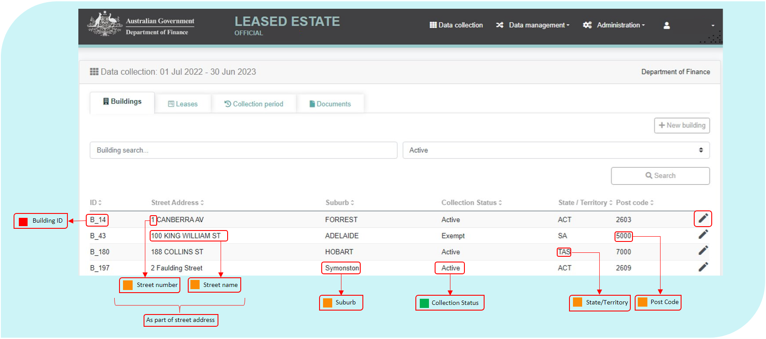

Once logged into the AGPR Leased Estate application, the Buildings tab is the first to appear. This tab lists all the buildings an Entity has reported under the AGPR collection mandate.

The fields highlighted in the figure above are visible to users but can only be edited by the Finance Property Data Team. The data fields are defined as part of the next section ‘New Building Request’.

Clicking on the view/edit icon will take users to the Building Record section, containing the ‘Building’ and ‘Building Management’ tabs.



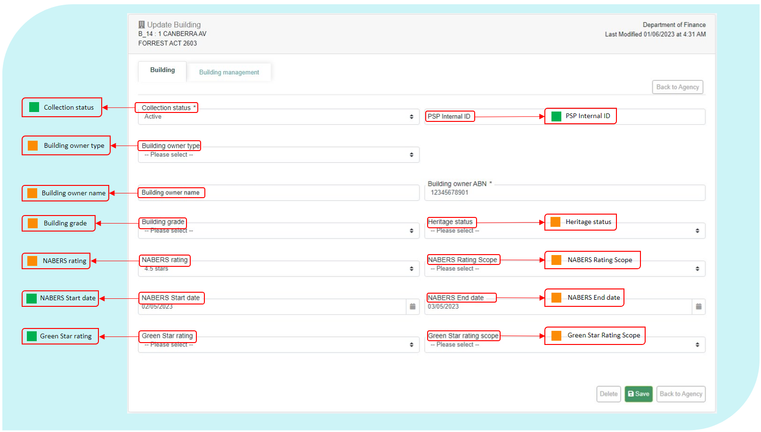

These data fields are defined in the ‘New Building Request’ section (below). These fields can only be edited by System Administrators within the Finance Property Data Team. Data elements in the ‘Building Management’ tab will be defined later in the manual.

* + 1. New Building Request

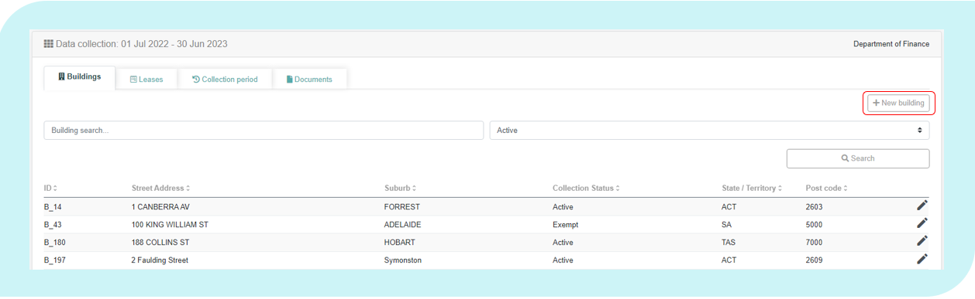A new building can only be created or updated through a request to the Finance Property Data Team.

The following data definitions apply to this section.

Search Address

|  |  |
| --- | --- |
| Definition: | Users should enter the address of their new building into the ‘Search Address’ field. As the user types a street address, the system will compare and display pre-populated addresses against a list of known formatted addresses. If there is pre-populated match displayed in this list, clicking on that match will auto-populate the majority of locality fields on the Building Request form. |
| Notes: | It is critical that building addresses are consistent. Users should try to match their address within the ‘Search Address’ field before completing address fields manually. |

Building ID

|  |  |
| --- | --- |
| Definition: | A unique code that identifies each building. |
| Notes: | The system generates this unique code for each building. |
| Format: | [B_nnn],[Bnnnnn] |

Collection Status

|  |  |
| --- | --- |
| **Definition:** | Select whether or not the tenancy is to be considered in scope for the Office Data Collection. |
| Notes: | Status applied to a building record will be automatically applied to all leases within the building.  Status applied to a lease won’t be applied to subleases within the lease. Sublease status must be updated manually, and any affected entities notified of the change. |
| Format: | [Pick from list]   |  |  | | --- | --- | | Code | Meaning | | Active | Building is to be included in the Collection. | | Inactive | Building is expired or abolished.  NB: Tenancies marked ‘Inactive’ will be removed from the AGPR at the closure of the Collection. | | Exempt | Building is exempt from inclusion in the Collection, and an exemption request has been approved by the Property Data Team. | | Out of scope | Building is out of scope for the Collection. | |

PSP internal ID

|  |  |
| --- | --- |
| **Definition:** | Unique identifier assigned to the building record within PSP internal systems. |
| Notes: | Each tenancy record should have a unique internal ID.  It is preferable for PSPs to use the same internal IDs through multiple collection periods. |
| Include: | Unique identifier that can be used to cross-match AGPR data with PSP internal systems. |
| Exclude: | Unique identifier used in Entity internal systems |
| Format: | Free text |

Building Name

|  |  |
| --- | --- |
| Definition: | The name of the property or building, if applicable. |
| Exclude: | Information provided in other street address fields or the entity name  Only include official building names or information as noted below. |
| Notes: | This field is used to denote a name for a property or building and may be used to provide additional context to the building address.  If the lease is for a specific floor in a building, please enter the floors(s) occupied in this field.  If the property does not have a building name **OR** a street number **AND** is located on a corner, report ‘Corner’ for this element.  This field should include information about the building, or building name and is **NOT** to be used as an additional reference field. |
| Format: | [Text] |

Street Number

|  |  |
| --- | --- |
| Definition: | The exact street number of the building. |
| Notes: | If the property is a unit, use the format ‘10B/131’.  If the property spans more than one street number, use the format ‘12‑14’.  **Do not** include information the level/floor of the building on which the Entity is located. |
| Format: | [nn], [nn-nn], [n/nnn] |

Street Name

|  |  |
| --- | --- |
| Definition: | The exact street name on which the property is located. |
| Notes: | Record the street type (i.e. street, road, lane, square etc) without abbreviation.  If the property is reported as being on a corner, report both street names for this element using the format ‘X Street and Y Street’. |
| Format: | [Name of Street], [Street Type] |

Suburb

|  |  |
| --- | --- |
| Definition: | The exact suburb in which the property is located. |
| Notes: | Record the suburb where the property is physically located. |
| Format: | [Text] |

State/Territory

|  |  |
| --- | --- |
| Definition: | The State or Territory in which the property is located. |
| Notes: | Record the State or Territory where the property is physically located.  **Do not** record the State or Territory where mail is sent for the property. |
| Format: | [Pick from List]   |  |  | | --- | --- | | **Code** | **Meaning** | | ACT | Australian Capital Territory | | NSW | New South Wales | | NT | Northern Territory | | QLD | Queensland | | SA | South Australia | | TAS | Tasmania | | VIC | Victoria | | WA | Western Australia | |

Post Code

|  |  |
| --- | --- |
| Definition: | The exact postcode in which the property is located. |
| Notes: | Record the postcode where the property is physically located.  **Do not** record the postcode where mail is sent for the property.  The postcode should match the suburb listed in the field Suburb. |
| Format: | [nnnn] |

Latitude

|  |  |
| --- | --- |
| Definition: | Latitude of the building. |
| Notes: | If the ‘Search Address’ feature is used, the latitude will populate automatically.  If an Entity needs to enter the latitude manually, they should take care to enter the value to a minimum of 5 decimal places to ensure the latitude works correctly.  If you are unsure on the Latitude of a tenancy you may source this information by following the steps outlines below   1. Navigate to [www.google.com/maps](http://www.google.com/maps) 2. Search for your building or tenancy address 3. Right click on the identified location 4. Left click on the coordinate value 5. Copy the relevant latitude value in to the AGPR |
| Format: | [nn.nnnnn] |

Longitude

|  |  |
| --- | --- |
| Definition: | Longitude of the building. |
| Notes: | If the ‘Search Address’ feature is used, the longitude will populate automatically.  If an Entity needs to enter the longitude manually, they should take care to enter the value to a minimum of 5 decimal places to ensure the longitude works correctly.  If you are unsure on the longitude of a tenancy you may source this information by following the steps outlines below   1. Navigate to [www.google.com/maps](http://www.google.com/maps) 2. Search for your building or tenancy address 3. Right click on the identified location 4. Left click on the coordinate value 5. Copy the relevant longitude value in to the AGPR |
| Format: | [nn.nnnnn] |

Building Owner Type

|  |  |
| --- | --- |
| Definition: | The type of organisation that owns the property. |
| Notes: | Report the current ownership type that applies for the reporting period.  If the Owner Type is Local Government then report ‘State Government’. |
| Format: | [Pick from List]   |  |  | | --- | --- | | **Code** | **Meaning** | | Commonwealth | The Commonwealth Government owns the building | | State Government | State, Territory or Local government owns the building | | Private | Non-government ownership | |

Building Owner ABN

|  |  |
| --- | --- |
| **Definition:** | **The Australian Business Number (ABN) for the owner of the building/tenancy.** |
| Include: | The official ABN of the current owner of the building (or floor) the tenancy is located in. |
| Exclude: | The ABN of the landlord where this is different from the owner, for example where the tenancy is a sublease, do not record the landlord’s (head tenant’s) ABN. |
| Note: | The ABN should be recorded in the official lease document, however if the owner has since changed, their ABN can be located via the Australian Business Register ABN Lookup (<https://abr.business.gov.au/>). |
| Reference: | <https://abr.business.gov.au/> |
| Format: | Positive value in ABN format, [nn nnn nnn nnn] |

Building Owner Name

|  |  |
| --- | --- |
| Definition: | The exact, registered business name of the building owner. |
| Notes: | The name of the current owner of the building – as recorded in the Australian Business Register that matches their ABN. If the Entity is leasing from a Local Government then give the name of the Local Government Entity.  Where two (2) or more building owners are listed on the lease agreement (e.g. “Company A and Company B, together the Lessor”) please select one (1) of these building owners to record within the AGPR. It is preferable for entities to list the same building owner through multiple collection periods. Building owner name and Building owner ABN must reflect the same organisation |
| Format: | [Text] |

Building Grade

|  |  |
| --- | --- |
| Definition: | Building grade is broadly divided into existing buildings ‘EB’ and new buildings ‘New’. The current grade of the building in which the property is located, in accordance with the Property Council of Australia: A Guide to Office Building Quality. |
| Notes: | New buildings are classified as buildings where a development application was submitted post 1 January 2012.  Where building grade information in accordance with the PCA guidance is not reliable or easily available, report ‘unknown’ for this element. |
| Reference: | PCA: A Guide to Office Building Quality, most current version |
| Format: | [Pick from List]   |  |  | | --- | --- | | **Code** | **Meaning** | | EB Premium | Premium grade for existing buildings | | EB Grade A | Grade A for existing buildings | | EB Grade B | Grade B for existing buildings | | EB Grade C | Grade C for existing buildings | | EB Grade D | Grade D for existing buildings | | New Premium | Premium grade for new buildings | | New Grade A | Grade A for new buildings | | New Grade B | Grade B for new buildings | | Unknown | Building grade not known or unreliable | |

Heritage Status

|  |  |
| --- | --- |
| Definition: | The outcome of a heritage assessment done under section 341ZB of the *Environment Protection and Biodiversity Conservation Act 1999 (EPBC Act).* |
| Notes: | A property is only reported as ‘heritage’ if the heritage assessment required under section 341ZB or the EPBC Act indicates that the property is located in, or includes, a place with identified heritage values. |
| Format: | [Pick from List]   |  |  | | --- | --- | | **Code** | **Meaning** | | Heritage | The property is located in, or includes, a place with identified heritage value | | Not Heritage | The property is not located in, and does not include, a place with identified heritage value | | Unknown | A heritage assessment has yet to be undertaken for the place in which the property is located | |

NABERS Rating

|  |  |
| --- | --- |
| Definition: | NABERS rating achieved by the tenancy of the leased/owned scope of the building. |
| Include: | Use Energy rating where available. |
| Exclude: | GreenPower and Green Star ratings. |
| Notes: | Note: this is not necessarily the rating of the base building as a whole.  NABERS is a national rating system that measures the environmental performance of Australian buildings, tenancies and homes. For example, a 6 star rating demonstrates market-leading performance, while a 1 star rating means the building or tenancy has considerable scope for improvement.  Most buildings will have a NABERS rating assigned, a register can be found at: https://www.nabers.gov.au/ratings/find-a-current-rating  Note: If a previous rating has expired and no new assessment is currently being undertaken, select ‘No Assessment Undertaken’. |
| Reference: | NABERS National Australian Built Environment Rating System: <https://www.nabers.gov.au/ratings/estimate-your-rating> |
| Format: | [Pick from List]   |  |  | | --- | --- | | **Code** | **Meaning** | | 6 stars | Market Leading Performance | | 5.5 stars | Excellent Performance | | 5 stars | Excellent Performance | | 4.5 stars | Good Performance | | 4 stars | Good Performance | | 3.5 stars | Average Performance | | 3 stars | Average Performance | | 2.5 stars | Below Average Performance | | 2 stars | Below Average Performance | | 1.5 stars | Poor Performance | | 1 star | Poor Performance | | 0 stars | Very Poor Performance | | Pending | NABERS Rating yet to be determined | | Not Applicable | Does not Apply (for leases under 2000sqm) | | No Assessment Undertaken | To date, no assessment has been completed, and no assessment is currently pending. | |

NABERS Rating Scope

|  |  |
| --- | --- |
| Definition: | The building type and rating scope the NABERS energy rating applies to. |
| Exclude: | GreenPower and Green Star ratings. |
| Notes: | This is not necessarily the rating of the base building as a whole.  NABERS is a national rating system that measures the environmental performance of Australian buildings, tenancies and homes. For example, a 6 star rating demonstrates market-leading performance, while a 1 star rating means the building or tenancy has considerable scope for improvement.  Where the building has not undergone a NABERS rating assessment; has a pending NABERS rating, or where a NABERS rating does not apply, please leave this field blank. |
| Reference: | Most buildings will have a NABERS rating assigned, a register can be found at: <https://www.nabers.gov.au/ratings/estimate-your-rating>  NABERS Rating Office Tenancies Page: <https://www.nabers.gov.au/tenancy>  Handbook for NABERS Ratings: <https://www.nabers.gov.au/file/1941/download?token=Qi0PXBBO> |
| Format: | [Pick from List]   |  |  | | --- | --- | | **Code** | **Meaning** | | Tenancy | Tenancy: assess the leased/owned area of the building | | Base Building | Base Building: assess the central services of an office building. (e.g. lifts and common area lighting) | | Whole Building | Whole Building: assess the combined impact of office tenancies and base building services (e.g. lifts and common area lighting) | |

NABERS Start Date

|  |  |
| --- | --- |
| **Definition:** | The date the rating displayed in *NABERS Rating* commenced. |
| Include: | Commencement date specified in the NABERS assessment outcome.  If multiple assessments have occurred, list details for the most recent NABERS assessment. |
| Exclude: | * NABERS assessments undertaken by a different entity or tenant. * Assessments that have not yet resulted in a rating outcome (pending). |
| Reference: | NABERS National Australian Built Environment Rating System: <https://www.nabers.gov.au/ratings/estimate-your-rating> |
| Format: | dd/mm/yyyy |

NABERS End Date

|  |  |
| --- | --- |
| **Definition:** | The date the rating displayed in *NABERS Rating* is due to expire. |
| Include: | Expiry date specified in the NABERS assessment outcome.  If multiple assessments have occurred, list details for the most recent NABERS assessment. |
| Exclude: | * NABERS assessments undertaken by a different entity or tenant. * Assessments that have not yet resulted in a rating outcome (pending). |
| Reference: | NABERS National Australian Built Environment Rating System: <https://www.nabers.gov.au/ratings/estimate-your-rating> |
| Format: | dd/mm/yyyy |

Expiry of last assessment

|  |  |
| --- | --- |
| **Definition:** | Expiry date of the last NABERS assessment undertaken at this tenancy. |
| Notes: | Date specified in the NABERS assessment outcome. |
| Include: | Expiry date of NABERS assessments undertaken by the entity occupying the tenancy as at the reporting date. If multiple assessments have occurred, list the most recent expiry date. |
| Exclude: | * NABERS assessments undertaken by a different entity or tenant. * Assessments that have not yet resulted in a rating outcome (pending). |
| Reference: | NABERS National Australian Built Environment Rating System: <https://www.nabers.gov.au/ratings/estimate-your-rating> |
| Format: | dd/mm/yyyy |

Submitter’s Comments

|  |  |
| --- | --- |
| Definition: | Any additional details about the Building the user considers relevant. |
| Exclude: | This information will be considered by the Finance administrator when creating or editing the building record for the Entity. |
| Format: | [Text] |

* + 1. Building Management

The ‘Building Management’ tab is accessible through the view button located on the right-hand side of a building record. It contains fields relating to building expenses, general information and facilities management.

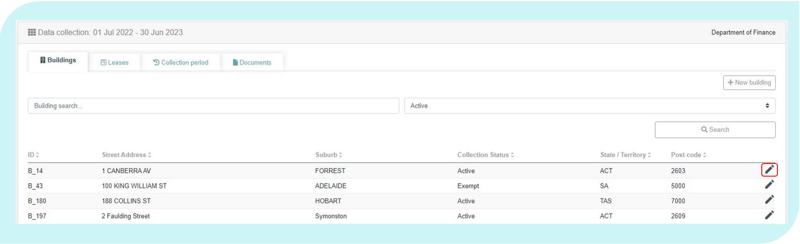

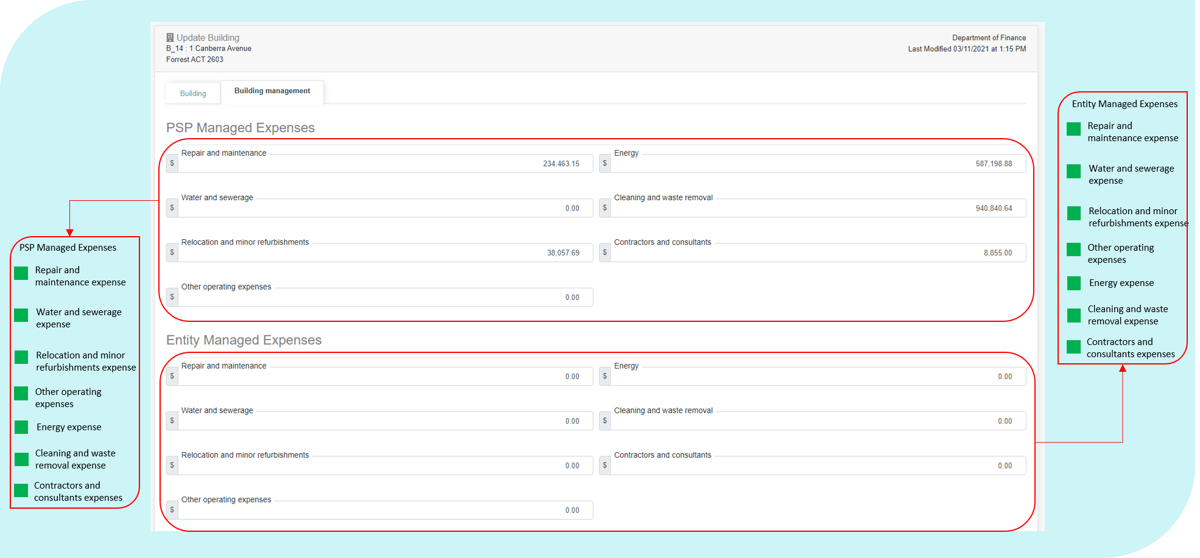

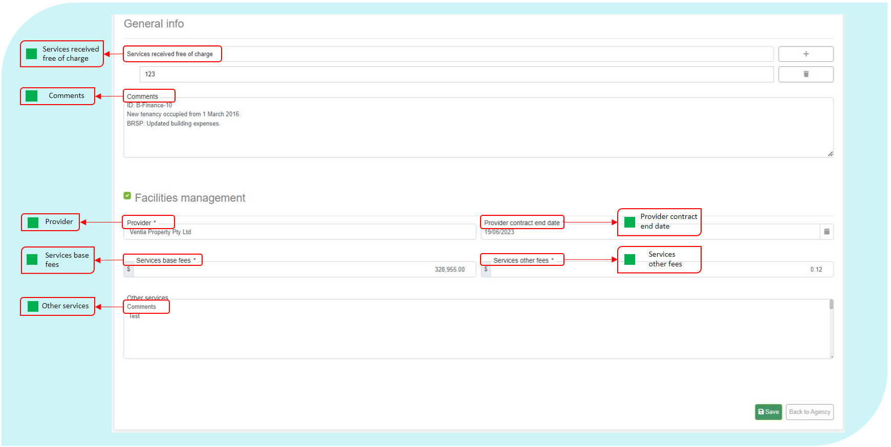

The following data definitions apply to this section.

|  |  |
| --- | --- |
|  | Please include the value for all property operating expenses for services received under the Property Services Coordinated Procurement arrangements in the expense fields prefixed with ‘**PSP Managed’**.  All operating expenses managed outside of these arrangements must be reported in the elements prefixed with **‘Entity Managed’.**  If you do not have a property service provider, please include all operating expense values in the data elements prefixed with ‘**Entity Managed’** |

|  |  |
| --- | --- |
| Split Tenancy Expense Fields | |
| **PSP Managed Operating Expense** | **Entity Managed Operating Expense** |
| Repair and Maintenance | Repair and Maintenance |
| Energy Expense | Energy Expense |
| Water and Sewerage Expense | Water and Sewerage Expense |
| Cleaning and Waste Removal Expense | Cleaning and Waste Removal Expense |
| Relocation and Minor Refurbishments Expense | Relocation and Minor Refurbishments Expense |
| Contractors or Consultants | Contractors or Consultants |
| Other operating Expense | Other operating Expense |
| **Combined Tenancy Expense Fields** | |
| Facilities Management Services Base Fees | |
| Facilities Management Services Other Fees | |

Repair and Maintenance Expense

|  |  |
| --- | --- |
| Definition: | Total actual, non-capitalised expenses (GST Inclusive) incurred by the Entity in the reporting period to keep the tenancy, onsite areas and building assets in a condition needed for the tenancy to function as intended by the Entity. |
| Include: | Cost of parts and labour for repair or maintenance of building assets, HVAC systems, fire protection systems, lighting, electrical wiring, electrical goods, plumbing, doors, windows, footpaths, gardens and grounds.  Cost of equipment testing and pest and vermin control.  Payments made to body corporate sinking funds.  Repair and maintenance for all areas in the tenancy, including office areas, non-office areas and leased-out areas.  Repair and maintenance to the base building if it is payable to a vendor other than the lessor (as per some triple net leases).  (As an offset) any discounts or reimbursements received for repair or maintenance received in the same reporting period in which the expenses were paid by the Entity. |
| Exclude: | Repair and maintenance costs that are capitalised and expensed across more than one financial year through depreciation of capitalised assets or make good provisions.  Repair and maintenance costs payable to the lessor. Any costs paid to a lessor should be included in Lessors Outgoing Expense.  Reimbursement of any repair and maintenance expenses incurred during previous reporting periods.  Depreciation deductions.  Professional or consultancy fees to obtain specialist advice on building condition.  Cost of establishing and managing contracts for repair and maintenance, coordinating repair and maintenance activities or paying accounts for repairs and maintenance.  General payments made to bodies corporate for property management services.  Repair and maintenance of security and ICT equipment.  Cleaning, rest-room services or waste removal – these will be reported in the field Cleaning and Waste Removal Expense.  Cost of non-capitalised refurbishments or minor works. |
| Format: | Positive value, whole Australian dollars [$nn,nnn,nnn] |

Energy Expense

|  |  |
| --- | --- |
| Definition: | Total actual expenses (GST Inclusive) incurred by the Entity in the reporting period for the supply of electricity, gas or other energy. |
| Include: | All energy costs paid by the Entity to a vendor other than the lessor. Any costs paid to a lessor should be included in Lessors Outgoing Expense.  Cost of heating, ventilation and air conditioning (HVAC) electricity and any fuels used for back-up power generation within the tenancy. It may also include energy supply to base building facilities where a net or triple net lease is in place.  (As an offset) any discounts or reimbursements received for energy supply received in the same reporting period in which the expenses were paid by the Entity. |
| Exclude: | Energy payments to the lessor. Any costs paid to a lessor should be included in Lessors Outgoing Expense.  Reimbursement of any energy expenses incurred during previous reporting periods.  Fuel costs for motor vehicles.  Recovered expenses from lessees or sublessees. That is, do not offset the expenses by amounts received for energy supply. |
| Format: | Positive value, whole Australian dollars [$nn,nnn,nnn] |

Water and Sewerage Expense

|  |  |
| --- | --- |
| Definition: | Total actual expenses (GST Inclusive) incurred by the Entity in the reporting period for the supply of water and sewerage services. |
| Include: | All water and sewage costs paid by the Entity to a vendor other than the lessor. Any costs paid to a lessor should be included in Lessor’s Outgoing Expense.  (As an offset) any discounts or reimbursements received for water and sewerage received in the same reporting period in which the expenses were paid by the Entity. |
| Exclude: | Water and sewerage costs that are covered by rent. (Any costs paid to a lessor should be included in Lessor’s Outgoing Expense).  Reimbursement of any water and sewerage expenses incurred during previous reporting periods. |
| Format: | Positive value, whole Australian dollars [$nn,nnn,nnn] |

Cleaning and Waste Removal Expense

|  |  |
| --- | --- |
| Definition: | Total actual expenses (GST Inclusive) incurred by the Entity in the reporting period for cleaning or removal of waste. |
| Include: | Cost of regular or incidental cleaning of the premises, including carpet and window cleaning, sanitary supplies and services, recycling and the removal of rubbish, green waste and security classified material.  Cost of cleaning consumables (i.e. hand towels, soaps, etc.)  All such cleaning and waste costs are to be reported, irrespective of whether they are in relation to an operational activity, non-office area, office area or leased-out area.  Cleaning of base building facilities where the Entity pays these costs, for example, where a triple net lease is in place.  (As an offset) any discounts or reimbursements received for cleaning and waste removal received in the same reporting period in which the expenses were paid by the Entity. |
| Exclude: | Expenditure on cleaning and waste removal that is paid to the lessor. Any costs paid to a lessor should be included in Lessor’s Outgoing Expense.  Reimbursement of any cleaning expenses incurred during previous reporting periods.  The cost of disposing of biological, chemical, radioactive or hazardous waste that is generated from the delivery of core functions of the Entity.  The cost of disposing of ICT equipment or security equipment.  The cost of establishing or managing contracts for cleaning and waste removal. |
| Notes: | Where costs are incurred across more than one tenancy and the amount attributable to each tenancy is not easily available, the costs are to be apportioned between tenancies according to the NLA of each tenancy or a more accurate method if one is available. |
| Format: | Positive value, whole Australian dollars [$nn,nnn,nnn] |

Relocation and Minor Refurbishments Expense

|  |  |
| --- | --- |
| Definition: | Actual expenses (GST Inclusive) incurred in the reporting period by the Entity to undertake non-capitalised refurbishments and relocation expenses. |
| Include: | Cost of changes to refurbishments that were not capitalised and were directly expensed to the income statement in the reporting period.  Cost of make good, where this cost was not included in the depreciation of assets.  Cost of removals and other relocation costs to enable refurbishment.  Cost of removals and relocation costs from normal churn or organisational restructures.  Depreciation deductions.  (As an offset) any discounts or reimbursements received for relocation and minor refurbishment received in the same reporting period in which the expenses were paid by the Entity. |
| Exclude: | Reimbursement of any expenses paid for relocation and minor refurbishment incurred during previous reporting periods.  Removal and relocation costs that are capitalised and expensed across more than one financial year through depreciation of capitalised assets or make good provision.  Costs of relocating ICT equipment.  Routine repair and maintenance. This is reported in Repair and maintenance expense. |
| Notes: | Relocation and removal expenses that relate to movements from one tenancy to another are to be attributed to the destination tenancy.  Where costs are incurred across more than one tenancy and the amount attributable to each tenancy is not easily available, the costs are apportioned between tenancies according to the NLA of each tenancy or a more accurate method if one is available.  Any fit-out costs are to be reported in the fields Last Year Major Fit-out Cost Conducted, Last Major Fit-out Cost and Total Fit-out Cost. |
| Format: | Positive value, whole Australian dollars [$nn,nnn,nnn] |

Contractors and Consultants

|  |  |
| --- | --- |
| Definition: | Total actual cost (GST Inclusive) for contractors or consultants procured to assist with property administration or management or provide specialist property advice. |
| Include: | Total actual cost for contractors and consultants delivering ad hoc property related services in the reporting period. |
| Exclude: | Any costs of contractors and consultants that has been capitalised through the capital work project budget. |
| Format: | Positive value, whole Australian dollars [$nn,nnn,nnn] |

Other Operating Expenses

|  |  |
| --- | --- |
| Definition: | Other substantial actual expenses (GST Inclusive) incurred in the reporting period by the Entity for the tenancy and onsite facilities to function as intended by the Entity. |
| Include: | Indoor plant hire.  Fire warden and emergency evacuation supplies.  Increases to an initial estimate of make good provision that is directly expensed in the income statement and interest expenses from unwinding of discounts associated with the provision of make good.  Other substantial operating expenses not included or excluded elsewhere in these specifications.  (As an offset) any discounts or reimbursements received in relation to other substantial operating expenses received in the same reporting period in which the expenses were paid by the Entity. |
| Exclude: | Reimbursement of any other operating expenses incurred during previous reporting periods. Cost of ICT services, ICT equipment or telecommunications. Cost of office consumables, such as paper, stationery, ad hoc cleaning products. Cost of first aid training, equipment or supplies. Cost of mailroom or courier services, offsite storage or archiving. Depreciation deductions. Disaster recovery costs. Insurance costs. Transport costs. Security costs. |
| Notes: | This element is used to identify costs incurred by the Entity that are not identified in the other cost data elements.  Where costs are incurred across more than one tenancy and the amount attributable to each tenancy is not easily available, the costs are apportioned between tenancies according to the NLA of each tenancy or a more accurate method if one is available. |
| Reference: | Resource Management Guide 114 may be applicable. |
| Format: | Positive value, whole Australian dollars [$nn,nnn,nnn] |

Services Received Free of Charge

|  |  |
| --- | --- |
| Definition: | Services received (GST Inclusive) as part of the lease agreement, free of charge. |
| Notes: | Only include services that the provided free of charge under current lease arrangements. For example cleaning, building maintenance, security. |
| Format: | [Text] |

Comments

|  |  |
| --- | --- |
| Definition: | Any comments that the Entity would like to include to support data relating to building information. |
| Format: | [Text] |

Facilities Management – Provider

|  |  |
| --- | --- |
| Definition: | Name of facilities management provider (if applicable). |
| Notes: | If the Entity does not use a facilities management provider (i.e. facilities management contracts are managed in house), leave blank. |
| Format: | [Text] |

Facilities Management Provider Contract End Date

|  |  |
| --- | --- |
| Definition: | End date of the facilities management provider contract (if applicable). |
| Notes: | If the Entity does not use a facilities management provider (i.e. facilities management contracts are managed in house), leave blank. |
| Format: | [dd/mm/yyyy] |

Facilities Management – Services Base Fees (excluding pass through costs)

|  |  |
| --- | --- |
| Definition: | Total non-capitalised expenses (GST Inclusive) of external property service providers for the delivery of facilities management services to the building. |
| Include: | Total base costs for external property service providers delivering property management services for the building on behalf of the Entity. |
| Exclude: | If the Entity does not use a facilities management provider (i.e. facilities management contracts are managed in house) for the building, leave blank.  Other contractors and consultants delivering ad hoc property services during the reporting period.  Pass through costs. |
| Notes: | If the Entity pays one total fee for facilities management for all properties use the following example and formula to calculate the fee per building:  If the base fee for the facilities manager is $1,000,000 across three buildings  as below;  Building 1 has a total Net Lettable Area of 5,000m2 Building 2 has a total Net Lettable Area of 10,000m2 Building 3 has a total Net Lettable Area of 15,000m2  The total Net Lettable Area the Facilities Manager is responsible for is 30,000m2  The total Base fee should then be divided by the total Net Lettable Area (1,000,000 ÷ 30,000 = 33.3333333)  The Base fee can then be apportioned in AGPR as follows: Building 1 (5,000m2 x 33.3333333 = $166,666.67) Building 2 (10,000m2 x 33.3333333 = $333,333.33) Building 3 (15,000m2 x 33.3333333 = $500,000.00)  The total of the apportioned costs must be equal back to the total base fee of $1,000,000. |
| Format: | Positive value, whole Australian dollars [$nn,nnn,nnn] |

Facilities Management – Services Other Fees (excluding pass through costs)

|  |  |
| --- | --- |
| Definition: | Total non-capitalised expenses (GST Inclusive) of services delivered by the facilities management provider not included in the base fee. |
| Include: | Total other fees charged by the external facilities management service providers delivering lease management services for the Entity for the building not included in the base fee. |
| Exclude: | If the Entity does not use a facilities management provider (i.e. facilities management contracts are managed in house) for the building, leave blank.  Other contractors and consultants delivering ad hoc property services during the reporting period.  Pass through costs. |
| Notes: | If the Entity pays one total other services fee for facilities management for all properties, use the example and formula in Services Base Fees to calculate the other services fee per building. |
| Format: | Positive value, whole Australian dollars [$nn,nnn,nnn] |

Other (Facilities Management) Services

|  |  |
| --- | --- |
| Definition: | Name of other facilities management providers, services provided and contract end dates not included in the fields Facilities Management – Provider and Facilities Management Provider Contract End Date. |
| Include: | Other facilities management providers directly contracted by the Entity. |
| Exclude: | Sub-contractors engaged by the facilities management providers. |
| Format: | [Text] |

* 1. Leases

The Leases table includes all tenancy Leases belonging to an Entity.

Within the Lease record, which users can access by clicking the icon at the end of line, there are four sub tabs. These tabs include data elements that will defined in the next section.

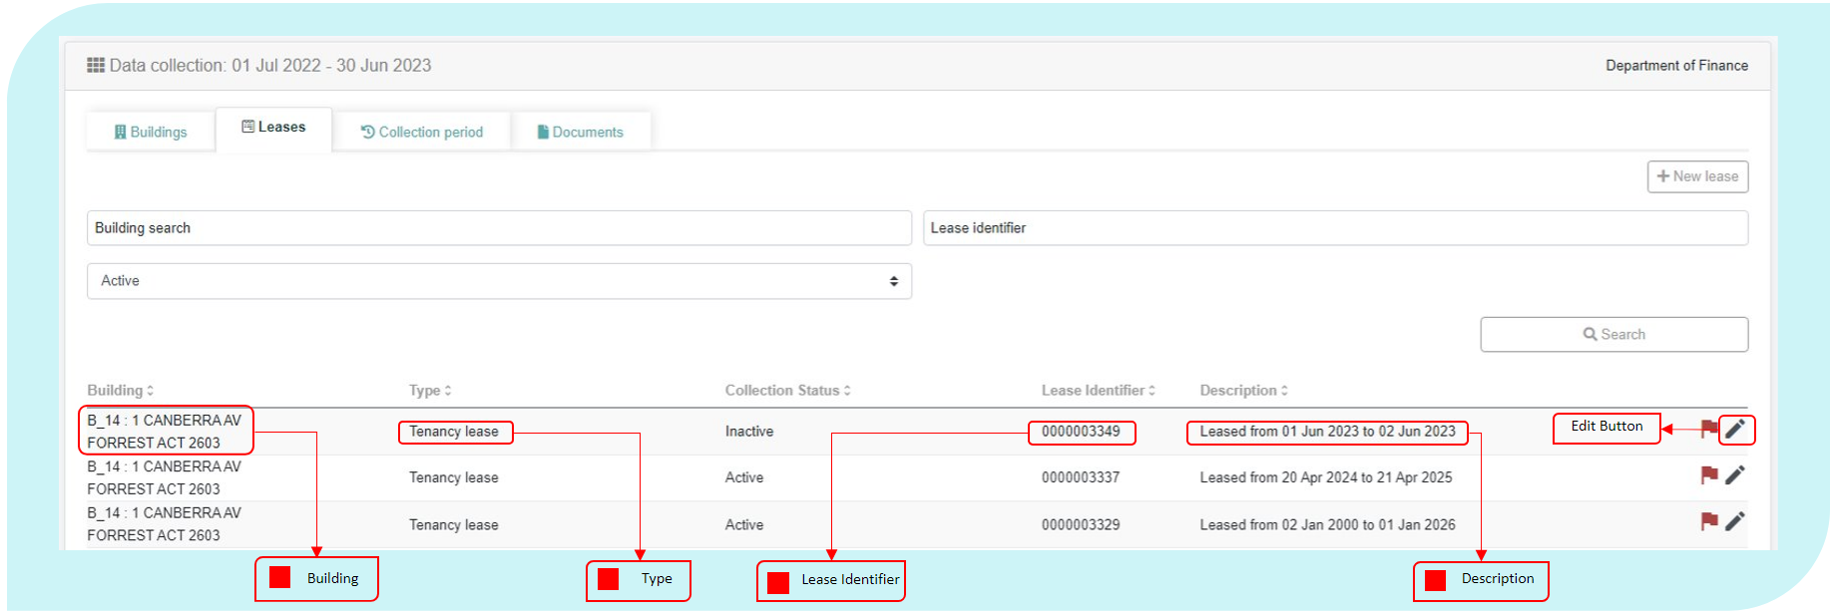To create a new lease, Entities can select the button located at the top right of the table. To edit an existing lease, select the edit button at the end of a record.

During collection periods, Entities will be asked to confirm that the information contained in each lease record is correct as at 30 June 2023. Clicking the flag icon, located to the right of the record but before the edit button, will change the flag colour from red to green to indicate that the lease record has been confirmed. The ‘confirm all’ button at the bottom right hand side of the table will confirm each lease record. Entities can opt to use this function to track which data has been finalised.

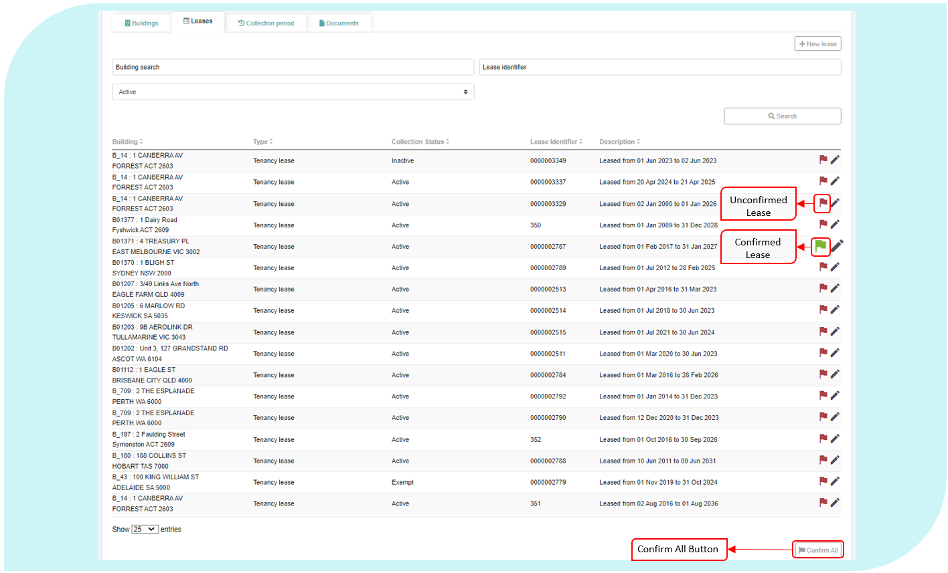

The following data definitions apply to this section.

Building

|  |  |
| --- | --- |
| Definition: | This is a reference field that displays the Building ID, name and address that an Entity has previously provided to Finance. |
| Format: | [Text] |

Type

|  |  |
| --- | --- |
| Definition: | This is a reference field that displays the type of lease under which the Entity is occupying or has the right to occupy the building. |
| Notes: | From 2018 onwards, the only Lease Type will be ‘Tenancy lease’. |
| Format: | [Text] |

Lease Identifier

|  |  |
| --- | --- |
| Definition: | A unique, system auto-generated, number that a lessee can use to identify a lease. |
| Notes: | System generated unique ID. |
| Format: | [nnnnnnnnnn] |

Collection Status

|  |  |
| --- | --- |
| **Definition:** | Select whether or not the lease is to be considered in scope for the Office Data Collection. |
| Notes: | Status applied to a building record will be automatically applied to all leases within the building.  Status applied to a lease won’t be applied to subleases within the lease. Sublease status must be updated manually, and any affected entities notified of the change. |
| Format: | [Pick from list]   |  |  | | --- | --- | | **Code** | **Meaning** | | Active | Lease is to be included in the Collection. | | Inactive | Lease is expired or abolished.  NB: Tenancies marked ‘Inactive’ will be removed from the AGPR at the closure of the Collection. | | Exempt | Lease is exempt from inclusion in the Collection, and an exemption request has been approved by the Property Data Team. | | Out of scope | Lease is out of scope for the Collection. | |

PSP internal ID

|  |  |
| --- | --- |
| **Definition:** | Unique identifier assigned to the building record within PSP internal systems. |
| Notes: | Each tenancy record should have a unique internal ID.  It is preferable for PSPs to use the same internal IDs through multiple collection periods. |
| Include: | Unique identifier that can be used to cross-match AGPR data with PSP internal systems. |
| Exclude: | * Lease description (record in ‘Lease Description’ field) * Comments (record in ‘Comments’ field) * Unique identifier used in Entity internal systems (record in ‘Comments’ field) |
| Format: | Free text |

Description

|  |  |
| --- | --- |
| Definition: | This is a reference field that displays the start and end date of the lease. |
| Format: | [Text] |

* + 1. Tenancy Leases

All new and existing leases in the AGPR are treated as tenancy leases. An existing tenancy lease is accessible through the view button of a tenancy lease record. Where Entities own their office-space, they should select the ‘Owned’ option in the Lease Type and Lease Status fields.

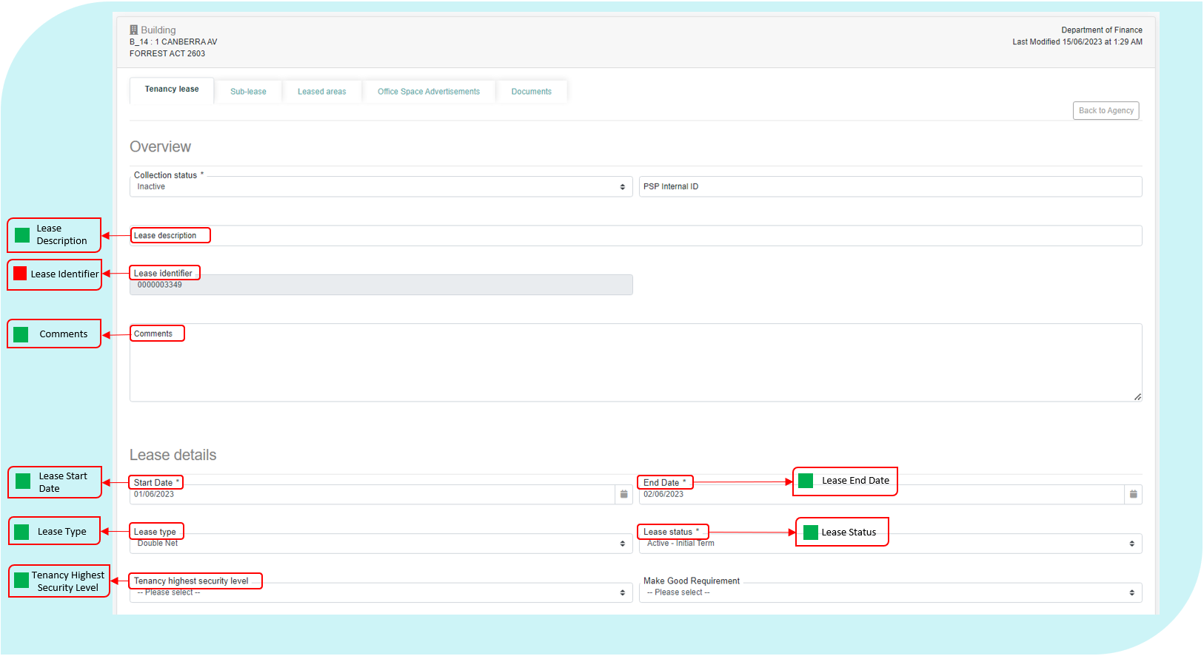

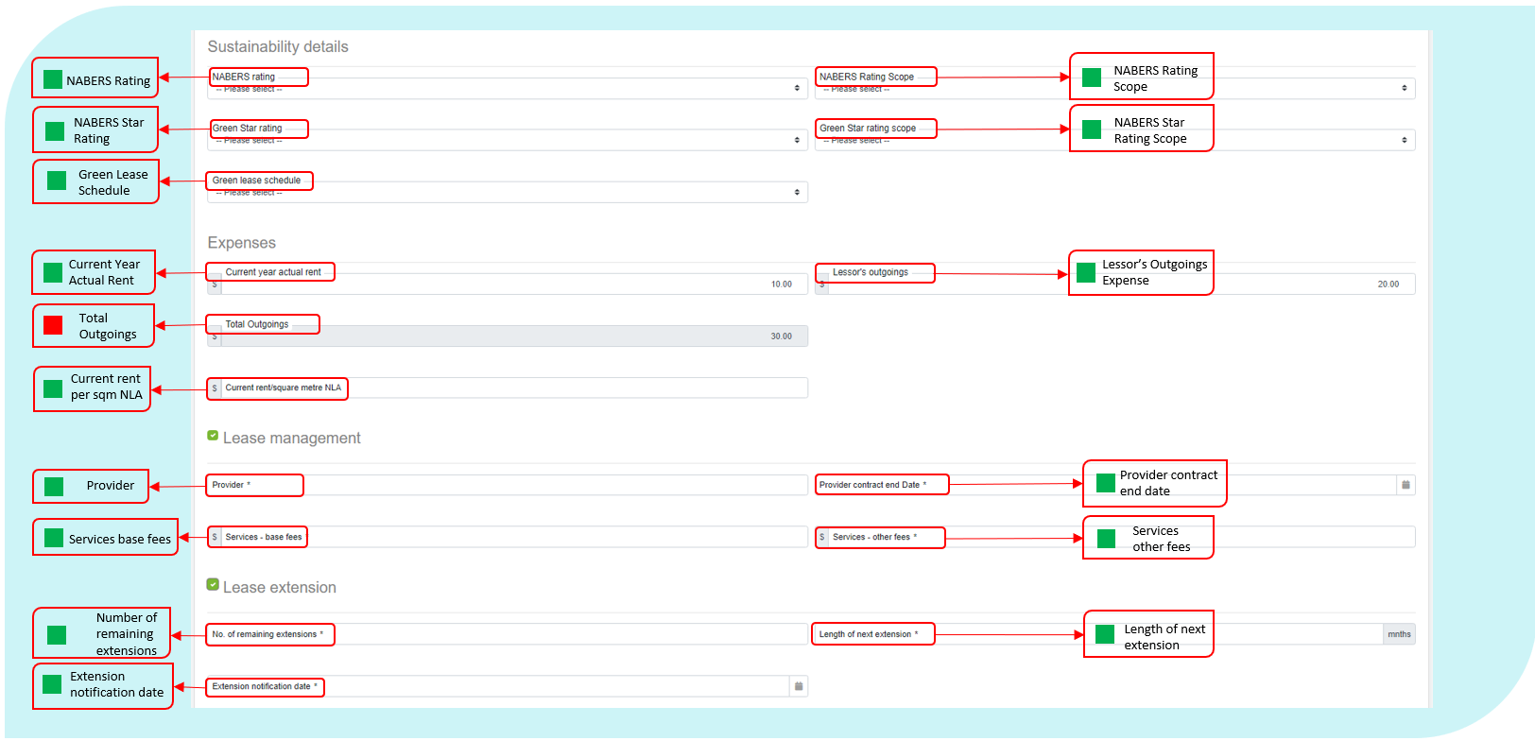

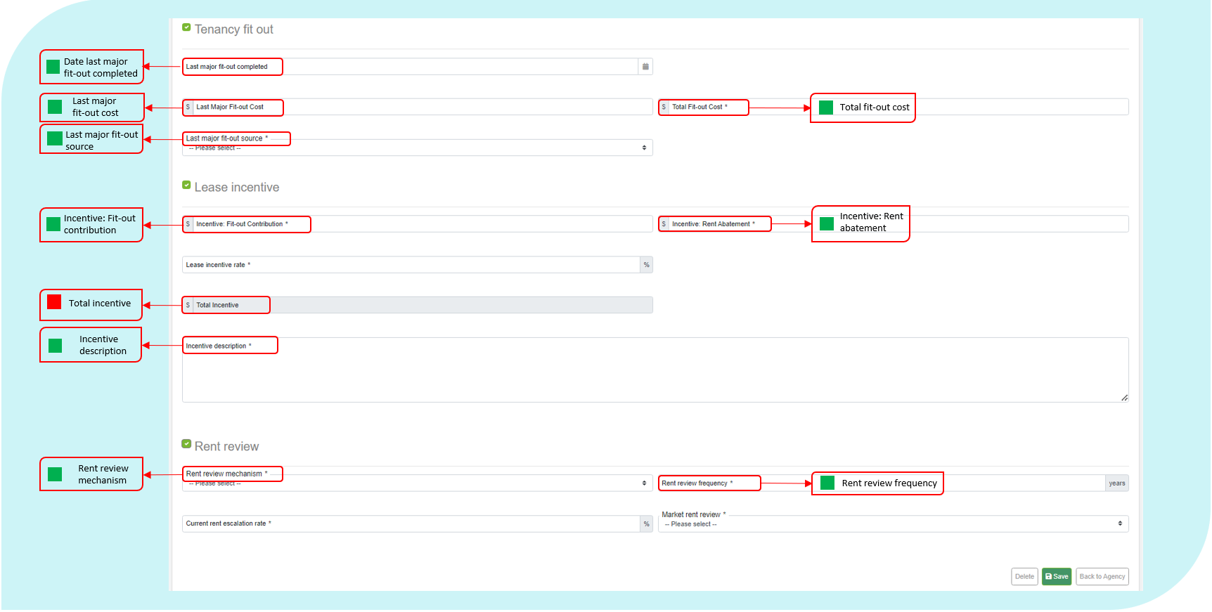

To create a new tenancy lease, select the New Lease button.

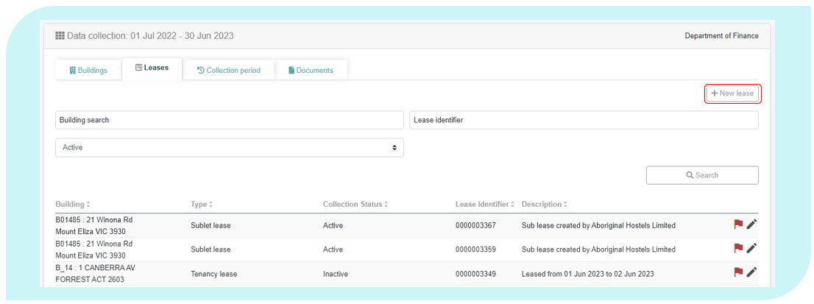

The following data definitions apply to this section.

Lease Description

|  |  |
| --- | --- |
| Definition: | An Entity-generated reference number or short descriptive text for a lease. This field provides Entities with the ability to record the unique identifier from their own system to enable faster and more accurate data matching between entity, PSP and AGPR data sources. |
| Notes: | Each lease should have a unique lease description.  It would be preferable if Entities use the same lease identifiers through multiple collection periods. |
| Format: | Free text |

Comments

|  |  |
| --- | --- |
| Definition: | Any comments that the Entity would like to include that further supports or explains data relating to the lease. |
| Notes: | A comments field to provide additional context for the lease record such and are encouraged. |
| Format: | [Text] |

Lease Start Date

|  |  |
| --- | --- |
| Definition: | The date when the lease obligation for the property began. |
| Notes: | This is the start date of the *initial* term of the lease, regardless of whether or not lease extensions have been taken. |
| Exclude: | Any updated state date where a new lease has been negotiated at the same premises.  Engagement of a new lease at an existing premises must be reported as a separate lease record. |
| Format: | [dd/mm/yyyy] |

Lease End Date

|  |  |
| --- | --- |
| Definition: | The date when the current obligation to lease the property ends. |
| Notes: | For initial term leases, this is the end date of the initial term.  For leases in a lease extension period, this is the end date of the current lease extension period. |
| Exclude: | Options periods that have not yet been exercised. |
| Format: | [dd/mm/yyyy] |

|  |  |
| --- | --- |
| Definition: | The type of lease under which the Entity is occupying or has the right to occupy the building. |
| Notes: | The type of lease is to be determined from the terms and conditions contained in the current lease as they relate to the coding below.  If the lease is in a holdover period, the Entity is to report the lease type that applied immediately prior to commencing the holdover period.  Classification into lease type is based on what the Entity is obliged by the lease to pay, irrespective of whether the Entity meets the costs directly or through reimbursement to the lessor.  Important: Commonwealth subleases (e.g. MOUs) are to be reported as either a *Fully Gross* or *Gross* lease to ensure correct treatment of sublease revenue and rent in the AGPR. This is required to match the reporting requirements in the Sublease Revenue field. Reporting in this manner then requires reconciliation of the Total Outgoings field with Sublease Revenue, while Rent minus Lessors Outgoing Expenses. |
| Format: | [Pick from List]   |  |  | | --- | --- | | **Code** | **Meaning** | | Fully Gross | Entity is obliged to pay only rent (inclusive of lessor’s outgoings) to the lessor. | | Gross | Entity is obliged to pay rent (inclusive of lessor’s outgoings) and increases to statutory charges to the lessor. | | Single Net | Also known as a net lease, requires the Entity to pay property taxes in addition to rent. | | Double Net | Requires the Entity to pay the property taxes and insurance premiums in addition to rent. | | Triple Net | A triple-net lease requires the Entity to pay rent plus property taxes, insurance premiums and maintenance costs. | | Owned | The building is owned by the Entity. | | Not Recorded | The Lease Type is not known. | |

Lease Type

Lease Status

|  |  |
| --- | --- |
| Definition: | The status of the current property lease as at 30 June of the reporting year. |
| Notes: | If a lease is reported as ‘expired’, the related lease record will not be available when a new collection period is activated.  Leases that have expired but are continuing on a month-to-month basis, without new terms being agreed (for example, lease negotiations are in progress), must be reported as ‘Holdover’.  Leases that are yet to be formally agreed but are occupied under a *heads of agreement* should be reported as ‘Pending’.   |  |  | | --- | --- | |  | The lease status must be reported as at the Collection End Date.  Any lease with an end date of 30 June in the given reporting year must be reported as ‘Active’ or ‘Holdover’ as it is deemed active as at that date. | |
| Format: | [Pick from List]   |  |  | | --- | --- | | **Code** | **Meaning** | | Active - Initial Term | The lease is active and still in the initial term. | | Active – Lease Extension Period | The lease is active and in an extension period. | | Expired | The Lease agreement has elapsed its end date, no further extension options have been exercised, and the tenancy has been relinquished back to the landlord. | | Holdover | The lease has expired but is continuing on a month-to-month basis without new terms being agreed. | | Pending | The property is occupied under a *heads of agreement* without an agreed lease contact. | | Owned | The building is owned by the Entity. | |

Make Good Requirement

|  |  |
| --- | --- |
| **Definition:** | **The type of the *make good* requirement included in the lease.** |
| Include: | The type of the make good requirement as recorded in the clauses for the lease (if applicable). |
| Exclude: |  |
| Note: | Make good provisions are not a standard element of the Commonwealth National Lease, however in some cases they are included where the landlord requires it. This field will capture the details of the type of make good provision included in a lease. |
| Reference: | [RMG 110 - Accounting for Leases](https://www.finance.gov.au/government/managing-commonwealth-resources/accounting-leases-rmg-110) |
| Format: | [Pick from list]   |  |  | | --- | --- | | **Code** | **Meaning** | | No make good provision | There is no requirement to make good the tenancy at the end of the lease. | | Removal of detachable property only | The tenant is required to remove their property (that is detachable) from the tenancy, for example: workstations, lockers, filing cabinets, free-standing bookcases, etc. | | Removal of all property and basic repairs | The tenant is required to remove all property, which includes all detachable property as well as any property that has been fixed to the premises. Basic repairs, such as ensuring all walls, etc. are in the same condition as the entry condition may also be required. | | Return the premises to state of condition report | The tenant is required to return the premises to the standard shown in a condition report. | | Base building standard | The tenant is required to be returned to the state it was in when it was first occupied.  This may include removal of plumbing, wiring, installations and fit-outs as well as attached and detached property. | |

Green Star Rating

|  |  |
| --- | --- |
| **Definition:** | The Green Star rating applied to the building or lease. |
| Exclude: | * Green lease schedule * NABERS rating |
| Reference: | <https://new.gbca.org.au/green-star/certification-process/> |
| Format: | [Pick from list]   |  |  | | --- | --- | | Code | Meaning | | 1 Star | Minimum practice | | 2 Star | Average practice | | 3 Star | Good practice | | 4 Star | Best practice | | 5 Star | Australian excellence | | 6 Star | World leadership | | Pending | Application has been submitted and is pending assessment | | No assessment undertaken | To date, no assessment has been completed, and no assessment is currently pending. | |

Green Star Rating Source

|  |  |
| --- | --- |
| **Definition:** | The scope of the Green Star rating applied to the building or lease. |
| Notes: | Not required if *Green Star Rating* is ‘Pending’ or ‘No Assessment Undertaken’. |
| Reference: | <https://new.gbca.org.au/green-star/certification-process/> |
| Format: | [Pick from list]   |  |  | | --- | --- | | **Code** | **Meaning** | | Performance | Minimum practice | | Building | Average practice | | Design & As Built | Good practice | | Interiors | Best practice | | Communities | Australian excellence | |

Green Lease Schedule

|  |  |
| --- | --- |
| Definition: | Type of agreement between the Entity and lessor that sets out each party’s role in the achievement of energy efficiency objectives. |
| Notes: | Only code a property as a type of GLS if it has a current Green Lease Schedule, as defined in the Green Lease Schedules Guidance Notes - Energy Efficiency in Government Operations (EEGO Policy). |
| Reference: | Energy Efficiency in Government Operations Policy at: <https://www.energy.gov.au/publications/energy-efficiency-government-operations-policy> |
| Format: | [Pick from List]   |  |  | | --- | --- | | **Code** | **Meaning** | | GLS A | Green Lease Schedule, type A1 or A2 | | GLS B | Green Lease Schedule, type B1 or B2 | | GLS C | Green Lease Schedule, type C1 or C2 | | GLS D | Green Lease Schedule, type D1 or D2 | | Nil | No energy efficiency agreement currently in place | | Other | Another form of energy efficiency agreement | | Pending | Green Lease Schedule yet to be determined | | Not recorded | Not available. | |

Tenancy Highest Security Level

|  |  |
| --- | --- |
| Definition: | The Protective Security Policy Framework mandates Entities design and modify their facilities in order to define restricted access areas according to the five security zones, with increasing restrictions and access controls as the zones progress from Zone One to Zone Five.  Buildings or tenancies may have a number of different zones. The Tenancy highest security reflects the highest level of security in the current building or tenancy. |
| Notes: | The tenancy’s highest-rated security zone in accordance with the Protective Security Policy Framework, Policy 16.  Section *C.6 Security zone certification and accreditation* refers to the requirements to obtain this information for a tenancy. |
| Include: | The highest security classification of all areas within the tenancy.   |  |  | | --- | --- | |  | Where a tenancy’s highest-rated security zone is known, it **must** be reported accurately.  Entities **must not** report a value of *Unknown* where the rating is actually known. | |
| Exclude: | Any areas of the tenancy that are not part of the controlled area. |
| Reference: | The Protective Security Policy Framework at:  https://www.protectivesecurity.gov.au/physical/entity-facilities/Pages/default.aspx |
| Format: | [Pick from List]   |  |  | | --- | --- | | **Code** | **Meaning** | | Zone 1 | Public access | | Zone 2 | Restricted public access. Unrestricted access for authorised personnel.  May use single factor authentication for access control. | | Zone 3 | No public access.  Visitor access only for visitors with a need to know and with close escort.  Restricted access for authorised personnel.  Single factor authentication for access control. | | Zone 4 | No public access. Visitor access only for visitors with a need to know and with close escort. Restricted access for authorised personnel with appropriate security clearance. Single factor authentication for access control. | | Zone 5 | No public access. Visitor access only for visitors with a need to know and with close escort. Restricted access for authorised personnel with appropriate security clearance. Dual factor authentication for access control. | | Unknown | Floor highest security level not known. | |

Current Year Actual Rent

|  |  |
| --- | --- |
| Definition: | Total, actual effective rent (GST Inclusive) expense of the lease for all net lettable areas within the tenancy, and onsite storage within the reporting period. |
| Include: | Minimum actual lease payments.  Rent expenses for all net lettable areas in the building, including office areas, non-office areas and subleased areas.  Rent expenses for all onsite storage.  Rent for offsite storage where it can be used for office space.  Lessors Outgoings, for Fully Gross and Gross leases. For these lease types the Lessors Outgoings are not added to Current Year Actual Rent to calculate Total Outgoings as it is expected the value is reported within this field. This is especially important for Commonwealth MOU subleases where Total Revenue for the sublease will include these outgoings as well as rent. |
| Exclude: | Non-office areas such as grounds.  Monetary benefit of any incentives as these are captured separately.  Rent for offsite storage that cannot be used for office space.  Anything that is included in a separate lease.  Rents received from sub-leasing arrangements. That is, do not offset the rent expenses by rent received. This data is collected elsewhere in the system.  Rent expenses for onsite and offsite car parking facilities that have been acquired as part of the lease for Entity staff in the building or people visiting Entity staff in the tenancy. |
| Note: | This figure would be the exact actual expenditure, regardless of Lease Type.  Current Annual Rent must be reported GST Inclusive.  Where a sublessor pays rent directly to the head-lessor’s landlord this must be reported at this item, while Sublease Revenue paid to the head-lessor is accounted for in Section 2.2. |
| Reference: | RMG 110 - Accounting for operating lease expenses and incentives |
| Format: | Positive value, whole Australian dollars [$nn,nnn,nnn] |

Lessor’s Outgoings Expense

|  |  |
| --- | --- |
| Definition: | Total actual expense (GST Inclusive) incurred by the Entity in the reporting period for all outgoings payable to the lessor. |
| Include: | All expenses payable to the lessor under the relevant lease/s, other than rent, such as: landscaping, cleaning, maintenance, after-hours air conditioning.  Lessor’s outgoings for all leased areas in the tenancy, including office areas, non-office areas and leased-out areas.  (As an offset) reimbursement of lessor’s outgoings received in the same reporting period in which the outgoings were paid by the Entity. |
| Exclude: | Reimbursement of lessor’s outgoings incurred during previous reporting periods.  Outgoings that are included in the rent and not separately charged by the lessor.  Outgoings paid to vendors other than the lessor, these should be covered in the Building Management section. |
| Notes: | If the lease type is *Fully Gross* or *Gross*, please provide an estimate of the Lessor’s Outgoings Expense and ensure the amount has been included in the Current Year Actual Rent field. This estimate figure should not affect the accurate reporting of the gross lease amount. Finance will analyse this information separately to ensure that this expense is not double counted.  If the lease type is *Single*, *Double* or *Triple Net*, this figure must be the exact actual expenditure.  Report all non-rent payments to the lessor irrespective of whether they relate to the base building.  Report $0 for owned tenancies.  Lessor’s Outgoing Expense must be reported GST Inclusive. |
| Format: | Positive value, whole Australian dollars [$nn,nnn,nnn] |

Current Rent per sqm

|  |  |
| --- | --- |
| Definition: | Current gross effective rent (GST Inclusive) expense of the lease per square metre of net lettable area. |
| Include: | Gross lease rental rate (inclusive of GST) per square metre of total net lettable area (including all sub-let areas) as at the reporting date, for example $650 per sqm. |
| Exclude: | Any values in excess of the base building rent, for example:   * Lessors outgoing expenses. * Rent for offsite storage that cannot be used for office space. * Anything that is included in a separate lease. * Rents received from sub-leasing arrangements. That is, do not offset the rent expenses by rent received. * Rent expenses for onsite and offsite car parking facilities that have been acquired as part of the lease for Entity staff in the building or people visiting Entity staff in the tenancy. |
| Note: | Unlike the current year rent field, which captures the total dollar value for the lease for the reporting period, this value is the rental rate (per sqm) applicable to the lease as at the reporting date.  Current Rent per sqm must be reported GST Inclusive. |
| Reference: | [RMG 110 - Accounting for Leases](https://www.finance.gov.au/government/managing-commonwealth-resources/accounting-leases-rmg-110) |
| Format: | Positive value, Australian dollars and cents [$nn,nnn,nnn.nn] |

Total Outgoings

|  |  |
| --- | --- |
| Definition: | The total amount of outgoing expenses. |
| Notes: | If the lease type is Fully Gross or Gross, the total will be only Current Annual Rent expense.  If the lease type is either Single, Double or Triple Net, the total will be of Current Annual Rent expense and Lessor’s Outgoings expense. |
| Format: | Data Auto Total: Positive value, whole Australian dollars [$nn,nnn,nnn] |

Provider

|  |  |
| --- | --- |
| Definition: | Name of lease management provider. |
| Notes: | If the Entity does not use a lease management provider (i.e. leases are managed in house), leave blank. |
| Format: | [Text] |

Provider Contract End Date

|  |  |
| --- | --- |
| Definition: | End date of the lease management provider contract. |
| Notes: | If the Entity does not use a lease management provider (i.e. leases are managed in house), leave blank. |
| Format: | [dd/mm/yyyy] |

Services - Base Fees

|  |  |
| --- | --- |
| Definition: | Total cost (GST Inclusive) of external lease management services provided for the Entity’s property portfolio. |
| Notes: | Field should exclude pass through costs.  If a single total fee is paid for lease management for all properties use the following example and formula to calculate the fee per building:  If the base fee for the lease manager is $1,000,000 across three buildings as below; Building 1 has a total Net Lettable Area of 5,000m2 Building 2 has a total Net Lettable Area of 10,000m2 Building 3 has a total Net Lettable Area of 15,000m2  The total Net Lettable Area the lease manager is responsible for is 30,000m2  The total Base fee should then be divided by the total Net Lettable Area (1,000,000 ÷ 30,000 = 33.3333333)  The base fee can then be apportioned in AGPR as follows: Building 1 (5,000m2 x 33.3333333 = $166,666.67) Building 2 (10,000m2 x 33.3333333 = $333,333.33) |
| Format: | Positive value, whole Australian dollars [$nn,nnn,nnn] |

Services – Other Fees

|  |  |
| --- | --- |
| Definition: | Total actual cost (GST Inclusive) of services delivered by the lease management provider not included in the base fee. |
| Notes: | Field should exclude pass through costs.  If a single payment for other services fee for lease management for all properties is paid, use the example and formula in Services Base Fees to calculate the other services fee per building. |
| Include: | Total other fees charged by the external lease management service providers delivering lease management services for the Entity not included in the base fee. |
| Exclude: | Other contractors and consultants delivering ad hoc property services during the reporting period.  Pass-through costs.  If the Entity does not use a lease management provider (i.e. leases are managed in house), leave blank. |
| Format: | Positive value, whole Australian dollars [$nn,nnn,nnn] |

Number of Remaining Extensions

|  |  |
| --- | --- |
| Definition: | Number of remaining lease extensions available under the current lease. |
| Notes: | If currently in an extension period, then only include the remaining lease extensions. |
| Format: | [nn] |

Length of Next Lease Extension

|  |  |
| --- | --- |
| Definition: | Length (in months) of next available lease extension period. |
| Notes: | Only note the length of the next extension under the lease agreement. |
| Format: | Number of months: [mm] |

Extension Notification Date

|  |  |
| --- | --- |
| Definition: | The notification date for the next lease extension. |
| Notes: | The final date to advise the lessor of the intent to exercise the next lease extension option. |
| Format: | [dd/mm/yyyy] |

Incentive: Rent Abatement

|  |  |
| --- | --- |
| Definition: | Lease incentive (as a dollar amount) provided by the Lessor that has been allocated as a rent reduction over the current term of the lease. |
| Notes: | A rent abatement is an agreement between the landlord and the tenant that provides a period of free or reduced rent. During the abatement period, the Entity is not required to pay full rent to occupy the lease. Abatement may include a rent free period in a block or proportioned rent reduction over the lease period.  Incentive’s for Rent Abatement must be reported GST Inclusive. |
| Include: | The full estimated amount of lease cost savings allocated from the lease incentive to rental abatement.  If the lease is currently in an extension period include any rent abatement incentive for the current lease extension. |
| Exclude: | Incentive payments that have been allocated to other uses, see the field Incentive: Fit-Out Contribution.  Rent abatement amounts related to unexercised extensions available under the current lease. |
| Format: | Positive value, whole Australian dollars [$nn,nnn,nnn] |

Incentive: Fit-out Contribution

|  |  |
| --- | --- |
| Definition: | Lease incentive (as a dollar amount) provided by the landlord that has been apportioned to the cost of fitting out the tenancy over the current term of the lease. |
| Notes: | Fit-out is the design and delivery of the interior partitioning, floor, ceiling, mechanical, electrical and environmental components to meet the requirements of the building’s occupants. This includes the customising and finishing of the base building (where base building is the raw floor space bounded by walls but not specifically adapted to the requirements of its occupants).  This includes the portion of fit-out works where the landlord has provided a contribution as a lease incentive, either through cash payment, or reimbursement. Alternatively, the landlord may carry out the fit-out works under prior agreements to the value of the incentive amount.  Incentives for Fit-out Contribution must be reported GST Inclusive. |
| Include: | This may include the value of an integrated fit out, or a cash payment or similar.  If the lease is currently in an extension period, then include any fit-out contribution incentive for the current lease extension. |
| Exclude: | Do not include fit-out costs funded from the Entity’s capital works budget. These will be captured in the full fit out costs data field.  Incentive amounts that are allocated to rent abatement, please record this in the Incentive: Rent Abatement field.  Lease incentive amounts related to unexercised extensions available under the current lease. |
| Reference: | Lease documentation |
| Format: | Positive value, whole Australian dollars [$nn,nnn,nnn] |

Lease incentive rate

|  |  |
| --- | --- |
| **Definition:** | **The lease incentive applicable for the current lease period, expressed as a percentage of gross rent payable for the current lease.** |
| Include: | When calculating the percentage, include the minimum yearly lease payments for all years in the current lease term, for example:   * If the lease is in an initial term of ten years and has two extensions of five years, the percentage would be the incentive divided by the first ten years rent. * If the lease is in an extension period of 5 years, following an initial term of 15 years, if there was no incentive paid for the extension then the percentage reported would be zero, regardless of whether an incentive was received at the beginning of the initial term of the lease. |
| Exclude: | When calculating the percentage do not offset the gross rent with any planned revenue from sub-leasing arrangements. |
| Note: |  |
| Reference: | [RMG 110 - Accounting for Leases](https://www.finance.gov.au/government/managing-commonwealth-resources/accounting-leases-rmg-110) |
| Format: | Percentage [nn.n%] |

Total Incentive

|  |  |
| --- | --- |
| Definition: | The total dollar value of all incentives associated with the current lease term. |
| Notes: | A lease incentive is a bonus or discount offered to a tenant in consideration for their entry into a lease. |
| Include: | The total dollar value of all lease incentives, including both cash-based incentives, such as fit-out subsidies or reimbursements (including integrated fit-outs), or rent abatement, as well as the value of other incentives such as early access to the tenancy.  This field should reflect the sum of Fit-out Contribution and Rent Abatement.  If in an extension period, include incentives negotiated as part of the lease extension to the total. |
| Format: | Data Auto Total: Positive value, whole Australian dollars [$nn,nnn,nnn] |

Incentive Description

|  |  |
| --- | --- |
| Definition: | A short description of any incentives associated with executing the lease (including estimated value if known). |
| Notes: | If in an extension period, only include incentives negotiated as part of the lease extension. |
| Format: | [Text] |

Last Major Fit-out Completed

|  |  |
| --- | --- |
| Definition: | The date the last major fit-out was completed. |
| Include: | The date the last major fit-out was completed. |
| Exclude: | Fit-out works or repairs and maintenance less than 20 per cent of the existing fit-out within the tenancy, or below the value for notification or referral to the Public Works Committee. |
| Notes: | Fit-out is the design and delivery of the interior partitioning, floor, ceiling, mechanical, electrical and environmental components to meet the requirements of the building’s occupants. This includes the customising and finishing of the base building (where base building is the raw floor space bounded by walls but not specifically adapted to the requirements of its occupants). This should be recorded at the date the last major fit-out was completed – even where it was prior to the current lease start date (for example, multiple continuous leases at the same location).  A major fit out is considered to have been undertaken when either :   * initial fit-out completed; or * more than 20 per cent of the tenancy’s existing fit-out was refreshed or replaced; or * the project was of a sufficient value to require notifying or referring to the Public Works Committee. |
| Reference: | Parliamentary Standing Committee on Public Works Procedure Manual, Entity PWC Submissions |
| Format: | Date value, [dd/mm/yyyy]. |

Last Major Fit-out Source

|  |  |
| --- | --- |
| Definition: | The source of the last major fit-out. |
| Notes: | Fit-out is the design and delivery of the interior partitioning, floor, ceiling, mechanical, electrical and environmental components to meet the requirements of the building’s occupants. This includes the customising and finishing of the base building (where base building is the raw floor space bounded by walls but not specifically adapted to the requirements of its occupants).  Where an Entity has commenced a new lease to continue occupancy of a tenancy, then Last Major Fit-out Source should include previous lease period in the tenancy.  Legacy Fit-out must only be selected if the fit-out details cannot be identified. All reasonable efforts must be made to ensure fit-out details reflect the actual source where possible. |
| Format: | [Pick from List]   |  |  | | --- | --- | | **Code** | **Meaning** | | Entity | The Entity was responsible for organising the fit-out. | | Landlord | The landlord was responsible for organising the fit-out. | | Existing Fit-out | No fit-out was conducted at the commencement of the tenancy with the entity utilising an existing fit-out that was completed before the tenancy was advertised. | | Legacy Fit-out | The fit-out was conducted at least 10 years ago and details are unable to be confirmed. | |

Last Major Fit-out Cost

|  |  |
| --- | --- |
| Definition: | The cost of the most recent major fit-out project.  See: Last Major Fit-out Completed for definition of major fit-out. |
| Notes: | Fit-out is the design and delivery of the interior partitioning, floor, ceiling, mechanical, electrical and environmental components to meet the requirements of the building’s occupants. This includes the customising and finishing of the base building (where base building is the raw floor space bounded by walls but not specifically adapted to the requirements of its occupants).  Please record any relocation and minor refurbishment expenses in Relocation and Minor Refurbishment Expenses. |
| Include: | The dollar value of the fit-out including where this is funded by incentive payments.  Include the full cost of the fit-out project in line with the cost estimate requirements for PWC including:   * cost of any external works and services, such as civil, electrical and mechanical works; * costs of demolition, remediation, decontamination; * relocation costs, where applicable; * cost provisions for phasing of construction; * fees for project management, consultancies or other professional services related to the work; * the Entity’s internal planning, management and oversight costs; * escalation allowance; * risk estimation, including contingency; * total estimated cost at current prices; and * estimated costs for ‘below-the-line’ items. Any components which fall outside the required scope of works, but which may be included later, pending available funds are sometimes referred to as ‘below-the-line’ items. |
| Reference: | [PWC Manual](https://www.google.com/url?sa=t&rct=j&q=&esrc=s&source=web&cd=&ved=2ahUKEwiorrz6kfTpAhXPyjgGHYMwCRMQFjACegQIARAB&url=https%3A%2F%2Fwww.aph.gov.au%2FParliamentary_Business%2FCommittees%2FJoint%2F~%2Fmedia%2FAF35AB88C9DB4632B9D8393545F50D9C.ashx&usg=AOvVaw0kGARh_Siznik9QFT2Xf2U) Entity PWC Submissions |
| Format: | Positive value, whole Australian dollars [$nn,nnn,nnn] |

Total Fit-out Cost

|  |  |
| --- | --- |
| Definition: | The total dollar value of all fit-out costs associated with the lease over the tenancy lifecycle. |
| Notes: | Fit-out is the design and delivery of the interior partitioning, floor, ceiling, mechanical, electrical and environmental components to meet the requirements of the building’s occupants. This includes the customising and finishing of the base building (where base building is the raw floor space bounded by walls but not specifically adapted to the requirements of its occupants).  This includes:   * the portion of fit-out works where the landlord has provided a contribution as a lease incentive, either through cash payment, or reimbursement; * Any fit-out works completed by the landlord under prior agreements to the value of the incentive amount. |
| Include: | All fit-out cost funding, inclusive of fit-out contribution, including those completed during previous leases in the same tenancy. |
| Format: | Positive value, whole Australian dollars [$nn,nnn,nnn] |

Rent Review Mechanism

|  |  |
| --- | --- |
| Definition: | The mechanism in which the annual rent is adjusted. |
| Format: | [Pick from List]   |  |  | | --- | --- | | **Code** | **Meaning** | | CPI | Adjusted by the consumer price index | | Other | Adjusted by another calculation | | Fixed | Fixed percentage increase | |

Rent Review Frequency

|  |  |
| --- | --- |
| Definition: | The frequency of Market Rent Reviews under the lease agreement. |
| Notes: | Specify the number of years between Market Rent Reviews. If the review is to occur at the end of the lease term then please enter the lease term (in years) in this field. |
| Format: | Number of years: [nn.n] |

Current rent escalation rate

|  |  |
| --- | --- |
| **Definition:** | **The escalation rate applicable to the rent for the lease as at the reporting date.** |
| Include: | Record the actual lease rent escalation rate applicable as at the reporting date, i.e., the most recent escalation rate. |
| Exclude: |  |
| Note: | The escalation mechanism is recorded in the Rent Review Mechanism field. This field captures the percentage of the most recent rent escalation. |
| Reference: | [RMG 110 - Accounting for Leases](https://www.finance.gov.au/government/managing-commonwealth-resources/accounting-leases-rmg-110) |
| Format: | Percentage [nn.n%] |

Market Rent Review

|  |  |
| --- | --- |
| **Definition:** | **The type of Market Rent Review included in the lease.** |
| Include: | The type of Market Rent Review included in the lease, e.g., face or effective, with or without a ratchet clause. |
| Exclude: | Annual increase mechanisms, e.g., CPI or fixed annual increases. |
| Note: | Market Rent Reviews usually occur at the cessation of the initial lease term but can be included at fixed points during the term.  Annual increases in rent (e.g., CPI or fixed) should be recorded in the Rent Review Mechanism field.  Net or gross reviews are dependent on lease type and do not need to be recorded at this field. |
| Reference: | [RMG 110 - Accounting for Leases](https://aus01.safelinks.protection.outlook.com/?url=https%3A%2F%2Fwww.finance.gov.au%2Fgovernment%2Fmanaging-commonwealth-resources%2Faccounting-leases-rmg-110&data=05%7C01%7CMelissa.Ilett%40finance.gov.au%7Cafefd753ff44467891d008db34d2b07e%7C08954cee47824ff69ad51997dccef4b0%7C0%7C0%7C638161851725797478%7CUnknown%7CTWFpbGZsb3d8eyJWIjoiMC4wLjAwMDAiLCJQIjoiV2luMzIiLCJBTiI6Ik1haWwiLCJXVCI6Mn0%3D%7C3000%7C%7C%7C&sdata=fhQYinSBGJ6MztmB9ZArc5i7XqO0qahzQPoc0fJVze8%3D&reserved=0) |
| Format: | [Pick from list]   |  |  | | --- | --- | | **Code** | **Meaning** | | No Market Rent Review | The lease does not include a market rent review clause. | | Face Market Rent Review - no ratchet clause. | Review will be at the face rent level (i.e., without incentives) and there is no ratchet clause. | | Face Market Rent Review - with ratchet clause. | Review will be at the face rent level (i.e., without incentives) and there is a ratchet clause (lower limit to starting rent, e.g., must not be less than the rent payable immediately before the rent review). | | Effective Market Rent Review – no ratchet clause. | Review will be at the effective rent level (i.e., incentives included) and there is no ratchet clause. | | Effective Market Rent Review – with ratchet clause. | Review will be at the effective rent level (i.e., incentives included) and there is a ratchet clause (lower limit to starting rent, e.g., must not be less than the rent payable immediately before the rent review). | |

* + 1. Sub-Leases

The Sub-lease tab is used by an Entity who has sub-leased space to another Entity, State Government, or private company.

The Sub-lease table is located inside all lease records and provides an overview all sub-leases attributed to a tenancy lease. The table includes summary information, such as Lease Description Lease Status, Leasing Entity Name, Sub-Lease To, and Lease Details (Sub-Lease Start and End Date).

All subleases must be reported in the AGPR including subleasing arangements that do not have a formal lease aggrement such as space shared through an MOU. Where a sublease or MOU arangement does not have a specified lease term the ‘Sublease Lease Status’ selection of ‘’Holdover’ is to selected and the ‘Sublease End Date’ of the arangment is to be set to the as-at reporting date of the current collection (i.e 30 June 2023).

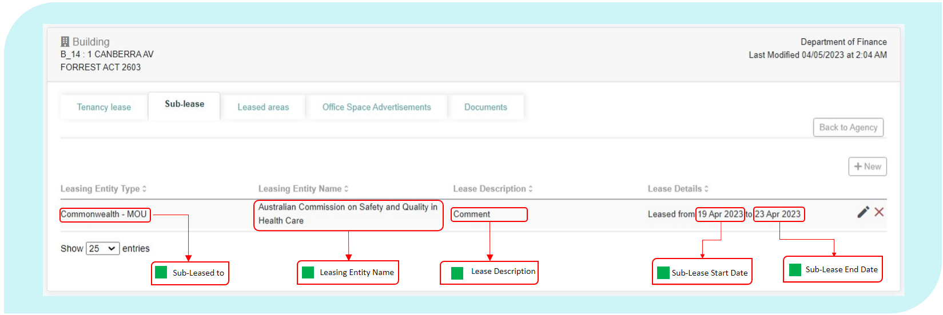

From this table, an Entity can:

* create a sub-lease, using the ‘New’ button located above the table on right side of the screen;
* delete a sub-lease, by clicking the cross symbol at the end of the sub-lease record; and
* edit a sub-lease, by clicking the edit/view symbol at the end of the sub-lease record.

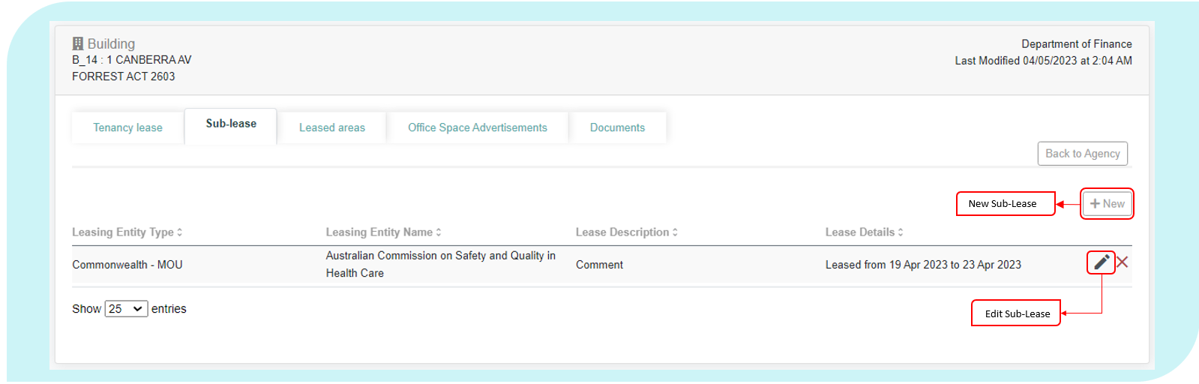

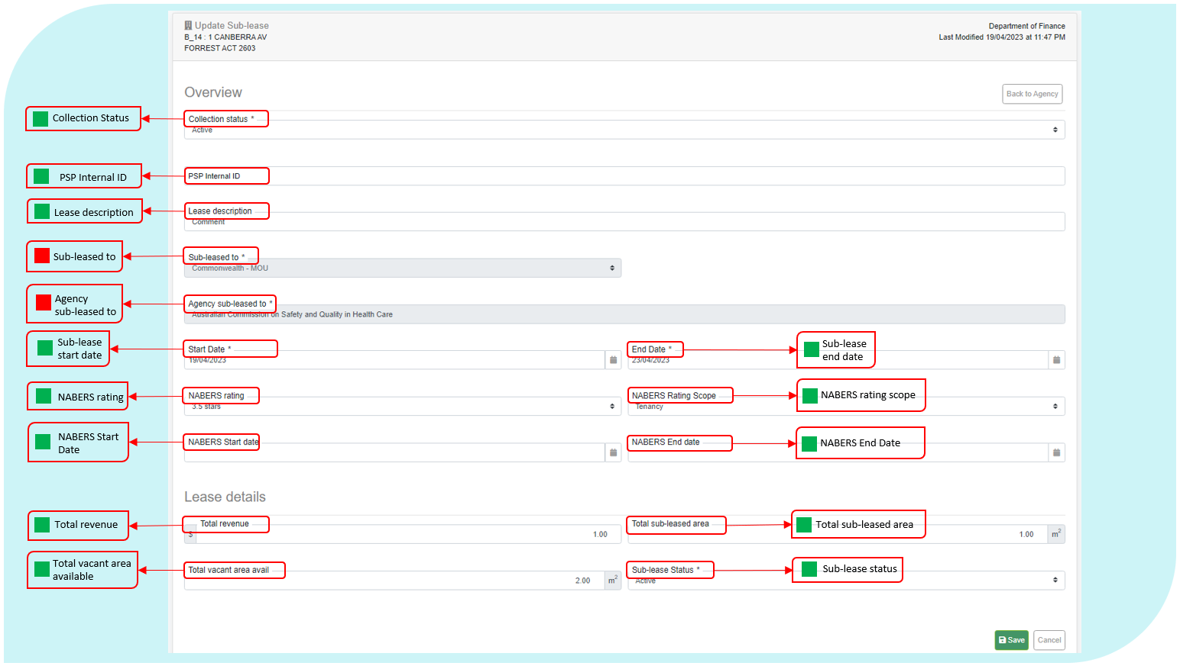

The following data definitions apply to this section.

Sub-Leased To

|  |  |
| --- | --- |
| Definition: | Type of Entity that is sub-leasing office space. This selection will determine if an additional field is exposed. |
| Format: | [Pick from List]   |  |  | | --- | --- | | **Code** | **Meaning** | | Commonwealth – MOU | Sub-lease is with a Commonwealth Entity under a MOU | | Commonwealth – Other | Sub-lease is with a Commonwealth Entity under a lease | | Private | Sub-lease is with a Private Entity | | State Government | Sub-lease is with a State Government or local Government Entity | |

Collection Status

|  |  |
| --- | --- |
| **Definition:** | Select whether or not the sublease is to be considered in scope for the Office Data Collection. |
| Notes: | Status applied to a building record will be automatically applied to all leases within the building.  Status applied to a lease won’t be applied to subleases within the lease. Sublease status must be updated manually, and any affected entities notified of the change. |
| Format: | [Pick from list]   |  |  | | --- | --- | | **Code** | **Meaning** | | Active | Sublease is to be included in the Collection. | | Inactive | Sublease is expired or abolished.  NB: Tenancies marked ‘Inactive’ will be removed from the AGPR at the closure of the Collection. | | Exempt | Sublease is exempt from inclusion in the Collection, and an exemption request has been approved by the Property Data Team. | | Out of scope | Sublease is out of scope for the Collection. | |

PSP internal ID

|  |  |
| --- | --- |
| **Definition:** | Unique identifier assigned to the sublease record within PSP internal systems. |
| Notes: | Each tenancy record should have a unique internal ID.  It is preferable for PSPs to use the same internal IDs through multiple collection periods. |
| Include: | Unique identifier that can be used to cross-match AGPR data with PSP internal systems. |
| Exclude: | * Sublease description (record in ‘Sub-Lease Description’ field) * Unique identifier used in Entity internal systems |
| Format: | Free text |

Sub-Lease Description

|  |  |
| --- | --- |
| Definition: | An Entity-generated reference number or short descriptive text for a sublease. This field provides Entities with the ability to create a reference that identifies the lease in a way that the Entity can readily identify the lease and if required, assist with data matching between entity, PSP and AGPR data sources. |
| Notes: | Each lease should have a unique sub-lease description.  It would be preferable if Entities use the same lease identifiers through multiple collection periods. |
| Format: | Free text |

Leasing Entity Name

|  |  |
| --- | --- |
| Definition: | The Entity Name of the sub-lessor. |
| Notes: | Each sublease should contain the name of the Entity that is the sub-lessor. |
| Format: | [text] |

Start Date

|  |  |
| --- | --- |
| Definition: | Start date of the current sub-lease. |
| Format: | [dd/mm/yyyy] |

End Date

|  |  |
| --- | --- |
| Definition: | End date of the current sub-lease. |
| Notes: | If there is no end date for the sub-lease, use the end date of the head lease. In this scenario, the Entity will need to change the sub-lease end date whenever the head lease end date is changed. |
| Format: | [dd/mm/yyyy] |

Sub-lease Status

|  |  |
| --- | --- |
| Definition: | The status of the current property sub-lease as at 30 June of the reporting year. |
| Notes: | If a sub-lease is reported as ‘expired’, it must be deleted from the record, otherwise the calculations for controlled area and Net Tenancy Expenditure will be incorrect.  Sub-leases that have expired but are continuing on a month-to-month basis, without new terms being agreed, should be reported as ‘Holdover’.   |  |  | | --- | --- | |  | The sub-lease status must be reported as at the Collection End Date.  Any sub-lease with an end date of 30 June 2023 in the given reporting year must be reported as ‘Active’ or ‘Holdover’. | |
| Format: | [Pick from List]   |  |  | | --- | --- | | **Code** | **Meaning** | | Active | The sub-lease is active. | | Expired | The sub-lease agreement has elapsed its end date, no further extension options have been exercised, and the tenancy has been relinquished to the landlord. | | Holdover | The sub-lease end date has passed but the sub-lease is continuing on a month-to-month basis. | |

Sub-Leasing Parties/Agencies Sub-Leased To

|  |  |
| --- | --- |
| Definition: | The name of the Entity or company that is occupying the sub-leased office space. |
| Notes: | If the ‘Sub-leased To’ field indicates that space is being sub-leased to another Entity, then this field will prompt users to choose which Entity.  If office space is being sub-leased to a private company then users should enter the name of that company. |
| Format: | [Drop down of Text] or [Text] |

Total Revenue

|  |  |
| --- | --- |
| Definition: | Revenue and gains (GST Inclusive) from sub-lease arrangements. |
| Include: | This item comprises revenue/gains received from sub-lease or landlord arrangements for the specified sub-lease as follows:   * rent expense, * repair and maintenance expense, * energy expense, * water and sewerage expense, * cleaning and waste removal expense, and * other operating expense.   This information can be found in the Tenancy Schedule. |
| Notes: | When reconciling Total Revenue (from the head-lessor) with outgoings (for the sub-lessor) please compare Total Revenue with Total Outgoings. |
| Format: | Positive value, whole Australian dollars [$nn,nnn,nnn] |

Total Sub-Leased Area

|  |  |
| --- | --- |
| Definition: | Total area within the reported NLA of the property which is sub-leased or leased-out to another Entity or a third party, measured in accordance with the PCA: Method of Measurement of Lettable Area. |
| Notes: | This element is used to work out the area that the Entity does not retain full control of due to sub-letting or landlord arrangements.  If the sub-lease agreement indicates only the number of work-points to be provided, and not the amount of office space, then the NLA should be derived by multiplying the number of work-points provided with the fit-out density of the tenancy.  If the Entity considers that the area in the sub-lease, MOU, licence or similar arrangement is inaccurate, report the leased-out area determined by a surveyor, architect or similarly qualified professional. |
| Reference: | PCA: Method of Measurement for Lettable Area, most recent version.  Sub-lease or other relevant documents.  Surveyor’s report. |
| Format: | Square metres: [nn,nnn.nn] |

Total Vacant Area Available

|  |  |
| --- | --- |
| Definition: | Any additional area of the lease that is currently available for sub-leasing. |
| Notes: | Only include areas that are not currently subject to a new sub-lease agreement.  Finance encourages Entities to support the efficient usage of property by advertising vacant space available through their PSP and the Property Marketplace. |
| Format: | Square metres: [nn,nnn.nn] |

|  |  |
| --- | --- |
|  | All areas reported as vacant should be advertised on the Property Marketplace. |

* + 1. Leased Areas

The Leased Areas tab is accessible through the view button of a Tenancy Lease record.

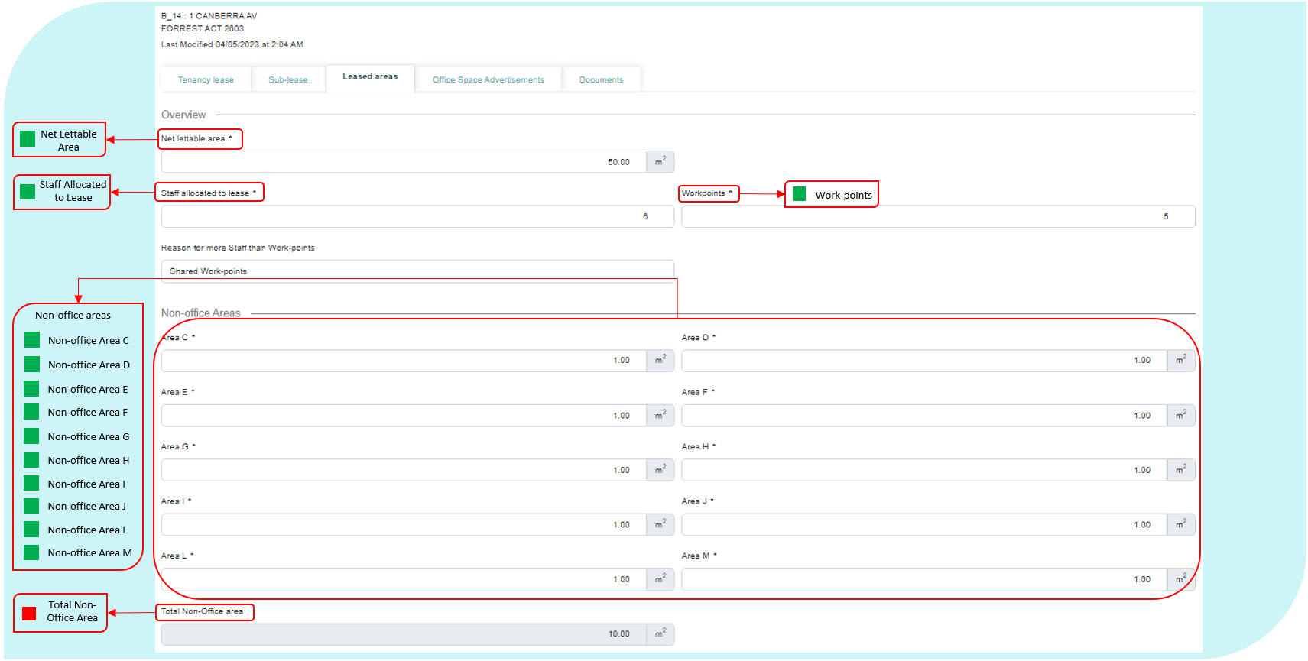

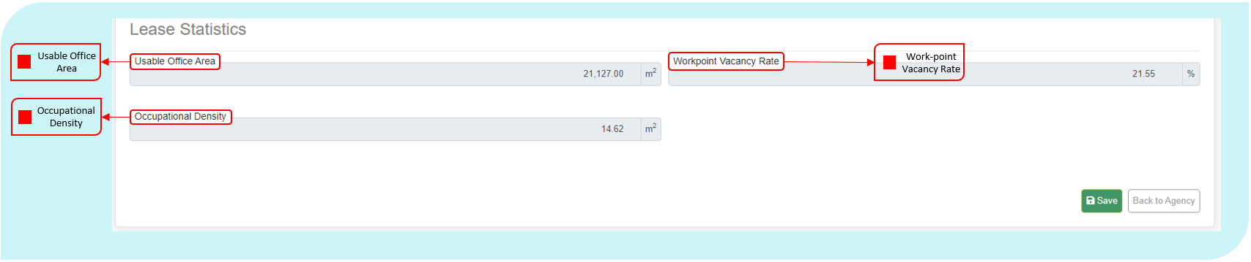

The following data elements definitions apply to this section.

Net Lettable Area

|  |  |
| --- | --- |
| Definition: | For leased and owned property, the Net Lettable Area (NLA) for building or leased area is the sum of all lettable areas within the lease, including areas that are being sub-leased to another Entity. NLA is calculated by taking measurements from the internal finished surfaces of permanent internal walls and the internal finished surfaces of dominant portions of the permanent outer building walls. |
| Include: | Included in the NLA calculation are:  Window mullions; window frames; structural columns; engaged perimeter columns or piers; fire hose reels attached to walls; and  Additional facilities specially constructed for or used by individual tenants that are not covered in the exclusions (below). |
| Exclude: | Excluded from the NLA of each tenancy are:  Stairs; access ways; fire stairs; toilets; recessed doorways; cupboards; telecommunications cupboards; fire hose reel cupboards; lift shafts; escalators; smoke lobbies; plant/motor rooms;  Lift lobbies where lifts face other lifts;  Areas set aside for the provision of all services, such as electrical or telephone ducts and air conditioning risers to the floor, where such facilities are standard facilities in the building; and  Areas dedicated as public spaces or thoroughfares such as foyers, atria and access ways in lift and building service areas.  Areas for car parking, even if included within the lease. |
| Notes: | If the lease does not have an area figure or the lease contains a GLA figure, determine the total NLA in accordance with the PCA: Method of Measurement for Lettable Area.  If the Entity considers that the NLA recorded in the lease is inaccurate, report the NLA determined by a surveyor, architect or similarly qualified professional.  For further information on treatment of stairs; inclusions of security or reception facilities, common areas in a sub-lease, sub divided floors, balconies etc.; and how to measure please refer to chapter 3 of the Property Council of Australia’s Method of Measurement for Lettable Area. |
| Reference: | Property Council of Australia: Method of Measurement for Lettable Area, 2008.  The lease or other relevant documents.  Surveyor’s report. |
| Format: | Square metres [nn,nnn.nn] |

Staff Allocated to Lease

|  |  |
| --- | --- |
| Definition: | Number of staff (including contractors) allocated to the lease. |
| Notes: | Include an estimated number of unique/individual staff that are regularly assigned to work in the tenancy on any given day – ‘Staff Allocated to Lease’ should include all staff (including contractors) regardless of if they were present in the tenancy on the ‘as at’ reporting date.  This includes those on short term leave (i.e. less than 30 days consecutive leave), but not long term leave or secondment.  Where the lease includes a shopfront, staff reported should be the total number of staff for the lease.  If available, Entities should utilise their Human Resource (HR) teams to obtain the necessary data to complete this section.  The number of staff assigned to a tenancy is a key factor in determining a lease’s regular utilisation rate, Occupational Density and Work-point Vacancy Rate. |
| Exclude: | As this is a count of unique staff, Average Staffing Level (ASL) or Full-Time Equivalent (FTE) values must not be reported in this field. |
| Format: | [nn,nnn] |

Work-points

|  |  |
| --- | --- |
| Definition: | Total number of work-points within the usable office area of the property.  A work-point is defined as a desk, enclosed office or a counter where it would be reasonable to expect a person to carry out office work on an ongoing basis. This would apply to traditional, flexible or activity-based working fit-out arrangements. |
| Notes: | If an office is fitted-out for two or more people, then the office is to be counted as containing two or more work-points as appropriate.  If a counter is the primary location for office work for two or more people, then the counter is to be counted as containing two or more work-points as appropriate.  A training or meeting room converted into an office is to be treated as an office. |
| Exclude: | Work-points that reside within space that has been sublet to another entity, state or local government body, or private third party.  Work-points that reside in any area designated as non-office, such as work-points in a shopfront (Non-Office Area L), laboratory (Non-Office Area D), or operational area (Non-Office Area E). |
| Format: | [nn,nnn] |

Reason for more Staff than Work-points

| **Definition:** | **A reason explaining why the number of *Staff Allocated to Lease* is recorded to be greater than the number of *Work-points*.** |
| --- | --- |
| Notes: | This field is mandatory for any lease that has recorded more *Staff Allocated to Lease* than *Work-points*.  If there is more than one reason why there are more *Staff Allocated to Lease* than *Work-points*, please select the option that best describes why this is occurring for most staff in the tenancy.  If “Other” is selected, the reason why there are more *Staff Allocated to Lease* than *Work-points* must be provided during the Data Validation phase of the AGPR Office Data Collection. |
| Format: | [Pick from List]   |  |  | | --- | --- | | **Code** | **Meaning** | | Shared Work-points | There are staff who share a work-point with other staff. E.g. this can be the result of flexible work arrangements, activity based working or shift work. | | Staff work in Non-Office Area | The number of *Staff Allocated to Lease* includes staff who work in a mix of different area types within the tenancy (e.g. shopfronts, laboratories and/or office areas) and do not require a work-point in an office area to undertake their usual work activities. | | Tenancy Relocation | The number of *Staff Allocated to Lease* and *Work-points* reported are affected by facility closure and/or relocation of staff to a different tenancy. | | Other | The reason why a lease has more *Staff Allocated to Lease* than *Work-points* cannot be explained with one of the above options. | |  |  | |

Non-Office Area C – Basement or Inadequate Amenity

|  |  |
| --- | --- |
| Definition: | Total of all areas within the reported NLA that are a Basement or Inadequate Amenity. |
| Include: | All areas and facilities in a basement, except car parking (which should not be included in the NLA)  All areas and facilities which do not provide adequate amenity for use as office space due to the absence of natural light or other physical constraints, including ongoing building maintenance, construction or fit-out.  All private facilities such as private libraries, private galleries, private cafeterias and private gymnasiums - where access is fully or partially restricted to staff and contractors within the Entity |
| Format: | [nnnnn] |

Non-Office Area D – Police Station, Laboratory or Hospital

|  |  |
| --- | --- |
| Definition: | Total of all areas within the reported NLA that are a police station, laboratory or hospital and are not leased-out. |
| Include: | A police station, laboratory, hospital, quarantine area, public hearing room or workshop. |
| Exclude: | An area specifically used to repair and maintain office items. |
| Notes: | Measurements of the non-office area can be taken from the physical space or the floor plans, whichever is considered by the Entity to be the most reliable.  Areas categorised as police station, laboratory or hospital are recorded under this element.  Area reported as non-office area needs to fit a category of AGPR defined non-office area at the point in time of data collection. Area expected to be a non-office area but not used as such must not be included in this element.  An area can only be included in non-office area if it is in the NLA and the controlled area for the property. For example, areas such as base building stairs, access-ways, base building toilets and plant rooms must not be included in non-office area because they are not in the NLA.  If there is uncertainty about whether an area is an office area or non-office area, it must be treated as an office area. |
| Format: | Square metres: [nn,nnn.nn] |

Non-Office Area E – Specifically for Operational Activity

|  |  |
| --- | --- |
| Definition: | Total of all areas within the reported NLA that are specifically for operational activity and are not leased-out. |
| Include: | Rooms or areas specifically used to detain, examine, interview, observe, assess or counsel members of the public.  All areas used to store equipment and items, other than office items, that are needed for operational activities.  Operational areas within Airports, but not office areas within Airports that support the operational activities.  Additional facilities that have been fitted out by the Entity (that is, not part of the base building) such as bathrooms, showers, kitchenettes specifically to support operational activities. |
| Exclude: | General meeting rooms or offices that may be used for meetings with members of the public or stakeholders on an ad hoc basis.  Office area within Airports.  Areas used to store office items or any form of paper-based media, including files, archived files, books or other documents.  Additional facilities that have been fitted out by the Entity (that is, not part of the base building) such as bathrooms, showers, kitchenettes, unless they are specifically to support operational activities.  All areas used for office activities, including where the office activities enable operational activities. |
| Notes: | Measurements of the non-office area can be taken from the physical space or the floor plans, whichever is considered by the Entity to be the most reliable.  Only areas categorised as Specifically for Operational Activity are recorded under this element.  Area reported as non-office area needs to fit a category of AGPR defined non-office area at the point in time of data collection. Area expected to be a non-office area but not used as such must not be included in this element.  An area can only be included in non-office area if it is in the NLA and the controlled area for the property. For example, areas such as base building stairs, access-ways, base building toilets and plant rooms must not be included in non-office area because they are not in the NLA.  If there is uncertainty about whether an area is an office area or non-office area, it must be treated as an office area.  For assistance identifying whether office area in sites is to be included or excluded in this category, please contact the Property Data team at Finance via email on [propertydata@finance.gov.au](mailto:propertydata@finance.gov.au). |
| Format: | Square metres: [nn,nnn.nn] |

Non-Office Area F – Public Facility

|  |  |
| --- | --- |
| Definition: | Total of all areas within the reported NLA that are a public facility and are not leased-out. |
| Include: | All areas which are freely accessible to the public, such as public libraries, public galleries, public cafeterias, public reception areas, public waiting areas and public retail areas. |
| Exclude: | Private libraries, private galleries, private cafeterias, private gymnasiums - where access is fully or partially restricted to staff and contractors within the Entity (these areas must be recorded under Non-Office Area C).  Excludes shopfronts (these areas must be recorded under Non-Office Area L)  Any area not included in the building’s NLA (i.e. atriums). |
| Notes: | An area can only be included in non-office area if it is in the NLA and the controlled area for the property. For example, areas such as atriums, base building stairs, access-ways, base building toilets and plant rooms must not be included in non-office area because they are not in the NLA.  Measurements of the non-office area can be taken from the physical space or the floor plans, whichever is considered by the Entity to be the most reliable.  Only areas categorised as Public Facility are recorded under this element.  Area reported as non-office area needs to fit a category of AGPR defined non-office area at the point in time of data collection. Area expected to be a non-office area but not used as such must not be included in this element.  If there is uncertainty about whether an area is an office area or non-office area, it must be treated as an office area. |
| Format: | Square metres: [nn,nnn.nn] |

Non-Office Area G – Judicial Chambers and Court Rooms

|  |  |
| --- | --- |
| Definition: | Total of all areas within the reported NLA that are judicial chambers and court rooms and are not leased-out. |
| Include: | Judicial chambers and the secure zone around judicial chambers, court rooms and hearing rooms. |
| Exclude: | Offices provided for tribunal members, commissioners, ombudsmen or similar officers. |
| Notes: | Measurements of the non-office area can be taken from the physical space or the floor plans, whichever is considered by the Entity to be the most reliable.  Only areas categorised as judicial chambers and court rooms are recorded under this element.  Area reported as non-office area needs to fit a category of AGPR defined non-office area at the point in time of data collection. Area expected to be a non-office area but not used as such must not be included in this element.  An area can only be included in non-office area if it is in the NLA and the controlled area for the property. For example, areas such as base building stairs, access-ways, base building toilets and plant rooms must not be included in non-office area because they are not in the NLA.  If there is uncertainty about whether an area is an office area or non-office area, it must be treated as an office area. |
| Format: | Square metres: [nn,nnn.nn] |

Non-Office Area H – Areas Specifically for the Governor-General, Prime Minister and Parliamentarians

|  |  |
| --- | --- |
| Definition: | Total of all areas within the reported NLA that are areas specifically for the Governor-General, Prime Minister and parliamentarians and are not leased-out. |
| Include: | All areas specifically provided for the use of the Governor-General, Commonwealth Parliamentarians, former Governors-General, former Prime Ministers and former members of the judiciary. |
| Exclude: | Areas provided for Accountable Authorities, chief executives, senior executives, contractors, consultants and uniformed or sworn personnel, to undertake office activities. |
| Notes: | Measurements of the non-office area can be taken from the physical space or the floor plans, whichever is considered by the Entity to be the most reliable.  Only areas categorised as Areas Specifically for the Governor-General, Prime Minister and Parliamentarians are recorded under this element.  Area reported as non-office area needs to fit a category of AGPR defined non-office area at the point in time of data collection. Area expected to be a non-office area but not used as such must not be included in this element.  An area can only be included in non-office area if it is in the NLA and the controlled area for the property. For example, areas such as base building stairs, access-ways, base building toilets and plant rooms must not be included in non-office area because they are not in the NLA.  If there is uncertainty about whether an area is an office area or non-office area, it must be treated as an office area. |
| Format: | Square metres: [nn,nnn.nn] |

Non-Office Area I – Emergency and Crisis Coordination Areas

|  |  |
| --- | --- |
| Definition: | Total of all areas within the reported NLA that are emergency and crisis coordination areas and are not leased-out. |
| Include: | An area designed and used specifically for coordinating responses to emergency or crisis situations. |
| Exclude: | Call centres, unless designed and used specifically for directing responses to emergency or crisis situations. |
| Notes: | Measurements of the non-office area can be taken from the physical space or the floor plans, whichever is considered by the Entity to be the most reliable.  Only areas categorised as emergency and crisis coordination areas are recorded under this element.  Area reported as non-office area needs to fit a category of AGPR defined non-office area at the point in time of data collection. Area expected to be a non-office area but not used as such must not be included in this element.  An area can only be included in non-office area if it is in the NLA and the controlled area for the property. For example, areas such as base building stairs, access-ways, base building toilets and plant rooms must not be included in non-office area because they are not in the NLA.  If there is uncertainty about whether an area is an office area or non-office area, it must be treated as an office area. |
| Format: | Square metres: [nn,nnn.nn] |

Non-Office Area J – Exempt Area

|  |  |
| --- | --- |
| Definition: | Total of all areas within the reported NLA that are classified as an Exempt Area (refer Attachment A) and are not leased-out. |
| Include: | An area specifically designated by the Department of Finance as an exempt area. |
| Notes: | Measurements of the non-office area can be taken from the physical space or the floor plans, whichever is considered by the Entity to be the most reliable.  Only areas categorised as Exempt Area are recorded under this element.  Area reported as non-office area needs to fit a category of AGPR defined non-office area at the point in time of data collection. Area expected to be a non-office area but not used as such must not be included in this element.  An area can only be included in non-office area if it is in the NLA and the controlled area for the property. For example, areas such as base building stairs, access-ways, base building toilets and plant rooms must not be included in non-office area because they are not in the NLA.  If there is uncertainty about whether an area is an office area or non-office area, it must be treated as an office area. |
| Format: | Square metres: [nn,nnn.nn] |

Non-Office Area L – Shopfronts

|  |  |
| --- | --- |
| Definition: | Total of all areas within the reported NLA that are shopfronts. |
| Include: | Areas used as a shopfront specifically designed to provide face-to-face Commonwealth Government services to the public.  Areas where customers access or use self-help services related to the nature of business conducted at the shopfront.  Please refer to the Dictionary of Applicable Terms for a definition of a *shopfront.* |
| Notes: | Measurements of the non-office area can be taken from the physical space or the floor plans, whichever is considered by the Entity to be the most reliable.  Only areas categorised as Shopfronts are recorded under this element.   |  |  | | --- | --- | |  | All areas that can be accessed by the public, for shopfront services, should be included in this area, except where that area is not part of the NLA, for example atriums.  Work-points that reside in this area must not be recorded in the collection record for this lease. |   Area reported as non-office area needs to fit a category of AGPR defined non-office area at the point in time of data collection. Area expected to be a non-office area but not used as such must not be included in this element.  An area can only be included in non-office area if it is in the NLA and the controlled area for the property. For example, areas such as base building stairs, access-ways, base building toilets and plant rooms must not be included in non-office area because they are not in the NLA.  If there is uncertainty about whether an area is an office area or non-office area, it must be treated as an office area. |
| Format: | Square metres: [nn,nnn.nn] |

Non-Office Area M – ICT/Data Warehouse

|  |  |
| --- | --- |
| Definition: | Total of all areas within the reported NLA that are ICT/Data warehouse within the Entity’s control. |
| Include: | Areas dedicated to housing ICT equipment including servers etc. |
| Exclude: | Under desk standalone servers. |
| Notes: | Measurements of the non-office area can be taken from the physical space or the floor plans, whichever is considered by the Entity to be the most reliable.  Only areas categorised as ICT/Data warehouse are recorded under this element.  Area reported as non-office area needs to fit a category of AGPR defined non-office area at the point in time of data collection. Area expected to be a non-office area but not used as such must not be included in this element.  An area can only be included in non-office area if it is in the NLA and the controlled area for the property. For example, areas such as base building stairs, access-ways, base building toilets and plant rooms must not be included in non-office area because they are not in the NLA.  If there is uncertainty about whether an area is an office area or non-office area, it must be treated as an office area. |
| Format: | Square metres: [nn,nnn.nn] |

Total Non-Office Area

|  |  |
| --- | --- |
| Definition: | Total of all non-office areas within the reported NLA that are not currently sub-leased. |
| Notes: | This is automatically generated to reflect the sum of all preceding non-office areas. |
| Format: | Data Auto Total: Square metres [nn,nnn.nn] |

Total Sub-Leased Area

|  |  |
| --- | --- |
| Definition: | Where the lease is a sublet tenant lease the Total Sub-Leased Area, as required by the head-lessor, will be displayed in this field. |
| Notes: | This field cannot be changed as it is populated directly from the head-lease.  The value recorded for the Net Lettable Area field (for sublet tenancy leases) must equal the value shown at *Total Sub-Leased Area.* |
| Format: | Square metres: [nn,nnn.nn] |

Cost per Square Metre

|  |  |
| --- | --- |
| Definition: | Automated calculation to show the cost per square metre of the lease. |
| Calculation: | Net Rent Expense (Current Annual Rent Expense *minus* Sub-lease Revenue) *divided by* Controlled Area (NLA *minus* Sub-leased Area) |
| Format: | Data Auto Total: Positive value, whole Australian dollars [$nn,nnn,nnn] |

Cost per Work-point

|  |  |
| --- | --- |
| Definition: | Automated calculation to show the cost per work-point of the lease. |
| Calculation: | Net Rent Expense (Current Annual Rent Expense *minus* Sub-lease Revenue) *divided* *by* Work-points |
| Format: | Data Auto Total: Positive value, whole Australian dollars [$nn,nnn,nnn] |

Usable Office Area

|  |  |
| --- | --- |
| Definition: | Automated calculation to show the useable office area of the lease. |
| Calculation: | Controlled Area (NLA *minus* Sub-leased Area) *minus* Total Non-Usable Office Area |
| Format: | Square metres: [nn,nnn.nn] |

Work-point Vacancy Rate

|  |  |
| --- | --- |
| Definition: | Automated calculation to show the work-point vacancy rate of the lease. |
| Calculation: | Number of Vacant Work-points (Number of Work-points *minus* Staff Allocated to Lease) *divided by* Number of Work-points *multiplied by 100.* |
| Format: | Percentage: [nn,n%] |

Occupational Density

|  |  |
| --- | --- |
| Definition: | Automated calculation to show the occupational density of the lease. |
| Calculation: | Usable Office Area divided *by* the number of occupied work-points in a tenancy. |
| Format: | Square metres: [nn,nnn.nn] |

* + 1. Advertising

The advertising tab provides a place where Entities can list vacant work-points and office space.

Entities can edit advertisements by selecting at the end of the record or create a new advertisement by clicking on the ‘New Advertisement’ button.

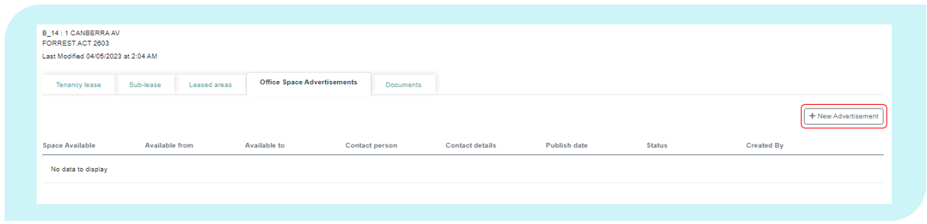

Once completed, an advert will be published in the Property Marketplace.

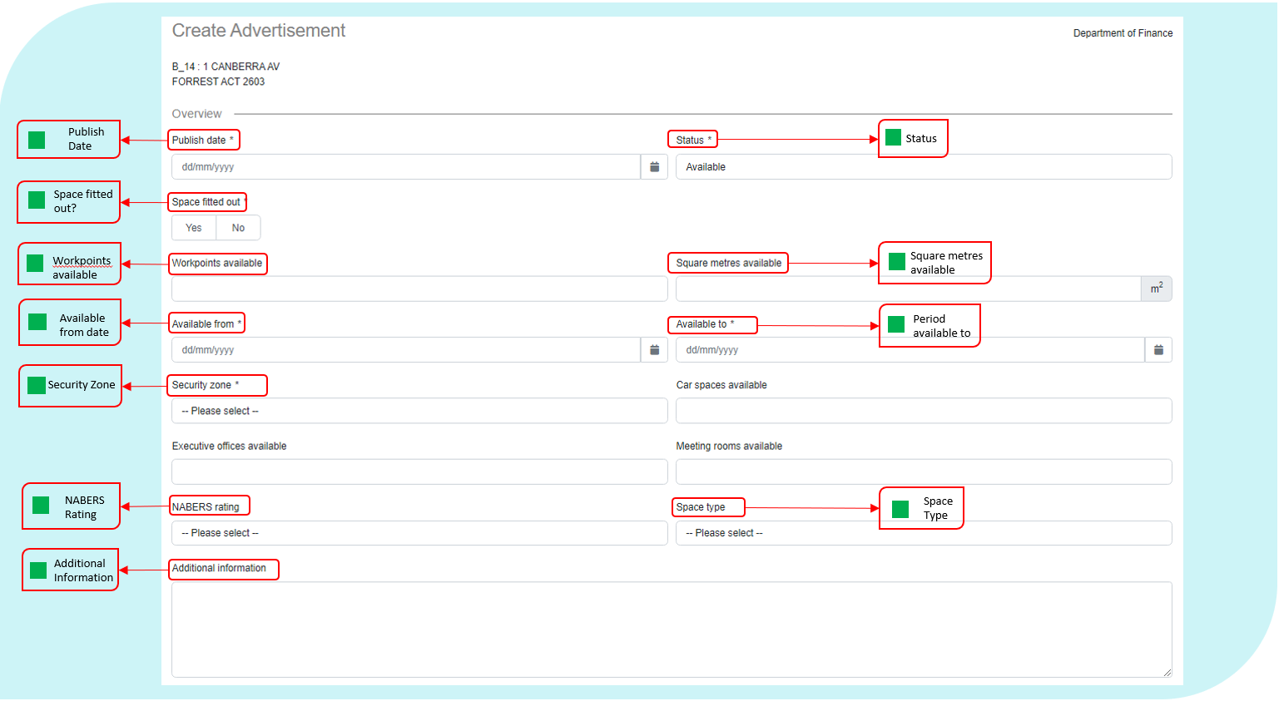

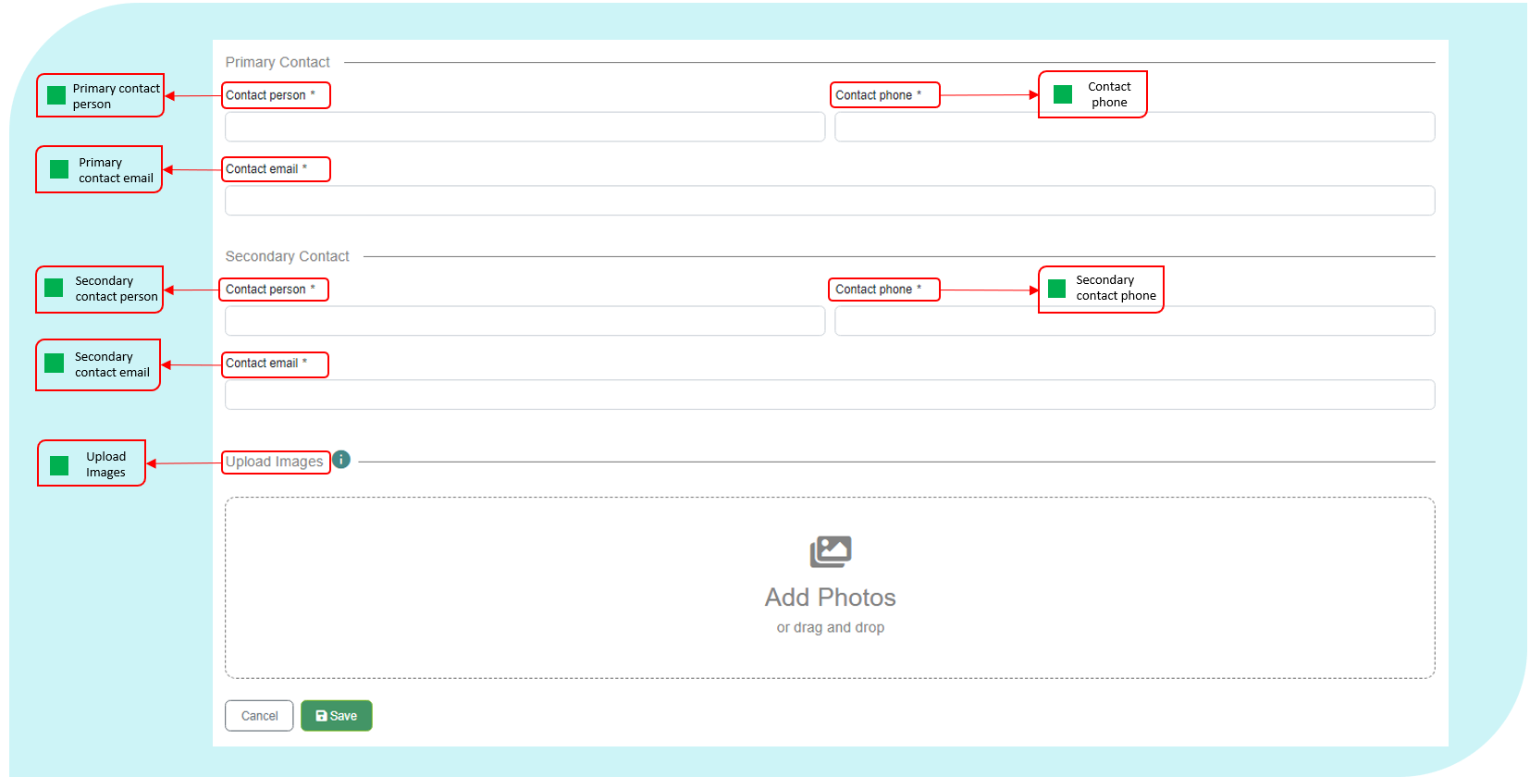

The fields in this section include the following.

Published Date

|  |  |
| --- | --- |
| Definition: | The date the advertisement was published. |
| Format: | [dd/mm/yyyy] |

Status

|  |  |
| --- | --- |
| Definition: | The status of the advertisement. |
| Notes: | This field should be updated when a vacancy is filled. |
| Format: | Select from drop down list: Available Vacancy filled/Tenanted |

Space Fitted Out?

|  |  |
| --- | --- |
| Definition: | Is the advertised space fitted out with work-points? |
| Format: | [Select Yes/No] |

Work-points Available

|  |  |
| --- | --- |
| Definition: | The number of work-points available with the spare office space (if applicable). |
| Notes: | Only include the number of work-points your Entity wishes to fill, not necessarily the overall number of vacant work-points |
| Format: | [nnnn] |

Square Metres Available

|  |  |
| --- | --- |
| Definition: | The total square metres of Usable Office Area available. |
| Format: | [nnn.nn] |

Available From Date

|  |  |
| --- | --- |
| Definition: | The date vacant office space is available. |
| Format: | [dd/mm/yyyy] |

Period Available

|  |  |
| --- | --- |
| Definition: | The time period the vacant office space is available. |
| Format: | Select from drop down:  0-3 Months 3-6 Months 6-12 Months Over 12 Months |

Additional Information

|  |  |
| --- | --- |
| Definition: | Any other information that may be relevant to Entities looking for office space. |
| Format: | [Text] |

Contact Person

|  |  |
| --- | --- |
| Definition: | The name of the point of contact within the advertising entity. |
| Format: | [Text] |

Contact Phone

|  |  |
| --- | --- |
| Definition: | The phone number of the point of contact within the advertising entity. |
| Format: | [nn-nnnnnnnn] or [Work Mobile] |

Contact Email

|  |  |
| --- | --- |
| Definition: | The business email address of the point of contact within the advertising entity. |
| Format: | [xxxxx@xxxxxx.xxx.xx] |

* + 1. Lease Documents

The Documents tab within a lease record allows Entities to upload documents relevant to the lease.

Entities can edit documents by selecting at the end of the record or upload a new document by clicking on the ‘Upload document’ button.

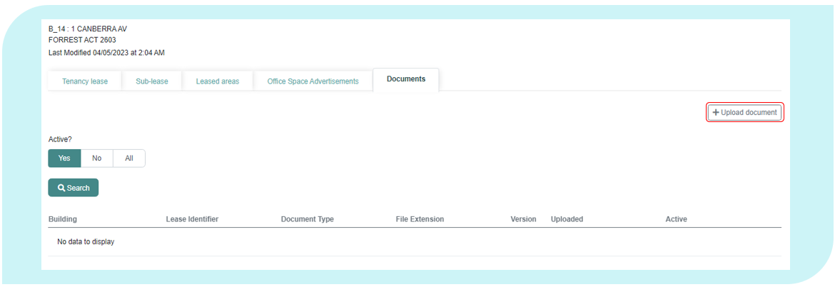

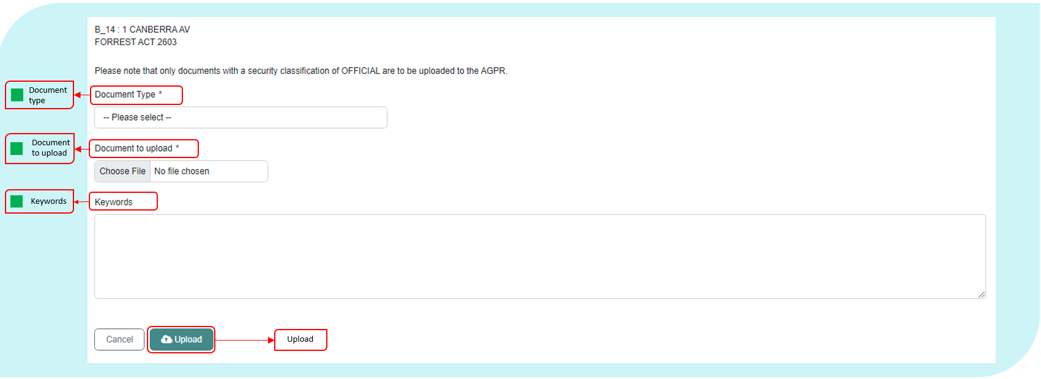

Once completed, the document will be uploaded into the repository.

The fields in this section include the following.

Document Type

|  |  |
| --- | --- |
| Definition: | The type of document being uploaded. |
| Format: | [Pick from list]   |  |  | | --- | --- | | **Code** | **Meaning** | | Lease | The lease contract between the tenant and head-lessor. | | Property Management Plan | The document that includes property objectives, ensures the quality of property is appropriate and assesses options for acquisition.  This must be provided to Finance and updated as necessary.  For further reference, please view the RMG500. | |

Keywords

|  |  |
| --- | --- |
| Definition: | Keywords that summarise the document. |
| Format: | [Text] |

* 1. Documents

The Documents tab is a document storage tab. This gives Entities the ability to store and manage all documents and property management plans which have been uploaded via the lease record’s “Documents” tab as outlined in section “Lease Documents 2.5”.

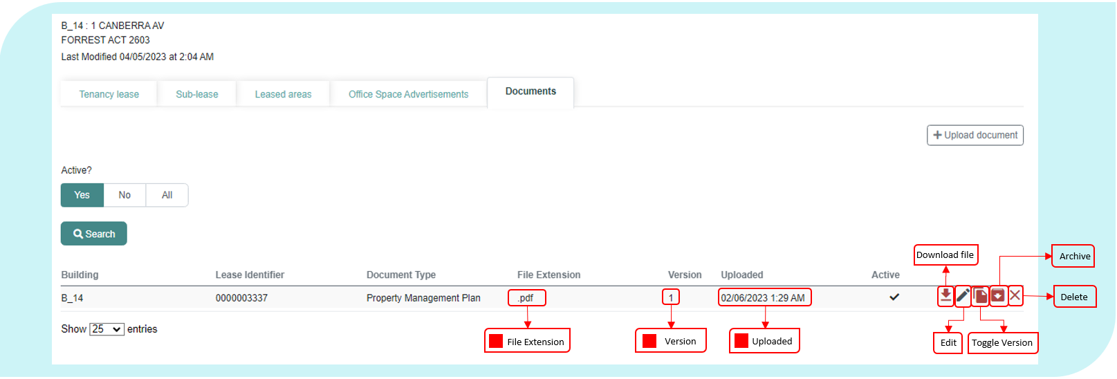

The following data element definitions apply to this section.

File Extension

|  |  |
| --- | --- |
| Definition: | The file extension of the document. |
| Notes: | Only Word, PDF and images can be uploaded |
| Format: | |  |  | | --- | --- | | **Code** | **Meaning** | | .docx | Word Document | | .pdf | PDF | |

Version

|  |  |
| --- | --- |
| Definition: | The latest and current version of the document. |
| Format: | [nnnn] |

Upload Date

|  |  |
| --- | --- |
| Definition: | The date when the file was uploaded into the document repository. |
| Format: | [dd/mm/yyyy] |

1. Dictionary of Applicable Terms

The following definitions apply for the purposes of the AGPR (Leased Estate) Data Collection. Each data element and derived element is also a defined term and the definitions are contained in the data specifications for the appropriate element.

**Building** includes any building leased or owned by the Entity with a Usable Office Area. If an Entity has two or more leases in a building, the same building is reported for all leases. If an Entity leases one or more buildings under a single lease, or leases an area of land that contains buildings under a single lease, the same lease is reported for multiple buildings. Cost data elements are apportioned for each building in scope.

**Capitalised** in relation to an asset, means an asset from which the Entity expects to receive economic benefits during more than one financial year.

**Effective Rent** is the actual liability for rent and outgoings after adjustments for any incentives to the face rent are taken into account.

**Entity** as defined in the Public Governance, Performance and Accountability Act 2013.

**Entity code** is a concise and recognisable code assigned by each Entity, which uniquely identifies the Entity’s properties. The Entity code is an acronym (e.g. PMC) or key word (e.g. Treasury).

**Heads of Agreement (HoA)** is either a binding or non-binding document that sets out the key terms of a proposed agreement between a landlord and a tenant. It is a summary of the negotiated commercial terms including the commencement date and lease length, that both parties wish to have included in the formal lease document.

**Lease** includes any lease, sub-lease or other arrangement where possession and use of property is transferred for a limited period in return for rent and under certain specified conditions in accordance with the Property Council of Australia (PCA) - Glossary of Property Terms. This includes heads of agreement, exchange of letters, memorandum of understanding, contract, licence or agreement under which an Entity may occupy part or all of a building that is not owned by the Entity. It excludes arrangements to hire venues on a short-term basis.

**Lessee** means the tenant. A person/legal entity who receives the right to occupy and use the property under the terms of a lease.

**Lessor** means the owner of a property who transfers the right to occupy and use property to another by way of a lease agreement.

**Memorandum of Understanding,** in the context of this collection,is a written agreement between two Commonwealth entities regarding the use of office space, including work-points leased by one entity (the head-lessor) but used by another entity.

**Minimum Lease Payment** means minimum lease payment as defined in RMG 110 - Accounting for operating lease expenses and incentives include base rent and fixed rent escalations.

**Non-Office Area** is area within the controlled area of the property that is not used or cannot be used to undertake office work.

**Office Items** includes all paper, paper-based products, files, books, brochures, paper forms, paper handling products, document holders, binding equipment, binding supplies, laminating equipment, laminating supplies, paper shredders, paper recycling containers, stationery, photocopiers, printers, printer supplies, paper scanners, facsimile machines, telephones, telephone accessories, projection devices, chairs, desks, tables, computer hardware, computer software and computer networking hardware.

**Office Activity** is comprised of office support work, which is any activity that supports or enables office work, which are activities undertaken at a desk, counter, office or meeting room. This excludes the maintenance and repair of office items.

**Operational Activity** is any activity other than office activity undertaken by an Entity that is directly related to the functions of the Entity.

**PCA** means the Property Council of Australia.

**Property** means real estate that can be owned; an interest can be held; control can be exercised over; can be traded; or that benefits can be obtained from.

**Refurbishment** means the upgrading of a building’s fabric and services with the aim of enhancing its ability to attract tenants, improve rental value and maximise market value.

**Reporting Period** is by Financial Year. This data collection is for reporting period 1 July 2022 to 30 June 2023.

A **Shopfront** is a defined area of a tenancy where an entity delivers government services with customer interactions, where customers can attend the site in a face-to-face environment and obtain information and assistance from staff.

**Sublease** is when the tenant transfers responsibility of all or part of their leased space to another entity, either within or external to the Commonwealth. A tenant may choose to enter into a sublease agreement with another party to minimise surplus office space. Subleases may be documented through a Memorandum of Understanding or sublease contract.

**Subleased Area** means an area that is placed in the control of another Entity under any type of arrangement (such as a heads of agreement, exchange of letters, memorandum of understanding, contract, licence or agreement) and which has been established in accordance with the PGPA Act 2013.

**Sub-lessee** is the entity holding or renting the sublease.

**Sub-lessor** is the entity granting the sublease.

**Tenancy** is one building in which an Entity occupies or has a right to occupy space under one or more leases.

# Attachment A – Data Supplier Agreement

The attached table has been pre-populated by the Property Data team at Finance based on the requirements of PSPs as outlined in the Property Services Deed.

Individual Entities and PSPs may agree on amendments to the data supplier listed below.

Once agreement has been reached please forward the completed document to [propertydata@finance.gov.au](mailto:propertydata@finance.gov.au).

Where agreement cannot be reached please contact the Property Data team at Finance ([propertydata@finance.gov.au](mailto:propertydata@finance.gov.au)) for advice.

Data Suppliers - Building Details

|  |  |  |
| --- | --- | --- |
| Field Name | Field Description | Data Supplier |
| PSP Internal ID | Unique identifier assigned to the building record within PSP internal systems. | PSP |
| Building Name | The name of the property or building, if applicable. | PSP |
| Street Number | The exact street number of the building. | PSP |
| Street Name | The exact street name on which the property is located. | PSP |
| Suburb | The exact suburb in which the property is located. | PSP |
| State or Territory | The State or Territory in which the property is located. | PSP |
| Post Code | The exact postcode in which the property is located. | PSP |
| Latitude | Latitude of the building. |  |
| Longitude | Longitude of the building. |  |
| Building Owner Type | The type of organisation that owns the property. | PSP |
| Building Owner ABN | The Australian Business Number (ABN) for the owner of the building/tenancy. | PSP |
| Building Owner Name | The exact, registered business name of the building owner. | PSP |
| Building Grade | Building grade is broadly divided into existing buildings ‘EB’ and new buildings ‘New’. The current grade of the building in which the property is located, in accordance with the Property Council of Australia: A Guide to Office Building Quality. | PSP |
| Heritage Status | The outcome of a heritage assessment done under section 341ZB of the Environment Protection and Biodiversity Conservation Act 1999 (EPBC Act). | PSP |
| NABERS Rating | NABERS energy rating achieved by the tenancy of the leased/owned scope of the building. | PSP |
| NABERS Rating Scope | The building type and rating scope the NABERS energy rating applies to. | PSP |
| NABERS Start Date | The date the rating displayed in NABERS Rating commenced. | PSP |
| NABERS End Date | The date the rating displayed in NABERS Rating is due to expire. | PSP |
| Expiry of last assessment | Expiry date of the last NABERS assessment undertaken at this tenancy. | PSP |
| Repair And Maintenance Expense | Total actual, non-capitalised expenses incurred by the Entity in the reporting period to keep the tenancy, onsite areas and building assets in a condition needed for the tenancy to function as intended by the Entity. | PSP |
| Energy Expense | Total actual expenses (GST inclusive) incurred by the Entity in the reporting period for the supply of electricity, gas or other energy. | PSP |
| Water And Sewerage Expense | Total actual expenses (GST inclusive) incurred by the Entity in the reporting period for the supply of water and sewerage services. | PSP |
| Cleaning And Waste Removal Expense | Total actual expenses (GST inclusive) incurred by the Entity in the reporting period for cleaning or removal of waste. | PSP |
| Relocation And Minor Refurbishments Expense | Actual expenses (GST inclusive) incurred in the reporting period by the Entity to undertake non-capitalised refurbishments and relocation expenses. | PSP |
| Contractors And Consultants | Total actual cost (GST inclusive) for contractors or consultants procured to assist with property administration or management or provide specialist property advice. | PSP |
| Other Operating Expenses | Other substantial actual expenses (GST inclusive) incurred in the reporting period by the Entity for the tenancy and onsite facilities to function as intended by the Entity. | PSP |
| Services Received Free of Charge | Services received (GST inclusive) as part of the lease agreement, free of charge. | Entity |
| Entity Comments | Any comments that the Entity would like to include to support data relating to building information. | Entity |
| Facilities Management - Provider | Name of facilities management provider (if applicable). | PSP |
| Facilities Management Provider Contract End Date | End date of the facilities management provider contract (if applicable). | PSP |
| Facilities Management - Services Base Fees (excluding pass through costs) | Total non-capitalised expenses (GST Inclusive) of external property service  providers for the delivery of facilities management services to the building. | PSP |
| Facilities Management - Services Other Fees (excluding pass through costs) | Total non-capitalised expenses (GST Inclusive) of services delivered by the  facilities management provider not included in the base fee. | PSP |
| Other (Facilities Management) Services | Name of other facilities management providers, services provided and  contract end dates not included in the fields Facilities Management –  Provider and Facilities Management Provider Contract End Date. | Entity |
| Entity Managed Repair and Maintenance Expense | Total actual, non-capitalised expenses incurred by the Entity in the reporting period to keep the tenancy, car parks, onsite areas and building assets in a condition needed for the tenancy to function as intended by the Entity. | Entity |
| Entity Managed Energy Expense | Total actual expenses (GST Inclusive) incurred by the Entity in the reporting period for the supply of electricity, gas or other energy. | Entity |
| Entity Managed Water and Sewerage Expense | Total actual expenses incurred by the Entity in the reporting period for the supply of water and sewerage services. | Entity |
| Entity Managed Cleaning and Waste Removal Expense | Total actual expenses incurred by the Entity in the reporting period for cleaning or removal of waste. | Entity |
| Entity Managed Relocation and Minor Refurbishments Expense | Actual expenses incurred in the reporting period by the Entity to undertake non-capitalised refurbishments and relocation expenses. | Entity |
| Entity Managed Contractors and Consultants Expense | Total actual cost for contractors or consultants procured to assist with property administration or management or provide specialist property advice. | Entity |
| Entity Managed Other Operating Expenses | Other substantial actual expenses (GST Inclusive) incurred in the reporting period by the Entity for the tenancy and onsite facilities to function as intended by the Entity. | Entity |

Data Suppliers – Lease Details

|  |  |  |
| --- | --- | --- |
| Field Name | Field Description | Data supplier |
| PSP Internal ID | Unique identifier assigned to the lease record within PSP internal systems. |  |
| Lease Description | An Entity-generated reference number or short descriptive text for a lease..This field provides Entities with the ability to record the unique identifier from their own system to enable faster and more accurate data matching between entity, PSP and AGPR data sources. | PSP |
| Entity Comment | Any comments that the Entity would like to include that further supports or explains data relating to the lease. | Entity and PSP |
| Lease Start Date | The date when the lease obligation for the property began. | PSP |
| Lease End Date | The date when the current obligation to lease the property ends. | PSP |
| Lease Type | The type of lease under which the Entity is occupying or has the right to occupy the building. | PSP |
| Lease Status | The status of the current property lease as at 30 June of the reporting year. | PSP |
| Make Good Requirement | The lease incentive applicable for the current lease period, expressed as a percentage of gross rent payable for the current lease. | PSP |
| Green Star Rating | The Green Star rating applied to the building or lease. | PSP |
| Green Star Rating Scope | The scope of the Green Star rating applied to the building or lease. | PSP |
| Green Lease Schedule | Type of agreement between the Entity and lessor that sets out each party’s role in the achievement of energy efficiency objectives. | PSP |
| Tenancy Highest Security Level | The Protective Security Policy Framework mandates Entities design and modify their facilities in order to define restricted access areas according to the five security zones, with increasing restrictions and access controls as  the zones progress from Zone One to Zone Five.  Buildings or tenancies may have a number of different zones. The Tenancy highest security reflects the highest level of security in the current building or tenancy. | PSP |
| NABERS Rating | NABERS energy rating achieved by the tenancy of the leased/owned scope of the building | PSP |
| NABERS Rating Scope | The building type and rating scope the NABERS energy rating applies to. | PSP |
| NABERS Start Date | The date the rating displayed in *NABERS Rating* commenced. |  |
| NABERS End Date | The date the rating displayed in *NABERS Rating* is due to expire. |  |
| Expiry of last assessment | Expiry date of the last NABERS assessment undertaken at this tenancy. |  |
| Current Year Actual Rent | Total, actual effective rent (GST Inclusive) expense of the lease for all net lettable areas within the tenancy, and onsite storage within the reporting period. | PSP |
| Lessor’s Outgoings Expense | Total actual expense (GST inclusive) incurred by the Entity in the reporting period for all outgoings payable to the lessor. | Entity and PSP |
| Current Rent per sqm | Current gross effective rent (GST Inclusive) expense of the lease per square metre of net lettable area. | PSP |
| Provider | Name of lease management provider. | PSP |
| Provider Contract End Date | The end date of the lease management provider contract. | PSP |
| Services - Base Fees | Total cost (GST Inclusive) of external lease management services provided for the Entity’s property portfolio. | PSP |
| Services - Other Fees | Total actual cost (GST Inclusive) of services delivered by the lease management provider not included in the base fee. | PSP |
| NumberOfRemainingExtensions | Number of remaining lease extensions available under the current lease. | PSP |
| Length Of Next Lease Extension | Length (in months) of next available lease extension period. | PSP |
| Extension Notification Date | The notification date for the next lease extension. | PSP |
| Incentive: Rent Abatement | Lease incentive (as a dollar amount) provided by the Lessor that has been allocated as a rent reduction over the current term of the lease. | PSP |
| Incentive: Fit-out Contribution | Lease incentive (as a dollar amount) provided by the landlord that has been apportioned to the cost of fitting out the tenancy over the current term of the lease. | PSP |
| Lease incentive rate | The lease incentive applicable for the current lease period, expressed as a percentage of gross rent payable for the current lease. | PSP |
| Incentive Description | A short description of any incentives associated with executing the lease (including estimated value if known). | PSP |
| Last Major Fit-out Completed | The date the last major fit-out was completed. | Entity |
| Last Major Fit-out Source | The source of the last major fit-out. | Entity |
| Last Major Fit-out Cost | The cost of the most recent major fit-out project. | Entity |
| Total Fit-out Cost | The total dollar value of all fit-out costs associated with the lease over the tenancy lifecycle. | Entity |
| Rent Review Mechanism | The mechanism in which the annual rent is adjusted. | PSP |
| Rent Review Frequency | The frequency that the rent is reviewed under the lease agreement. | PSP |
| Current Rent Escalation Rate | The escalation rate applicable to the rent for the lease as at the reporting date. | PSP |
| Market Rent Review | The type of Market Rent Review included in the lease. | PSP |
| Net Lettable Area | For leased and owned property, the Net Lettable Area (NLA) for building or leased area is the sum of all lettable areas within the lease, including areas that are being sub-leased to another Entity. NLA is calculated by taking measurements from the internal finished surfaces of permanent internal walls and the internal finished surfaces of dominant portions of the permanent outer building walls. | PSP |
| Staff Allocated To Lease | Number of staff (including contractors) allocated to the lease. | Entity |
| Work-points | Total number of work-points within the usable office area of the property.  A work-point is defined as a desk, enclosed office or a counter where it would be reasonable to expect a person to carry out office work on an ongoing basis. This would apply to traditional, flexible or activity-based working fit-out arrangements. | Entity |
| Reason for more Staff than Work-points | A reason explaining why the number of *Staff Allocated to Lease* is recorded to be greater than the number of *Work-points*. | Entity |
| Non-Office Area C - Basement or Inadequate Amenity | Total of all areas within the reported NLA that are a Basement or Inadequate Amenity. | Entity |
| Non-Office Area D - Police Station, Laboratory or Hospital | Total of all areas within the reported NLA that are a police station, laboratory or hospital and are not leased-out. | Entity |
| Non-Office Area E - Specifically for Operational Activity | Total of all areas within the reported NLA that are specifically for operational activity and are not leased-out. | Entity |
| Non-Office Area F - Public Facility | Total of all areas within the reported NLA that are a public facility and are not leased-out. | Entity |
| Non-Office Area G - Judicial Chambers and Court Rooms | Total of all areas within the reported NLA that are judicial chambers and court rooms and are not leased-out. | Entity |
| Non-Office Area H - Areas Specifically for the Governor-General, Prime Minister and Parliamentarians | Total of all areas within the reported NLA that are areas specifically for the Governor-General, Prime Minister and parliamentarians and are not leased-out. | Entity |
| Non-Office Area I - Emergency and Crisis Coordination Areas | Total of all areas within the reported NLA that are emergency and crisis coordination areas and are not leased-out. | Entity |
| Non-Office Area J - Exempt Area | Total of all areas within the reported NLA that are classified as an Exempt Area (refer Attachment B) and are not leased-out. | Entity |
| Non-Office Area L - Shopfronts | Total of all areas within the reported NLA that are shopfronts. | Entity |
| Non-Office Area M - ICT/Data Warehouse | Total of all areas within the reported NLA that are ICT/Data warehouse within the Entity’s control. | Entity |

Data Suppliers – Sublease Details

*PSP in instances where the sublease is managed by a PSP as an additional service under the PSCP arrangements.

|  |  |  |
| --- | --- | --- |
| Field Name | Field Description | Data supplier |
| PSP Internal ID | Unique identifier assigned to the sublease record within PSP internal systems. | PSP |
| Sub-Leased To | Type of entity that is sub-leasing office space. | Entity* |
| Sub-Lease Description | An Entity-generated reference number or short descriptive text for a sublease. This field provides Entities with the ability to create a reference that identifies the lease in a way that the Entity can readily identify the lease  and if required, assist with data matching between entity, PSP and AGPR data sources. | Entity* |
| Leasing Entity Name | The Entity Name of the sub-lessor. | Entity* |
| Start Date | Start date of the current sub-lease. | Entity* |
| End Date | End date of the current sub-lease. | Entity* |
| Sub-lease Status | The status of the current property sub-lease as at 30 June of the reporting year. | Entity* |
| Sub-Leasing Parties/Agencies Sub-Lease To | The name of the Entity or company that is occupying the sub-leased office space. | Entity* |
| Total Revenue | Revenue and gains (GST inclusive) from sub-lease arrangements. | Entity* |
| Total Sub-Leased Area | Total area within the reported NLA of the property which is sub-leased or leased-out to another Entity or a third party, measured in accordance with the PCA: Method of Measurement of Lettable Area. | Entity* |
| Total Vacant Area Available | Any additional area of the lease that is currently available for sub-leasing. | Entity* |

Agreed by: _______________________ ______________________

(Name of delegate at Entity) (Name of delegate at PSP)

_______________________ ______________________

(Entity Name) (PSP)

Date of agreement: _______________________

# Attachment B Non-Office Area Category J – Exempt Area Application Form

The Leasing and Property data team may exempt areas within an in-scope tenancy that are unsuitable for office work but do not meet the non-office-area exclusions defined in this document on a case by case basis.

Entities must submit this form to the [propertydata@finance.gov.au](mailto:propertydata@finance.gov.au) for consideration for exclusion under Non-Office Area J.

1. Entity Details

|  |
| --- |
|  |

2. Exempt Area Details

New Application

Previous Exempt Area Review

|  |  |  |  |  |
| --- | --- | --- | --- | --- |
| No. | Building Identifier | Street Number/Building Name | Exempt Area Classification | Proposed Exempt Area (m2) |
| E.g. | B-ABC-1234 |  |  |  |
| 1 |  |  |  |  |
| 2 |  |  |  |  |
| 3 |  |  |  |  |
| 4 |  |  |  |  |
| 5 |  |  |  |  |
| 6 |  |  |  |  |

*Additional rows may be added if necessary.

3. Does the Entity plan to refit the proposed Exempt Area in the next 12 months? If so, how will this result in a change in the use of the area?

|  |
| --- |
|  |

4. Name and contact details of the PSP or Entity contact person to answer any queries regarding this application.

|  |
| --- |
|  |

5. List which supporting documents have been attached to this application, for example, plans.

|  |
| --- |
|  |

Name, position and signature of the Assistant Secretary level official who has authorised this application.

**Signature** _____________________________________________

**Name** *(Printed.)*  _____________________________________________

**Position**  _____________________________________________

**Date** _______/_______/_______

The Property Data Team at Finance can be contacted for assistance in the completion of the Exempt Area Application Form.

Please send your completed form to [propertydata@finance.gov.au](mailto:propertydata@finance.gov.au).

# Attachment C – Defined Calculated Fields

Controlled Area

|  |  |
| --- | --- |
| Definition: | Controlled Area is the Net Lettable Area of a tenancy, minus any sub-leased area. Where there is more than one sub-let area, the aggregate of all sub-leased areas is used. |
| Calculation: | $$Net Lettable Area - Sub Leased Area$$ |
| Units: | Square metres |
| Use: | **Controlled Area** is used in the calculation for **Usable Office Area**, and in the Occupancy Report as a metric for the size of the Commonwealth office accommodation footprint. |

Cost per Controlled Area

|  |  |
| --- | --- |
| Definition: | Net Tenancy Expenditure per square metre of Controlled Area. |
| Calculation: | $$\frac{Net Tenancy Expenditure}{Controlled Area}$$ |
| Units: | Dollars |
| Use: | **Cost per Controlled Area** is used as a cost indicator in the Occupancy Report |

Cost per Net Lettable Area

|  |  |
| --- | --- |
| **Definition:** | **Effective Annual Rent** per square metre of **Net Lettable Area**. |
| Calculation: | [Equation] |
| Units: | Dollars |
| Use: | **Cost per Net Lettable Area** is used in the validation process to review the rent and Net Lettable Area values entered. |

Cost per Work-point

|  |  |
| --- | --- |
| Definition: | The Net Tenancy Expenditure divided by the number of Work-points. |
| Calculation: | $$\frac{Net Tenancy Expenditure}{Workpoints}$$ |
| Units: | Dollars |
| Use: | **Cost per Work-point** is used as a cost indicator in the Occupancy Report |

Fit-Out Density

|  |  |
| --- | --- |
| Definition: | The size of the Usable Office Area (including support areas) per Work-point (including unoccupied work-points). |
| Calculation: | $$\frac{Usable Office Area}{Workpoints}$$ |
| Units: | Square metres |
| Use: | **Fit-out Density** is reported in the Occupancy Report |

Net Tenancy Expenditure

|  |  |
| --- | --- |
| Definition: | The Current Annual Rent paid (GST Inclusive) for a tenancy minus any Sub-lease Revenue received from sub-leases. |
| Calculation: | $$Current Annual Rent Expense - Sub Lease Revenue$$ |
| Units: | Dollars |
| Use: | Net Tenancy Expenditure is used to calculate Cost per Controlled Area, Cost per Net Lettable Area and Cost per Work-point.  **Net Tenancy Expenditure** is also used to calculate the cost of the Commonwealth’s office space and as a cost indicator in the Occupancy Report |

Occupational Density

|  |  |
| --- | --- |
| Definition: | Usable Office Area divided by Occupied Work-points |
| Calculation: | $$\frac{Usable Office Area}{Occupied Work points}$$ Occupied Work-points is the number of occupied desks in a tenancy, which is currently equivalent to the number of *Staff Allocated to Lease*. |
| Units: | Square metres |
| Use: | **Occupational Density** is used as an efficiency metric in the Occupancy Report. |

Property Size

|  |  |
| --- | --- |
| Definition: | Property Size is the category assigned based on the Usable Office Area |
| Notes: | **Usable Office Area** sorted into the following categories:   * Extra small (0 to <500m2) * Small (500 to < 1,000m2) * Medium (1,000 to <5,000m2) * Large (5,000 to <15,000 m2) * Extra Large (15,000m2 or larger) |
| Use: | **Property Size** is used in the Occupancy Report to compare the average relative performance of different sized leases. |

Ratio of Usable Office Area

|  |  |
| --- | --- |
| Definition: | The proportion of Controlled Area that can be used for, or to support, office activities (measured by Usable Office Area). |
| Calculation: | $$\frac{Usable Office Area}{Controlled Area}$$ |
| Units: | Percentage |
| Use: | The **Ratio of Usable Office Area** is used to determine the **Tenancy Type**, which is used in the Occupancy Report to compare the relative number, size and performance of different types of offices. |

Remoteness Classification

|  |  |
| --- | --- |
| Definition: | The measures of remoteness are based on population estimates obtained from the Census of Population and Housing, produced every five years by the Australian Bureau of Statistics.  Remoteness measures are calculated using Accessibility/Remoteness Index of Australia (ARIA+) scores, which are based on the distance of geographic locations from the nearest population centre in various size ranges.  The lower the ARIA+ score for a location, the better its level of access to goods and services. Typically, a population centre is not likely to provide a full range of goods and services until its population reaches about 250,000 people. |
| Notes: | Uses building postcode to sort into categories based on ABS standard:   * Major Cities of Australia * Inner Regional Australia * Outer Regional Australia * Remote Australia * Very Remote Australia * No Fixed Address (OT) |
| Use: | **Remoteness Classification** informs the accessibility and remoteness of a property to goods, services and other people. This is used for reporting and statistical purposes. |

Tenancy Type

|  |  |
| --- | --- |
| Definition: | Tenancy Type is the category assigned based on the percentage of controlled area used for or to support office activities. |
| Notes: | Ratio of Usable Office Area sorted into categories:   * Solely Office (100%) * Mainly Office (75% to <100%) * Mixed (25 to <75%) * Mainly Operational (0 to <25%) |
| Use: | **Tenancy Type** is used in the Occupancy Report to compare the relative number, size and performance of different types of offices. |

Unoccupied Work-points

|  |  |
| --- | --- |
| Definition: | The number of Work-points that are not being used on the reporting date. This being the difference between the number of Work-points reported and the number of Staff Allocated to the Lease |
| Calculation: | $$Workpoints - Staff Allocated to Lease$$ |
| Units: | None |
| Use: | Unoccupied work-points is used to calculate the **Work-point Vacancy Rate**. Both of these are used to demonstrate how efficiently a tenancy is being used. |

Usable Office Area

|  |  |
| --- | --- |
| Definition: | Usable Office Area is the Controlled Area of a tenancy, minus any area that is deemed unsuitable for office activities, in line with the non-office area categories defined in this manual. |
| Calculation: | $$Controlled Area - Total Non Office Area$$ |
| Units: | Square metres |
| Use: | **Usable Office Area** is used to calculate the values of a number leasing metrics, including **Fit-out Density** and **Occupational Density**. It is also used in the Occupancy Report as a metric for the size of the Commonwealth office accommodation footprint |

# Attachment D - AGPR Troubleshooting

|  |  |
| --- | --- |
| Issue | Solution |
| Data Lost after Browser Auto-Refresh  Users have reported that unsaved data is lost when the web-browser auto-refreshed after a period of inactivity. | Users may be able to disable the flag in their browser (, if using Edge or Chrome browsers) that causes the browser auto-refresh issue.  *Note*: Users may be blocked from making this change on their organisation’s device by their organisation’s IT administrators.  To disable the *Calculate window occlusion on Windows* flag, please follow the following steps:   1. Open your Edge or Chrome Browser 2. Search for the following in the URL bar    1. In Chrome, search for *chrome://flags/#calculate-native-win-occlusion*    2. In Edge, search for *edge://flags/#calculate-native-win-occlusion* 3. Locate the flag *Calculate window occlusion on Windows* (this should be highlighted and near the top of the page) 4. Change the status from “Default” to “Disabled” 5. Relaunch the Edge or Chrome Browser for the change to take effect   As not all users will be able to disable this flag it is important that all users save records frequently and before they move to a different tab or window.  To increase the frequency of user records saves and minimise the impact of this issue, some fields now no longer require input for users to save the record.  *Note*: These fields still need to be reported and validation checks will identify whether these fields are empty upon final submission. |
| AGPR is not recognising my account | Users should use their govteams.gov.au account to access the AGPR.  If users are experiencing more issues with their govteams.gov.au username, please contact the Property Data Team. |
| I have been locked out of my AGPR account | Users will be locked out of their AGPR accounts after 90 days of inactivity. Contact the Property Data Team to request an account to be unlocked. Users will be asked to confirm their current Entity. |

1. Some Special Purposes or Operational use properties may have Usable Office Space but no designated work-points. These properties are to be reported as in-scope.
2. The Dictionary of Applicable Terms contains a definition of Shopfronts, and the Non-Office Area L definition provides further clarifying details of what are is considered a shopfront.