Australian Data and Digital Council

Trust Principles

The Australian Data and Digital Council has committed to using data and digital technologies to improve the lives of Australians, now and into the future. This includes projects to drive smarter service delivery and improved outcomes for you. Through bringing together ministers from the Australian Government and all state and territory governments, the Council is improving the way we work together to deliver data and digital projects.

To make sure we keep citizens’ needs front of mind and earn your trust as we deliver these projects, the Council has identified the following four principles and eight commitments to guide how we work. These principles will guide government actions as we design and deliver the services you need.
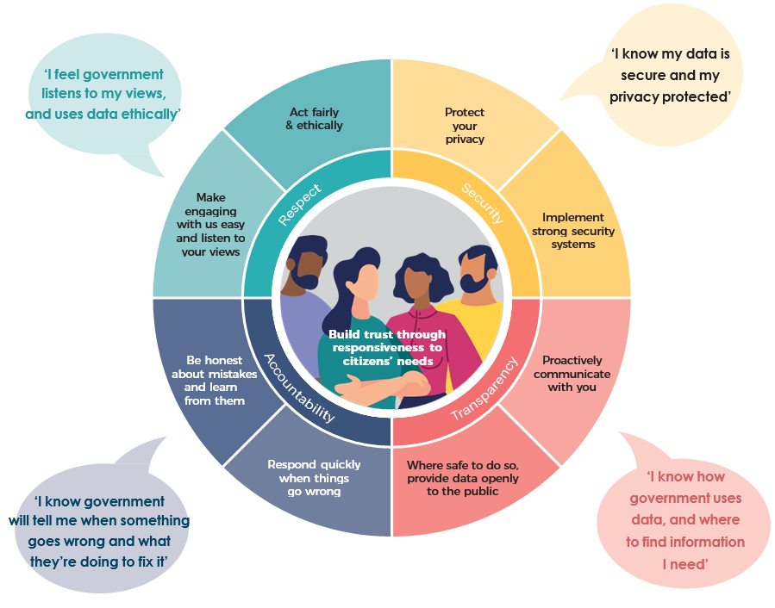w - www.pmc.gov.au/public-data/australian-data-and-digital-council
e - addc@pmc.gov.au

