PREFACE

I am pleased to present the Australian Government’s Consolidated Financial Statements (CFS) for the financial year ended 30 June 2021. The CFS presents the whole of government and general government sector (GGS) financial reports, including the audited accounts of 190 entities across the public sector.

The CFS has been prepared in accordance with the regulations of the *Public Governance, Performance and Accountability Act 2013* (PGPA Act) and applicable Australian Accounting Standards (AAS), including the requirements of AASB 1049 *Whole of Government and General Government Sector Financial Reporting* (AASB 1049). The CFS shows the results of the Australian Government’s financial performance and cash flows for the year ended 30 June 2021 and the Australian Government’s financial position as at 30 June 2021.

The COVID-19 pandemic has continued to have a profound impact on Australia’s economy across the financial year to 30 June 2021. In response, the Australian Government has provided critical support to affected Australian households, businesses and industries. The financial impact of the Australian Government’s necessary response is reflected in the CFS.

The Preface and the Commentary should be read in light of the information and explanations provided in the CFS.

# Operating statement

The Australian Government’s net operating balance for the year ended 30 June 2021 was a deficit of $130.5 billion. For the year ended 30 June 2020, the Australian Government reported a net operating balance deficit of $98. 8 billion.

While the Australian Government’s revenue increased by $40.7 billion (8.1 per cent), there was an increase in expenditure of $72.3 billion (12.1 per cent) in 2020-21, primarily as a result of the Government’s economic response to the COVID-19 pandemic.

Information on the operating results, including the financial impacts of the COVID-19 pandemic, are included in the Commentary on the CFS.

# Balance sheet

The Australian Government’s net worth was negative $743.2 billion as at 30 June 2021. As at 30 June 2020, the Australian Government’s net worth was negative $679.9 billion.

The Australian Government’s financial assets increased by $155.0 billion (26.0 per cent) for the year ended 30 June 2021. Total non-financial assets increased by $6.2 billion (2.6 per cent).

*Preface*

The Australian Government’s liabilities increased by $224.5 billion, primarily driven by an increase in deposit liabilities of $277.0 billion, reflecting the increase in exchange settlement funds from the Government’s economic response to the COVID-19 pandemic.

# Cash flows

The Australian Government recorded a cash deficit of $135.7 billion for the year ended 30 June 2021 from operating activities and investing activities in non-financial assets. The cash position at the end of the year was $7.7 billion.

# Contingent liabilities, contingent assets and risks

Contingent liabilities and contingent assets for the Australian Government are not disclosed in the balance sheet but are set out in detail in Note 9A of the CFS. Analysis of financial risks that could potentially impact on the Australian Government’s financial position is included in Note 9B and Note 9C.

# Final Budget Outcome

Under the *Charter of Budget Honesty Act 1998* (the Charter), the Australian Government is required to publicly release and table a Final Budget Outcome (FBO) report no later than three months after the end of the financial year. The FBO for the 2020-21 financial year was released on 30 September 2021, presenting the fiscal outcomes for the Australian Government general government sector.

Consistent with the requirements of the Charter, the FBO is prepared on an accrual basis that complies with both the Australian Bureau of Statistics’ (ABS) accrual Government Finance Statistics (GFS) publication and the Australian Accounting Standards, except for the departures disclosed in the FBO. An explanation of the differences between the key fiscal aggregates reported in the CFS under AASB 1049 and the corresponding fiscal aggregates reported under the ABS GFS publication is included in Note 12A.

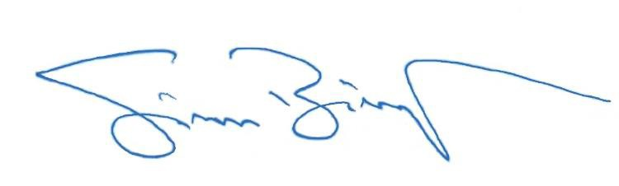I would like to thank the many Australian Government employees whose efforts have contributed to the completion of the 2020-21 CFS.

Senator the Hon Simon Birmingham Minister for Finance

2