# Australian Government Property Register

2021 Office Data Collection Manual

17 September 2021

* 1. Contents

2021 Office Data Collection Manual 1

17 September 2021 1

1.1 Contents 2

2. Background 4

2.1 The Australian Government Property Register (AGPR) 4

2.2 Purpose 4

2.3 The AGPR Application 4

3. 2021 AGPR Office Data Collection 5

3.1 Collection Timeframe – Key Dates 5

3.2 Action Required 5

3.2.1 Data Supplier Agreement 5

3.2.2 Scope Phase 6

3.2.3 Data Collation and Entry Phase 6

3.2.4 Validation 7

3.2.5 Entity Sign-off 8

3.3 Extensions to Timeframes 8

3.4 Collection Scope 8

3.4.1 Entity Scope 8

3.4.2 Property Scope 9

3.5 Role of PSPs 10

3.6 Role of Entities 11

3.7 Data Quality and Governance 11

3.8 Non-Office Space and Exemptions for Space 11

3.9 Inter-Entity Property Transfers – Machinery of Government Changes 12

3.10 Issue Escalation Process 12

3.11 Requesting AGPR Access 13

3.12 Further Assistance 13

3.13 Troubleshooting 14

3.14 Updates since the 2020 Collection 15

3.14.1 Additional fields 15

3.14.2 Field changes 16

3.14.3 Field deletions 16

3.15 Field Definitions Contents Table 17

3.16 AGPR field definitions and guidance material 22

4. Dictionary of Applicable Terms 92

5. Attachment A – Data Suppliers 94

6. Attachment B Non-Office Area Category J – Exempt Area Application Form 100

7. Attachment C – Defined Calculated Fields 102

1. Background
   1. The Australian Government Property Register (AGPR)

The Department of Finance (Finance) has established the AGPR to hold data on the Commonwealth’s office accommodation and owned land. This data provides a Whole-of-Government dataset that informs evidence based decision-making, and assists Finance and non-corporate Commonwealth entities (Entities) with identifying opportunities to support the cost efficient use of Commonwealth property.

This data also informs the development of the Commonwealth Leasing Strategy.

Finance is responsible for maintaining the AGPR for leased and owned Commonwealth property, based on information reported by entities.

All Non-corporate Commonwealth Entities (NCEs) are required to report their office accommodation data in line with the requirements set out in Section 7 of the [Commonwealth Property Framework (Resource Management Guide 500)](https://www.finance.gov.au/sites/default/files/2020-08/rmg-500.pdf). Property Service Providers (PSPs) must assist their NCEs complete their reporting requirements for the AGPR.

* 1. Purpose

The purpose of this document is to provide guidance to Commonwealth Entities (Entities) and Property Service Providers (PSPs), on behalf of Entities under the Property Services Coordinated Procurement (PSCP) arrangements, on the 2021 Australian Government Property Office Data Collection (2021 AGPR Office Data Collection).

* 1. The AGPR Application

The AGPR application is a set of web forms that Entities and PSPs use to enter property data. The data is then stored in the AGPR database to maintain a single source of truth for the Commonwealth’s property footprint.

|  |  |
| --- | --- |
|  | Some modern browsers include plug-ins that refresh pages after a period of inactivity. It may be necessary to disable these plug-ins while entering data through the AGPR application in order to ensure unsaved changes are not lost where the browser auto-refreshed a page. Instructions for doing this are included in the Troubleshooting section of the manual. |

1. 2021 AGPR Office Data Collection
   1. Collection Timeframe – Key Dates

Entities required to complete the data collection must finalise their submission for the 2021 AGPR Office Data Collection by no later than close of business **25 October 2021**.

Key dates for the 2021 AGPR Office Data Collection are included in the table below

| **Collection Activity** | **Week Commencing** | **Duration (weeks)** |
| --- | --- | --- |
| Agreement on Data Supplier | 26 July 2021 | 1 |
| Scope Confirmation (buildings, leases and subleases) | 2 August 2021 | 3 |
| Primary Data Collation | 23 August 2021 | 3 |
| Data Entry | 6 September 2021 | 4 |
| Data Validation | 27 September 2021 | 3 |
| Entity Sign-off | 11 October 2021 | 2 |
| **Submission completion** | **By 25 October 2021** | |

* 1. Action Required

To complete the 2021 AGPR Office Data Collection, Entities and PSPs (on behalf of Entities under the PSCP Arrangements) are required to complete a number of sub-processes. These are detailed in the 2021 Collection Schedule and Process Description document supplied to all Entities and PSPs. A summary of these processes follows:

* + 1. Data Supplier Agreement

Where an Entity is provided services by a PSP under the PSCP Arrangements, the PSP will be responsible for supplying the majority of data for the 2021 AGPR Office Data Collection. A list of all data fields in the collection is included in Attachment A, along with details of the recommended Data Supplier. Where PSP has been listed as the Data Supplier, this has been done in line with the expectations on the PSP as set out in *section 17 of Schedule 1 of the Deed in relation to Property Services to the Commonwealth of Australia* (the Property Services Deed) and Section 7 of RMG500. However, there is scope for PSPs and Entities to agree to variations to the Data Suppliers listed in the attachment on a case-by-case basis.

To assist with streamlining the collection process, agreement on the Data Supplier for each field must be finalised before the main collection process commences on 2 August 2021. Once finalised the agreement needs to be forwarded to Finance via email at [propertydata@finance.gov.au](mailto:propertydata@finance.gov.au).

Entities without a PSP are required to supply data for all fields in the collection.

* + 1. Scope Phase

During this phase, entities are required to report the details of accommodation that is in-scope for the collection (refer to section *2.4 Collection Scope* for further details on what is in-scope). The collection of more detailed information will occur in the subsequent *Data Entry* phase.

* Data stored for accommodation reported in the 2020 AGPR Office Data Collection will need to be reviewed to confirm that it is still current as at 30 June 2021 (the Collection End Date).
* Any buildings, leases (or owned accommodation), or sub-lease arrangements that are not current as at the Collection End Date should be deleted.
* Where new accommodation or sublease arrangements exists, baseline details of these need to added into the AGPR to facilitate the data entry phase by all Entities and PSPs (where applicable). Baseline details are outlined on page 8 of this manual.

Responsibility for completing this phase

* Where an Entity is under the PSCP arrangements, the PSP will assist by providing details of all known tenancies for confirmation and update by the entity. The PSP will then complete all applicable data entry and will request any deletions from Finance.
* Where an Entity is not yet part of the PSCP arrangements, they will be fully responsible for completing this task.

|  |  |
| --- | --- |
|  | Nested subleases: In the AGPR, subleases (including MOUs) are recorded within a Tenancy lease record, which in turn generates a Sublet lease record for the sub-lessor to report their details. Unfortunately, there is no functionality in the system to record a sublease within a Sublet lease record.  Where this situation will occur, PSPs should contact Finance at [propertydata@finance.gov.au](mailto:propertydata@finance.gov.au) as soon as possible. Finance will work with relevant entities to modify how leases are linked to address this situation. Once linking issues have been addressed by Finance, the PSP will still be required to enter in relevant lease information. |

This phase needs to be completed by no later than **20 August 2021**.

* + 1. Data Collation and Entry Phase

The Data Entry phase is the main element of the 2021 AGPR Office Data Collection process and requires detailed building, lease and sublease data to be collated and entered into the AGPR.

Data must be reported using the online AGPR application, which can be accessed via <https://dofwad001.azurewebsites.net/#/login> and in accordance with the definitions and specifications as stated in this document.

* Where an Entity is under the PSCP arrangements, the PSP will manually enter the data to the AGPR application this on their behalf.
* Where an Entity is not yet part of the PSCP arrangements, they will be fully responsible for completing this task.

|  |  |
| --- | --- |
|  | For the 2021 AGPR Office Data Collection, all data will need to be manually entered into the AGPR via the web-forms.  Whilst Finance is exploring opportunities for alternative data collection methods, these will not be available for this collection. PSPs and Entities should proceed with the collection planning for all data to be entered manually. |

To assist with streamlining the collection, PSPs can commence entering data they are supplying (as per Data Supplier Agreement) into the AGPR while awaiting further data from Entities. PSP supplied data *does not need to be verified by Entities* prior to data entry as this *verification* occurs in the validation and sign-off phases.

Entities and PSPs should familiarise themselves with the AGPR data definitions and collection requirements detailed in this document. Entities and PSPs can seek further clarification from Finance as required.

Prior to the submission of data, PSPs and Entities should review the submission to ensure that all data fields are updated and that data provided is correct. While Finance will also review the data, this validation does not replace quality assurance processes that should be undertaken by entities and their PSPs.

|  |  |
| --- | --- |
|  | All data (including financial data) must also be reported as at 30 June 2021.  All financial data, e.g. expenses, must be reported as **‘inclusive of GST’**. |

All data entry must be completed for all Entities by no later than 26 September 2021.

* + 1. Validation

Once all data for an Entity has been entered into the AGPR, Finance will review the data, testing it against the AGPR data validation rules to check for potential errors. These rules are not a comprehensive check of all data items, rather, they focus on the integrity of key data items.

Once completed, Validation Reports will be issued to both Entities and PSPs for actioning. These reports will be separated into three sections: Buildings, Leases, and Sub-leases, to facilitate faster verification of data.

|  |  |
| --- | --- |
|  | Once all validation issues have been addressed, including provision of commentary for issues not requiring data corrections, the data will be re-validated. |

Entities will remain in the data validation phase until all of their validation issues are resolved.

Where a validation error relates to a PSP data item (as per the Data Supplier agreement) the PSP will be expected to resolve this issue. Similarly for Entity supplied items the Entity will be responsible for actioning the issue, with the exception of data entry, which remains the responsibility of the PSP (for those Entities under the PSCP Arrangements).

It is important to recognise that some data validation issues may require a join effort to resolve. The Entity and their PSP are expected to work collaboratively to clear all issues in a timely manner.

All validation issues are expected to be resolved by **15 October 2021**.

* + 1. Entity Sign-off

Once all validation issues have been addressed, Finance will issue a sign-off report to the Entity.

The sign-off report contains three components:

* An Office Accommodation data-set (Excel spreadsheet) with details of all reported Buildings, Leases (including owned office accommodation) and Sub-leases for the entity (current as at the Collection End Date),
* an Entity Property Statistics Summary, and
* a Property Delegate Sign-Off sheet.

|  |  |
| --- | --- |
|  | Entities are required to review all data in their Office Accommodation data-set and provide executive sign-off, by a SES Band 1 or equivalent, no later than close of business on **25 October 2021**. |

* 1. Extensions to Timeframes

If an Entity is unable to complete the scoping, data entry of validation phases by the prescribed deadlines they should contact the Property Data team at Finance via [propertydata@finance.gov.au](mailto:propertydata@finance.gov.au).

However, while some flexibility will be provided to the dates of completion of earlier phases, no extensions will be provided to the sign-off completion date of 25 October 2021, as property data for all Entities is required at this time to inform development of the Commonwealth Leasing Strategy and property policy.

* 1. Collection Scope
     1. Entity Scope

Participation in the 2021 AGPR Office Data Collection is a mandatory requirement for all NCEs with in-scope office accommodation (see section 2.4.2 below). This requirement is set out in Section 7 of the [Commonwealth Property Framework (Resource Management Guide 500)](https://www.finance.gov.au/sites/default/files/2020-08/rmg-500.pdf).

Corporate Commonwealth entities and Commonwealth companies are not required to report details of their office accommodation, but are encouraged to contribute to the data collection on a voluntary basis.

* + 1. Property Scope

#### *In Scope*

Entities are required to report details of all property (leased or owned) which:

* has Usable Office Area (in-scope accommodation); and
* is used, in any part, to conduct office activity that supports the government business and outcomes.

The collection scope **includes** any office properties, special purpose properties, operational facilities and other types of property located in Australia.

Examples of in-scope accommodation are:

* office accommodation;
* properties used mostly for ‘operational’ purposes that are have areas where office work is completed, including to support operational activities. For example, desks in staff-only access areas at airports for completion of administrative work to support other operational activities conducted at the property;
* Special Purpose Properties, such as dog-training facilities or car-depots, where there is space used to conduct office work. For example, a desk or work-point to complete paperwork or administrative tasks;[1]
* shopfronts[2]; and
* sub-leases or Memorandums of Understanding (MOU) arrangements from other Commonwealth Entities. For example, 140m2 of office space for 10 work-points accessed under an MOU.

|  |  |
| --- | --- |
|  | Entities are required to record details for all leased and owned office space, with data as at 30 June 2021, regardless of cost or tenancy size.  Entities, or PSPs for those under the PSCP arrangements, must record data in the AGPR on all owned or leased office space attributed to the Entity as at 30 June 2021, regardless of cost or tenancy size. This **includes** office accommodation of less than 500 square metres of usable office area, and whole-of-life costs of less than $2 million, which was not collected prior to 2017. |

#### *Out of Scope*

Any property that does not have the capacity to be used for office work is regarded as out-of-scope. Additionally, properties located overseas, military bases and intelligence agencies are also regarded as out-of-scope for this collection.

Hosted arrangements where there is no lease or formal MOU, and where there is no payment for the arrangement, are considered out of scope for the hosted entity, and the hosting entity should report these work-points in their AGPR submission.

Some examples of out-of-scope properties are:

* data warehouses;
* car-depots or car-parks with no usable office area;
* facilities used exclusively for storage;
* leased or owned land with no office structures, noting that any buildings on this land may be in-scope depending on usage. For example, an animal enclosure would be out-of-scope but an administration building supporting operational functions on the land would be in-scope; and
* Special Purpose or operational facilities with zero usable office area.
  1. Role of PSPs

Under the PSCP arrangements, PSPs are responsible for collecting, validating and submitting all property data to the AGPR on behalf of Entities.

The Property Services Deed requires all PSPs to obtain and store a range of property data on behalf of the Entities they are contracted to assist. As such, the PSP will be the data supplier for the majority of data required to be reported in the 2021 AGPR Office Data Collection.

PSPs are required to ensure all relevant data is available for distribution to their Entities at the beginning of the *Scope* and *Data Entry* phases of this collection; with data being sent no later than five days after commencement of the relevant phase.

While Entities don’t need to verify PSP supplied data before it can be entered into the AGPR web-forms, providing a full dataset to Entities is likely to assist in achieving a more efficient collection process as it will give the Entity more time to identify potential issues with data, enabling them to be rectified before sign-off is required.

PSPs will collate data supplied by the Entity and enter this into the AGPR on behalf of the entity.

There is some data that PSPs may not have access to, and may require the Entity’s assistance in the collection (e.g. staff allocated to a lease, if this is not managed through a PSP run system) for the PSP to upload to the AGPR. Attachment A contains a list of these data items and must be agreed with each Entity prior to commencement of the 2021 AGPR Office Data Collection.

Finance will provide appropriate level of AGPR access to the PSPs to allow them to undertake this task. Requests for new user access for the AGPR should be sent to [propertydata@finance.gov.au](mailto:propertydata@finance.gov.au).

PSPs are also responsible for tracking Entity progress through the collection process and providing regular updates on request to Finance at [propertydata@finance.gov.au](mailto:propertydata@finance.gov.au).

* 1. Role of Entities

Where an Entity has a PSP, they are required to work closely with their PSP and provide data they have agreed to supply, in a timely manner, so that it can be entered into the AGPR by their PSP. Attachment A contains a list of these data items and must be agreed with the PSP prior to commencement of the 2021 AGPR Office Data.

Entities are also required to address all validation issues for data items they are responsible for supplying.

Entities without a PSP are responsible for completing all elements of the 2021 AGPR Office Data Collection.

The Property Data team at Finance is available to provide assistance all entities, in the form of advice, however they are not able to complete the process on behalf of an Entity or its PSP.

* 1. Data Quality and Governance

Each Entity is responsible and accountable for the quality and completeness of data reported on its behalf. Entities and their PSPs where relevant should undertake a quality assurance review of the data prior to submission, however final verification of data entered is completed in the Validation and Sign-off phases of the collection.

The Property Data team at Finance will work with Entities to ensure the data collected in the AGPR aligns to the standards as outlined in this document. Validation reports will be provided to Entities upon completion of data entry. These reports will contain full details of all data entered for their office accommodation, along with a list of validation issues to be resolved.

Entities are required to review all data to ensure its accuracy and completeness before the Property Delegate (SES Band 1 or equivalent position at the Entity) completes the final sign-off.

* 1. Non-Office Space and Exemptions for Space

The property data collected in the AGPR is used to inform the annual Office Occupancy report, which is publically reported, as well as to support a range of different policy analysis tasks.

When reporting on the usage of area within a building, Entities (or PSPs on their behalf) are required to ensure that details NLA, subleases and all applicable non-office area are correctly recorded. There are 10 categories of non-office area available for Entity or PSP use, these are:

* Non-Office Area C – Basement or Inadequate Amenity
* Non-Office Area D – Police Station, Laboratory or Hospital
* Non-Office Area E – Specifically for Operational Activity
* Non-Office Area F – Public Facility
* Non-Office Area G – Judicial Chambers and Court Rooms
* Non-Office Area H – Areas Specifically for the Governor-General, Prime Minister and Parliamentarians
* Non-Office Area I – Emergency and Crisis Coordination Areas
* Non-Office Area J – Exempt Area
* Non-Office Area L – Shopfronts
* Non-Office Area M – ICT/Data Warehouse

Where an Entity assesses an area as non-office space, but is not able to allocate it within the current classifications for non-office space (Area C to Area I, or Area L or M), they should complete the Non-Office Area Category J – Exempt Area Application Form (located at Attachment B) and send to [propertydata@finance.gov.au](mailto:propertydata@finance.gov.au) for consideration.

Where an exemption has been previously approved, *Non-Office Area Category J – Exempt Area Application Forms* are to be re-submitted to Finance via email with evidence of previous exemption and comments from the Entity to validate the continued exemption in the 2020 -2021 reporting period.

For assistance identifying whether office area in operational sites is non-office or usable office area, please contact the Property Data team at Finance via email on [propertydata@finance.gov.au](mailto:propertydata@finance.gov.au).

* 1. Inter-Entity Property Transfers – Machinery of Government Changes

This process applies to all MoG changes between 1 July 2020 and 30 June 2021.

Where an Entity acquires a property from another Entity as a result of a Machinery of Government (MoG) change, the relinquishing Entity must work with their PSP to provide all required data up to the date of the property transfer to the gaining Entity. The gaining Entity is then responsible for providing the data on the transferred property to Finance as if it held the property for the full reporting period.

Data supplied by the relinquishing Entity, and their PSP, must be signed-off in accordance with the standard sign-off process.

The PSP representing the Entity gaining the property should then check the data for any obvious errors or anomalies, and resolve potential issues before accepting responsibility of the data.

* 1. Issue Escalation Process

Where an Entity has a PSP, the PSP is responsible for tracking the Entity’s progress through the collection and providing regular updates to Finance on the status of each Entity’s submission.

Entities not under the PSCP Arrangements should also monitor their progress and provide updates to Finance on a regular basis.

Entities and PSPs should contact Finance via [propertydata@finance.gov.au](mailto:propertydata@finance.gov.au) immediately where they encounters issues that will risk completion of their full submission by the required date. Were these issues are identified, Finance will work with Entities and PSPs to get the submission back on schedule.

* 1. Requesting AGPR Access

Entities and PSP staff can request access to the AGPR Portal by contacting the Property Data team via email at [propertydata@finance.gov.au](mailto:propertydata@finance.gov.au). An AGPR User Access Request Form will then be sent to the user for completion.

|  |  |
| --- | --- |
|  | All user access requires require approval from the user’s manager.  For Commonwealth Entities this is a minimum of Director (EL2) level. |

Access to the AGPR utilises a multi-factor authenticator (MFA) identification process. As such, all users will be required to set up a MFA using either the Microsoft or Google Authenticator applications on a suitable device. When this is initially set up, a list of 10 single-use recovery codes will be generated. These recovery codes can be used to enter the AGPR without entering the authenticator token.

|  |  |
| --- | --- |
|  | **Please save the recovery codes** in a secure and easily accessible location as AGPR administrators do not have a copy of these codes. There have been multiple instances where users have had issues with their authenticators and not been able to access the AGPR. In these situations, the recovery codes allow users to regain access to the AGPR Portal quickly. |

Please refer to Troubleshooting section of the manual for further details where users need to setup their authenticator on a new device or if the recovery codes have been misplaced or used up.

* 1. Further Assistance

The Property Data team at Finance manage the 2021 AGPR Office Data Collection process on behalf of the Commonwealth and can be contacted if assistance is required with the completion of the collection, including clarification of any information in the Manual, or the Collection Schedule or Process documentation.

Please send all queries to [propertydata@finance.gov.au](mailto:propertydata@finance.gov.au).

* 1. Troubleshooting

|  |  |
| --- | --- |
| Issue | Solution |
| Data Lost after Browser Auto-Refresh  Users have reported that unsaved data is lost when the web-browser auto-refreshed after a period of inactivity. | Users may be able to disable the flag in their browser (, if using Edge or Chrome browsers) that causes the browser auto-refresh issue.  *Note*: Users may be blocked from making this change on their organisation’s device by their organisation’s IT administrators.  To disable the *Calculate window occlusion on Windows* flag, please follow the following steps:   1. Open your Edge or Chrome Browser 2. Search for the following in the URL bar    1. In Chrome, search for *chrome://flags/#calculate-native-win-occlusion*    2. In Edge, search for *edge://flags/#calculate-native-win-occlusion* 3. Locate the flag *Calculate window occlusion on Windows* (this should be highlighted and near the top of the page) 4. Change the status from “Default” to “Disabled” 5. Relaunch the Edge or Chrome Browser for the change to take effect   As not all users will be able to disable this flag it is important that all users save records frequently and before they move to a different tab or window.  To raise the frequency of which a user can save a record and minimise the impact of this issue, some fields now no longer require input for users to save the record.  *Note*: These fields still need to be reported and validation checks will identify whether these fields are empty upon final submission. |
| How to Set-up the Multi-Factor Authenticator on a New Device | 1. Login in to the AGPR Portal (if you don’t have your authenticator, use one of the 10 recovery codes which have not been previously used to login)   If you log in with your recovery code, skip steps 2-3.   1. Select your email address near the top left corner of the page 2. Select “Two-factor authentication” 3. Select “Setup authenticator app” and follow the instructions |
| How to Generate New Recovery Codes | 1. Login in to the AGPR Portal (if you don’t have your authenticator, use one of the 10 recovery codes which have not been previously used to login)   If you log in with your recovery code, skip steps 2-3.   1. Select your email address near the top left corner of the page 2. Select “Two-factor authentication” 3. Select “Reset recovery codes” 4. Select “Generate Recovery Codes” 5. Save the new recovery codes in secure and easily accessible location |

* 1. Updates since the 2020 Collection

Since the last collection in 2020, the AGPR has been upgraded to further improve the accuracy of the data held, and to ensure that the data collected if fit-for-purpose.

* + 1. Additional fields

|  |  |
| --- | --- |
| Field Name/Location | Reason for addition |
| Tenancy Lease Details |  |
| Annual Lease Effective Rent | This has been included to capture the annualised rent for the lease/tenancy as recorded in the lease documentation. For example, where a lease commenced part way through the collection cycle the Current Year Actual Rent field will capture the actual expense paid, while the Annual Lease Effective Rent will capture the amount of rent for a full year, i.e. an annualised rent amount. |
| Building Management |  |
| Entity Managed Expenses - Repair and Maintenance | This field has been duplicated to also capture the Repair and Maintenance expenses that are managed and paid for directly by Entities rather than PSPs. Existing fields will remain, under a renamed section ‘PSP Managed Expenses’ to capture PSP managed Repair and Maintenance. |
| Entity Managed Expenses - Water and Sewerage | This field has been duplicated to also capture the Water and Sewerage expenses that are managed and paid for directly by Entities rather than PSPs. Existing fields will remain, under a renamed section ‘PSP Managed Expenses’ to capture PSP managed Water and Sewerage. |
| Entity Managed Expenses - Relocation and Minor Refurbishments | This field has been duplicated to also capture the Relocation and Minor Refurbishments expenses that are managed and paid for directly by Entities rather than PSPs. Existing fields will remain, under a renamed section ‘PSP Managed Expenses’ to capture PSP managed Relocation and Minor Refurbishments. |
| Entity Managed Expenses - Other Operating Expenses | This field has been duplicated to also capture the Other Operating Expenses that are managed and paid for directly by Entities rather than PSPs. Existing fields will remain, under a renamed section ‘PSP Managed Expenses’ to capture PSP managed Other Operating Expenses. |
| Entity Managed Expenses - Energy | This field has been duplicated to also capture the Energy expenses that are managed and paid for directly by Entities rather than PSPs. Existing fields will remain, under a renamed section ‘PSP Managed Expenses’ to capture PSP managed Energy. |
| Entity Managed Expenses - Cleaning and Waste Removal | This field has been duplicated to also capture the Cleaning and Waste Removal expenses that are managed and paid for directly by Entities rather than PSPs. Existing fields will remain, under a renamed section ‘PSP Managed Expenses’ to capture PSP managed Cleaning and Waste Removal. |
| Entity Managed Expenses - Contractors and Consultants | This field has been duplicated to also capture the Contractors and Consultants expenses that are managed and paid for directly by Entities rather than PSPs. Existing fields will remain, under a renamed section ‘PSP Managed Expenses’ to capture PSP managed Contractors and Consultants. |
| Sublease Details |  |
| Sublease Status | This has been included to capture the status (active, holdover, expired) of the sublease, MOU, etc. within a head-lease record. |

* + 1. Field changes

|  |  |
| --- | --- |
| Field Name/Location | Change Type |
| Building Management |  |
| PSP Managed Expenses | Field name change – formerly known as “Expenses”. |
| Tenancy Lease Details |  |
| Current Year Actual Rent | Field name change – formerly known as “Current Annual Rent”. |

* + 1. Field deletions

|  |  |
| --- | --- |
| Field Name/Location | Reason for deletion |
| Regional Costs |  |
| Regional Type | Information no longer required |
| Region | Information no longer required |
| Security Expenses | Information no longer required |
| Comments | Information no longer required |

* 1. Field Definitions Contents Table

Buildings 1.0 22

New Building Request 1.1 24

Search Address 25

Building ID 25

Building Name 25

Street Number 26

Street Name 26

Suburb 26

State/Territory 26

Post Code 27

Latitude 27

Longitude 28

Building Owner Type 28

Building Owner Name 28

Building Grade 29

Heritage Status 30

NABERS Rating 31

NABERS Rating Scope 32

Submitter’s Comments 32

Building Management 1.2 33

Repair and Maintenance Expense 36

Energy Expense 37

Water and Sewerage Expense 37

Cleaning and Waste Removal Expense 38

Relocation and Minor Refurbishments Expense 39

Contractors and Consultants 39

Other Operating Expenses 40

Services Received Free of Charge 41

Comments 41

Facilities Management – Provider 41

Facilities Management Provider Contract End Date 41

Facilities Management – Services Base Fees (excluding pass through costs) 42

Facilities Management – Services Other Fees (excluding pass through costs) 43

Other (Facilities Management) Services 43

Leases 2.0 44

Building 46

Type 46

Lease Identifier 46

Description 46

Tenancy Leases 2.1 47

Lease Description 49

Comments 49

Lease Start Date 49

Lease End Date 49

Lease Type 50

Lease Status 51

Green Lease Schedule 52

Tenancy Highest Security Level 53

Current Year Actual Rent 54

Lessor’s Outgoings Expense 55

Annual Lease Effective Rent 56

Total Outgoings 56

Provider 57

Provider Contract End Date 57

Services - Base Fees 57

Services - Other Fees 58

Manager Name 58

Manager Phone 58

Manager Email 58

Manager Contact Details 58

Number of Remaining Extensions 59

Length of Next Lease Extension 59

Extension Notification Date 59

Incentive: Rent Abatement 59

Incentive: Fit-out Contribution 60

Total Incentive 60

Incentive Description 61

Last Year Major Fit-out Conducted 61

Last Major Fit-out Cost 62

Total Fit-out Cost 63

Rent Review Mechanism 63

Rent Review Frequency 63

Sub-Leases 2.2 64

Sub-Leased To 66

Sub-Lease Description 66

Leasing Entity Name 66

Start Date 67

End Date 67

Sub-lease Status 68

Sub-Leasing Parties/Agencies Sub-Leased To 68

Total Revenue 69

Total Sub-Leased Area 69

Total Vacant Area Available 69

Leased Areas 2.3 70

Net Lettable Area 71

Staff Allocated to Lease 72

Work-points 72

Non-Office Area C – Basement or Inadequate Amenity 73

Non-Office Area D – Police Station, Laboratory or Hospital 73

Non-Office Area E – Specifically for Operational Activity 74

Non-Office Area F – Public Facility 75

Non-Office Area G – Judicial Chambers and Court Rooms 76

Non-Office Area H – Areas Specifically for the Governor-General, Prime Minister and Parliamentarians 77

Non-Office Area I – Emergency and Crisis Coordination Areas 78

Non-Office Area J – Exempt Area 78

Non-Office Area L – Shopfronts 79

Non-Office Area M – ICT/Data Warehouse 80

Total Non-Office Area 80

Total Sub-Leased Area 80

Cost per Square Metre 81

Cost per Work-point 81

Usable Office Area 81

Work-point Vacancy Rate 81

Occupational Density 81

Advertising 2.4 82

Published Date 84

Status 84

Space Fitted Out? 84

Work-points Available 84

Square Metres Available 84

Available From Date 84

Period Available 85

Additional Information 85

Contact Person 85

Contact Phone 85

Contact Email 85

Lease Documents 2.5 86

Document Type 88

Keywords 88

Documents 5.0 89

File Extension 91

Version 91

Upload Date 91

* 1. AGPR field definitions and guidance material

Data Element Specifications

Non-editable/non-selectable fields Fields editable upon request Fields editable/selectable

Buildings 1.0

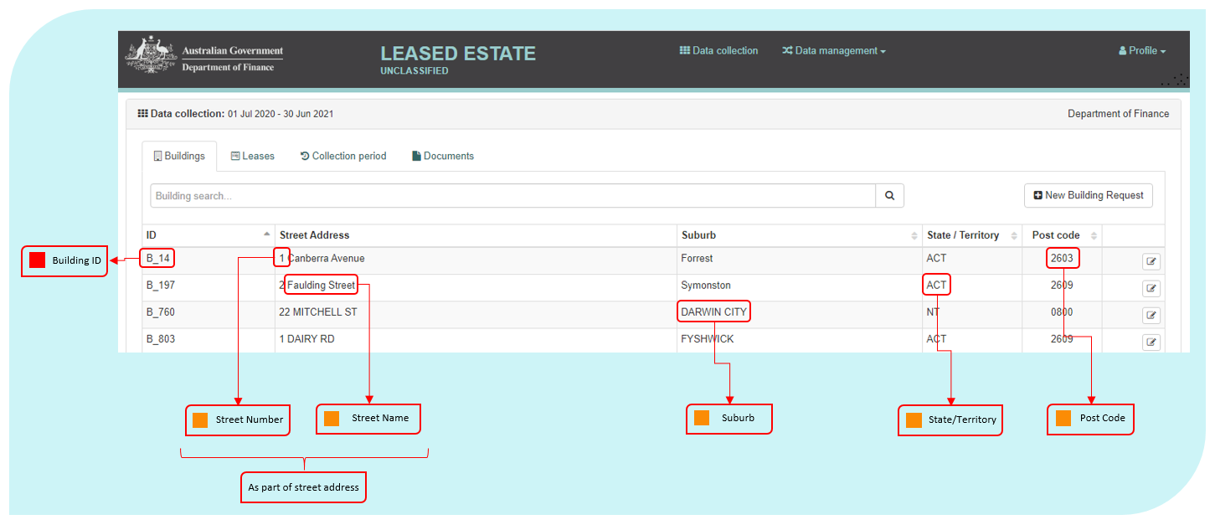

Once logged into the AGPR Leased Estate application, the Buildings tab is the first to appear. This tab lists all the buildings an Entity has reported under the AGPR collection mandate.

The fields highlighted in the figure above are visible to users but can only be edited by the Finance Property Data Team. The data fields are defined as part of the next section ‘New Building Request’.

Clicking on the view/edit icon will take users to the Building Record section, containing the ‘Building’ and ‘Building Management’ tabs.

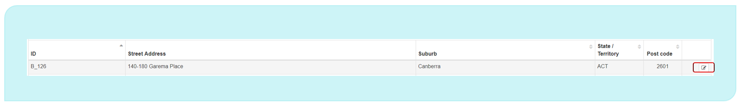

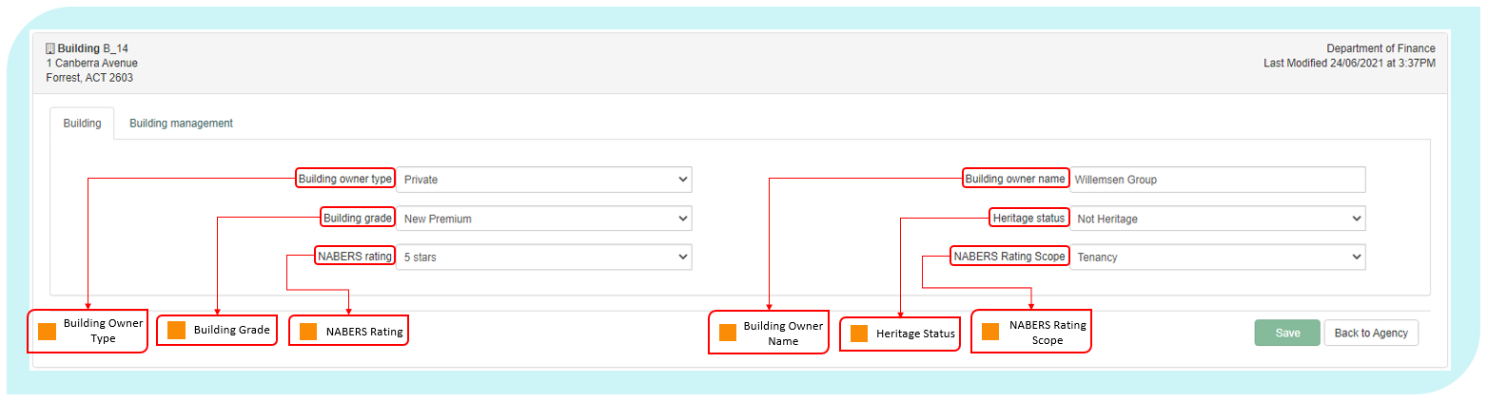

These data fields are defined in the ‘New Building Request’ section (below). These fields can only be edited by System Administrators within the Finance Property Data Team. Data elements in the ‘Building Management’ tab will be defined later in the manual.

New Building Request 1.1

A new building can only be created or updated through a request to the Finance Property Data Team.

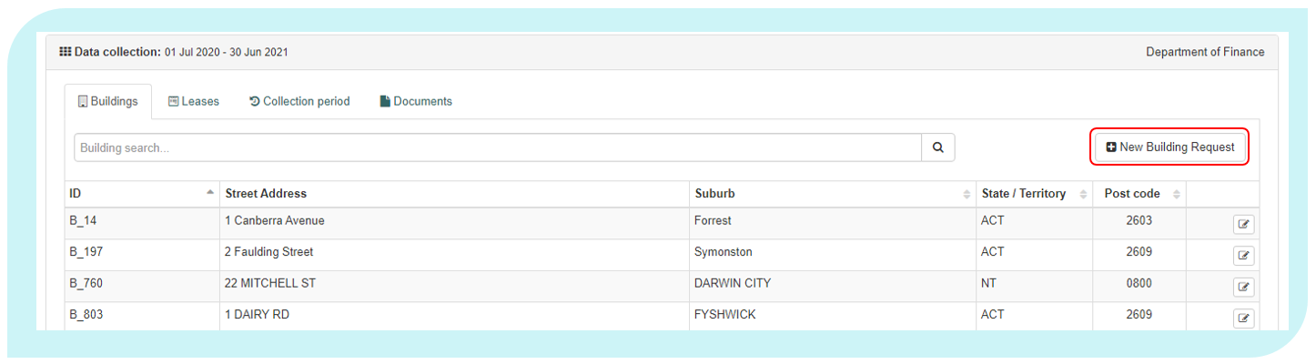

The following data definitions apply to this section.

Search Address

|  |  |
| --- | --- |
| Definition: | Users should enter the address of their new building into the ‘Search Address’ field. As the user types a street address, the system will compare and display pre-populated address against a known of formatted addresses. If there is pre-populated match displayed in this list, clicking on that match will auto-populate the majority of locality fields on the Building Request form. |
| Notes: | It is critical that building addresses are consistent. Users should try to match their address within the ‘Search Address’ field before completing address fields manually. |

Building ID

|  |  |
| --- | --- |
| Definition: | A unique code that identifies each building. |
| Notes: | The system generates this unique code for each building. |
| Format: | [B_nnn],[Bnnnnn] |

Building Name

|  |  |
| --- | --- |
| Definition: | The name of the property or building, if applicable. |
| Exclude: | Information provided in other street address fields or the entity name  Only include official building names or information as noted below. |
| Notes: | This field is used to denote a name for a property or building and may be used to provide additional context to the building address.  If the lease is for a specific floor in a building, please enter the floors(s) occupied in this field.  If the property does not have a building name **OR** a street number **AND** is located on a corner, report ‘Corner’ for this element.  This field should include information about the building, or building name and is **NOT** to be used as an additional reference field. |
| Format: | [Text] |

Street Number

|  |  |
| --- | --- |
| Definition: | The exact street number of the building. |
| Notes: | If the property is a unit, use the format ‘10B/131’.  If the property spans more than one street number, use the format ‘12‑14’.  **Do not** include information the level/floor of the building on which the Entity is located. |
| Format: | [nn], [nn-nn], [n/nnn] |

Street Name

|  |  |
| --- | --- |
| Definition: | The exact street name on which the property is located. |
| Notes: | Record the street type (i.e. street, road, lane, square etc) without abbreviation.  If the property is reported as being on a corner, report both street names for this element using the format ‘X Street and Y Street’. |
| Format: | [Name of Street], [Street Type] |

Suburb

|  |  |
| --- | --- |
| Definition: | The exact suburb in which the property is located. |
| Notes: | Record the suburb where the property is physically located. |
| Format: | [Text] |

State/Territory

|  |  |
| --- | --- |
| Definition: | The State or Territory in which the property is located. |
| Notes: | Record the State or Territory where the property is physically located.  **Do not** record the State or Territory where mail is sent for the property. |
| Format: | [Pick from List]   |  |  | | --- | --- | | Code | Meaning | | ACT | Australian Capital Territory | | NSW | New South Wales | | NT | Northern Territory | | QLD | Queensland | | SA | South Australia | | TAS | Tasmania | | VIC | Victoria | | WA | Western Australia | |

Post Code

|  |  |
| --- | --- |
| Definition: | The exact postcode in which the property is located. |
| Notes: | Record the postcode where the property is physically located.  **Do not** record the postcode where mail is sent for the property.  The postcode should match the suburb listed in the field Suburb. |
| Format: | [nnnn] |

Latitude

|  |  |
| --- | --- |
| Definition: | Latitude of the building. |
| Notes: | If the ‘Search Address’ feature is used, the latitude will populate automatically.  If an Entity needs to enter the latitude manually, they should take care to enter the value to a minimum of 5 decimal places to ensure the latitude works correctly.  If you are unsure on the Latitude of a tenancy you may source this information by following the steps outlines below   1. Navigate to [www.google.com/maps](http://www.google.com/maps) 2. Search for your building or tenancy address 3. Right click on the identified location 4. Left click on the coordinate value 5. Copy the relevant latitude value in to the AGPR |
| Format: | [nn.nnnnn] |

Longitude

|  |  |
| --- | --- |
| Definition: | Longitude of the building. |
| Notes: | If the ‘Search Address’ feature is used, the longitude will populate automatically.  If an Entity needs to enter the longitude manually, they should take care to enter the value to a minimum of 5 decimal places to ensure the longitude works correctly.  If you are unsure on the longitude of a tenancy you may source this information by following the steps outlines below   1. Navigate to [www.google.com/maps](http://www.google.com/maps) 2. Search for your building or tenancy address 3. Right click on the identified location 4. Left click on the coordinate value 5. Copy the relevant longitude value in to the AGPR |
| Format: | [nn.nnnnn] |

Building Owner Type

|  |  |
| --- | --- |
| Definition: | The type of organisation that owns the property. |
| Notes: | Report the current ownership type that applies for the reporting period.  If the Owner Type is Local Government then report ‘State Government’. |
| Format: | [Pick from List]   |  |  | | --- | --- | | Code | Meaning | | Commonwealth | The Commonwealth Government owns the building | | State Government | State, Territory or Local government owns the building | | Private | Non-government ownership | |

Building Owner Name

|  |  |
| --- | --- |
| Definition: | The exact, registered business name of the building owner. |
| Notes: | The name of the current owner of the building – as recorded in the Australian Business Register that matches their ABN. If the Entity is leasing from a Local Government then give the name of the Local Government Entity. |
| Format: | [Text] |

Building Grade

|  |  |
| --- | --- |
| Definition: | Building grade is broadly divided into existing buildings ‘EB’ and new buildings ‘New’. The current grade of the building in which the property is located, in accordance with the Property Council of Australia: A Guide to Office Building Quality. |
| Notes: | New buildings are classified as buildings where a development application was submitted post 1 January 2012.  Where building grade information in accordance with the PCA guidance is not reliable or easily available, report ‘unknown’ for this element. |
| Reference: | PCA: A Guide to Office Building Quality, most current version |
| Format: | [Pick from List]   |  |  | | --- | --- | | Code | Meaning | | EB Premium | Premium grade for existing buildings | | EB Grade A | Grade A for existing buildings | | EB Grade B | Grade B for existing buildings | | EB Grade C | Grade C for existing buildings | | EB Grade D | Grade D for existing buildings | | New Premium | Premium grade for new buildings | | New Grade A | Grade A for new buildings | | New Grade B | Grade B for new buildings | | Unknown | Building grade not known or unreliable | |

Heritage Status

|  |  |
| --- | --- |
| Definition: | The outcome of a heritage assessment done under section 341ZB of the *Environment Protection and Biodiversity Conservation Act 1999 (EPBC Act).* |
| Notes: | A property is only reported as ‘heritage’ if the heritage assessment required under section 341ZB or the EPBC Act indicates that the property is located in, or includes, a place with identified heritage values. |
| Format: | [Pick from List]   |  |  | | --- | --- | | Code | Meaning | | Heritage | The property is located in, or includes, a place with identified heritage value | | Not Heritage | The property is not located in, and does not include, a place with identified heritage value | | Unknown | A heritage assessment has yet to be undertaken for the place in which the property is located | |

NABERS Rating

|  |  |
| --- | --- |
| Definition: | NABERS energy rating achieved by the tenancy of the leased/owned scope of the building. |
| Exclude: | GreenPower and Green Star ratings. |
| Notes: | Note this is not necessarily the rating of the base building as a whole.  NABERS is a national rating system that measures the environmental performance of Australian buildings, tenancies and homes. For example, a 6 star rating demonstrates market-leading performance, while a 1 star rating means the building or tenancy has considerable scope for improvement.  Most buildings will have a NABERS rating assigned, a register can be found at: <https://www.nabers.gov.au/ratings/find-a-current-rating> |
| Reference: | NABERS National Australian Built Environment Rating System: <https://www.nabers.gov.au/ratings/estimate-your-rating> |
| Format: | [Pick from List]   |  |  | | --- | --- | | Code | Meaning | | 6 stars | Market Leading Performance | | 5 – 5.5 stars | Excellent Performance | | 4 – 4.5 stars | Good Performance | | 3 – 3.5 stars | Average Performance | | 2 – 2.5 stars | Below Average Performance | | 1 – 1.5 stars | Poor Performance | | 0 stars | Very Poor Performance | | Pending | NABERS Rating yet to be determined | | Not Applicable | Does not Apply (for leases under 1000sqm) | | No Assessment Undertaken | To date, no assessment has been completed, and no assessment is currently pending. | |

NABERS Rating Scope

|  |  |
| --- | --- |
| Definition: | The building type and rating scope the NABERS energy rating applies to. |
| Exclude: | GreenPower and Green Star ratings. |
| Notes: | This is not necessarily the rating of the base building as a whole.  NABERS is a national rating system that measures the environmental performance of Australian buildings, tenancies and homes. For example, a 6 star rating demonstrates market-leading performance, while a 1 star rating means the building or tenancy has considerable scope for improvement.  Where the building has not undergone a NABERS rating assessment; has a pending NABERS rating, or where a NABERS rating does not apply, please leave this field blank. |
| Reference: | Most buildings will have a NABERS rating assigned, a register can be found at: <https://www.nabers.gov.au/ratings/estimate-your-rating>  NABERS Rating Office Tenancies Page: <https://www.nabers.gov.au/tenancy>  Handbook for NABERS Ratings: <https://www.nabers.gov.au/file/1941/download?token=Qi0PXBBO> |
| Format: | [Pick from List]   |  |  | | --- | --- | | Code | Meaning | | Tenancy | Tenancy: assess the leased/owned area of the building | | Base Building | Base Building: assess the central services of an office building. (e.g. lifts and common area lighting) | | Whole Building | Whole Building: assess the combined impact of office tenancies and base building services (e.g. lifts and common area lighting) | |

Submitter’s Comments

|  |  |
| --- | --- |
| Definition: | Any additional details about the Building the user considers relevant. |
| Exclude: | This information will be considered by the Finance administrator when creating or editing the building record for the Entity. |
| Format: | [Text] |

Building Management 1.2

The ‘Building Management’ tab is accessible through the view button located on the right-hand side of a building record. It contains fields relating to building expenses, general information and facilities management.

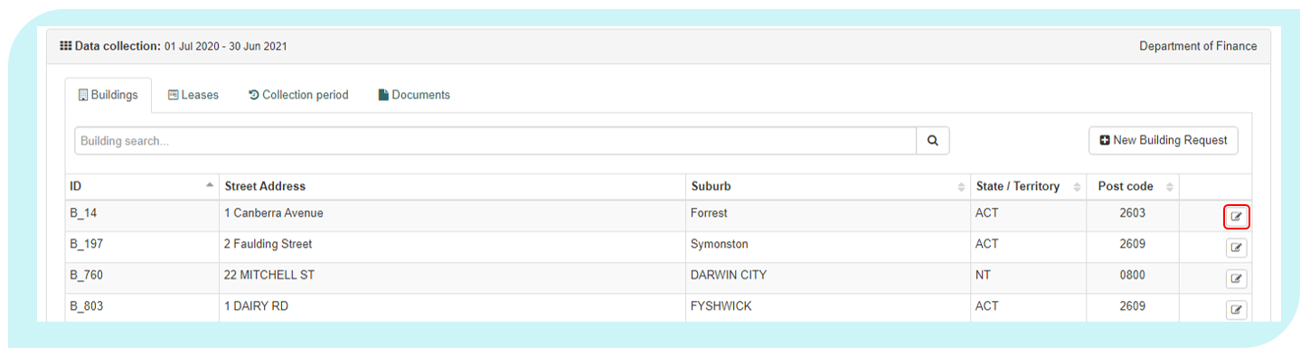

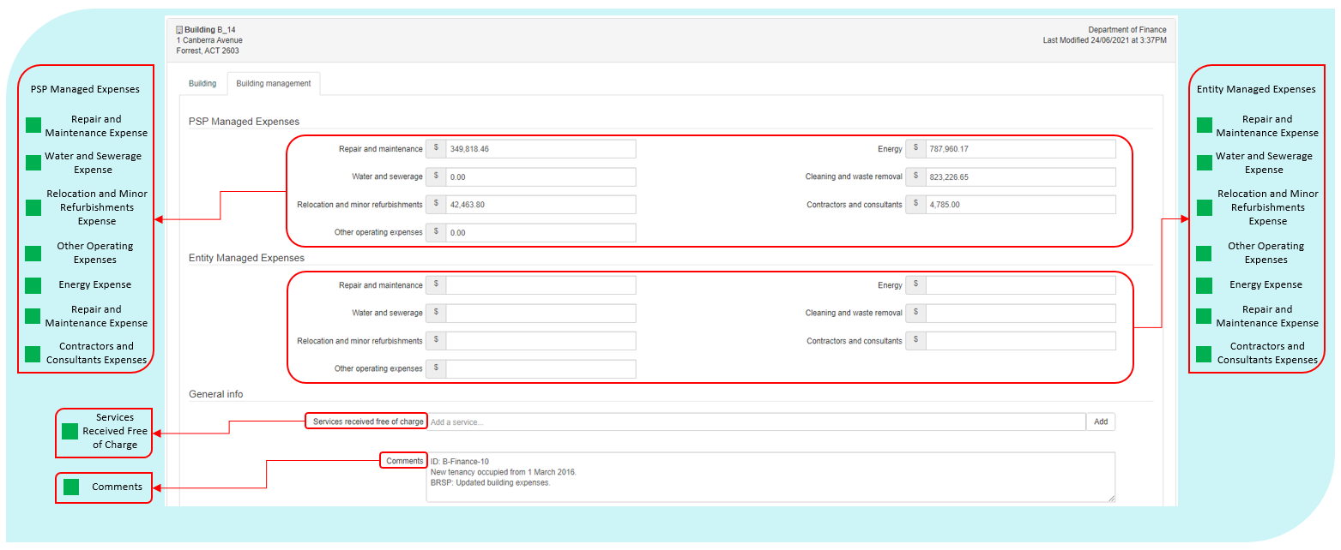

The following data element definitions apply to this section.

The following data definitions apply to this section.

|  |  |
| --- | --- |
|  | In previous years all property operating expenses were reported as aggregate values within each expense category, regardless of whether they were managed by the entity or PSP.  In the 2021 Office Data Collection, Property Operating Expenses are to be reported separately, with categories for PSP Managed operating expenses and Entity Managed operating expenses. |

Please include the value for all property operating expenses for services received under the Property Services Coordinated Procurement arrangements in the expense fields prefixed with ‘**PSP Managed’**.

All operating expenses managed outside of these arrangements must be reported in the elements prefixed with **‘Entity Managed’.**

If you do not have a property service provider, please include all operating expense values in the data elements prefixed with ‘**Entity Managed’**

|  |  |
| --- | --- |
|  | As the AGPR is prepopulated with previous year’s data it will be necessary to review all values for the operating expenses in the PSP Managed fields as this is the default location for all previous year’s values.  If your Entity does not have a PSP under the PSCP Arrangements you will need to move the Property Operating Expenses to the new Entity Managed Property Operating Expenses fields. |

|  |  |
| --- | --- |
| Split Tenancy Expense Fields | |
| **PSP Managed Operating Expense** | **Entity Managed Operating Expense** |
| Repair and Maintenance | Repair and Maintenance |
| Energy Expense | Energy Expense |
| Water and Sewerage Expense | Water and Sewerage Expense |
| Cleaning and Waste Removal Expense | Cleaning and Waste Removal Expense |
| Relocation and Minor Refurbishments Expense | Relocation and Minor Refurbishments Expense |
| Contractors or Consultants | Contractors or Consultants |
| Other operating Expense | Other operating Expense |
| **Combined Tenancy Expense Fields** | |
| Facilities Management Services Base Fees | |
| Facilities Management Services Other Fees | |

Repair and Maintenance Expense

|  |  |
| --- | --- |
| Definition: | Total actual, non-capitalised expenses (GST Inclusive) incurred by the Entity in the reporting period to keep the tenancy, car parks, onsite areas and building assets in a condition needed for the tenancy to function as intended by the Entity. |
| Include: | Cost of parts and labour for repair or maintenance of building assets, HVAC systems, fire protection systems, lighting, electrical wiring, electrical goods, plumbing, doors, windows, footpaths, gardens and grounds.  Cost of equipment testing and pest and vermin control.  Payments made to body corporate sinking funds.  Repair and maintenance for all areas in the tenancy, including office areas, non-office areas and leased-out areas.  Repair and maintenance to the base building if it is payable to a vendor other than the lessor (as per some triple net leases).  (As an offset) any discounts or reimbursements received for repair or maintenance received in the same reporting period in which the expenses were paid by the Entity. |
| Exclude: | Repair and maintenance costs that are capitalised and expensed across more than one financial year through depreciation of capitalised assets or make good provisions.  Repair and maintenance costs payable to the lessor. Any costs paid to a lessor should be included in Lessors Outgoing Expense.  Reimbursement of any repair and maintenance expenses incurred during previous reporting periods.  Depreciation deductions.  Professional or consultancy fees to obtain specialist advice on building condition.  Cost of establishing and managing contracts for repair and maintenance, coordinating repair and maintenance activities or paying accounts for repairs and maintenance.  General payments made to bodies corporate for property management services.  Repair and maintenance of security and ICT equipment.  Cleaning, rest-room services or waste removal – these will be reported in the field Cleaning and Waste Removal Expense.  Cost of non-capitalised refurbishments or minor works. |
| Format: | Positive value, whole Australian dollars [$nn,nnn,nnn] |

Energy Expense

|  |  |
| --- | --- |
| Definition: | Total actual expenses (GST Inclusive) incurred by the Entity in the reporting period for the supply of electricity, gas or other energy. |
| Include: | All energy costs paid by the Entity to a vendor other than the lessor. Any costs paid to a lessor should be included in Lessors Outgoing Expense.  Cost of heating, ventilation and air conditioning (HVAC) electricity and any fuels used for back-up power generation within the tenancy. It may also include energy supply to base building facilities where a net or triple net lease is in place.  (As an offset) any discounts or reimbursements received for energy supply received in the same reporting period in which the expenses were paid by the Entity. |
| Exclude: | Energy payments to the lessor. Any costs paid to a lessor should be included in Lessors Outgoing Expense.  Reimbursement of any energy expenses incurred during previous reporting periods.  Fuel costs for motor vehicles.  Recovered expenses from lessees or sublessees. That is, do not offset the expenses by amounts received for energy supply. |
| Format: | Positive value, whole Australian dollars [$nn,nnn,nnn] |

Water and Sewerage Expense

|  |  |
| --- | --- |
| Definition: | Total actual expenses (GST Inclusive) incurred by the Entity in the reporting period for the supply of water and sewerage services. |
| Include: | All water and sewage costs paid by the Entity to a vendor other than the lessor. Any costs paid to a lessor should be included in Lessor’s Outgoing Expense.  (As an offset) any discounts or reimbursements received for water and sewerage received in the same reporting period in which the expenses were paid by the Entity. |
| Exclude: | Water and sewerage costs that are covered by rent. (Any costs paid to a lessor should be included in Lessor’s Outgoing Expense).  Reimbursement of any water and sewerage expenses incurred during previous reporting periods. |
| Format: | Positive value, whole Australian dollars [$nn,nnn,nnn] |

Cleaning and Waste Removal Expense

|  |  |
| --- | --- |
| Definition: | Total actual expenses (GST Inclusive) incurred by the Entity in the reporting period for cleaning or removal of waste. |
| Include: | Cost of regular or incidental cleaning of the premises, including carpet and window cleaning, sanitary supplies and services, recycling and the removal of rubbish, green waste and security classified material.  Cost of cleaning consumables (i.e. hand towels, soaps, etc.)  All such cleaning and waste costs are to be reported, irrespective of whether they are in relation to an operational activity, non-office area, office area or leased-out area.  Cleaning of base building facilities where the Entity pays these costs, for example, where a triple net lease is in place.  (As an offset) any discounts or reimbursements received for cleaning and waste removal received in the same reporting period in which the expenses were paid by the Entity. |
| Exclude: | Expenditure on cleaning and waste removal that is paid to the lessor. Any costs paid to a lessor should be included in Lessor’s Outgoing Expense.  Reimbursement of any cleaning expenses incurred during previous reporting periods.  The cost of disposing of biological, chemical, radioactive or hazardous waste that is generated from the delivery of core functions of the Entity.  The cost of disposing of ICT equipment or security equipment.  The cost of establishing or managing contracts for cleaning and waste removal. |
| Notes: | Where costs are incurred across more than one tenancy and the amount attributable to each tenancy is not easily available, the costs are to be apportioned between tenancies according to the NLA of each tenancy or a more accurate method if one is available. |
| Format: | Positive value, whole Australian dollars [$nn,nnn,nnn] |

Relocation and Minor Refurbishments Expense

|  |  |
| --- | --- |
| Definition: | Actual expenses (GST Inclusive) incurred in the reporting period by the Entity to undertake non-capitalised refurbishments and relocation expenses. |
| Include: | Cost of changes to refurbishments that were not capitalised and were directly expensed to the income statement in the reporting period.  Cost of make good, where this cost was not included in the depreciation of assets.  Cost of removals and other relocation costs to enable refurbishment.  Cost of removals and relocation costs from normal churn or organisational restructures.  Depreciation deductions.  (As an offset) any discounts or reimbursements received for relocation and minor refurbishment received in the same reporting period in which the expenses were paid by the Entity. |
| Exclude: | Reimbursement of any expenses paid for relocation and minor refurbishment incurred during previous reporting periods.  Removal and relocation costs that are capitalised and expensed across more than one financial year through depreciation of capitalised assets or make good provision.  Costs of relocating ICT equipment.  Routine repair and maintenance. This is reported in Repair and maintenance expense. |
| Notes: | Relocation and removal expenses that relate to movements from one tenancy to another are to be attributed to the destination tenancy.  Where costs are incurred across more than one tenancy and the amount attributable to each tenancy is not easily available, the costs are apportioned between tenancies according to the NLA of each tenancy or a more accurate method if one is available.  Any fit-out costs are to be reported in the fields Last Year Major Fit-out Cost Conducted, Last Major Fit-out Cost and Total Fit-out Cost. |
| Format: | Positive value, whole Australian dollars [$nn,nnn,nnn] |

Contractors and Consultants

|  |  |
| --- | --- |
| Definition: | Total actual cost (GST Inclusive) for contractors or consultants procured to assist with property administration or management or provide specialist property advice. |
| Include: | Total actual cost for contractors and consultants delivering ad hoc property related services in the reporting period. |
| Exclude: | Any costs of contractors and consultants that has been capitalised through the capital work project budget. |
| Format: | Positive value, whole Australian dollars [$nn,nnn,nnn] |

Other Operating Expenses

|  |  |
| --- | --- |
| Definition: | Other substantial actual expenses (GST Inclusive) incurred in the reporting period by the Entity for the tenancy and onsite facilities to function as intended by the Entity. |
| Include: | Indoor plant hire.  Fire warden and emergency evacuation supplies.  Increases to an initial estimate of make good provision that is directly expensed in the income statement and interest expenses from unwinding of discounts associated with the provision of make good.  Other substantial operating expenses not included or excluded elsewhere in these specifications.  (As an offset) any discounts or reimbursements received in relation to other substantial operating expenses received in the same reporting period in which the expenses were paid by the Entity. |
| Exclude: | Reimbursement of any other operating expenses incurred during previous reporting periods. Cost of ICT services, ICT equipment or telecommunications. Cost of office consumables, such as paper, stationery, ad hoc cleaning products. Cost of first aid training, equipment or supplies. Cost of mailroom or courier services, offsite storage or archiving. Depreciation deductions. Disaster recovery costs. Insurance costs. Transport costs. Security costs. |
| Notes: | This element is used to identify costs incurred by the Entity that are not identified in the other cost data elements.  Where costs are incurred across more than one tenancy and the amount attributable to each tenancy is not easily available, the costs are apportioned between tenancies according to the NLA of each tenancy or a more accurate method if one is available. |
| Reference: | Resource Management Guide 114 may be applicable. |
| Format: | Positive value, whole Australian dollars [$nn,nnn,nnn] |

Services Received Free of Charge

|  |  |
| --- | --- |
| Definition: | Services received (GST Inclusive) as part of the lease agreement, free of charge. |
| Notes: | Only include services that the provided free of charge under current lease arrangements. For example cleaning, building maintenance, security. |
| Format: | [Text] |

Comments

|  |  |
| --- | --- |
| Definition: | Any comments that the Entity would like to include to support data relating to building information. |
| Format: | [Text] |

Facilities Management – Provider

|  |  |
| --- | --- |
| Definition: | Name of facilities management provider (if applicable). |
| Notes: | If the Entity does not use a facilities management provider (i.e. facilities management contracts are managed in house), leave blank. |
| Format: | [Text] |

Facilities Management Provider Contract End Date

|  |  |
| --- | --- |
| Definition: | End date of the facilities management provider contract (if applicable). |
| Notes: | If the Entity does not use a facilities management provider (i.e. facilities management contracts are managed in house), leave blank. |
| Format: | [dd/mm/yyyy] |

Facilities Management – Services Base Fees (excluding pass through costs)

|  |  |
| --- | --- |
| Definition: | Total non-capitalised expenses (GST Inclusive) of external property service providers for the delivery of facilities management services to the building. |
| Include: | Total base costs for external property service providers delivering property management services for the building on behalf of the Entity. |
| Exclude: | If the Entity does not use a facilities management provider (i.e. facilities management contracts are managed in house) for the building, leave blank.  Other contractors and consultants delivering ad hoc property services during the reporting period.  Pass through costs. |
| Notes: | If the Entity pays one total fee for facilities management for all properties use the following example and formula to calculate the fee per building:  If the base fee for the facilities manager is $1,000,000 across three buildings  as below;  Building 1 has a total Net Lettable Area of 5,000m2 Building 2 has a total Net Lettable Area of 10,000m2 Building 3 has a total Net Lettable Area of 15,000m2  The total Net Lettable Area the Facilities Manager is responsible for is 30,000m2  The total Base fee should then be divided by the total Net Lettable Area (1,000,000 ÷ 30,000 = 33.3333333)  The Base fee can then be apportioned in AGPR as follows: Building 1 (5,000m2 x 33.3333333 = $166,666.67) Building 2 (10,000m2 x 33.3333333 = $333,333.33) Building 3 (15,000m2 x 33.3333333 = $500,000.00)  The total of the apportioned costs must be equal back to the total base fee of $1,000,000. |
| Format: | Positive value, whole Australian dollars [$nn,nnn,nnn] |

Facilities Management – Services Other Fees (excluding pass through costs)

|  |  |
| --- | --- |
| Definition: | Total non-capitalised expenses (GST Inclusive) of services delivered by the facilities management provider not included in the base fee. |
| Include: | Total other fees charged by the external facilities management service providers delivering lease management services for the Entity for the building not included in the base fee. |
| Exclude: | If the Entity does not use a facilities management provider (i.e. facilities management contracts are managed in house) for the building, leave blank.  Other contractors and consultants delivering ad hoc property services during the reporting period.  Pass through costs. |
| Notes: | If the Entity pays one total other services fee for facilities management for all properties, use the example and formula in Services Base Fees to calculate the other services fee per building. |
| Format: | Positive value, whole Australian dollars [$nn,nnn,nnn] |

Other (Facilities Management) Services

|  |  |
| --- | --- |
| Definition: | Name of other facilities management providers, services provided and contract end dates not included in the fields Facilities Management – Provider and Facilities Management Provider Contract End Date. |
| Include: | Other facilities management providers directly contracted by the Entity. |
| Exclude: | Sub-contractors engaged by the facilities management providers. |
| Format: | [Text] |

Leases 2.0

The Leases table includes all tenancy Leases belonging to an Entity.

Within the Lease record, which users can access by clicking the icon at the end of line, there are four sub tabs. These tabs include data elements that will defined in the next section.

To create a new lease, Entities can select the button located at the top right of the table. To edit an existing lease, select the edit button at the end of a record.

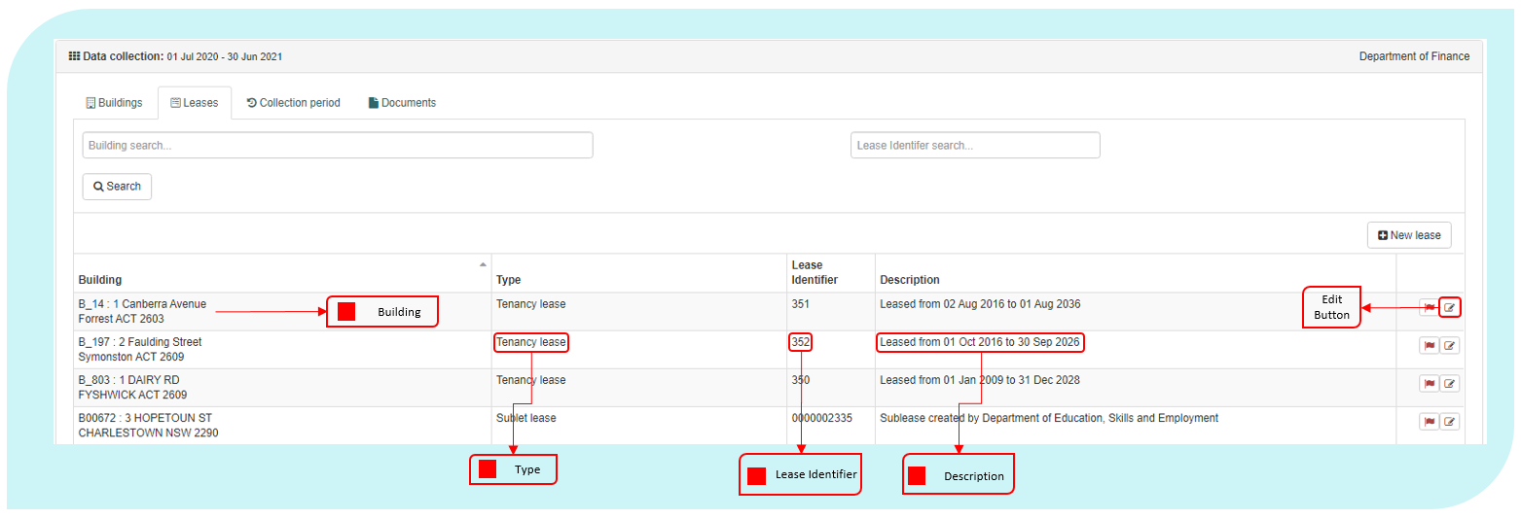

During collection periods, Entities will be asked to confirm that the information contained in each lease record is correct as at 30 June. Clicking the flag icon, located to the right of the record but before the edit button, will change the flag colour from red to green to indicate that the lease record has been confirmed. The ‘confirm all’ button at the bottom right hand side of the table will confirm each lease record. This process should not be undertaken until all data has been signed off by the Property Delegate in the sign-off phase of the collection.

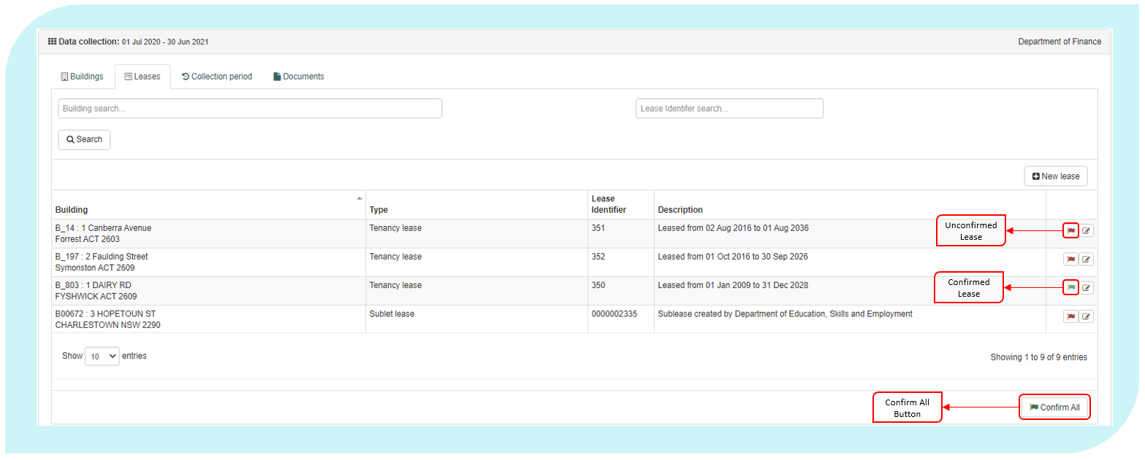

The following data definitions apply to this section.

Building

|  |  |
| --- | --- |
| Definition: | This is a reference field that displays the Building ID, name and address that an Entity has previously provided to Finance. |
| Format: | [Text] |

Type

|  |  |
| --- | --- |
| Definition: | This is a reference field that displays the type of lease under which the Entity is occupying or has the right to occupy the building. |
| Notes: | From 2018 onwards, the only Lease Type will be ‘Tenancy lease’. |
| Format: | [Text] |

Lease Identifier

|  |  |
| --- | --- |
| Definition: | A unique, system auto-generated, number that a lessee can use to identify a lease. |
| Notes: | System generated unique ID. |
| Format: | [nnnnnnnnnn] |

Description

|  |  |
| --- | --- |
| Definition: | This is a reference field that displays the start and end date of the lease. |
| Format: | [Text] |

Tenancy Leases 2.1

All new and existing leases in the AGPR are treated as tenancy leases. An existing tenancy lease is accessible through the view button of a tenancy lease record. Where Entities own their office-space, they should select the ‘Owned’ option in the Lease Type and Lease Status fields.

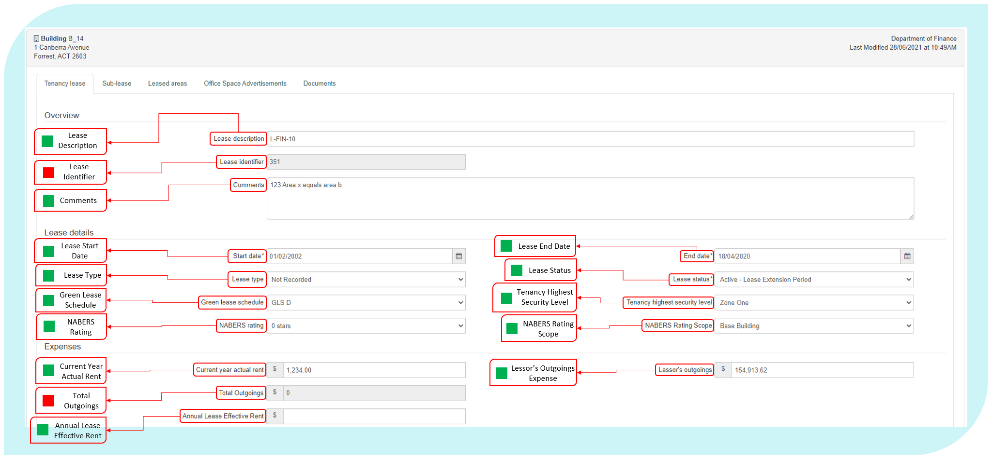

To create a new tenancy lease, select the New Lease button.

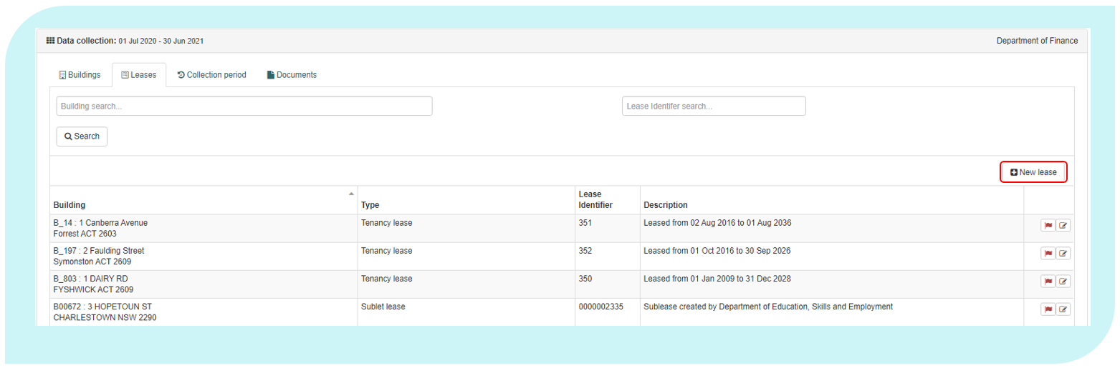

The following data definitions apply to this section.

Lease Description

|  |  |
| --- | --- |
| Definition: | An Entity-generated reference number or short descriptive text for a lease. This field provides Entities with the ability to create a reference that identifies the lease in a way that the Entity can readily identify the lease and if required, assist with data matching between entity, PSP and AGPR data sources. |
| Notes: | Each lease should have a unique lease description.  It would be preferable if Entities use the same lease identifiers through multiple collection periods. |
| Format: | Free text |

Comments

|  |  |
| --- | --- |
| Definition: | Any comments that the Entity would like to include that further supports or explains data relating to the lease. |
| Notes: | A comments field to provide additional context for the lease record such and are encouraged. |
| Format: | [Text] |

Lease Start Date

|  |  |
| --- | --- |
| Definition: | The date when the lease obligation for the property began. |
| Notes: | This is the start date of the *initial* term of the lease, regardless of whether or not lease extensions have been taken. |
| Exclude: | Any updated state date where a new lease has been negotiated at the same premises.  Engagement of a new lease at an existing premises must be reported as a separate lease record. |
| Format: | [dd/mm/yyyy] |

Lease End Date

|  |  |
| --- | --- |
| Definition: | The date when the current obligation to lease the property ends. |
| Notes: | For initial term leases, this is the end date of the initial term.  For leases in a lease extension period, this is the end date of the current lease extension period. |
| Exclude: | Options periods that have not yet been exercised. |
| Format: | [dd/mm/yyyy] |

|  |  |
| --- | --- |
| Definition: | The type of lease under which the Entity is occupying or has the right to occupy the building. |
| Notes: | The type of lease is to be determined from the terms and conditions contained in the current lease as they relate to the coding below.  If the lease is in a holdover period, the Entity is to report the lease type that applied immediately prior to commencing the holdover period.  Classification into lease type is based on what the Entity is obliged by the lease to pay, irrespective of whether the Entity meets the costs directly or through reimbursement to the lessor. |
| Format: | [Pick from List]   |  |  | | --- | --- | | Code | Meaning | | Fully Gross | Entity is obliged to pay only rent to the lessor. | | Gross | Entity is obliged to pay rent and increases to statutory charges to the lessor. | | Single Net | Also known as a net lease, requires the Entity to pay property taxes in addition to rent. | | Double Net | Requires the Entity to pay the property taxes and insurance premiums in addition to rent. | | Triple Net | A triple-net lease requires the Entity to pay rent plus property taxes, insurance premiums and maintenance costs. | | Owned | The building is owned by the Entity. | | Not Recorded | The Lease Type is not known. | |

Lease Type

Lease Status

|  |  |
| --- | --- |
| Definition: | The status of the current property lease as at 30 June of the reporting year. |
| Notes: | If a lease is reported as ‘expired’, the related lease record will not be available when a new collection period is activated.  Leases that have expired but are continuing on a month-to-month basis, without new terms being agreed, should be reported as ‘Holdover’.  Leases that are yet to be formally agreed but are occupied under a heads of agreement should be reported as ‘Pending’.   |  |  | | --- | --- | |  | The lease status must be reported as at the Collection End Date.  Any Lease with an end date of 30 June in the given reporting year must be reported as ‘Active’ or ‘Holdover’. | |
| Format: | [Pick from List]   |  |  | | --- | --- | | Code | Meaning | | Active - Initial Term | The lease is active and still in the initial term. | | Active – Lease Extension Period | The lease is active and in an extension period. | | Expired | The Lease agreement has elapsed its end date, no further extension options have been exercised, and the tenancy has been relinquished back to the landlord. | | Holdover | The lease end date has passed but the lease is continuing on a month-to-month basis. | | Pending | The property is occupied under a *heads of agreement* without an agreed lease contact. | | Owned | The building is owned by the Entity. | |

Green Lease Schedule

|  |  |
| --- | --- |
| Definition: | Type of agreement between the Entity and lessor that sets out each party’s role in the achievement of energy efficiency objectives. |
| Notes: | Only code a property as a type of GLS if it has a current Green Lease Schedule, as defined in the Green Lease Schedules Guidance Notes - Energy Efficiency in Government Operations (EEGO Policy). |
| Reference: | Energy Efficiency in Government Operations Policy at: <https://www.energy.gov.au/publications/energy-efficiency-government-operations-policy> |
| Format: | [Pick from List]   |  |  | | --- | --- | | Code | Meaning | | GLS A | Green Lease Schedule, type A1 or A2 | | GLS B | Green Lease Schedule, type B1 or B2 | | GLS C | Green Lease Schedule, type C1 or C2 | | GLS D | Green Lease Schedule, type D1 or D2 | | Nil | No energy efficiency agreement currently in place | | Other | Another form of energy efficiency agreement | | Pending | Green Lease Schedule yet to be determined | | Not recorded | Not available. | |

Tenancy Highest Security Level

|  |  |
| --- | --- |
| Definition: | The Protective Security Policy Framework mandates Entities design and modify their facilities in order to define restricted access areas according to the five security zones, with increasing restrictions and access controls as the zones progress from Zone One to Zone Five.  Buildings or tenancies may have a number of different zones. The Tenancy highest security reflects the highest level of security in the current building or tenancy. |
| Notes: | The tenancies highest rated security zone in accordance with the Protective Security Policy Framework. |
| Include: | The classification of the hightest rated area of the building that have a security classification. |
| Exclude: | Any area of the tenancy that are not part of the controlled area. |
| Reference: | The Protective Security Policy Framework at:  https://www.protectivesecurity.gov.au/physical/entity-facilities/Pages/default.aspx |
| Format: | [Pick from List]   |  |  | | --- | --- | | Code | Meaning | | Zone 1 | Public access | | Zone 2 | Restricted public access. Unrestricted access for authorised personnel.  May use single factor authentication for access control. | | Zone 3 | No public access.  Visitor access only for visitors with a need to know and with close escort.  Restricted access for authorised personnel.  Single factor authentication for access control. | | Zone 4 | No public access. Visitor access only for visitors with a need to know and with close escort. Restricted access for authorised personnel with appropriate security clearance. Single factor authentication for access control. | | Zone 5 | No public access. Visitor access only for visitors with a need to know and with close escort. Restricted access for authorised personnel with appropriate security clearance. Dual factor authentication for access control. | | Unknown | Floor highest security level not known. | |

Current Year Actual Rent

|  |  |
| --- | --- |
| Definition: | Total, actual effective rent (GST inclusive) expense of the lease for all areas within the tenancy, associated car parking, and onsite storage within the reporting period. |
| Include: | Minimum actual lease payments.  Rent expenses for all areas in the building, including office areas, non-office areas and leased-out areas.  Rent expenses for all onsite storage.  Rent expenses for onsite and offsite car parking facilities that have been acquired as part of the lease for Entity staff in the building or people visiting Entity staff in the tenancy.  Rent for offsite storage where it can be used for office space. |
| Exclude: | Monetary benefit of any incentives as these are captured separately.  Rent for offsite storage that cannot be used for office space.  Anything that is included in a separate lease.  Rents received from sub-leasing arrangements. That is, do not offset the rent expenses by rent received. This data is collected elsewhere in the system. |
| Note: | This figure would be the exact actual expenditure, regardless of Lease Type.  Current Annual Rent must be reported **GST inclusive**. |
| Reference: | RMG 110 - Accounting for operating lease expenses and incentives |
| Format: | Positive value, whole Australian dollars [$nn,nnn,nnn] |

Lessor’s Outgoings Expense

|  |  |
| --- | --- |
| Definition: | Total actual expense (GST inclusive) incurred by the Entity in the reporting period for all outgoings payable to the lessor. |
| Include: | All expenses payable to the lessor under the relevant lease/s, other than rent, such as: landscaping, cleaning, maintenance, after-hours air conditioning.  Lessor’s outgoings for all leased areas in the tenancy, including office areas, non-office areas and leased-out areas.  (As an offset) reimbursement of lessor’s outgoings received in the same reporting period in which the outgoings were paid by the Entity. |
| Exclude: | Reimbursement of lessor’s outgoings incurred during previous reporting periods.  Outgoings that are included in the rent and not separately charged by the lessor.  Outgoings paid to vendors other than the lessor, these should be covered in the Building Management section. |
| Notes: | If the lease type is *Fully Gross* or *Gross*, please provide an estimate of Lessor’s Outgoings Expense. This estimate figure should not affect the accurate reporting of the gross lease amount. Finance will analyse this information separately to ensure that this expense is not double counted.  If the lease type is *Single*, *Double* or *Triple Net*, this figure must be the exact actual expenditure.  Report all non-rent payments to the lessor irrespective of whether they relate to the base building.  Report $0 for owned tenancies.  Lessor’s Outgoing Expense must be reported GST Inclusive. |
| Format: | Positive value, whole Australian dollars [$nn,nnn,nnn] |

Annual Lease Effective Rent

|  |  |
| --- | --- |
| Definition: | Annualised net effective rent (GST inclusive) expense of the lease for all areas within the tenancy, associated car parking, and onsite storage within the last financial year. |
| Include: | Minimum yearly lease payments for a lease.  Actual Rent expenses for all areas in the building, including office areas, non-office areas and leased-out areas.  Rent expenses for all onsite storage.  Rent expenses for onsite and offsite car parking facilities that have been acquired as part of the lease for Entity staff in the building or people visiting Entity staff in the tenancy.  Rent for offsite storage that can be used for office space. |
| Exclude: | Rent for offsite storage that cannot be used for office space.  Anything that is included in a separate lease.  Rents received from sub-leasing arrangements. That is, do not offset the rent expenses by rent received. This data is collected elsewhere in the system. |
| Note: | This figure would be the annualised net effective rental expenditure, regardless of Lease Type.  If the lease has been active for the entire reporting period, the ‘Annual Net Effective Rent’ element should be equal to the ‘Current Annual Rent’ element.  Where a lease has started part way through a reporting year, an annualised figure must be derived by multiplying a monthly lease payment by 12.  Annual Lease Effective Rent must be reported GST Inclusive. |
| Reference: | RMG 110 - Accounting for operating lease expenses and incentives |
| Format: | Positive value, whole Australian dollars [$nn,nnn,nnn] |

Total Outgoings

|  |  |
| --- | --- |
| Definition: | The total amount of outgoing expenses. |
| Notes: | If the lease type is Fully Gross or Gross, the total will be only Current Annual Rent expense.  If the lease type is either Single, Double or Triple Net, the total will be of Current Annual Rent expense and Lessor’s Outgoings expense. |
| Format: | Data Auto Total: Positive value, whole Australian dollars [$nn,nnn,nnn] |

Provider

|  |  |
| --- | --- |
| Definition: | Name of lease management provider. |
| Notes: | If the Entity does not use a lease management provider (i.e. leases are managed in house), leave blank. |
| Format: | [Text] |

Provider Contract End Date

|  |  |
| --- | --- |
| Definition: | End date of the lease management provider contract. |
| Notes: | If the Entity does not use a lease management provider (i.e. leases are managed in house), leave blank. |
| Format: | [dd/mm/yyyy] |

Services - Base Fees

|  |  |
| --- | --- |
| Definition: | Total cost (GST Inclusive) of external lease management service providers for the Entity’s property portfolio. |
| Notes: | Field should exclude pass through costs.  If a single total fee is paid for lease management for all properties use the following example and formula to calculate the fee per building:  If the base fee for the lease manager is $1,000,000 across three buildings as below; Building 1 has a total Net Lettable Area of 5,000m2 Building 2 has a total Net Lettable Area of 10,000m2 Building 3 has a total Net Lettable Area of 15,000m2  The total Net Lettable Area the lease manager is responsible for is 30,000m2  The total Base fee should then be divided by the total Net Lettable Area (1,000,000 ÷ 30,000 = 33.3333333)  The base fee can then be apportioned in AGPR as follows: Building 1 (5,000m2 x 33.3333333 = $166,666.67) Building 2 (10,000m2 x 33.3333333 = $333,333.33) |
| Format: | Positive value, whole Australian dollars [$nn,nnn,nnn] |

Services - Other Fees

|  |  |
| --- | --- |
| Definition: | Total actual cost (GST Inclusive) of services delivered by the lease management provider not included in the base fee. |
| Notes: | Field should exclude pass through costs.  If a single payment for other services fee for lease management for all properties is paid, use the example and formula in Services Base Fees to calculate the other services fee per building. |
| Include: | Total other fees charged by the external lease management service providers delivering lease management services for the Entity not included in the base fee. |
| Exclude: | Other contractors and consultants delivering ad hoc property services during the reporting period.  Pass-through costs.  If the Entity does not use a lease management provider (i.e. leases are managed in house), leave blank. |
| Format: | Positive value, whole Australian dollars [$nn,nnn,nnn] |

Manager Name

|  |  |
| --- | --- |
| Definition: | Name details of Entity representative looking after the lease. |
| Format: | [Text] |

Manager Phone

|  |  |
| --- | --- |
| Definition: | Manager phone. |
| Format: | [Text] |

Manager Email

|  |  |
| --- | --- |
| Definition: | Contact number of Entity representative looking after the lease. |
| Format: | [Email address format] |

Manager Contact Details

|  |  |
| --- | --- |
| Definition: | Any necessary information that is needed about the Entity representative looking after the lease. |
| Notes: | Comments in this field are only required at the Entity’s discretion and could include an address. |
| Format: | [Email address format] |

Number of Remaining Extensions

|  |  |
| --- | --- |
| Definition: | Number of remaining lease extensions available under the current lease. |
| Notes: | If currently in an extension period, then only include the remaining lease extensions. |
| Format: | [nn] |

Length of Next Lease Extension

|  |  |
| --- | --- |
| Definition: | Length (in months) of next available lease extension period. |
| Notes: | Only note the length of the next extension under the lease agreement. |
| Format: | Number of months: [mm] |

Extension Notification Date

|  |  |
| --- | --- |
| Definition: | The notification date for the next lease extension. |
| Notes: | The final date to advise the lessor of the intent to exercise the next lease extension option. |
| Format: | [dd/mm/yyyy] |

Incentive: Rent Abatement

|  |  |
| --- | --- |
| Definition: | Lease incentive (as a dollar amount) provided by the Lessor that has been allocated as a rent reduction over the current term of the lease. |
| Notes: | A rent abatement is an agreement between the landlord and the tenant that provides a period of free or reduced rent. During the abatement period, the Entity is not required to pay full rent to occupy the lease. Abatement may include a rent free period in a block or proportioned rent reduction over the lease period.  Incentive’s for Rent Abatement must be reported **GST inclusive**. |
| Include: | The full estimated amount of lease cost savings allocated from the lease incentive to rental abatement.  If the lease is currently in an extension period include any rent abatement incentive for the current lease extension. |
| Exclude: | Incentive payments that have been allocated to other uses, see the field Incentive: Fit-Out Contribution.  Rent abatement amounts related to unexercised extensions available under the current lease. |
| Format: | Positive value, whole Australian dollars [$nn,nnn,nnn] |

Incentive: Fit-out Contribution

|  |  |
| --- | --- |
| Definition: | Lease incentive (as a dollar amount) provided by the landlord that has been apportioned to the cost of fitting out the tenancy over the current term of the lease. |
| Notes: | Fit-out is the design and delivery of the interior partitioning, floor, ceiling, mechanical, electrical and environmental components to meet the requirements of the building’s occupants. This includes the customising and finishing of the base building (where base building is the raw floor space bounded by walls but not specifically adapted to the requirements of its occupants).  This includes the portion of fit-out works where the landlord has provided a contribution as a lease incentive, either through cash payment, or reimbursement. Alternatively, the landlord may carry out the fit-out works under prior agreements to the value of the incentive amount.  Incentives for Fit-out Contribution must be reported **GST inclusive**. |
| Include: | This may include the value of an integrated fit out, or a cash payment or similar.  If the lease is currently in an extension period, then include any fit-out contribution incentive for the current lease extension. |
| Exclude: | Do not include fit-out costs funded from the Entity’s capital works budget. These will be captured in the full fit out costs data field.  Incentive amounts that are allocated to rent abatement, please record this in the Incentive: Rent Abatement field.  Lease incentive amounts related to unexercised extensions available under the current lease. |
| Reference: | Lease documentation |
| Format: | Positive value, whole Australian dollars [$nn,nnn,nnn] |

Total Incentive

|  |  |
| --- | --- |
| Definition: | The total dollar value of all incentives associated with the current lease term. |
| Notes: | A lease incentive is a bonus or discount offered to a tenant in consideration for their entry into a lease. |
| Include: | The total dollar value of all lease incentives, including both cash-based incentives, such as fit-out subsidies or reimbursements (including integrated fit-outs), or rent abatement, as well as the value of other incentives such as early access to the tenancy.  This field should reflect the sum of Fit-out Contribution and Rent Abatement.  If in an extension period, include incentives negotiated as part of the lease extension to the total. |
| Format: | Data Auto Total: Positive value, whole Australian dollars [$nn,nnn,nnn] |

Incentive Description

|  |  |
| --- | --- |
| Definition: | A short description of any incentives associated with executing the lease (including estimated value if known). |
| Notes: | If in an extension period, only include incentives negotiated as part of the lease extension. |
| Format: | [Text] |

Last Year Major Fit-out Conducted

|  |  |
| --- | --- |
| Definition: | The year the last major fit out occurred. |
| Notes: | Fit-out is the design and delivery of the interior partitioning, floor, ceiling, mechanical, electrical and environmental components to meet the requirements of the building’s occupants. This includes the customising and finishing of the base building (where base building is the raw floor space bounded by walls but not specifically adapted to the requirements of its occupants). This should be recorded at the last year a major fit-out was completed – even where it was prior to the current leases start date.  A major fit out is considered to have been undertaken when either :   * more than 20 per cent of the tenancy’s existing fit-out was refreshed or replaced; or * the project was of a sufficient value to require notifing or referring to the Public Works Committee. |
| Exclude: | Fit-out works or repairs and maintenance less then 20 per cent of the existing fit-out within the tenancy, or below the value for notification or referral to the Public Works Committee. |
| Reference: | Parliamentary Standing Committee on Public Works Procedure Manual, Entity PWC Submissions |
| Format: | Positive value, [yyyy]. |

Last Major Fit-out Cost

|  |  |
| --- | --- |
| Definition: | The cost of the most recent major fit-out project.  See: Fit-out year for definition of major fit-out. |
| Notes: | Fit-out is the design and delivery of the interior partitioning, floor, ceiling, mechanical, electrical and environmental components to meet the requirements of the building’s occupants. This includes the customising and finishing of the base building (where base building is the raw floor space bounded by walls but not specifically adapted to the requirements of its occupants).  Please record any relocation and minor refurbishment expenses in Relocation and Minor Refurbishment Expenses. |
| Include: | The dollar value of the fit-out including where this is funded by incentive payments.  Include the full cost of the fit-out project in line with the cost estimate requirements for PWC including:   * cost of any external works and services, such as civil, electrical and mechanical works; * costs of demolition, remediation, decontamination; * relocation costs, where applicable; * cost provisions for phasing of construction; * fees for project management, consultancies or other professional services related to the work; * the Entity’s internal planning, management and oversight costs; * escalation allowance; * risk estimation, including contingency; * total estimated cost at current prices; and * estimated costs for ‘below-the-line’ items. Any components which fall outside the required scope of works, but which may be included later, pending available funds are sometimes referred to as ‘below-the-line’ items. |
| Reference: | [PWC Manual](https://www.google.com/url?sa=t&rct=j&q=&esrc=s&source=web&cd=&ved=2ahUKEwiorrz6kfTpAhXPyjgGHYMwCRMQFjACegQIARAB&url=https%3A%2F%2Fwww.aph.gov.au%2FParliamentary_Business%2FCommittees%2FJoint%2F~%2Fmedia%2FAF35AB88C9DB4632B9D8393545F50D9C.ashx&usg=AOvVaw0kGARh_Siznik9QFT2Xf2U) Entity PWC Submissions |
| Format: | Positive value, whole Australian dollars [$nn,nnn,nnn] |

Total Fit-out Cost

|  |  |
| --- | --- |
| Definition: | The total dollar value of all fit-out costs associated with the lease over the tenancy lifecycle. |
| Notes: | Fit-out is the design and delivery of the interior partitioning, floor, ceiling, mechanical, electrical and environmental components to meet the requirements of the building’s occupants. This includes the customising and finishing of the base building (where base building is the raw floor space bounded by walls but not specifically adapted to the requirements of its occupants).  This includes the portion of fit-out works where the landlord has provided a contribution as a lease incentive, either through cash payment, or reimbursement. Alternatively, the landlord may carry out the fit-out works under prior agreements to the value of the incentive amount. |
| Include: | All fit-out cost funding, inclusive of fit-out contribution, including those completed during previous leases in the same tenancy. |
| Format: | Positive value, whole Australian dollars [$nn,nnn,nnn] |

Rent Review Mechanism

|  |  |
| --- | --- |
| Definition: | The mechanism in which the annual rent is adjusted. |
| Format: | [Pick from List]   |  |  | | --- | --- | | Code | Meaning | | CPI | Adjusted by the consumer price index | | Market Rent Review | Adjusted to match the current market price | | Other | Adjusted by another calculation | | Fixed | Fixed percentage increase | |

Rent Review Frequency

|  |  |
| --- | --- |
| Definition: | The frequency that the rent is reviewed under the lease agreement. |
| Notes: | Specify in years the frequency of rent reviews. |
| Format: | Number of years: [nn.n] |

Sub-Leases 2.2

The Sub-lease tab is used by an Entity who has sub-leased space to another Entity, State Government, or private company.

The Sub-lease table is located inside all lease records and provides an overview all sub-leases attributed to a tenancy lease. The table includes summary information, such as Lease Description Lease Status, Leasing Entity Name, Sub-Lease To, and Lease Details (Sub-Lease Start and End Date).

All subleases must be reported in the AGPR including subleasing arangements that do not have a formal lease aggrement such as space shared through an MOU. Where a sublease or MOU arangement does not have a specified lease term the ‘Sublease Lease Status’ selection of ‘’Holdover’ is to selected and the ‘Sublease End Date’ of the arangment is to be set to the as-at reporting date of the current collection (i.e 30 June 2021).

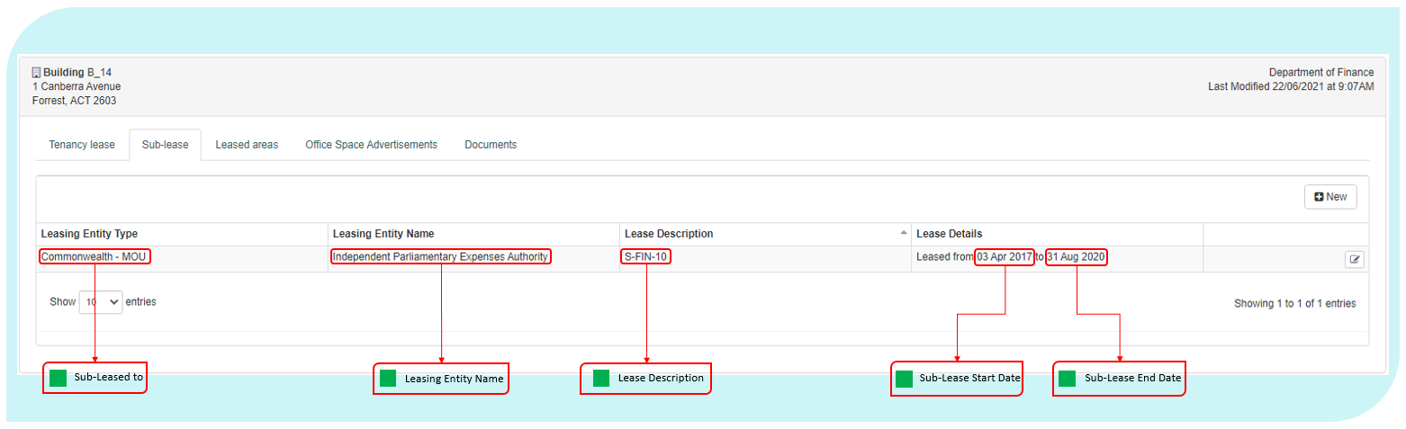

From this table, an Entity can:

* create a sub-lease, using the ‘New’ button located above the table on right side of the screen;
* delete a sub-lease, by clicking the cross symbol at the end of the sub-lease record; and
* edit a sub-lease, by clicking the edit/view symbol at the end of the sub-lease record.

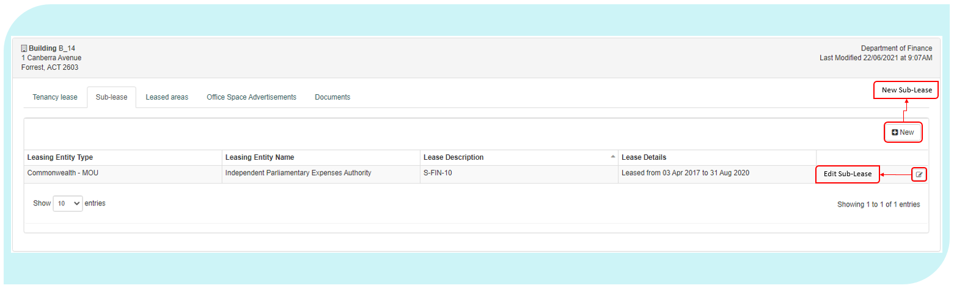

The following data definitions apply to this section.

Sub-Leased To

|  |  |
| --- | --- |
| Definition: | Type of Entity that is sub-leasing office space. This selection will determine if an additional field is exposed. |
| Format: | [Pick from List]   |  |  | | --- | --- | | Code | Meaning | | Commonwealth – MOU | Sub-lease is with a Commonwealth Entity under a MOU | | Commonwealth – Other | Sub-lease is with a Commonwealth Entity under a lease | | Private | Sub-lease is with a Private Entity | | State Government | Sub-lease is with a State Government Entity | |

Sub-Lease Description

|  |  |
| --- | --- |
| Definition: | An Entity-generated reference number or short descriptive text for a sublease. This field provides Entities with the ability to create a reference that identifies the lease in a way that the Entity can readily identify the lease and if required, assist with data matching between entity, PSP and AGPR data sources. |
| Notes: | Each lease should have a unique sub-lease description.  It would be preferable if Entities use the same lease identifiers through multiple collection periods. |
| Format: | Free text |

Leasing Entity Name

|  |  |
| --- | --- |
| Definition: | The Entity Name of the sub-lessor. |
| Notes: | Each sublease should contain the name of the Entity that is the sub-lessor. |
| Format: | [text] |

Start Date

|  |  |
| --- | --- |
| Definition: | Start date of the current sub-lease. |
| Format: | [dd/mm/yyyy] |

End Date

|  |  |
| --- | --- |
| Definition: | End date of the current sub-lease. |
| Notes: | If there is no end date for the sub-lease, use the end date of the head lease. In this scenario, the Entity will need to change the sub-lease end date whenever the head lease end date is changed. |
| Format: | [dd/mm/yyyy] |

Sub-lease Status

|  |  |
| --- | --- |
| Definition: | The status of the current property sub-lease as at 30 June of the reporting year. |
| Notes: | If a sub-lease is reported as ‘expired’, it must be deleted from the record, otherwise the calculations for controlled area and Net Tenancy Expense will be incorrect.  Sub-leases that have expired but are continuing on a month-to-month basis, without new terms being agreed, should be reported as ‘Holdover’.   |  |  | | --- | --- | |  | The sub-lease status must be reported as at the Collection End Date.  Any sub-lease with an end date of 30 June in the given reporting year must be reported as ‘Active’ or ‘Holdover’. | |
| Format: | [Pick from List]   |  |  | | --- | --- | | Code | Meaning | | Active | The sub-lease is active. | | Expired | The sub-lease agreement has elapsed its end date, no further extension options have been exercised, and the tenancy has been relinquished back to the landlord. | | Holdover | The sub-lease end date has passed but the sub-lease is continuing on a month-to-month basis. | |

Sub-Leasing Parties/Agencies Sub-Leased To

|  |  |
| --- | --- |
| Definition: | The name of the Entity or company that is occupying the sub-leased office space. |
| Notes: | If the ‘Sub-leased To’ field indicates that space is being sub-leased to another Entity, then this field will prompt users to choose which Entity.  If office space is being sub-leased to a private company then users should enter the name of that company. |
| Format: | [Drop down of Text] or [Text] |

Total Revenue

|  |  |
| --- | --- |
| Definition: | Revenue and gains (GST Inclusive) from sub-lease arrangements. |
| Notes: | This item comprises revenue/gains from: rent expense, repair and maintenance expense, energy expense, water and sewerage expense, cleaning and waste removal expense, and other operating expense received from sub-lease or landlord arrangements for the specified sub-lease.  This information can be found in the Tenancy Schedule. |
| Format: | Positive value, whole Australian dollars [$nn,nnn,nnn] |

Total Sub-Leased Area

|  |  |
| --- | --- |
| Definition: | Total area within the reported NLA of the property which is sub-leased or leased-out to another Entity or a third party, measured in accordance with the PCA: Method of Measurement of Lettable Area. |
| Notes: | This element is used to work out the area that the Entity does not retain full control of due to sub-letting or landlord arrangements.  If the sub-lease agreement indicates only the number of work-points to be provided, and not the amount of office space, then the NLA should be derived by multiplying the number of work-points provided with the fit-out density of the tenancy.  If the Entity considers that the area in the sub-lease, MOU, licence or similar arrangement is inaccurate, report the leased-out area determined by a surveyor, architect or similarly qualified professional. |
| Reference: | PCA: Method of Measurement for Lettable Area, most recent version.  Sub-lease or other relevant documents.  Surveyor’s report. |
| Format: | Positive value, whole Australian dollars [$nn,nnn,nnn] |

Total Vacant Area Available

|  |  |
| --- | --- |
| Definition: | Any additional area of the lease that is currently available for sub-leasing. |
| Notes: | Only include areas that are not currently subject to a new sub-lease agreement.  Finance encourages Entities to support the efficient usage of property by advertising vacant space available through their PSP and the Property Marketplace. |
| Format: | Square metres: [nn,nnn.nn] |

Leased Areas 2.3

The Leased Areas tab is accessible through the view button of a Tenancy Lease record.

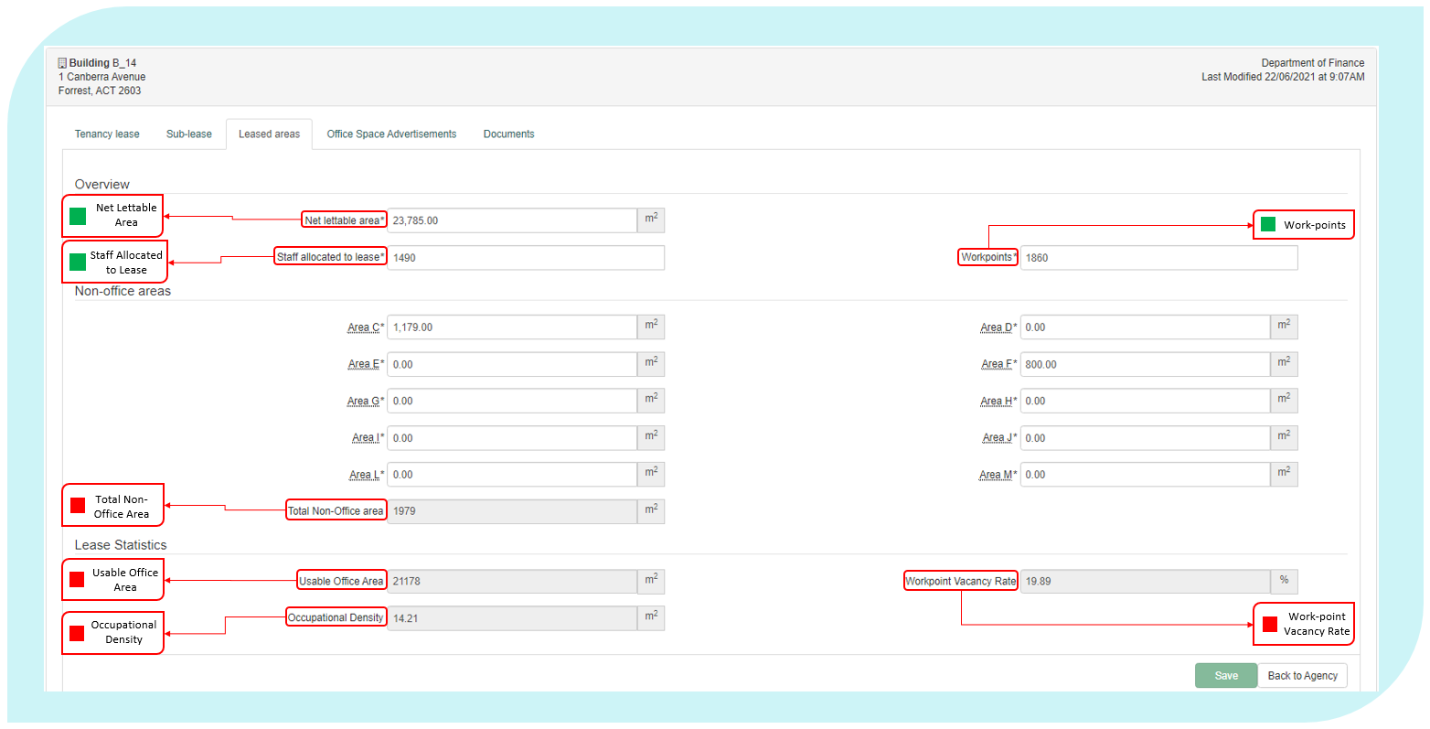

The following data elements definitions apply to this section.

Net Lettable Area

|  |  |
| --- | --- |
| Definition: | For leased and owned property, the Net Lettable Area (NLA) for building or leased area is the sum of all lettable areas within the lease, including areas that are being sub-leased to another Entity. NLA is calculated by taking measurements from the internal finished surfaces of permanent internal walls and the internal finished surfaces of dominant portions of the permanent outer building walls. |
| Include: | Included in the NLA calculation are:  Window mullions; window frames; structural columns; engaged perimeter columns or piers; fire hose reels attached to walls; and  Additional facilities specially constructed for or used by individual tenants that are not covered in the exclusions (below). |
| Exclude: | Excluded from the NLA of each tenancy are:  Stairs; access ways; fire stairs; toilets; recessed doorways; cupboards; telecommunications cupboards; fire hose reel cupboards; lift shafts; escalators; smoke lobbies; plant/motor rooms;  Lift lobbies where lifts face other lifts;  Areas set aside for the provision of all services, such as electrical or telephone ducts and air conditioning risers to the floor, where such facilities are standard facilities in the building; and  Areas dedicated as public spaces or thoroughfares such as foyers, atria and access ways in lift and building service areas. |
| Notes: | If the lease does not have an area figure or the lease contains a GLA figure, determine the total NLA in accordance with the PCA: Method of Measurement for Lettable Area.  If the Entity considers that the NLA recorded in the lease is inaccurate, report the NLA determined by a surveyor, architect or similarly qualified professional.  For further information on treatment of stairs; inclusions of security or reception facilities, common areas in a sub-lease, sub divided floors, balconies etc.; and how to measure please refer to chapter 3 of the Property Council of Australia’s Method of Measurement for Lettable Area. |
| Reference: | Property Council of Australia: Method of Measurement for Lettable Area, 2008.  The lease or other relevant documents.  Surveyor’s report. |
| Format: | Square metres [nn,nnn.nn] |

Staff Allocated to Lease

|  |  |
| --- | --- |
| Definition: | Number of staff (including contractors) allocated to the lease. |
| Notes: | Include an estimated number of staff that are regularly assigned to work in the tenancy on any given day – ‘Staff Allocated to Lease’ should be include all staff (including contractors) regardless of if they were present in the tenancy on the ‘as at’ reporting date.  This includes those on short term leave (i.e. less than 30 days consecutive leave), but not long term leave or secondment.  Where the lease includes a shopfront, staff reported should be the total number of staff for the lease.  If available, Entities should utilise their Human Resource (HR) teams to obtain the necessary data to complete this section.  The number of staff assigned to a tenancy is a key factor in determining a lease’s regular utilization rate, Occupational Density and Work-point Vacancy Rate. |
| Format: | [nn,nnn] |

Work-points

|  |  |
| --- | --- |
| Definition: | Total number of work-points within the usable office area of the property.  A work-point is defined as a desk, enclosed office or a counter where it would be reasonable to expect a person to carry out office work on an ongoing basis. This would apply to traditional, flexible or activity-based working fit-out arrangements. |
| Notes: | If an office is fitted-out for two or more people, then the office is to be counted as containing two or more work-points as appropriate.  If a counter is the primary location for office work for two or more people, then the counter is to be counted as containing two or more work-points as appropriate.  A training or meeting room converted into an office is to be treated as an office. |
| Exclude: | Work-points that reside within space that has been sublet to another entity, state or local government body, or private third party.  Work-points that reside in any area designated as non-office, such as work-points in a shopfront (Non-Office Area L), laboratory (Non-Office Area D), or operational area (Non-Office Area E). |
| Format: | [nn,nnn] |

Non-Office Area C – Basement or Inadequate Amenity

|  |  |
| --- | --- |
| Definition: | Total of all areas within the reported NLA that are a Basement or Inadequate Amenity. |
| Include: | All areas and facilities in a basement.  All areas and facilities which do not provide adequate amenity for use as office space due to the absence of natural light or other physical constraints, including ongoing building maintenance, construction or fit-out.  All car parking and private facilities such as private libraries, private galleries, private cafeterias and private gymnasiums - where access is fully or partially restricted to staff and contractors within the Entity |
| Format: | [nnnnn] |

Non-Office Area D – Police Station, Laboratory or Hospital

|  |  |
| --- | --- |
| Definition: | Total of all areas within the reported NLA that are a police station, laboratory or hospital and are not leased-out. |
| Include: | A police station, laboratory, hospital, quarantine area, public hearing room or workshop. |
| Exclude: | An area specifically used to repair and maintain office items. |
| Notes: | Measurements of the non-office area can be taken from the physical space or the floor plans, whichever is considered by the Entity to be the most reliable.  Areas categorised as police station, laboratory or hospital are recorded under this element.  Area reported as non-office area needs to fit a category of AGPR defined non-office area at the point in time of data collection. Area expected to be a non-office area but not used as such must not be included in this element.  An area can only be included in non-office area if it is in the NLA and the controlled area for the property. For example, areas such as base building stairs, access-ways, base building toilets and plant rooms must not be included in non-office area because they are not in the NLA.  If there is uncertainty about whether an area is an office area or non-office area, it must be treated as an office area. |
| Format: | Square metres: [nn,nnn.nn] |

Non-Office Area E – Specifically for Operational Activity

|  |  |
| --- | --- |
| Definition: | Total of all areas within the reported NLA that are specifically for operational activity and are not leased-out. |
| Include: | Rooms or areas specifically used to detain, examine, interview, observe, assess or counsel members of the public.  All areas used to store equipment and items, other than office items, that are needed for operational activities.  Operational areas within Airports, but not office areas within Airports that support the operational activities.  Additional facilities that have been fitted out by the Entity (that is, not part of the base building) such as bathrooms, showers, kitchenettes specifically to support operational activities. |
| Exclude: | General meeting rooms or offices that may be used for meetings with members of the public or stakeholders on an ad hoc basis.  Office area within Airports.  Areas used to store office items or any form of paper-based media, including files, archived files, books or other documents.  Additional facilities that have been fitted out by the Entity (that is, not part of the base building) such as bathrooms, showers, kitchenettes, unless they are specifically to support operational activities.  All areas used for office activities, including where the office activities enable operational activities. |
| Notes: | Measurements of the non-office area can be taken from the physical space or the floor plans, whichever is considered by the Entity to be the most reliable.  Only areas categorised as Specifically for Operational Activity are recorded under this element.  Area reported as non-office area needs to fit a category of AGPR defined non-office area at the point in time of data collection. Area expected to be a non-office area but not used as such must not be included in this element.  An area can only be included in non-office area if it is in the NLA and the controlled area for the property. For example, areas such as base building stairs, access-ways, base building toilets and plant rooms must not be included in non-office area because they are not in the NLA.  If there is uncertainty about whether an area is an office area or non-office area, it must be treated as an office area.  For assistance identifying whether office area in sites is to be included or excluded in this category, please contact the Property Data team at Finance via email on [propertydata@finance.gov.au](mailto:propertydata@finance.gov.au). |
| Format: | Square metres: [nn,nnn.nn] |

Non-Office Area F – Public Facility

|  |  |
| --- | --- |
| Definition: | Total of all areas within the reported NLA that are a public facility and are not leased-out. |
| Include: | All areas which are freely accessible to the public, such as public libraries, public galleries, public cafeterias, public reception areas, public waiting areas and public retail areas. |
| Exclude: | Private libraries, private galleries, private cafeterias, private gymnasiums - where access is fully or partially restricted to staff and contractors within the Entity (these areas must be recorded under Non-Office Area C).  Excludes shopfronts (these areas must be recorded under Non-Office Area L)  Any area not included in the building’s NLA (i.e. atriums). |
| Notes: | An area can only be included in non-office area if it is in the NLA and the controlled area for the property. For example, areas such as atriums, base building stairs, access-ways, base building toilets and plant rooms must not be included in non-office area because they are not in the NLA.  Measurements of the non-office area can be taken from the physical space or the floor plans, whichever is considered by the Entity to be the most reliable.  Only areas categorised as Public Facility are recorded under this element.  Area reported as non-office area needs to fit a category of AGPR defined non-office area at the point in time of data collection. Area expected to be a non-office area but not used as such must not be included in this element.  If there is uncertainty about whether an area is an office area or non-office area, it must be treated as an office area. |
| Format: | Square metres: [nn,nnn.nn] |

Non-Office Area G – Judicial Chambers and Court Rooms

|  |  |
| --- | --- |
| Definition: | Total of all areas within the reported NLA that are judicial chambers and court rooms and are not leased-out. |
| Include: | Judicial chambers and the secure zone around judicial chambers, court rooms and hearing rooms. |
| Exclude: | Offices provided for tribunal members, commissioners, ombudsmen or similar officers. |
| Notes: | Measurements of the non-office area can be taken from the physical space or the floor plans, whichever is considered by the Entity to be the most reliable.  Only areas categorised as judicial chambers and court rooms are recorded under this element.  Area reported as non-office area needs to fit a category of AGPR defined non-office area at the point in time of data collection. Area expected to be a non-office area but not used as such must not be included in this element.  An area can only be included in non-office area if it is in the NLA and the controlled area for the property. For example, areas such as base building stairs, access-ways, base building toilets and plant rooms must not be included in non-office area because they are not in the NLA.  If there is uncertainty about whether an area is an office area or non-office area, it must be treated as an office area. |
| Format: | Square metres: [nn,nnn.nn] |

Non-Office Area H – Areas Specifically for the Governor-General, Prime Minister and Parliamentarians

|  |  |
| --- | --- |
| Definition: | Total of all areas within the reported NLA that are areas specifically for the Governor-General, Prime Minister and parliamentarians and are not leased-out. |
| Include: | All areas specifically provided for the use of the Governor-General, Commonwealth Parliamentarians, former Governors-General, former Prime Ministers and former members of the judiciary. |
| Exclude: | Areas provided for Accountable Authorities, chief executives, senior executives, contractors, consultants and uniformed or sworn personnel, to undertake office activities. |
| Notes: | Measurements of the non-office area can be taken from the physical space or the floor plans, whichever is considered by the Entity to be the most reliable.  Only areas categorised as Areas Specifically for the Governor-General, Prime Minister and Parliamentarians are recorded under this element.  Area reported as non-office area needs to fit a category of AGPR defined non-office area at the point in time of data collection. Area expected to be a non-office area but not used as such must not be included in this element.  An area can only be included in non-office area if it is in the NLA and the controlled area for the property. For example, areas such as base building stairs, access-ways, base building toilets and plant rooms must not be included in non-office area because they are not in the NLA.  If there is uncertainty about whether an area is an office area or non-office area, it must be treated as an office area. |
| Format: | Square metres: [nn,nnn.nn] |

Non-Office Area I – Emergency and Crisis Coordination Areas

|  |  |
| --- | --- |
| Definition: | Total of all areas within the reported NLA that are emergency and crisis coordination areas and are not leased-out. |
| Include: | An area designed and used specifically for coordinating responses to emergency or crisis situations. |
| Exclude: | Call centres, unless designed and used specifically for directing responses to emergency or crisis situations. |
| Notes: | Measurements of the non-office area can be taken from the physical space or the floor plans, whichever is considered by the Entity to be the most reliable.  Only areas categorised as emergency and crisis coordination areas are recorded under this element.  Area reported as non-office area needs to fit a category of AGPR defined non-office area at the point in time of data collection. Area expected to be a non-office area but not used as such must not be included in this element.  An area can only be included in non-office area if it is in the NLA and the controlled area for the property. For example, areas such as base building stairs, access-ways, base building toilets and plant rooms must not be included in non-office area because they are not in the NLA.  If there is uncertainty about whether an area is an office area or non-office area, it must be treated as an office area. |
| Format: | Square metres: [nn,nnn.nn] |

Non-Office Area J – Exempt Area

|  |  |
| --- | --- |
| Definition: | Total of all areas within the reported NLA that are classified as an Exempt Area (refer Attachment A) and are not leased-out. |
| Include: | An area specifically designated by the Department of Finance as an exempt area. |
| Notes: | Measurements of the non-office area can be taken from the physical space or the floor plans, whichever is considered by the Entity to be the most reliable.  Only areas categorised as Exempt Area are recorded under this element.  Area reported as non-office area needs to fit a category of AGPR defined non-office area at the point in time of data collection. Area expected to be a non-office area but not used as such must not be included in this element.  An area can only be included in non-office area if it is in the NLA and the controlled area for the property. For example, areas such as base building stairs, access-ways, base building toilets and plant rooms must not be included in non-office area because they are not in the NLA.  If there is uncertainty about whether an area is an office area or non-office area, it must be treated as an office area. |
| Format: | Square metres: [nn,nnn.nn] |

Non-Office Area L – Shopfronts

|  |  |
| --- | --- |
| Definition: | Total of all areas within the reported NLA that are shopfronts. |
| Include: | Areas used as a shopfront specifically designed to provide face-to-face Commonwealth Government services to the public.  Areas where customers access or use self-help services related to the nature of business conducted at the shopfront.  Please refer to the Dictionary of Applicable Terms for a definition of a *shopfront.* |
| Notes: | Measurements of the non-office area can be taken from the physical space or the floor plans, whichever is considered by the Entity to be the most reliable.  Only areas categorised as Shopfronts are recorded under this element.   |  |  | | --- | --- | |  | All areas that can be accessed by the public, for shopfront services, should be included in this area, except where that area is not part of the NLA, for example atriums.  Work-points that reside in this area must not be recorded in the collection record for this lease. |   Area reported as non-office area needs to fit a category of AGPR defined non-office area at the point in time of data collection. Area expected to be a non-office area but not used as such must not be included in this element.  An area can only be included in non-office area if it is in the NLA and the controlled area for the property. For example, areas such as base building stairs, access-ways, base building toilets and plant rooms must not be included in non-office area because they are not in the NLA.  If there is uncertainty about whether an area is an office area or non-office area, it must be treated as an office area. |
| Format: | Square metres: [nn,nnn.nn] |

Non-Office Area M – ICT/Data Warehouse

|  |  |
| --- | --- |
| Definition: | Total of all areas within the reported NLA that are ICT/Data warehouse within the Entity’s control. |
| Include: | Areas dedicated to housing ICT equipment including servers etc. |
| Exclude: | Under desk standalone servers. |
| Notes: | Measurements of the non-office area can be taken from the physical space or the floor plans, whichever is considered by the Entity to be the most reliable.  Only areas categorised as ICT/Data warehouse are recorded under this element.  Area reported as non-office area needs to fit a category of AGPR defined non-office area at the point in time of data collection. Area expected to be a non-office area but not used as such must not be included in this element.  An area can only be included in non-office area if it is in the NLA and the controlled area for the property. For example, areas such as base building stairs, access-ways, base building toilets and plant rooms must not be included in non-office area because they are not in the NLA.  If there is uncertainty about whether an area is an office area or non-office area, it must be treated as an office area. |
| Format: | Square metres: [nn,nnn.nn] |

Total Non-Office Area

|  |  |
| --- | --- |
| Definition: | Total of all non-office areas within the reported NLA that are not currently sub-leased. |
| Notes: | This is automatically generated to reflect the sum of all preceding non-office areas. |
| Format: | Data Auto Total: Square metres [nn,nnn.nn] |

Total Sub-Leased Area

|  |  |
| --- | --- |
| Definition: | Where the lease is a sublet tenant lease the Total Sub-Leased Area, as required by the head-lessor, will be displayed in this field. |
| Notes: | This field cannot be changed as it is populated directly from the head-lease.  The value recorded for the Net Lettable Area field (for sublet tenancy leases) must equal the value shown at *Total Sub-Leased Area.* |
| Format: | Positive value, whole Australian dollars [$nn,nnn,nnn] |

Cost per Square Metre

|  |  |
| --- | --- |
| Definition: | Automated calculation to show the cost per square metre of the lease. |
| Calculation: | Net Rent Expense (Current Annual Rent Expense *minus* Sub-lease Revenue) *divided by* Controlled Area (NLA *minus* Sub-leased Area) |
| Format: | Data Auto Total: Positive value, whole Australian dollars [$nn,nnn,nnn] |

Cost per Work-point

|  |  |
| --- | --- |
| Definition: | Automated calculation to show the cost per work-point of the lease. |
| Calculation: | Net Rent Expense (Current Annual Rent Expense *minus* Sub-lease Revenue) *divided* *by* Work-points |
| Format: | Data Auto Total: Positive value, whole Australian dollars [$nn,nnn,nnn] |

Usable Office Area

|  |  |
| --- | --- |
| Definition: | Automated calculation to show the useable office area of the lease. |
| Calculation: | Controlled Area (NLA *minus* Sub-leased Area) *minus* Total Non-Usable Office Area |
| Format: | Data Auto Total: Positive value, whole Australian dollars [$nn,nnn,nnn] |

Work-point Vacancy Rate

|  |  |
| --- | --- |
| Definition: | Automated calculation to show the work-point vacancy rate of the lease. |
| Calculation: | Number of Vacant Work-points (Number of Work-points *minus* Staff Allocated to Lease) *divided by* Number of Work-points *multiplied by 100.* |
| Format: | Data Auto Total: Positive value, whole Australian dollars [$nn,nnn,nnn] |

Occupational Density

|  |  |
| --- | --- |
| Definition: | Automated calculation to show the occupational density of the lease. |
| Calculation: | Usable Office Area *divided by* the number of occupied work-points in a tenancy. |
| Format: | Data Auto Total: Positive value, whole Australian dollars [$nn,nnn,nnn] |

Advertising 2.4

The advertising tab provides a place where Entities can list vacant work points and office space.

Entities can edit advertisements by selecting at the end of the record or create a new advertisement by clicking on the ‘New Advertisement’ button.

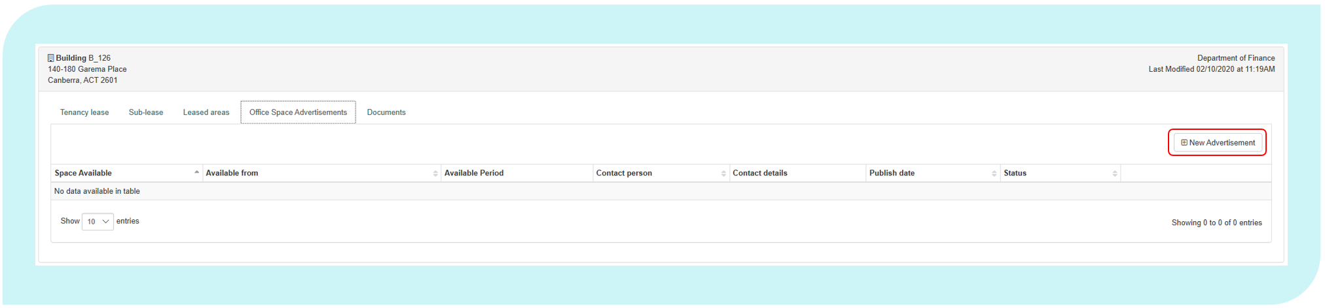

Once completed, an advert will be published in the Property Marketplace.

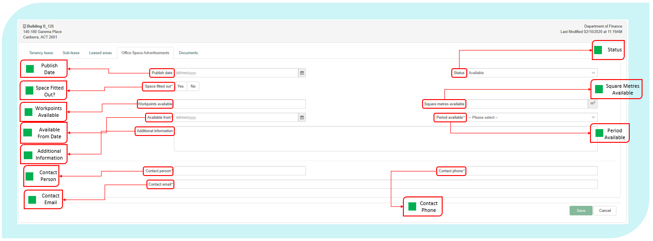

The fields in this section include the following.

Published Date

|  |  |
| --- | --- |
| Definition: | The date the advertisement was published. |
| Format: | [dd/mm/yyyy] |

Status

|  |  |
| --- | --- |
| Definition: | The status of the advertisement. |
| Notes: | This field should be updated when a vacancy is filled. |
| Format: | Select from drop down list: Available Vacancy filled/Tenanted |

Space Fitted Out?

|  |  |
| --- | --- |
| Definition: | Is the advertised space fitted out with work-points? |
| Format: | [Select Yes/No] |

Work-points Available

|  |  |
| --- | --- |
| Definition: | The number of work-points available with the spare office space (if applicable). |
| Notes: | Only include the number of work-points your Entity wishes to fill, not necessarily the overall number of vacant work-points |
| Format: | [nnnn] |

Square Metres Available

|  |  |
| --- | --- |
| Definition: | The total square metres of Usable Office Area available. |
| Format: | [nnn.nn] |

Available From Date

|  |  |
| --- | --- |
| Definition: | The date vacant office space is available. |
| Format: | [dd/mm/yyyy] |

Period Available

|  |  |
| --- | --- |
| Definition: | The time period the vacant office space is available. |
| Format: | Select from drop down:  0-3 Months 3-6 Months 6-12 Months Over 12 Months |

Additional Information

|  |  |
| --- | --- |
| Definition: | Any other information that may be relevant to Entities looking for office space. |
| Format: | [Text] |

Contact Person

|  |  |
| --- | --- |
| Definition: | The name of the point of contact within the advertising entity. |
| Format: | [Text] |

Contact Phone

|  |  |
| --- | --- |
| Definition: | The phone number of the point of contact within the advertising entity. |
| Format: | [nn-nnnnnnnn] or [Work Mobile] |

Contact Email

|  |  |
| --- | --- |
| Definition: | The business email address of the point of contact within the advertising entity. |
| Format: | [xxxxx@xxxxxx.xxx.xx] |

Lease Documents 2.5

The Documents tab within a lease record allows Entities to upload documents relevant to the lease.

Entities can edit documents by selecting at the end of the record or upload a new document by clicking on the ‘Upload document’ button.

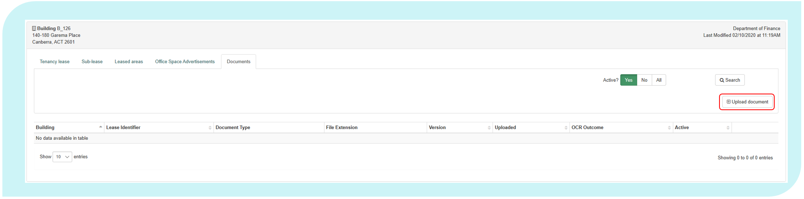

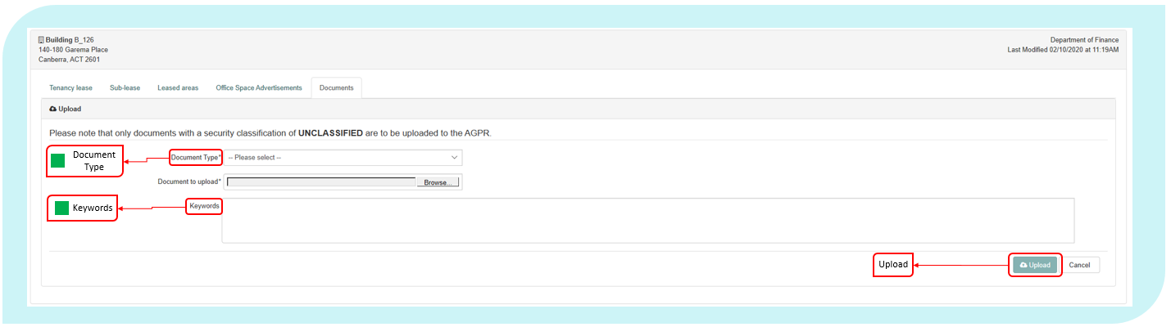

Once completed, the document will be uploaded into the repository.

The fields in this section include the following.

Document Type

|  |  |
| --- | --- |
| Definition: | The type of document being uploaded. |
| Format: | [Pick from list]   |  |  | | --- | --- | | Code | Meaning | | Lease | The lease contract between the tenant and head-lessor. | | Property Management Plan | The document that includes property objectives, ensures the quality of property is appropriate and assesses options for acquisition.  This must be provided to Finance and updated as necessary.  For further reference, please view the RMG500. | |

Keywords

|  |  |
| --- | --- |
| Definition: | Keywords that summarise the document. |
| Format: | [Text] |

Documents 5.0

The Documents tab is a document storage tab. This gives Entities the ability to store and manage all documents and property management plans which have been uploaded via the lease record’s “Documents” tab as outlined in section “Lease Documents 2.5”.

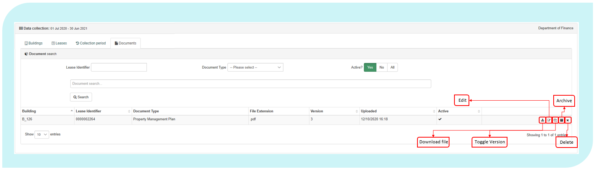

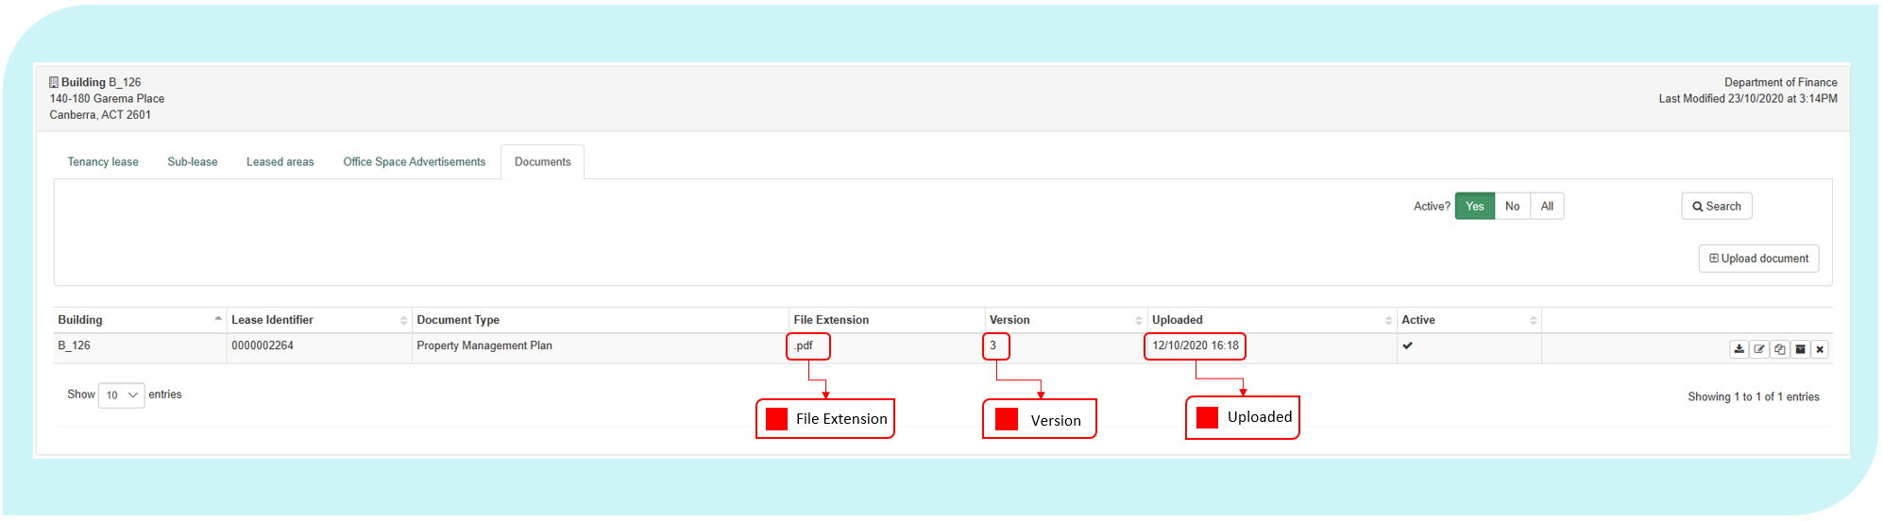

The following data element definitions apply to this section.

File Extension

|  |  |
| --- | --- |
| Definition: | The file extension of the document. |
| Notes: | Only Word, PDF and images can be uploaded |
| Format: | |  |  | | --- | --- | | Code | Meaning | | .docx | Word Document | | .pdf | PDF | |

Version

|  |  |
| --- | --- |
| Definition: | The latest and current version of the document. |
| Format: | [nnnn] |

Upload Date

|  |  |
| --- | --- |
| Definition: | The date when the file was uploaded into the document repository. |
| Format: | [dd/mm/yyyy] |

1. Dictionary of Applicable Terms

The following definitions apply for the purposes of the AGPR (Leased Estate) Data Collection. Each data element and derived element is also a defined term and the definitions are contained in the data specifications for the appropriate element.

**Building** includes any building leased or owned by the Entity with a Usable Office Area. If an Entity has two or more leases in a building, the same building is reported for all leases. If an Entity leases one or more buildings under a single lease, or leases an area of land that contains buildings under a single lease, the same lease is reported for multiple buildings. Cost data elements are apportioned for each building in scope.

**Capitalised** in relation to an asset, means an asset from which the Entity expects to receive economic benefits during more than one financial year.

**Entity** as defined in the Public Governance, Performance and Accountability Act 2013.

**Entity code** is a concise and recognisable code assigned by each Entity, which uniquely identifies the Entity’s properties. The Entity code is an acronym (e.g. PMC) or key word (e.g. Treasury).

**Lease** includes any lease, sub-lease or other arrangement where possession and use of property is transferred for a limited period in return for rent and under certain specified conditions in accordance with the PCA - Glossary of Property Terms. This includes heads of agreement, exchange of letters, memorandum of understanding, contract, licence or agreement under which an Entity may occupy part or all of a building that is not owned by the Entity. It excludes arrangements to hire venues on a short-term basis.

**Lessee** means the tenant. A person/legal entity who receives the right to occupy and use the property under the terms of a lease.

**Lessor** means the owner of a property who transfers the right to occupy and use property to another by way of a lease agreement.

**Memorandum of Understanding,** in the context of this collection,is a written agreement between two Commonwealth entities regarding the use of office space, including work-points leased by one entity (the head-lessor) but used by another entity.

**Minimum Lease Payment** means minimum lease payment as defined in RMG 110 - Accounting for operating lease expenses and incentives include base rent and fixed rent escalations.

**Non-Office Area** is area within the controlled area of the property that is not used or cannot be used to undertake office work.

**Office Items** includes all paper, paper-based products, files, books, brochures, paper forms, paper handling products, document holders, binding equipment, binding supplies, laminating equipment, laminating supplies, paper shredders, paper recycling containers, stationery, photocopiers, printers, printer supplies, paper scanners, facsimile machines, telephones, telephone accessories, projection devices, chairs, desks, tables, computer hardware, computer software and computer networking hardware.

**Office Activity** is comprised of office support work, which is any activity that supports or enables office work, which are activities undertaken at a desk, counter, office or meeting room. This excludes the maintenance and repair of office items.

**Operational Activity** is any activity other than office activity undertaken by an Entity that is directly related to the functions of the Entity.

**PCA** means the Property Council of Australia.

**Property** means real estate that can be owned; an interest can be held; control can be exercised over; can be traded; or that benefits can be obtained from.

**Refurbishment** means the upgrading of a building’s fabric and services with the aim of enhancing its ability to attract tenants, improve rental value and maximise market value.

**Reporting Period** is by Financial Year. This data collection is for reporting period 1 July 2019 to 30 June 2020.

A **Shopfront** is a defined area of a tenancy where an entity delivers government services with customer interactions, where customers can attend the site in a face-to-face environment and obtain information and assistance from staff.

**Sublease** is the lease of part of the property by a sub-lessor to a sub-lessee.

**Subleased Area** means an area that is placed in the control of another Entity under any type of arrangement (such as a heads of agreement, exchange of letters, memorandum of understanding, contract, licence or agreement) and which has been established in accordance with the PGPA Act 2013.

**Sub-lessee** is the entity holding or renting the sublease.

**Sub-lessor** is the entity granting the sublease.

**Tenancy** is one building in which an Entity occupies or has a right to occupy space under one or more leases.

1. Attachment A – Data Suppliers

The attached table has been pre-populated by the Property Data team at Finance based on the requirements of PSPs as outlined in the Property Services Deed.

Individual Entities and PSP situations may agree on amendments to the data supplier listed below.

Once agreement has been reached please forward the completed document to [propertydata@finance.gov.au](mailto:propertydata@finance.gov.au).

Where agreement cannot be reached please contact the Property Data team at Finance ([propertydata@finance.gov.au](mailto:propertydata@finance.gov.au)) for advice.

Data Suppliers - Building Details

|  |  |  |
| --- | --- | --- |
| Field Name | Field Description | Data Supplier |
| Street Number | The exact street number of the building. | PSP |
| Street Name | The exact street name on which the property is located. | PSP |
| Suburb | The exact suburb in which the property is located. | PSP |
| State or Territory | The State or Territory in which the property is located. | PSP |
| Postcode | The exact postcode in which the property is located. | PSP |
| Building Owner Type | The type of organisation that owns the property. | PSP |
| Building Owner Name | The exact, registered business name of the building owner. | PSP |
| Building Grade | The current grade of the building in which the property is located. | PSP |
| NABERS Rating | NABERS energy rating achieved by the tenancy of the leased/owned scope of the building. | PSP |
| NABERS Rating Type | The building type and rating scope the NABERS energy rating applies to. | PSP |
| Heritage Status | The heritage status of the building. | PSP |
| Repair And Maintenance Expense | Total actual, non-capitalised expenses (GST Inclusive) incurred by the Entity in the reporting period to keep the tenancy, car parks, onsite areas and building assets in a condition needed for the tenancy to function as intended by the Entity. | PSP |
| Energy Expense | Total actual expenses (GST Inclusive) incurred by the Entity in the reporting period for the supply of electricity, gas or other energy. | PSP |
| Water And Sewerage Expense | Total actual expenses (GST Inclusive) incurred by the Entity in the reporting period for the supply of water and sewerage services. | PSP |
| Cleaning And Waste Removal Expense | Total actual expenses (GST Inclusive) incurred by the Entity in the reporting period for cleaning or removal of waste. | PSP |
| Relocation And Minor Refurbishments Expense | Actual expenses (GST Inclusive) incurred in the reporting period by the Entity to undertake non-capitalised refurbishments and relocation expenses. | PSP |
| Contractors And Consultants Expense | Total actual cost (GST Inclusive) for contractors or consultants procured to assist with property administration or management or provide specialist property advice. | PSP |
| Other Operating Expenses | Other substantial actual expenses (GST Inclusive) incurred in the reporting period by the Entity for the tenancy and onsite facilities to function as intended by the Entity. | PSP |
| Other Facilities Management Services | Free text field for the name of other facilities management providers, services provided and contract end dates | PSP |
| Entity Managed Repair And Maintenance Expense | Total actual, non-capitalised expenses (GST Inclusive) incurred by the Entity in the reporting period to keep the tenancy, car parks, onsite areas and building assets in a condition needed for the tenancy to function as intended by the Entity. | Entity |
| Entity Managed Energy Expense | Total actual expenses (GST Inclusive) incurred by the Entity in the reporting period for the supply of electricity, gas or other energy. | Entity |
| Entity Managed Water And Sewerage Expense | Total actual expenses (GST Inclusive) incurred by the Entity in the reporting period for the supply of water and sewerage services. | Entity |
| Entity Managed Cleaning And Waste Removal Expense | Total actual expenses (GST Inclusive) incurred by the Entity in the reporting period for cleaning or removal of waste. | Entity |
| Entity Managed Relocation And Minor Refurbishments Expense | Actual expenses (GST Inclusive) incurred in the reporting period by the Entity to undertake non-capitalised refurbishments and relocation expenses. | Entity |
| Entity Managed Contractors And Consultants Expense | Total actual cost (GST Inclusive) for contractors or consultants procured to assist with property administration or management or provide specialist property advice. | Entity |
| Entity Managed Other Operating Expenses | Other substantial actual expenses (GST Inclusive) incurred in the reporting period by the Entity for the tenancy and onsite facilities to function as intended by the Entity. | Entity |
| Other Facilities Management Services | Free text field for the name of other facilities management providers, services provided and contract end dates | Entity |
| Facilities Management Provider | The name of facilities management provider. | PSP |
| Facilities Management Services Base Fees | The facilities management services' base fee. | PSP |
| Facilities Management Services Other Fees | The facilities management services' other fees. | PSP |
| Facilities Management Provider Contract End Date | The end date of the facilities management provider contract. | PSP |
| Entity Comments | Any comments that the Entity would like to include to support data relating to building information. | Entity |
| Services Free of Charge | Services received (GST Inclusive) as part of the lease agreement, free of charge. | Entity |

Data Suppliers – Lease Details

|  |  |  |
| --- | --- | --- |
| Field Name | Field Description | Data supplier |
| Green Lease Schedule | The type of agreement between the Entity and lessor that sets out each party’s role in the achievement of energy efficiency objectives | PSP |
| Lease Manager Contact Details | Any necessary information that is needed about the Entity representative looking after the lease. | PSP |
| Lease Management Provider | The lease management provider's name. | PSP |
| Lease Manager Name | Name of the Entity representative looking after the lease. | PSP |
| Lease Manager Email | The lease manager's email. | PSP |
| Lease Manager Phone | The lease manager's phone number. | PSP |
| Rent Review Mechanism | The mechanism in which the annual rent is adjusted. | PSP |
| Rent Review Frequency | The frequency that the rent is reviewed under the lease agreement. | PSP |
| Management Services Base Fees | The lease management services' base fee. | PSP |
| Management Services Other Fees | The lease management services' other fees. | PSP |
| Management Provider Contract End Date | The end date of the lease management provider's contract. | PSP |
| NABERS Rating Type | This field identifies the scope (i.e. base building, tenancy or whole building) for which the selected NABERS rating applies to. | PSP |
| NABERS Rating | This field identifies the NABERS rating of the lease based on the selected NABERS Rating Scope. | PSP |
| Lease Type | This field identifies the type of lease under which the Entity is occupying or has the right to occupy the building. | PSP |
| Lease Description | This field was designed to allow entities to enter their internal lease IDs which can be used to identify the lease. | PSP |
| Lease Status | This field identifies the status of the current property lease as at 30 June of the reporting year. | PSP |
| Start Date | The date when the lease obligation for the property began. | PSP |
| End Date | The date when the current obligation to lease the property ends. | PSP |
| Incentive Description | A short description of any incentives associated with executing the lease (including estimated value if known). | PSP |
| NumberOfRemainingExtensions | Number of remaining lease extensions available under the current lease. | PSP |
| Length Of Next Extension | Length (in months) of next available lease extension period. | PSP |
| Extension Notification Date | The notification date for the next lease extension. | PSP |
| Current Year Actual Rent | Total annual, actual rent (**GST inclusive**) expense for all areas within the tenancy, associated car parking, and onsite storage within the last financial year. | PSP |
| Annual Lease Effective Rent | Annualised net effective rent (GST inclusive) expense of the lease for all areas within the tenancy, associated car parking, and onsite storage within the last financial year. | PSP |
| Lessors Outgoings Expense | Total actual expense (**GST inclusive**) incurred by the Entity in the reporting period for all outgoings payable to the lessor. | Entity and PSP |
| Entity Comment | Any comments that the Entity would like to include that further supports or explains data relating to the lease. | Entity and PSP |
| Non-Office Area C - Basement or Inadequate Amenity | The amount of space within a tenancy which is not used as office space as it is the basement or has inadequate amenities required for office activity. | Entity |
| Non-Office Area D - Police Station, Laboratory or Hospital | The amount of space within a tenancy which is not used as office space as it is a police station, laboratory, hospital, quarantine area, public hearing room or workshop. | Entity |
| Non-Office Area E - Specifically for Operational Activity | The amount of space within a tenancy which is not used as office space and is being used specifically for operational activities. | Entity |
| Non-Office Area F - Public Facility | The amount of space within a tenancy which is not used as office space and is freely accessible by the public. | Entity |
| Non-Office Area G - Judicial Chambers and Court Rooms | The amount of space within a tenancy which is not used as office space and are judicial chambers & their secure zone, court rooms and hearing rooms. | Entity |
| Non-Office Area H - Areas Specifically for the Governor-General, Prime Minister and Parliamentarians | The amount of space within a tenancy which is not used as office space and is for the Governor-General, Commonwealth Parliamentarians, former Governors-General, former Prime Ministers and former members of the judiciary. | Entity |
| Non-Office Area I - Emergency and Crisis Coordination Areas | The amount of space within a tenancy which is not used as office space and is an area designed and used specifically for coordinating responses to emergency or crisis situations. | Entity |
| Non-Office Area J - Exempt Area | The amount of space within a tenancy which is not used as office space. For this category, users must make an application to exempt this area as non-office area. | Entity |
| Non-Office Area L - Shopfronts | The amount of space within a tenancy which is not used as office space as it is used as a shopfront specifically designed to provide Commonwealth Government services to the public. | Entity |
| Non-Office Area M - ICT/Data Warehouse | The amount of space within a tenancy which is not used as office space as it is area dedicated to housing ICT equipment including servers etc. | Entity |
| Floor Highest Security Level | The classification of the zone that is most highly classified regardless of its size or location in the tenancy. | Entity |
| Fit Out Cost | Lease incentive (as a dollar amount) provided by the landlord that has been apportioned to the cost of fitting out the tenancy over the current term of the lease. | PSP |
| Rent Abatement | Lease incentive (as a dollar amount) provided by the Lessor that has been allocated as a rent reduction over the current term of the lease. | PSP |
| Last Year Major Fit-out | The year the last major fit out occurred. | PSP |
| Last Major Fit-out Cost | The cost of the most recent major fit-out project. | PSP |
| Total Fit-out Cost | The total dollar value of all fit-out costs associated with the lease over the lease’s lifecycle. | PSP |
| Net Lettable Area | The sum of all lettable areas within the lease | PSP |
| Work points | Total number of work-points within the usable office area of the property. | Entity |
| Staff Allocated To Lease | Number of staff (including contractors) allocated to the lease. | Entity |

Data Suppliers – Sublease Details

|  |  |  |
| --- | --- | --- |
| Field Name | Field Description | Data supplier |
| Sublet Area | Total area within the reported NLA of the property which is sub-leased or leased-out to another Entity or a third party | Entity  (or PSP in instances where the sublease is managed by a PSP as an additional service under the PSCP arrangements.) |
| Total Revenue | Revenue and gains (GST Inclusive) from sub-lease arrangements. | Entity  (or PSP in instances where the sublease is managed by a PSP as an additional service under the PSCP arrangements.) |
| Leased To | The name of the Entity or company that is occupying the sub-leased office space. | Entity  (or PSP in instances where the sublease is managed by a PSP as an additional service under the PSCP arrangements.) |
| Subleased To | Type of entity that is sub-leasing office space. | Entity  (or PSP in instances where the sublease is managed by a PSP as an additional service under the PSCP arrangements.) |
| Subleasing Agency | The name of the Entity which is sub-leasing the space. | Entity  (or PSP in instances where the sublease is managed by a PSP as an additional service under the PSCP arrangements.) |

Agreed by: _______________________ ______________________

(Name of delegate at Entity) (Name of delegate at PSP)

_______________________ ______________________

(Entity Name) (PSP)

Date of agreement: _______________________

1. Attachment B Non-Office Area Category J – Exempt Area Application Form

The Leasing and Property data team may exempt areas within an in-scope tenancy that are unsuitable for office work but to not meet the non-office-area exclusions defined in this document on a case by case basis.

Entities must submit this form to the [propertydata@finance.gov.au](mailto:propertydata@finance.gov.au) for consideration for exclusion under Non-Office Area J.

1. Entity Details

|  |
| --- |
|  |

2. Exempt Area Details

New Application

Previous Exempt Area Review

|  |  |  |  |  |
| --- | --- | --- | --- | --- |
| No. | Building Identifier | Street Number/Building Name | Exempt Area Classification | Proposed Exempt Area (m2) |
| E.g. | B-ABC-1234 |  |  |  |
| 1 |  |  |  |  |
| 2 |  |  |  |  |
| 3 |  |  |  |  |
| 4 |  |  |  |  |
| 5 |  |  |  |  |
| 6 |  |  |  |  |

*Additional rows may be added if necessary.

3. Does the Entity plan to refit the proposed Exempt Area in the next 12 months? If so, how will this result in a change in the use of the area?

|  |
| --- |
|  |

4. Name and contact details of the PSP or Entity contact person to answer any queries regarding this application.

|  |
| --- |
|  |

5. List which supporting documents have been attached to this application, for example, plans.

|  |
| --- |
|  |

Name, position and signature of the Assistant Secretary level official who has authorised this application.

**Signature** _____________________________________________

**Name** *(Printed.)*  _____________________________________________

**Position**  _____________________________________________

**Date** _______/_______/_______

The Property Data Team at Finance can be contacted for assistance in the completion of the Exempt Area Application Form.

Please send your completed form to [propertydata@finance.gov.au](mailto:propertydata@finance.gov.au).

1. Attachment C – Defined Calculated Fields

Controlled Area

|  |  |
| --- | --- |
| Definition: | Controlled Area is the Net Lettable Area of a tenancy, minus any sub-leased area. Where there is more than one sub-let area, the aggregate of all sub-leased areas is used. |
| Calculation: | $$Net Lettable Area - Sub Leased Area$$ |
| Units: | Square metres |
| Use: | **Controlled Area** is used in the calculation for **Usable Office Area**, and in the Occupancy Report as a metric for the size of the Commonwealth office accommodation footprint. |

Cost per Controlled Area

|  |  |
| --- | --- |
| Definition: | Net Tenancy Costs per square metre of Controlled Area. |
| Calculation: | $$\frac{Net Tenancy Costs}{Controlled Area}$$ |
| Units: | Dollars |
| Use: | **Cost per Controlled Area** is used as a cost indicator in the Occupancy Report |

Cost per Net Lettable Area

|  |  |
| --- | --- |
| Definition: | Net Tenancy Costs per square metre of Net Lettable Area. |
| Calculation: | $$\frac{Net Tenancy Costs}{Net Lettable Area}$$ |
| Units: | Dollars |
| Use: | **Cost per Net Lettable Area** is used as a cost indicator in the Occupancy Report |

Cost per Work-point

|  |  |
| --- | --- |
| Definition: | The Net Tenancy Cost divided by the number of Work-points. |
| Calculation: | $$\frac{Net Tenancy Costs}{Workpoints}$$ |
| Units: | Dollars |
| Use: | **Cost per Work-point** is used as a cost indicator in the Occupancy Report |

Fit-Out Density

|  |  |
| --- | --- |
| Definition: | The size of the Usable Office Area (including support areas) per Work-point (including unoccupied work-points). |
| Calculation: | $$\frac{Usable Office Area}{Workpoints}$$ |
| Units: | Square metres |
| Use: | **Fit-out Density** is reported in the Occupancy Report |

Net Tenancy Costs

|  |  |
| --- | --- |
| Definition: | The Current Annual Rent paid (GST Inclusive) for a tenancy minus any Sub-lease Revenue received from sub-leases. |
| Calculation: | $$Current Annual Rent Expense - Sub Lease Revenue$$ |
| Units: | Dollars |
| Use: | Net Tenancy Cost is used to calculate Cost per Controlled Area, Cost per Net Lettable Area and Cost per Work-point.  **Net Tenancy Expense** is also used to calculate the cost of the Commonwealth’s office space and as a cost indicator in the Occupancy Report |

Occupational Density

|  |  |
| --- | --- |
| Definition: | Usable Office Area divided by Occupied Workpoints |
| Calculation: | $$\frac{Usable Office Area}{Occupied Workpoints}$$ Occupied Workpoints is the number of occupied desks in a tenancy, which is currently equivalent to the number of *Staff Allocated to Lease*. |
| Units: | Square metres |
| Use: | **Occupational Density** is used as an efficiency metric in the Occupancy Report. |

Property Size

|  |  |
| --- | --- |
| Definition: | Property Size is the category assigned based on the Usable Office Area |
| Notes: | **Usable Office Area** sorted into the following categories:   * Extra small (0-500m2) * Small (500-999m2) * Medium (1,000-4,999m2) * Large (5,000-14,999 m2) * Extra Large (15,000m2 or larger) |
| Use: | **Property Size** is used in the Occupancy Report to compare the average relative performance of different sized leases. |

Ratio of Usable Office Area

|  |  |
| --- | --- |
| Definition: | The proportion of Controlled Area that can be used for, or to support, office activities (measured by Usable Office Area). |
| Calculation: | $$\frac{Usable Office Area}{Controlled Area}$$ |
| Units: | Percentage |
| Use: | The **Ratio of Usable Office Area** is used to determine the **Tenancy Type**, which is used in the Occupancy Report to compare the relative number, size and performance of different types of offices. |

Remoteness Classification

|  |  |
| --- | --- |
| Definition: | The measures of remoteness are based on population estimates obtained from the Census of Population and Housing, produced every five years by the Australian Bureau of Statistics.  Remoteness measures are calculated using Accessibility/Remoteness Index of Australia (ARIA+) scores, which are based on the distance of geographic locations from the nearest population centre in various size ranges.  The lower the ARIA+ score for a location, the better its level of access to goods and services. Typically, a population centre is not likely to provide a full range of goods and services until its population reaches about 250,000 people. |
| Notes: | Uses building postcode to sort into categories based on ABS standard:   * Major Cities of Australia * Inner Regional Australia * Outer Regional Australia * Remote Australia * Very Remote Australia * No Fixed Address (OT) |
| Use: | **Remoteness Classification** informs the accessibility and remoteness of a property to goods, services and other people. This is used for reporting and statistical purposes. |

Tenancy Type

|  |  |
| --- | --- |
| Definition: | Tenancy Type is the category assigned based on the percentage of controlled area used for or to support office activities. |
| Notes: | Ratio of Usable Office Area sorted into categories:   * Solely Office (100%) * Mainly Office (75-99%) * Mixed (25-74%) * Mainly Operational (0-24%) |
| Use: | **Tenancy Type** is used in the Occupancy Report to compare the relative number, size and performance of different types of offices. |

Unoccupied Work-points

|  |  |
| --- | --- |
| Definition: | The number of Work-points that are not being used on the reporting date. This being the difference between the number of Work-points reported and the number of Staff Allocated to the Lease |
| Calculation: | $$Workpoints - Staff Allocated to Lease$$ |
| Units: | None |
| Use: | Unoccupied work-points is used to calculate the **Work-point Vacancy Rate**. Both of these are used to demonstrate how efficiently a tenancy is being used. |

Usable Office Area

|  |  |
| --- | --- |
| Definition: | Usable Office Area is the Controlled Area of a tenancy, minus any area that is deemed unsuitable for office activities, in line with the non-office area categories defined in this manual. |
| Calculation: | $$Controlled Area - Total Non Office Area$$ |
| Units: | Square metres |
| Use: | **Usable Office Area** is used to calculate the values of a number leasing metrics, including **Fit-out Density** and **Occupational Density**. It is also used in the Occupancy Report as a metric for the size of the Commonwealth office accommodation footprint |

1. Some Special Purposes or Operational use properties may have Usable Office Space but no designated work-points. These properties are to be reported as in-scope.
2. The Dictionary of Applicable Terms contains a definition of Shopfronts, and the Non-Office Area L definition provides further clarifying details of what are is considered a shopfront.