## **Risk management policy**

# Comcover information sheet

Understanding Risk Appetite and Tolerance

Audience

This information sheet is intended to assist Commonwealth officials at the Foundation, Generalist and Executive levels understand:

* the purpose of defining an entity’s risk appetite and its benefits,
* the concepts of risk appetite and tolerance and the difference between them, and
* examples of how risk appetite can be expressed in practice.

At a glance

Risk appetite is the amount of risk that an entity is willing to accept or retain in order to achieve its objectives. Determining and articulating an entity’s risk appetite assists entities to make better choices by considering risk more effectively in decision making.

While a risk assessment enables an entity to understand its risk exposure, it is risk appetite that defines how much risk the entity will accept. Only by comparing risk appetite and exposure can the entity assess if it is maintaining the right level of risk and appropriately balancing threats with opportunities.

What are the benefits of defining risk appetite and tolerance?

### Supporting conscious and informed risk taking

By defining how much risk the entity is willing to accept, officials can make informed choices about taking on new programs, improve efficiency, and reduce delays in decision making. Risk appetite provides structure to this conversation and communicates explicitly what is acceptable.

### Promoting more consistent risk management

An entity’s risk appetite communicates broadly how much risk is acceptable, or indeed desirable, enabling more consistent risk taking throughout the entity.

### Guiding risk decision making and seizing opportunities

Risk appetite statements can increase the transparency of the decision making process by enabling officials to better understand the entity’s position on risk. It allows officials to better identify opportunities for further risk taking or identify areas where unacceptable risk taking is occurring.

### Structuring the executive conversation on risk taking

Senior executives can often find it challenging to articulate appropriate levels of risk taking. A structured approach to articulating risk appetite facilitates this process and encourages useful debate on what constitutes desirable, acceptable and unacceptable risk.

### Calibrating the entity risk assessment process.

Most entities use likelihood and consequence tables and ‘heatmap’ matrices to assess the severity of individual risks. In turn, these risk severity ratings typically determine the acceptability of the risk or define the treatment approach to be followed. If these are not calibrated, the resultant actions may be skewed either too lightly (e.g. no action required) or result in an over-controlled risk response.

A carefully developed risk appetite can support the development of these narrative statements often used to describe different levels of risk. Indeed, for entities with otherwise mature existing risk frameworks, these can form a starting point for developing risk appetite.

Defining risk appetite and tolerance

**Risk appetite** - The amount of risk an entity is willing to accept or retain in order to achieve its objectives. It is a statement or series of statements that describes the entity’s attitude towards risk taking.

**Risk tolerance** - The levels of risk taking acceptable to achieve a specific objective or manage a category of risk. Risk tolerance represents the practical application of risk appetite and is typically aligned to categories of risk such as strategy, financial, people or reputation.

While risk appetite usually involves qualitative statements, risk tolerance operationalises the statements by using quantitative measures where possible, to better enable monitoring and review.

Risk appetite sets the tone for risk taking in general, whilst tolerance informs:

* expectations for mitigating, accepting and pursuing specific types of risk,
* boundaries and thresholds of acceptable risk taking, and
* actions to be taken or consequence for acting beyond approved tolerances.

Risk appetite statements

Together, risk appetite and tolerance form the key components of a risk appetite statement. Although the specific content and format will vary in line with the needs of individual entities, a risk appetite statement is typically a short document containing:

* a clear statement of endorsement of the senior executive, reinforcing the importance of informed risk taking,
* a definition of what the risk appetite statement is and how it is to be used,
* a high level statement of the entity’s risk appetite, including its overall attitude to risk taking and acceptance, and
* a series of risk tolerance statements, typically aligned against risk categories and sub categories where additional detail is desired (these are often presented in a tabular format and describe the relative level of tolerance for that nature of risk, ranging from very low tolerance to very high tolerance, and the conditions, caveats and limitations in exercising that risk tolerance).

The risk appetite statement should be an integral element of an entity’s risk management framework. They must be tailored to each entity and consequently will look and feel different according to an entity’s internal and external context. For example, larger more complex entities may have more detailed risk appetite statements, including more detailed tolerance statements and some quantitative measures.

Some simple examples of risk tolerance statements are provided below:

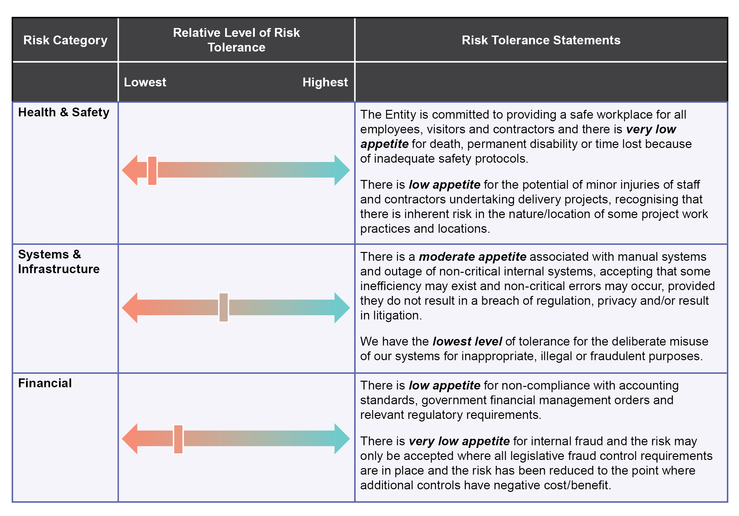

Contact

If you have any questions or feedback in relation to this information sheet please contact Comcover Member Services at [comcover@comcover.com.au](mailto:comcover@comcover.com.au).

Use of this information sheet

Comcover’s series of Risk Management Information Sheets are designed to be used as learning resources and are not mandatory.

It is important that entities develop risk management frameworks and systems that are tailored to the needs of their entity. Entities may choose to adapt some or all of the concepts contained in this information sheet to suit their specific needs or use alternative methodologies.