Embedding an active risk culture
Part 2: The benefits of an active risk culture.

Brought to you by Comcover with the support of our service providers Major Training Services and Deloitte

Your feedback is important to Comcover. Please complete the survey at the end of this microbite as your feedback will inform the future development of learning resources that are designed to meet the needs of you and others within your organisation.

Hello, and welcome to Part 2 of Comcover's microbite on Risk Culture. We finished Part 1 with our risk experts Victoria and Sal providing some real-life examples of organisations that have successfully fostered an active risk culture and today we are going to discuss the benefits of an active risk culture, understanding where you are and where do you want to be, risk culture building blocks and Influencing behavioural change.

Benefits of an active Risk Culture

Kevin: I imagine there are benefits that flow from an active risk culture? Sal when you are making your pitch to an Executive Board, how do you describe the benefits?

Sal: Managing risk is a bit like using the accelerator and brake in your car or truck. Sometimes you want to go faster and sometimes you want to slow down. But what if you own a fleet of trucks – you can’t be in the cab of every one of them pressing the pedals. Frameworks, rules, guidelines and processes can only go so far. They can’t cover every situation and the senior executive can’t be included in every conversation. People have to know how, and want to, manage risk appropriately.

Kevin: Victoria what would you add?

Victoria: In our fast paced world we can’t write a control for every decision, we have to trust our people to have good judgement, to think critically and ethically, and to make good risk decisions. But we also have to create the conditions where this is possible. We need to know what the leadership and the systems and controls are doing that are influencing behaviours. By creating the right conditions we can make it easy for people to make the right decisions.

Kevin: However, it requires more than just a good pitch. Those entities that have benefited from an active risk culture have probably had to sustain that change in culture over some time. I am guessing that instilling a positive risk culture can’t be done with the flick of a switch?

Victoria: No. There are several other things that are needed to embed an effective risk culture within an organisation: Gaining board and Executive buy-in; Defining the aspirational culture; Developing a measurement framework and then measuring the culture; Developing an action plan for change; Measuring the effectiveness of the change activities

Understanding where you are

Kevin: Sal, how can people watching today make a start?

Sal: You need to acknowledge that your risk culture isn’t simply “good or bad”. Similarly, it won’t be uniform up and down and across your organisation. It is a diverse set of attitudes and actions. The first step is to break up the culture into its component parts and to then test that across your organisation. An example of a model that can help with this is on screen now.
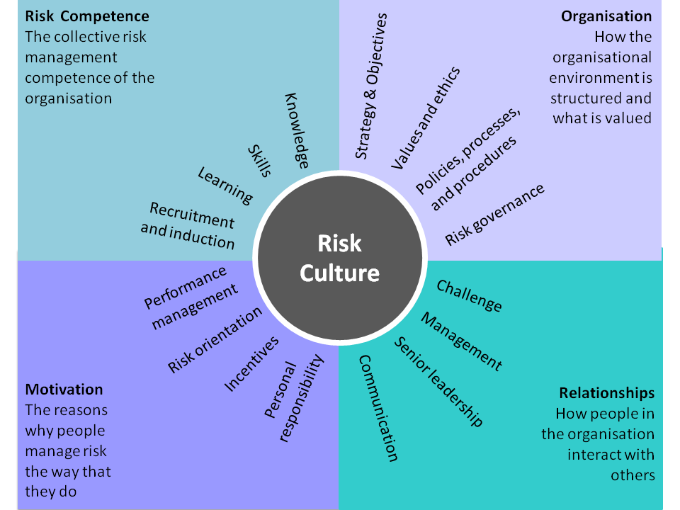

Where do you want to be?

Kevin: Victoria, what comes next?

Victoria: We want to make sure the tone is being set from the top. The executive and board need to agree on what good looks like. How do they need people to think, to feel and what to do to manage risk effectively? Once we have a target or aspirational culture, we then need to understand the indicators we can use to see where we are at. To get a baseline. We usually combine a mixture of perception based indicators, what people think, and consider some hard data within the organisation. There is no sense in measuring risk culture, unless we also are able to link it to the impact it is having on risk management. From here we identify the appropriate methods by which to collect this data. Surveys, interviews, focus groups, observations for the perception data; and then existing organisational data for some of the hard data.

Risk culture building blocks

Kevin: If we are focused on the building blocks of risk culture, set out in Comcover’s Information Sheet ‘Developing a Positive Risk Culture’, I imagine that the entity’s senior leaders play a crucial role. Sal, what would you expect the senior leaders to be doing to get those risk culture building blocks in place?

Sal: Three key things Kevin: Firstly, they need to meaningfully express their appetite for different types of risk. What does good and not-so-good risk-taking look like? Secondly, they have to communicate and model the importance of good risk management. Encourage staff to speak out about risk, both positive and negative, knowing they will not be reprimanded for doing so. Thirdly, they need to accept when things go wrong, without looking to lay blame but seeking to learn from the experience. Were we managing our risks the way we said we wanted to?

Influencing behavioural change

Kevin: If that all happens, will it be enough? What are your thoughts Victoria?

Victoria: You have to look at all the levers available to you. The motivation part of the image is an important part – How consequences are managed – is it consistent? Are people personally motivated? Do people even know which risks they have responsibility for? Or how to manage them? And how are the systems and the processes of the organisation designed to help them? Is it an overly complex risk system? Is the code of conduct in legal speak or can an everyday person understand it, and know how to use it in their everyday work? You can consider using a Work, Worker, and Workplace model to think of all the levers we can use to shape culture. Work is about systems and processes, codes and controls. Worker is about the people, the leadership, and the values of the organisation. Workplace is about the organisational structure and the physical workplace. Each of these shape the way we think at work and influence our decision making. We can pull levers across these areas to help make it easy for people to have the right mindset and make the right decisions.
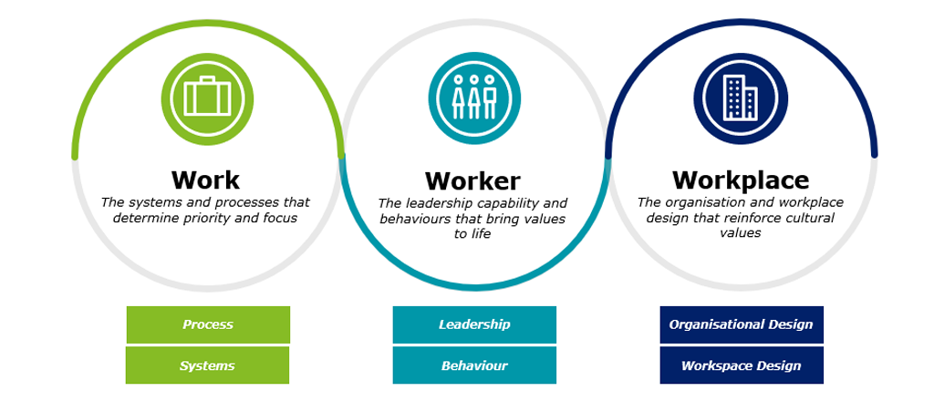

Kevin: Thank you Sal and Victoria I’ve appreciated your insights today and, you've given us all a lot to think about in building an entity’s risk culture. Would you like to add any final thoughts in closing?

Sal: Risk culture is a bit like steering an oil tanker on the ocean: Firstly, you have to know where you are and where you want to go. Secondly, changing direction takes time, it doesn’t just swing around in an instant. Finally, you don’t change the direction of an oil tanker – you turn its rudder and the ship changes direction. It’s about practical steps and actions to influence behaviours. This is cultural change.

Kevin: And your final thoughts Victoria?

Victoria: If you get curious about why people make the decision they are making, and what is influencing the decisions, then you can see how powerful risk culture can be. By creating the right conditions for good decision making risk will be managed more effectively in the business.

Kevin: Thank you again Victoria Whitaker and Sal Sidoti for your contribution today. That brings us to the end of this Comcover microbite learning activity. I hope you have found today’s discussion informative and useful. Comcover can provide advice and support if you need assistance in measuring or enhancing your entity’s risk culture. If you include a request for support in the survey below, one of Comcover’s staff will be in touch. Thank you for watching.

End of Part 2

