**Reporting requirements following   
machinery of government changes**

Resource Management Guide No. 119

June 2020

© Commonwealth of Australia 2020

ISBN: 978-1-925537-55-0 (Online)

With the exception of the Commonwealth Coat of Arms and where otherwise noted, all material presented in this document is provided under a Creative Commons Attribution 3.0 Australia ([http://creativecommons.org/licenses/by/3.0/au](http://creativecommons.org/licenses/by/3.0/au/)) licence.

Creative Commons logo

The details of the relevant licence conditions are available on the Creative Commons website (accessible using the links provided) as is the full legal code for the CC BY 3 AU licence.

**Use of the Coat of Arms**

The terms under which the Coat of Arms can be used are detailed on the following website: [www.dpmc.gov.au/government/its-honour](http://www.dpmc.gov.au/government/its-honour).

**Contact us**

Please direct questions or comments about the guide to:

Accountability & Reporting

Governance

Department of Finance

1 Canberra Avenue

Forrest ACT 2603

Email: [pgpa@finance.gov.au](mailto:pgpa@finance.gov.au)

The words ‘**must**’, ‘**required**’, ‘**requires**’ and ‘**requiring**’ denote mandatory compliance by accountable authorities/officials. The use of the words ‘could’, ‘may’, ‘encouraged’ or ‘consider’ convey non-mandatory guidance. The guidance to which these words relate may or may not be applied by accountable authorities/officials in their approach to resource management, depending on the operating circumstances of the entity and its appetite for risk.

Contents

Audience 4

Key points 4

Resources 4

Introduction 5

Part 1 – Legislative framework for reporting 5

Part 2 – Presentation requirements 7

Part 3 – Entity has ceased to exist 9

Entity has ceased to exist - no functions have transferred 9

Entity has ceased to exist - some functions have transferred 11

Entity has ceased to exist - all functions have transferred 12

Part 4 – Entity not ceased – impracticable to report 13

Entity has not ceased to exist - some functions transferred 13

Entity has not ceased to exist - all functions are transferred 14

Part 5 – Reporting for transferred functions 15

Presentation within the annual report 15

Annual performance statements 16

Annual financial statements 18

Part 6 – Miscellaneous reporting 21

Determinations by Finance Minister 21

KMP reporting following MoG changes 21

KMP reporting in annual reports 22

KMP disclosures in annual financial statements 22

Entity responsibilities 23

Appendix 1 – Determining reporting requirements 24

Reporting requirements for annual performance statements 25

Determining requirements for annual financial statements 26

Determining requirements for annual reports 27

Appendix 2 – Abbreviations 28

# Audience

This Resource Management Guide (RMG) is relevant to accountable authorities, chief financial officers and officials of Commonwealth entities with responsibility for preparing annual performance statements, annual financial statements and annual reports following a machinery of government (MoG) change.

For ease of reference and presentation, this RMG uses ‘entities’ to mean Commonwealth entities as defined by the [Public Governance, Performance and Accountability Act 2013](https://www.legislation.gov.au/Series/C2013A00123) (PGPA Act).

# Key points

This guide:

* + - outlines the special reporting responsibilities for preparing annual performance statements, annual financial statements and annual reports following a MoG change
    - provides guidance to assist entity officials in meeting their reporting responsibilities in accordance with the PGPA Act and Division 4 of the [Public Governance, Performance and Accountability Rule 2014](https://www.legislation.gov.au/Series/F2014L00911) (PGPA Rule).

# Resources

This guide is available on the [Department of Finance](https://www.finance.gov.au) (Finance) website.

Other relevant publications include:

* + - [Accounting for machinery of government changes (RMG 118)](https://www.finance.gov.au/publications/resource-management-guides)
    - [Commonwealth entities financial statements guide — 2019-20 (RMG 125)](https://www.finance.gov.au/publications/resource-management-guides/commonwealth-entities-financial-statements-guide-rmg-125)
    - [Corporate plans for Commonwealth entities (RMG 132)](https://www.finance.gov.au/government/managing-commonwealth-resources/corporate-plans-commonwealth-entities-rmg-132)
    - [Annual performance statements for Commonwealth entities (RMG 134)](https://www.finance.gov.au/government/managing-commonwealth-resources/annual-performance-statements-commonwealth-entities-rmg-134)
    - [Annual report for non-corporate Commonwealth entities (RMG 135)](https://www.finance.gov.au/government/managing-commonwealth-resources/annual-report-non-corporate-commonwealth-entities-rmg-135)
    - [Annual report for corporate Commonwealth entities (RMG 136)](https://www.finance.gov.au/government/managing-commonwealth-resources/annual-report-corporate-commonwealth-entities-rmg-136)
    - [Annual report for Commonwealth-companies (RMG 137)](https://www.finance.gov.au/government/managing-commonwealth-resources/annual-reports-commonwealth-companies-rmg-137)
    - [Commonwealth entities Executive Remuneration Reporting Guide for Annual Reports (RMG 138)](https://www.finance.gov.au/government/managing-commonwealth-resources/commonwealth-entities-executive-remuneration-reporting-guide-annual-reports-rmg-138)
    - [Commonwealth companies Executive Remuneration Reporting Guide for Annual Reports (RMG 139)](https://www.finance.gov.au/government/managing-commonwealth-resources/commonwealth-companies-executive-remuneration-reporting-guide-annual-reports-rmg-139)
    - [Machinery of Government (MoG) changes: A guide](https://www.apsc.gov.au/machinery-government-mog-changes-guide)
    - relevant [accounting standards](https://www.aasb.gov.au/Pronouncements/Current-standards.aspx) published by the Australian Accounting Standards Board (AASB).

# Introduction

1. MoG changes can involve the movement of functions, appropriations, other resources and people from one entity to another under a number of different scenarios that impact the reporting responsibilities of affected entities. MoG changes may include:
   * + an entity (old entity) ceasing to exist with:

* none of its functions transferred, or
* some or all of its functions transferred
  + - an old entity continuing to exist with:
* some or all functions transferred to one or more entities
* some functions transferred to one or more entities, but where it is not practicable for the old entity to report on the non-transferred functions.

1. Division 4 of the [PGPA Rule](https://www.legislation.gov.au/Series/F2014L00911) sets out the special reporting requirements that apply where entities have ceased to exist or functions have been transferred. Division 4 of the PGPA Rule details, in four subdivisions, the reporting requirements that apply for the movement of functions, appropriations, other resources following a MoG change.
2. The reporting requirements at:
   * + Subdivision A, sections 17A–17D, of the PGPA Rule apply where an entity has ceased to exist with no functions transferred
     + Subdivision B, sections 17E–17G, of the PGPA Rule apply where an entity has ceased to exist with some or all functions transferred
     + Subdivision C, sections 17H–17J, of the PGPA Rule apply to reporting on transferred functions
     + Subdivision D, section 17K, of the PGPA Rule applies for miscellaneous reporting.
3. This RMG provides guidance on these requirements, to assist accountable authorities (ie secretaries, chief executives or governing boards) to meet their reporting responsibilities following MoG changes. Also:
   * + Tables 1–3 provide a summary of the reporting requirements that apply for various MoG scenarios
     + Appendix 1 provides decision-trees to assist officials in identifying the relevant sections of the PGPA Rule that apply for their particular MoG circumstances.

# Part 1 – Legislative framework for reporting

1. The [PGPA Act](https://www.legislation.gov.au/Series/C2013A00123) requires accountable authorities to produce, for each reporting period:
   * + annual performance statements (section 39 of the PGPA Act)
     + annual financial statements (section 42 of the PGPA Act)
     + an annual report (section 46 of the PGPA Act).
2. A MoG change occurs when the government decides to change the way Commonwealth responsibilities are managed. MoG changes may result from:
   * a change to the [Administrative Arrangement Orders](https://www.legislation.gov.au/Browse/ByRegDate/AdministrativeArrangementsOrders/InForce) (AAO), which set out the matters dealt with by entities, and the legislation administered by ministers of state
   * a decision of the Prime Minister or Cabinet, regarding a movement of responsibilities and functions between entities, where the change is not a change to the [AAO](https://www.legislation.gov.au/Browse/ByRegDate/AdministrativeArrangementsOrders/InForce).
3. Sections 17A–17J of the PGPA Rule set out the special reporting requirements that apply where an entity has ceased to exist or functions have been transferred as a result of a MoG change. These reporting arrangements are designed to ensure that:
   * + all accountability obligations are met following MoG changes
     + there is no duplication of reporting of operations impacted by these changes, including reporting relating to key management personnel (KMP).
4. Section 17K of the PGPA Rule provides for the Minister for Finance (Finance Minister) to determine that a transfer of functions between entities is to be taken as not to have occurred for annual reporting purposes.
5. Should a situation arise, as a result of a MoG change, that does not comfortably fit into any of the scenarios addressed at sections 17A–17K of the PGPA Rule, the affected entities should contact Finance [PGPA team](mailto:PGPA%20%3cPGPA@finance.gov.au%3e).

Example 1: MoG scenario where an entity should contact Finance

If the governance structure or the name of an entity is changed as a result of a MoG change, but its functions remain unchanged, the entity should discuss the appropriate reporting arrangements with Finance in the first instance.

1. There is a need for the parliament to be informed about the financial and non-financial performance of the old entity in relation to the functions performed up until the entity ceased to exist. Therefore, while the PGPA Rule provides discretion to the Finance Minister to nominate an accountable authority of an entity, it would ordinarily be expected that the Finance Minister would nominate an accountable authority to prepare the necessary reports and information for the old entity.
2. The implementation of MoG changes necessarily involves consultation between impacted entities and Finance. Where these consultations identify the need for the Finance Minister to make a nomination, Finance will work with relevant entities to request that the Finance Minister, or delegate, make the required nomination.
3. For more information on these requirements, or the process of seeking a determination or nomination, please email Finance [PGPA team](mailto:PGPA%20%3cPGPA@finance.gov.au%3e).

# Part 2 – Presentation requirements

1. For the differing scenarios addressed in sections 17A–17K of the PGPA Rule, different presentation requirements apply. Generally speaking:
   * + under sections 17B–17G of the PGPA Rule, separate annual performance statements, annual financial statements and a separate annual report must be prepared for the old entity to report on the non-transferred functions (the accountable authority of the nominated entity has discretion in how these statements and reports are presented)
     + under section 17J of the PGPA Rule, reporting requirements vary according to the type of reporting document and the situation. Entities should check the relevant presentation requirements applicable to their circumstances.
2. The following tables:
   * + show the preparation requirements that apply for various MoG scenarios
     + intentionally exclude information for sections 17A, 17E and 17H of the PGPA Rule (these are sections are guides to subdivisions A,B and C)
     + provide links from the section reference number to related information in this RMG.

**Table 1: Reporting on non-transferred functions (Subdivisions A and B)**

| **PGPA Rule Section** | **Functions transferred** | **Additional criteria** | **Has old entity ceased to exist?** | **Responsible AA for the APS, AFS and AR*:** | **Period for reporting** |
| --- | --- | --- | --- | --- | --- |
| 17B | No functions |  | Yes | AA of the nominated entity | APS, AFS and AR:  The nominated entity reports for the full reporting period of non-transferred functions |
| 17C | Some functions |  | Yes | AA of the nominated entity | APS, AFS and AR:  The nominated entity reports for the full reporting period of non-transferred functions |
| 17D | All functions |  | Yes | N/A – see Table 2 | N/A |
| 17F | Some functions | Unfeasible for the AA of the old entity to report | No | AA of the nominated entity | APS, AFS and AR:  The nominated entity reports for the full reporting period of non-transferred functions |
| 17G | All functions |  | No | N/A – see Table 2 | N/A |

* AA means accountable authority, APS means annual performance statements, AFS means annual financial statements, AR means annual report.

**Table 2: Reporting on transferred functions (Subdivision C)**

| **PGPA Rule Section** | **Functions transferred** | **Additional criteria** | **Has old entity ceased to exist?** | **Responsible AA for the APS, AFS and AR*:** | **Period for reporting** |
| --- | --- | --- | --- | --- | --- |
| 17J | Some or all functions |  | Yes or No | AA of the reporting entity (ie the nominated entity or otherwise the new entity) | APS and AR: The reporting entity reports for the full reporting period in relation to transferred functions (including the part of the reporting period prior to the transfer of functions)  AFS: If the old entity:  ceased to exist or all its functions are transferred, the reporting entity prepares a single set of AFS as if the old entity was part of the reporting entity for the entire reporting period in relation to the transferred function(s).  continues to exist and some functions of the old entity have been transferred, the old entity will report on the non-transferred functions for the full reporting period and the transferred functions up to the date of transfer; the reporting entity will report on the transferred functions from the date of transfer until the end of the reporting period. |

* AA means accountable authority, APS means annual performance statements, AFS means annual financial statements, AR means annual report.

**Table 3: Minister determines, for reporting purposes, transfer has not occurred (Subdivision D)**

| **PGPA Rule Section** | **Functions transferred** | **Additional criteria** | **Has old entity ceased to exist?** | **Responsible AA for the APS, AFS and AR*:** | **Period for reporting** |
| --- | --- | --- | --- | --- | --- |
| 17K | Some or all |  | Yes or No | AA of the old entity | APS, AFS and AR:  The old entity reports for the full reporting period in relation to the transferred and non-transferred functions |

* AA means accountable authority, APS means annual performance statements, AFS means annual financial statements, AR means annual report.

Statement of preparation for annual financial statements

1. Under the scenarios set out in sections 17A–17K of the PGPA Rule, the relevant annual financial statements must include a reference to the PGPA Rule in the basis of preparation note, stating that the financial statements have been prepared in accordance with, among other things, the PGPA Rule as shown in the following example.

**Example 2: Basis of preparation of financial statements (extract)**

The financial statements have been prepared in accordance with:

a) Division 4 of Part 2-3, *Public Governance, Performance and Accountability Rule 2014*

b) *Public Governance, Performance and Accountability (Financial Reporting) Rule 2015*

c) *Australian Accounting Standards and Interpretations – Reduced Disclosure Requirements* issued by the Australian Accounting Standards Board (AASB) that apply for the reporting period.

# Part 3 – Entity has ceased to exist

## Entity has ceased to exist - no functions have transferred

1. Section 17B of the [PGPA Rule](https://www.legislation.gov.au/Series/F2014L00911) applies where an entity (the old entity) has ceased to exist but none of its functions have been transferred to other entities.

Presentation within the annual report

1. Subsection 17B(1) of the [PGPA Rule](https://www.legislation.gov.au/Series/F2014L00911) enables the Finance Minister to nominate an accountable authority of an entity (the nominated entity) to report for the old entity.
2. For this scenario, the nominated entity must prepare separate annual performance statements, annual financial statements and a separate annual report for the old entity, on the non-transferred functions.
3. Under subsection 17B(2) of the PGPA Rule the annual performance statements and annual report prepared for the old entity must include all information required of the old entity (ie as if it still existed). This means that the annual report, prepared for the old entity, must also include:
   * + the annual performance statements for the old entity
     + audited annual financial statements for the old entity
     + any other information required under the old entity’s enabling legislation.
4. These reports are to address the old entity’s non-transferred functions for the full reporting period.
5. The content of the annual performance statements and annual report will be dictated by the nature and significance of the functions performed, and length of time that the functions were performed by the old entity during the reporting period.
6. However, the accountable authority of the nominated entity has discretion in how the reports for the old entity are presented.

**Example 3: Presenting of annual statements and report for an old entity**

It may be helpful for users of annual reports (which incorporate annual performance statements and annual financial statements) if the annual report of the nominated entity presents the reports for the old entity in a separate section or appendix.

Regardless of the approach adopted, the statements and report for the old entity must be clearly distinguishable from those relating to the nominated entity.

Annual performance statements

1. The content of the annual performance statements and annual report will be dictated by:
   * + the nature and significance of the functions performed
     + the length of time the functions were performed by the entity during the reporting period.
2. Where the functions were substantial and contributed in a significant manner to achieving the purposes of the entity before the entity ceases to exist, and were performed for the majority of the reporting period, it can be expected that the annual performance statements would report in a meaningful way on the performance of these functions.
3. The performance measures and targets relating to the functions performed should be used to report on the level of performance achieved up until the date the entity ceased to exist. The annual performance statements must also include an analysis of the factors that contributed to the old entity’s performance, as required by Item 3 of subsection 16F(2) of the [PGPA Rule](https://www.legislation.gov.au/Series/F2014L00911). It is expected that the annual report will also report in a substantive way on the operations of the old entity for the reporting period, up until the date it ceased to exist.
4. On the other hand, if the functions are relatively minor and only contributed in a minor way to the achievement of the old entity’s purposes, the annual performance statements and annual report could consist of a concise explanation to the effect—while still providing sufficient information to meet the requirements of the PGPA Rule.

Annual financial statements

1. Under subsection 17B(2)(b) of the PGPA Rule, the accountable authority of the nominated entity must prepare the annual financial statements for the old entity. These should be consistent with those the accountable authority of the old entity was required to prepare had that entity not ceased to exist.
2. Under subsection 17B(2)(c) of the PGPA Rule, the accountable authority of the nominated entity must give the annual financial statements to the Auditor-General as soon as practicable after they are prepared.

## Entity has ceased to exist - some functions have transferred

1. Section 17C of the [PGPA Rule](https://www.legislation.gov.au/Series/F2014L00911) applies where an entity (the old entity) has ceased to exist and some, but not all, of its functions have been transferred to one or more other entities. When this occurs, subsection 17C(1) of the PGPA Rule enables the Finance Minister to nominate the accountable authority of an entity (the nominated entity) to report on the non-transferred functions. The accountable authority of the nominated entity would report for the full reporting period in relation to the non-transferred functions.
2. While this scenario is likely to be rare, situations occasionally occur when an entity has ceased to exist even though not all of the functions it previously was responsible for have been transferred.

Presentation within the annual report

1. Under subsections 17C(2)(a)(ii) and (c)(ii) of the PGPA Rule, the annual performance statements, annual financial statements and annual report must not include information relating to the functions transferred. For the requirements relating to transferred functions, see Reporting for transferred functions.
2. While separate annual performance statements, annual financial statements and a separate annual report must be prepared for the old entity on the non-transferred functions, similar to the scenario dealt with by section 17B, the accountable authority of the nominated entity has discretion in how these statements and the report are presented.

**Example 4: Presenting of annual statements and report of an old entity**

It may be helpful for users of annual reports (which incorporate annual performance statements and annual financial statements) if the nominated entity presents one annual report with one set of annual performance statements that clearly separate and identify the targets and results of the old entity.

Regardless of the approach adopted, the statements and report for the old entity must be clearly distinguishable from those relating to the nominated entity.

1. For KMP disclosure requirements where an entity has ceased to exist with some functions transferred, see Reporting for transferred functions.

Annual performance statements and annual reports

1. Under subsection 17C(2)(a) of the PGPA Rule, the accountable authority of the nominated entity must prepare annual performance statements and an annual report for the old entity—consistent with the reports that the old entity was required to prepare had it not ceased to exist.
2. Similar to reporting under section 17B, the approach followed will be influenced by the significance of these functions. In practice, the remaining functions are likely to be minimal and entities should adopt a proportionate approach to the preparation and presentation of the required information.

Annual financial statements

1. The accountable authority of the nominated entity is required to prepare annual financial statements for the old entity in relation to those functions not transferred prior to the old entity ceasing to exist.
2. The accountable authority of the nominated entity must give the annual financial statements to the Auditor-General as soon as practicable after they are prepared.

## Entity has ceased to exist - all functions have transferred

1. Section 17D of the PGPA Rule applies where an entity (the old entity) has ceased to exist, and all of its functions have been transferred to one or more other entities.
2. Where an entity ceases to exist and all of its functions have been transferred, there is no requirement for annual performance statements, annual financial statements or an annual report to be prepared for the old entity. For more information the reporting arrangements that apply in this situation, see Reporting for transferred functions.

# Part 4 – Entity not ceased – impracticable to report

## Entity has not ceased to exist - some functions transferred

1. Section 17F of the PGPA Rule details the reporting requirements where an entity has not ceased to exist and some of its functions are transferred.
2. Subsection 17F(1) of the [PGPA Rule](https://www.legislation.gov.au/Series/F2014L00911) clarifies that this section applies where:
   * + some, but not all, of the functions of an entity (the old entity) have been transferred to one or more other entities
     + the old entity has not ceased to exist
     + the Finance Minister is reasonably satisfied that it is not practicable for the accountable authority of the old entity to report in relation to the function(s) that have not been transferred.
3. In this scenario, subsection 17F(1) of the PGPA Rule, enables the Finance Minister to nominate the accountable authority of an entity (ie the nominated entity) to report on the non-transferred functions of the old entity. The nominated entity would report for the full reporting period in relation to the non-transferred functions.

Example 5: Reporting where an entity has not ceased but it is not practicable for it to report

An entity may have no staff and/or no funding during a period when legislation to formally abolish the entity or to transfer responsibility for functions to another entity is yet to be enacted. In such situations, section 17F of the PGPA Rule would apply.

1. In rare situations, an entity may continue to be legally responsible for certain functions but it may not be practical for it to meet its reporting responsibilities for these functions.

Presentation within the annual report

1. For this scenario, separate annual performance statements, annual financial statements and a separate annual report must be prepared for the old entity on the non-transferred functions. However, the accountable authority of the nominated entity has discretion in how these are presented.

Example 6: Presenting information for entity that has not ceased to exist

It may help users of annual reports (which incorporate annual performance statements and annual financial statements) if the nominated entity’s annual report includes a separate section with statements and a report for the old entity.

Regardless of the approach adopted, the statements and report for the old entity must be clearly distinguishable from those relating to the nominated entity.

Annual performance statements and annual report

1. The Finance Minister may nominate an entity (the nominated entity) to prepare the annual performance statements and an annual report that reports on the performance and operations of the functions that remain the responsibility of the ‘old entity’, that is, the non-transferred functions.
2. To ensure no duplication of reporting occurs, subsection 17F(2) of the PGPA Rule indicates that where the Finance Minister nominates another entity (ie in accordance with subsection 17F(1) of the PGPA Rule) the accountable authority of the old entity must not prepare annual performance statements, annual financial statements or an annual report for the old entity.

Annual financial statements

1. The accountable authority of the nominated entity must prepare annual financial statements for the old entity to report on the functions that have remained with the old entity (non-transferred functions).

**Example 7: Australian National Preventive Health Agency Financial Statements**

The essential functions of the [Australian National Preventative Health Agency](https://www.directory.gov.au/portfolios/health/australian-national-preventive-health-agency) (ANPHA) were transferred to the Department of Health from 1 July 2014. ANPHA retains a dormant special account. Legislation to abolish ANPHA has not been passed, requiring ANPHA to continue to prepare annual financial statements. These statements, together with the auditor’s report, are included in the Department of Health’s annual report as an appendix.

1. The accountable authority must also give the annual financial statements to the   
   Auditor-General as soon as practicable after they are prepared.

## Entity has not ceased to exist - all functions are transferred

1. Section 17G of the PGPA Rule applies where all of the functions of an entity (the old entity) have been transferred to one or more other entities but the old entity has not ceased to exist. Where this occurs, the old entity is not required to prepare the annual performance statements, annual financial statements or an annual report.
2. The reports and information that would otherwise have been reported for the old entity, must now be reported by the entity or entities to which the functions have been transferred in accordance with sections 17H–17J of the [PGPA Rule](https://www.legislation.gov.au/Series/F2014L00911).
3. For more information, see Reporting for transferred functions.

# Part 5 – Reporting for transferred functions

1. Section 17J of the [PGPA Rule](https://www.legislation.gov.au/Series/F2014L00911) applies where functions of an entity (the old entity) have been transferred to another entity (the new entity).
2. Under subsection 17J(1) of the PGPA Rule, these arrangements apply whether or not the old entity has ceased to exist. Under subsection 17J(3) of the PGPA Rule, the Finance Minister may nominate the accountable authority of an entity to report in relation to the transferred functions.
3. For the purpose of sections 17J of the PGPA Rule, the ‘reporting entity’ is defined as:
   * + the entity nominated by the Finance Minister under subsection 17J(3), or
     + the new entity—if no entity is nominated.

## Presentation within the annual report

1. Unlike the statements and reports prepared in accordance with sections 17A–17G of the PGPA Rule, the preparation and presentation of documents under section 17J of the PGPA Rule varies according to the type of document and the situation.
2. Subsection 17J(6) of the [PGPA Rule](https://www.legislation.gov.au/Series/F2014L00911) requires the information relating to the transferred functions to be included in the annual report of the reporting entity.
3. The accountable authority of the reporting entity would be expected to report in relation to the transferred functions for the full reporting period (including that part of the reporting period prior to the transfer of functions).
4. This means that the accountable authority of the reporting entity should prepare one consolidated annual report which includes performance and other information relating to the transferred functions for the entire reporting period.

Where functions have been transferred, the relevant information for the functions transferred from an old entity must be incorporated into the reporting entity’s annual report, rather than being presented in a separate annual report.

1. Section 37 of the [PGPA Act](https://www.legislation.gov.au/Series/C2013A00123) requires the accountable authority of entities to cause records to be kept in a manner that properly records and explains the entity’s performance in achieving its purposes. To enable the reporting entity to prepare the annual report, it is expected that the old entity would provide the reporting entity with records relating to the performance of the transferred functions.
2. The reporting entity has discretion in how to incorporate the information relating to the transferred functions into its consolidated annual report. As a minimum, the accountable authority of the reporting entity would be expected to include notes or explanations in the annual report to explain that the reporting entity has gained the relevant functions during the reporting period and, therefore, is reporting on them.
3. Section 17K of the PGPA Rule provides the Finance Minister the authority to determine that a transfer of functions is taken not to have occurred, for the purposes of reporting under sections 17A–17J of the PGPA Rule.

## Annual performance statements

1. Subsection 17J(4) of the PGPA Rule, requires the information relating to the transferred functions to be included in the annual performance statements of the reporting entity.
2. The accountable authority of the reporting entity should prepare one consolidated set of annual performance statements, which include the performance and other information relating to the transferred functions, for the entire reporting period.

Where functions have been transferred, performance and other information for the functions transferred from an old entity must be incorporated into the reporting entity’s annual performance statements, rather than in a separate annual performance statement.

1. The reporting entity has discretion in how to incorporate performance and other information of the transferred functions into its consolidated annual performance statements. As a minimum, the accountable authority of the reporting entity would be expected to include notes or explanations in the annual performance statements that explain that the reporting entity has gained the relevant functions during the reporting period and, therefore, is reporting on them. For examples of notes and explanations to annual performance statements, see Example 8A and Example 8B.
2. The approach adopted will depend on a number of factors including:
   * + the nature and significance of the functions transferred
     + the timing of the transfer of functions.
3. Where the old entity has performed the functions for the majority of the reporting period, it is expected that the reporting entity would report on the extent to which the performance measures and targets relating to the transferred functions had been achieved by the old entity, in accordance with the [Commonwealth Performance Framework](https://www.finance.gov.au/government/managing-commonwealth-resources/planning-reporting/commonwealth-performance-framework).
4. However, where functions are transferred early in the reporting period, it may not be practical to report on the performance of the old entity in relation to the transferred functions. In these circumstances, the annual performance statements of the new entity should explain how its performance relating to these functions has been measured, including any changes that have been made to the performance measures and targets following the transfer.
5. Where the transfer has occurred very late in the reporting period, for example, the Finance Minister may make a determination under section 17K of the PGPA Rule.

**Example 8A: Statement for combined annual performance statements**

As a result of MoG changes during the 2017-18 reporting period, functions were transferred to the [Department of Home Affairs](https://www.homeaffairs.gov.au/reports-and-pubs/Annualreports/2017-18/01-annual-report-2017-18.pdf) (HA), from the Department of Immigration and Border Protection, the Attorney-General’s Department, the Department of Infrastructure and Regional Development, the Department of Social Services and the Department of Prime Minister and Cabinet.

At the introduction to the 2017-18 annual performance statements for HA, the following note explained the inclusion of results for the transferred functions against the performance criteria that had been published in the 2017-18 corporate plans, portfolio budget statements, portfolio additional estimates statements for the old entities.

|  |
| --- |

**Example 8B: Statement for combined annual performance statements**

HA also distinguished the performance information for the transferred functions by including the following statement in the annual performance statement. This provided additional context before presenting the results and analysis for the transferred performance measures.

|  |
| --- |

## Annual financial statements

1. Different requirements apply when an old entity:
   * + ceases to exist, or all the functions of an old entity have been transferred to one or more entities
     + has not ceased to exist and only some its functions have been transferred.
2. Under subsection 17J(5), if the old entity ceases to exist, a reporting entity is required to prepare its annual financial statements, covering the function/s transferred from the old entity, as if the old entity has been part of the new entity for the entire reporting period.
3. If subsection 17J(5) does not apply, the ordinary requirements in relation to the preparation of annual financial statements apply, subject to sections 17B, 17C and 17F.
4. The detailed requirements are specified below.

Old entity has ceased to exist or all functions have been transferred

1. Where an entity ceases to exist (the old entity) or all its functions have been transferred to one or more other entities, the accountable authority of the reporting entity(s) is required to produce a single set of annual financial statements, incorporating the functions transferred from the old entity, for the full reporting period.
2. This requires the accountable authority of the reporting entity to take responsibility for reporting on the functions transferred for the period prior to the transfer date.
3. In preparing the annual financial statements, the accountable authority of the reporting entity is to disclose the carrying amount of assets, liabilities, expenses and/or income that are reliably attributable to the transferred function(s) from the old entity, over the entire reporting period, that is, prior to and post the transfer date.
4. As a minimum, the accountable authority of the reporting entity would be expected to include notes or explanations in their annual financial statements, explaining the reporting entity gained the relevant functions during the reporting period and is therefore reporting on them.
5. It would be expected that the reporting entity(s) would include the following additional disclosures in their annual financial statements:
   * + meaningful comparatives for the old entity and the reporting entity’s prior year annual financial statements
     + a budgetary reporting note with the comparative original budget from the old entity(s) and the reporting entity
     + a restructure note that includes the amount of total expenses and revenue attributable to the transferred functions from the old entity(s) up to the date of transfer
     + an appropriation note at the entity level on an aggregated basis, which should include sufficient notes and footnotes to identify the amounts attributable to the old entity.
6. If the above listed disclosures are impractical, the reporting entity should disclose the fact, together with an explanation as to why this is the case.
7. Finance recommends entities discuss the disclosure requirements for transferred functions with the [Australian National Audit Office](https://www.anao.gov.au/) as part of the planning process for the preparation of their annual financial statements.
8. Example 9 demonstrates the approach to presenting annual financial statements where the old entity has ceased to exist and all of its functions have been transferred.

**Example 9: Financial statements - old entity ceased, all functions transferred**

In the example below, as a part of MoG changes, Entity B ceased to exist effective 1 February 2020 and all its functions transferred to Entity A. For the purposes of section 17J of the PGPA Rule, Entity A is the reporting entity.

In column 1, for the reporting period, Entity A would present, the aggregated total of expenses and income, including for:

* + Entity B operating results that are reliably attributable to the transferred functions prior to the transfer date (ie the period 1 July 2019 until 31 January 2020)
  + Entity A operating results during the financial year (which would include the income/ expenses attributable to functions transferred from 1 February 2020).

Columns 2 and 3 separately disclose the prior year’s comparative figures for Entity A and Entity B. This would normally reflect the actuals from Entity A and Entity B prior year financial statements in their entirety, not just for the transferred functions.

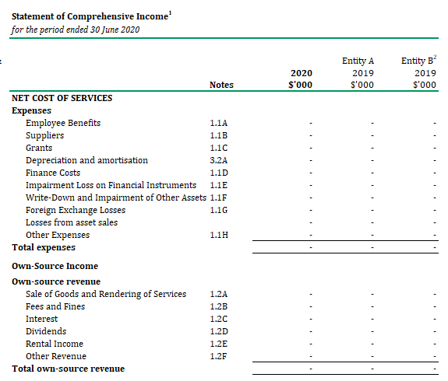

**1**

**2**

**3**

Incorporates Entity B for the period 1 July 2019 until 31 January 2020.

Comparative figures for Entity B are included due to functions transferred to Entity A effective 1 February 2020.

Old entity has not ceased to exist with some functions transferred

1. Where the old entity continues to exist and only some functions have been transferred (ie the old entity has retained some functions), the accountable authority of the:
   * + old entity should report on the:

* transferred functions up until the date of the transfer
* non-transferred functions (those functions that remained with the old entity) for the full reporting period
  + - reporting entity is required to report on the functions transferred from the old entity from the date of transfer until the end of the reporting period.

1. Also see KMP reporting following MoG changes.

# Part 6 – Miscellaneous reporting

## Determinations by Finance Minister

1. Under subsection 17K(2) of the [PGPA Rule](https://www.legislation.gov.au/Series/F2014L00911), despite amendments to the [AAO](https://www.legislation.gov.au/Browse/ByRegDate/AdministrativeArrangementsOrders/InForce) providing for a transfer of functions between entities, the Finance Minister can determine, for the purposes of reporting under sections 17A–17J of the PGPA Rule, that a transfer of functions is taken not to have occurred.
2. This would usually mean that the old entity would prepare its own statements and reports for the reporting period, rather than the new entity (or a reporting entity) reporting on the transferred functions.

Example 10: Finance Minister determination - PGPA Rule, section 17K

A MoG change may involve the formal transfer of some or all functions from the old entity to one or more other entities with the date of effect being close to the end of a reporting period. For this scenario, section 17K of the PGPA Rule enables the Finance Minister to make a determination that the old entity must prepare the required reports and documents for the full reporting period, as the best-placed entity for this.

1. It is important to note that a determination under section 17K of the PGPA Rule does not alter the effect or content of the [AAO](https://www.legislation.gov.au/Browse/ByRegDate/AdministrativeArrangementsOrders/InForce)—it only changes the allocation of reporting responsibilities for the reporting period in which the transfer of functions has occurred.

## KMP reporting following MoG changes

1. Where KMP reporting is affected by a MoG change, for clarity, transparency and accuracy in remuneration reporting in annual reports and annual financial statements entities should include notes, footnotes and cross references in KMP reports and disclosures.
2. Professional judgement is required in determining the positions that meet the KMP definition in [AASB 124 Related Party Disclosures](https://www.aasb.gov.au/Pronouncements/Current-standards.aspx), in the context of an entity’s structure, before and after a MoG change. For more information, see [RMG 138](https://www.finance.gov.au/government/managing-commonwealth-resources/commonwealth-entities-executive-remuneration-reporting-guide-annual-reports-rmg-138) and [RMG 139](https://www.finance.gov.au/government/managing-commonwealth-resources/commonwealth-companies-executive-remuneration-reporting-guide-annual-reports-rmg-139).
3. Entities should also ensure that there is no duplication of the reporting of KMP remuneration, and the reporting of executive remuneration more broadly.

### KMP reporting in annual reports

1. Following a MoG change, the annual report is expected to include explanations on any discrepancies that arise, between the:
   * + KMP executive remuneration reported in an entity’s annual report, and
     + the KMP disclosure note in that entity’s annual financial statements*.*
2. For more information on:
   * + who constitutes KMP for the purposes of executive remuneration reporting in entity annual reports, see [RMG 138](https://www.finance.gov.au/government/managing-commonwealth-resources/commonwealth-entities-executive-remuneration-reporting-guide-annual-reports-rmg-138) and [RMG 139](https://www.finance.gov.au/government/managing-commonwealth-resources/commonwealth-companies-executive-remuneration-reporting-guide-annual-reports-rmg-139)

### KMP disclosures in annual financial statements

1. The following arrangements relate to KMP disclosures in annual financial statements.

#### Standard arrangements for KMP disclosures

1. Apart from the scenario outlined at special arrangements for KMP disclosures*,* the reporting of KMP remuneration in entity financial statements should be consistent with the requirements for annual financial statements as outlined in this RMG for various scenarios.
2. Following a MoG change, the annual financial statements are expected to include notes and/or footnotes to explain any discrepancies that arise, between the:
   * + KMP executive remuneration reported in an entity’s annual report*,* and
     + KMP disclosure note in that entity’s annual financial statements.

#### Special arrangements for KMP disclosures

1. The following special arrangements apply to the reporting of KMP remuneration in entity financial statements where an old entity has ceased to exist, and some functions of the old entity have been transferred to two or more (new) entities.
2. For the:
   * + **old entity** — annual financial statements that are prepared by the entity nominated by the Finance Minister (the reporting entity), the KMP disclosures should include:

* remuneration of the KMP that remained with the old entity prior to its cessation
* a cross-reference to associated disclosures made by other entities relating to the KMP that transferred as a result of the MoG change
  + - **reporting entity** — the KMP disclosures in the annual financial statements should include:
* a separate note or footnote that discloses details of the remuneration of the KMP that transferred with the transferred functions from the old entity to new entities, from the commencement of the reporting period to the transfer date
* remuneration of transferred KMP position(s), from the transfer date until the end of the reporting period, where the transferred KMP position is determined as KMP by the reporting entity
* a cross-reference to the associated disclosure notes of the new entity (see below) about the MoG change
  + - **new entity** (ie not the reporting entity nominated by the Finance Minister) — the KMP disclosures should include:
* remuneration details of transferred KMP position(s), from the transfer date until the end of the reporting period, where the KMP position is determined as KMP by the new entity
* a cross-reference to the associated disclosure notes about the MoG change including the KMP remuneration disclosure by the reporting entity as outlined above.

## Entity responsibilities

1. For the reporting entity(s) to meet Division 4 of the PGPA Rule requirements, following a MoG change, it is expected that the old entity(s) would provide the reporting entity(s) with records relating to of transferred functions, for the full reporting period, including:
   * + transactions and information on the old entity’s financial position
     + non-financial performance information.
2. Section 37 of the [PGPA Act](https://www.legislation.gov.au/Series/C2013A00123) requires the accountable authority of entities to cause records to be kept in a manner that properly records and explains the entity’s performance in achieving its purposes.
3. Section 41 of the PGPA Act sets out the requirements for the keeping of accounts and records of entities and section 17 of the PGPA Act requires accountable authorities to encourage entity officials to cooperate with others to achieve common objectives, where practicable.
4. Providing full and ready access to data and information is essential to enable the reporting entity to meet their responsibilities. All entities impacted by MoG changes are encouraged to establish agreed protocols or arrangements as soon as practical after MoG changes are announced or as they take effect. Where necessary, Finance will discuss reporting arrangements with entities and facilitate access arrangements.

# Appendix 1 – Determining reporting requirements

This appendix provides several decision-trees that are designed to assist entities in determining the appropriate reporting requirements that apply in different situations and the relevant sections of Division 4 of the PGPA Rule.

The appendix is separated according to whether or not the reporting relates to transferred functions or non-transferred functions and the type of statements or report to be produced, including the requirements for:

* + - Annual performance statements
    - Annual financial statements
    - Annual report

## Reporting requirements for annual performance statements

Reporting requirements for non-transferred functions of the old entity

| Decision-tree for non-transferred functions of the old entity |
| --- |

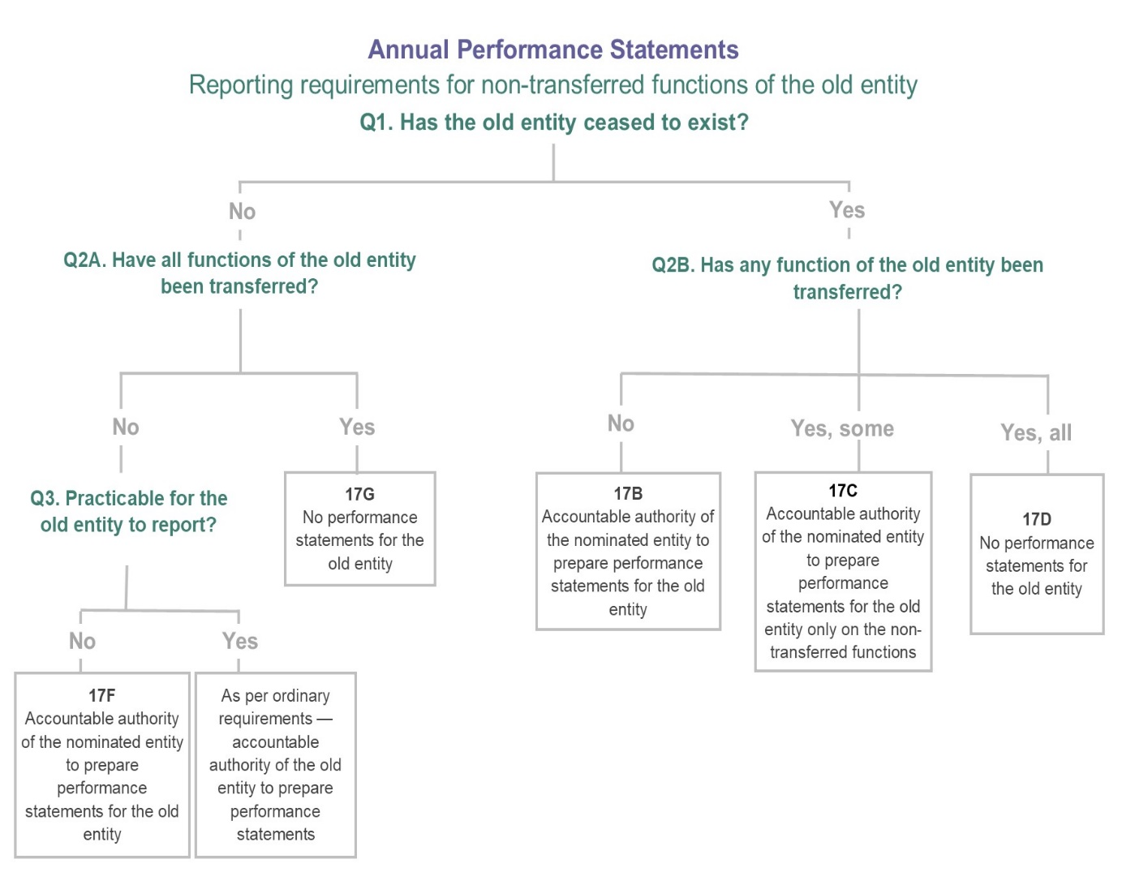

Reporting requirements for functions transferred from old the entity

Under subsection 17J(4) of the PGPA Rule, the accountable authority of the reporting entity is to prepare its annual performance statements as if the old entity had been part of the new entity for the entire reporting period, to the extent of the transferred functions.

## Determining requirements for annual financial statements

Reporting for non-transferred functions of the old entity

| Decision-tree for non-transferred functions of the old entity |
| --- |

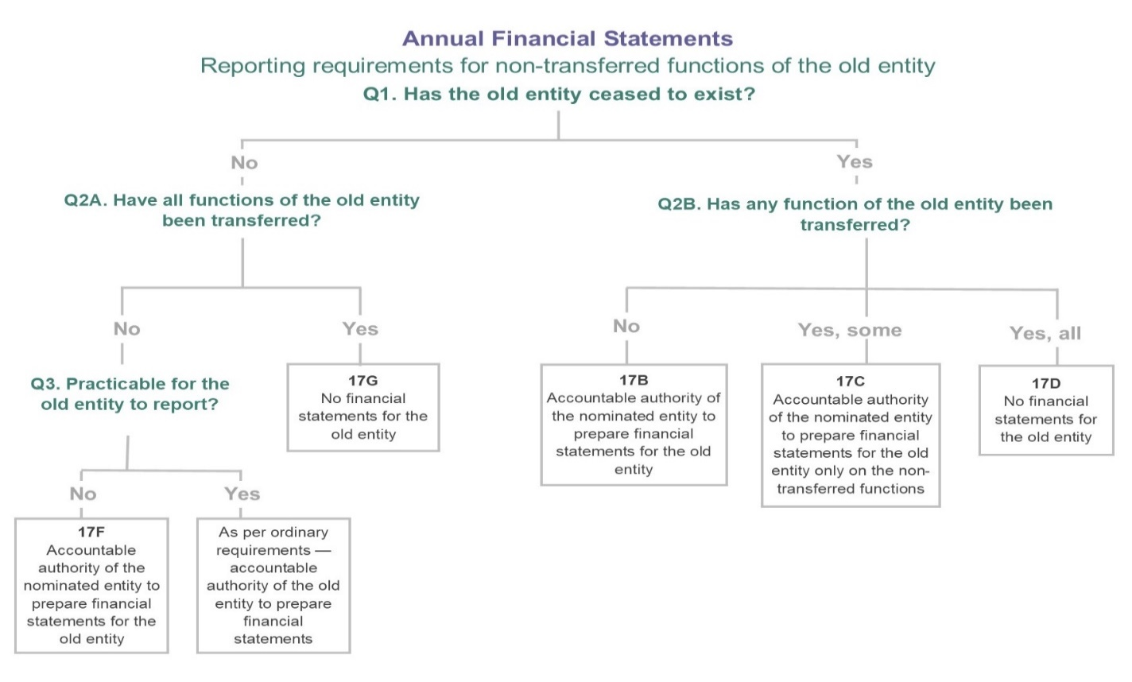

Reporting requirements for functions transferred from the old entity

| **Decision-tree for annual financial statements requirements for functions transferred from the old entity** |
| --- |

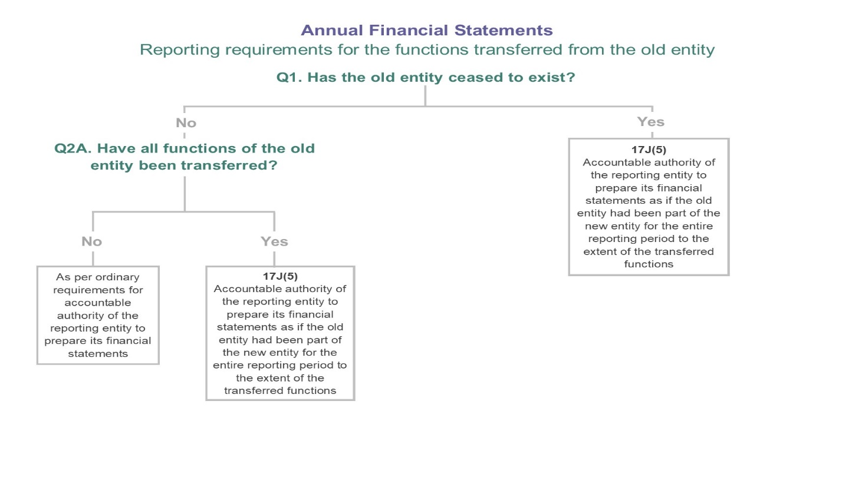

## Determining requirements for annual reports

Reporting requirements for non-transferred functions of the old entity

| **Decision-tree for annual report requirements for non-transferred functions of the old entity** |
| --- |

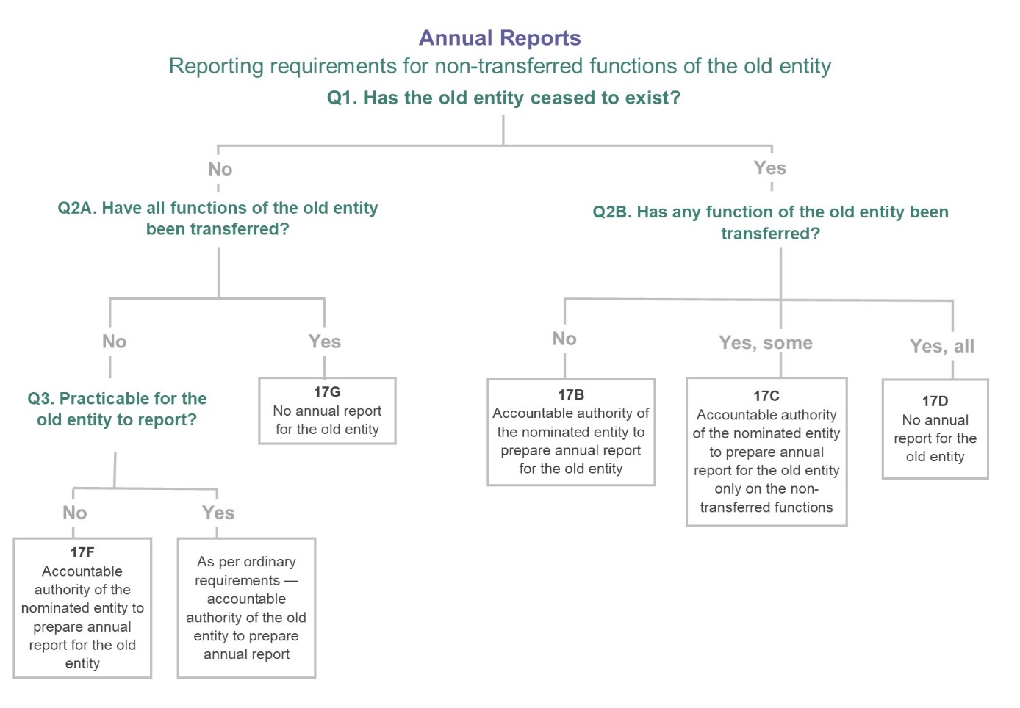

Reporting for functions transferred from the old entity

Under subsection 17J(6) of the PGPA Rule, the accountable authority of the reporting entity is to include in the annual report the information relating to the transferred function or functions that would have been required to have been included in the annual report for the old entity.

# Appendix 2 – Abbreviations

| **Abbreviation** | **Full title or term** |
| --- | --- |
| **AA** | Accountable authority |
| **AAO** | [Administrative Arrangement Orders](https://www.legislation.gov.au/Browse/ByRegDate/AdministrativeArrangementsOrders/InForce) |
| **AASB** | Australian Accounting Standards Board |
| **AFS** | Annual financial statements |
| **AGD** | Attorney-General’s Department |
| **ANPHA** | [Australian National Preventative Health Agency](https://www.directory.gov.au/portfolios/health/australian-national-preventive-health-agency) |
| **APS** | Annual performance statements |
| **AR** | Annual report |
| **DIBP** | Department of Immigration and Border Protection |
| **Finance** | [Department of Finance](https://www.finance.gov.au) |
| **Finance Minister** | Minister for Finance |
| **HA** | [Department of Home Affairs](https://www.homeaffairs.gov.au/reports-and-pubs/Annualreports/2017-18/01-annual-report-2017-18.pdf) |
| **KMP** | Key management personnel |
| **MoG** | Machinery of government |
| **PBS** | Portfolio Budget Statements |
| **PGPA Act** | [Public Governance, Performance and Accountability Act 2013](https://www.legislation.gov.au/Series/C2013A00123) |
| **PGPA Rule** | [Public Governance, Performance and Accountability Rule 2014](https://www.legislation.gov.au/Series/F2014L00911) |
| **RMG** | Resource management guide |