2019 Australian Government

Office Occupancy Report

© Department of Finance  
Commercial and Government Services

978-1-925537-57-4 (online)



**Copyright Notice**

**Content**

This work is copyright and owned by the Commonwealth of Australia.

With the exception of the Commonwealth Coat of Arms, this work is licensed under a Creative Commons Attribution 3.0 Australia licence (CC BY 3.0) (http://creativecommons.org/licenses/by/3.0/au/deed.en)

This work must be attributed as: “Commonwealth of Australia, Department of Finance, Commercial and Government Services, 2019 Australian Government Office Occupancy Report”.

**Use of the Coat of Arms**

The terms under which the Coat of Arms can be used are set out on the Department of Prime Minister and Cabinet website (pmc.gov.au/government/commonwealth-coat-arms).

**Contact us**

Inquiries regarding the licence and any use of this work are welcome at:

Commercial and Government Services Department of Finance, One Canberra Avenue FORREST ACT 2603 Email: PropertyData@finance.gov.au

Contents

1. Executive Summary 4

1.1 Overview 4

1.2 Policy Context 5

1.3 Key Terminology 5

1.4 Key Findings 6

2. Geography 11

2.1 Remoteness Classification 11

2.2 Entities with Regional or Remote Tenancies 12

2.3 States and Territories 13

3. Lease Expiry, Office Type and Tenancy Size 16

3.1 Lease Expiry 16

3.2 Office Type 17

4. Largest Entities 19

Appendix A: Glossary of Terms and Concepts 20

Appendix B: Technical Notes 24

Appendix C: Collection and Verification of Data 24

Appendix D: Sources 24

1. Executive Summary

The 2019 Australian Government Office Occupancy Report (Occupancy Report) shows that key indicators measuring the Commonwealth’s leased office footprint have remained relatively stable.

The 2019 results show small increases in the overall number of tenancies and the amount of controlled area when compared to 2018. These increases are due to the addition of new tenancies and a greater number of existing tenancies now meeting the threshold for reporting (500 square metres (m2) of usable office area) by increasing their usable office area (refer to section 1.4 for more detail). Overall, when factoring in all non-corporate Commonwealth entity tenancies regardless of size, the Commonwealth's office space footprint has grown by only 0.4 per cent.

Key indicators including fit-out density and occupational density have remained relatively stable. The average cost per square metre and average cost per work‑point have decreased.

While the work-point vacancy rate increased slightly in 2019 due to a modest increase in total work-points not matched by the increase in total staff, the number of vacant work-points is expected to return to trend and fall as entities continue to fill vacant space or move into more efficient tenancies. Both fit‑out density and occupational density are expected to improve as leases for older tenancies expire and are replaced by tenancies with more efficient work space.

The 2019 Occupancy Report includes cost indicators and private-sector benchmarking for the first time. These new indicators help to provide a more complete picture of Commonwealth property performance and increase transparency around government expenditure on office accommodation.

This information, together with other data collected through the Australian Government Property Register (AGPR), provides an evidence base to assist entities to identify and progressively implement better property management practices, while also informing decisions in relation to whole-of-government leasing and property policy.

* 1. Overview

The Occupancy Report includes office accommodation that is leased or owned by non‑corporate Commonwealth entities (entities) with at least 500 m2 of usable office area as at 30 June 2019.

Data is collected through the AGPR, which entities (through their Property Service Providers) are required to update annually in August.

The point-in-time nature of collecting this information adds a degree of volatility to annual results. However, the information provides an understanding of the medium and long-term trends, especially given the impact of leasing decisions are evident over many years. Likewise, the length of leases can mean changes in outcomes may take some time to be reflected in the data.

* 1. Policy Context

The *Commonwealth Property Management Framework* (Resource Management Guide 500) provides the foundation for achieving value for money and promoting the efficient, effective, economical and ethical management of owned and leased Commonwealth property in Australia, including external territories. The Framework outlines the requirement for entities to seek to minimise surplus office space, and includes the:

* Property Services Coordinated Procurement arrangements that are improving the efficiency of property services across the Commonwealth and maximising the value for money that can be achieved by consolidating the Commonwealth’s purchasing power. The arrangements cover leasing and facilities management services for Commonwealth domestic office accommodation and shopfronts for entities;
* Commonwealth Leasing Strategy (CLS) that provides a whole-of-government strategic plan for office and shopfront leases held by entities over a ten year period. The CLS considers leases from a strategic, value for money perspective and provides leasing recommendations for all in-scope leases, based on commercial market advice. The CLS promotes efficiencies in occupied space and reduced leasing costs, while continuing to prioritise the operational requirements of the leasing entities; and
* Government’s occupational density target of 14 m2 of usable office area per occupied work-point, which was introduced in May 2013.

All new leases are expected to meet the occupational density target. Entities consider the occupational density target when undertaking planning and throughout the property management lifecycle, including when negotiating new leases, considering a major fit-out, refurbishment of existing office space, or to determine if surplus office space or work-points could be sub-leased.

* 1. Key Terminology

A complete glossary of terms and concepts is provided at Appendix A.

Previous editions of the Occupancy Report use net lettable area as the standard measure of space within a tenancy. This year’s Occupancy Report uses controlled area as the standard measure. This provides a more accurate measurement of space at a whole‑of‑government level and a more accurate picture of the Commonwealth’s overall footprint because it separately accounts for sub-leased space and avoids any double counting of sub-leased space. Figures from prior years have been adjusted in this Occupancy Report to reflect controlled area to ensure consistency, however this does not result in any material changes to results between years. Refer to Appendix B for more details.

Frequently used terminology includes:

Net lettable area which represents the total office space of a tenancy; this is measured in square metres (m2) and is the area between internal walls of a building that is being leased.

Controlled area is the *net lettable area* of a tenancy, minus any area that has been sub-let to a third party.

Usable office area is the *controlled area* of a tenancy, minus any area that is deemed unsuitable for office work. The definition of what makes an area unsuitable for office work is explained at Appendix A.

Work-point vacancy rate is the number of vacant work-points expressed as a percentage of total work-points.

Fit-out density is the square metres of *usable office area* divided by the total number of work‑points (both vacant and occupied).

Occupational density is the square metres of *usable office area* divided by the number of *work-points* that are occupied.

Net tenancy expenditure is the total annual rent (GST inclusive) expense of each lease for all areas within the tenancy.

Cost per square metre is the *net tenancy expenditure* divided by the *controlled area*.

Cost per staff is the *net tenancy expenditure* divided by the number of *staff*.

Cost per work-point is the *net tenancy expenditure* divided by the number of *work-points*.

* 1. Key Findings

Table 1a: Size of Commonwealth footprint

|  |  |  |  |
| --- | --- | --- | --- |
| Measure | **2019** | 2018 | 2017 |
| Tenancies (n) | **568** | 541 | 596 |
| Controlled Area (m2) | **2,838,345** | 2,744,222 | 2,765,630 |
| Usable Office Area (m²) | **2,253,361** | 2,177,308 | 2,279,729 |

The number of reported Commonwealth tenancies has increased by 27 in 2019 compared to 2018, but there are 28 fewer tenancies in 2019 compared to 2017.

The increases seen in Table 1a are due to a number of new tenancies being reported, and also a number of existing tenancies being reported for the first time. Existing tenancies may increase their usable office area above the reporting threshold at any time, and are therefore included in the Occupancy Report at the next reporting period. The usable office area associated with a tenancy can increase for a number of reasons, such as when sub-leases are absorbed back into head leases or when non-office area is reduced (such is the case when office space is reclaimed through changes to fit‑outs).

The total reported controlled area has increased by 94,123 m2 (3.4 per cent) since 2018 or by 72,715 m2 (2.6 per cent) since 2017. However, when factoring in all tenancies regardless of size (including those below the 500 m2 threshold that are excluded from this report) the change in total controlled area increased by only 18,951 m2 overall (or 0.4 per cent) from 4,719,416 m2 to 4,738,367 m2 since 2018.

The increase seen in Table 1a (and subsequent increase in the number of vacant work‑points seen in Table 1b) is also partially due to the point-in-time nature of the data underlying the Occupancy Report. Due to this point-in-time data, the figures in Table 1a can include situations where there is an overlap of expiring leases and new leases, or where there is a short-term lease used to support internal fit-out works in an ongoing tenancy.

Similarly, the incremental and expected improvement in occupational density is not immediately reflected in the Occupancy Report in cases where entities enter into newer, larger leases and are yet to sub-lease underutilised areas and before additional staff move into the buildings.

Table 1b: Work-points and staff (a)

|  |  |  |  |
| --- | --- | --- | --- |
| Measure | **2019** | 2018 | 2017 |
| Work-points (n) | **164,632** | 158,357 | 158,806 |
| Staff (n) | **139,583** | 136,008 | 133,117 |
| Vacant Work-points (n) | **25,049** | 22,349 | 25,689 |
| Work-point Vacancy Rate (%) | **15.2%** | 14.1% | 16.2% |

(a) A work-point is defined as a desk, enclosed office or counter where it would be reasonable to expect a person to carry out office work on an ongoing basis. This applies to traditional, flexible or activity-based working fit-out arrangements. Staff includes contractors and is taken on a headcount basis for leases that meet the criteria for inclusion (office accommodation with at least 500 m2 of usable office area) in the Occupancy Report. For these reasons, the number of staff will not align with the Australian Public Service Commission’s *State of the Service* report, which excludes contractors and has no such criteria for inclusion; nor will it align with staffing estimates contained in *Budget Paper No.4*, which do not include contractors and are reported on an Average Staffing Level basis.

Entities reported 6,275 more work-points and 3,575 more staff allocated to leases in 2019 compared to 2018, or 5,826 more work-points and 6,466 more staff compared to 2017. Accordingly, entities also reported a work-point vacancy rate of 15.2 per cent in 2019 compared to 14.1 per cent in 2018 or 16.2 per cent in 2017.

In addition to the explanation provided above at Table 1a with respect to coordination of lease expiration and consolidation, leasing decisions are guided by a requirement for a degree of flexibility to accommodate for both expected and unplanned growth.

As a result, many entities choose to enter into larger leases for longer terms at more favourable rates to reduce leasing costs, achieve better value for money and provide the ability to accommodate fluctuations in staffing numbers and scale appropriately. Where this occurs, Finance works with entities, Property Service Providers and the Australian Government’s Strategic Property Adviser to sub-lease, co-locate, or otherwise dispose of space to ensure an efficient lease.

Table 1c: Average density rates

|  |  |  |  |
| --- | --- | --- | --- |
| Measure | **2019** | 2018 | 2017 |
| Average Fit-out Density (m²) | **13.7** | 13.7 | 14.4 |
| Average Occupational Density (m²) | **16.1** | 16.0 | 17.1 |
| Meeting the Occupational Density Target (%) | **29.6%** | 31.6% | 25.0% |

The average fit-out density for entities has remained consistent at 13.7 m2 across 2019 and 2018. This remains an improvement from 14.4 m2 of usable office space per work-point in 2017. Moving to a lease with a fit-out that is more dense, or adding more work-points to an existing tenancy, enables entities to increase fit-out density to accommodate more staff in their usable office area.

Where reconfiguration occurs in an existing tenancy, an entity may require a staging area to accommodate staff. This short term space is included in the Occupancy Report when it is held by the Commonwealth as at 30 June 2019, regardless of a future intent to relinquish or sub-let the space.

The average occupational density has remained consistent, deteriorating slightly from 16.0 m2 in 2018 to 16.1 m2 in 2019. Occupational density has improved overall from 17.1 m2 in 2017.

The percentage of Commonwealth tenancies meeting the Government’s occupational density target of 14 m2 usable office space per occupied work-point has reduced slightly with 29.6 per cent of tenancies meeting the target in 2019 compared to 31.6 per cent of tenancies meeting the target in 2018, however this remains an improvement from 25 per cent meeting the target in 2017.

There are 168 tenancies that achieve the Government’s target of 14 m2 of usable office space per occupied work-point. These 168 tenancies have an average fit-out density of 11.7 m2 of usable office area per work-point and an average work-point vacancy rate of 6.8 per cent – both of which are better than the Commonwealth average.

The chart below is snapshot of the majority of tenancies and shows a cluster around the occupational density target. There are 113 tenancies with an occupational density between 14‑16 m2. A modest improvement in these tenancies would see a far higher proportion of Commonwealth tenancies meeting the Government’s target. Of the 188 tenancies with an occupational density between 14-18 m2, 26 per cent of these leases have a lease end date within the next two years and provide an opportunity to reconsider leases and consolidate space in line with the Government’s target.

**Chart 1: Distribution of Occupational Density Rates for Tenancies between 10-18 m2**

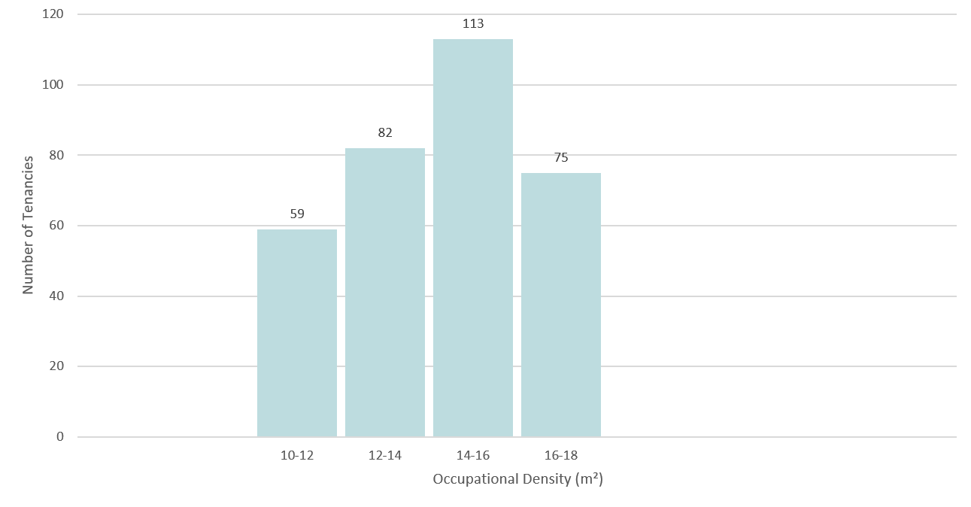

**Table 1d: Cost Indicators**

|  |  |  |  |
| --- | --- | --- | --- |
| Measure | **2019** | 2018 | 2017 |
| Net Tenancy Expenditure ($m) | **$1,336.5** | $1,299.3 | $1,258.3 |
| Average Cost per m2 ($) | **$ 471** | $ 473 | $ 455 |
| Average Cost per Staff ($) | **$ 9,575** | $ 9,553 | $ 9,452 |
| Average Cost per Work-point ($) | **$ 8,118** | $ 8,205 | $ 7,923 |

Net tenancy expenditure increased by 2.9 per cent over the 12 month period. This is less than the 3.4 per cent increase in the amount of controlled area over the same period, resulting in a marginal decrease in the average cost per square metre (down 0.5 per cent). The increase in net tenancy expenditure is expected given the increase in controlled area and factoring in annual price escalation built into existing leases and market shifts for new leases.

To determine how the average square metre costs above compare to the broader Australian market, the Australian Government’s Strategic Property Adviser undertook an analysis of A‑grade office space across major Australian cities and identified an average cost (net effective rent which excludes outgoings but includes the amortised benefits of incentives) of $539 per m2, which exceeds the Commonwealth’s figure of $471 per m2. The Commonwealth does have a more diverse portfolio by location and grade, which contributes to the lower figure, however it also demonstrates that the Commonwealth is utilising office space that is fit for purpose and meets business needs to enable entities to deliver their functions and provide important services to the public.

The Commonwealth’s result for major cities of Australia at Table 2 is $476 per m2, which is a closer comparator to the Strategic Property Adviser’s finding, however still includes more diverse property grades consistent with the Commonwealth’s approach to source office accommodation to achieve value for money and meet business needs.

Figures for the average cost per square metre for Commonwealth tenancies show a slight decrease between 2019 ($471 per m2) and 2018 ($473 per m2), and an increase from 2017 ($455 per m2).

Cost per staff shows a minor but steady increase year-on-year between 2017 and 2019 with $9,452 in 2017, $9,553 in 2018 and $9,575 in 2019.

Figures for cost per work-point show a slight decrease between 2019 ($8,118 per work‑point) and 2018 ($8,205 per work-point), and an increase from 2017 ($7,923 per work‑point).

The average figures in Table 1d are subject to changes in rental costs across multiple different markets. The figures are also subject to fluctuations in the reported amount of controlled area and the reported number of staff and work-points each year.

**Chart 2: Key figures**

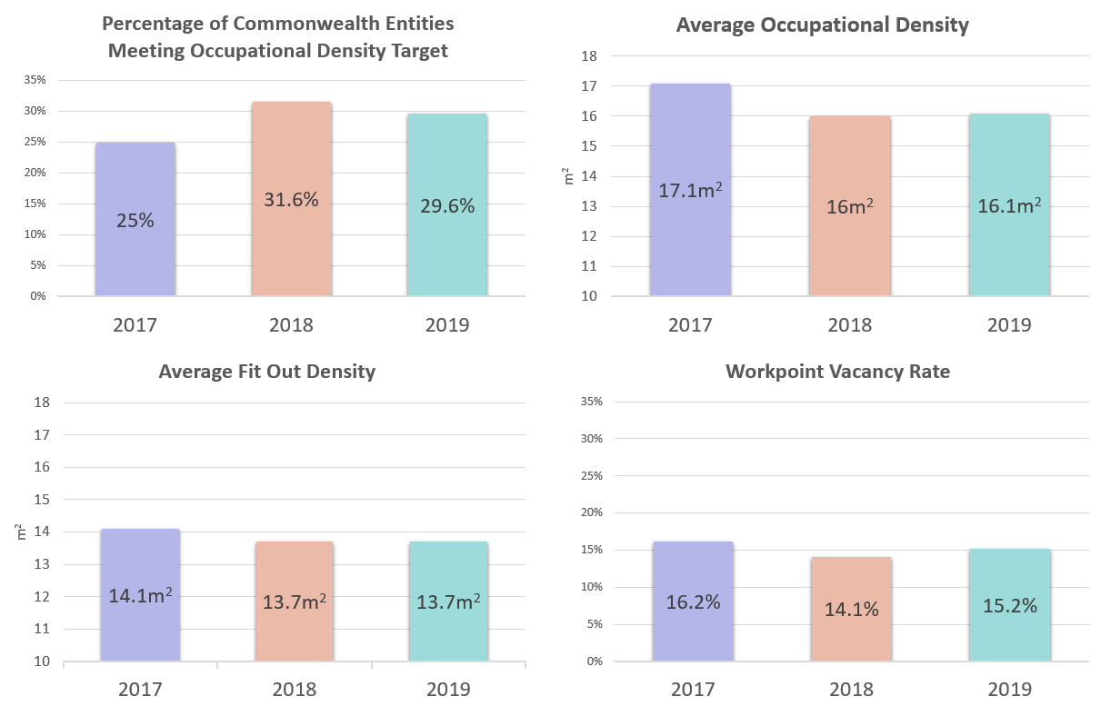

1. Geography
   1. Remoteness Classification

Table 2: Summary of Tenancies by Remoteness Classification (a)

|  |  |  |  |  |  |
| --- | --- | --- | --- | --- | --- |
| Measure | Major Cities of Australia | Inner Regional Australia | Outer Regional Australia | Remote Australia (b) | Total (all tenancies) |
| Number of Tenancies (n) | 473 | 49 | 35 | 11 | 568 |
| Controlled area (m2) | 2,654,623 | 117,906 | 56,970 | 8,847 | 2,838,345 |
| Usable Office Area (m²) | 2,098,939 | 101,415 | 45,691 | 7,316 | 2,253,361 |
| Work-points (n) | 153,246 | 8,001 | 3,115 | 270 | 164,632 |
| Staff (n) | 130,250 | 6,809 | 2,369 | 155 | 139,583 |
| Vacant Work-points (n) | 22,996 | 1,192 | 746 | 115 | 25,049 |
| Work-point Vacancy Rate (%) | 15.0% | 14.9% | 23.9% | 42.6% | 15.2% |
| Average Fit-out Density (m²) | 13.7 | 12.7 | 14.7 | 27.1 | 13.7 |
| Average Occupational Density (m²) | 16.1 | 14.9 | 19.3 | 47.2 | 16.1 |
| Meeting the Occupational Density Target (%) | 30.7% | 30.6% | 22.9% | 0.0% | 29.6% |
| Net Tenancy Expenditure ($m) | $1,263.5 | $44.1 | $25.5 | $3.5 | $1,336.5 |
| Average Cost per m² | $476 | $374 | $447 | $390 | $471 |
| Average Cost per Staff | $9,700 | $6,478 | $10,749 | $22,275 | $9,575 |
| Average Cost per Work-point ($) | $8,245 | $5,513 | $8,175 | $12,788 | $8,118 |

(a) The Occupancy Report uses the Australian Bureau of Statistics’ classification of remoteness, which considers Hobart to be ‘inner regional’ and Darwin as ‘outer regional’.

(b) ‘Remote Australia’ includes figures for tenancies classed as ‘Very Remote Australia’.

Table 2 provides a summary of tenancies by remoteness classification and allows for a comparison of key measures between tenancies in major cities, inner and outer regional areas, and remote areas.

The results from 2019 show that the majority of tenancies (83 per cent of tenancies) are located in major cities and that this accounts for 94 per cent of controlled area.

The average cost per square metre, per staff and per work-point is lowest in inner regional Australia. While average cost per square metre is next lowest in remote Australia, this region has the highest average costs per staff and per work-point.

Spatial measures perform better (and are comparable) in major cities and inner regional locations, while outer regional and remote locations are less dense on average.

There are limited accommodation options in outer regional and remote Australia, which impacts the ability to find as spatially efficient office accommodation as what can be achieved in major cities. However given their location, the square metre costs for outer regional and remote locations are lower than those in major cities, as illustrated in the Table 2.

* 1. Entities with Regional or Remote Tenancies

Table 3a: Entities with Regional Tenancies

|  |  |  |  |  |
| --- | --- | --- | --- | --- |
|  | Regional Tenancies | | | |
| Entity | Number of Tenancies (n) | Controlled Area (m²) | Usable Office Area (m²) | Average Occupational Density (m²) |
| Services Australia | 45 | 91,497 | 74,930 | 14.1 |
| Department of Home Affairs | 8 | 13,402 | 11,114 | 37.9 |
| Department of the Prime Minister and Cabinet | 5 | 4,893 | 4,619 | 33.7 |
| Australian Taxation Office | 4 | 25,659 | 22,876 | 13.0 |
| Department of Defence | 4 | 3,638 | 3,632 | 19.4 |
| Australian Securities and Investments Commission | 2 | 9,081 | 7,471 | 24.9 |
| Bureau of Meteorology | 2 | 2,330 | 2,066 | 33.9 |
| Department of Agriculture | 2 | 3,785 | 2,141 | 21.6 |
| Department of Social Services | 2 | 1,855 | 1,855 | 31.4 |
| Department of the Environment and Energy | 2 | 7,779 | 6,865 | 17.2 |
| Great Barrier Reef Marine Park Authority | 2 | 4,327 | 3,407 | 14.8 |
| Australian Bureau of Statistics | 1 | 1,663 | 1,663 | 15.4 |
| Australian Electoral Commission | 1 | 732 | 700 | 20.6 |
| Australian Fisheries Management Authority | 1 | 650 | 650 | 28.3 |
| Department of Health | 1 | 1,053 | 1,036 | 14.6 |
| Department of Veterans' Affairs | 1 | 1,850 | 1,480 | 21.8 |
| Fair Work Ombudsman and Registered Organisations Commission Entity | 1 | 682 | 601 | 20.7 |

Table 3b: Entities with Remote Tenancies[1]

|  |  |  |  |  |
| --- | --- | --- | --- | --- |
|  | Remote Tenancies | | | |
| Entity | Number of Tenancies (n) | Controlled Area (m²) | Useable Office Area (m²) | Average Occupational Density (m²) |
| Department of the Prime Minister and Cabinet | 6 | 3,847 | 3,599 | 44.4 |
| Department of Home Affairs | 4 | 3,770 | 2,849 | 118.7 |
| Services Australia | 1 | 1,230 | 868 | 17.4 |

Note: entities reflect their composition as at July 2019 at the time of the data collection, and do not incorporate Machinery of Government changes that took effect on 1 February 2020.

* 1. States and Territories

**Table 4: State and Territories**

|  |  |  |  |  |  |  |  |  |  |
| --- | --- | --- | --- | --- | --- | --- | --- | --- | --- |
| Measure | ACT | NSW | VIC | QLD | SA | WA | TAS | NT | Australia |
| Tenancies (n) | 155 | 117 | 97 | 76 | 42 | 41 | 21 | 19 | 568 |
| Controlled Area (m²) | 1,318,890 | 489,863 | 424,195 | 268,983 | 132,452 | 125,040 | 54,531 | 24,392 | 2,838,345 |
| Usable Office Area (m²) | 1,114,323 | 356,954 | 327,707 | 197,308 | 98,974 | 89,178 | 48,623 | 20,293 | 2,253,361 |
| Work-points (n) | 80,403 | 26,705 | 23,980 | 14,846 | 7,464 | 6,455 | 3,709 | 1,070 | 164,632 |
| Staff (n) | 68,122 | 22,066 | 21,355 | 12,882 | 6,745 | 4,551 | 3,150 | 712 | 139,583 |
| Vacant Work-points (n) | 12,281 | 4,639 | 2,625 | 1,964 | 719 | 1,904 | 559 | 358 | 25,049 |
| Work-point Vacancy Rate (%) | 15.3% | 17.4% | 10.9% | 13.2% | 9.6% | 29.5% | 15.1% | 33.5% | 15.2% |
| Average Fit-out Density (m²) | 13.9 | 13.4 | 13.7 | 13.3 | 13.3 | 13.8 | 13.1 | 19.0 | 13.7 |
| Average Occupational Density (m²) | 16.4 | 16.2 | 15.3 | 15.3 | 14.7 | 19.6 | 15.4 | 28.5 | 16.1 |
| Meeting the Occupational Density Target (%) | 24.5% | 31.6% | 43.3% | 28.9% | 33.3% | 19.5% | 19.0% | 15.8% | 29.6% |
| Net Tenancy Expenditure ($m) | $609.2 | $269.7 | $185.7 | $129.3 | $57.0 | $53.4 | $19.2 | $13.1 | $1,336.5 |
| Average Cost per (m²) | $462 | $551 | $438 | $481 | $430 | $427 | $352 | $535 | $471 |
| Average Cost per staff ($) | $8,942 | $12,224 | $8,695 | $10,037 | $8,445 | $11,738 | $6,093 | $18,332 | $9,575 |
| Average Cost per Work-point ($) | $7,577 | $10,100 | $7,743 | $8,709 | $7,631 | $8,275 | $5,175 | $12,199 | $8,118 |

There are 568 tenancies across Australia. The Australian Capital Territory has 27 per cent of Commonwealth tenancies, followed by New South Wales (21 per cent), Victoria (17 per cent) and Queensland (13 per cent). The Australian Capital Territory has 47 per cent of total controlled area, and 49 per cent of total staff and work‑points.

The Australian Capital Territory also has an above average number of tenancies with longer leases (that are due to expire between 10 and 20 years) with 20 tenancies in this category, compared to 14 tenancies in the same category across the rest of Australia. This year’s data shows that tenancies with longer leases are less likely to meet the occupational density target (refer to section 4.1 for further detail).

In the Australian Capital Territory, 24.5 per cent of tenancies meet the Government’s occupational density target (up slightly from 23.1 per cent in 2018). The three states/territories with a lower percentage of tenancies meeting the occupational density target are Northern Territory (15.8 per cent), Tasmania (19.0 per cent) and Western Australia (19.5 per cent). The four states with a higher percentage of tenancies meeting the occupational density target are Victoria (43.3 per cent), South Australia (33.3 per cent), New South Wales (31.6 percent) and Queensland (28.9 per cent).

The average occupational density of tenancies in the Australian Capital Territory (16.4 m2) is higher than New South Wales (16.2 m2), Victoria (15.3 m2), Queensland (15.3 m2), South Australia (14.7 m2) and Tasmania (15.4 m2).There are 34 tenancies in the Australian Capital Territory (22 per cent of total tenancies in the Territory) that have an occupational density between 14 m2 and 16 m2. This is likely to improve as longer leases expire and are replaced with more efficient tenancies.

The cost per square metre is the lowest in Tasmania ($352 per m2) followed by Western Australia ($427 per m2), South Australia ($430 per m2), Victoria ($438 per m2), Australian Capital Territory ($462 per m2), Queensland ($481 per m2), Northern Territory ($535 per m2) and New South Wales ($551 per m2).

The cost per staff is also lowest in Tasmania ($6,093) followed by South Australia ($8,445), Victoria ($8,695), Australian Capital Territory ($8,942), Queensland ($10,037), Western Australia ($11,738), New South Wales ($12,224) and Northern Territory ($18,332).

The cost per work-point is lowest in Tasmania ($5,175 per work-point) when compared to the rest of Australia. The Australian Capital Territory, South Australia, Victoria, Western Australia and Queensland range between $7,577 and $8,709 per work-point. The cost per work-point in New South Wales and Northern Territory are $10,100 and $12,199 respectively.

**Figure 1: Location and number of tenancies**

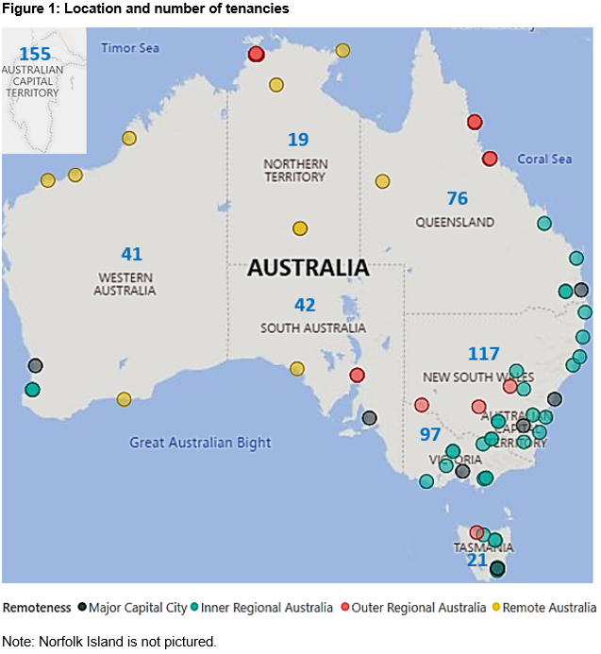

Note: Norfolk Island is not pictured.

1. Lease Expiry, Office Type and Tenancy Size
   1. Lease Expiry

**Table 5: Lease Expiry**

|  |  |  |  |  |  |  |
| --- | --- | --- | --- | --- | --- | --- |
| Measure | Holdover | 0-2 Years | 2-5 Years | 5-10 Years | 10-20 Years | 20+ Years |
| Number of Tenancies (n) | 12 | 159 | 198 | 153 | 35 | 11 |
| Controlled Area (m²) | 34,818 | 477,784 | 749,274 | 798,038 | 643,816 | 134,616 |
| Usable Office Area (m²) | 32,311 | 397,343 | 635,929 | 686,870 | 420,154 | 80,754 |
| Work-points (n) | 2,289 | 29,370 | 46,325 | 50,532 | 30,119 | 5,997 |
| Staff (n) | 2,170 | 22,991 | 39,397 | 43,910 | 25,671 | 5,444 |
| Vacant Work-points (n) | 119 | 6,379 | 6,928 | 6,622 | 4,448 | 553 |
| Work-point Vacancy Rate (%) | 5.2% | 21.7% | 15.0% | 13.1% | 14.8% | 9.2% |
| Average Fit-out Density (m²) | 14.1 | 13.5 | 13.7 | 13.6 | 13.9 | 13.5 |
| Average Occupational Density (m²) | 14.9 | 17.3 | 16.1 | 15.6 | 16.4 | 14.8 |
| Meeting the Occupational Density Target (%) | 25.0% | 28.9% | 30.3% | 28.8% | 28.6% | 45.5% |
| Net Tenancy Expenditure ($m) | $17.8 | $246.9 | $377.0 | $384.2 | $297.9 | $12.7 |
| Average Cost per m² ($) | $512 | $517 | $503 | $481 | $463 | $94 |
| Average Cost per Staff ($) | $8,210 | $10,739 | $9,569 | $8,750 | $11,602 | $2,336 |
| Average Cost per Work-point ($) | $7,783 | $8,407 | $8,138 | $7,603 | $9,889 | $2,121 |

Table 5 provides a summary of tenancies split by the length of time until leases are due to expire. This allows for a comparison between key measures across different lease lengths.

Approximately 2 per cent of Commonwealth tenancies (representing 1 per cent of controlled area) are continuing on a month-by-month basis (holdover). These tenancies have an average occupational density of 14.9 m2 and a fit-out density of 14.1 m2.

A further 28 per cent of tenancies (representing 17 per cent of controlled area) have leases expiring within the next two years. These tenancies have the highest average occupational density at 17.3 m2.

Another 35 per cent of leases expire between 2 and 5 years, 27 per cent within 5 to 10 years, and 6 per cent in 10 to 20 years. These tenancies have similar average fit‑out density and occupational density rates.

The cost per square metre ranges between $463 and $517 for leases with lengths up to 20 years until they expire. The cost per square metre of $94 for leases in the 20 or more year category is much lower by comparison as 10 out of the 11 buildings in this category are owned and occupied by the same entity and therefore do not incur rental costs.

These lease expiry categories do not take into account any existing lease options that may be exercised by tenants.

* 1. Office Type

**Table 6: Office type**

|  |  |  |  |  |
| --- | --- | --- | --- | --- |
| Measure | Solely office (100% office area) | Mostly office (80% to 99% office) | Mixed (50% to 79% office) | Mostly operational (0% to 49% office) |
| Number of Tenancies (n) | 120 | 305 | 122 | 21 |
| Controlled Area m² | 246,494 | 1,899,048 | 429,479 | 263,324 |
| Usable Office Area (m²) | 246,494 | 1,739,897 | 235,511 | 31,458 |
| Work-points (n) | 18,135 | 127,743 | 16,902 | 1,852 |
| Staff (n) | 15,018 | 109,627 | 13,098 | 1,840 |
| Vacant Work-points (n) | 3,117 | 18,116 | 3,804 | 12 |
| Work-point Vacancy Rate (%) | 17.2% | 14.2% | 22.5% | 0.6% |
| Average Fit-out Density (m²) | 13.6 | 13.6 | 13.9 | 17.0 |
| Average Occupational Density (m²) | 16.4 | 15.9 | 18.0 | 17.1 |
| Meeting the Occupational Density Target (%) | 34.2% | 30.8% | 21.3% | 33.3% |
| Net Tenancy Expenditure ($m) | $130.4 | $921.8 | $189.1 | $95.3 |
| Average Cost per m² ($) | $529 | $485 | $440 | $362 |
| Average Cost per Staff ($) | $8,680 | $8,409 | $14,435 | $51,783 |
| Average Cost per Work-point ($) | $7,188 | $7,216 | $11,186 | $51,448 |

A tenancy is categorised as ‘solely office’, ‘mostly office’, ‘mixed’, or ‘mostly operational’ depending on the ratio of usable office area to controlled area.

* If a tenancy’s usable office area equals 100 per cent of its controlled area, then it is deemed to be ‘solely office’;
* if the ratio is between 80 and 99 per cent, the tenancy is considered to be ‘mostly office’;
* if the ratio falls to between 50 and 79 per cent, the tenancy is ‘mixed’; and
* if usable office area makes up less than 50 per cent of the controlled area, then the tenancy is ‘mostly operational’.

Calculation of spatial density measures is not influenced by office type because they are determined relative to usable office area. However, net tenancy expenditure throughout the report is based on controlled area (as costs relate to the total controlled area of the tenancy). These cost figures can be rebased on usable office area to provide a better comparison between different office type categories.

When rebased for usable office area, the average cost per staff and work-point for mostly operational tenancies is $6,186 per staff and $6,146 per work-point respectively. Office space in this category includes space that is attached to operational facilities, archives facilities, container examination facilities, and federal law court buildings.

The results for mixed and mostly office tenancies when rebased for usable office area are:

* mixed – the average costs per staff and work-point is $7,916 per staff and $6,134 per work-point; and
* mostly office – the average costs per staff and work-point is $7,704 per staff and $6,611 per work-point.

The costs for solely office tenancies remains the same as in Table 6 as these tenancies have 100 per cent of their space deemed as usable office area.

* 1. Tenancy Size

**Table 7: Tenancy Size**

|  |  |  |  |  |  |
| --- | --- | --- | --- | --- | --- |
| Measure | Small | Medium | Large | Very Large | Total |
| Number of Tenancies (n) | 180 | 272 | 85 | 31 | 568 |
| Controlled Area m² | 243,823 | 895,470 | 846,835 | 852,216 | 2,838,345 |
| Usable Office Area (m²) | 129,410 | 608,424 | 742,785 | 772,742 | 2,253,361 |
| Work-points (n) | 8,702 | 43,986 | 56,796 | 55,148 | 164,632 |
| Staff (n) | 6,777 | 36,918 | 48,253 | 47,635 | 139,583 |
| Vacant Work-points (n) | 1,925 | 7,068 | 8,543 | 7,513 | 25,049 |
| Work-point Vacancy Rate (%) | 22.1% | 16.1% | 15.0% | 13.6% | 15.2% |
| Average Fit-out Density (m²) | 14.9 | 13.8 | 13.1 | 14.0 | 13.7 |
| Average Occupational Density (m²) | 19.1 | 16.5 | 15.4 | 16.2 | 16.1 |
| Meeting the Occupational Density Target (%) | 21.7% | 36.4% | 30.6% | 12.9% | 29.6% |
| Net Tenancy Expenditure ($m) | $113.7 | $388.1 | $411.0 | $423.7 | $1,336.5 |
| Average Cost per m² ($) | $466 | $433 | $485 | $497 | $471 |
| Average Cost per Staff ($) | $16,777 | $10,513 | $8,518 | $8,894 | $9,575 |
| Average Cost per Work-point ($) | $13,066 | $8,824 | $7,236 | $7,683 | $8,118 |

A tenancy is categorised as:

* Small, where the usable office area is between 500-1000 m2;
* Medium, where the usable office area is between 1000-5000 m2;
* Large, where the usable office area is between 5000-15,000 m2; or
* Very large, where the usable office area is greater than 15,000 m2.

This year’s data shows that 36.4 per cent of medium sized tenancies meet the occupational density target, the highest across all categories. The highest work-point vacancy rate (22.1 per cent) belongs to small tenancies.

The data also shows that small tenancies have less dense fit-outs on average compared to large tenancies (an average of 14.9 m2 for small tenancies and an average of 13.1 m2 for large tenancies). Medium tenancies have the lowest cost per square metre at $433 m2, with all other tenancy sizes ranging from $466 to $497 m2.

The cost per staff is lowest in large tenancies at $8,518 and highest in small tenancies at $16,777 per staff. The cost per work-point is again lowest in large tenancies at $7,236 and highest in small tenancies at $13,066 per work-point.

1. Largest Entities

Table 8: Largest Ten Entities by Controlled Area

|  |  |  |  |  |
| --- | --- | --- | --- | --- |
| Entity | Controlled Area (m²) | Tenancies (n) | Usable Office Area (m²) | Average Occupational Density (m²) |
| Services Australia | 497,948 | 153 | 404,908 | 14.5 |
| Australian Taxation Office | 327,332 | 22 | 311,752 | 15.8 |
| Department of Home Affairs | 311,030 | 52 | 256,951 | 19.4 |
| Department of Defence | 290,927 | 45 | 261,854 | 16.4 |
| Federal Court of Australia | 157,250 | 9 | 15,718 | 15.1 |
| Australian Federal Police | 116,627 | 11 | 73,662 | 17.2 |
| Department of Health | 95,645 | 11 | 87,835 | 17.3 |
| Department of Industry, Innovation and Science | 72,814 | 15 | 41,627 | 15.6 |
| Department of Foreign Affairs and Trade | 71,980 | 11 | 59,785 | 15.3 |
| Department of Agriculture | 63,213 | 13 | 56,602 | 14.4 |
| **Subtotal of Top 10 Entities** | **2,004,766** | **342** | **1,570,694** | **16.1** |
| **Total (all entities)** | **2,838,345** | **568** | **2,253,361** | **16.1** |
| Top 10 Entities as proportion of total | 71% | 60% | 70% | ― |

The ten entities with the most controlled area account for 71 per cent of the Commonwealth’s office space or 60 per cent of the total number of tenancies.

Note: entities reflect their composition as at July 2019 at the time of the data collection, and do not incorporate Machinery of Government changes that took effect on 1 February 2020.

# Appendix A: Glossary of Terms and Concepts

Terms and concepts used in the Occupancy Report are detailed below.

Controlled area is the *net lettable area* of a tenancy, minus any area that has been sub-let to a third party.

Cost per square metre is the *net tenancy expenditure* divided by the *controlled area*.

Cost per staff is the *net tenancy expenditure* divided by the number of *staff*.

Cost per work-point is the *net tenancy expenditure* divided by the number of *work-points*.

Fit-out density is the square metres of *usable office area* divided by the total number of *work‑points*.

Meeting the occupational density target expressed as a percentage by dividing the number of tenancies with an occupational density of less than, or equal to, 14 m2 by the total number of tenancies that meet a given criteria.

Net lettable area represents the total office space of a tenancy, this is measured in square metres (m2) and is the area between internal walls of a building that is being leased.

Net tenancy expenditure is the total annual rent (GST inclusive) expense of each lease for all areas within the tenancy.

Occupational density is the square metres of *usable office area* divided by the number of *occupied work-points*.

The Government has set an occupational density target of 14 m2 of *usable office area* per *occupied work-point*.

Occupied work-point is the number of occupied desks in a tenancy, which is equivalent to the number of *staff allocated to lease*.

Staff, or staff allocated to lease is the number of staff allocated to a tenancy, measured on a headcount basis and inclusive of contractors. Staff are counted once or at a point in time by entities in the weeks leading up to 30 June.

Usable office area is the *controlled area* of a tenancy, minus any area that is deemed unsuitable for office work.

Most areas that are deemed not suitable for office work may fall into one of the following categories:

* Basement or inadequate amenities – including physical constraints, such as the absence of natural light or ongoing construction, maintenance or fit-out.
* Police station, laboratory, or hospital.
* Areas specifically for operational activity – including space to interview, counsel, or detain members of the public.
* Public facilities – including areas that are freely accessibly to the public, such as libraries, galleries, reception areas and waiting areas.
* Judicial chambers and court rooms.
* Areas specifically for the Governor-General, the Prime Minister, and Parliamentarians.
* Emergency and Crisis Coordination Areas.

Vacant work-point is the number of vacant desks in a tenancy, which is derived by subtracting the *staff allocated to lease* from the number of *work-points* in a tenancy.

Work-points is defined as a desk, enclosed office, or a counter where it would be reasonable to expect a person to carry out office work on an ongoing basis. Work-points are counted by entities in the weeks leading up to 30 June.

Work-point vacancy rate is the number of *vacant work-points* expressed as a percentage of total *work-points*.

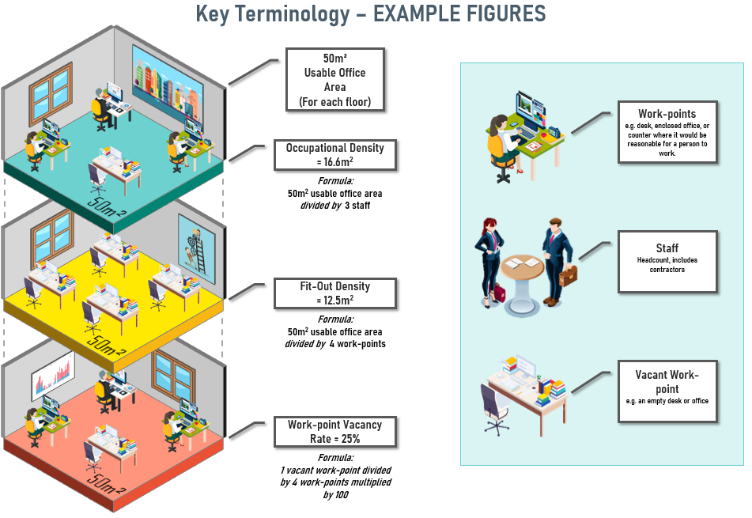

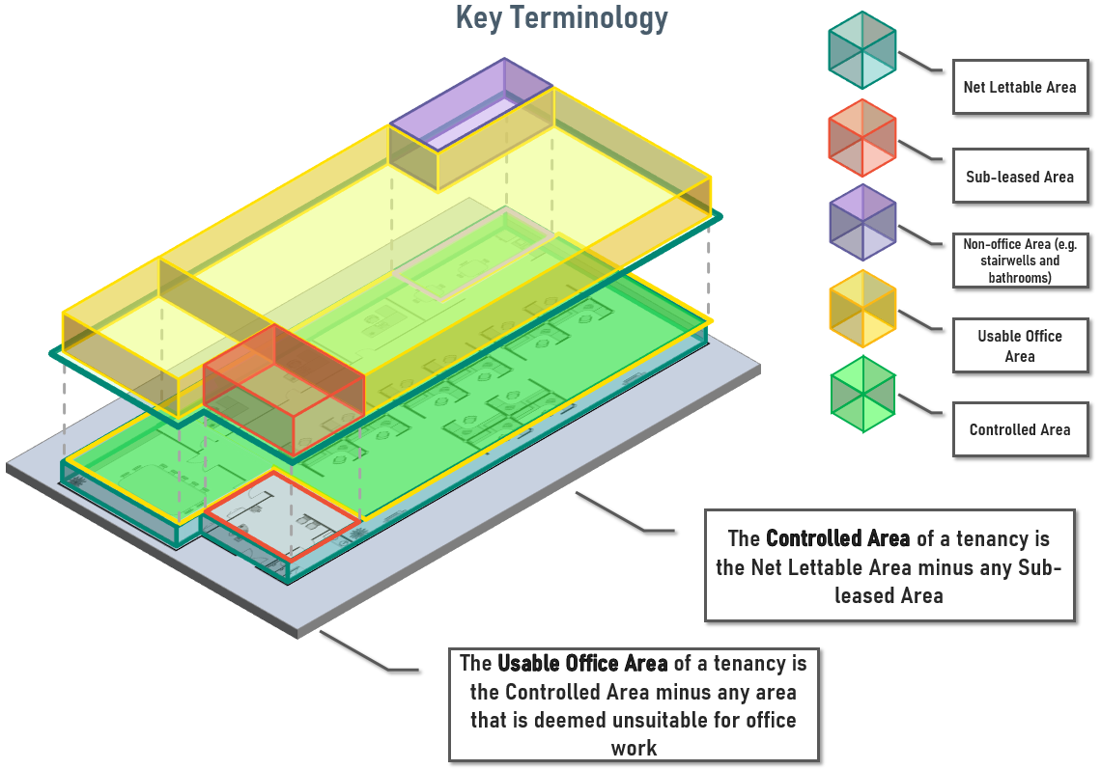

# Appendix B: Technical Notes

Previous editions of the Occupancy Report use net lettable area as the standard measure of space within a tenancy. This year’s Occupancy Report uses controlled area as the standard measure. Controlled area is the net lettable area of a tenancy, minus any area that is sub‑leased to a third party.

This provides a more accurate measurement of space at a whole-of-government level and a more accurate picture of the Commonwealth’s overall footprint because it separately accounts for sub-leased space and avoids any double counting of the sub-leased space. Figures from prior years have been adjusted in this Occupancy Report to reflect controlled area to ensure consistency, however this does not result in any material changes to results between years.

Table 9 below includes net lettable area figures for 2017 to 2019 and allow for comparison against controlled area figures in the same year.

**Table 9: Size of Commonwealth footprint including Net Lettable Area**

|  |  |  |  |
| --- | --- | --- | --- |
| Measure | **2019** | 2018 | 2017 |
| Tenancies (n) | **568** | 541 | 596 |
| Net Lettable Area (m2) | **2,963,177** | 2,850,834 | 2,863,097 |
| Controlled Area (m2) | **2,838,345** | 2,744,222 | 2,765,630 |
| Usable Office Area (m²) | **2,253,361** | 2,177,308 | 2,279,729 |

# Appendix C: Collection and Verification of Data

Non-corporate commonwealth entities are required to report office space information for all tenancies (regardless of size and cost) to Finance annually, unless exempted as a security or intelligence organisation. Corporate Commonwealth entities and Commonwealth companies are invited to report office space information to Finance, but are not required to do so, and their information is not presented in the Occupancy Report.

Entities’ property information is stored on the AGPR, which is a cloud-based database that can be accessed and updated at any time.

Property information is entered into the AGPR by entities or their Property Service Provider (PSP) and is verified by a senior executive before being submitted to Finance.

Once submitted, Finance interrogates the data to ensure it is internally consistent and reasonable, liaising with entities or the PSPs as required.

# Appendix D: Sources

The Occupancy Report relies on information entered into the AGPR by entities or the PSPs, between 2017 and 2019.

The Occupancy Report also uses the Australian Bureau of Statistics catalogue *1270.0.55.006 - Australian Statistical Geography Standard (ASGS): Correspondences, July 2011. Datacube: Postcode 2011 to Remoteness Area 2006* to designate the remoteness category for each tenancy.

1. Table 3b includes three ‘very remote’ tenancies. One is a Commonwealth owned building and one is located on Norfolk Island. Leasing options in remote and very remote locations are limited, and tenancies in these locations have a small number of staff.