Consolidated Financial Statements,
including the Australian Government
And General Government Sector
Financial Reports

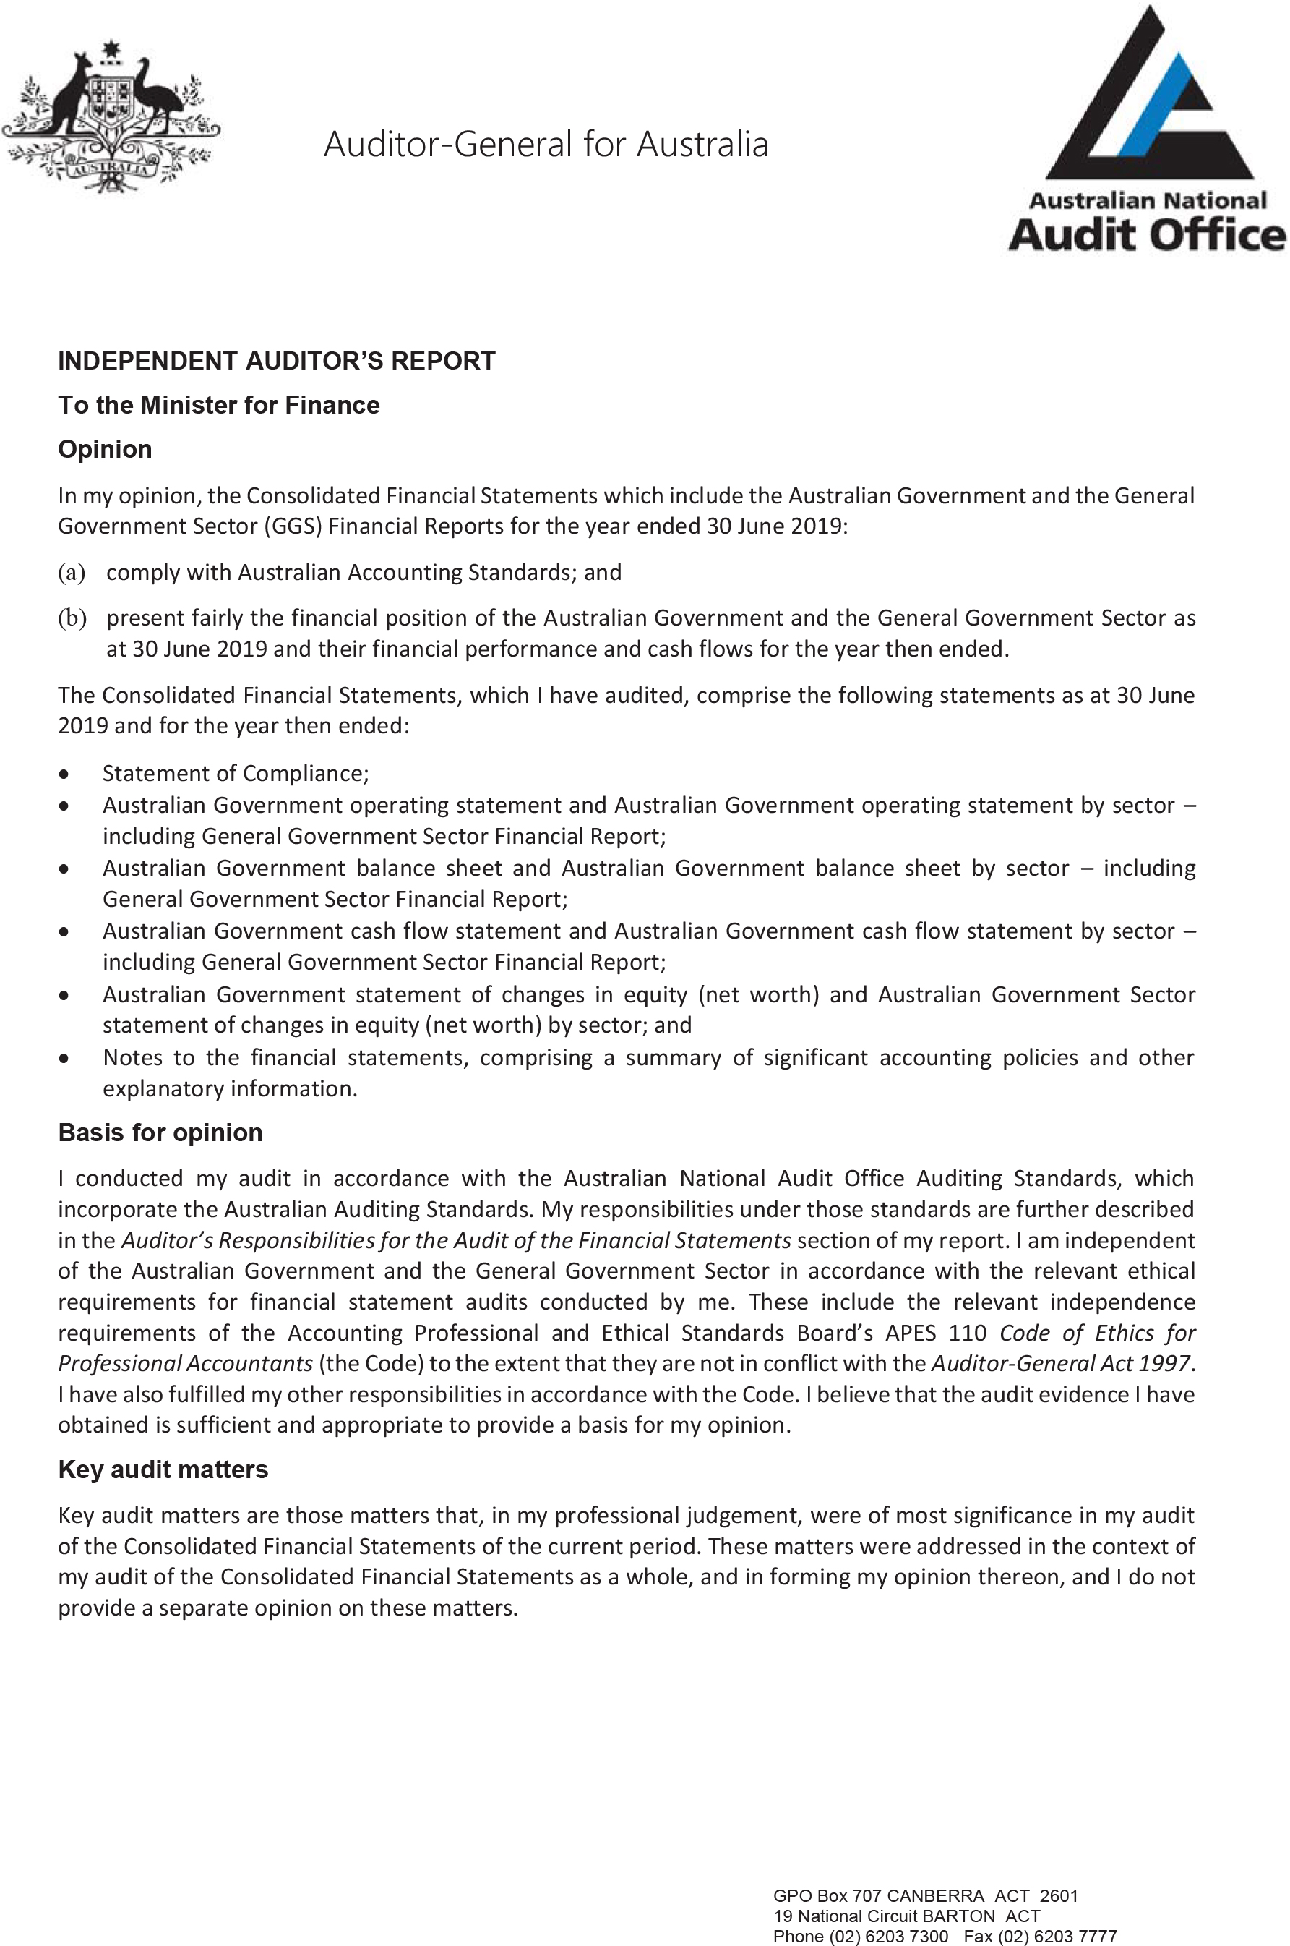

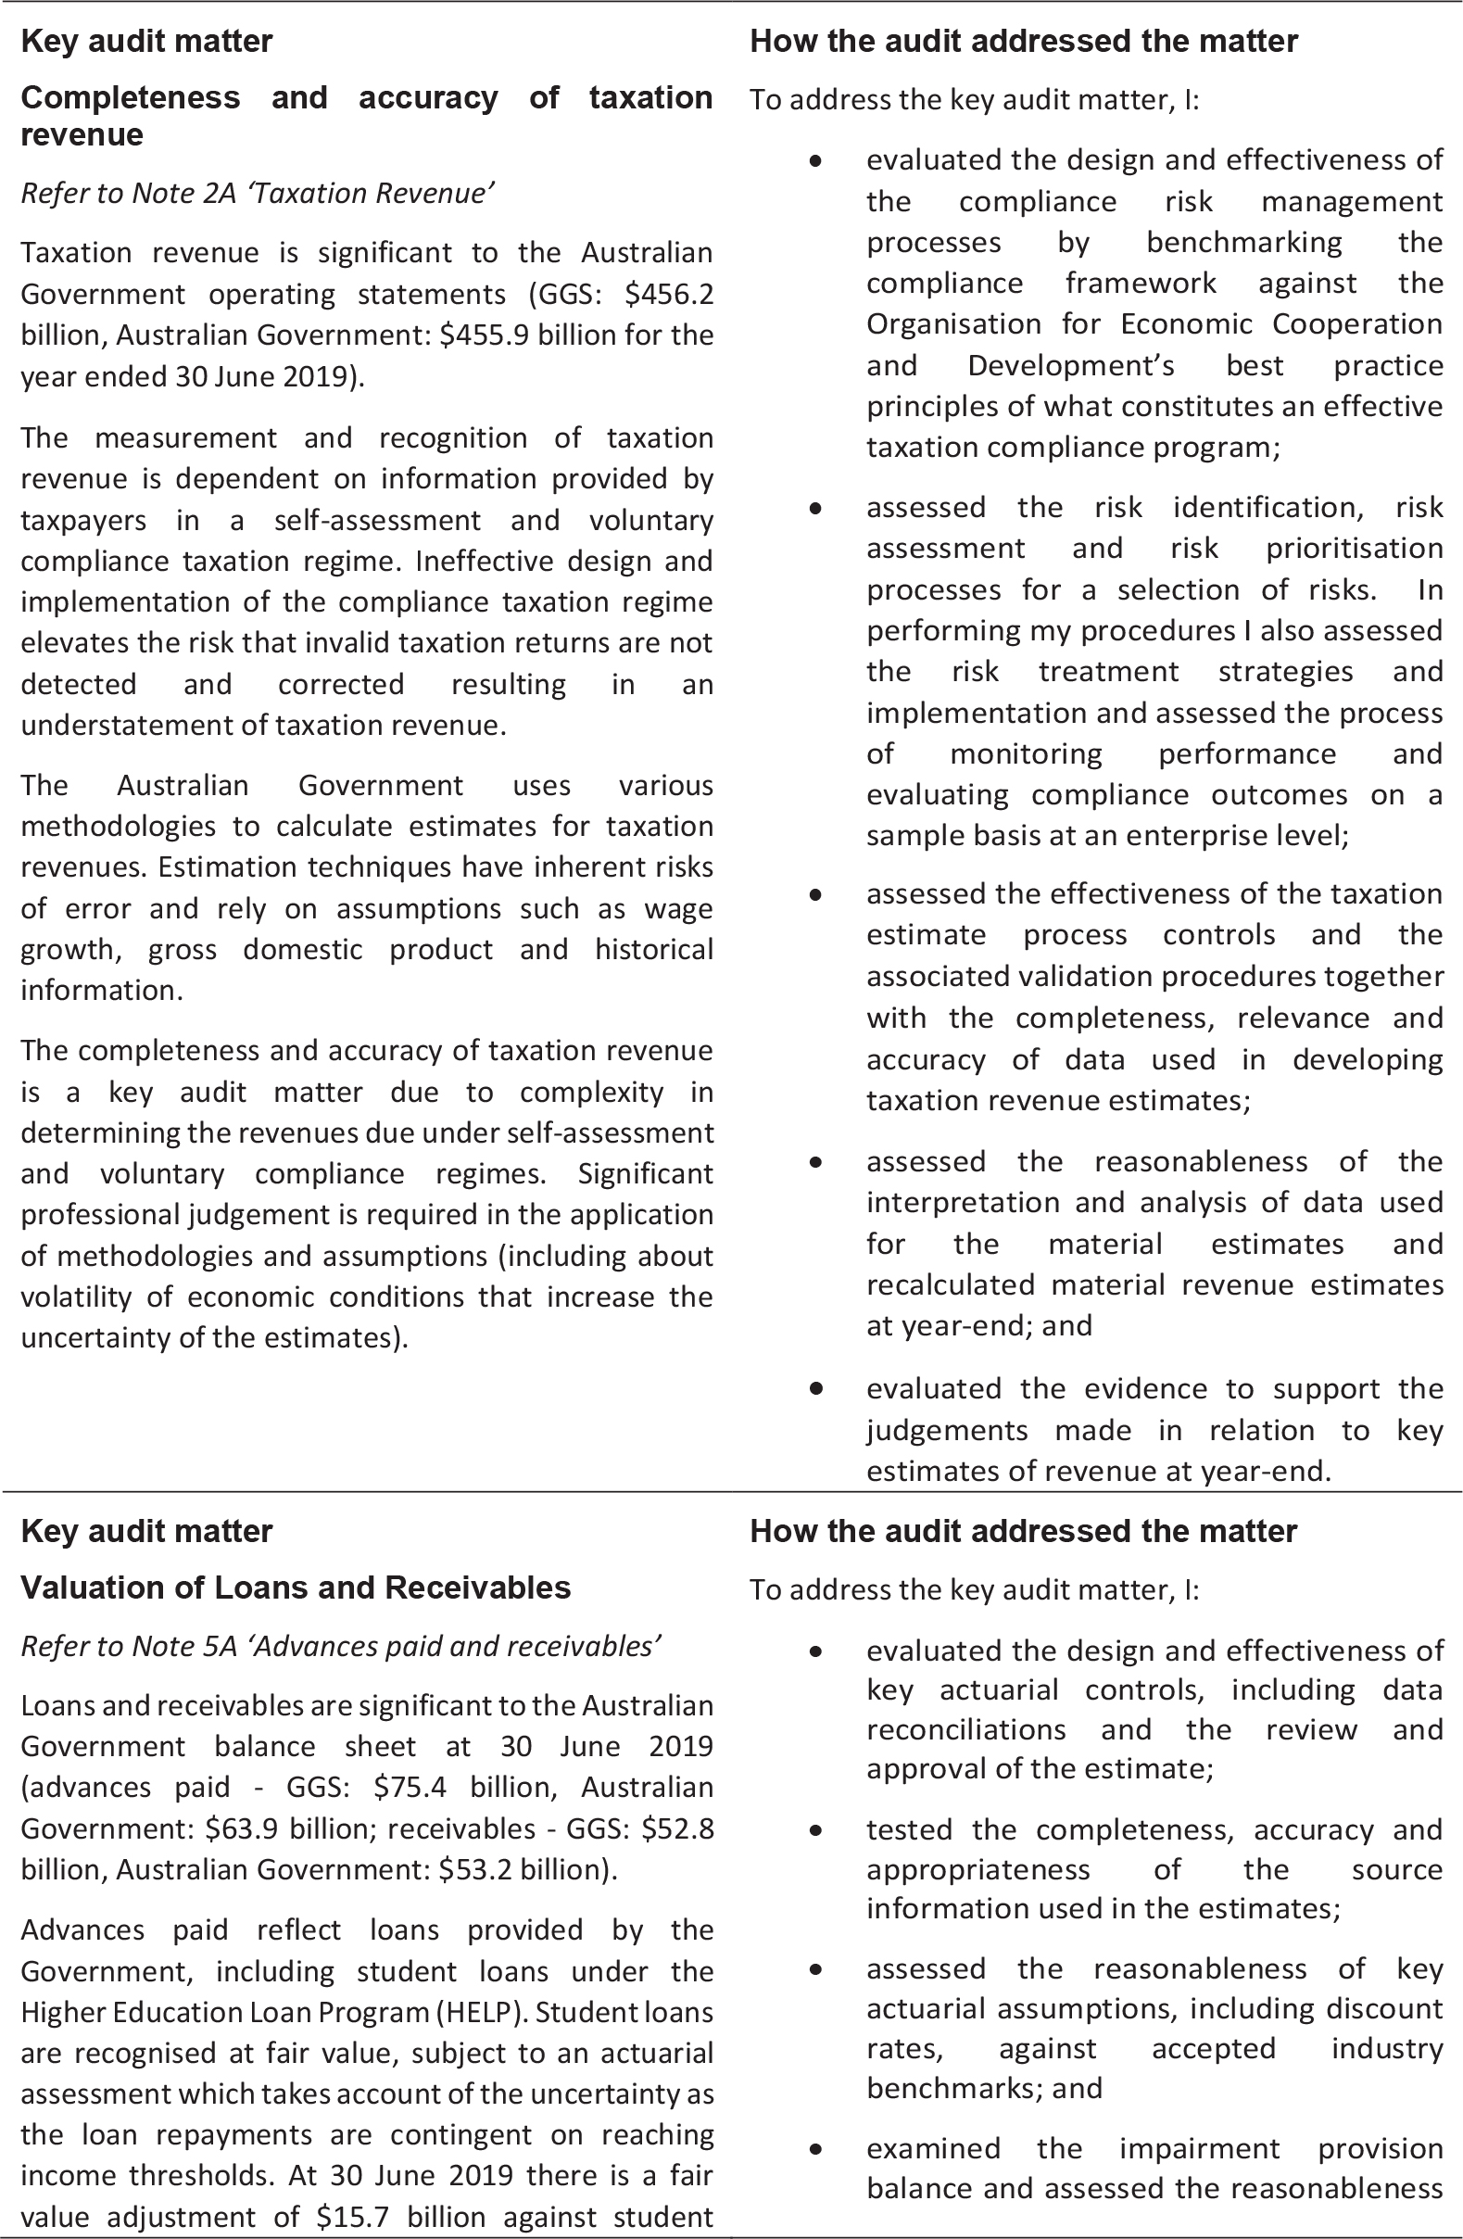

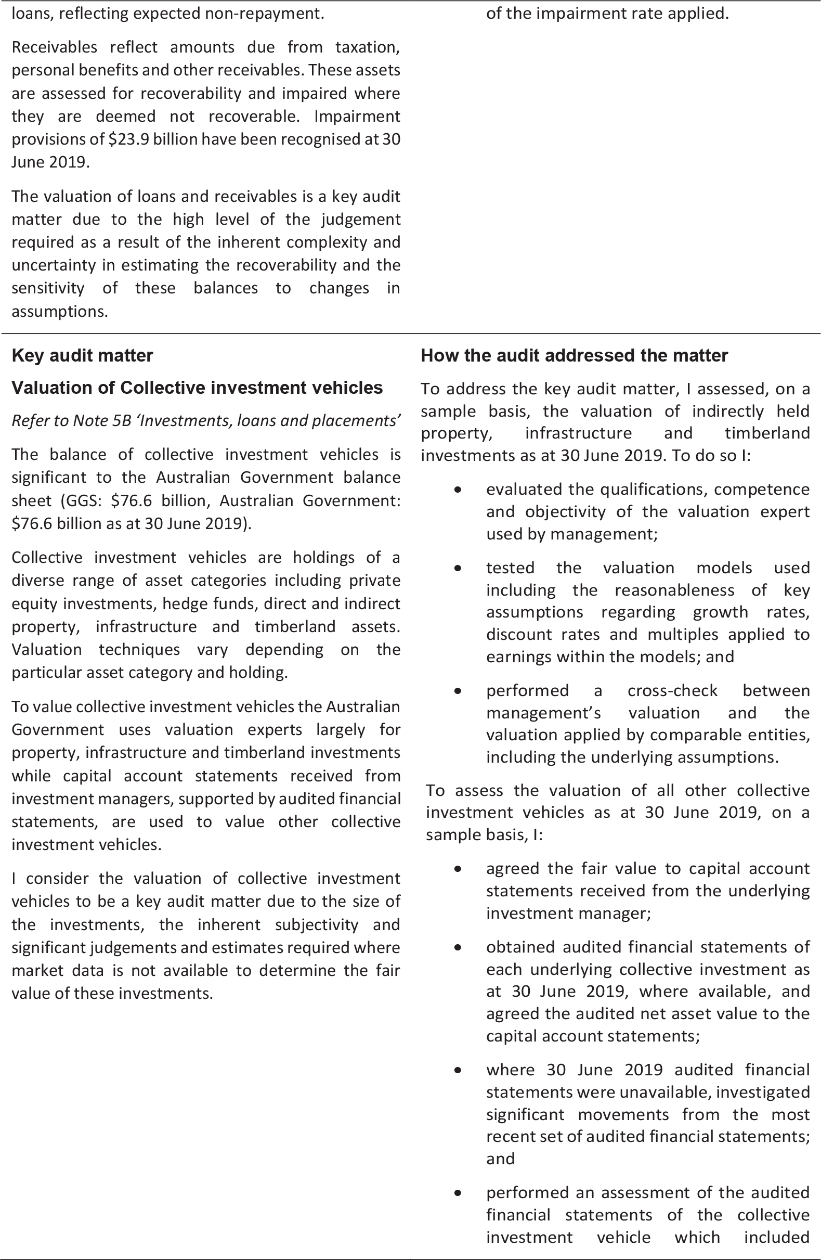

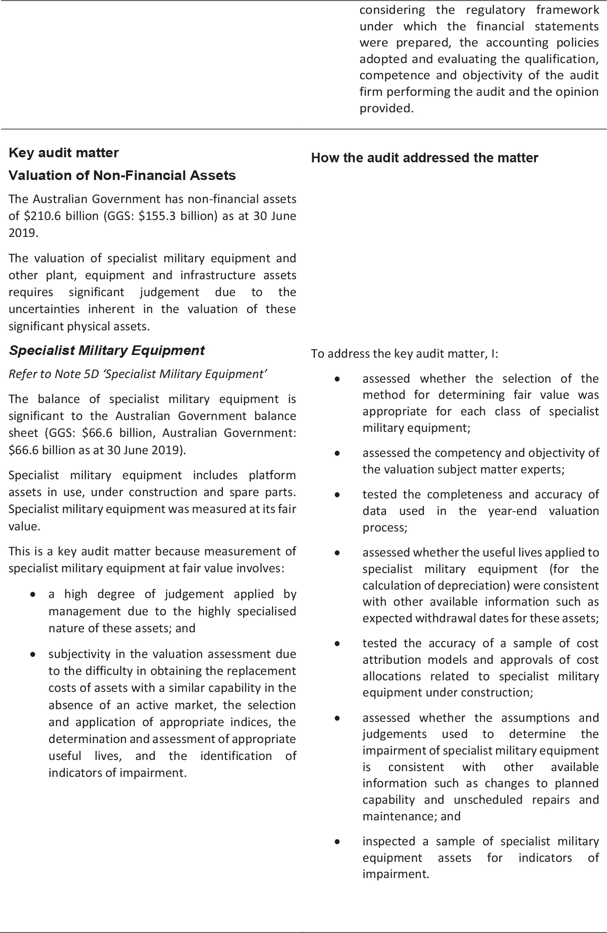

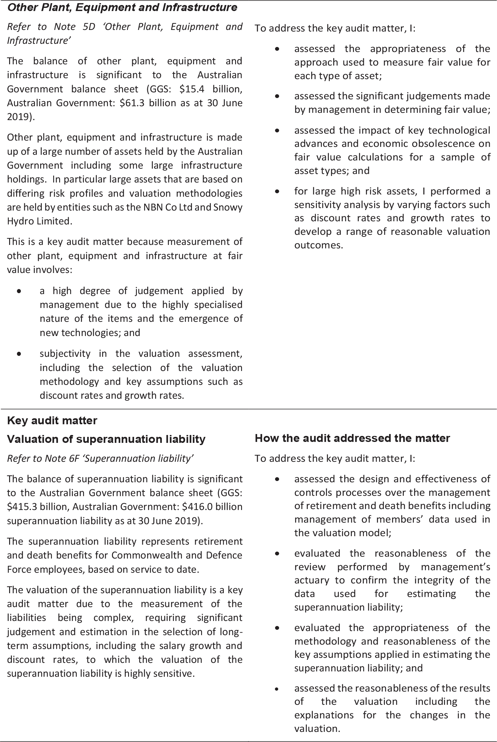

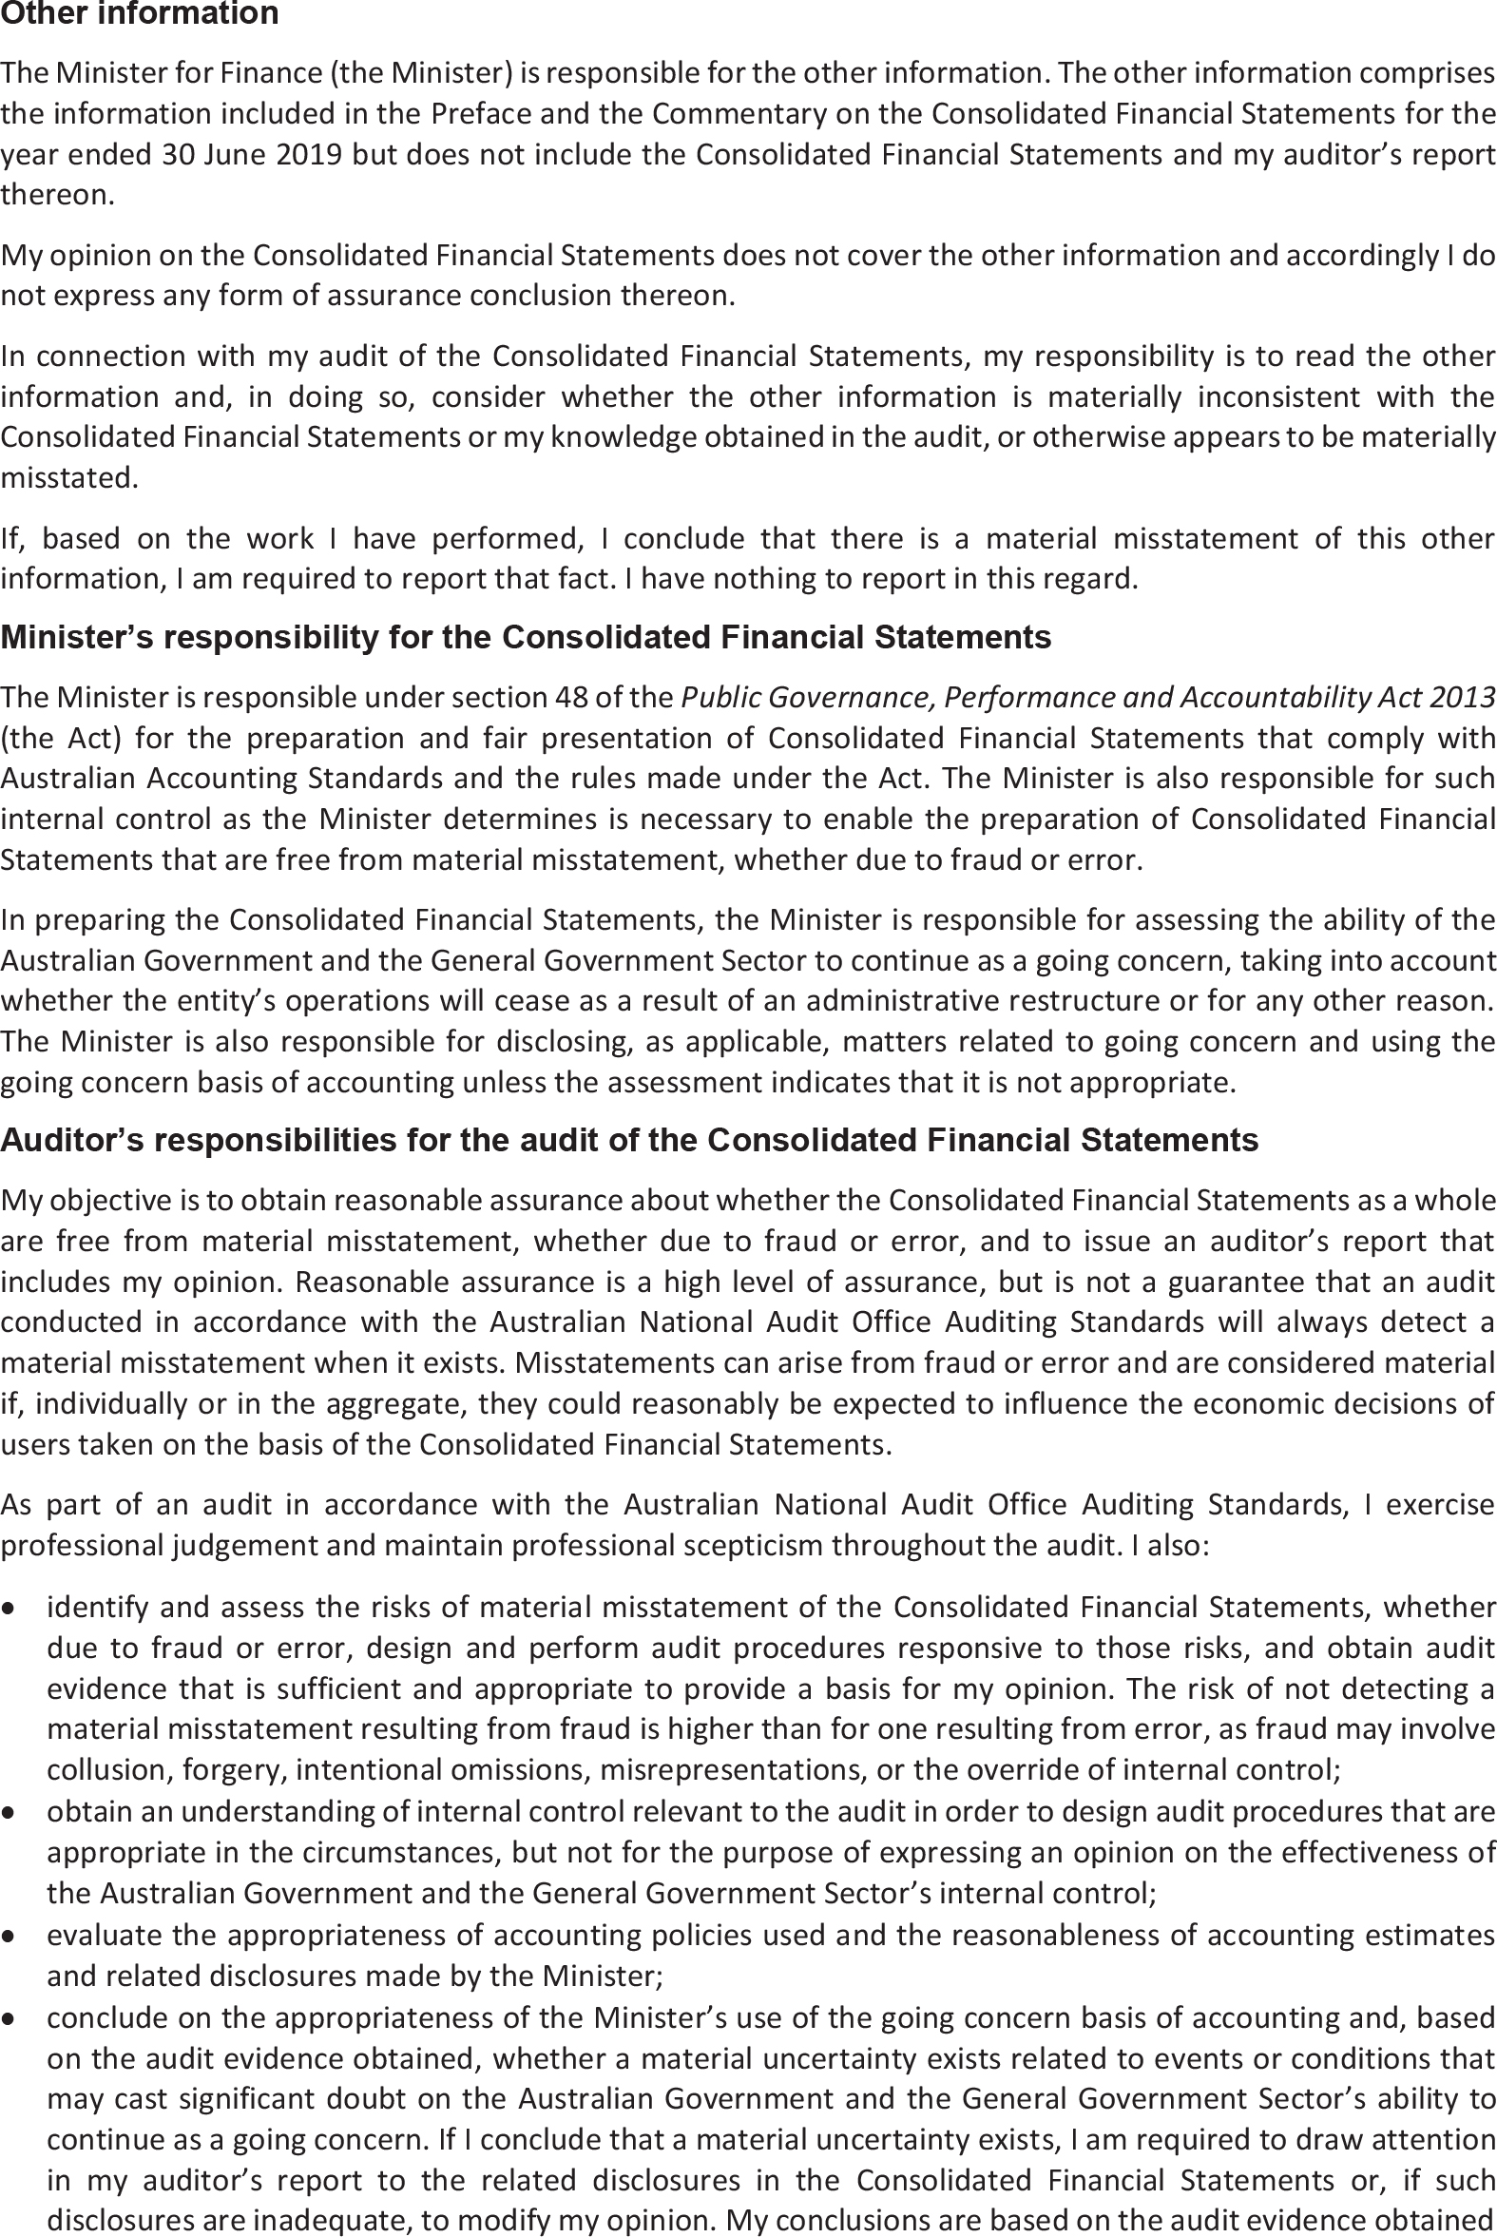

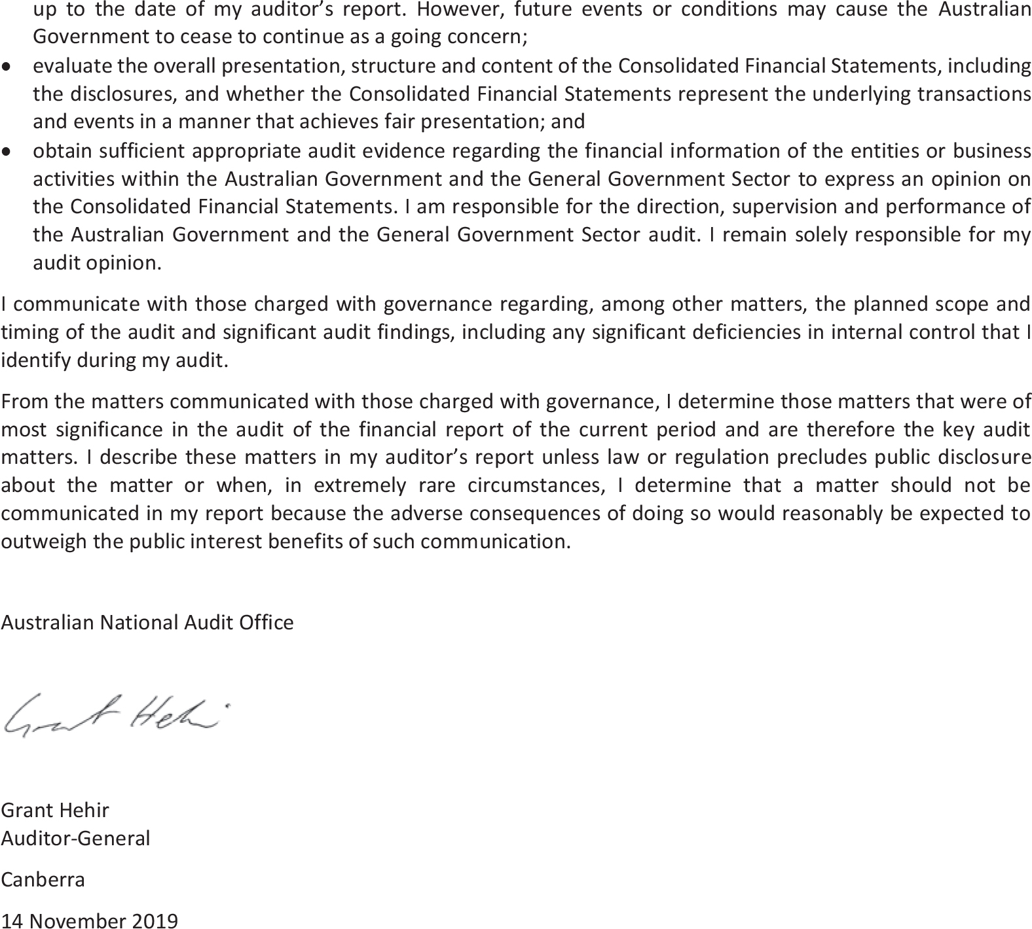

Statement of Compliance

The annual Consolidated Financial Statements of the Australian Government are required by section 48 of the Public Governance, Performance and Accountability Act 2013.
In my opinion, the attached annual Consolidated Financial Statements of the
Australian Government, which includes the whole of government and general government sector financial statements:
- comply with Australian Accounting Standards; and
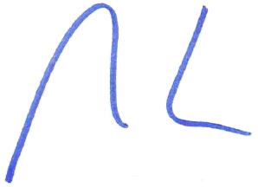
- present fairly the Australian Government’s financial position as at 30 June 2019 and its financial performance and cash flows for the year then ended.

Senator the Hon Mathias Cormann
Minister for Finance
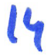
November 2019

Australian Government operating statement
for the year ended 30 June 2019
 |  | 2019 | 2018
 | Note | $m | $m
Revenue from transactions
Taxation revenue | 2A | 455,891 | 426,971
Sales of goods and services | 2B | 27,730 | 21,114
Interest income | 2C | 6,026 | 4,774
Dividend income | 2C | 7,797 | 4,247
Other | 2D | 10,538 | 10,755
Total revenue |  | 507,982 | 467,861
Expenses from transactions
Gross operating expenses
Wages and salaries | 3A | 24,337 | 23,571
Superannuation | 3A | 9,695 | 8,359
Depreciation and amortisation | 3B | 12,666 | 11,684
Supply of goods and services | 3C | 124,652 | 107,218
Other operating expenses | 3A | 8,726 | 7,353
Total gross operating expenses |  | 180,076 | 158,185
Superannuation interest expense | 3A | 9,444 | 9,240
Interest expense | 3D | 19,470 | 18,996
Current transfers
Current grants | 3E | 147,956 | 139,430
Subsidy expenses |  | 11,363 | 11,070
Personal benefits |  | 125,324 | 127,146
Total current transfers |  | 284,643 | 277,646
Capital transfers
Mutually agreed write-downs | 3E | 1,243 | 1,996
Other capital grants | 3E | 9,848 | 10,180
Total capital transfers |  | 11,091 | 12,176
Total expenses | 3F | 504,724 | 476,243
Net operating balance |  | 3,258 | (8,382)
Other economic flows - included in operating result
Net write-down of assets (including bad and doubtful debts) | 4A | (7,072) | (7,941)
Net gains/(losses) from the sale of assets | 4B | 5,494 | 7,220
Net foreign exchange gains/(losses) | 4C | 2,268 | 1,982
Net interest on derivatives gains/(losses) | 4C | (604) | 89
Net fair value gains/(losses) | 4C | (32,108) | 5,578
Net other gains/(losses) | 4C | (10,517) | (2,672)
Operating result(a) |  | (39,281) | (4,126)
Other economic flows - other non-owner movements in equity
Items that will not be reclassified to operating result
Revaluation of non-financial assets | 7 | 3,943 | 2,728
Actuarial revaluations of superannuation |  | (92,629) | (25,293)
Other economic revaluations |  | (8) | 62
Items that may be reclassified subsequently to operating result
Revaluation of equity investments | 7 | 1,084 | 515
Comprehensive result - total change in net worth |  | (126,891) | (26,114)
Net operating balance |  | 3,258 | (8,382)
less Net acquisition of non-financial assets
Purchases of non-financial assets |  | 24,170 | 22,190
less Sales of non-financial assets |  | 420 | 4,434
less Depreciation and amortisation |  | 12,666 | 11,684
plus Change in inventories |  | 655 | 680
plus Other movements in non-financial assets |  | (1) | (31)
Total net acquisition of non-financial assets |  | 11,738 | 6,721
Fiscal balance (Net lending/(borrowing)) |  | (8,480) | (15,103)
- Includes $18 million attributable to minority interests (2018: $4 million).

Certain comparatives have been restated. Refer to Note 1.5 for further details.

Australian Government balance sheet
as at 30 June 2019
 |  | 2019 | 2018
 | Note | $m | $m
Assets
Financial assets
Cash and deposits |  | 8,261 | 6,325
Advances paid | 5A | 63,918 | 51,765
Other receivables and accrued revenue | 5A | 53,179 | 51,105
Investments, loans and placements | 5B | 333,479 | 325,638
Equity investments | 5C | 67,919 | 59,092
Total financial assets |  | 526,756 | 493,925
Non-financial assets
Land | 5D | 13,628 | 13,316
Buildings | 5D | 30,026 | 29,073
Specialist military equipment | 5D | 66,593 | 62,020
Other plant, equipment and infrastructure | 5D | 61,256 | 54,689
Intangibles | 5D | 12,731 | 11,571
Investment property | 5D | 340 | 341
Inventories | 5E | 9,145 | 8,831
Heritage and cultural assets | 5D | 11,695 | 11,619
Other non-financial assets | 5F | 5,139 | 3,943
Total non-financial assets |  | 210,553 | 195,403
Total assets | 5G | 737,309 | 689,328
Liabilities
Interest bearing liabilities
Deposits held | 6A | 34,056 | 33,841
Government securities | 6B | 619,219 | 567,661
Loans | 6C | 16,240 | 15,181
Other borrowings | 6D | 10,164 | 8,807
Other interest bearing liabilities | 6E | 9,469 | 10,760
Total interest bearing liabilities |  | 689,148 | 636,250
Provisions and payables
Superannuation liability | 6F | 416,046 | 313,970
Other employee liabilities | 6F | 28,090 | 21,698
Supplier payables | 6G | 13,152 | 11,861
Personal benefits payable | 6G | 2,994 | 2,758
Subsidies payable | 6G | 630 | 602
Grants payable | 6G | 2,750 | 3,384
Australian currency on issue | 6H | 80,024 | 75,565
Other payables | 6G | 3,985 | 3,028
Other provisions | 6H | 45,123 | 37,950
Total provisions and payables |  | 592,794 | 470,816
Total liabilities |  | 1,281,942 | 1,107,066
Net worth
Accumulated results |  | (635,192) | (500,718)
Reserves |  | 90,376 | 82,869
Minority interests |  | 183 | 111
Net worth |  | (544,633) | (417,738)

Certain comparatives have been restated. Refer to Note 1.5 for further details.

Australian Government cash flow statement
for the year ended 30 June 2019
 |  | 2019 | 2018
 | Note | $m | $m
OPERATING ACTIVITIES
Operating cash received
Taxes received |  | 448,256 | 417,966
Receipts from sales of goods and services |  | 28,041 | 21,357
Interest receipts |  | 5,270 | 4,736
Dividend receipts |  | 7,899 | 4,102
Other receipts |  | 10,277 | 8,598
Total cash received |  | 499,743 | 456,759
Operating cash used
Payments for employees |  | (34,149) | (32,368)
Payments for goods and services |  | (120,991) | (105,903)
Grants and subsidies paid |  | (170,207) | (161,643)
Interest paid |  | (19,482) | (16,943)
Personal benefits paid |  | (126,362) | (127,940)
Other payments |  | (7,474) | (7,527)
Total cash used |  | (478,665) | (452,324)
Net cash flows from operating activities | 8 | 21,078 | 4,435
INVESTING ACTIVITIES
Investments in non-financial assets
Sales of non-financial assets |  | 799 | 1,657
Purchases of non-financial assets |  | (22,592) | (19,838)
Net investments in non-financial assets |  | (21,793) | (18,181)
Investments in financial assets for policy purposes
Receipts from policy investments |  | 4,060 | 5,446
Payments for policy investments(a) |  | (10,375) | (17,539)
Net investments in financial assets for policy purposes |  | (6,315) | (12,093)
Investments in financial assets for liquidity purposes |  | (4,075) | (6,213)
Net cash from investing activities |  | (32,183) | (36,487)
FINANCING ACTIVITIES
Net financing cash received
Borrowings |  | 12,088 | 34,481
Other financing |  | 6,803 | 3,778
Net cash received |  | 18,891 | 38,259
Net financing cash used
Distributions paid |  | (6) | -
Other financing |  | (5,844) | (6,165)
Net cash used |  | (5,850) | (6,165)
Net cash flows from financing activities |  | 13,041 | 32,094
Net (decrease)/increase in cash held |  | 1,936 | 42
Cash at beginning of year |  | 6,325 | 6,283
Cash at end of year |  | 8,261 | 6,325
Key fiscal aggregate
Net cash flows from operating activities |  | 21,078 | 4,435
Net cash flows from investments in non-financial assets |  | (21,793) | (18,181)
Cash surplus/(deficit) |  | (715) | (13,746)
- Includes $6,114 million in payments to New South Wales and Victoria for their shareholdings in Snowy Hydro Limited in 2018. Refer to Note 9 for further detail.

Certain comparatives have been restated. Refer to Note 1.5 for further details.

Australian Government statement of changes in equity (net worth)
for the year ended 30 June 2019
 |  | Reserves
Item | Accumulated results | Asset revaluation reserve | Foreign currency translation reserve | Investments reserve | Statutory funds | Other reserves | Total reserves | Contributed equity | Total net worth
 | $m | $m | $m | $m | $m | $m | $m | $m | $m
Australian Government
Adjusted opening balance as at 1 July 2017 | (468,738) | 50,693 | 43 | 14,203 | 8,514 | 3,664 | 77,117 | - | (391,621)
Dividends provided for or paid | (3) | - | - | - | - | - | - | - | (3)
Comprehensive result - change in net worth | (29,519) | 2,974 | 16 | 273 | - | 142 | 3,405 | - | (26,114)
Transfers to/(from)/between reserves | (2,348) | (12) | - | (809) | - | 3,169 | 2,348 | - | -
Net worth as at 30 June 2018 | (500,608) | 53,655 | 59 | 13,667 | 8,514 | 6,975 | 82,870 | - | (417,738)
less: Minority interests | 110 | - | - | 1 | - | - | 1 | - | 111
Attributable to the General Government
Sector at 30 June 2018 | (500,718) | 53,655 | 59 | 13,666 | 8,514 | 6,975 | 82,869 | - | (417,849)
Adjustment on initial application of AASB 9 | 46 | (43) | - | - | - | - | (43) | - | 3
Adjusted opening balance as at 1 July 2018 | (500,562) | 53,612 | 59 | 13,667 | 8,514 | 6,975 | 82,827 | - | (417,735)
Dividends provided for or paid | (7) | - | - | - | - | - | - | - | (7)
Comprehensive result - change in net worth | (131,613) | 4,935 | 14 | 75 | - | (302) | 4,722 | - | (126,891)
Transfers to/(from)/between reserves | (2,828) | (109) | - | 14 | - | 2,923 | 2,828 | - | -
Net worth as at 30 June 2019 | (635,010) | 58,438 | 73 | 13,756 | 8,514 | 9,596 | 90,377 | - | (544,633)
less: Minority interests | 182 | - | - | 1 | - | - | 1 | - | 183
Attributable to the General Government
Sector at 30 June 2019 | (635,192) | 58,438 | 73 | 13,755 | 8,514 | 9,596 | 90,376 | - | (544,816)

The above statements should be read in conjunction with the accompanying notes.

