# Commentary on the Consolidated Financial Statements

## Introduction

The 2018-19 Consolidated Financial Statements (CFS) for the Australian Government present the whole of government and general government sector (GGS) financial reports and are prepared in accordance with AASB 1049 *Whole of Government and General Government Sector Financial Reporting* (AASB 1049). They are required by section 48 of the *Public Governance, Performance and Accountability Act 2013* (PGPA Act).

The CFS includes the consolidated results for all Australian Government controlled entities as well as disaggregated information on the sectors of government (GGS, public non‑financial corporations (PNFC) and public financial corporations (PFC))[1]. Unless explicitly stated, the financial results reported in this commentary comprise consolidated amounts for the Australian Government as a whole, inclusive of the GGS, and PNFC and PFC sectors[2]. The GGS results in the 2018-19 CFS materially align with the 2018-19 Final Budget Outcome.

At A Glance

Table 1: Financial results for the year ended 30 June 2019[3]

|  |  |  |  |
| --- | --- | --- | --- |
|  | 2018-19 $b | 2017-18 $b | Change $b |
| Revenue | 508.0 | 467.9 | 40.1 |
| Expenses | 504.7 | 476.2 | 28.5 |
| **Net operating balance(a)** | **3.3** | **(8.4)** | **11.6** |
| Per cent of GDP | 0.2 | 0.5 |  |
| Net capital investment | 11.7 | 6.7 | 5.0 |
| **Fiscal balance(b)** | **(8.5)** | **(15.1)** | **6.6** |
| Per cent of GDP | 0.4 | 0.8 |  |
| Total assets | 737.3 | 689.3 | 48.0 |
| Total liabilities | 1,281.9 | 1,107.1 | 174.9 |
| **Net worth(c)** | **(544.6)** | **(417.7)** | **(126.9)** |
| Per cent of GDP | 28.0 | 22.6 |  |
| Net cash flows from operating activities | 21.1 | 4.4 | 16.6 |
| Net cash flows from investments in non-financial assets | (21.8) | (18.2) | (3.6) |
| **Cash surplus/(deficit)** | **(0.7)** | **(13.7)** | **13.0** |

1. Net operating balance equals total revenue minus total expenses.
2. Fiscal balance (or net lending/borrowing) is the net operating balance less net capital investment.
3. Net worth is calculated as total assets minus total liabilities.

#### Operating statement (net operating balance)

Table 2: Operating statement

|  |  |  |  |  |
| --- | --- | --- | --- | --- |
|  | 2018-19 $b | 2017-18 $b | Change $b | Change % |
| Revenue | 508.0 | 467.9 | 40.1 | 8.6 |
| Per cent of GDP | 26.1 | 25.3 |  | 0.8 |
| Expenses | 504.7 | 476.2 | 28.5 | 6.0 |
| Per cent of GDP | 25.9 | 25.8 |  | 0.1 |
| **Net operating balance** | **3.3** | **(8.4)** | **11.6** | **>100.0** |
| Per cent of GDP | 0.2 | 0.5 |  | 0.7 |
| Net capital investment | 11.7 | 6.7 | 5.0 | 74.6 |
| Per cent of GDP | 0.6 | 0.4 |  | 0.2 |
| **Fiscal balance** | **(8.5)** | **(15.1)** | **6.6** | **43.9** |
| Per cent of GDP | 0.4 | 0.8 |  | 0.4 |

Chart 1: Operating statement (per cent of GDP) since 2009-10

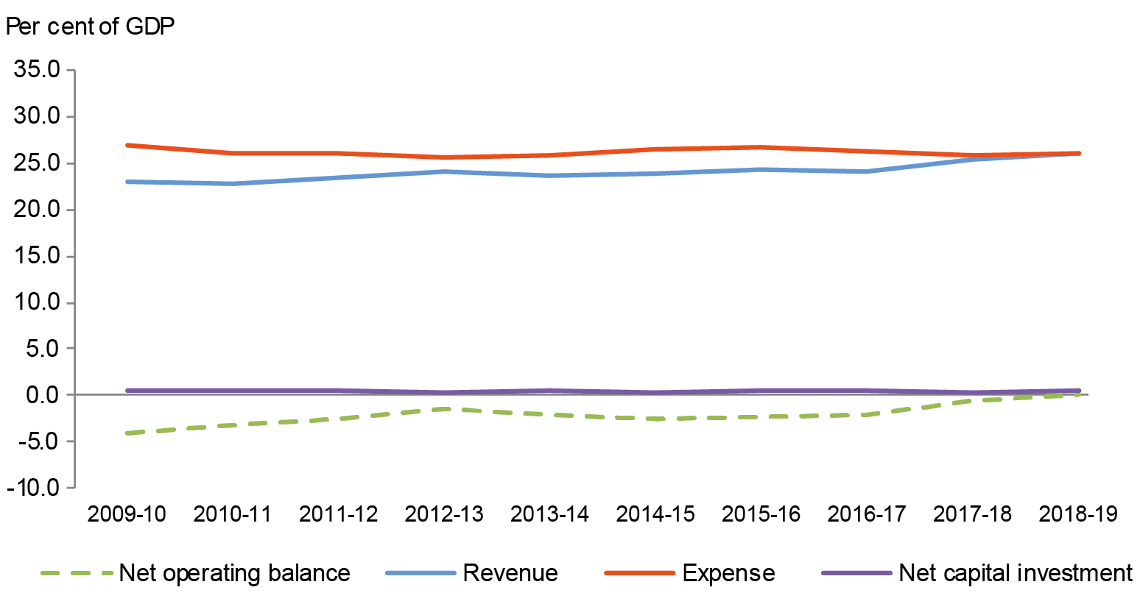

#### Balance sheet (net worth)

Table 3: Balance sheet

|  |  |  |  |  |
| --- | --- | --- | --- | --- |
|  | 2018-19 $b | 2017-18 $b | Change $b | Change % |
| Financial assets | 526.8 | 493.9 | 32.8 | 6.6 |
| Non-financial assets | 210.6 | 195.4 | 15.2 | 7.8 |
| **Total assets** | **737.3** | **689.3** | **48.0** | **7.0** |
| **Total liabilities** | **1,281.9** | **1,107.1** | **174.9** | **15.8** |
| **Net worth** | **(544.6)** | **(417.7)** | **(126.9)** | **30.4** |
| Per cent of GDP | 28.0 | 22.6 |  | 5.4 |
| **Net financial worth**(a) | **(755.2)** | **(613.1)** | **(142.0)** | **23.2** |
| Per cent of GDP | 38.8 | 33.2 |  | 5.6 |
| **Net debt(b)** | **274.0** | **241.8** | **32.3** | **13.3** |
| Per cent of GDP | 14.1 | 13.1 |  | 1.0 |
| **Net interest payments** | **(14.2)** | **(12.2)** | **(2.0)** | **16.4** |
| Per cent of GDP | 0.7 | 0.7 |  | 0.1 |

1. Net financial worth equals total financial assets minus total liabilities.
2. Net debt equals the sum of the deposits held, government securities, loans and other borrowing, minus the sum of the cash and deposits, advances paid and investments, loans and placements.

Chart 2: Balance sheet (per cent of GDP) since 2009-10

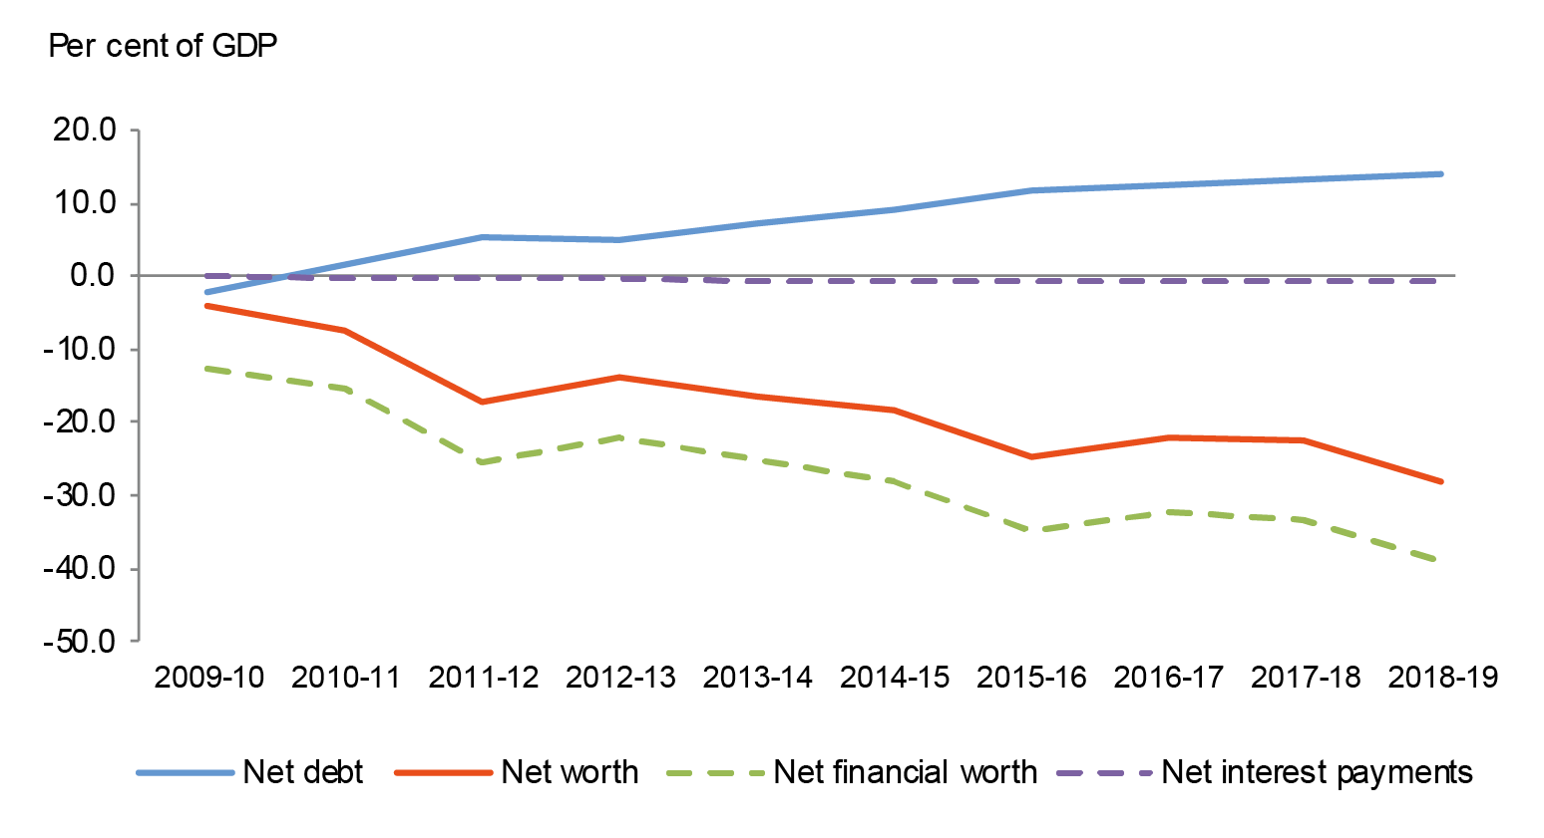

## Discussion and Analysis

### Net operating balance

The Australian Government’s net operating balance was a surplus of $3.3 billion for the year ended 30 June 2019, an improvement of $11.6 billion against the 30 June 2018 result.

Table 4: Operating statement

|  |  |  |  |  |
| --- | --- | --- | --- | --- |
|  | 2018-19 $b | 2017-18 $b | Change $b | Change % |
| Revenue | 508.0 | 467.9 | 40.1 | 8.6 |
| Expenses | 504.7 | 476.2 | 28.5 | 6.0 |
| **Net operating balance** | **3.3** | **(8.4)** | **11.6** | **>100.0** |
| *Less* Net acquisitions of non-financial assets | 11.7 | 6.7 | 5.0 | 74.6 |
| **Fiscal balance** | **(8.5)** | **(15.1)** | **6.6** | **43.9** |

Chart 3 below shows the composition of the Australian Government’s net operating balance since 2009-10.

Chart 3: Operating statement since 2009-10

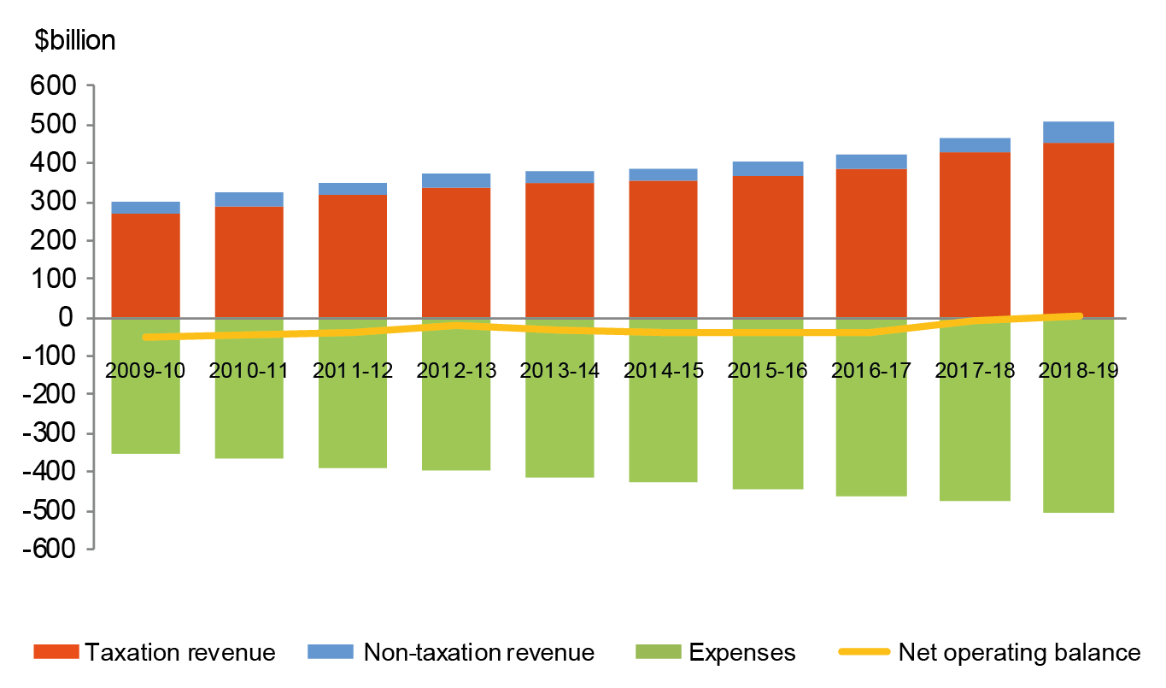

#### Revenue

The Australian Government’s revenue increased by $40.1 billion (8.6 per cent) in 2018-19 to $508.0 billion.

Table 5: Revenue

|  |  |  |  |  |
| --- | --- | --- | --- | --- |
|  | 2018-19 $b | 2017-18 $b | Change $b | Change % |
| Taxation revenue | 455.9 | 427.0 | 28.9 | 6.8 |
| Non-taxation revenue | 52.1 | 40.9 | 11.2 | 27.4 |
| **Total revenue** | **508.0** | **467.9** | **40.1** | **8.6** |

#### Taxation revenue

The Australian Government’s total taxation revenue for the year ended 30 June 2019 was $455.9 billion. The composition of taxation revenue is shown in Chart 4 below.

Chart 4: Composition of taxation revenue

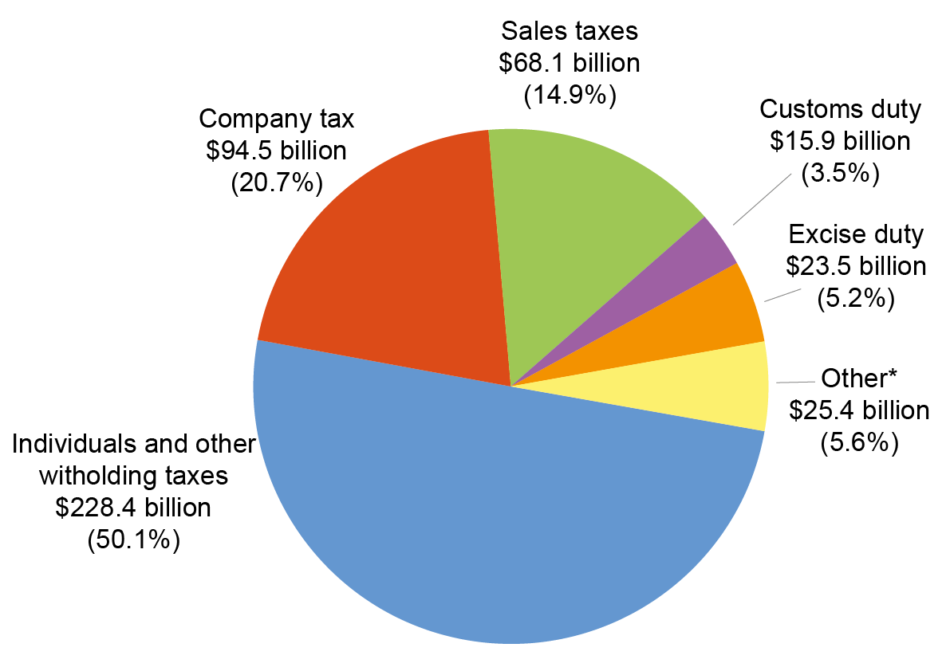

* Other includes: Superannuation funds taxes ($10.9 billion); Other indirect taxation ($9.4 billion); Fringe benefits tax ($3.9 billion); and Resource rent taxes ($1.2 billion).

Taxation revenue increased by $28.9 billion (6.8 per cent) in comparison to  
2017-18. The key changes were:

* an increase of $17.1 billion (8.1 per cent) in **individuals and other withholding taxes** consistent with strong employment growth;
* an increase of $8.8 billion (10.3 per cent) in **company tax** as a result of higher corporate profitability; and
* an increase of $1.1 billion (1.7 per cent) in **sales taxes**, predominantly driven by an increase in the goods and services tax (GST), consistent with growth in consumption subject to GST.

Refer to Note 2A of the 2018-19 CFS for further information.

#### Non-taxation revenue

The Australian Government’s total non-taxation revenue for the year ended 30 June 2019 was $52.1 billion. For more information, refer to Notes 2B to 2D of the 2018‑19 CFS.

#### Expenses

The Australian Government’s total expenses for the year ended 30 June 2019 were $504.7 billion. The composition of expenses is shown in Chart 5 below.

Chart 5: Composition of expenses

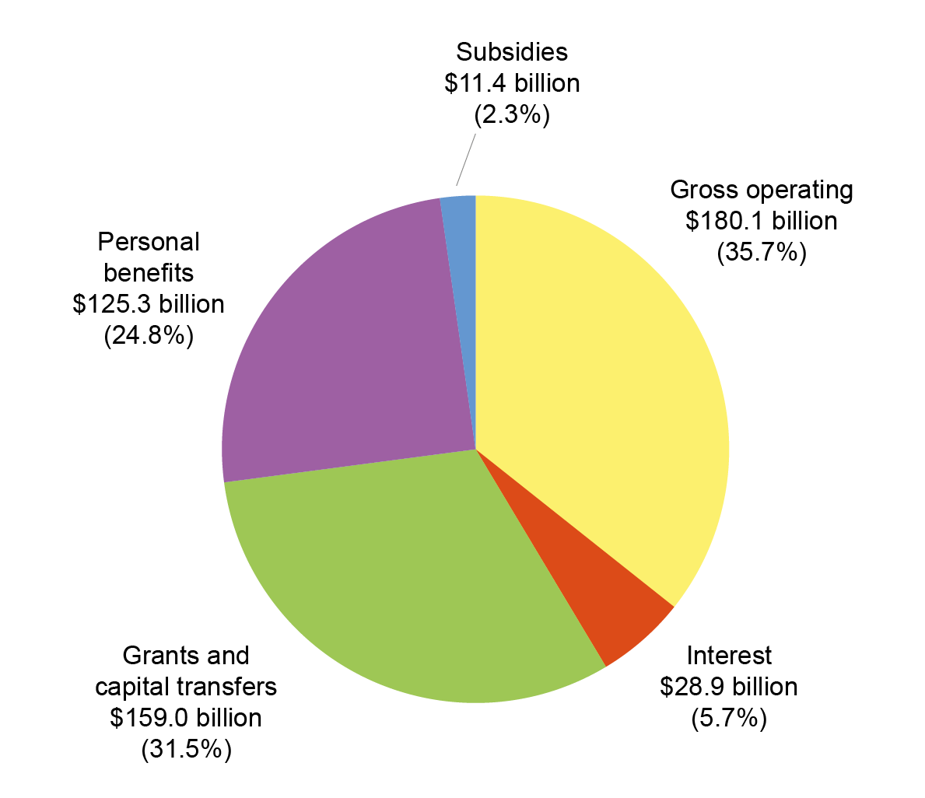

The Australian Government’s total expenses increased by $28.5 billion (6.0 per cent) in comparison to 2017-18. The key changes were:

* an increase in **gross operating expenses** of $21.9 billion (13.8 per cent). This was driven by an increase of $17.4 billion in the supply of goods and services expense, mainly due to:
  + an increase in benefits to households in goods and services of $11.3 billion, primarily relating to an increase in participants under the National Disability Insurance Scheme ($5.0 billion), the reclassification of the child care subsidies program ($3.8 billion), aged care services ($1.3 billion) and medical benefits ($1.1 billion);
  + an increase in general supply of goods and services expenses of $4.2 billion, which in part is driven by the inclusion of expenditure for Snowy Hydro Limited ($1.8 billion) for the first time in 2018-19; and
* an increase of $7.4 billion (4.9 per cent) in **capital and** **current grants**, primarily as a result of increased grants to state and territory governments ($6.9 billion).

Chart 6 below provides a presentation of total expenses based on how the Australian Government allocated resources across the range of policy areas. The chart highlights the relative cost of each function for 2018-19.

Chart 6: Total expenses by function

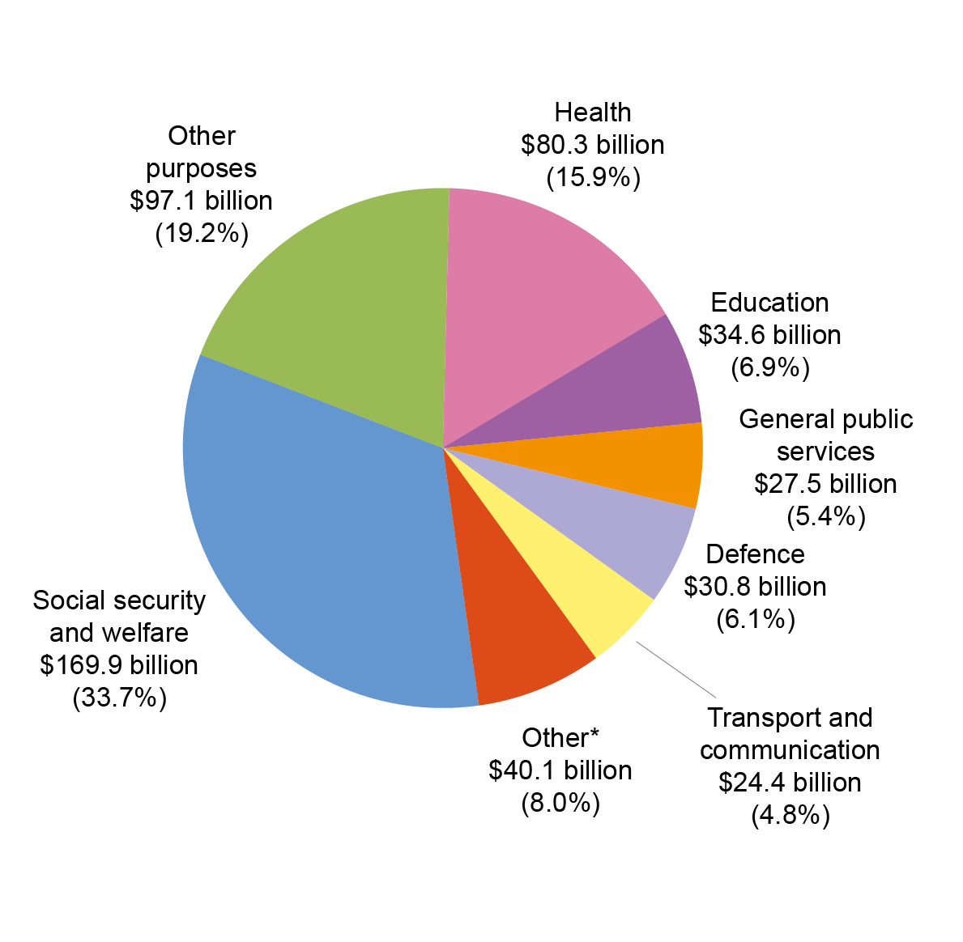

* Other includes: Fuel and energy ($10.3 billion); Other economic affairs ($9.8 billion); Public order and safety ($5.8 billion); Housing and community amenities ($5.1 billion); Recreation and culture ($4.0 billion); Agriculture, forestry and fishing ($2.6 billion); and Mining, manufacturing and construction ($2.6 billion).

Refer to Note 3 of the 2018-19 CFS for further information on expenses.

#### Net worth

The Australian Government’s net worth declined by $126.9 billion in 2018-19 to a negative net worth of $544.6 billion as at 30 June 2019.

Table 6: Balance sheet

|  |  |  |  |  |
| --- | --- | --- | --- | --- |
|  | 2018-19 $b | 2017-18 $b | Change $b | Change % |
| Financial assets | 526.8 | 493.9 | 32.8 | 6.6 |
| Non-financial assets | 210.6 | 195.4 | 15.2 | 7.8 |
| **Total assets** | **737.3** | **689.3** | **48.0** | **7.0** |
| Interest bearing liabilities | 689.1 | 636.3 | 52.9 | 8.3 |
| Provisions and payables | 592.8 | 470.8 | 122.0 | 25.9 |
| **Total liabilities** | **1,281.9** | **1,107.1** | **174.9** | **15.8** |
| **Net worth** | **(544.6)** | **(417.7)** | **(126.9)** | **30.4** |

Chart 7 below shows the composition of the Australian Government’s financial position since 2009-10.

Chart 7: Balance sheet since 2009-10

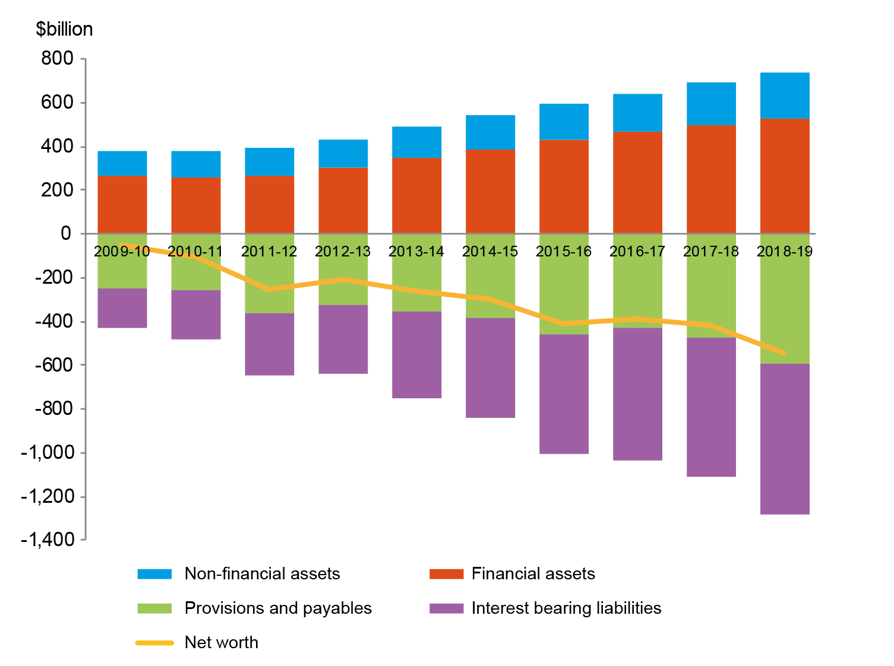

#### Assets

The Australian Government’s total assets as at 30 June 2019 were $737.3 billion.

Table 7: Assets

|  |  |  |  |  |
| --- | --- | --- | --- | --- |
|  | 2018-19 $b | 2017-18 $b | Change $b | Change % |
| Financial assets |  |  |  |  |
| Cash and deposits | 8.3 | 6.3 | 1.9 | 30.6 |
| Advances paid | 63.9 | 51.8 | 12.2 | 23.5 |
| Other receivables and accrued revenue | 53.2 | 51.1 | 2.1 | 4.1 |
| Investments, loans and placements | 333.5 | 325.6 | 7.8 | 2.4 |
| Equity investments | 67.9 | 59.1 | 8.8 | 14.9 |
| Total financial assets | 526.8 | 493.9 | 32.8 | 6.6 |
| Non-financial assets | 210.6 | 195.4 | 15.2 | 7.8 |
| **Total assets** | **737.3** | **689.3** | **48.0** | **7.0** |

The Australian Government’s total assets increased by $48.0 billion (7.0 per cent) since 30 June 2018. The composition of assets is shown in Chart 8 below.

Chart 8: Composition of assets

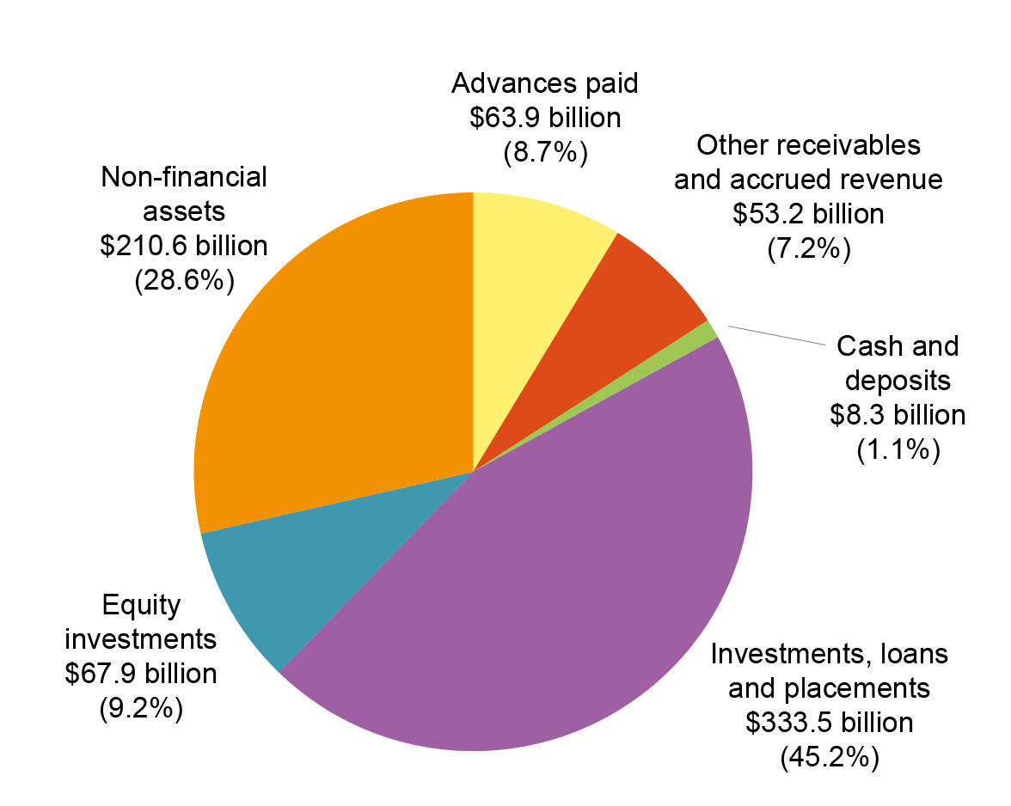

The key changes in **financial assets** were:

* an increase of $12.2 billion in **advances paid**, mainly due to an increase in higher education loan recipients and the actuarial revaluation of loans in the Higher Education Loan Program (HELP) scheme;
* an increase of $8.8 billion in **equity investments**, mainly due to an increase in share investments held by the Future Fund;
* an increase of $7.8 billion in **investments, loans and placements**, primarily attributed to:
  + an increase in investments held by the Future Fund ($7.1 billion) and other Australian Government investment funds ($4.8 billion); and
  + a $4.6 billion net decrease in securities and foreign exchange holdings held by the Reserve Bank of Australia (RBA);
* an increase of $2.1 billion in **other receivables and accrued revenue**, primarily driven by an increase in net tax receivables of $2.5 billion; and
* an increase of $1.9 billion in **cash and deposits**, which in part reflects the change in cash holdings of the National Disability Insurance Agency.

The key changes in **non-financial assets** were:

* an increase of $6.6 billion for **other plant, equipment and infrastructure**,primarily driven by an increase of $4.9 billion in network assets for the continued investment in the deployment of the National Broadband Network (NBN);
* an increase of $4.6 billion for **specialist military equipment**, primarily as a result of additions and revaluation adjustments; and
* an increase of $1.2 billion for **intangibles**, in part driven by the acquisition of water entitlements.

Refer to Note 5 of the 2018-19 CFS for further information on assets.

#### Liabilities

The Australian Government’s total liabilities were $1,281.9 billion as at  2019.

Table 8: Liabilities

|  |  |  |  |  |
| --- | --- | --- | --- | --- |
|  | 2018-19 $b | 2017-18 $b | Change $b | Change % |
| Interest bearing liabilities | 689.1 | 636.3 | 52.9 | 8.3 |
| Provisions and payables | 592.8 | 470.8 | 122.0 | 25.9 |
| **Total liabilities** | **1,281.9** | **1,107.1** | **174.9** | **15.8** |

The Australian Government’s liabilities increased by $174.9 billion (15.8 per cent) since 30 June 2018. The composition of liabilities is shown in Chart 9 below.

**Chart 9: Composition of liabilities**

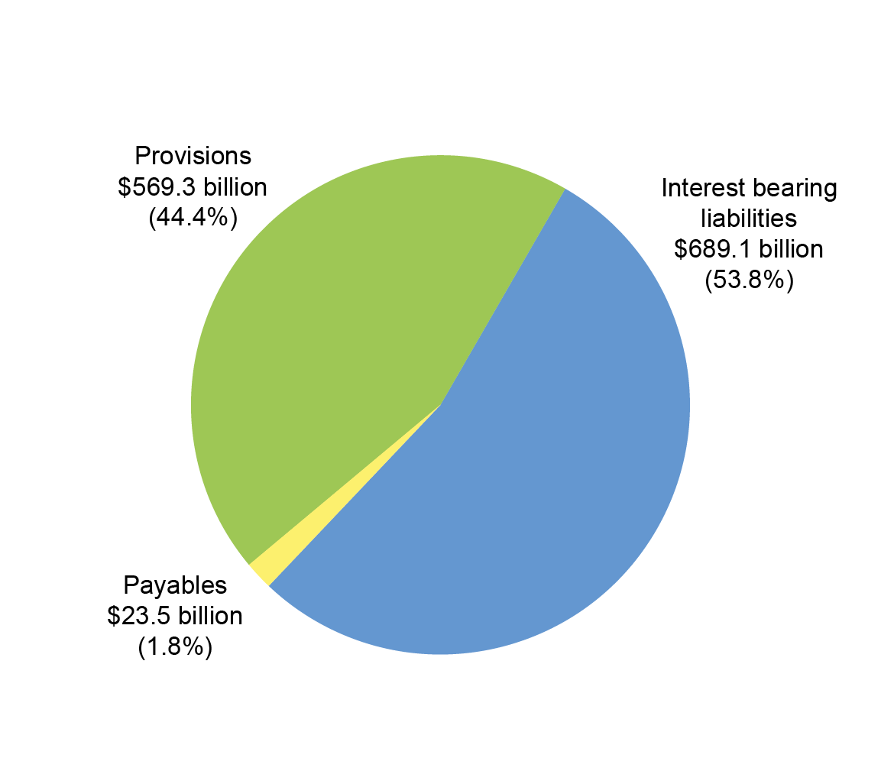

The increase of $52.9 billion in **interest bearing liabilities** was primarily as a result of an increase of $51.6 billion in the market value and issuance volume of Australian Government Securities.

The increase in **provisions and payables** of $122.0 billion was primarily as a result of:

* an increase of $102.1 billion in the superannuation liability, predominantly due to the decrease in the long-term government bond rate used to discount expected future superannuation payments (refer to Note 10C of the 2018-19 CFS for further information);
* an increase of $10.1 billion relating to the actuarial revaluation of other employee liabilities and other provisions for military compensation; and
* an increase of $4.5 billion in Australian currency (notes) on issue.

Note 6 of 2018-19 CFS provides further information on liabilities.

#### Cash flows

The Australian Government’s cash balance was $8.3 billion at 30 June 2019. For the year ended 30 June 2019, the Australian Government recorded a cash deficit of $0.7 billion, an improvement of $13.0 billion compared to a cash deficit of $13.7 billion for 2017-18.

Table 9: Cash flows

|  |  |  |  |  |
| --- | --- | --- | --- | --- |
|  | 2018-19 $b | 2017-18 $b | Change $b | Change % |
| Cash receipts |  |  |  |  |
| Operating activities | 499.7 | 456.8 | 43.0 | 9.4 |
| Investing activities in non-financial assets | 0.8 | 1.7 | (0.9) | 51.8 |
| Investing activities in financial assets  for policy purposes | 4.1 | 5.4 | (1.4) | 25.4 |
| Financing activities (net) | 18.9 | 38.3 | (19.4) | 50.6 |
| **Total cash receipts** | **523.5** | **502.1** | **21.4** | **4.3** |
| Cash payments |  |  |  |  |
| Operating activities | 478.7 | 452.3 | (26.3) | 5.8 |
| Investing activities in non-financial assets | 22.6 | 19.8 | (2.8) | 13.9 |
| Investing activities in financial assets  for policy purposes | 10.4 | 17.5 | 7.2 | 40.8 |
| Investing activities in financial assets  for liquidity purposes (net) | 4.1 | 6.2 | 2.1 | 34.4 |
| Financing activities (net) | 5.9 | 6.2 | 0.3 | 5.1 |
| **Total cash payments** | **521.6** | **502.1** | **(19.5)** | **3.9** |
| **Net movement in cash** | **1.9** | **0.0** | **1.9** | **>100.0** |
| Cash at beginning of the year | 6.3 | 6.3 | 0.0 | 0.7 |
| **Cash at end of year** | **8.3** | **6.3** | **1.9** | **30.6** |
| **Key fiscal aggregate** |  |  |  |  |
| Net cash flows from operating activities | 21.1 | 4.4 | 16.6 | >100.0 |
| Net cash flows from investments in non-financial  assets | (21.8) | (18.2) | (3.6) | 19.9 |
| **Cash surplus/(deficit)** | **(0.7)** | **(13.7)** | **13.0** | **94.8** |

#### Receipts and payments

The following charts provide a detailed breakdown of Australian Government receipts and payments for 2018-19, showing the relative composition of each dollar received and paid.

Chart 10: Composition of each dollar of cash received in 2018-19

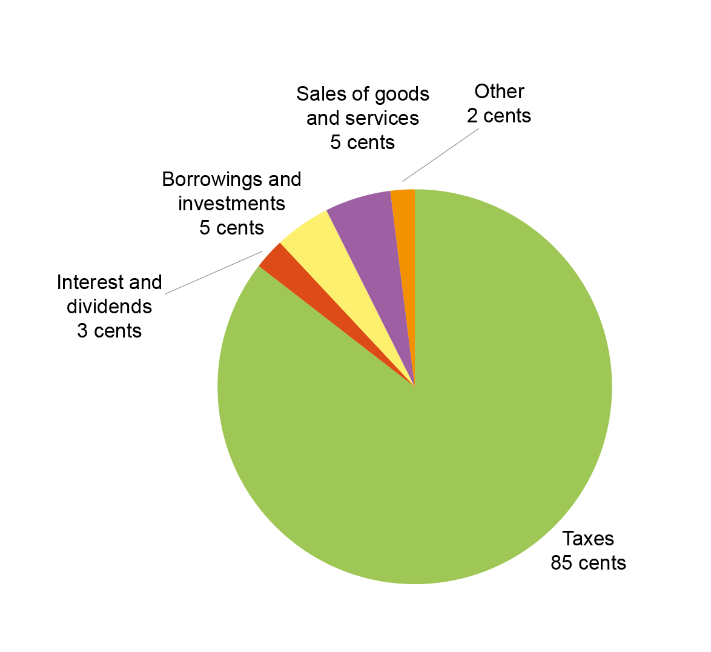

Chart 11: Composition of each dollar of cash paid in 2018-19

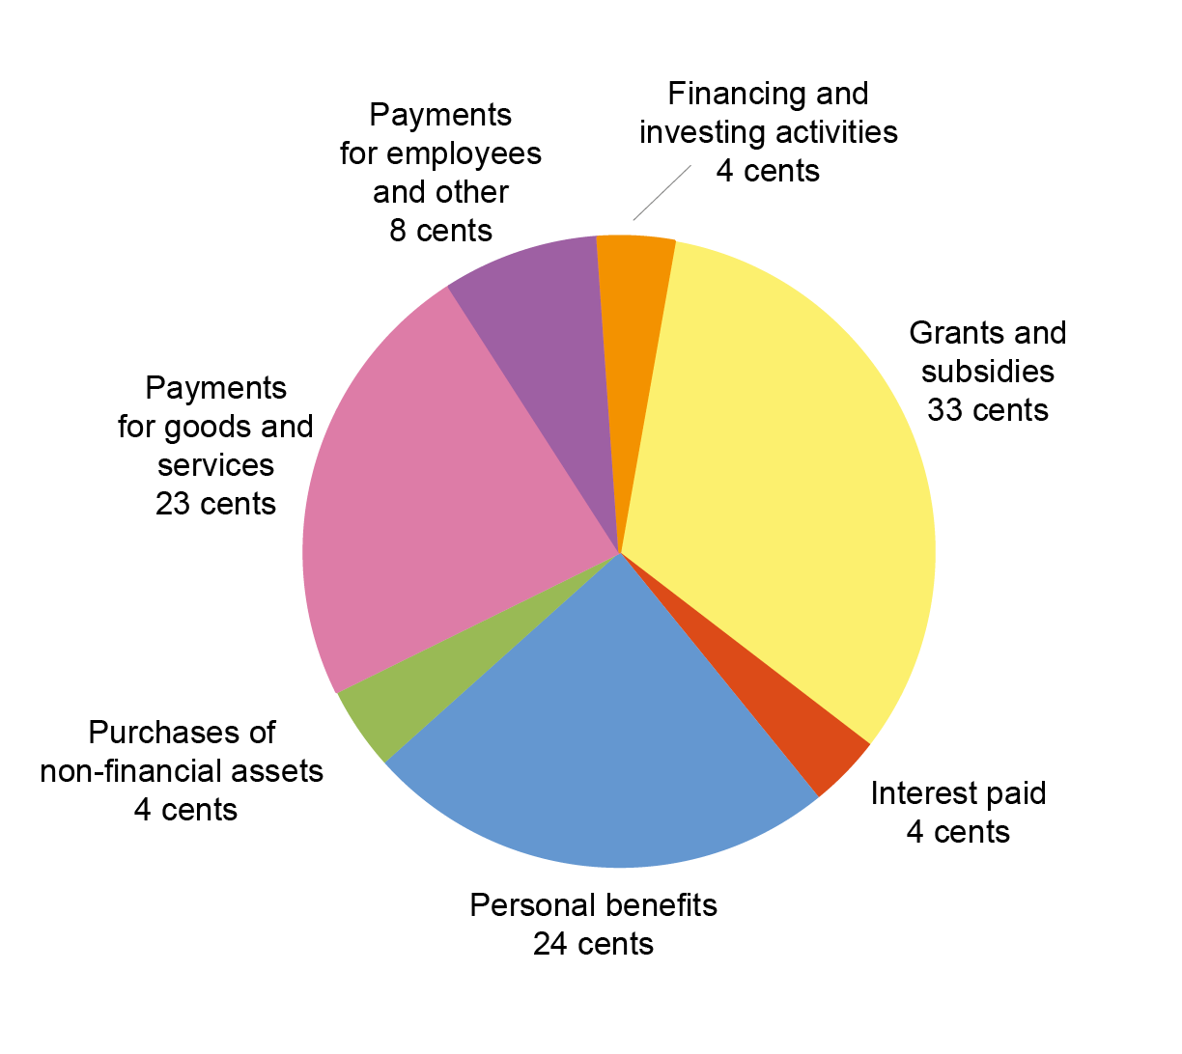

Chart 12 provides the trend of the Australian Government’s receipts and payments for operating activities and the sales and purchases of non-financial assets since 2009-10.

Chart 12: Receipts and payments – operating and non-financial assets

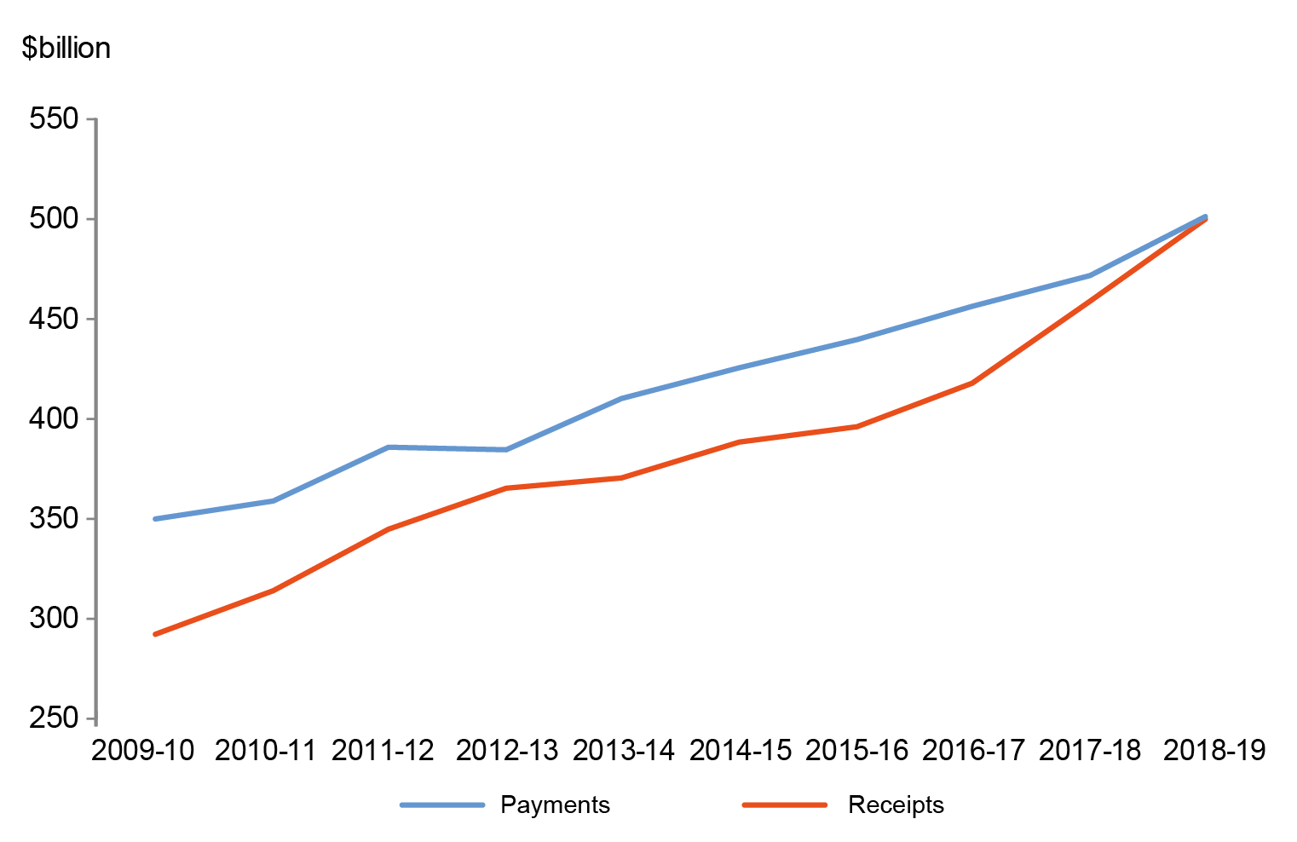

APPENDIX A

Previous years

The CFS since 1995-96 are available on the Department of Finance website at:   
<http://www.finance.gov.au/publications/commonwealth-consolidated-financial-statements>.

The historical series datasets are available in electronic format at:   
<http://data.gov.au/dataset/australian-government-consolidated-financial-statements-tables-and-data>.

Links to other publications

The Australian Government publishes a range of information about its projected and actual financial position. Links to some of these documents are set out below. The information in the following documents has been prepared for different purposes and therefore does not form part of the CFS. Further, the documents listed below are not subject to audit.

#### 2018-19 Final Budget Outcome

The 2018-19 Final Budget Outcome (FBO) was prepared in a manner consistent with the *Charter of Budget Honesty Act 1998* (the Charter). The Charter requires that the Government provide the FBO no later than three months after the end of the financial year. Consistent with these requirements, the FBO encompasses Australian Government GGS fiscal outcomes for the 2018-19 financial year and is based on external reporting standards.

The 2018-19 FBO was released on the 19 September 2019 and is available on the Australian Government website at:

https://www.budget.gov.au/2019-20/content/fbo/.

#### Australian Government Monthly Financial Statements

The Australian Government GGS monthly financial statements (MFS) are prepared on a basis consistent with the Budget as required under section 47 of the PGPA Act. The statements are prepared in accordance with AASB 1049.

The Australian Government GGS MFS are available on the website of the Minister for Finance as well as the Department of Finance website:

https://www.finance.gov.au/publications/commonwealth-monthly-financial-statements/ and http://www.financeminister.gov.au/media-releases.

The historical series datasets are available in electronic format at: <http://data.gov.au/dataset/australian-government-general-government-sector-monthly-financial-statements-tables-and-data>.

#### Budget Strategy and Outlook and Mid-Year Economic and Fiscal Outlook

The Budget Strategy and Outlook — Budget Paper No.1 — 2018-19, the Mid-Year Economic and Fiscal Outlook 2018-19 and the Budget Strategy and Outlook — Budget Paper No.1 — 2019-20 have been prepared in accordance with the Charter.

These Budget papers are available on the Australian Government website at http://www.budget.gov.au/.

#### Tax Benchmarks and Variations Statement 2018

The Tax Benchmarks and Variations Statement provides details of concessions, benefits, incentives and charges provided through the tax system (tax expenditures) to taxpayers by the Australian Government. Information is published on the Treasury website at:

https://www.treasury.gov.au/publication/p2019-357183.

1. The institutional structure of the public sector is explained in Note 1 of the 2018-19 CFS.   
   Note 15 of the 2018-19 CFS provides the list of Australian Government controlled reporting entities, including their sectoral classification.
2. The balances and movements detailed in the commentary have been rounded to the nearest tenth of a billion. Discrepancies between totals and sums of components are due to rounding.
3. The 2017-18 comparatives include adjustments to assets ($0.5 billion increase) and liabilities ($0.4 billion increase). Refer to Note 1.5 of the 2018-19 CFS for further information.