
Pre-election Economic
and Fiscal Outlook
2019
A report by
The Secretary to the Treasury
and
The Secretary of the Department of Finance
April 2019
© Commonwealth of Australia 2019
ISBN 978-1-925832-02-0
This publication is available for your use under a Creative Commons BY Attribution 3.0 Australia licence, with the exception of the Commonwealth Coat of Arms, third party content and where otherwise stated. The full licence terms are available from www.creativecommons.org/licenses/by/3.0/au/legalcode.

Use of Commonwealth of Australia material under a Creative Commons BY Attribution 3.0 Australia licence requires you to attribute the work (but not in any way that suggests that the Commonwealth of Australia endorses you or your use of the work).
Commonwealth of Australia material used ‘as supplied’.
Provided you have not modified or transformed Commonwealth of Australia material in any way including, for example, by changing the Commonwealth of Australia text; calculating percentage changes; graphing or charting data; or deriving new statistics from published statistics — then the Commonwealth of Australia prefers the following attribution:
Source: The Commonwealth of Australia.
Derivative material
If you have modified or transformed Commonwealth of Australia material, or derived new material from those of the Commonwealth of Australia in any way, then the Commonwealth of Australia prefers the following attribution:
Based on Commonwealth of Australia data.
Use of the Coat of Arms
The terms under which the Coat of Arms can be used are set out on the Department of the Prime Minister and Cabinet website (see www.pmc.gov.au/government/
commonwealth-coat-arms).
Other uses
Enquiries regarding this licence and any other use of this document are welcome at:
Manager
Media Unit
The Treasury
Langton Crescent
Parkes ACT 2600
Email: medialiaison@treasury.gov.au
Internet
A copy of this document is available at www.treasury.gov.au and www.finance.gov.au.
Notes
(a) The following definitions are used in the Pre-election Economic and Fiscal Outlook (PEFO):
- ‘real’ means adjusted for the effect of inflation;
- real growth in expenses and payments is calculated using the Consumer Price Index (CPI) as the deflator;
- the Budget year refers to 2019-20, while the forward years refer to 2020-21, 2021-22 and 2022-2023; and
- one billion is equal to one thousand million.
(b) Figures in tables and generally in the text have been rounded. Discrepancies in tables between totals and sums of components are due to rounding:
- estimates under $100,000 are rounded to the nearest thousand;
- estimates $100,000 and over are generally rounded to the nearest tenth of a million;
- estimates midway between rounding points are rounded up; and
- the percentage changes in statistical tables are calculated using unrounded data.
(c) For the budget balance, a negative sign indicates a deficit while no sign indicates a surplus.
(d) The following notations are used:
- | nil
na | not applicable (unless otherwise specified)
$m | millions of dollars
$b | billions of dollars
nfp | not for publication
(e) | estimates (unless otherwise specified)
(p) | projections (unless otherwise specified)
NEC/nec | not elsewhere classified
(e) The Australian Capital Territory and the Northern Territory are referred to as ‘the territories’. References to the ‘states’ or ‘each state’ include the territories. The following abbreviations are used for the names of the states, where appropriate:
NSW | New South Wales
VIC | Victoria
QLD | Queensland
WA | Western Australia
SA | South Australia
TAS | Tasmania
ACT | Australian Capital Territory
NT | Northern Territory

(f) In this paper the term ‘Commonwealth’ refers to the Commonwealth of Australia. The term is used when referring to the legal entity of the Commonwealth of Australia.
The term ‘Australian Government’ is used when referring to the Government and the decisions and activities made by the Government on behalf of the Commonwealth of Australia.

Contents
Preface vii
Statement by the Treasurer and the Minister for Finance and the Public Service viii
Statement by the Secretary to the Treasury and the Secretary of the Department of Finance ix
Pre-election Economic and Fiscal Outlook 1
Overview 1
Economic outlook 2
Fiscal outlook 6
Appendix A: Financial Statements 15
Appendix B: Policy Decisions Since the 2019-20 Budget 25
Appendix C: Statement of Risks 29

Preface
The Charter of Budget Honesty Act 1998 (the Charter) provides for the Secretary to the Treasury and the Secretary of the Department of Finance (the Secretaries) to release publicly a Pre-election Economic and Fiscal Outlook report (PEFO) within 10 days of the issue of the writs for a general election. Such writs were issued on 11 April 2019.
The purpose of the PEFO is to provide updated information on the economic and fiscal outlook. The information in the report takes into account, to the fullest extent possible, all Government decisions and all other circumstances that may have a material effect on the economic and fiscal outlook that were in existence before the issue of the writs for the election.
The Charter provides that, where there is information unchanged from that set out in full in an earlier budget report, the PEFO may summarise and state this information is unchanged. As the writs for the 2019 election were issued shortly after the release of the 2019-20 Budget, this PEFO provides reference to information published in the 2019-20 Budget where it is unchanged.
Consistent with the requirements of the Charter, the PEFO includes:
- fiscal estimates and projections for the current financial year (2018-19) and the following four financial years (2019-20, 2020-21, 2021-22 and 2022-23);
- economic and other assumptions for the current financial year and the following four financial years used in preparing these updated fiscal estimates;
- discussion of the sensitivity of updated fiscal estimates to changes in those economic and other assumptions and refers to the detailed analysis in the 2019-20 Budget that remains unchanged;
- an updated set of financial statements and summary of the external reporting standards used in the preparation of the PEFO (Appendix A);
- a list of policy decisions taken by the Government since the 2019-20 Budget and decisions that were taken but not announced at that time (Appendix B). The PEFO does not include the impact of commitments made in the context of the current election campaign; and
- an updated statement of the risks that may have a material effect on the fiscal outlook (Appendix C).

Statement by the Treasurer and the
Minister for Finance and the Public Service
Consistent with the Charter of Budget Honesty Act 1998, we declare that we have disclosed to the Secretary to the Treasury and the Secretary of the Department of Finance all details of any Government decision, or any other circumstance, that we know about:
(i) that has, or could have, material fiscal or economic implications; and
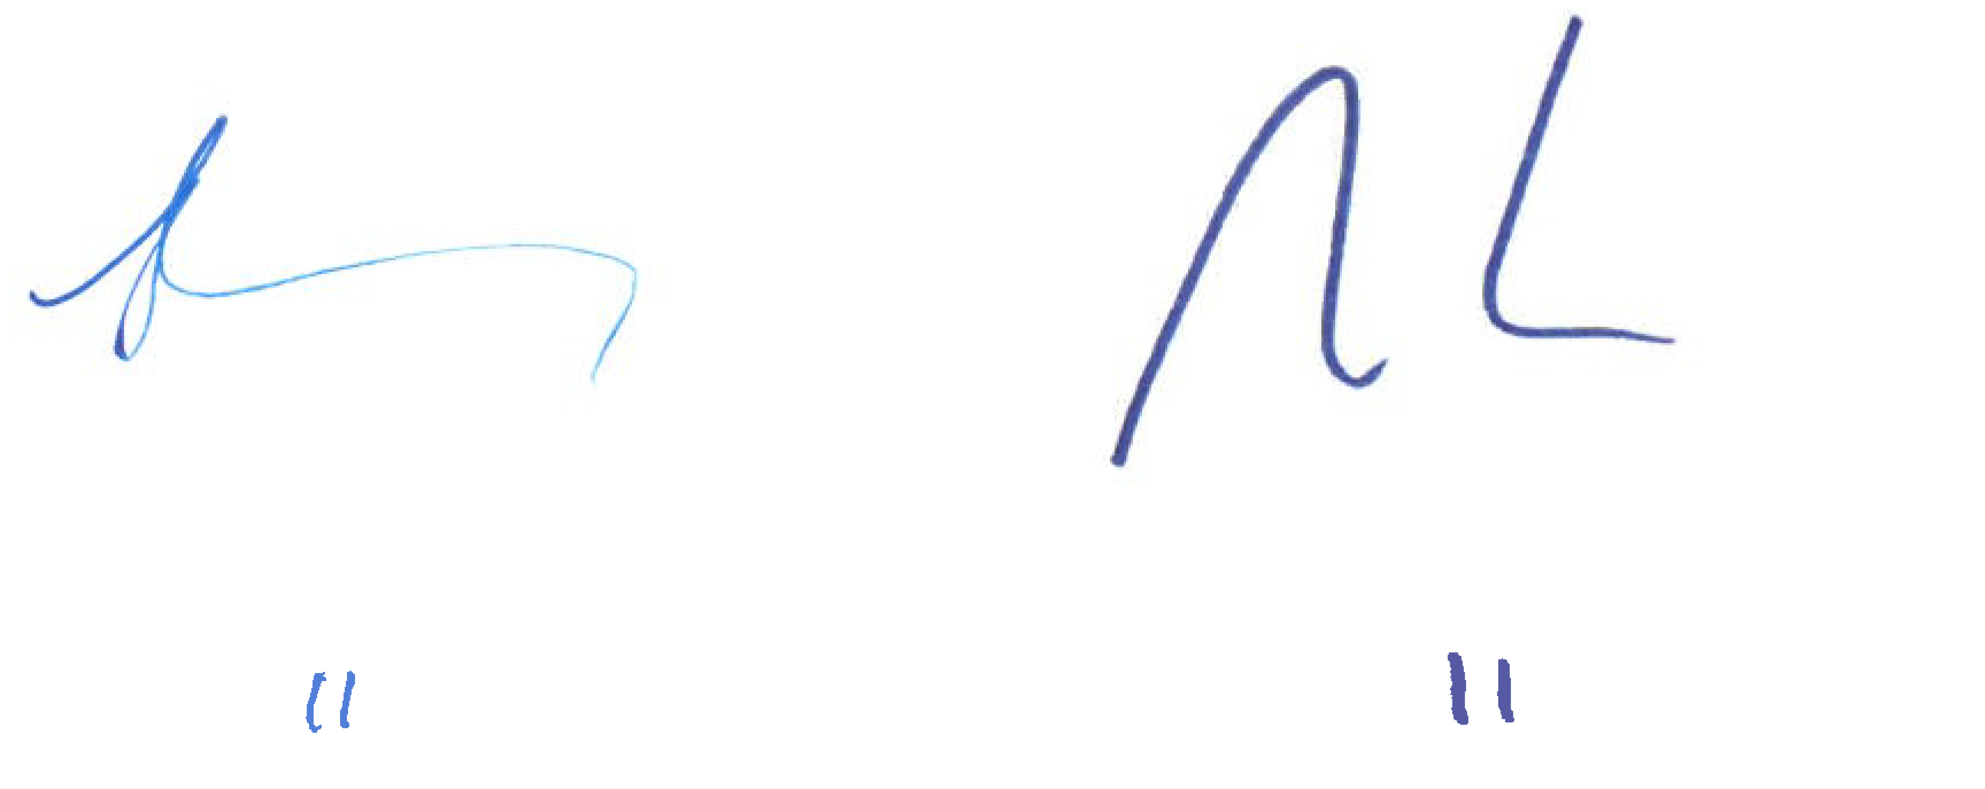
(ii) that neither of the responsible Secretaries could reasonably be expected to know about.

The Hon Josh Frydenberg MP Senator the Hon Mathias Cormann
Treasurer Minister for Finance and the Public
Service
April 2019 April 2019

Statement by the Secretary to the
Treasury and the Secretary of the
Department of Finance
Consistent with the Charter of Budget Honesty Act 1998, we declare that, to the fullest extent possible, the information in the Pre-election Economic and Fiscal Outlook 2019 for which we are responsible:
(i) reflects the best professional judgment of the officers of the Treasury and the Department of Finance;
(ii) takes into account all economic and fiscal information available; and
(iii) incorporates the fiscal implications of Government decisions and circumstances disclosed by the responsible Ministers.
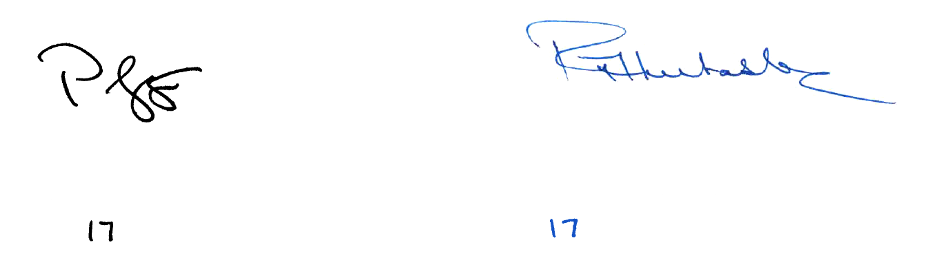  Mr Philip Gaetjens  Secretary to the Treasury  April 2019 | Ms Rosemary Huxtable, PSM  Secretary, Department of Finance  April 2019

