**Consolidated Financial Statements,   
including the Australian Government   
And General Government Sector   
Financial Reports**

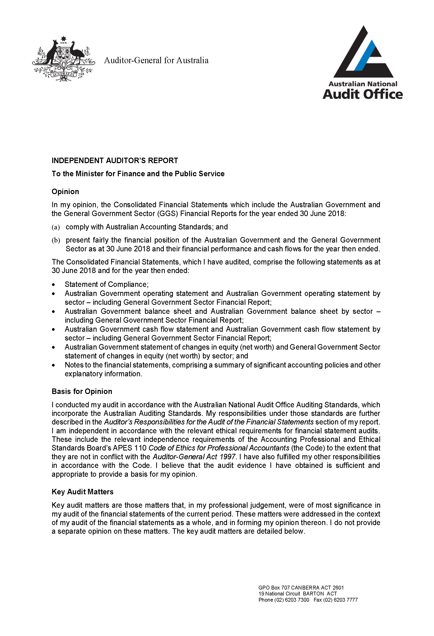**Independent Audit Report**

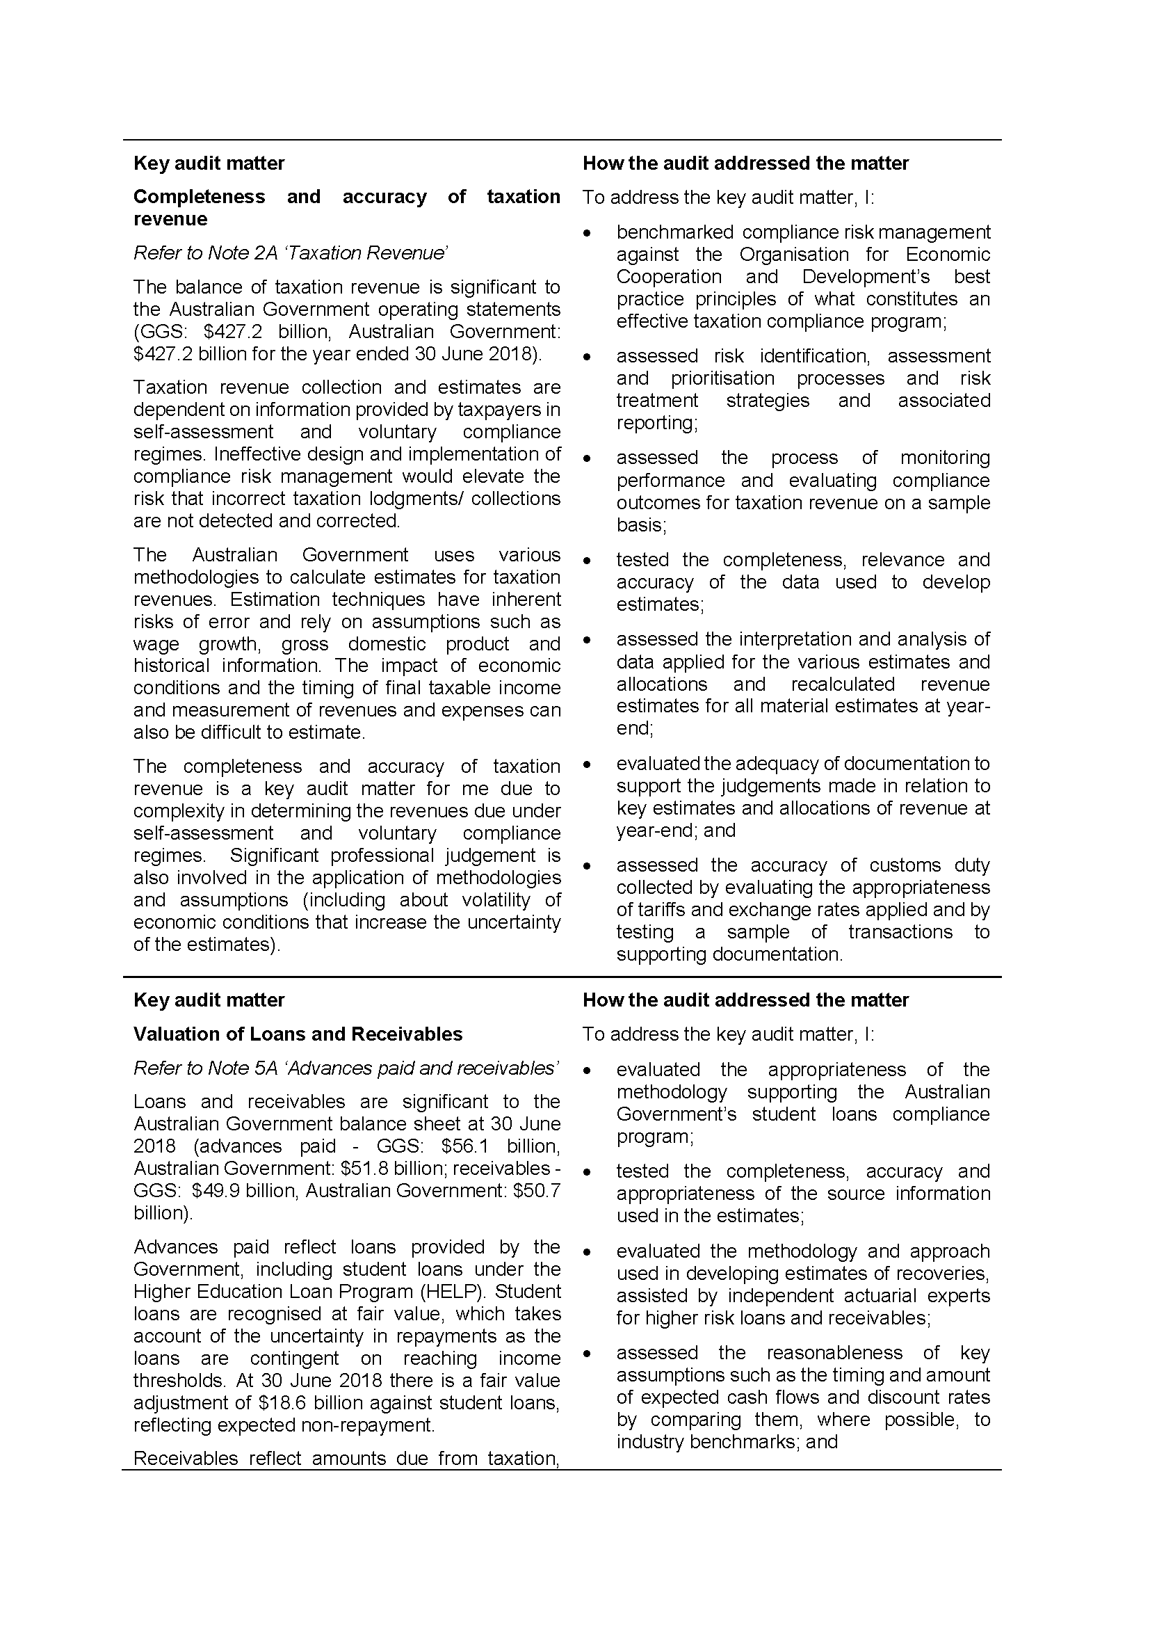

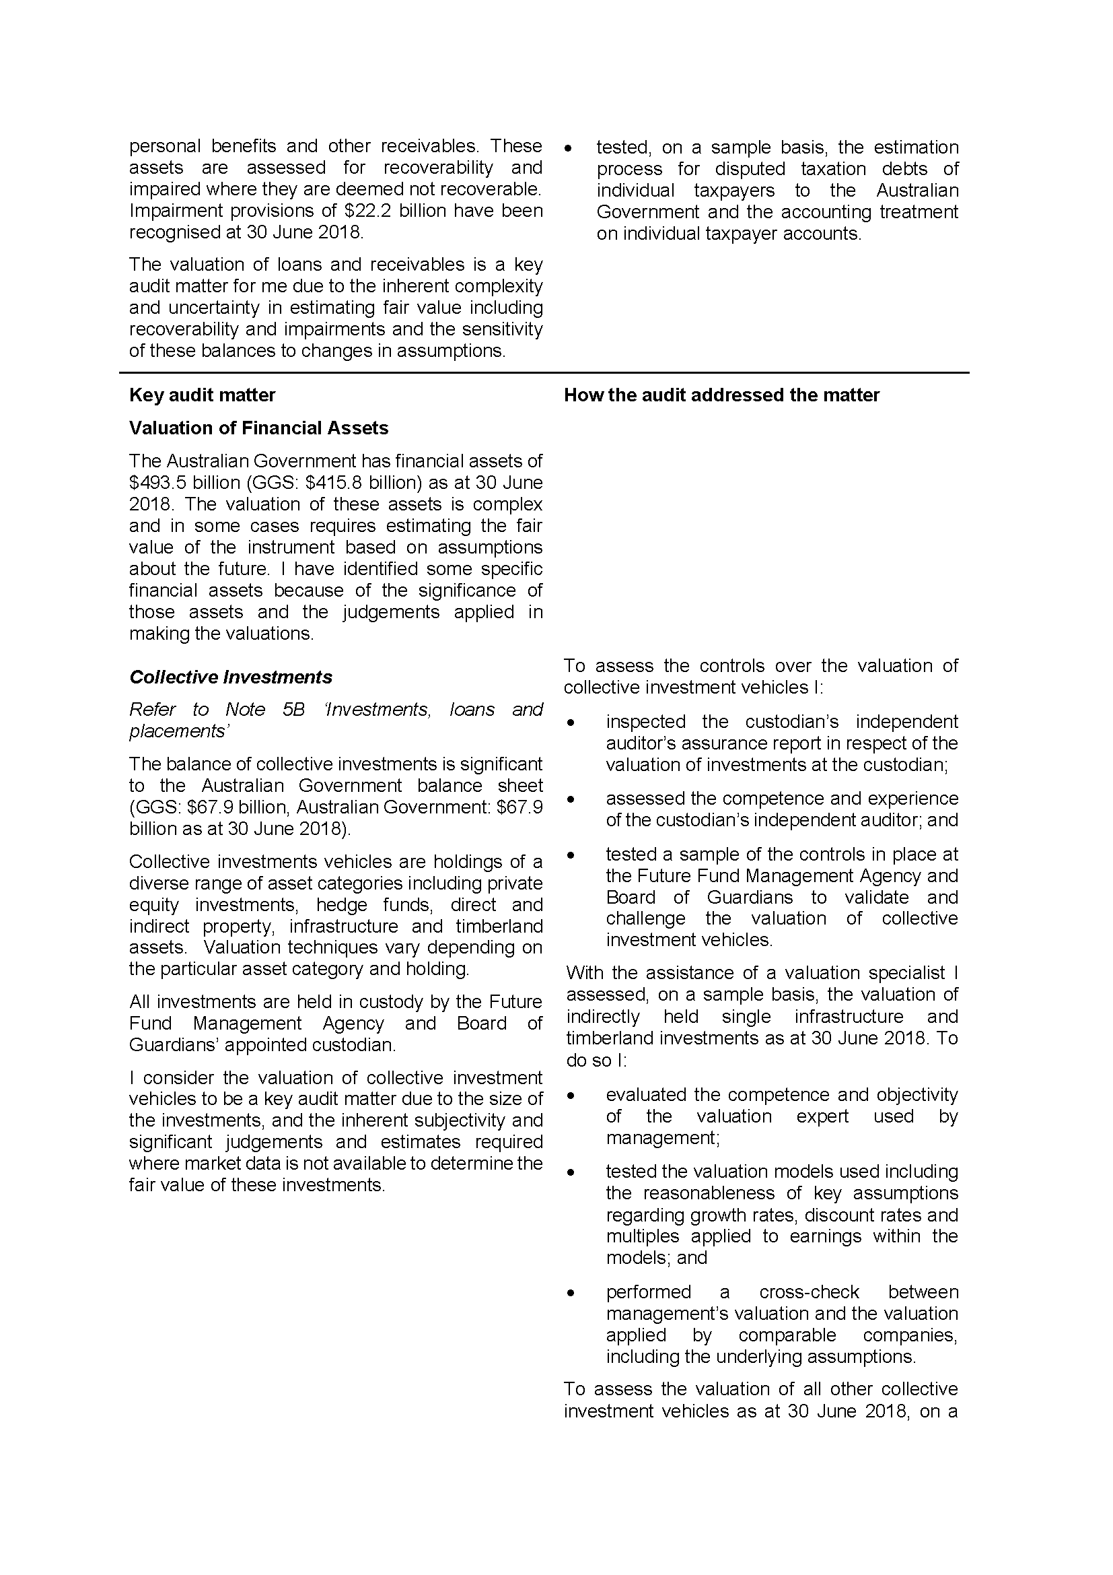

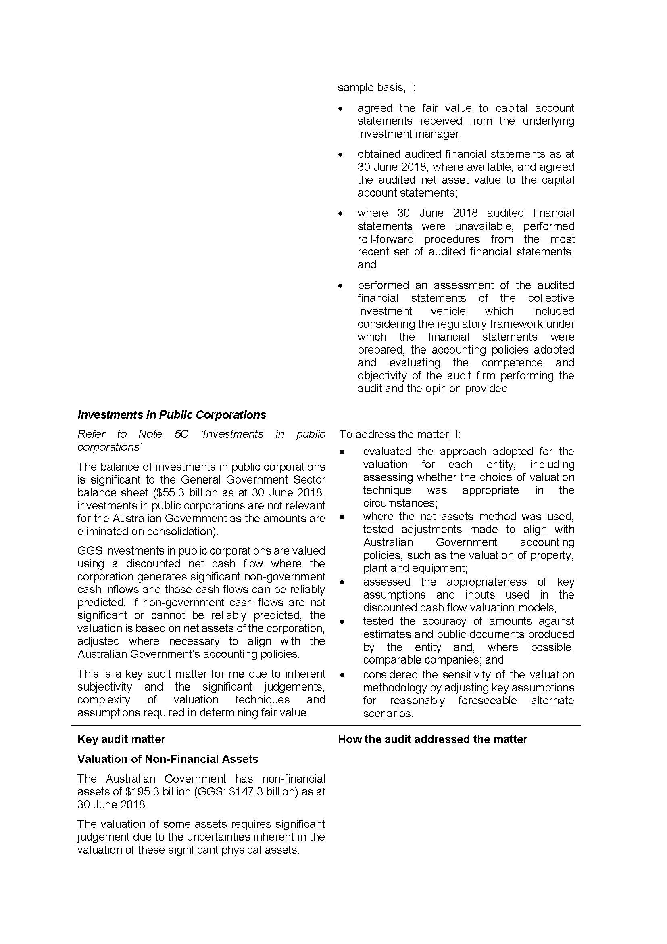

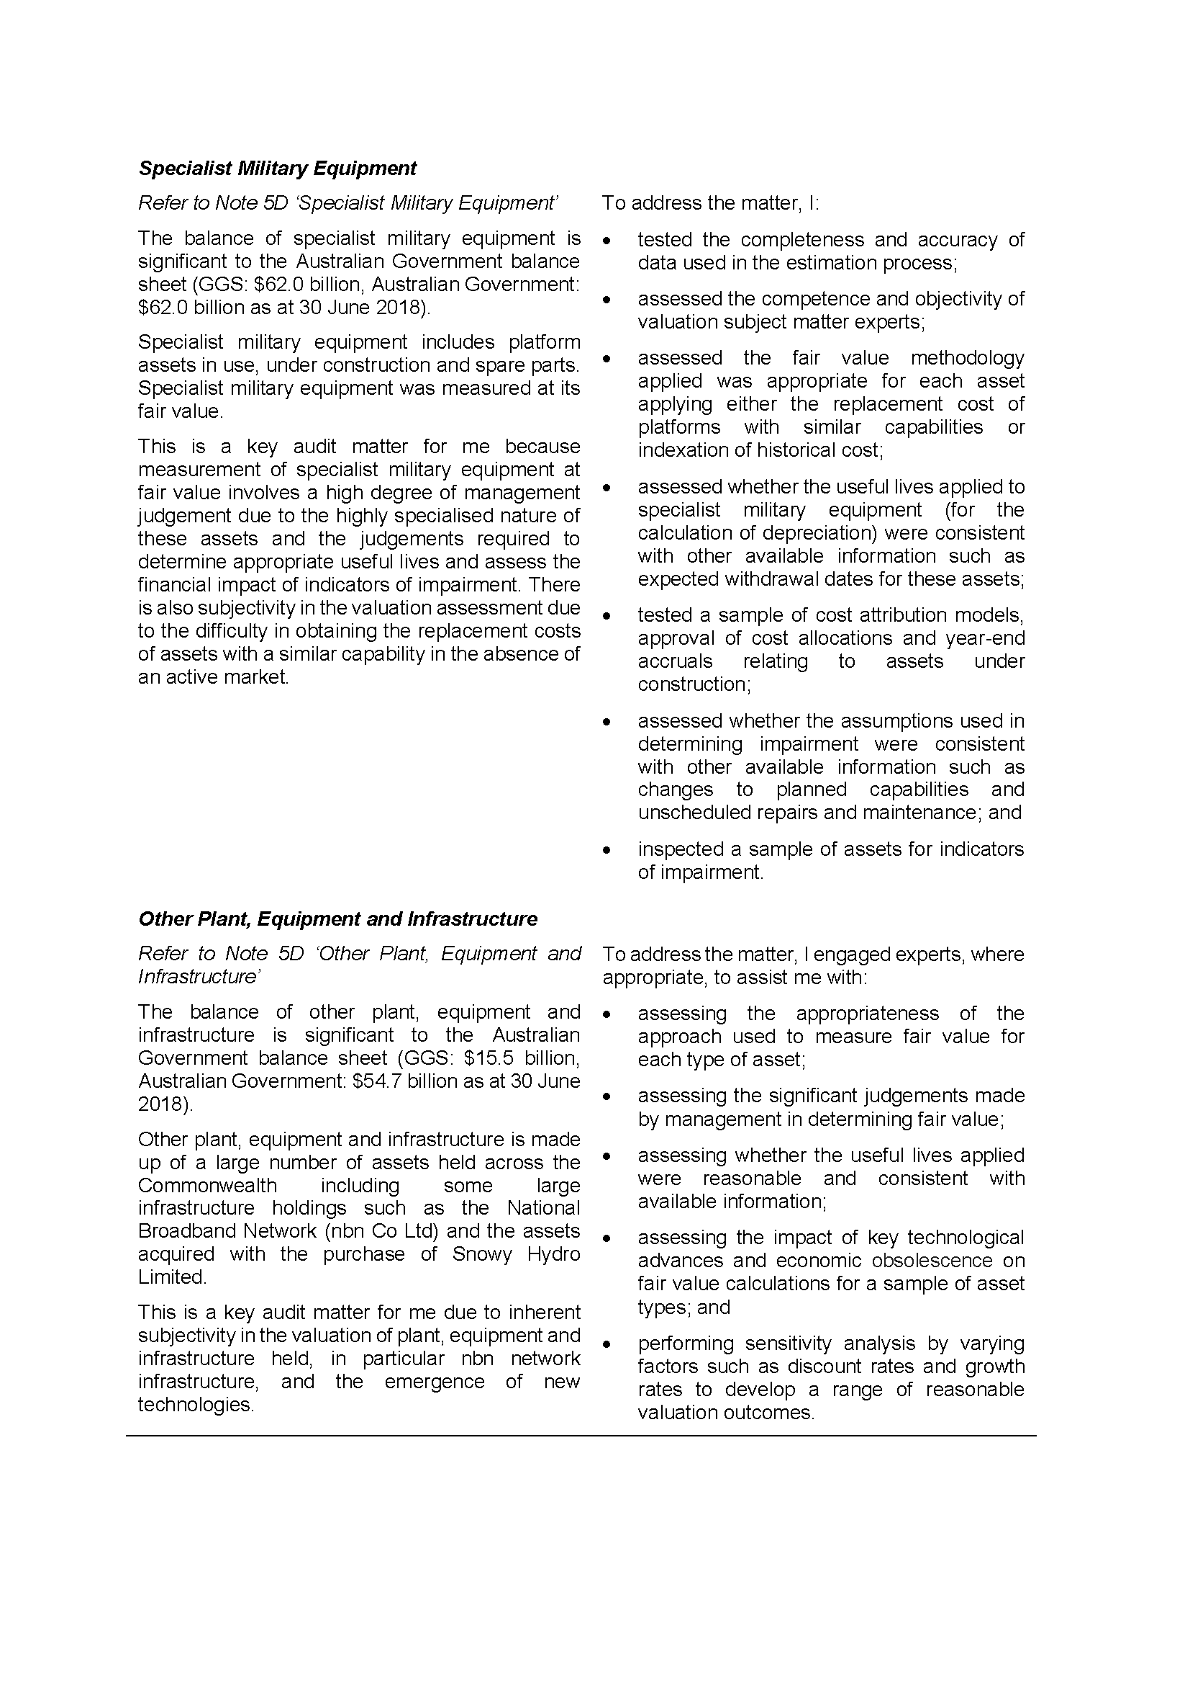

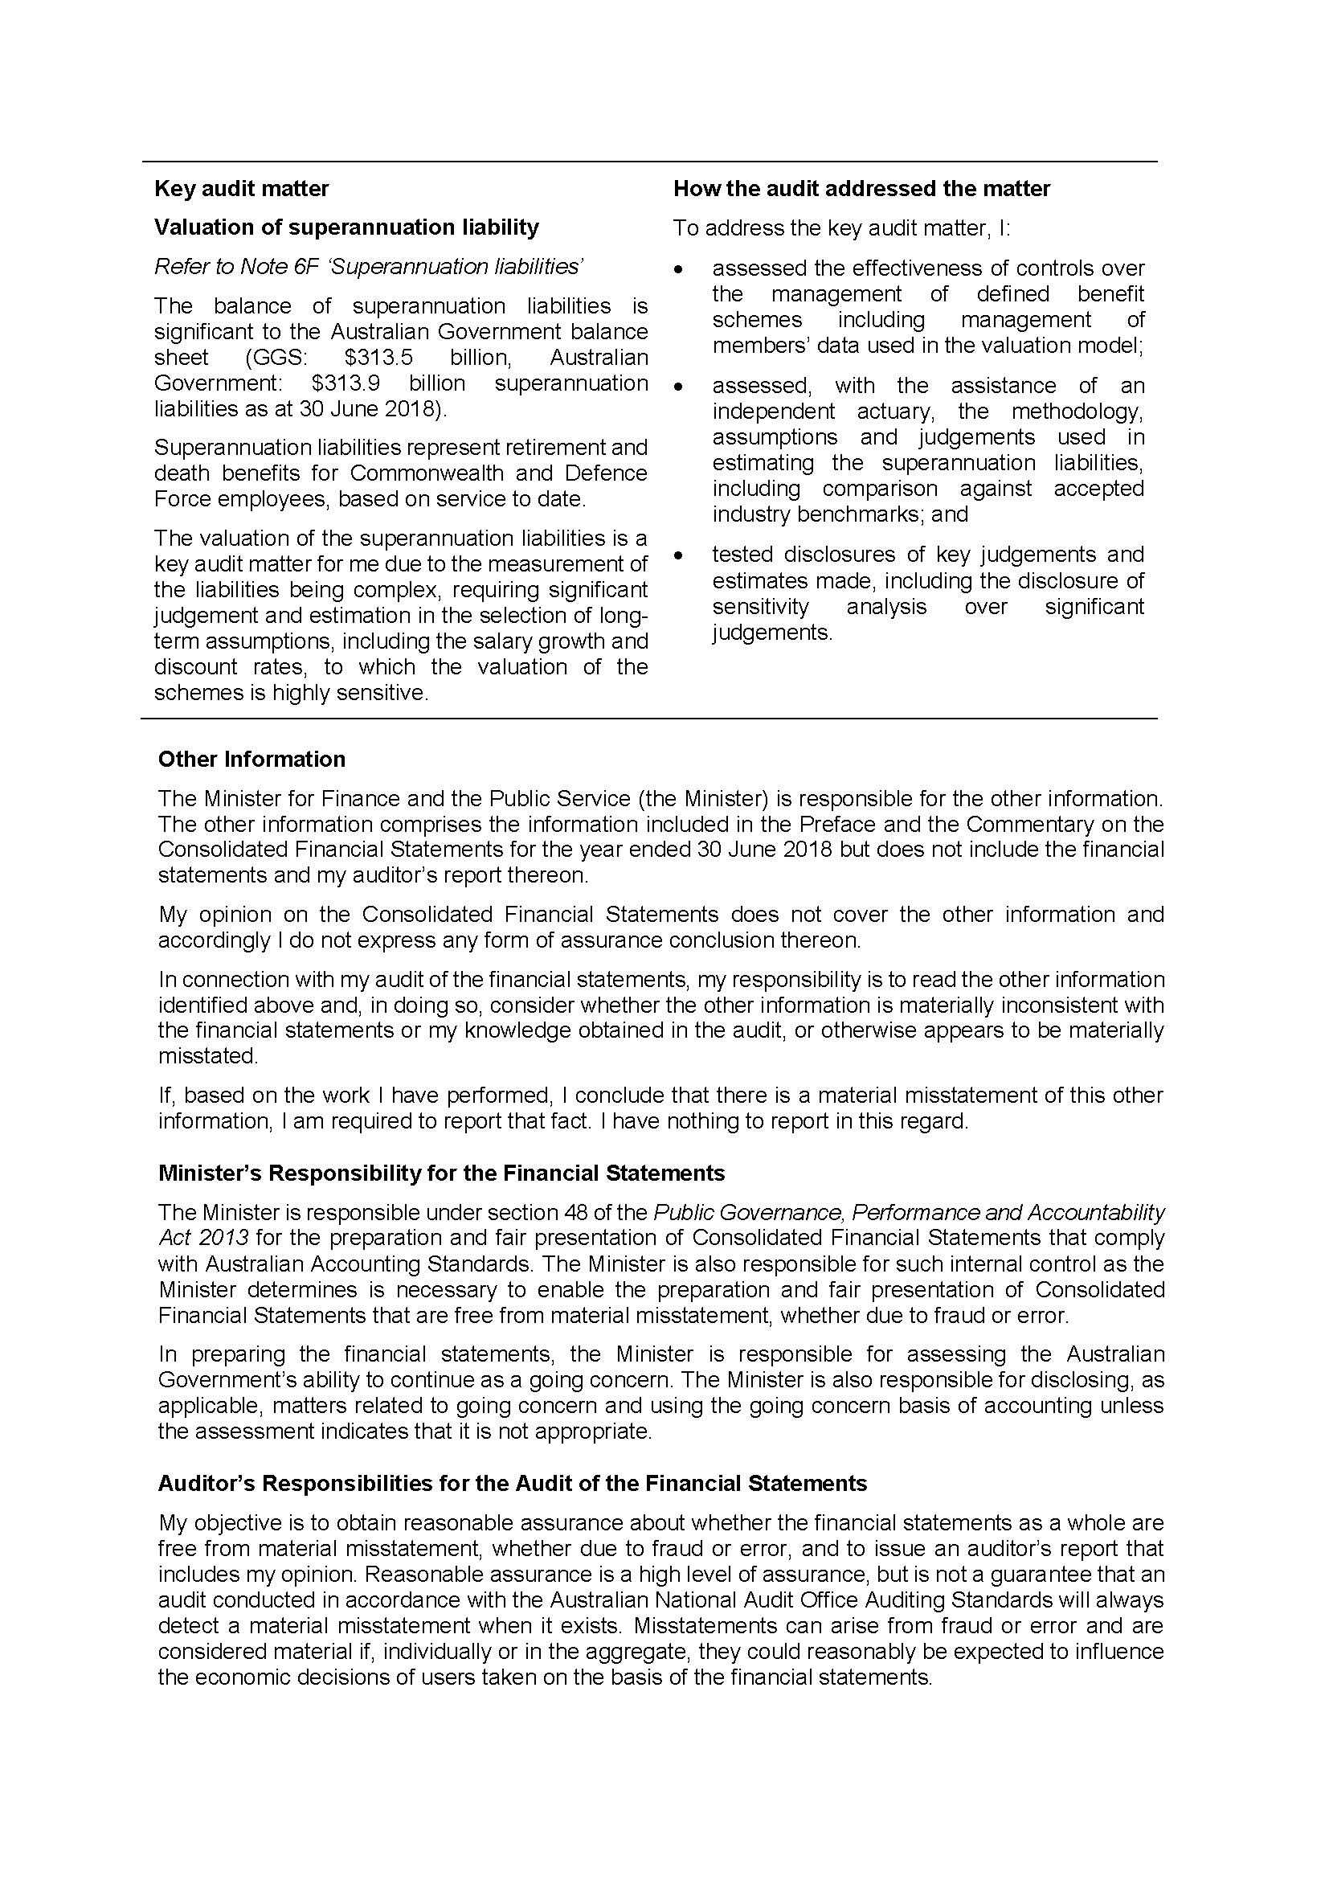

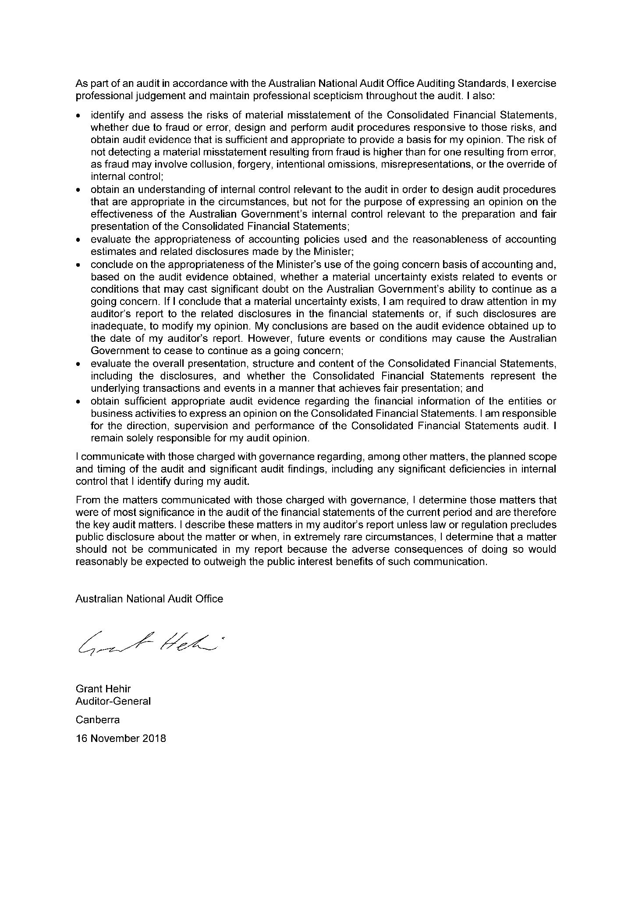

**Statement of compliance**

The annual Consolidated Financial Statements of the Australian Government are required by section 48 of the *Public Governance, Performance and Accountability Act 2013.*

In my opinion, the attached annual Consolidated Financial Statements of the   
Australian Government, which includes the whole of government and general government sector financial statements:

1. comply with Australian Accounting Standards; and
2. present fairly the Australian Government’s financial position as at 30 June 2018   
   and its financial performance and cash flows for the year then ended.

November 2018

Senator the Hon Mathias Cormann

Minister for Finance and the Public Service

**Australian Government operating statement**

for the year ended 30 June 2018

|  |  |  |  |
| --- | --- | --- | --- |
|  |  | 2018 | 2017 |
|  | Note | $m | $m |
| **Revenue from transactions** |  |  |  |
| Taxation revenue | 2A | 427,239 | 388,296 |
| Sales of goods and services | 2B | 21,114 | 18,404 |
| Interest income | 2C | 4,774 | 4,145 |
| Dividend income | 2C | 4,247 | 3,556 |
| Other | 2D | 10,487 | 10,795 |
| **Total revenue** |  | **467,861** | **425,196** |
| **Expenses from transactions** |  |  |  |
| *Gross operating expenses* |  |  |  |
| Wages and salaries | 3A | 23,570 | 23,322 |
| Superannuation | 3A | 8,357 | 10,431 |
| Depreciation and amortisation | 3B | 11,684 | 10,456 |
| Supply of goods and services | 3C | 107,362 | 100,609 |
| Other operating expenses | 3A | 7,353 | 6,718 |
| *Total gross operating expenses* |  | *158,326* | *151,536* |
| Superannuation interest expense | 3A | 9,240 | 8,445 |
| Interest expense | 3D | 18,996 | 17,553 |
| *Current transfers* |  |  |  |
| Current grants | 3E | 139,286 | 134,313 |
| Subsidy expenses |  | 11,070 | 10,853 |
| Personal benefits |  | 127,146 | 128,150 |
| *Total current transfers* |  | *277,502* | *273,316* |
| *Capital transfers* |  |  |  |
| Mutually agreed write-downs | 3E | 1,996 | 1,203 |
| Other capital grants | 3E | 10,180 | 10,028 |
| *Total capital transfers* |  | *12,176* | *11,231* |
| **Total expenses** | 3F | **476,240** | **462,081** |
|  |  |  |  |
| **Net operating balance** |  | **(8,379)** | **(36,885)** |
| **Other economic flows - included in operating result** |  |  |  |
| Net write-down of assets (including bad and doubtful debts) | 4A | (8,239) | (13,420) |
| Net gains/(losses) from the sale of assets | 4B | 7,220 | 4,967 |
| Net foreign exchange gains/(losses) | 4C | 1,982 | 149 |
| Net swap interest gains/(losses) | 4C | 89 | 122 |
| Net fair value gains/(losses) | 4C | 5,876 | 19,330 |
| Net other gains/(losses) | 4C | (2,636) | 222 |
| **Operating result(a)** |  | **(4,087)** | **(25,515)** |
| **Other economic flows - other non-owner movements in equity** |  |  |  |
| ***Items that will not be reclassified to operating result*** |  |  |  |
| Revaluation of non-financial assets | 7 | 2,728 | 1,705 |
| Actuarial revaluations of superannuation |  | (25,293) | 45,898 |
| Other economic revaluations |  | 62 | (95) |
| ***Items that may be reclassified subsequently to operating result*** |  |  |  |
| Revaluation of equity investments | 7 | 515 | 59 |
| **Comprehensive result - total change in net worth** |  | **(26,075)** | **22,052** |
| **Net operating balance** |  | **(8,379)** | **(36,885)** |
| ***less* Net acquisition of non-financial assets** |  |  |  |
| Purchases of non-financial assets |  | 22,190 | 19,667 |
| *less* Sales of non-financial assets |  | 4,434 | 939 |
| *less* Depreciation and amortisation |  | 11,684 | 10,456 |
| *plus* Change in inventories |  | 680 | 397 |
| *plus* Other movements in non-financial assets |  | (31) | 29 |
| **Total net acquisition of non-financial assets** |  | **6,721** | **8,698** |
| **Fiscal balance (Net lending/(borrowing))** |  | **(15,100)** | **(45,583)** |

1. Includes $4 million attributable to minority interests (2017: $1 million).

Certain comparatives have been restated. Refer to Note 1.5 for further details.

**Australian Government balance sheet**

as at 30 June 2018

|  |  |  |  |
| --- | --- | --- | --- |
|  |  | 2018 | 2017 |
|  | Note | $m | $m |
| **Assets** |  |  |  |
| *Financial assets* |  |  |  |
| Cash and deposits |  | 6,242 | 6,283 |
| Advances paid | 5A | 51,765 | 46,093 |
| Other receivables and accrued revenue | 5A | 50,696 | 46,150 |
| Investments, loans and placements | 5B | 326,823 | 320,878 |
| Equity investments | 5C | 57,992 | 46,561 |
| *Total financial assets* |  | *493,518* | *465,965* |
| *Non-financial assets* |  |  |  |
| Land | 5D | 13,316 | 12,237 |
| Buildings | 5D | 29,073 | 28,112 |
| Specialist military equipment | 5D | 62,020 | 58,573 |
| Other plant, equipment and infrastructure | 5D | 54,689 | 42,475 |
| Intangibles | 5D | 11,519 | 10,360 |
| Investment property | 5D | 341 | 281 |
| Inventories | 5E | 8,831 | 8,689 |
| Heritage and cultural assets | 5D | 11,619 | 11,630 |
| Other non-financial assets | 5F | 3,943 | 4,280 |
| *Total non-financial assets* |  | *195,351* | *176,637* |
| **Total assets** | 5G | **688,869** | **642,602** |
|  |  |  |  |
| **Liabilities** |  |  |  |
| *Interest bearing liabilities* |  |  |  |
| Deposits held | 6A | 33,841 | 34,761 |
| Government securities | 6B | 567,661 | 535,445 |
| Loans | 6C | 15,181 | 14,100 |
| Other borrowings | 6D | 8,807 | 7,515 |
| Other interest bearing liabilities | 6E | 10,760 | 10,885 |
| *Total interest bearing liabilities* |  | *636,250* | *602,706* |
| *Provisions and payables* |  |  |  |
| Superannuation liability | 6F | 313,913 | 279,799 |
| Other employee liabilities | 6F | 21,714 | 20,058 |
| Supplier payables | 6G | 11,906 | 11,010 |
| Personal benefits payable | 6G | 2,758 | 2,451 |
| Subsidies payable | 6G | 602 | 549 |
| Grants payable | 6G | 3,068 | 3,924 |
| Australian currency on issue | 6H | 75,565 | 73,623 |
| Other payables | 6G | 2,945 | 4,259 |
| Other provisions | 6H | 37,899 | 35,966 |
| *Total provisions and payables* |  | *470,370* | *431,639* |
| **Total liabilities** |  | **1,106,620** | **1,034,345** |
|  |  |  |  |
| **Net worth** |  |  |  |
| Accumulated results |  | (500,731) | (468,931) |
| Reserves |  | 82,869 | 77,125 |
| Minority interests |  | 111 | 63 |
| **Net worth** |  | **(417,751)** | **(391,743)** |

Certain comparatives have been restated. Refer to Note 1.5 for further details.

**Australian Government cash flow statement**

for the year ended 30 June 2018

|  |  |  |  |
| --- | --- | --- | --- |
|  |  | 2018 | 2017 |
|  | Note | $m | $m |
| **OPERATING ACTIVITIES** |  |  |  |
| **Operating cash received** |  |  |  |
| Taxes received |  | 417,966 | 379,239 |
| Receipts from sales of goods and services |  | 21,357 | 18,182 |
| Interest receipts |  | 4,736 | 4,061 |
| Dividend receipts |  | 4,102 | 3,500 |
| Other receipts |  | 8,598 | 10,349 |
| **Total cash received** |  | **456,759** | **415,331** |
| **Operating cash used** |  |  |  |
| Payments for employees |  | (32,368) | (32,934) |
| Payments for goods and services |  | (105,903) | (99,041) |
| Grants and subsidies paid |  | (161,643) | (155,717) |
| Interest paid |  | (16,943) | (15,415) |
| Personal benefits paid |  | (127,940) | (130,828) |
| Other payments |  | (7,527) | (5,277) |
| **Total cash used** |  | **(452,324)** | **(439,212)** |
| **Net cash flows from operating activities** | 8 | **4,435** | **(23,881)** |
| **INVESTING ACTIVITIES** |  |  |  |
| **Investments in non-financial assets** |  |  |  |
| Sales of non-financial assets |  | 1,657 | 2,340 |
| Purchases of non-financial assets |  | (19,838) | (17,339) |
| **Net investments in non-financial assets** |  | **(18,181)** | **(14,999)** |
| **Investments in financial assets for policy purposes** |  |  |  |
| Receipts from policy investments |  | 5,446 | 3,679 |
| Payments for policy investments(a) |  | (17,539) | (9,712) |
| **Net investments in financial assets for policy purposes** |  | **(12,093)** | **(6,033)** |
| **Investments in financial assets for liquidity purposes** |  | **(6,213)** | **(37,307)** |
| **Net cash from investing activities** |  | **(36,487)** | **(58,339)** |
| **FINANCING ACTIVITIES** |  |  |  |
| **Net financing cash received** |  |  |  |
| Borrowings |  | 34,481 | 75,280 |
| Other financing |  | 3,695 | 11,347 |
| **Net cash received** |  | **38,176** | **86,627** |
| **Net financing cash used** |  |  |  |
| Other financing |  | (6,165) | (3,836) |
| **Net cash used** |  | **(6,165)** | **(3,836)** |
| **Net cash flows from financing activities** |  | **32,011** | **82,791** |
| **Net (decrease)/increase in cash held** |  | **(41)** | **571** |
| **Cash at beginning of year** |  | **6,283** | **5,712** |
| **Cash at end of year** |  | **6,242** | **6,283** |
| **Key fiscal aggregate** |  |  |  |
| Net cash flows from operating activities |  | 4,435 | (23,881) |
| Net cash flows from investments in non-financial assets |  | (18,181) | (14,999) |
| **Cash surplus/(deficit)** |  | **(13,746)** | **(38,880)** |

1. Includes $6,114 million in payments to New South Wales and Victoria for their shareholdings in Snowy Hydro Limited in 2018. Refer to Note 9 for further detail.

Certain comparatives have been restated. Refer to Note 1.5 for further details.

**Australian Government statement of changes in equity (net worth)**

for the year ended 30 June 2018

|  |  |  |  |  |  |  |  |  |  |
| --- | --- | --- | --- | --- | --- | --- | --- | --- | --- |
|  |  | Reserves | | | | | |  |  |
| Item | Accumulated results | Asset revaluation reserve | Foreign currency translation reserve | Investments reserve | Statutory funds | Other reserves | Total reserves | Contributed equity | **Total Net Worth** |
|  | $m | $m | $m | $m | $m | $m | $m | $m | **$m** |
| **Australian Government** |  |  |  |  |  |  |  |  |  |
|  |  |  |  |  |  |  |  |  |  |
| Adjusted opening balance as at 1 July 2016 | (483,495) | 49,510 | 56 | 5,900 | 8,514 | 5,720 | 69,700 | - | **(413,795)** |
| Comprehensive result - change in net worth | 20,128 | 1,262 | (12) | 688 | - | (14) | 1,924 | - | **22,052** |
| Transfers to/(from)/between reserves | (5,503) | (63) | (1) | 7,616 | - | (2,049) | 5,503 | - | **-** |
| **Net worth as at 30 June 2017** | **(468,870)** | **50,709** | **43** | **14,204** | **8,514** | **3,657** | **77,127** | - | **(391,743)** |
| *less:* Minority interests | 61 | - | - | 2 | - | - | 2 | - | **63** |
| **Attributable to the General Government** |  |  |  |  |  |  |  |  |  |
| **Sector at 30 June 2017** | **(468,931)** | **50,709** | **43** | **14,202** | **8,514** | **3,657** | **77,125** | **-** | **(391,806)** |
| Non-material changes in accounting policy and errors | 80 | (16) | - | (1) | - | 7 | (10) | - | **70** |
| Adjusted opening balance as at 1 July 2017 | (468,790) | 50,693 | 43 | 14,203 | 8,514 | 3,664 | 77,117 | - | **(391,673)** |
| Dividends provided for or paid | *(3)* | - | - | - | - | - | - | - | **(3)** |
| Comprehensive result - change in net worth | *(29,480)* | 2,974 | 16 | 273 | - | 142 | 3,405 | - | **(26,075)** |
| Transfers to/(from)/between reserves | (2,348) | (12) | - | (809) | - | 3,169 | 2,348 | - | **-** |
| **Net worth as at 30 June 2018** | **(500,621)** | **53,655** | **59** | **13,667** | **8,514** | **6,975** | **82,870** | **-** | **(417,751)** |
| *less:* Minority interests | 110 | - | - | 1 | - | - | 1 | - | **111** |
| **Attributable to the General Government** |  |  |  |  |  |  |  |  |  |
| **Sector at 30 June 2018** | **(500,731)** | **53,655** | **59** | **13,666** | **8,514** | **6,975** | **82,869** | **-** | **(417,862)** |

The above statements should be read in conjunction with the accompanying notes