|  |
| --- |
| Health Wealth Career    DEPARTMENT OF FINANCE  Judges’ pensions scheme Long Term Cost Report 2017    A report on the long term Cost of the  Judges’ Pensions Scheme    **Prepared by Mercer Consulting (Australia) Pty Ltd using data as at 30 June 2017**  25 June 2018 |

Contents

1. Executive Summary 1
2. Scheme Information 3
3. Membership and Data 4
4. Assumptions 5
5. Accrued Liability 8
6. Projected Outlays 11
7. Notional Employer Contribution Rate 12
8. Sensitivity Analysis 13
9. Actuary’s Certification 15
10. Summary of Benefits 17
11. Experience of the Scheme 19
12. Details of Actuarial Assumptions 22

# Executive Summary

We are pleased to present this report on the actuarial investigation of the long term costs of the Judges’ Pensions Scheme (the Scheme), prepared at the request of the Department of Finance. This report has been carried out based on membership data as at 30 June 2017.

Previous Long Term Cost Report

The previous actuarial investigation into the long term costs of the Scheme was undertaken by the Australian Government Actuary, based on data as at 30 June 2014. The outcomes of that investigation are outlined in a report entitled *The Judges Pension Scheme Long Term Cost Report 2014*, dated 27 May 2015 (2014 LTCR).

Purpose of the Report

This report estimates the long term cost of providing benefits to members of the Scheme. The Scheme costs have been estimated in three ways:

* + - * 1. accrued liability as at 30 June 2017;
        2. projected annual outlays; and
        3. the notional employer contribution rate.

Accrued Liability

The accrued liability represents an estimate of the present value of the benefit entitlements in respect of service already rendered to the Australian Government. The total accrued liability of the Scheme at 30 June 2017 was $1,141.6 million. This compares with the accrued liability calculated as at 30 June 2014 (the effective date of the previous report) of $857.0 million.

The accrued liability was expected to increase during the investigation period as further benefit accruals and notional interest on accrued liabilities were expected to more than outweigh the reduction in liabilities as a result of benefit payments during the period.

The 2014 LTCR projected that the accrued liability would be $977.0 million as at 30 June 2017, $164.6 million less than the current estimate. The factors leading to the difference in the previously projected accrued liability are quantified in the following chart:

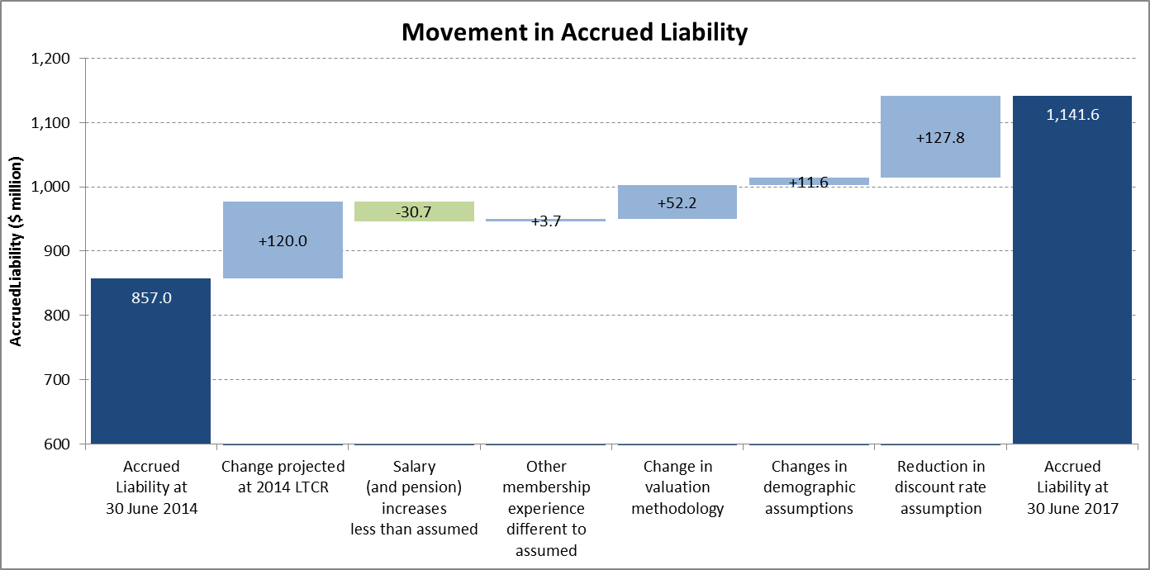

The most significant items are the reduction in the discount rate from 6% per annum to 5% per annum and the change in valuation methodology.

Further details are provided in Section 5.

Projected Outlays

The projected outlays of the Scheme for the next three years are as follows:

| Year Ending 30 June | Nominal Outlays ($ million) |
| --- | --- |
| 2018 | 51.7 |
| 2019 | 54.9 |
| 2020 | 57.4 |

Further detail regarding the projected outlays is contained in Section 6.

Notional Employer Contribution Rate

The notional employer contribution rate (NECR) represents the estimated contribution rate (as a percentage of serving judges’ salaries) that would be required to finance the benefits accruing over the next three years (from 1 July 2017 to 30 June 2020).

The NECR as at 30 June 2017 is calculated as 90.6% of salaries.

Further details are provided in Section 7.



# Scheme Information

The Scheme is governed by the *Judges’ Pensions Act 1968* (the Act) and covers the following office holders:

* + - * 1. Justices of the High Court of Australia;
        2. Judges of the Federal Court of Australia;
        3. Judges of the Family Court of Australia (including the Family Court of Western Australia);
        4. Judges of the Australian Capital Territory Supreme Court appointed before self-government; and
        5. Persons who, under the Act, have the same status of Justice or a Judge.

The Scheme remains open to new members.

Members do not contribute to the Scheme and the Australian Government meets all of the costs of benefits (except for one retired Judge of the ACT Supreme Court for whom the ACT Government funds 80% of the benefits) from Consolidated Revenue as they become due. This is an acceptable method of funding as the Scheme is effectively guaranteed by the Australian Government.

The Scheme is untaxed and no tax is levied on employer contributions. The Scheme is an exempt public sector superannuation scheme under the *Superannuation Industry (Supervision) Act 1993*.

The 2016 Federal Budget introduced a number of changes to the taxation of superannuation benefits. These changes have now been legislated and in most cases are effective from 1 July 2017.

The changes affect the taxation of superannuation benefits (including benefits paid by the Scheme), and impose additional administrative requirements. However, they are not expected to affect the cost of providing benefits payable from the Scheme.

We note also that since 30 June 2017 the Federal Government has passed legislation enabling same sex marriages to be recognised. This did not impact the Scheme financially as same sex partners were already eligible to receive spouse benefits from the Scheme.

Details of the benefits are set out in Appendix A.

# Membership and Data

This report has been based on data supplied by the Department of Finance which carries out the administration of the Scheme.

We have conducted a range of validity data checks including internal consistency and general reasonableness, and a reconciliation of membership movements, but we have not verified or audited any of the information provided. However, we are satisfied that the data is sufficiently accurate for the purpose of this report. The Scheme’s administrator is ultimately responsible for the validity, accuracy and comprehensiveness of this information.

The membership of the Scheme as at 30 June 2017 is summarised below:

| Serving  Judges | Headcount | | | Average Age | Annual Salaries |
| --- | --- | --- | --- | --- | --- |
| Males | Females | Total |
| High Court | 4 | 3 | 7 | 59.4 | $3,767,095 |
| Federal Court | 36 | 11 | 47 | 60.4 | $21,187,165 |
| Family Court | 21 | 16 | 37 | 61.0 | $16,688,911 |
| Fair Work Commission | 3 | - | 3 | 58.9 | $1,372,145 |
| **Total** | **64** | **30** | **94** | **60.5** | **$43,015,315** |

| Pensioners | Headcount | | | Average Age | Annual Pensions |
| --- | --- | --- | --- | --- | --- |
| Males | Females | Total |
| Retirement | 123 | 29 | 152 | 75.9 | $40,243,659 |
| Invalidity | 4 | 0 | 4 | 63.5 | # |
| Spouse | 3 | 47 | 50 | 79.6 | $8,380,958 |
| Associate Spouse* | 1 | 4 | 5 | 67.4 | # |
| **Total** | **131** | **80** | **211** | **76.4** | **$50,113,458** |

* Member’s former spouse following a Family Law split.

# Not separately disclosed

# Assumptions

In order to value the liabilities, it is necessary to make assumptions regarding the incidence, timing and amount of future benefits. These assumptions fall into two broad categories:

* + - * 1. economic assumptions: relating to the general economic environment and not directly to the membership of the Scheme; and
        2. demographic assumptions: relating to the experience of the membership of the Scheme.

This section sets out the assumptions used in this report and highlights any changes from those used for the 2014 LTCR. The assumptions are detailed in Appendix C.

In total, the changes in assumptions have resulted in an increase to the accrued liability of $139.3 million, or +13.9%, as at 30 June 2017.

Section 8 provides sensitivity analysis of the results under different individual assumptions.

Economic Assumptions

### Key Economic Assumptions

The key economic assumptions include:

* + - * 1. future increases in salaries, which also determines the level of pension increases; and
        2. a discount rate.

The relationships between the assumptions adopted for these factors have a greater bearing on the long term cost estimates of the Scheme than do the individual assumptions. This is due to the effect of one assumption being used to project the liability into the future (future salary and pension increases) and another assumption being used to discount that liability to current day values (discount rate).

The key economic assumptions are shown below together with the assumptions from the 2014 LTCR:

|  | Assumption as at 30 June 2017 | Assumption as at 30 June 2014 |
| --- | --- | --- |
| Salary and pension increases | 4% per annum | 4% per annum |
| Discount rate | 5% per annum | 6% per annum |

The discount rate assumption is consistent with that adopted for the PSS and CSS Long Term Cost Report 2017, which covers the Australian Government’s main civilian superannuation schemes, the Public Sector Superannuation Scheme (PSS) and the Commonwealth Superannuation Scheme (CSS). The salary and pension increase assumption is 0.5% per annum higher than the salary increase assumption adopted for the PSS and CSS Long Term Cost Report 2017, as discussed below.

### Salary and Pension Increases

The assumed rate for long term future salary and pension increases has been determined having regard to the average expected long term outlook for national wage inflation.

This approach differs slightly from the approach used to determine the salary increase assumption for the PSS and CSS Long Term Cost Report 2017. For those Schemes, consideration was also given to shorter term expectations for national wage growth, given the relatively short duration of salary linked liabilities. This resulted in a lower average salary increase assumption than that adopted for this Scheme.

### Discount Rate

The discount rate is used to calculate the present value of projected future benefit payments and provide a summary measure of those cash flows. The accrued liability represents the present value of the estimated future benefit payments in respect of service already rendered. A lower discount rate leads to a higher estimate of the unfunded liability, and vice versa.

The present value does not change the ultimate benefit payments, as these are dictated by actual experience, but does however provide a manageable way to assess and compare the value of expected future cash flows, expressed in today’s dollars.

The discount rate has been determined based on the expected return on Government bonds over the long term, as this would be the cost to the Australian Government were it to fund future benefit payments via borrowings. This contrasts to a funded scheme where a discount rate is typically based on an assumption for the investment earning rate on the scheme’s assets.

Consistent with the PSS and CSS Long Term Cost Report 2017, we believe a long term rate of 5% per annum is appropriate to assume as a discount rate.

Demographic Assumptions

The demographic assumptions adopted incorporate the results of an analysis of the membership experience. The analysis is set out in Appendix B. Details of the updated demographic assumptions are set out in Appendix C.

### Retirement

Assumed rates of retirement are unchanged from the 2014 LTCR.

### Invalidity

Rates of invalidity retirement are assumed to be the same as those used in the PSS and CSS Long Term Cost Report 2017, extended to age 70 (age 65 for Fair Work Commission). These rates are unchanged from the 2014 LTCR.

### Death

Based on Scheme experience, male retiree pensioners (other than invalidity pensioners) are assumed to experience mortality at 90% of the rates applicable in the PSS and CSS, while all other pensioners are assumed to experience mortality at the same rates applicable in the CSS. The assumed rates of death have been updated to reflect the assumptions used in the PSS and CSS Long Term Cost Report 2017.

Allowance has also been made for assumed future improvements (i.e. reductions) in pensioner mortality. Assumed improvement rates have been updated to reflect the short term (25 year experience) and long term (125 year experience) factors derived by the Australian Government Actuary and published in the Australian Life Tables 2010-12. The short term improvement factors are significantly higher (i.e. result in lower projected mortality) than the long term improvement factors.

Short term improvements are incorporated for the period 2018 to 2021, with long term improvements assumed thereafter.

### Spouse Assumptions

Assumptions regarding the proportion of members with a spouse, and the age of their spouse, are unchanged from the 2014 LTCR.

### Future New Entrants

Each departing Judge is assumed to be replaced by a new entrant. The assumed distribution and characteristics of new entrants is similar to that adopted for the 2014 LTCR but in a simplified form.

# Accrued Liability

The accrued liability represents the discounted present value of the estimated future benefit payments in respect of service already rendered to the Australian Government. These benefits payments are spread over many years into the future. The present value represents the amount which would need to be set aside at the valuation date to provide for these benefits at the time they are payable, assuming the valuation assumptions were borne out in practice.

Valuation Methodology

The valuation method evaluates, for each member, expected future benefit payments for each future year multiplied by the probability that the benefit will be payable in that year. The accrued liability is determined as the part of the total benefit which has accrued to the valuation date. The present value of the accrued liability is determined by discounting these expected payments back to the valuation date.

For the 2014 LTCR, two different methods were used to determine that part of the liability which had accrued up to the valuation date:

**Best Estimate Method -** Under this method, benefits were assumed to accrue to a member over a member’s entire expected service period (based on the assumptions adopted).

**AASB119 Method -** Under this method, benefits were assumed to accrue to each member over the period until the member first becomes eligible to receive a retirement benefit. That is, if a member joins prior to age 50, benefits are assumed to accrue over the period from joining to age 60. Upon becoming eligible there is no further accrual.

For the purposes of this valuation, we have adopted the AASB119 Method in determining the accrued liability (both at valuation date and in the future), for consistency with results reported in Australian Government financial statements.

For determining the NECR, we have adopted the Best Estimate Method. Our understanding is the primary use of this rate is to estimate the value of the benefits provided as a component of an individual’s overall remuneration. For this purpose, it is appropriate that the value be spread over an individual’s entire service period (i.e. the Best Estimate Method), rather than just the period until becoming eligible to receive a retirement benefit.

The calculation methodology is consistent with the requirements of Professional Standard No. 402 of the Institute of Actuaries of Australia *“Determination of Accrued Benefits for Defined Benefit Superannuation Funds”*.

Results

The following table shows the accrued liability of the Scheme as at 30 June 2017:

| As at  30 June 2017 | Accrued Liability  ($ million) |
| --- | --- |
| Serving Judges | 376.2 |
| Pensioners | 765.4 |
| **Total** | **1,141.6** |

Analysis of Change Compared with previous report

The 2014 LTCR projected that the accrued liability would be $977.0 million as at 30 June 2017, $164.6 million less than the actual accrued liability. The factors leading to the difference in the previously projected accrued liability are quantified in the following chart:



The most significant items are the reduction in the discount rate from 6% per annum to 5% per annum and the change in valuation methodology.

Projected Accrued Liability

Based on the assumptions used for this investigation, the projected nominal accrued liability over the next 40 years is shown below:

| As at  30 June | Accrued Liability  ($ million) |
| --- | --- |
| 2017 | 1,141.6 |
| 2018 | 1,178.1 |
| 2019 | 1,213.9 |
| 2020 | 1,250.8 |
| 2021 | 1,288.4 |
| 2022 | 1,327.6 |
| 2023 | 1,370.0 |
| 2024 | 1,415.0 |
| 2025 | 1,461.8 |
| 2026 | 1,509.2 |
| 2027 | 1,557.3 |
| 2028 | 1,609.6 |
| 2029 | 1,661.0 |
| 2030 | 1,715.4 |
| 2031 | 1,770.6 |
| 2032 | 1,827.5 |
| 2033 | 1,885.3 |
| 2034 | 1,942.7 |
| 2035 | 2,001.8 |
| 2036 | 2,063.5 |
| 2037 | 2,129.2 |
| 2038 | 2,197.4 |
| 2039 | 2,278.0 |
| 2040 | 2,358.5 |
| 2041 | 2,449.9 |
| 2042 | 2,544.0 |
| 2043 | 2,643.1 |
| 2044 | 2,750.3 |
| 2045 | 2,857.8 |
| 2046 | 2,974.4 |
| 2047 | 3,092.1 |
| 2048 | 3,219.2 |
| 2049 | 3,349.1 |
| 2050 | 3,485.8 |
| 2051 | 3,620.5 |
| 2052 | 3,768.1 |
| 2053 | 3,920.7 |
| 2054 | 4,083.0 |
| 2055 | 4,262.4 |
| 2056 | 4,441.9 |
| 2057 | 4,633.9 |

# Projected Outlays

The projected outlays represent the future cost of Scheme benefits paid each year. The expected (nominal) outlays for the next 40 years are:

| Year Ending 30 June | Nominal Outlays ($ million) |
| --- | --- |
| 2018 | 51.7 |
| 2019 | 54.9 |
| 2020 | 57.4 |
| 2021 | 60.5 |
| 2022 | 64.3 |
| 2023 | 68.1 |
| 2024 | 71.3 |
| 2025 | 74.9 |
| 2026 | 78.1 |
| 2027 | 81.6 |
| 2028 | 84.4 |
| 2029 | 88.4 |
| 2030 | 91.5 |
| 2031 | 95.4 |
| 2032 | 99.3 |
| 2033 | 103.0 |
| 2034 | 107.6 |
| 2035 | 111.5 |
| 2036 | 115.9 |
| 2037 | 120.1 |
| 2038 | 124.1 |
| 2039 | 127.5 |
| 2040 | 132.7 |
| 2041 | 136.3 |
| 2042 | 140.2 |
| 2043 | 144.7 |
| 2044 | 147.9 |
| 2045 | 152.9 |
| 2046 | 156.8 |
| 2047 | 162.8 |
| 2048 | 167.5 |
| 2049 | 172.6 |
| 2050 | 178.1 |
| 2051 | 185.9 |
| 2052 | 192.2 |
| 2053 | 200.2 |
| 2054 | 207.7 |
| 2055 | 213.9 |
| 2056 | 222.2 |
| 2057 | 230.1 |

# Notional Employer Contribution Rate

The notional employer contribution rate (NECR) represents the estimated contribution rates that would be required to finance the benefits accruing over the next three years (from 1 July 2017 to 30 June 2020). That is, if the Scheme was fully funded at the valuation date and contributions were made at the NECR, the liability for contributors would be expected to remain fully funded at the end of the period.

The NECR is determined using long term assumptions as this rate is notional in nature. No employer contributions are actually paid to the Scheme.

Method of Determining the Notional Employer Contribution Rates

A notional fund with initial assets equal to the accrued liabilities at the valuation date is projected for the three years to 30 June 2020, together with notional employer contributions, investment earnings and benefit payments in line with the valuation assumptions. The notional contributions are determined so that the projected notional assets are equal to the projected accrued liabilities after three years. The NECR is the notional employer contributions expressed as a constant annual percentage of projected salaries.

As described in Section 5 above, the NECR has been determined using the Best Estimate Method to determine the accrued liabilities at each relevant date.

Results

| NECR (% of Salaries) | |
| --- | --- |
| As at 30 June 2014 | 76.1 |
| As at 30 June 2017 | 90.6 |
| Movement | +14.5 |

The NECR has increased primarily due to the reduction in discount rate assumption.

# Sensitivity Analysis

Economic Assumptions

The sensitivity of the estimated accrued liability as at 30 June 2017 to the key economic assumptions was tested by measuring the effect of varying each key assumption in turn by plus or minus 1% whilst keeping all other assumptions unchanged.

The alternative assumptions used were:

* + - * 1. discount rate plus 1% (increased to 6% per annum);
        2. discount rate minus 1% (reduced to 4% per annum);
        3. salary and pension increases plus 1% (increased to 5% per annum); and
        4. salary and pension increases minus 1% (reduced to 3% per annum).

| Assumption | Accrued Liability as at 30 June 2017 ($ million) | Impact  ($ million) |
| --- | --- | --- |
| **Base case** | **1,141.6** | **-** |
| +1% per annum discount rate | 1,012.1 | -129.5 |
| -1% per annum discount rate | 1,299.2 | +157.6 |
| +1% per annum salary and pension increase | 1,293.6 | +152.0 |
| -1% per annum salary and pension increase | 1,014.3 | -127.3 |

Demographic Assumptions

The sensitivity of the estimated accrued liability to certain demographic assumptions was tested by measuring the effect of varying each assumption in turn whilst keeping all other assumptions unchanged.

The alternative assumptions used were:

* + - * 1. 5% higher pensioner mortality rates (e.g. a 3% probability of death becomes 3.15%);
        2. 5% lower pensioner mortality rates (e.g. a 3% probability of death becomes 2.85%); and
        3. future improvements in pensioner mortality in line with short term (25 year experience) factors only, with no reversion to long term factors after 2021.

| Assumption | Accrued Liability as at 30 June 2017 ($ million) | Impact  ($ million) |
| --- | --- | --- |
| **Base case** | **1,141.6** | **-** |
| 5% higher pensioner mortality | 1,123.9 | -17.7 |
| 5% lower pensioner mortality | 1,160.2 | +18.6 |
| 25 year experience future mortality improvements | 1,158.0 | +16.4 |

Please note that the alternative results shown above are illustrations only, and show what may occur under assumed future experiences which differ from the base case assumptions. These scenarios do not in any way constitute upper or lower bounds and the results may differ significantly from the ranges shown above, depending on actual future experience.

# Actuary’s Certification

Professional standards and scope

This report satisfies the requirements of Professional Standard No. 400 of The Institute of Actuaries of Australia. Professional Standard No. 400 relates to the preparation of reports commenting on the financial condition of defined benefit superannuation funds.

Use of report

This investigation report should not be relied upon for any other purpose or by any party other than the Australian Government. Mercer is not responsible for the consequences of any other use. This report should be considered in its entirety and not distributed in parts.

The advice contained in this report is given in the context of Australian law and practice. No allowance has been made for taxation, accountancy or other requirements in any other country.

Actuarial Uncertainty and Assumptions

An actuarial investigation provides a snapshot of a scheme’s financial condition at a particular point in time, and projections of a scheme’s estimated future financial position based on certain assumptions. It does not provide certainty in relation to a scheme’s future financial condition or its ability to pay benefits in the future.

Future funding and actual costs relating to a scheme are primarily driven by the scheme’s benefit design, the actual rate of salary inflation and any discretions exercised by the Australian Government. The scheme’s actuary does not directly control or influence any of these factors in the context of an actuarial investigation.

A scheme’s future financial position and the estimated long term cost depend on a number of factors, including the amount of benefits the scheme pays, the cause and timing of member withdrawals, plan expenses, the level of taxation and the amount earned on any assets invested to pay the benefits. These amounts and others are uncertain and unknowable at the valuation date, but are predicted to fall within a reasonable range of possibilities.

To prepare this report, assumptions, as described in Section 4, are used to select a single scenario from the range of possibilities. The results of that single scenario are included in this report.

However, the future is uncertain and a scheme’s actual experience will differ from those assumptions; these differences may be significant or material. In addition, differentassumptions or scenarios may also be within the reasonable range and results based on those assumptions would be different. For this reason this report also shows the impact on the results of certain changes in assumptions.

Actuarial assumptions may also be changed from one valuation to the next because of mandated requirements, scheme experience, changes in expectations about the future and other factors. We did not perform, and thus do not present, an analysis of the potential range of future possibilities and scenarios.

Because actual scheme experience will differ from the assumptions, decisions about benefit changes, investment policy, funding amounts, benefit security and/or benefit related issues should be made only after careful consideration of alternative future financial conditions and scenarios, and not solely on the basis of a set of results.

Prepared by:

|  |
| --- |
| signature |
| **Esther Conway**  Fellow of the Institute of Actuaries of Australia  Principal |

Peer Reviewed by:

|  |
| --- |
|  |
| **David Knox**  Fellow of the Institute of Actuaries of Australia  Partner |

25 June 2018

Summary of Benefits

This report covers liabilities relating to members of the Scheme. Provisions relating to the Scheme are set down in the *Judges’ Pensions Act 1968*. The provisions of the Scheme are complex and a **summary** of the principal provisions is set out below. It should not be used to calculate benefits for individuals.

Member Contributions

Members are not required to contribute to the Scheme. The Australian Government meets the whole cost of the Scheme.

Retirement Benefit

Minimum Age for Retirement Pension: Age 60

Maximum Age at Retirement (except FWC): Age 70

Maximum Age at Retirement (FWC): Age 65

The benefit payable for a judge who has attained 10 or more years of service and the minimum retirement age is a lifetime pension of 60% of the salary currently paid in respect of an equivalent appointment to that of the judge at the time of retirement.

The benefit payable for a judge who retires at the maximum retirement age and with at least six, but less than ten, years of service is a lifetime pension of 0.5% of the appropriate judicial salary for each completed month of service.

Invalidity Benefit

The benefit payable for a judge who is certified by the Finance Minister as having retired on the grounds of permanent disability or infirmity, is a lifetime pension of 60% of the salary currently paid in respect of an equivalent appointment to that of the judge at the time of invalidity retirement.

Spouse’s Benefit

On death in service of a married judge, 62.5% of the full pension the judge would have received had they retired either voluntarily or, if not eligible for a voluntary retirement pension, on the grounds of invalidity, on the date of their death.

On the death of a married retired judge, providing the marriage took place:

* + - * 1. prior to the later of retirement and age 60 years; or
        2. at least 5 years before the judge’s death;

62.5% of the full pension entitlement of the retired judge.

Note that marriage includes de facto relationships and same sex partners.

Resignation (or voluntary exit not included above) and Death in Service with no spouse

If voluntary exit occurs:

* + - * 1. prior to attainment of age 60 years; or
        2. prior to the maximum retiring age with less than 10 years judicial service; or
        3. at the maximum retiring age with less than 6 years of judicial service;

no benefit is payable from the Scheme if the judge commenced office prior to 1 July 2006.

If a judge dies in service with no spouse or eligible children, no benefit is payable from the Scheme if the judge commenced office prior to 1 July 2006.

Note that a small benefit would be payable under Superannuation Guarantee legislation where no benefit is payable from the Scheme.

For judges who commenced office on or after 1 July 2006, a lump sum accumulation benefit is payable from the Scheme at a level sufficient to meet Superannuation Guarantee requirements.

Family Law

The Scheme was amended with effect from 15 March 2013 to provide a new approach to splitting of superannuation for Family Law purposes. Before the change, the Scheme operated on a “percentage only” basis where the non-member spouse received a percentage of each pension payment during the member spouse’s lifetime. Following the change, the member spouse’s pension is reduced and a separate pension, or deferred pension, entitlement is created for the member’s former spouse. Transitional arrangements apply for some members who had pre-existing Family Law splits.

Superannuation Surcharge

The benefits set out above apply to those judges who have no surcharge debt account. If a judge has a surcharge debt account at the time a benefit becomes payable, benefits are reduced in line with the relevant legislative provisions. Superannuation surcharge was abolished for benefits accruing on or after 1 July 2005.

Experience of the Scheme

Reconciliation of Serving Judges

|  | High Court | Federal  Court | Family Court | Fair Work Commission | Total |
| --- | --- | --- | --- | --- | --- |
| **As at 30/06/14** | **7** | **46** | **38** | **13** | **104** |
| New | 2 | 9 | 4 | 0 | 15 |
| Age Retirement | 3 | 7 | 5 | 9 | 24 |
| Invalidity Retirement | 0 | 0 | 0 | 1 | 1 |
| Transfer | 1 | -1 | 0 | 0 | 0 |
| **As at 30/06/17** | **7** | **47** | **37** | **3** | **94** |

Reconciliation of Pensioners

|  | Retirement | Invalidity | Spouse | Associate Spouse | Total |
| --- | --- | --- | --- | --- | --- |
| **As at 30/06/14** | **143** | **3** | **44** | **4** | **194** |
| New | 24 | 1 | 10 | 1 | 36 |
| Deaths | 15 | 0 | 4 | 0 | 19 |
| Transfers | 0 | 0 | 0 | 0 | 0 |
| **As at 30/06/17** | **152** | **4** | **50** | **5** | **211** |

Salary and Pension Increases

At 1 July 2017, the salary paid to a Federal Court Judge was $449,840. The equivalent salary at 1 July 2014 was $412,550. This represents an average annual increase of 2.9% per annum.

Retirement

The following chart shows the actual number of retirements at each age in the three year review period, compared with the expected number based on the 2014 LTCR assumptions:

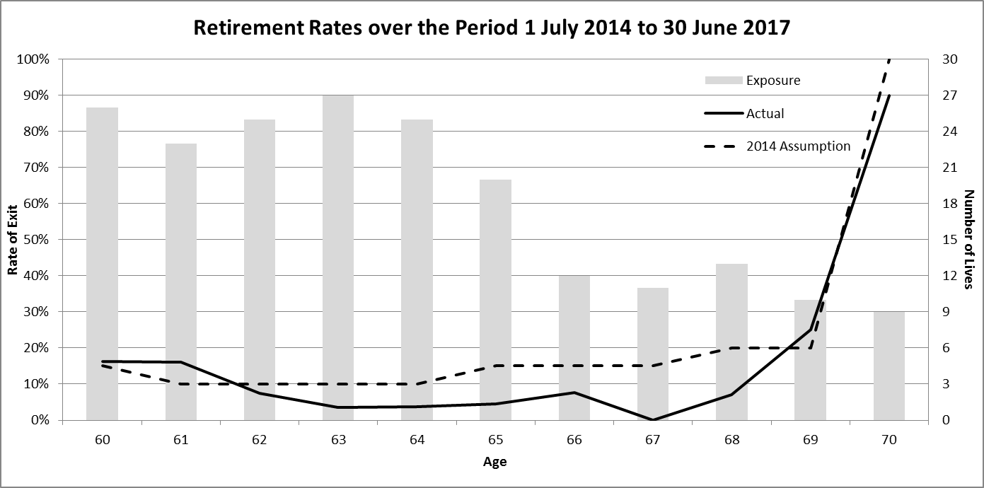

Overall, 24 Judges retired compared with 34 expected. Given the small size of the Scheme, we would expect to see significant variations in the numbers between different periods.

Invalidity

There was one invalidity retirement during the period which was in line with the number expected based on the 2014 LTCR assumptions.

Mortality

No Judges died in service during the review period.

Pensioner Mortality

The following table shows the actual number of pensioner deaths in the three year review period, compared with the expected number based on the 2014 LTCR assumptions:

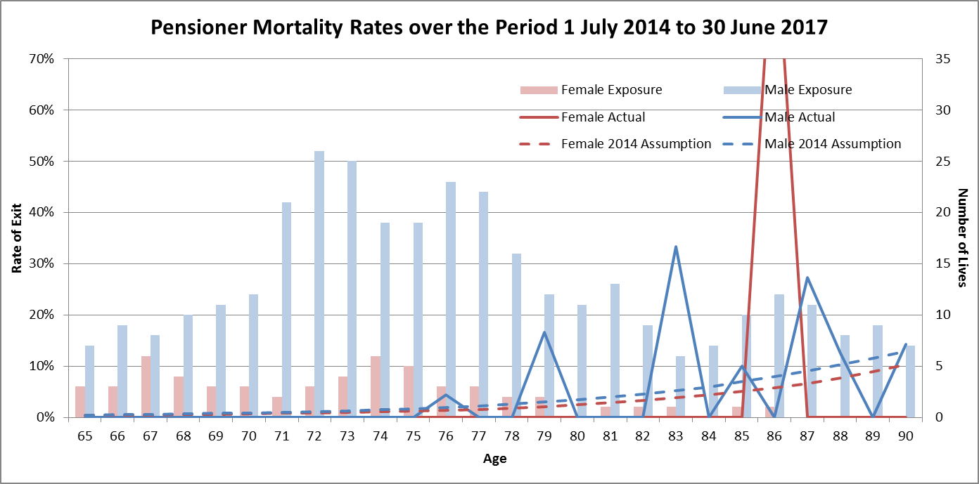

Overall, the number of pensioner deaths was broadly in line with the number expected based on the 2014 LTCR assumptions.

New Entrant Age distribution

In the previous investigation, the adopted new entrant distribution specified an assumed percentage for each age from 54 to 60 for High Court Judges and from 40 to 64 for non-High Court Judges. In order to fit within the Mercer valuation system we have simplified this to age 60 for High Court Judges and an assumed percentage for each 5 year age interval for non-High Court Judges.

As can be seen in the graph below, the age and gender distribution of new entrants has been broadly consistent with this (simplified) distribution:

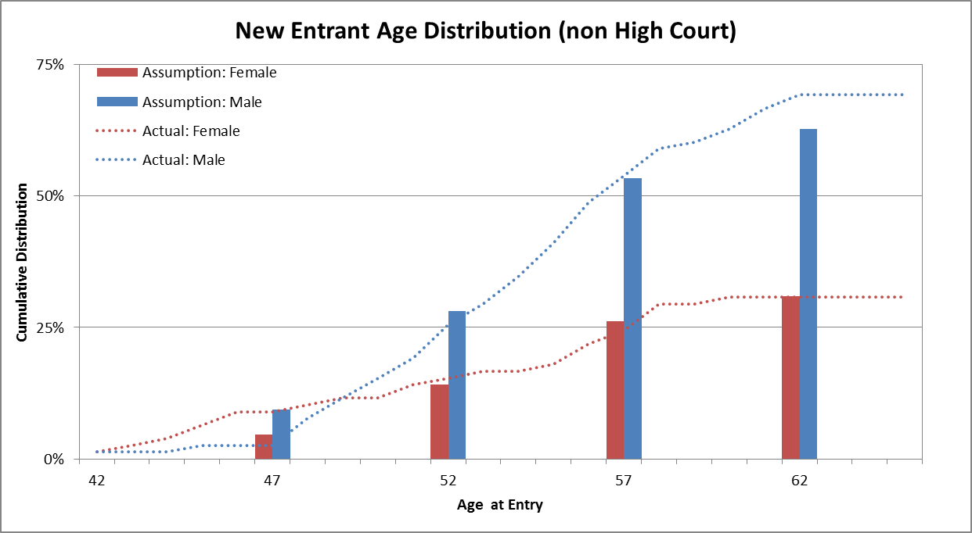

Details of Actuarial Assumptions

Economic Assumptions

### Discount Rate

The assumed long term average discount rate is 5% per annum.

### Salary and Pension Increases

The assumed long term rate of increase in salaries and pensions is 4% per annum.

### Taxation

No allowance has been made for:

* + - * 1. Superannuation surcharge, as members’ benefits are reduced by a surcharge offset amount.
        2. Excess contributions tax, as this is payable by the member.
        3. Division 293 tax on contributions for those with incomes above the threshold, is this is payable by the member.

In determining the projected outlays, no adjustment is made for any tax payable by members on receipt of a benefit.

### Superannuation Guarantee

Superannuation Guarantee legislation requires employers to provide a minimum level of superannuation benefits for their employees. Due to the generous nature of the Scheme benefits, the increase in the Superannuation Guarantee rate (which is currently 9.5% and increasing to 12% by 1 July 2025) does not have a material impact on the valuation results.

Demographic Assumptions

### Retirement Rates

Prior to maximum retiring age (70 except for the FWC where it is 65), Judges only become eligible for benefits upon both completion of 10 years’ service and attainment of age 60. No voluntary resignation or retirement is assumed before a Judge becomes eligible. Once eligible, retirement is assumed at the following rates, except in the first year of eligibility, where double the rate is assumed:

| Age | Fair Work Commission | Non-Fair Work Commission |
| --- | --- | --- |
| 60 | 15% | 15% |
| 61 | 10% | 10% |
| 62 | 10% | 10% |
| 63 | 10% | 10% |
| 64 | 10% | 10% |
| 65 | 100% | 15% |
| 66 | - | 15% |
| 67 | - | 15% |
| 68 | - | 20% |
| 69 | - | 20% |
| 70 | - | 100% |

### Death and Invalidity Retirement Rates

| Age | Death | | Invalidity | |
| --- | --- | --- | --- | --- |
| Male | Female | Male | Female |
| 45 | 0.063% | 0.041% | 0.127% | 0.164% |
| 50 | 0.088% | 0.062% | 0.194% | 0.255% |
| 55 | 0.124% | 0.106% | 0.305% | 0.426% |
| 60 | 0.183% | 0.173% | 0.601% | 0.646% |
| 65 | 0.274% | 0.269% | 0.704% | 0.851% |

### Pensioner Mortality Rates

| Age | Male | | | Female | | |
| --- | --- | --- | --- | --- | --- | --- |
| Retiree | Invalid | Widower | Retiree | Invalid | Widow |
| 55 | 0.146% | 0.291% | 0.358% | 0.146% | 0.325% | 0.214% |
| 60 | 0.231% | 0.519% | 0.602% | 0.208% | 0.530% | 0.330% |
| 65 | 0.418% | 0.973% | 1.036% | 0.341% | 0.874% | 0.515% |
| 70 | 0.799% | 1.707% | 1.835% | 0.640% | 1.476% | 0.863% |
| 75 | 1.550% | 2.863% | 3.029% | 1.166% | 2.432% | 1.490% |
| 80 | 3.215% | 5.251% | 5.281% | 2.293% | 3.952% | 2.830% |
| 85 | 6.635% | 9.655% | 9.490% | 4.827% | 7.579% | 5.728% |
| 90 | 12.454% | 15.417% | 15.665% | 9.911% | 14.078% | 10.683% |
| 95 | 21.888% | 23.847% | 23.847% | 17.328% | 21.202% | 18.933% |
| 100 | 37.139% | 35.329% | 35.329% | 30.897% | 35.151% | 33.393% |
| 105 | 100.000% | 100.000% | 100.000% | 100.000% | 100.000% | 100.000% |

The mortality rates shown above include assumed improvements to 2017.

### Future Mortality Improvements

Allowance is made for assumed future improvements (i.e. reductions) in pensioner mortality.

Improvements in mortality have been updated to reflect the short term (25 year experience) and long term (125 year experience) factors derived by the Australian Government Actuary and published in the Australian Life Tables 2010-12. The short term improvement factors are significantly higher (i.e. result in lower projected mortality) than the long term improvement factors.

Short term improvements are incorporated for the period 2018 to 2021, with long term improvements assumed thereafter.

### Proportion Married

| Age | Male | Female |
| --- | --- | --- |
| 60 | 95.0% | 95.0% |
| 70 | 94.4% | 88.5% |
| 80 | 84.4% | 58.5% |
| 90 | 57.6% | 13.5% |
| 100 | 15.4% | 0.9% |

The above rates include allowance for same sex marriages.

### Age Difference between Member and Spouse

It is assumed that male members are five years older than their spouse, and that female members are three years younger than their spouse.

### Future New Members

Fair Work Commissioners are assumed not to be replaced as the Scheme is no longer open to these individuals.

High Court Judges are assumed to be replaced by a new entrant aged 60. The assumed proportion of male and female new entrants is based on the current membership (i.e. 57% male and 43% female).

Other Judges are assumed to be replaced by a new entrant according to the following distribution:

| Age | Male | Female |
| --- | --- | --- |
| 47 | 10% | 5% |
| 52 | 20% | 10% |
| 57 | 27% | 13% |
| 62 | 10% | 5% |
| **Total** | **67%** | **33%** |

Mercer Consulting (Australia) Pty Ltd

ABN 55 153 168 140

Collins Square

727 Collins Street Melbourne VIC 3008

GPO Box 9946 Melbourne VIC 3001

www.mercer.com.au