Australian Government

Grants News – December 2018 Edition

***Great News!***

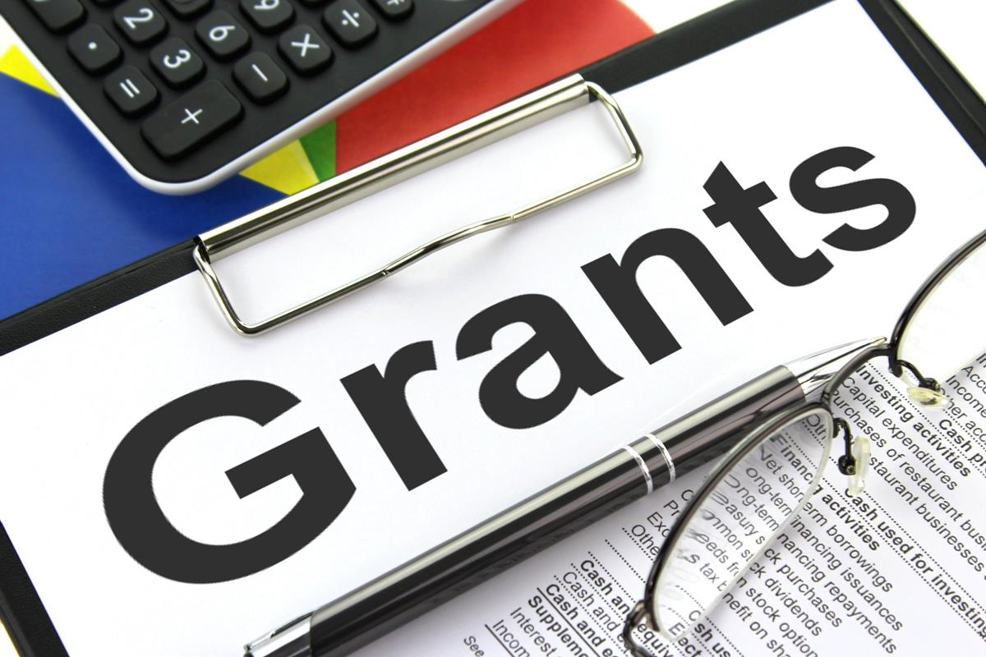

***This December edition of Grants News provides a number of interesting articles on:***

* ***Launch of Grant Guidelines and Grant Agreements Templates***
* ***Child Safe Framework***
* ***End of Year ‘wrap up’***

**It’s now LIVE!!!**

On 4 December 2018, the Department of Finance (Finance) hosted the end of year Community of Practice Forum. Speakers included officials from the Department of the Prime Minister and Cabinet who provided an overview of the Indigenous Grants Policy (IGP) and the cross agency collaborative IGP Trial.

GrantConnect and the Community Grants Hub teams provided updates with GrantConnect demonstrating the Go Application Submission.

To round off the Forum, Finance launched the Commonwealth Grant Guidelines and Grant Agreement template suites. As many of you have been involved in the development of the template suites, this was a great time to express our thanks for all your hard work.

The development of the templates is a great example of how, when we work together collaboratively, we can improve how we deliver on the Government’s objectives.

The new template suites are an innovative approach to meeting the Government’s commitment to simplify, standardise and improve the transparency of grants administration. The templates also seek to reduce red tape in grants processes.

The templates are for use by all non-corporate Commonwealth entities that undertake grants administration. They complement the Government’s ongoing work to streamline grants administration, through two grants administration hubs, established under the *Streamlining Government Grants Administration Program*.

The grant guidelines templates make it easier and more efficient for potential grant applicants to navigate and understand key requirements for submitting an application.

The grant agreement templates streamline and consolidate grant agreements between the Commonwealth and grantees through the use of standard terms and conditions. Through the use of these templates, non-government organisations are expected to experience lower administrative and legal costs, and better timeframes when entering into grant agreements.

Access the templates at www.[finance](https://www.finance.gov.au/resource-management/grants/).gov.au/resource-management/grants/

**Child Safe Framework**

**What is the Commonwealth Child Safe Framework?**

The Commonwealth Child Safe Framework (the Framework) sets minimum standards for creating and embedding child safe culture and practice in all Australian Government agencies. Under the Framework, agencies are required to:

* undertake risk assessments annually in relation to agency activities to identify the level of responsibility for, and contact with, children and young people, evaluate the risk of harm or abuse, and put in place appropriate strategies to manage identified risks;
* establish and maintain a system of training and compliance, to ensure staff are aware of, and compliant with, the Framework and relevant legislation, including working with children checks and mandatory reporting requirements; and
* adopt and implement the National Principles for Child Safe Organisations within 12 months of the Council of Australian Governments endorsement.

At a minimum, this will involve:

* clear internal child safe policies;
* child safe recruitment, screening and induction packages;
* ongoing training for all staff;
* procedures that reflect agencies’ commitment to upholding children’s rights;
* processes that are child-focused, trauma-informed, and culturally appropriate; and
* procedures for responding to concerns and complaints around child safety.

The Framework has been developed in response to recommendations of the Royal Commission into Institutional Responses to Child Sexual Abuse.

**Extending the Framework to third parties**

As part of the Australian Government’s commitment to child safety, minimum requirements for the protection of children are being extended through written agreements to organisations that receive Commonwealth funding, where the funded activity involves children (including funding through grants and procurements).

**What does this mean for Commonwealth grants?**The Australian Government has committed to applying the child safety obligations in the Framework to Commonwealth funded third parties where appropriate. The decision about when to use the child safety clause is at the discretion of the Accountable Authority of each Commonwealth agency.

It is recommended that a child safety clause should be included in written agreements where the funding is for:

* services directly to children. For example, providing early childhood learning services to children, providing telephone counselling services to primary school aged children or teaching children to abseil at an outdoor mentoring program; or
* activities that involve contact with children that is a usual part of, and more than incidental to, the funded activity. For example a service to train vulnerable parents may involve significant contact with the vulnerable parent’s child even if the service is directed at the parent.

**What clause should I use?**

A child safety clause has been drafted for use in the Commonwealth Standard Grant Agreement template (available from the Department of Finance). Clauses are also under development for use in the Commonwealth Simple Grant Agreement template and the Commonwealth Clause Bank for procurement.

There are a wide variety of written agreements in use by Commonwealth entities, you should seek advice from your internal legal service providers on your specific written agreement.

**Where can I get further information?**

For further information please contact the National Office for Child Safety CommonwealthChildSafe@dss.gov



### Subscribe to Grants News: <http://www.finance.gov.au/financial-framework/financial-management-policy-guidance/grants/news.htm>

### Submit an article: [grants@finance.gov.au](mailto:grants@finance.gov.au)

**Connecting Communities to Grants**

The 29 October 2018 Edition of **PS** [**News**](https://psnews.com.au/2018/10/29/grants-galore-for-armistice-celebrations/) featured an article on how important it is to connect communities to grant opportunities. The article spoke about how the Department of Veterans’ Affairs is to distribute more than 660 grants for community projects commemorating the 100th anniversary of the Armistice that ended   
World War I.

In all, more than $5.3 million will be shared under the *Armistice Centenary Grants Program.* Announcing the grants, Minister for Veterans’ Affairs, the Hon Darren Chester MP, said he was impressed with the projects that had been approved for funding, and the innovative ways groups were commemorating the centenary.

“Successful projects and activities include the restoration of relics from the First World War, installation of commemorative plaques, the creation of displays and books, activities to honour the role women played during the war, as well as the installation of honour boards,” Mr Chester said.

“Of two projects that particularly resonated, one was the establishment of a dedicated learning centre at Redfield College in Dural, NSW to educate students about Australia’s role in the First World War.

“The other was the production of a short documentary showcasing students’ work and learning about the centenary of the Armistice at St Mary’s Primary School in Dandenong, Victoria.”

The Minister said the projects were central to the goals of the Anzac Centenary 2014–18, creating a lasting legacy for those in the community and educating the younger generation of Australians of the service and sacrifice of those who served during World War I.

***We would like to acknowledge the above article was first published by PS News on 29 October 2018.***

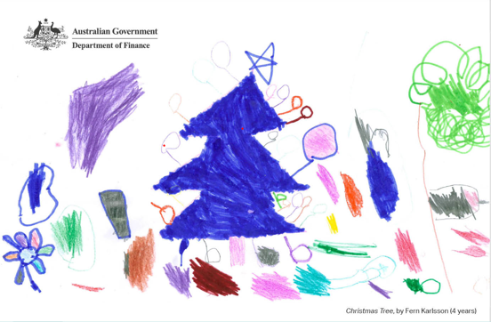

**GrantConnect**

**GrantConnect Statistics**

GrantConnect has been the single point of discovery for all Australian Government Grant Opportunities since 30 April 2017, and Grants Awarded information since 31 December 2017.

GrantConnect statistics as at 6 December 2018:

* Approx. 22,200 public - Registered Users, 400 Entity Users
* 1.1 million opportunity notifications emails have been sent to Registered Users
* 61 Forecast Opportunities published (40 linked to Grant Opportunities)
* 446 Grant Opportunities published with 42,000 downloads of grant guidelines
* Approx. 22,200 Grant Awards published with a total value $13.4 billion

**GrantConnect Application Submission**

* The final phase of the GrantConnect project for 2012 is ‘application submission’. This functionality has been developed and is in the final stages of user acceptance testing. With the assistance and input from a cross entity working group, it has taken just over   
  12 months to fully scope, build, test and deploy the functionality

A few key details:

* it is based on the proven, mature and robust AusTender lodgement functionality, in use since 2003;
* it is simple to use and free of charge;
* it provides a secure and encrypted application process;
* training and user guides will be available to support implementation; and
* support will be provided by the GrantConnect Help Desk.

For more information about GrantConnect, visit [www.grants.gov.au](http://www.grants.gov.au/) or watch the video available on [YouTube](https://www.youtube.com/watch?v=mS57X2RZ3MI).