USER GUIDE TO THE

PORTFOLIO BUDGET STATEMENTS

USER GUIDE

The purpose of the 2018-19 Portfolio Budget Statements (PB Statements) is to inform Senators and Members of Parliament of the proposed allocation of resources to government outcomes by entities within the portfolio. Entities receive resources from the annual appropriations, special appropriations (including standing appropriations and special accounts) and revenue from other sources.

A key role of the PB Statements is to facilitate the understanding of proposed annual appropriations in Appropriation Bills (No. 1 and No. 2) 2018-19 (or Appropriation (Parliamentary Departments) Bill (No. 1) 2018-19 for the parliamentary departments). In this sense, the PB Statements are Budget related papers and are declared by the Appropriation Acts to be ‘relevant documents’ to the interpretation of the Acts according to section 15AB of the Acts Interpretation Act 1901.

The PB Statements provide information, explanation and justification to enable Parliament to understand the purpose of each outcome proposed in the Bills.

As required under section 12 of the Charter of Budget Honesty Act 1998, only entities within the general government sector are included as part of the Commonwealth general government sector fiscal estimates and produce PB Statements where they receive funding (either directly or via portfolio departments) through the annual appropriations acts.

The Enhanced Commonwealth Performance Framework

The following diagram outlines the key components of the enhanced Commonwealth performance framework. The diagram identifies the content of each of the publications and the relationship between them. Links to the publications for each entity within the portfolio can be found in the introduction to Section 2: Outcomes and planned performance.

vii

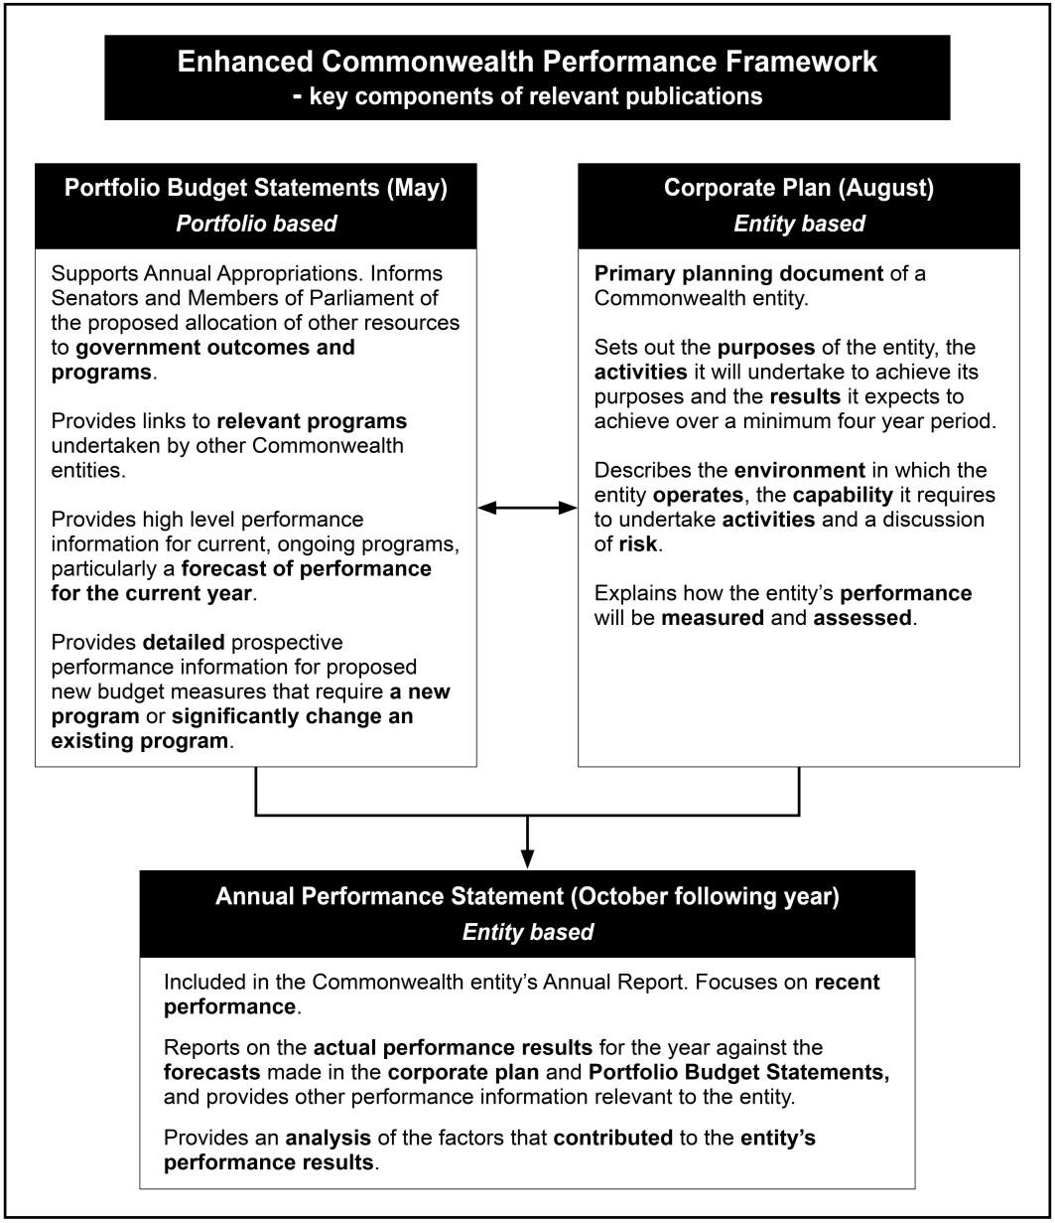

viii

PORTFOLIO OVERVIEW

FINANCE PORTFOLIO OVERVIEW

Ministers and portfolio responsibilities

The Minister for Finance has overall responsibility for the Finance portfolio and particular responsibility for the following:

- Budget policy advice and process and review of government programs.
- Government financial accountability, governance and financial management frameworks, including grants and procurement policy and services.
- Shareholder advice on Government Business Enterprises (GBEs) and commercial entities treated as GBEs.
- Policy guidance and management of act of grace requests and waiver of debts owed to the Commonwealth.
- General policy guidelines for Commonwealth statutory authorities.
- Superannuation arrangements for Australian Government civilian employees and parliamentarians and retirement benefits for Governors-General, Federal Judges and Federal Court Judges.
- Asset sales.
- Policy advice on the Future Fund and Australian Government Investment Funds and authorisation of payments from Australian Government Investment Funds to entities.

The Special Minister of State has responsibility for the following:

- Administration of Parliamentary entitlements.
- Members of Parliament (Staff) Act 1984 (MOP(S)) Act employment framework1.
- Electoral administration and electoral policy.

1. Shared responsibility with the Hon Malcolm Turnbull MP, Prime Minister

Portfolio overview

The Assistant Minister for Finance assists the Finance Minister in performing functions in relation to:

- Whole-of-Government property policy and administration, including non Defence owned estate.
- The Public Works Committee.
- Western Sydney Airport (excluding appointments).
- Moorebank Intermodal Terminal (excluding appointments).
- Government campaign advertising.
- Service Delivery and Coordination Committee (SDCC) on the government’s campaign advertising.
- Requests for act of grace payments and waivers of debt under the Public Governance, Performance and Accountability Act 2013.
- Comcover, the government’s self-managed insurance fund.
- Responding to correspondence relating to the administration of government superannuation.

For information on resourcing across the portfolio, please refer to part 1: Agency Financial Resourcing in Budget Paper No. 4: Agency Resourcing.

Portfolio overview

Figure 1: Finance portfolio structure and outcomes

Minister for Finance Special Minister of State
Senator the Hon Mathias Cormann

Assistant Minister for Finance
The Hon David Coleman MP
Department of Finance
Portfolio Secretary: Rosemary Huxtable PSM

Outcome 1 Support sustainable Australian Government finances through providing high quality policy advice and operational support to the government and Commonwealth entities to maintain effective and efficient use of public resources.

Outcome 2 Support an efficient and high-performing public sector through providing leadership to Commonwealth entities in ongoing improvements to public sector governance, including through systems, frameworks, policy, advice and service delivery.

Outcome 3 Support for Parliamentarians and others as required by the Australian Government through the delivery of and advice on, work expenses and allowances, entitlements and targeted programs.
Australian Electoral Commission
Electoral Commissioner: Tom Rogers

Outcome 1 Maintain an impartial and independent electoral system for eligible voters through active electoral roll management, efficient delivery of polling services and targeted education and public awareness programs.
Commonwealth Superannuation Corporation
Chair: Patricia Cross

Outcome 1 Retirement and insurance benefits for scheme members and beneficiaries, including past, present and future employees of the Australian Government and other eligible employers and members of the Australian Defence Force, through investment and administration of their superannuation funds and schemes.
Future Fund Management Agency
Chair: Hon Peter Costello AC

Outcome 1 Make provision for the Commonwealth’s unfunded superannuation liabilities, payments for the creation and development of infrastructure and payments from the DisabilityCare Australia Fund and Medical Research Future Fund by managing the investment activities of the Future Fund, Nation-building Funds, DisabilityCare Australia Fund and Medical Research Future Fund, in line with the Government’s investment mandates.
Independent Parliamentary Expenses Authority
CEO: Annwyn Godwin
Outcome 1 Support for current and former Parliamentarians and others as required by the Australian Government through the delivery of, independent oversight and advice on, work resources and travel resources.

