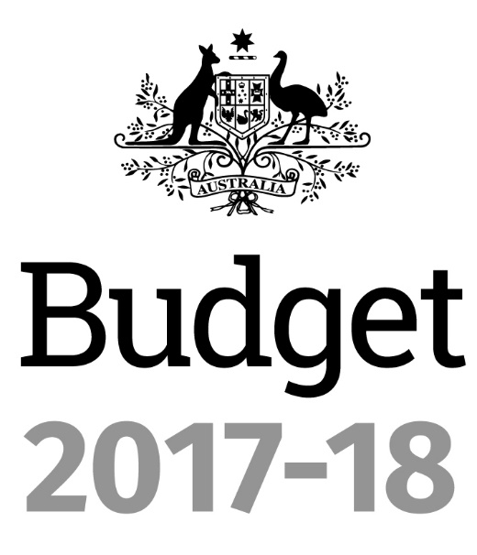

**Portfolio Budget Statements 2017‑18**

**Budget Related Paper No. 1.8**

Finance Portfolio

Budget Initiatives and Explanations of

Appropriations Specified by Outcomes

and Programs by Entity

© Commonwealth of Australia 2017

ISBN 978-1-76044-849-3

This publication is available for your use under a [Creative Commons BY Attribution 3.0 Australia](http://creativecommons.org/licenses/by/3.0/au/deed.en) licence, with the exception of the Commonwealth Coat of Arms, the Department of Finance (Finance) logo, photographs, images, signatures and where otherwise stated. The full licence terms are available from <http://creativecommons.org/licenses/by/3.0/au/legalcode>.

cc

Use of Finance material under a [Creative Commons BY Attribution 3.0 Australia](http://creativecommons.org/licenses/by/3.0/au/deed.en) licence requires you to attribute the work (but not in any way that suggests that Finance endorses you or your use of the work).

*Australian Government Department of Finance material used 'as supplied'*

Provided you have not modified or transformed Finance material in any way including, for example, by changing Finance text; calculating percentage changes; graphing or charting data; or deriving new statistics from published Finance statistics – then Finance prefers the following attribution:

*Source: The Australian Government Department of Finance*

**Derivative material**

If you have modified or transformed Finance material, or derived new material from those of Finance in any way, then Finance prefers the following attribution:

*Based on the Australian Government Department of Finance data*

**Use of the Coat of Arms**

The terms under which the Coat of Arms can be used are set out on the It’s an Honour website (see [www.itsanhonour.gov.au](http://www.itsanhonour.gov.au))

**Other Uses**

Enquiries regarding this licence and any other use of this document are welcome at:

Copyright Coordinator

Department of Finance

One Canberra Avenue

FORREST ACT 2603

Email: publications@finance.gov.au

President of the Senate

Australian Senate

Parliament House

CANBERRA ACT 2600

Speaker

House of Representatives

Parliament House

CANBERRA ACT 2600

Dear Mr President

Dear Mr Speaker

I hereby submit Portfolio Budget Statements in support of the 2017-18 Budget for the Finance Portfolio.

These statements have been developed, and are submitted to Parliament, as a statement on the outcomes for the portfolio.

I present these statements to provide accountability to the Parliament, and, through it, to the public.

Kind regards

Mathias Cormann

**Minister for Finance**

May 2017

Parliament House, Canberra ACT 2600 Telephone: (02) 6277 7400 ~ Facsimile: (02) 6273 4110

#### Abbreviations and conventions

The following notation may be used:

NEC/nec not elsewhere classified

- nil

.. not zero, but rounded to zero

na not applicable (unless otherwise specified)

nfp not for publication

$m $ million

$b $ billion

Figures in tables and in the text may be rounded. Figures in text are generally rounded to one decimal place, whereas figures in tables are generally rounded to the nearest thousand. Discrepancies in tables between totals and sums of components are due to rounding.

#### Enquiries

Should you have any enquiries regarding this publication, please contact the   
Chief Finance Officer, Department of Finance, on (02) 6215 2222.

Links to Portfolio Budget Statements (including Portfolio Additional Estimates Statements and Portfolio Supplementary Additional Statements) can be located on the Australian Government Budget website at: http://www.budget.gov.au.

User Guide

to the

Portfolio Budget Statements

# User guide

The purpose of the *2017-18 Portfolio Budget Statements* (PB Statements) is to inform Senators and Members of Parliament of the proposed allocation of resources to government outcomes by entities within the portfolio. Entities receive resources from the annual appropriations acts, special appropriations (including standing appropriations and special accounts), and revenue from other sources.

A key role of the PB Statements is to facilitate the understanding of proposed annual appropriations in Appropriation Bills (No. 1 and No. 2) 2017-18 (or Appropriation (Parliamentary Departments) Bill *(*No. 1) 2017-18 for the parliamentary departments). In this sense, the PB Statements are Budget related papers and are declared by the Appropriation Acts to be ‘relevant documents’ to the interpretation of the Acts according to section 15AB of the *Acts Interpretation Act 1901*.

The PB Statements provide information, explanation and justification to enable Parliament to understand the purpose of each outcome proposed in the Bills.

As required under section 12 of the *Charter of Budget Honesty Act 1998*, only entities within the general government sector are included as part of the Commonwealth general government sector fiscal estimates and produce PB Statements where they receive funding (either directly or via portfolio departments) through the annual appropriation acts.

**The Enhanced Commonwealth Performance Framework.**

The following diagram outlines the key components of the enhanced Commonwealth performance framework. The diagram identifies the content of each of the publications and the relationship between them. Links to the publications for each entity within the portfolio can be found in the introduction to Section 2: Outcomes and planned performance.

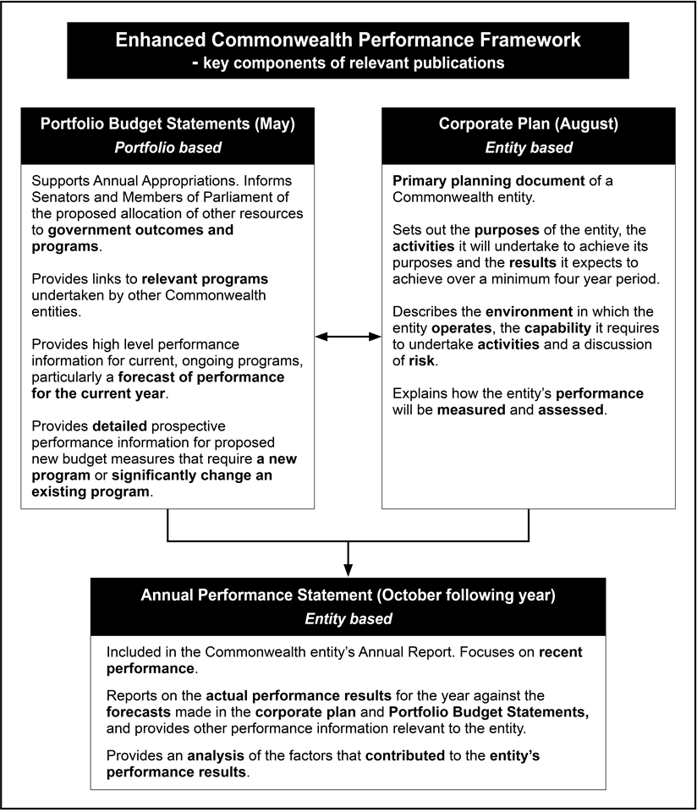

# Contents

FINANCE PORTFOLIO OVERVIEW 1

ENTITY RESOURCES AND PLANNED PERFORMANCE 7

Department of Finance 9

Australian Electoral Commission 67

Commonwealth Superannuation Corporation 89

Future Fund Management Agency 109

Independent Parliamentary Expenses Authority 131

PORTFOLIO GLOSSARY 149

Portfolio Overview

# Finance Portfolio Overview

## Ministers and portfolio responsibilities

The Ministers responsible for the Finance portfolio and its entities are:

* Senator the Hon Mathias Cormann, Minister for Finance; and
* Senator the Hon Scott Ryan, Special Minister of State.

The Minister for Finance has overall responsibility for the Finance portfolio, and particular responsibility for the following:

* Budget policy advice and process, and review of governmental programs.
* Government financial accountability, governance and financial management frameworks, including grants and procurement policy and services.
* Shareholder advice on Government Business Enterprises (GBEs) and commercial entities treated as GBEs.
* Policy guidance and management of Act of Grace requests and waiver of debts owed to the Commonwealth.
* General policy guidelines for Commonwealth statutory authorities.
* Superannuation arrangements for Australian Government civilian employees and parliamentarians, and retirement benefits for Governors-General, Federal Judges and Federal Court Judges.
* Asset sales.
* Policy advice on the Future Fund and the Australian Government Investment Funds, and authorisation of payments from the Australian Government Investment Funds to entities.
* The Public Works Committee.
* The administration of the Commonwealth non-Defence property portfolio and lease arrangements, with a view to reducing the Commonwealth’s property holdings and ensuring lease arrangements deliver better value for money across government.

The Special Minister of State is responsible for the following:

* Administration of parliamentary expenses.
* *Members of Parliament (Staff) Act 1984* (MOPs) employment framework[1].
* Electoral administration and electoral policy[2].
* Requests for act of grace payments and waivers of debt under the *Public Governance, Performance and Accountability Act 2013*.
* Government campaign advertising.
* Service Delivery and Coordination Committee on the government’s campaign advertising.
* Comcover, the government’s self-managed insurance fund.
* Responding to correspondence relating to the administration of government superannuation.

For information on resourcing across the portfolio, please refer to Part 1: Agency Financial Resourcing in *Budget Paper No. 4: Agency Resourcing*.

Figure 1: Finance portfolio structure and outcomes

**Minister for Finance**

Senator the Hon Mathias Cormann

**Special Minister of State**

Senator the Hon Scott Ryan

Pet

**Department of Finance**

Portfolio Secretary: Rosemary Huxtable PSM

**Outcome 1** Support sustainable Australian Government finances through providing high quality policy advice and operational support to the government and Commonwealth entitiestomaintain effective and efficient use of public resources.

**Outcome 2** Support an efficient and high-performing public sector through providing leadership to Commonwealth entities in ongoing improvements to public sector governance, including through systems, frameworks, policy, advice, and service delivery.

**Outcome 3** Support for Parliamentarians and others as required by the Australian Government through the delivery of, and advice on, work expenses and allowances, entitlements and targeted programs.

**Commonwealth Superannuation Corporation**

Chair: Patricia Cross

**Outcome 1** Retirement and insurance benefits for scheme members and beneficiaries, including past, present and future employees of the Australian Government and other eligible employers and members of the Australian Defence Force, through investment and administration of their superannuation funds and schemes.

**Australian Electoral Commission**

Electoral Commissioner: Tom Rogers

**Outcome 1** Maintain an impartial and independent electoral system for eligible voters through active electoral roll management, efficient delivery of polling services, and targeted education and public awareness programs.

**Future Fund Management Agency**

Chief Executive Officer: Hon Peter Costello AC

**Outcome 1** Make provision for the Commonwealth’s unfunded superannuation liabilities, payments for the creation and development of infrastructure, and payments from the DisabilityCare Australia Fund and Medical Research Future Fund by managing the investment activities of the Future Fund, Nation-building Funds, DisabilityCare Australia Fund and Medical Research Future Fund, in line with the Government’s investment mandates.

**Independent Parliamentary Expenses Authority**

Chief Executive Officer: Leonie McGregor

**Outcome 1** Support for current and former Parliamentarians and others as required by the Australian Government through the delivery of, independent oversight and advice on, work resources and travel resources.

1. Shared responsibility with the Prime Minister.
2. Working together with the Minister for Finance on electoral policy, including developing government responses to recommendations made by the Joint Standing Committee on Electoral Matters.