Consolidated Financial Statements, including the Australian Government and General Government Sector Financial Reports
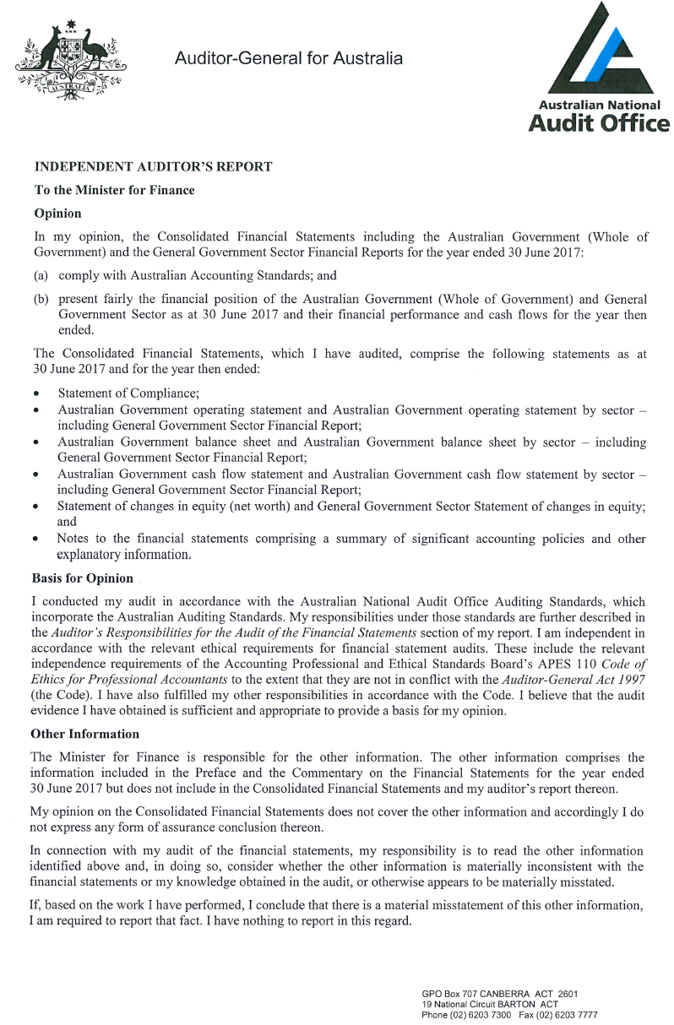
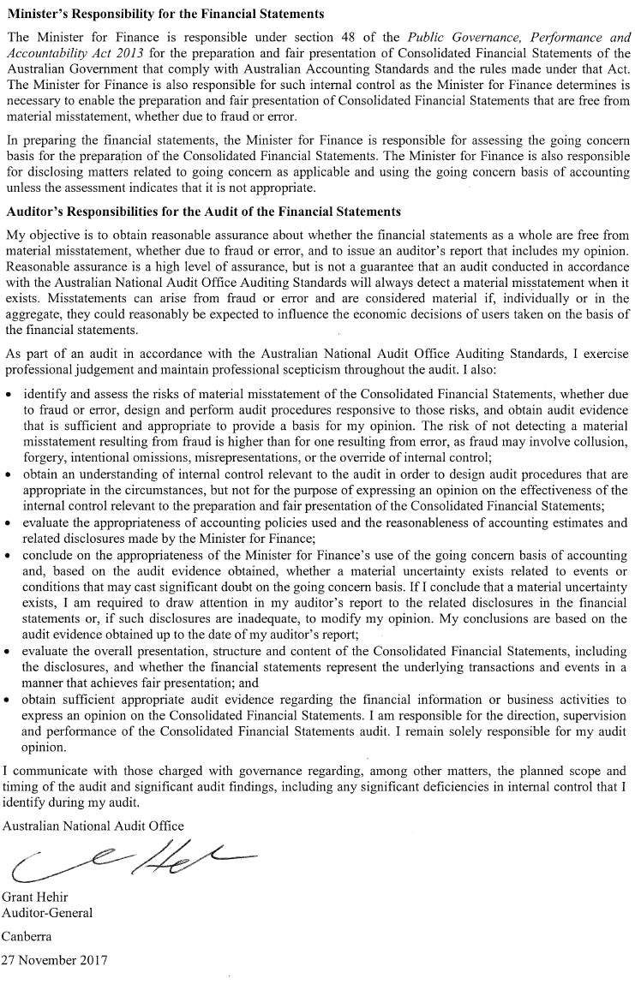
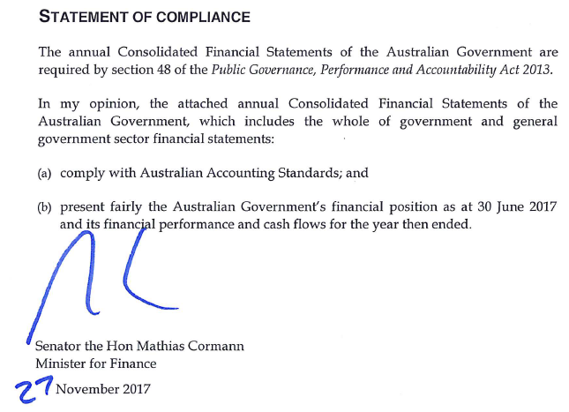

Australian Government operating statement
for the year ended 30 June 2017
Australian Government balance sheet
as at 30 June 2017

Australian Government cash flow statement
for the year ended 30 June 2017

Statement of changes in equity (net worth)
Consolidated financial statements
for the year ended 30 June 2017
(a) The opening balance as at 1 July 2015 has been restated by $190 million for a change in the percentage used to calculate the taxes receivable credit amendment allowance and provision for tax refunds.

The above statements should be read in conjunction with the accompanying notes.

