Commentary on the
consolidated financial statements

Introduction
The 2015-16 Consolidated Financial Statements (CFS) for the Australian Government present the whole of government and general government sector (GGS) financial reports and are prepared in accordance with AASB 1049 Whole of Government and General Government Sector Financial Reporting (AASB 1049). They are required by section 48 of the Public Governance, Performance and Accountability Act 2013 (PGPA Act).
The CFS include the consolidated results for all Australian Government controlled entities as well as disaggregated information on the sectors of government (GGS, public non-financial corporations (PNFC) and public financial corporations (PFC)). Unless explicitly stated, the financial results reported in this commentary comprise consolidated amounts for the Australian Government as a whole, inclusive of the GGS, and PNFC and PFC sectors.
The GGS results in the CFS materially align with the 2015-16 Final Budget Outcome, with the exception of the different measurement basis used for specialist military equipment, and advances paid to the International Development Association and Asian Development Fund.

At a glance
Table 1: Financial results for the year ended 30 June 2016
- Fiscal balance (or net lending/borrowing) is the net operating balance less net capital investment.
- Net worth is calculated as total assets minus total liabilities.

Operating Statement (Fiscal Balance)
Table 2: Operating statement

Chart 1: Operating statement (per cent of GDP) since 2007-08
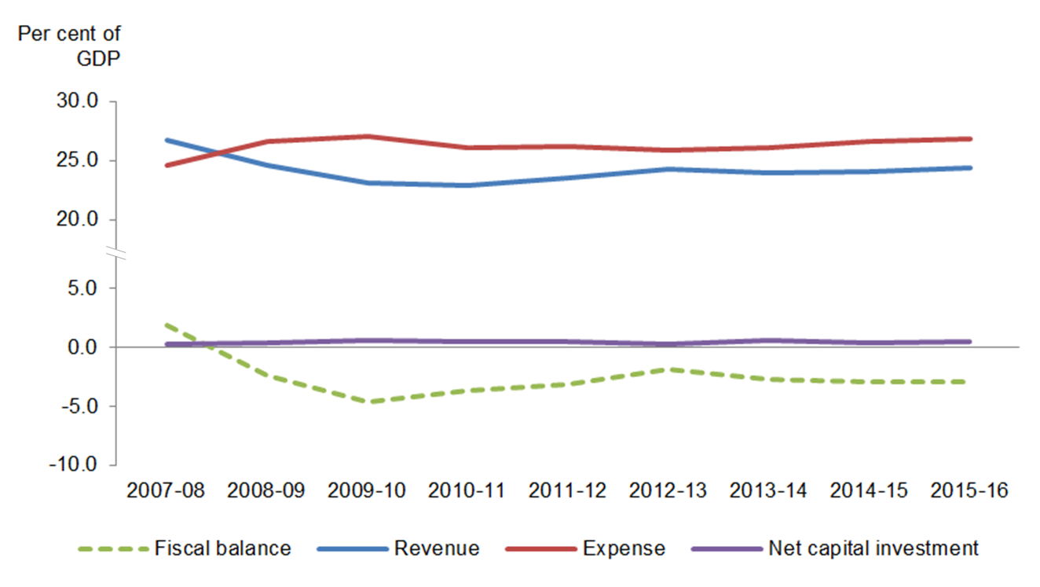

Balance Sheet (net worth)
Table 3: Balance sheet
- Net financial worth equals total financial assets minus total liabilities.
- Net debt equals the sum of the deposits held, government securities, loans and other borrowing, minus the sum of the cash and deposits, advances paid and investments, loans and placements.

Chart 2: Balance sheet (per cent of GDP) since 2007-08

Discussion and analysis

Fiscal balance
The Australian Government’s fiscal balance was a deficit of $47.3 billion for the year ended 30 June 2016, an increase of $0.5 billion (1.1 per cent) against the 30 June 2015 result.
Table 4: Operating statement

Chart 3 below shows the composition of the Australian Government’s fiscal balance since 2007-08.
Chart 3: Operating statement since 2007-08

Revenue
The Australian Government’s revenue increased by $15.1 billion (3.9 per cent) in
2015-16 to $402.5 billion.
Table 5: Revenue

Taxation revenue
The Australian Government’s total taxation revenue for the year ended 30 June 2016 was $368.9 billion. The composition of taxation revenue is shown in Chart 4 below.
Chart 4: Composition of taxation revenue
* Other includes Superannuation funds ($6.8 billion), Other indirect taxation ($5.8 billion), Fringe benefits tax ($4.5 billion) and Resource rent taxes ($0.9 billion).

Taxation revenue increased by $13.5 billion (3.8 per cent) to $368.9 billion. The key changes were:
- an increase of $9.2 billion (5.1 per cent) in individuals and other withholding taxation. The growth in individuals and other withholding taxation is broadly consistent with the moderate growth in the labour market, as well as growth in individuals’ incomes and capital gains;
- an increase of $4.1 billion (7.1 per cent) in sales taxes, with the main contributor being a $4.0 billion increase in goods and services tax (GST), consistent with growth in consumption subject to GST;
- a decrease of $1.5 billion (2.4 per cent) in company tax. This was due to weaker profitability in non-finance industries; and
- a decrease in excise duty of $2.1 billion (8.7 per cent) and an increase in customs duty of $3.2 billion (29.1 per cent), is largely due to a shift from domestic tobacco production to imported tobacco products.
Refer to Note 3A of the 2015-16 CFS for further information.

Non-taxation revenue
The Australian Government’s total non-taxation revenue for the year ended 30 June 2016 was $33.6 billion. For more information, refer to Notes 3B-D of the 2015-16 CFS.

Expenses
The Australian Government’s total expenses for the year ended 30 June 2016 were $442.0 billion. The composition of expenses is shown in Chart 5 below.
Chart 5: Composition of expenses

The Australian Government’s total expenses increased by $13.4 billion (3.1 per cent) in comparison to 2014-15. The key changes were:
- an increase in gross operating expenses of $10.2 billion (8.0 per cent). This was driven by an increase of $6.5 billion in the supply of goods and services expense, mainly due to:
  - an increase in benefits to households in goods and services ($3.8 billion) primarily relating to Pharmaceutical Benefits and Services ($1.7 billion), Medical Services and Benefits ($1.1 billion) and Assistance to the Aged ($0.9 billion);
  - an increase in the supply of goods and services for the Defence function ($1.7 billion);
- an increase of $1.8 billion in personal benefits expense, primarily relating to Income Support for Seniors; and
- an increase of $1.4 billion in grants. The primary contributors to the increase included:
  - an increase of $4.0 billion in grants to state and territory governments, primarily for General Revenue Assistance ($2.6 billion) and Assistance to the States for Healthcare Services ($1.7 billion); partially offset by
  - a decrease of $1.8 billion in grants through state and territory governments, primarily due to Local Government Financial Assistance Grants brought forward in June 2015.
Chart 6 below provides a presentation of total expenses based on how the Australian Government allocated resources across the range of policy areas. The chart highlights the relative cost of each function for 2015-16.
Chart 6: Total expenses by function

Refer to Note 4 of the 2015-16 CFS for further information on expenses.

Net worth
The Australian Government’s net worth decreased by $114.2 billion in 2015-16 to a negative net worth of $414.0 billion as at 30 June 2016.
Table 6: Balance sheet

Chart 7 below shows the composition of the Australian Government’s financial position since 2007-08.

Chart 7: Balance sheet since 2007-08

Assets
The Australian Government’s total assets as at 30 June 2016 were $594.2 billion. The composition of assets is shown in Chart 8 below.
Chart 8: Composition of assets

Table 7: Assets

The Australian Government’s total assets increased by $52.3 billion (9.6 per cent) since 30 June 2015.
The key changes in financial assets were:
- an increase of $34.4 billion in investments, loans and placements, which had a number of variances across multiple entities. The largest of these included an increase of $10.4 billion in non-equity investments held by the Future Fund, a $9.8 billion increase in Australian dollar securities and foreign exchange holdings held by the Reserve Bank of Australia and a $5.4 billion increase to the International Monetary Fund (IMF) quota;
- an increase of $6.4 billion in advances paid, mainly due to the Higher Education Loan Program scheme driven by an increase in loans;
- an increase of $2.5 billion in other receivables and accrued revenue, primarily resulting from decreases to offsetting provision accounts for:
  - provisions for doubtful debts – other taxes ($1.3 billion), due to increased settlement amounts for high value cases;
  - provisions for credit amendments to tax – other taxes ($1.2 billion), due to the settlement of a group of large cases in 2015-16, together with a $0.4 billion restatement to the 2014-15 provision; and
- a decrease of $3.3 billion in equity investments, primarily resulting from a reduction in listed equities and listed managed investment schemes held by the Future Fund.
The key changes in non-financial assets between 30 June 2015 and 30 June 2016 included the following:
- an increase of $5.1 billion for other plant, equipment and infrastructure, primarily driven by an increase of $4.6 billion in network assets for the rollout of the National Broadband Network;
- an increase of $4.3 billion for specialist military equipment, primarily as a result of additions; and
- an increase of $1.2 billion for intangibles, primarily driven by computer software additions by the NBN Co Ltd ($0.5 billion) and impairment reversals for water assets ($0.4 billion).

Liabilities
The Australian Government’s total liabilities were $1,008.2 billion as at 30 June 2016. The composition of liabilities is shown in Chart 9 below.
Chart 9: Composition of liabilities

Table 8: Liabilities

The Australian Government’s liabilities increased by $166.5 billion (19.8 per cent) since 30 June 2015.
The increase of $91.9 billion in interest bearing liabilities primarily resulted from:
- an increase of $76.7 billion in the issuance volume and market value of Australian Government Securities held by the AOFM;
- an increase of $5.6 billion in deposits held, primarily due to an increase in deposits with foreign governments, foreign institutions and international organisations;
- an increase of $5.0 billion in loans, primarily due to an increase in bills of exchange and promissory notes issued to the IMF; and
- an increase of $3.9 billion in other interest bearing liabilities, primarily due to increased amounts outstanding under repurchase agreements ($2.7 billion) and swap principal payables ($0.7 billion).
The increase in provisions and payables of $74.6 billion primarily resulted from:
- an increase of $66.4 billion in the superannuation liability predominantly due to a 1.0 percentage point decrease in the long-term government bond rate used to discount expected future superannuation payments;
- an increase of $4.7 billion in Australian currency (notes) on issue;
- an increase in other provisions of $2.2 billion, mainly driven by adjustments to the military compensation health care provision ($1.0 billion) and university superannuation provision ($0.9 billion) following actuarial revaluations; and
- an increase of $1.5 billion in other employee liabilities, mainly resulting from adjustment to the provision for military workers’ compensation following actuarial revaluation.

Cash flows
Table 9: Cash flow

The Australian Government’s cash balance was $5.7 billion at 30 June 2016. For the year ended 30 June 2016, the Australian Government recorded a cash deficit of $43.6 billion, an increase of $6.0 billion compared to a cash deficit of $37.6 billion for 2014-15.

Receipts and payments
The following charts provide a detailed break-down of Australian Government receipts and payments for 2015-16, showing the relative composition of each dollar received and paid.
Chart 10: Composition of each dollar of cash received in 2015-16
Chart 11: Composition of each dollar of cash paid in 2015-16

Chart 12 provides the trend of the Australian Government’s receipts and payments for operating activities and purchases/sales of non-financial assets since 2007-08.
Chart 12: Receipts and payments – operating and non-financial assets

APPENDIX A

Previous Years
The CFS since 1995-96 are available on the Department of Finance website at:
http://www.finance.gov.au/publications/commonwealth-consolidated-financial-statements.
The historical series datasets are available in electronic format at:
http://data.gov.au/dataset/australian-government-consolidated-financial-statements-tables-and-data.

Links to other publications
The Australian Government publishes a range of information about its projected and actual financial position. Links to some of these documents are set out below. The information in the following documents has been prepared for different purposes and therefore does not form part of the CFS. Further, the documents listed below are not subject to audit.

2015-16 Final Budget Outcome
The 2015-16 Final Budget Outcome (FBO) was prepared in a manner consistent with the Charter of Budget Honesty Act 1998 (the Charter). The Charter requires that the Government provide the FBO no later than three months after the end of the financial year. Consistent with these requirements, the FBO encompasses Australian Government GGS fiscal outcomes for the 2015-16 financial year and is based on external reporting standards.
The FBO is available on the Australian Government website at:
http://www.budget.gov.au/2015-16/content/fbo/html/index.htm.

Australian Government Monthly Financial Statements
The Australian Government GGS Monthly Financial Statements are prepared on a basis consistent with the Budget as required under section 47 of the PGPA Act. The statements are prepared in accordance with AASB 1049.
The Australian Government GGS Monthly Financial Statements are available on the Department of Finance website and the Minister for Finance website at:
http://www.finance.gov.au/publications/commonwealth-monthly-financial-statements; and http://www.financeminister.gov.au/media-releases/2016.
The historical series datasets are available in electronic format at: http://data.gov.au/dataset/australian-government-general-government-sector-monthly-financial-statements-tables-and-data.

Budget Strategy and Outlook and Mid-Year Economic and Fiscal Outlook
The Budget Strategy and Outlook — Budget Paper — 2015-16, the Mid-Year Economic and Fiscal Outlook 2015-16 and the Budget Strategy and Outlook — Budget Paper — 2016-17 have been prepared in accordance with the Charter.
The aforementioned Budget papers are available on the Australian Government website at http://www.budget.gov.au/.

Tax Expenditures Statement 2015
The Tax Expenditures Statement (TES) provides details of concessions, benefits, incentives and charges provided through the tax system (tax expenditures) to taxpayers by the Australian Government. Information is published on the Treasury website at:
http://www.treasury.gov.au/PublicationsAndMedia/Publications/2016/TES-2015.

The institutional structure of the public sector is explained in Note 1 of the 2015-16 CFS. Note 15 of the 2015-16 CFS provides the list of Australian Government controlled reporting entities, including their sectoral classification.
The balances and movements detailed in the commentary have been rounded to the nearest tenth of a billion. Discrepancies between totals and sums of components are due to rounding.
These differences are explained in Note 1 of the CFS.
The 2014-15 comparatives include adjustments for tax and loan fee items, and non-financial assets now measured at fair value. Refer to Note 1.5 of the 2015-16 CFS for further information.

