|  |
| --- |
| Health Wealth Career    DEPARTMENT OF FINANCE  PSS and CSS Long Term Cost Report 2017    A report on the long term Cost of the  Public Sector Superannuation Scheme and the Commonwealth Superannuation Scheme    **Prepared by Mercer Consulting (Australia) Pty Ltd using data as at 30 June 2017**  25 JUNE 2018 |

Contents

1. Executive Summary 1
2. Scheme Information 4
3. Membership and Data 9
4. Assumptions 11
5. Unfunded Liability 19
6. Projected Outlays 22
7. Notional Employer Contribution Rates 24
8. Sensitivity Analysis 26
9. Actuary’s Certification 30
10. Summary of Benefits 32
11. Details of Membership Data 40
12. Details of Actuarial Assumptions 45
13. Details of Projected Results 52

# Executive Summary

We are pleased to present this report on the actuarial investigation of the long term costs of the Public Sector Superannuation Scheme (PSS) and the Commonwealth Superannuation Scheme (CSS), prepared at the request of the Department of Finance. This report has been carried out based on membership data as at 30 June 2017.

Previous Long Term Cost Report

The previous actuarial investigation into the long term costs of the PSS and CSS was undertaken by Mercer Consulting (Australia) Pty Limited, based on data as at 30 June 2014. The outcomes of that investigation are outlined in our report entitled *PSS and CSS Long Term Cost Report 2014*, dated 25 June 2015 (2014 LTCR).

Purpose of the Report

This report estimates the long term cost of providing superannuation benefits to members of the PSS and CSS and monitors progress of the unfunded defined benefit liability. The scheme costs have been estimated in three ways:

* + - * 1. unfunded liability as at 30 June 2017;
        2. projected net annual outlays; and
        3. the notional employer contribution rates.

Unfunded Liability

The unfunded liability represents an estimate of the present value of the superannuation entitlements in respect of service already rendered, less the value of assets held by the schemes. The unfunded liability relates to all employers in the schemes, including entities which are no longer part of the Australian Government (e.g. the ACT and NT Governments in respect of certain long serving employees).

The total unfunded liability of the PSS and CSS at 30 June 2017 was $137.8 billion. This compares with the unfunded liability calculated as at 30 June 2014 (the effective date of the previous report) of $109.8 billion.

The unfunded liability was expected to increase during the investigation period as further benefit accruals and notional interest on accrued liabilities were expected to more than outweigh the reduction in liabilities as a result of benefit payments during the period. The unfunded liability has also increased significantly as a result of the reduction in the discount rate.

The 2014 LTCR projected that the unfunded liability would be $121.9 billion as at 30 June 2017, $15.9 billion less than the current estimate. The factors leading to the difference in the previously projected unfunded liability are quantified in the following chart:

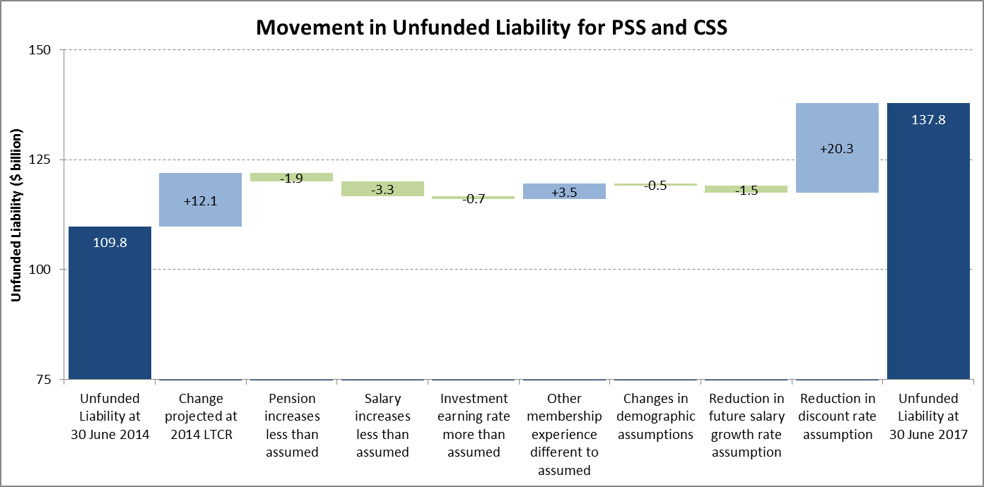

As previously noted, the most significant item is the reduction in the discount rate from 6% per annum to 5% per annum.

Further details are provided in Section 5.

Projected Outlays

The annual projected outlays represent the future annual cash cost of PSS and CSS benefit payments to current and past employees and their dependants.

Projected outlays are calculated as:

* + - * 1. productivity superannuation contributions paid by employers to the PSS and CSS; plus
        2. benefit payments made from the Australian Government’s Consolidated Revenue Fund (CRF); less
        3. transfers of scheme assets in respect of an individual member to the CRF at the time that benefits first become payable.

Note that no allowance has been made in this report for the reimbursement of the CRF for benefit payments made in respect of service with an employer which is no longer part of the Australian Government (e.g. ACT and NT Governments). The Australian Government has arrangements in place to be reimbursed directly by those employers.

The projected outlays are expected to reduce as a percentage of projected Gross Domestic Product (GDP) from 0.30% in the year ending 30 June 2018 to 0.07% in the year ending 30 June 2057.

Further detail regarding the projected outlays is contained in Section 6.

Notional Employer Contribution Rates

The notional employer contribution rates (NECR) represent the estimated contribution rates as a percentage of salary that would be required to finance the benefits accruing to contributors over the next three years (from 1 July 2017 to 30 June 2020). That is, if the schemes were fully funded at the valuation date and contributions were made to the schemes at the NECRs, the schemes would be expected to remain fully funded at the end of the period.

The NECR is determined using long term assumptions as the rates are notional in nature. Only the productivity contribution component of the NECR is actually paid by the employers to the PSS and CSS to be invested as scheme assets by the trustee.

The NECRs for the two schemes (including allowance for contributions towards the productivity superannuation benefit) are:

| NECR (% of Superannuation Salaries) | | |
| --- | --- | --- |
| PSS | CSS | Combined |
| 28.7 | 20.3 | 28.0 |

Further details are provided in Section 7.



# Scheme Information

The Commonwealth Superannuation Scheme (CSS) was established on 1 July 1976 by the Superannuation Act 1976 (as amended). The CSS was closed to new members from 1 July 1990. All CSS contributors at 1 July 1990 were given the option of transferring to the Public Sector Superannuation Scheme (PSS). A further option to transfer to the PSS was provided for a limited period of time in 1996. The current membership of the CSS consists of current and former employees of the Australian Government, or participating employers, who were members on 30 June 1990 and who have not elected to transfer to the PSS.

Prior to July 1976, superannuation for Australian Government public servants was covered by the Superannuation Act 1922 (the 1922 Scheme). Some pensioners remain entitled to benefits under the 1922 Scheme and the liabilities in respect of these payments are included in results for the CSS.

The PSS was established on 1 July 1990 by the Superannuation Act 1990 (as amended). Its operations are also governed by a Trust Deed dated 21 June 1990 (as amended). The PSS was closed to new members from 1 July 2005. Employees of the Australian Government or other participating employers who commenced service prior to 1 July 2005 were eligible for membership of the PSS.

Most employees of Australian Government agencies who commence employment on or after 1 July 2005 are eligible to join the Public Sector Superannuation Accumulation Plan (PSSap). PSSap is an accumulation plan and is not considered further in this report.

Goverance And Operations

The Australian Prudential Regulation Authority (APRA) is responsible for the licensing and supervision of regulated superannuation schemes.

The PSS and CSS are regulated superannuation funds, complying with the Superannuation Industry (Supervision) Act 1993 (SIS Act). The SIS Act governs the superannuation industry and provides the framework within which superannuation schemes operate.

APRA Prudential Standard SPS 160 does not apply to either the PSS or the CSS, as specified in SPS 160.

The Commonwealth Superannuation Corporation (CSC), a corporate Commonwealth entity established on 1 July 2011, is the trustee of the schemes. CSC is responsible for:

* + - * 1. providing administration services for the schemes, including payment to beneficiaries when eligible in accordance with scheme rules;
        2. management and investment of the scheme’s assets;
        3. compliance with relevant law and other applicable regulations.

CSC is supported by a custodian and other specialist service providers.

Benefits

The PSS is a defined benefit scheme – benefits are generally linked to final average salary. The CSS is a hybrid accumulation-defined benefit scheme – some benefits are linked to final salary and other benefits are based on an accumulation of contributions with investment earnings.

Benefits payable from the CSS include a lifetime CPI indexed pension, and the option between a lifetime non-indexed pension and a lump sum. The main retirement benefit is an employer-financed CPI indexed pension which is calculated by a set formula based on a member’s length of contributory service, age and final salary. Members’ basic contributions and employer productivity contributions, together with investment earnings, can be taken as a lump sum or an additional non-indexed lifetime pension. The non-indexed pension is calculated by converting accumulated contributions using age-based conversion factors.

The primary benefit from the PSS is expressed as a lump sum and is calculated based on the member’s length of contributory service, their rate of member contributions and final average salary (average of a member’s superannuation salary on their last three birthdays). Generally, members can convert 50% or more of their lump sum to a lifetime CPI indexed pension. The indexed pension is calculated by converting the lump sum benefit using age-based conversion factors.

Benefits may also be payable to a surviving eligible spouse and children on the death of a member or pensioner.

Further details of the benefits are set out in Appendix A.

funding and Scheme Assets

The PSS and CSS are partially funded to the extent that member and employer productivity superannuation contributions are paid and invested by the trustee.

In general, when a member becomes entitled to a benefit, the amounts held in the PSS or CSS for the member (i.e. funded member and productivity contributions, plus investment earnings) are transferred to the Australian Government’s Consolidated Revenue Fund (CRF) and the payment is made from the CRF.

Arrangements exist for the direct reimbursement of the CRF for benefit payments made in respect of service with an employer which is no longer part of the Australian Government (e.g. ACT and NT Governments).

The assets of the Australian Government’s Future Fund are ultimately intended to contribute towards the financing of the unfunded superannuation liabilities in the PSS and CSS, as well as other unfunded schemes. However, since these assets are not held by the schemes, no allowance has been made for the Future Fund in the results contained in this report.

The change in the net assets of each scheme is summarised below:

| ($ billion) | PSS | CSS | Combined |
| --- | --- | --- | --- |
| **Net Assets at 30 June 2014** | **16.6** | **4.0** | **20.6** |
| Investment revenue | +4.0 | +0.8 | +4.8 |
| Member contributions | +1.7 | +0.2 | +1.9 |
| Employer productivity contributions | +0.6 | +0.1 | +0.7 |
| Net appropriation from Consolidated Revenue Fund | +1.7 | +11.0 | +12.7 |
| Benefits paid | -5.4 | -13.1 | -18.5 |
| Income tax | -0.1 | - | -0.1 |
| **Net Assets at 30 June 2017** | **19.1** | **3.0** | **22.1** |

Source: Audited financial statements for the years ended 30 June 2015, 30 June 2016 and 30 June 2017.

The unfunded liability is that portion of the total superannuation liability in excess of the assets held in the schemes.

Investment and Earning Rate Policy

For PSS contributors, the primary benefit is a defined benefit based on service and final average salary. It does not depend on investment earnings. Member contributions and employer productivity contributions, accumulated with investment earnings, are paid from the PSS into the CRF at the time that a benefit first becomes payable to a member and offset the cost of the overall defined benefit. Hence, positive investment returns reduce the cost of the scheme to the Australian Government.

For preserved PSS members and CSS contributors and deferred members, the member and employer productivity contributions are accumulated with investment earnings to form part of the eventual benefits. Hence, positive investment returns for these members increase their benefit entitlements and the higher benefit entitlement when converted to pension form will lead to an increase in the cost to the Australian Government of providing the benefits for these members.

This arises because the accumulated contributions paid from the scheme into the CRF at the time that a benefit first becomes payable are lower than the expected value of the benefit payments to be made. Positive investment returns therefore generally increase the cost to the Australian Government of providing the benefits for these members.

The schemes’ assets are jointly invested in one pooled investment trust, with professional external investment managers responsible for the management of the investments. The trustee’s investment objective is to outperform the Consumer Price Index (CPI) by 3.5% per annum over 10 years. To achieve this objective, a target asset allocation and asset allocation ranges are set.

The current allocation is:

| Default Fund Investment Option | Target Asset Allocation (Range) | |
| --- | --- | --- |
| Equities | 45% | (15-75%) |
| Property | 10% | (5-25%) |
| Infrastructure | 1% | (0-20%) |
| Alternatives | 15% | (0-30%) |
| Fixed Interest | 14% | (0-65%) |
| Cash | 15% | (0-65%) |

Source: Product Disclosure Statements of CSS and PSS issued 27 September 2017.

We consider the trustee’s current target asset allocation to be suitable, taking into account the largely unfunded nature of the schemes’ liabilities and the Government’s method of funding outlays from the CRF.

The earning rate applied to members’ benefits is effectively the actual rate of investment return. The policy is documented and included on the trustee’s website. We consider the trustee’s earning rate policy to be suitable.

Earning rates over the three years to 30 June 2017 are shown in the table below:

| Default Fund Return  for Financial Year | PSS | CSS |
| --- | --- | --- |
| 2014-15 | 12.1% | 12.2% |
| 2015-16 | 1.7% | 1.9% |
| 2016-17 | 9.5% | 9.6% |
| **3 year average (per annum)** | **7.7%** | **7.8%** |

Source: Annual Reports 2014-15, 2015-16 and 2016-17.

Insurance Arrangements

Standard death and invalidity benefits in the PSS and CSS are self-insured. We consider this to be appropriate, given the unfunded nature of the schemes, the credit rating of the Australian Government, the ability to spread any risk over a sizeable population, and that benefits are generally paid as a pension so that payments are spread over many years.

PSS contributors have the option of taking out additional death and invalidity cover. This additional benefit is covered by an insurance policy held between the trustee and an external commercial insurer. The cost of the insurance premiums is shared between the member and employer.

Changes to Benefits Since 2014

There have been no material changes to the benefits provided by the PSS and CSS since the previous long term cost report as at 30 June 2014.

# Membership and Data

Data relating to the membership of the PSS and CSS was provided to us by the Commonwealth Superannuation Corporation (CSC), the schemes’ administrator and trustee. Membership is grouped into three broad categories:

| Contributors | Deferred/Preserved | Pensioners |
| --- | --- | --- |
| Currently employed by a participating scheme employer and a member of the scheme. | No longer employed by a participating employer but maintains an account within the scheme. Can generally recommence contributions if re-employed by a participating employer. | Members in receipt of a pension benefit. Includes dependant pensioners who are the eligible spouses and/or children of deceased members or pensioners. |

Detailed membership data provided for the purposes of this investigation included:

* + - * 1. benefit entitlements for all contributors, deferred/preserved members and pensioners of the PSS and CSS as at 30 June 2017; and
        2. contributor and deferred/preserved member exits from the PSS and CSS during the three year period from 1 July 2014 to 30 June 2017.

Following a family law split, an associate record may be established for the former spouse. For the purposes of this investigation, associate records are classified as deferred/preserved members if the entitlement is yet to be paid or as dependant pensioners if a pension is being paid.

A range of validity data checks is conducted by CSC prior to the data being provided to Mercer. Mercer has reviewed the data for internal consistency and has conducted a range of general reasonableness checks, including member movements, changes in salary and account balances, benefit payments and accruals, but has not verified or audited any of the information provided. However, we are satisfied that the data is sufficiently accurate for the stated purpose. The schemes’ administrator and trustee are ultimately responsible for the validity, accuracy and comprehensiveness of this information.

The membership as at 30 June 2017 is summarised below:

| As at  30/06/17 | | Headcount | | | Average Age | Average Service | Average Annual Salary |
| --- | --- | --- | --- | --- | --- | --- | --- |
| Males | Females | Total |
| Contributors | | | | | | | |
|  | CSS | 3,655 | 2,132 | 5,787 | 55.7 | 30.5 | $120,192 |
|  | PSS | 32,770 | 46,141 | 78,911 | 49.3 | 17.6 | $101,296 |
| **Total** | | **36,425** | **48,273** | **84,698** | **49.7** | **18.5** | **$102,587** |
| Deferred/Preserved | | | | | | | |
|  | CSS | 3,053 | 1,783 | 4,836 | 55.8 | 14.3 | - |
|  | PSS | 39,918 | 60,511 | 100,429 | 48.8 | 5.6 | - |
| **Total** | | **42,971** | **62,294** | **105,265** | **49.1** | **6.0** | **-** |

| As at  30/06/17 | | Headcount | | | Average Age | Average Annual Pension |
| --- | --- | --- | --- | --- | --- | --- |
| Males | Females | Total |
| Primary Pensioners | |  | | | | |
|  | 1922 Scheme | 404 | 175 | 579 | 80.0 | $37,617 |
|  | CSS | 58,881 | 24,382 | 83,263 | 72.8 | $42,201 |
|  | PSS | 21,411 | 24,780 | 46,191 | 63.7 | $32,218 |
| **Total** | | **80,696** | **49,337** | **130,033** | **69.6** | **$38,634** |
| Dependant Pensioners | |  | | | | |
|  | 1922 Scheme | 25 | 1,961 | 1,986 | 86.9 | $28,485 |
|  | CSS | 1,584 | 22,491 | 24,075 | 80.7 | $22,836 |
|  | PSS | 617 | 1,343 | 1,960 | 63.3 | $18,958 |
| **Total** | | **2,226** | **25,795** | **28,021** | **79.9** | **$22,966** |

Further detail of the membership is set out in Appendix B.

# Assumptions

In order to value the liabilities, it is necessary to make assumptions regarding the incidence, timing and amount of future benefits. These assumptions fall into two broad categories:

* + - * 1. economic assumptions: relating to the general economic environment and not directly to the membership of the schemes; and
        2. demographic assumptions: relating to the experience of the membership of the scheme.

This section sets out the assumptions used in this report and highlights any changes from those used for the 2014 LTCR. The assumptions are detailed in Appendix C.

In total, the changes in assumptions have resulted in an increase to the combined unfunded liability of $18.3 billion, or +15.3%, as at 30 June 2017.

Economic Assumptions

### Key Economic Assumptions

The key economic assumptions include:

* + - * 1. future increases in the Consumer Price Index (CPI) which links to the level of pension increases;
        2. future increases in salaries (other than those arising from promotions); and
        3. future rate of investment return / discount rate.

The relationships between the assumptions adopted for these factors have a greater bearing on the long term cost estimates of the PSS and CSS than do the individual assumptions. This is due to the effect of one assumption being used to project the liability into the future (future pension and salary increases) and another assumption being used to discount that liability to current day values (discount rate).

We have not adopted different economic assumptions for the short term and long term as a general principle. To adopt, for example, short term salary increase assumptions would necessitate the use of other short term assumptions (e.g. inflation and investment). However, as noted above, it is the relationships between the assumptions which are the key drivers to impact results. Whilst in the short term these rates may vary, in the longer term we expect them and their relationships to be more stable.

Frequent changes in economic assumptions are undesirable since they can overwhelm any examination of the impact of changes in experience or scheme design, and impede the understanding of the long term cost of the schemes. Changes to economic assumptions are therefore only expected to be made if there is a material shift in the long term expectations for economic conditions.

Accordingly the principles applied in setting the assumptions are:

1. They should be based on realistic long term future expectations over the term of the schemes’ liabilities, based on economic forecasts;
2. They should be stable over time, only changing when there has been a material change in long term expectations;
3. They should recognise the interrelationships between the assumptions; and
4. Take into account short term considerations only where there is a compelling reason to do so.

The key economic assumptions are shown below together with the assumptions from the 2014 LTCR:

|  | Assumption as at 30 June 2017 | Assumption as at 30 June 2014 |
| --- | --- | --- |
| CPI increases | 2.5% per annum | 2.5% per annum |
| General salary increases | 3.5% per annum (nominal) 1.0% per annum (real) | 4.0% per annum (nominal) 1.5% per annum (real) |
| Investment return / discount rate | 5.0% per annum (nominal) 2.5% per annum (real) | 6.0% per annum (nominal) 3.5% per annum (real) |

Section 8 provides sensitivity analysis of the results under different individual assumptions.

### CPI Increases

The assumed rate of future increases in the Consumer Price Index (CPI) remains at 2.5% per annum. This rate is set based on the following considerations:

* + - * 1. The Reserve Bank target for CPI increase is 2% to 3% per annum on average, over the medium term.
        2. The long term level of inflation projected by the 2015 Intergenerational Report is 2.5% per annum.
        3. Mercer’s best estimate of the long term economic outlook for CPI is 2.5% per annum and this is consistent with other market forecasters. It is noted that in the near term the outlook is for inflation below 2.5% per annum.

### General Salary Increases

The assumed rate for long term future general salary increases (i.e. excluding promotional salary increases) is 3.5% per annum (nominal). This is lower than the previous assumption of 4.0% per annum (nominal) and is based on the following considerations:

* + - * 1. The duration of salary linked liabilities is considerably less than liabilities for the schemes as a whole, since salary increases are only relevant to benefits while a member is in active service. Whilst the intention when setting assumptions for the long term is to not give too much weight to short term considerations, the shorter term nature of the salary linked liabilities means that short term factors have a greater significance than for the other economic assumptions.
        2. Wage growth is a function of spare capacity in the labour market, productivity growth, and inflationary expectations. In this regard, the following factors are noted over the shorter time frame relevant to the membership of the schemes:

The Australian Government forecasts have spare capacity in the labour market for some time;

The RBA expects that the unemployment rate will decrease only gradually;

Wage growth has been subdued and may remain subdued for a while;

Wage growth in US and UK has been subdued notwithstanding that they are near full employment;

There is evidence that productivity growth has slowed; and

The RBA target for CPI increases is 2% to 3% pa. The assumption adopted for CPI for this investigation is 2.5% per annum.

* + - * 1. There has been a continuation of structural change, including:

Globalisation and greater labour market flexibility;

Decline in unionisation; and

The end of the resources boom and the trend to a more services oriented economy.

* + - * 1. Public sector salary restraint in the short term. In particular, the current Workplace Bargaining Policy and the fact that the majority of civilian employees are not subject to signed agreements, and for those that are, the agreed increases are on average limited to 2% per annum.
        2. The relationship between the assumptions is important as noted above. The reduction in general salary increases narrows the margin above CPI to 1% per annum from 1.5% per annum. Due to the reasons set out above we believe this is appropriate, in particular, due to the slowing of productivity growth and continuation of structural changes leading to lower ‘real’ salary growth (i.e. growth above CPI). It is also consistent with the expected lowering of the discount rate – see below.

### Investment Return / Discount Rate

The discount rate is used to calculate the present value of projected future benefit payments and provide a summary measure of those cash flows. The unfunded liability represents the present value of the estimated future benefit payments in respect of service already rendered, less the value of scheme assets. A lower discount rate leads to a higher estimate of the unfunded liability, and vice versa.

The present value does not change the ultimate benefit payments but does however provide a manageable way to assess and compare the value of expected future cash flows, expressed in today’s dollars.

For consistency the discount rate assumption is also used as the assumption for the rate of investment returns at which productivity and member contributions are accumulated for the period up to a member’s retirement or exit.

The assumed investment return / discount rate has been reduced from 6.0% per annum (nominal) for the 2014 LTCR to 5.0% per annum (nominal). This rate is set based on the following considerations:

* + - * 1. The Australian Government does not have an obligation to finance immediately the unfunded superannuation liability of the PSS and CSS. Financing is only required as and when benefit entitlements become payable. As the PSS and CSS are largely unfunded, our view is that the best determinant of the discount rate is the expected return on government bonds over the long term as this would be the cost to the Australian Government were it to fund future benefit payments via borrowings. This contrasts to a funded scheme where a discount rate is typically based on an assumption for the investment earning rate on the scheme’s assets.
        2. The discount rate is intended to reflect the expected long-term (nominal) yield on Australian Government debt under stable market conditions, determined as the expected long-term average increase in the Consumer Price Index plus the expected long-term real yield on Australian Government debt (where long-term relates to the period over which all unfunded liabilities are expected to be paid).
        3. A useful check on the long term bond yield assumption is provided by considering long term expectations for nominal GDP growth. This essentially represents the earnings of the Government and so sets a reasonable limit on the rate that can be paid on any debt (all other things being equal). At the present time, we consider that a realistic expectation for long term GDP growth is likely to be in the order of 5.25% pa (see also next section on GDP) on the assumption that long term price inflation averages 2.5% pa. The return above CPI being generated by productivity growth and growth in hours worked.
        4. The bond market has seen an unprecedented period of historically low bond yields.
        5. Long term economic forecasts for yields on long dated government bonds are between 4.6% and 4.8% per annum. The latest long term 10 year government bond yield forecast by both Mercer and Consensus economics (a collation of views from 180 economic forecasters in Asia Pacific) is around 4.6% per annum.
        6. A long term assumption for bond yields of 6.0% per annum (nominal) is no longer within the range of reasonable economic forecasts for long term bond yields based on the above.

Overall, we believe a long term rate of 5% per annum is appropriate to assume as an investment return / discount rate.

### GDP

Based on projections of nominal Gross Domestic Product (GDP) provided by the Department of the Treasury specifically for the purpose of this report, GDP for the 2017/2018 financial year is assumed to be $1.85 trillion. The assumed average future increases are shown below together with the assumptions from the 2014 LTCR:

|  | Assumption as at  30 June 2017 | Assumption as at 30 June 2014 |
| --- | --- | --- |
| GDP Increases* | 5.2% per annum (nominal) 2.7% per annum (real) | 5.4% per annum (nominal) 2.9% per annum (real) |

* Average of the annual rates over the forty year period from the investigation date.

### Taxation

Allowance has been made for 15% tax payable by the schemes on employer productivity superannuation contributions.

### Superannuation Guarantee

Allowance has been made for increases in the Superannuation Guarantee rate (currently 9.5% and increasing to 12% by 1 July 2025).

Demographic Assumptions

The demographic assumptions adopted incorporate the results of a detailed analysis of the membership experience. Details of the updated demographic assumptions are set out in Appendix C.

### Promotional Salary Increases

Salary increases consist of general salary increases due to salary inflation together with increases due to promotion. General salary increases capture the average salary increase for all government employees, while promotional salary increases capture the increases due to promotion within and between employment bands.

We have used similar assumptions for promotional salary increases as for the 2014 LTCR, but these have been simplified to be based on age only, as we consider this to be more realistic. No distinction is made between males and females, as was previously the case.

### PSS Member Contribution Rate

The age based scale of assumed member contribution rates is unchanged from the 2014 LTCR.

### Rates of Age Retirement

Assumed rates of retirement have been simplified to be based on age only. No distinction is made between males and females, or between the PSS and PSS, as was previously assumed for the 2014 LTCR. There is little evidence of any difference in experience between males and females.

### Rates of Involuntary Retirement (Redundancy)

An assumption is required because benefits differ and may be also paid immediately on involuntary retirement. Although there were considerably more redundancies during the three-year investigation period than previously projected, this recent experience is considered to be cyclical, rather than reflective of longer term average trends. It is noted that experience during the period up to the 2014 LTCR showed fewer redundancies than previously assumed. Assumed rates of involuntary retirement (redundancy) have been simplified and, in line with experience, extended beyond age 65.

### Rates of Resignation

With the continued decline in the number of contributors, the assumed rates of resignation have become less significant for the projected results. Assumed rates of resignation have been simplified to be based on age only. For CSS contributors, a high rate of resignation is assumed at age 54, which reflects the specific benefit design and is consistent with CSS experience.

### Rates of Invalidity Retirement (Disablement)

Assumed rates of invalidity retirement (disablement) have been aligned between CSS and PSS.

### Death Rates for Contributors, Deferred/Preserved Members and Pensioners

Assumed rates of mortality before and after retirement are unchanged from the 2014 LTCR.

### Future Mortality Improvements

Allowance has been made for assumed future improvements in pensioner mortality.

Improvements in mortality have been updated to reflect the short term (25 year experience) and long term (125 year experience) factors derived by the Australian Government Actuary and published in the Australian Life Tables 2010-12. The short term improvement factors are significantly higher (i.e. result in lower projected mortality) than the long term improvement factors.

Short term improvements are incorporated for the period 2018 to 2021, with long term improvements assumed thereafter.

Based on the mortality assumptions adopted for this investigation, an example of the number of additional years expected to be lived by an age retirement pensioner is shown in the table below:

| Projected Future Life Expectancy | As at 30/06/2017 | As at 30/06/2027 |
| --- | --- | --- |
| Male pensioner aged 65 | 22.8 years | 23.3 years |
| Female pensioner aged 65 | 25.6 years | 26.1 years |

### Rates of Deferral/Preservation of Benefits

Members who are made redundant are eligible to be paid pension benefits immediately and therefore have a different pattern of deferral/preservation compared to members leaving due to resignation.

Scheme experience over the three year investigation period supports maintaining the assumptions adopted for the 2014 LTCR.

### Rates of Pension Take-up

For the 2014 LTCR it was assumed that 80% of members entitled to an age or involuntary retirement (redundancy) benefit from the PSS would elect to convert that benefit to a pension.

CSS members have the option to convert the funded portion of their benefits from a lump sum to a non-indexed lifetime pension. For the 2014 LTCR, it was assumed that 30% of members would elect to take their funded benefits as a non-indexed pension.

Scheme experience over the investigation period supports maintaining these assumptions.

### Spouse Assumptions

Assumptions regarding the proportion of members with a spouse, and the age of their spouse, are unchanged from the 2014 LTCR.

### Future New Entrants

No allowance is made for future new entrants. The PSS was closed to new members from 1 July 2005. The CSS has been closed to new members since 1 July 1990.

# Unfunded Liability

The unfunded liability represents the discounted present value of the estimated total future benefit payments in respect of superannuation entitlements accrued by virtue of scheme membership up to 30 June 2017, less the value of scheme assets.

Valuation Methodology

The steps involved in calculating the unfunded liability are as follows:

The membership of each scheme as at 30 June 2017 is projected into the future based on assumptions relating to the rates of exit of members (as set out in Appendix C).

The total amount of benefits payable to the projected exits and pensioners in each future year are determined taking into account assumed salary growth, pension indexation, and investment returns in each future year.

For contributory members, the projected benefits are determined based on members’ service rendered prior to 30 June 2017 only.

For example, for the PSS retirement benefit, this involves determining the benefit attributable to service to 30 June 2017 using:

|  |  |  |
| --- | --- | --- |
| Accrued Benefit Multiple  as at 30 June 2017 | × | Final Average Salary  at future date |

The unfunded liability as at 30 June 2017 is determined as the sum of the present values of the projected benefits over all future years (being the total liability), reduced by funded accumulated member and productivity contribution accounts as at 30 June 2017.

The calculation methodology is consistent with the requirements of Professional Standard No. 402 *“Determination of Accrued Benefits for Defined Benefit Superannuation Funds”* issued by the Institute of Actuaries of Australia.

The same methodology was used for the 2014 LTCR.

Results

The following table shows the unfunded liability as at 30 June 2017.

| ($ billion) | PSS | CSS | Combined |
| --- | --- | --- | --- |
| Contributors | 31.1 | 6.8 | 37.9 |
| Deferred/Preserved members | 7.3 | 4.0 | 11.3 |
| Pensioners | 29.4 | 59.2* | 88.6 |
| **Unfunded Liability at 30 June 2017** | **67.8** | **70.0** | **137.8** |

* Includes $0.6 billion in respect of the 1922 Scheme.

Analysis of Change Compared with previous report

The 2014 LTCR projected that the unfunded liability would be $121.9 billion as at 30 June 2017, $15.9 billion less than the actual unfunded liability.

The factors leading to the difference in the previously projected unfunded liability and quantified in the following chart:



The most significant item is the reduction in the discount rate from 6% per annum to 5% per annum.

Projected Unfunded Liability

Based on the assumptions used for this investigation, the projected nominal unfunded liability over the next 40 years is:

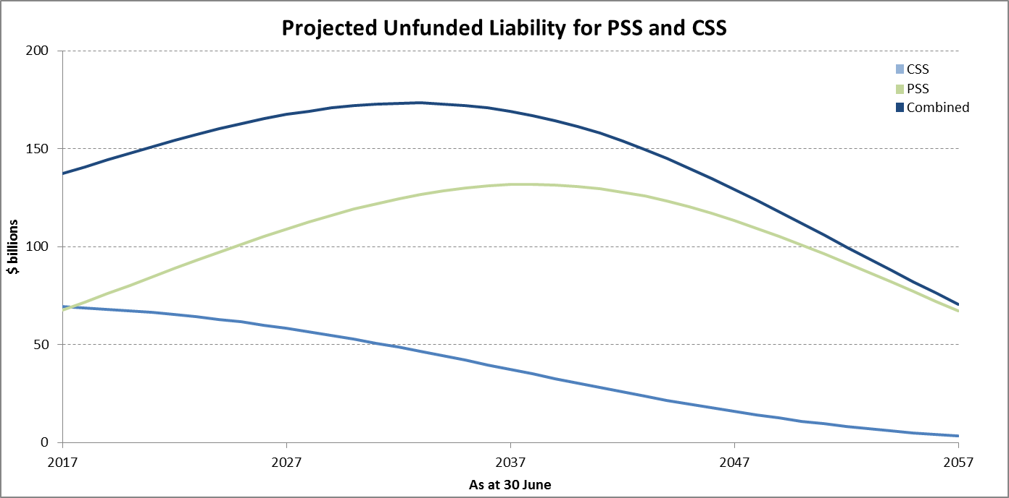

The chart above illustrates that the general trend is an increase in the combined unfunded liability over the next 15 years followed by a steady decline to approximately half the current liability by 2057.

A table with details of the projected unfunded liability each year is included in Appendix D.

# Projected Outlays

The annual projected outlays represent the future annual cost of PSS and CSS benefits to current and past employees, and their dependants.

In general, when a member becomes entitled to a benefit, the member's accumulation accounts (i.e. funded member and productivity contributions, plus investment earnings) are transferred to the Australian Government’s CRF. The total benefit payment to the member is then made from the CRF.

The projected outlays in each year are calculated as:

* + - * 1. productivity superannuation contributions paid by employers to the PSS and CSS; plus
        2. benefit payments made from the Australian Government’s CRF; less
        3. transfers of scheme assets to the CRF when benefits become payable.

No allowance is made for the reimbursement of the CRF directly for benefit payments made in respect of service with an employer no longer part of the Australian Government (e.g. ACT and NT Governments).

The expected nominal outlays each year for the next 40 years are shown in the following chart:

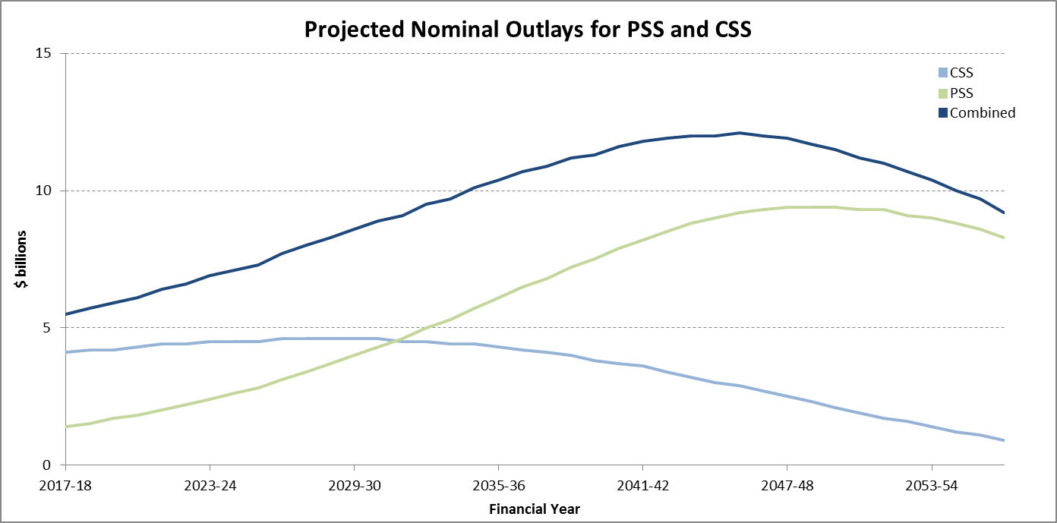

Overall outlays are projected to increase during the next 25-30 years as contributors leave the workforce and commence a pension. Outlays as a percentage of GDP will gradually decline as shown in the following chart:

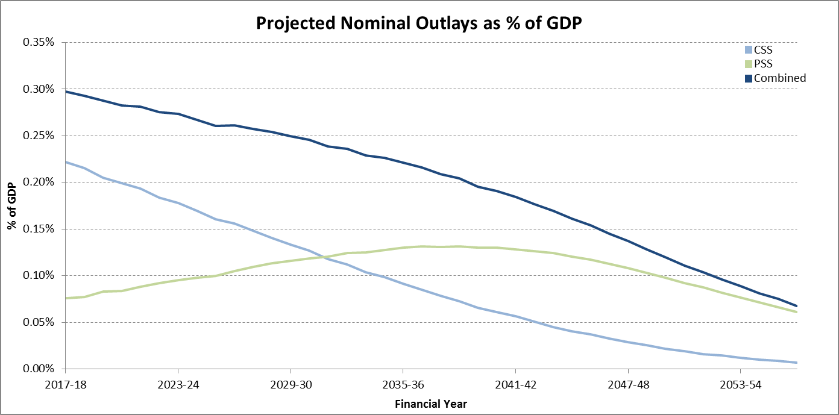

Future outlays are expected to reduce as a percentage of projected GDP from 0.30% in the year ending 30 June 2018 to 0.07% in the year ending 30 June 2057.

A table with details of the projected outlays is included in Appendix D.

# Notional Employer Contribution Rates

The notional employer contribution rates (NECR) represent the estimated contribution rates that would be required to finance the benefits accruing to contributors over the next three years (from 1 July 2017 to 30 June 2020). That is, if the schemes were fully funded at the valuation date and contributions were made at the NECRs, the liability for contributors would be expected to remain fully funded at the end of the period.

The NECR is therefore a short-term indicator and relates to the cost of funding future benefit accruals of contributors only (which make up approximately 5% of CSS membership and 35% of PSS membership).

The NECR is determined using long term assumptions as this rate is notional in nature. Only the productivity contribution component of the NECR is actually paid by the employers to the PSS and CSS to be invested as scheme assets by the trustee. The non-productivity contribution component is notional and no such contributions are actually paid to the schemes.

Method of Determining the Notional Employer Contribution Rates

A notional fund with initial assets equal to the accrued liabilities at the valuation date is projected for the three years to 30 June 2020, together with member contributions, notional employer contributions, investment earnings and benefit payments in line with the valuation assumptions. The notional contributions are determined so that the projected notional assets are equal to the projected accrued liabilities after three years. The NECRs are the notional employer contributions expressed as a constant annual percentage of projected salaries.

Results

| NECRs (% of  Superannuation Salaries) | PSS | CSS | Combined |
| --- | --- | --- | --- |
| As at 30 June 2014 | 22.6 | 18.3 | 22.1 |
| As at 30 June 2017 | 28.7 | 20.3 | 28.0 |
| Movement | +6.1 | +2.0 | +5.9 |

The NECRs are the amount of contributions expected to be necessary to meet the accruing liabilities, based on the assumptions. The value of accruing liabilities is sensitive to the discount rate assumption with a lower discount rate leading to a higher liability similar to the unfunded liability section. Both NECRs have therefore increased materially, primarily due to the reduction in discount rate assumption.

# Sensitivity Analysis

Economic Assumptions

The sensitivity of the estimated unfunded liability as at 30 June 2017 and the projected outlays to the key economic assumptions were tested by measuring the effect of varying each key assumption in turn by plus or minus 1% per annum whilst keeping all other assumptions unchanged.

The alternative assumptions used were:

* + - * 1. investment return / discount rate plus 1% per annum (increased to 6% per annum (nominal));
        2. investment return / discount rate minus 1% per annum (reduced to 4% per annum (nominal));
        3. general salary increases plus 1% per annum (increased to 4.5% per annum (nominal));
        4. general salary increases minus 1% per annum (reduced to 2.5% per annum (nominal));
        5. CPI increases plus 1% per annum (increased to 3.5% per annum); and
        6. CPI increases minus 1% per annum (reduced to 1.5% per annum).

| Unfunded Liability (UFL) as at 30 June 2017 ($ billion) | PSS | | CSS | | Combined | |
| --- | --- | --- | --- | --- | --- | --- |
| UFL | % Change | UFL | % Change | UFL | % Change |
| **Base case** | **67.8** | **-** | **70.0** | **-** | **137.8** | **-** |
| +1% per annum investment return / discount rate | 55.0 | -18.9% | 62.5 | -10.7% | 117.5 | -14.7% |
| -1% per annum investment return / discount rate | 84.1 | +24.0% | 78.6 | +12.3% | 162.7 | 18.1% |
| +1% per annum general salary increase | 71.2 | +5.0% | 70.2 | +0.3% | 141.4 | +2.6% |
| -1% per annum general salary increase | 64.7 | -4.6% | 69.9 | -0.1% | 134.6 | -2.3% |
| +1% per annum CPI increase | 79.4 | +17.1% | 77.7 | +11.0% | 157.1 | +14.0% |
| -1% per annum CPI increase | 58.3 | -14.0% | 63.6 | -9.1% | 121.9 | -11.5% |

The results show that the unfunded liability is not particularly sensitive to changes in the rate of salary increases because only liabilities for contributors are linked to salaries and this is a small proportion of the total liabilities. In addition, the impact of changes in salaries is only for a relatively short period of time (i.e. the remaining period of service).

| Period Ending 30 June | Change in Nominal Outlays(Combined) ($ billion) | | | | | | |
| --- | --- | --- | --- | --- | --- | --- | --- |
| Base case | +1%per annum investment return | -1%per annum investment return | +1% per annum general salary increase | - 1% per annum general salary increase | +1% per annum CPI increase | - 1% per annum CPI increase |
| 2018 | 5.5 | - | - | - | - | - | - |
| 2019 | 5.7 | - | - | - | - | - | -0.1 |
| 2020 | 5.9 | - | - | - | - | +0.1 | -0.1 |
| 2021 | 6.1 | - | - | - | - | +0.2 | -0.1 |
| 2022 | 6.4 | -0.1 | - | - | - | +0.2 | -0.3 |
| 2023 – 27 | 35.6 | -0.4 | +0.3 | +0.3 | -0.5 | +2.2 | -2.5 |
| 2028 – 32 | 42.9 | -0.9 | +0.7 | +1.0 | -1.0 | +4.6 | -4.3 |
| 2033 – 37 | 50.4 | -1.0 | +0.9 | +2.0 | -1.8 | +7.4 | -6.4 |
| 2038 – 42 | 56.8 | -0.8 | +0.6 | +3.1 | -2.7 | +10.2 | -8.5 |
| 2043 – 47 | 60.0 | - | -0.1 | +4.2 | -3.8 | +12.3 | -10.0 |
| 2048 – 52 | 57.3 | +0.5 | -0.5 | +4.8 | -4.1 | +13.5 | -10.8 |
| 2053 – 57 | 50.0 | +0.7 | -0.7 | +5.0 | -4.4 | +13.6 | -10.5 |

The nominal outlays are not significantly impacted by changes in the rate of salary increases for the same reasons as for the unfunded liability above. CPI changes have a more material effect as the majority of the liability is linked to these increases.

The investment return impacts upon the amount of funds held for members within CSS and PSS prior to when a benefit first becomes payable. This amount is transferred to the CRF and offsets the total amount of benefit payments in that year. The ‘investment and earning rate policy’ within Section 2 describes how investment returns on these funds impact upon the benefits payable.

In the short term higher investment returns will reduce total benefit outlays payable as offsets will be higher. In the longer term total benefit outlays will increase as benefits are typically paid over a long period while offsets are only received in the year that the benefit first becomes payable. The overall amounts of variation are small as there are offsetting impacts and the total benefits payable relating to the assets held are also small.

Demographic Assumptions

The sensitivity of the estimated unfunded liability as at 30 June 2017 to certain demographic assumptions was tested by measuring the effect of varying each assumption in turn whilst keeping all other assumptions unchanged.

The alternative assumptions used were:

* + - * 1. 5% higher pensioner mortality rates (e.g. a 3% probability of death becomes 3.15%);
        2. 5% lower pensioner mortality rates (e.g. a 3% probability of death becomes 2.85%);
        3. future improvements in pensioner mortality in line with short term (25 year experience) factors only, with no reversion to long term factors after 2021; and
        4. pension take-up rate assumed for PSS age and involuntary retirement benefits increased from 80% to 90%.

| Unfunded Liability (UFL) as at 30 June 2017 ($ billion) | PSS | | CSS | | Combined | |
| --- | --- | --- | --- | --- | --- | --- |
| UFL | % Change | UFL | % Change | UFL | % Change |
| **Base case** | **67.8** | **-** | **70.0** | **-** | **137.8** | **-** |
| 5% higher pensioner mortality rates | 67.1 | -1.0% | 69.2 | -1.1% | 136.3 | -1.1% |
| 5% lower pensioner  mortality rates | 68.4 | +0.9% | 70.9 | +1.3% | 139.3 | +1.1% |
| 25 year experience future mortality improvements | 69.4 | +2.4% | 71.0 | +1.4% | 140.4 | +1.9% |
| PSS pension take up increased to 90% | 70.6 | +4.1% | 70.0 | - | 140.6 | +2.0% |

| Period Ending 30 June | Change in Nominal Outlays(Combined) ($ billion) | | | | |
| --- | --- | --- | --- | --- | --- |
| Base case | 5% higher pensioner mortality rates | 5% lower pensioner mortality rates | 25 year experience future mortality improvements | PSS pension take up increased to 90% |
| 2018 | 5.5 | - | - | - | -0.1 |
| 2019 | 5.7 | - | - | - | -0.1 |
| 2020 | 5.9 | - | - | - | -0.1 |
| 2021 | 6.1 | - | - | - | -0.2 |
| 2022 | 6.4 | - | - | - | -0.2 |
| 2023 – 27 | 35.6 | -0.2 | +0.2 | +0.1 | -0.7 |
| 2028 – 32 | 42.9 | -0.2 | +0.2 | +0.2 | -0.2 |
| 2033 – 37 | 50.4 | -0.5 | +0.5 | +0.7 | +1.0 |
| 2038 – 42 | 56.8 | -0.6 | +0.7 | +1.3 | +2.5 |
| 2043 – 47 | 60.0 | -0.9 | +1.0 | +1.9 | +4.2 |
| 2048 – 52 | 57.3 | -1.0 | +1.1 | +3.0 | +5.0 |
| 2053 – 57 | 50.0 | -1.2 | +1.0 | +3.2 | +5.0 |

The impact of changes to the demographic assumptions has a much lesser impact in general on the unfunded liabilities and nominal outlays. The PSS pension take up rate having the most significant impact.

The sensitivity of the projected number of future years lived by an age retirement pensioner to the mortality rates and future improvements is demonstrated below:

| Projected Future Life Expectancy | Male pensioner aged 65 | % Change | Female pensioner aged 65 | % Change |
| --- | --- | --- | --- | --- |
| Base case | 22.8 years |  | 25.6 years |  |
| 5% higher pensioner mortality rates | 22.5 years | -1.3% | 25.3 years | -1.2% |
| 5% lower pensioner mortality rates | 23.2 years | +1.8% | 25.9 years | +1.2% |
| 25 year experience future mortality improvements | 23.6 years | +3.5% | 26.0 years | +1.6% |

The alternative results shown above are illustrations only, and show what may occur under future scenarios which differ from the base case assumptions. These scenarios do not in any way constitute upper or lower bounds and the ultimate results may differ from the ranges shown above, depending on actual future experience.

# Actuary’s Certification

Professional standards and scope

This report satisfies the requirements of Professional Standard No. 400 of The Institute of Actuaries of Australia. Professional Standard No. 400 relates to the preparation of reports commenting on the financial condition of defined benefit superannuation funds.

Use of report

This investigation report should not be relied upon for any other purpose or by any party other than the Australian Government and the schemes’ trustee. Mercer is not responsible for the consequences of any other use. This report should be considered in its entirety and not distributed in parts.

The advice contained in this report is given in the context of Australian law and practice. No allowance has been made for taxation, accountancy or other requirements in any other country.

Actuarial Uncertainty and Assumptions

An actuarial investigation provides a snapshot of a scheme’s financial condition at a particular point in time, and projections of a scheme’s estimated future financial position based on certain assumptions. It does not provide certainty in relation to a scheme’s future financial condition or its ability to pay benefits in the future.

Future funding and actual costs relating to a scheme are primarily driven by the scheme’s benefit design, the actual rate of salary inflation and any discretions exercised by the trustee of the scheme or the Australian Government. The scheme’s actuary does not directly control or influence any of these factors in the context of an actuarial investigation.

A scheme’s future financial position and the estimated long term cost depend on a number of factors, including the amount of benefits the scheme pays, the cause and timing of member withdrawals, scheme expenses, the level of taxation and the amount earned on any assets invested to pay the benefits. These amounts and others are uncertain and unknowable at the valuation date, but are predicted to fall within a reasonable range of possibilities.

To prepare this report, assumptions, as described in Section 4, are used to select a single scenario from the range of possibilities. The results of that single scenario are included in this report.

However, the future is uncertain and a scheme’s actual experience will differ from those assumptions; these differences may be significant or material. In addition, differentassumptions or scenarios may also be within the reasonable range and results based on those assumptions would be different. For this reason this report also shows the impact on the results of certain changes in assumptions.

Actuarial assumptions may also be changed from one valuation to the next because of mandated requirements, scheme experience, changes in expectations about the future and other factors. We did not perform, and thus do not present, an analysis of the potential range of future possibilities and scenarios.

Because actual scheme experience will differ from the assumptions, decisions about benefit changes, investment policy, funding amounts, benefit security and/or benefit related issues should be made only after careful consideration of alternative future financial conditions and scenarios, and not solely on the basis of a set of results.

Prepared by:

|  |  |
| --- | --- |
|  |  |
| **Richard Boyfield**  Fellow of the Institute of Actuaries of Australia  Partner | **Guy Holley**  Fellow of the Institute of Actuaries of Australia  Principal |

Peer Reviewed by:

|  |
| --- |
|  |
| **David A Scott**  Fellow of the Institute of Actuaries of Australia  Principal |

04 July 2019

Summary of Benefits

The scheme’s benefit entitlements are complex and a **summary** of the principal provisions is set out below. This summary should not be used to calculate benefits for individuals.

THE SUPERANNUATION ACT 1976 (CSS)

*Membership*

The CSS has been closed to new entrants since 1 July 1990.

*Salary*

Salary for contribution purposes is the amount agreed between the member and employer through an agreement such as an Enterprise Agremment. If no such agreement is in place, salary is basic annual salary plus any recognised allowances on a member’s last birthday.

*Final Salary*

The salary used for calculating benefits is, in most cases, the annual rate of salary on a member's last day of service.

*Member Contributions*

Basic contributions are 5% of salary. A member can also make supplementary (or voluntary) contributions. Contributions are accumulated with investment earnings based on the crediting rates of the CSS. Members can also choose not to contribute to the CSS.

*Productivity Contributions*

Most members have fortnightly employer productivity contributions paid to the CSS. The rate at which contributions are paid varies depending on income limits. The 2017-18 amounts are:

|  |  |
| --- | --- |
| **Fortnightly rate of salary** | **Fortnightly productivity contribution** |
| Less than $2,300.67 | $69.02 |
| $2,300.67 or more but less than  $3,706.00 | 3% of salary |
| $3,706.00 or more but less than  $5,559.00 | $111.18 |
| $5,559.00 or more | 2% of salary |

THE SUPERANNUATION ACT 1976 (CSS) *continued*

*Retirement Benefits*

Retirement benefits are payable upon retirement at maximum retirement age (usually age 65) or early retirement from minimum retirement age (usually age 55), subject to general superannuation preservation rules.

The retirement benefit comprises:

* + - * 1. an employer-financed indexed lifetime pension being a percentage of final salary based on the period of contributory service and discounted for early retirement before age 65 (the percentage is based on years of contributory service and on whether the member transferred from the 1922 Scheme or joined the CSS before or after 30 June 1976);
        2. a productivity component made up of accumulated productivity contributions which can be taken as a lump sum or converted to a non-indexed lifetime pension; and
        3. a member-financed component made up of accumulated basic and supplementary contributions which can be taken as a lump sum or converted to a non-indexed lifetime pension.

Generally, the accrual rates are 2% per annum for the first 20 years of contributory membership, 1% per annum for the next 10 years, and 0.25% per annum for each of the next 10 years. A maximum percentage of 52.5% of salary applies after 40 years of contributory membership.

The discount for retirement prior to age 65 depends on age at the time that the pension commences:

|  |  |  |  |
| --- | --- | --- | --- |
| **Age** | **Early Retirement Reduction** | **Age** | **Early Retirement Reduction** |
| 64 | 0.98 | 59 | 0.87 |
| 63 | 0.96 | 58 | 0.84 |
| 62 | 0.94 | 57 | 0.81 |
| 61 | 0.92 | 56 | 0.78 |
| 60 | 0.90 | 55 | 0.75 |

The factors to convert the productivity component and member-financed component to a non-indexed lifetime pension are the same as for resignation (see below). Note that the non-indexed pension is limited to 20% of the final salary if a member retires at age 60 or more, with any excess required to be paid as a lump sum. The maximum non-indexed pension percentage is reduced for retirement before age 60.

THE SUPERANNUATION ACT 1976 (CSS) *continued*

*Resignation*

An immediate lump sum benefit is payable on resignation equal to:

* + - * 1. the accumulated member and productivity contributions; plus
        2. an employer-financed top-up amount equal to the difference between the notional accumulation of minimum Superannuation Guarantee contributions and the accumulated productivity contributions.

Alternatively, a member may elect to defer receipt of the benefit by preserving it within the CSS until minimum retirement age. Under this option, after reaching preservation age and having retired from the workforce, the member will receive:

* + - * 1. an employer-financed indexed lifetime pension based on 2.5 times the accumulated basic contributions at the date of payment; and
        2. a productivity component made up of accumulated productivity contributions which can be taken as a lump sum or converted to a non-indexed lifetime pension; and
        3. a member-financed component made up of accumulated basic and supplementary contributions which can be taken as a lump sum or converted to a non-indexed lifetime pension.

The conversion factors used to calculate the lifetime pensions are:

|  |  |  |  |
| --- | --- | --- | --- |
| **Age** | **Conversion Factor** | **Age** | **Conversion Factor** |
| 65 | 0.110 | 56 | 0.0940 |
| 64 | 0.108 | 55 | 0.0925 |
| 63 | 0.106 | 54 | 0.0910 |
| 62 | 0.104 | 55 | 0.0895 |
| 61 | 0.102 | 54 | 0.0910 |
| 60 | 0.100 | 53 | 0.0895 |
| 59 | 0.0985 | 52 | 0.0880 |
| 58 | 0.0970 | 51 | 0.0865 |
| 57 | 0.0955 | 50 | 0.0850 |

Alternatively, the member can choose to take a transfer value of 3.5 times the accumulated basic contributions, plus accumulated supplementary and productivity contributions, to an eligible superannuation scheme.

THE SUPERANNUATION ACT 1976 (CSS) *continued*

*Invalidity Retirement*

The following amounts are payable on invalidity retirement:

* + - * 1. an employer-financed indexed lifetime pension being a percentage of final salary depending on the period of prospective service to maximum retirement age, or the actual period of contributory service where this is over 30 years; and
        2. a lump sum of accumulated basic contributions or, at the member’s election, an additional non-indexed lifetime pension being a percentage of final salary based on the period of prospective service to maximum retirement age; and
        3. a lump sum of accumulated supplementary and productivity contributions.

*Death of a Contributor*

A spouse’s pension payable at the rate of 67% of the invalidity pension that would have been payable to the deceased, plus 11% of the invalidity pension for each eligible child (until age 16 or, if a full-time student, until age 25) with the total pension limited to 100% of the invalidity pension.

No ongoing pension is payable if there is no spouse or eligible children.

Accumulated productivity contributions and any supplementary contributions are payable as a lump sum in addition to any ongoing pension benefit.

*Death of a Pensioner*

A pension is payable to a surviving spouse and any eligible children of an amount equal to a percentage of the pension payable to the deceased at the time of death. The percentages are the same as for the death of a contributor.

*Involuntary Retirement (Redundancy)*

The benefit options available to a member who is made redundant are similar combinations of pension (based on age) and lump sum as are available on age retirement or resignation.

*Indexation*

Indexed pensions are indexed twice yearly (in January and July) in line with changes in the Consumer Price Index (CPI).

THE SUPERANNUATION ACT 1990 (PSS)

*Membership*

The PSS has been closed to new entrants since 1 July 2005.

*Superannuation Salary*

Superannuation salary is the amount agreed between the member and employer through an agreement such as an Enterprise Agreement. If no such agreement is in place, superannuation salary is generally basic annual salary plus any recognised allowances on a member’s last birthday.

*Final Average Salary*

Final Average Salary (FAS) is the average superannuation salary on the three birthdays before leaving the PSS.

*Member Contributions*

Members can choose to contribute at any rate between 2% and 10% of superannuation salary. Members can also choose not to contribute to the PSS. The rate of contribution can be varied at any time.

*Productivity Contributions*

Members have fortnightly employer productivity contributions paid to the PSS. The rate at which contributions are paid varies depending on income limits. The 2017-18 amounts are:

|  |  |
| --- | --- |
| **Fortnightly rate of salary** | **Fortnightly productivity contribution** |
| Less than $2,300.67 | $69.02 |
| $2,300.67 or more but less than  $3,706.00 | 3% of salary |
| $3,706.00 or more but less than  $5,559.00 | $111.18 |
| $5,559.00 or more | 2% of salary |

THE SUPERANNUATION ACT 1990 (PSS) *continued*

*Total Benefit*

A member's Total Benefit is calculated by multiplying the member's Benefit Multiple by their FAS. The Total Benefit consists of three parts:

* + - * 1. the employer-financed component, determined as the Total Benefit less the productivity and member-financed component;
        2. the productivity component, made up of accumulated productivity contributions; and
        3. the member-financed component, made up of accumulated member contributions.

*Benefit Multiple*

A member's Benefit Multiple is equal to the aggregate of:

* + - * 1. 11% for each year of service; and
        2. 2 x the Member’s Contribution Rate (aggregated over the total period of service).

For example, the Benefit Multiple for a member contributing 5% of salary is 21% per annum.

*10 year Rule – Restriction on Employer's Share of Benefit Multiple*

The maximum employer component of the Benefit Multiple cannot be greater than that which would have accrued if member contributions had been made at 5% for the first 10 years of membership and 10% for membership in excess of 10 years.

*Maximum Benefit*

The maximum benefit allowable under the PSS is known as the Maximum Benefit Limit (MBL). For most members, the MBL is 10 times their Final Average Salary. On reaching the MBL, member and productivity contributions to the PSS will cease.

*Retirement Benefits*

Retirement benefits are payable upon retirement on or after minimum retiring age, subject to general superannuation preservation rules.

The four options on retirement are:

* + - * 1. Pension benefit – The Total Benefit is taken in the form of an indexed lifetime pension;
        2. Lump sum benefit – The Total Benefit is taken as an immediate lump sum;
        3. Lump sum plus pension benefit – The benefits are taken as a combination of indexed lifetime pension (subject to a minimum of 50% of the Total Benefit) and an immediate lump sum;
        4. Preserve benefit – The benefits are preserved within the PSS and later taken as a lump sum, indexed lifetime pension or a combination of both.

THE SUPERANNUATION ACT 1990 (PSS) *continued*

Any employer-financed component preserved within the PSS is indexed to changes in the Consumer Price Index (CPI). The member-financed and productivity components are adjusted with PSS investment earnings.

Lump sums can be converted to indexed pensions by dividing by age-based factors:

|  |  |  |  |
| --- | --- | --- | --- |
| **Age** | **Conversion Factor** | **Age** | **Conversion Factor** |
| 70 | 9.0 | 62 | 10.6 |
| 69 | 9.2 | 61 | 10.8 |
| 68 | 9.4 | 60 | 11.0 |
| 67 | 9.6 | 59 | 11.2 |
| 66 | 9.8 | 58 | 11.4 |
| 65 | 10.0 | 57 | 11.6 |
| 64 | 10.2 | 56 | 11.8 |
| 63 | 10.4 | 55 | 12.0 |

*Resignation*

There are three benefit options:

* + - * 1. preserve the Total Benefit within the PSS until early retirement age and then retirement pension options are available;
        2. immediate refund of the member-financed component, up to the limit allowed under superannuation preservation rules, and preserve the employer-financed and productivity components within the PSS (due to general superannuation preservation requirements, all post 1 July 1999 contributions are preserved under most circumstances); and
        3. transfer the Total Benefit to an eligible superannuation scheme.

*Invalidity Retirement*

On retirement on medical grounds before age 60, the Total Benefit is calculated based on potential service to age 60 (assuming that the member will continue to contribute at their rate at retirement or 5% if more, but subject to a maximum average contribution of 5% for the first 10 years of service). The Total Benefit is converted to an indexed pension using the same factors for age retirement but assuming that the member is aged 60 at the time of invalidity. The member-financed component may be taken as a lump sum.

THE SUPERANNUATION ACT 1990 (PSS) *continued*

*Death of a Contributor*

A spouse’s pension payable at the rate of 67% of the invalidity pension that would have been payable to the deceased, plus 11% of the invalidity pension for each eligible child (until age 16 or, if a full-time student, until age 25) with the total pension limited to 100% of the invalidity pension. The spouse can convert up to half of the pension to a lump sum or receive the full amount as a lump sum with no ongoing pension. No ongoing pension is payable if there is no spouse or eligible children.

*Death of a Pensioner*

A pension is payable to a surviving spouse and any eligible children of an amount equal to a percentage of the pension payable to the deceased at the time of death. The percentages are the same as for the death of a contributor.

*Redundancy*

The following benefit options are available to a member who is made redundant:

* + - * 1. receive the Total Benefit in the form of an immediate, non-commutable, indexed lifetime pension;
        2. immediate refund of member-financed component, up to the limit allowed under superannuation preservation rules, and receive the remainder as an immediate, non-commutable, indexed lifetime pension;
        3. preserve all benefits within the PSS until early retirement age and then pension options are available;
        4. immediate refund of member-financed component, up to the limit allowed under superannuation preservation rules, and preserve employer-financed and productivity components within the PSS; and
        5. transfer the Total Benefit to an eligible superannuation scheme.

*Indexation*

Pensions are indexed twice yearly (in January and July) in line with changes in the Consumer Price Index (CPI).

Details of Membership Data

Contributors

Contributor members’ statistics as at 30 June 2017 are:

| As at  30/06/17 | Headcount | | | Average Age | Average Service | Average Annual Salary |
| --- | --- | --- | --- | --- | --- | --- |
| Males | Females | Total |
| CSS | 3,655 | 2,132 | 5,787 | 55.7 | 30.5 | $120,192 |
| PSS | 32,770 | 46,141 | 78,911 | 49.3 | 17.6 | $101,296 |
| **Total** | **36,425** | **48,273** | **84,698** | **49.7** | **18.5** | **$102,587** |

The equivalent statistics for contributor members as at 30 June 2014 are shown below:

| As at  30/06/14 | Headcount | | | Average Age | Average Service | Average Annual Salary |
| --- | --- | --- | --- | --- | --- | --- |
| Males | Females | Total |
| CSS | 6,793 | 3,755 | 10,548 | 54.4 | 28.6 | $114,718 |
| PSS | 40,313 | 55,736 | 96,049 | 47.7 | 15.5 | $96,198 |
| **Total** | **47,106** | **59,491** | **106,597** | **48.4** | **16.8** | **$98,030** |

The distribution of contributors by age as at 30 June 2017 is shown in the chart below. There are more females, and at younger ages, than males.

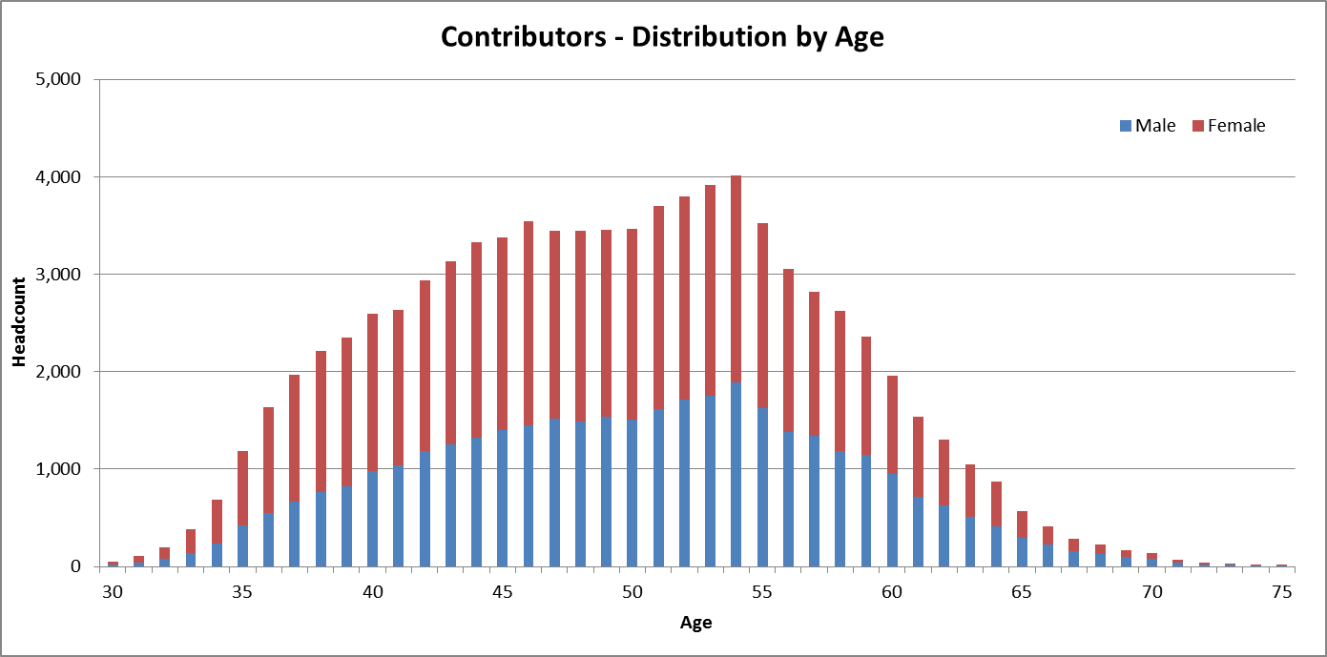

Deferred / Preserved Members

Statistics for deferred CSS and preserved PSS members as at 30 June 2017 are:

| As at  30/06/17 | Headcount | | | Average Age | Average Service |
| --- | --- | --- | --- | --- | --- |
| Males | Females | Total |
| CSS | 3,053 | 1,783 | 4,836 | 55.8 | 14.3 |
| PSS | 39,918 | 60,511 | 100,429 | 48.8 | 5.6 |
| **Total** | **42,971** | **62,294** | **105,265** | **49.1** | **6.0** |

The equivalent statistics for deferred/preserved members as at 30 June 2014 are:

| As at  30/06/14 | Headcount | | | Average Age | Average Service |
| --- | --- | --- | --- | --- | --- |
| Males | Females | Total |
| CSS | 4,455 | 2,239 | 6,694 | 54.4 | 14.8 |
| PSS | 41,417 | 61,489 | 102,906 | 46.7 | 5.2 |
| **Total** | **45,872** | **63,728** | **109,600** | **47.2** | **5.8** |

The distribution of deferred/preserved members by age as at 30 June 2017 is shown in the chart below.

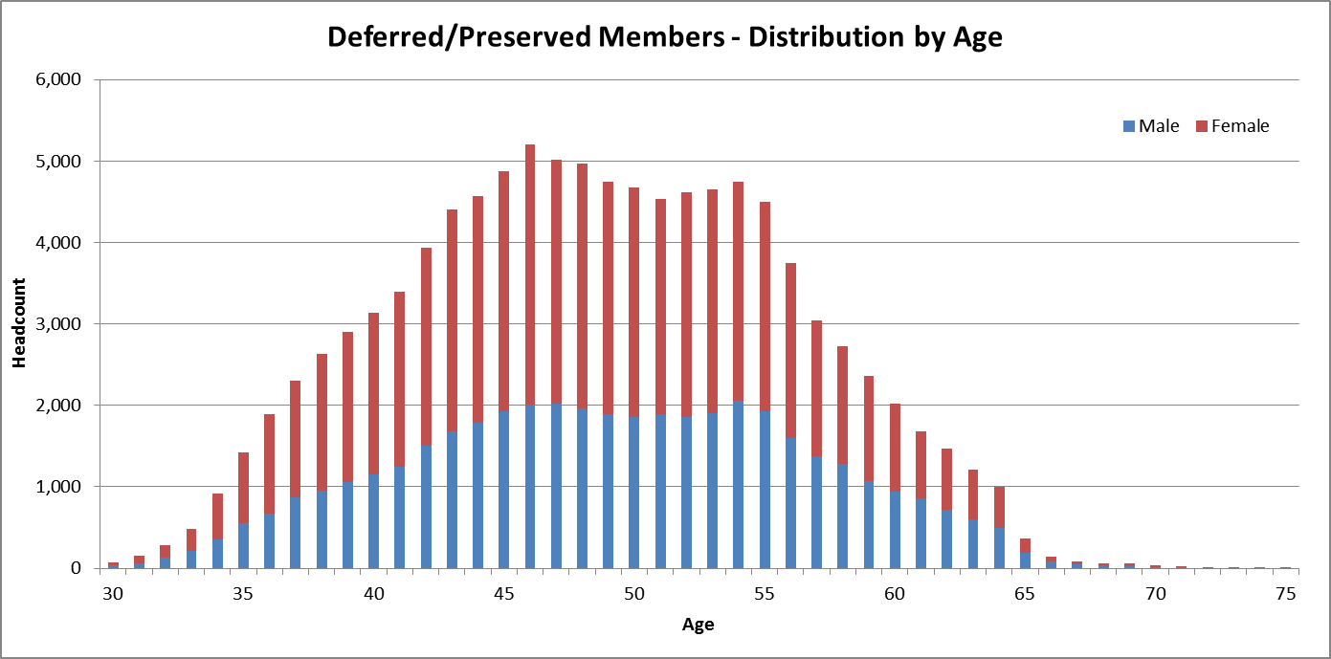

Pensioners

Statistics for age and invalidity retiree pensioners as at 30 June 2017 are:

| As at  30/06/17 | | Headcount | | | Average Age | Average Annual Pension |
| --- | --- | --- | --- | --- | --- | --- |
| Males | Females | Total |
| Primary Pensioners | |  | | | | |
|  | 1922 Scheme | 404 | 175 | 579 | 80.0 | $37,617 |
|  | CSS | 58,881 | 24,382 | 83,263 | 72.8 | $42,201 |
|  | PSS | 21,411 | 24,780 | 46,191 | 63.7 | $32,218 |
| **Total** | | **80,696** | **49,337** | **130,033** | **69.6** | **$38,634** |
| Dependant Pensioners | |  | | | | |
|  | 1922 Scheme | 25 | 1,961 | 1,986 | 86.9 | $28,485 |
|  | CSS | 1,584 | 22,491 | 24,075 | 80.7 | $22,836 |
|  | PSS | 617 | 1,343 | 1,960 | 63.3 | $18,958 |
| **Total** | | **2,226** | **25,795** | **28,021** | **79.9** | **$22,966** |

The equivalent statistics for pensioners as at 30 June 2014 are shown below:

| As at  30/06/14 | | Headcount | | | Average Age | Average Annual Pension |
| --- | --- | --- | --- | --- | --- | --- |
| Males | Females | Total |
| Primary Pensioners | |  | | | | |
|  | 1922 Scheme | 571 | 217 | 788 | 80.2 | $37,258 |
|  | CSS | 60,922 | 24,154 | 85,076 | 72.1 | $37,388 |
|  | PSS | 15,529 | 17,362 | 32,891 | 62.6 | $27,422 |
| **Total** | | **77,022** | **41,733** | **118,755** | **69.5** | **$34,627** |
| Dependant Pensioners | |  | | | | |
|  | 1922 Scheme | 24 | 2,789 | 2,813 | 86.4 | $26,964 |
|  | CSS | 1,526 | 23,107 | 24,633 | 80.0 | $21,600 |
|  | PSS | 434 | 989 | 1,423 | 60.2 | $17,882 |
| **Total** | | **1,984** | **26,885** | **28,869** | **79.7** | **$21,934** |

The distribution of primary pensioners by age as at 30 June 2017:

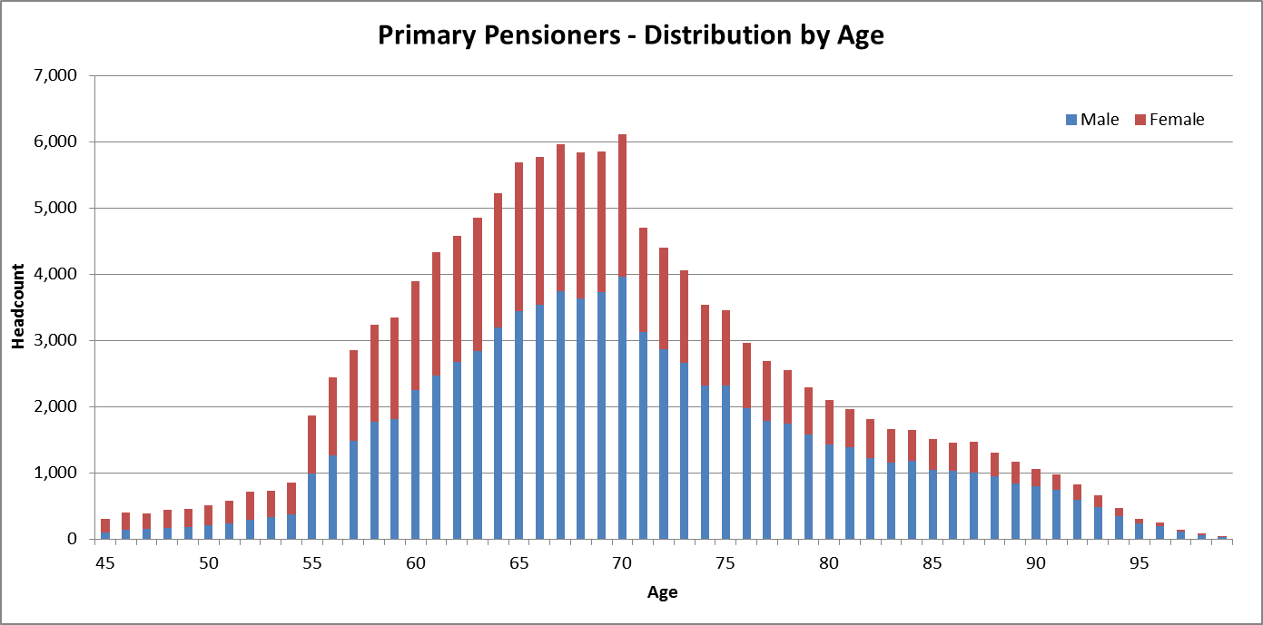

The distribution of dependant pensioners by age as at 30 June 2017 is:

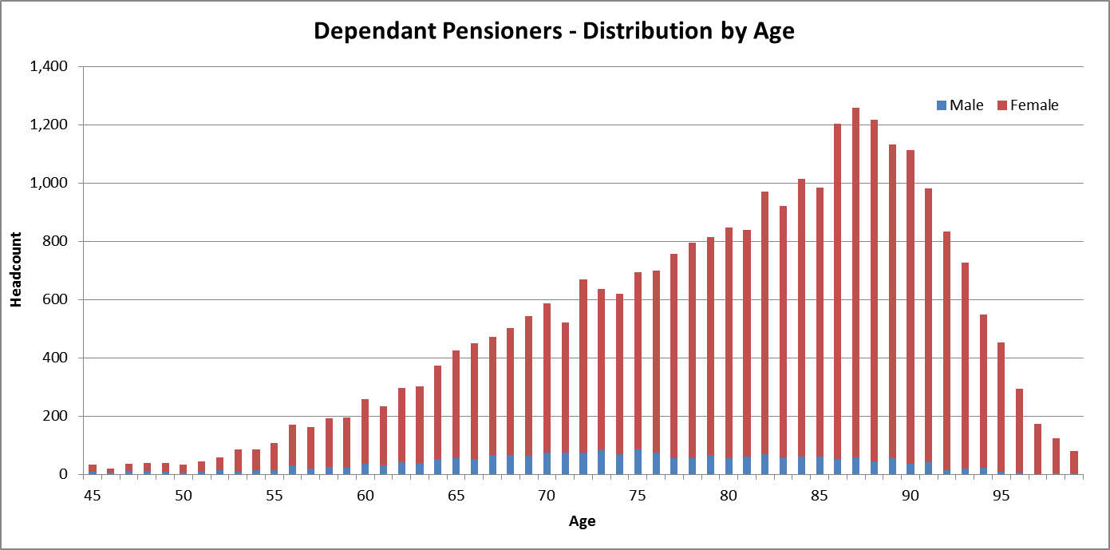

Reconciliation of Membership Movements

|  | CSS (including 1922 Scheme pensioners) | | | |
| --- | --- | --- | --- | --- |
| Contributor | Deferred | Pensioner | Total |
| **As at 30/06/14** | **10,548** | **6,694** | **113,310** | **130,552** |
| New | +65* | +571 | +10,363 | +10,999 |
| Exit | -4,826 | -2,429 | -13,770 | -21,025 |
| **As at 30/06/17** | **5,787** | **4,836** | **109,903** | **120,526** |

* Deferred members recommencing contributions on re-employment with a participating employer.

|  | PSS | | | |
| --- | --- | --- | --- | --- |
| Contributor | Preserved | Pensioner | Total |
| **As at 30/06/14** | **96,049** | **102,906** | **34,314** | **233,269** |
| New | +2,855* | +8,964 | +14,622 | +26,441 |
| Exits | -19,993 | -11,441 | -785 | -32,219 |
| **As at 30/06/17** | **78,911** | **100,429** | **48,151** | **227,491** |

* Preserved members recommencing contributions on re-employment with a participating employer.

Details of Actuarial Assumptions

Economic Assumptions

The key economic assumptions adopted are shown in the table below. Assumptions for the 2014 LTCR are also shown for comparative purposes.

|  | Assumption as at 30 June 2017 | Assumption as at 30 June 2014 |
| --- | --- | --- |
| CPI increases | 2.5% per annum | 2.5% per annum |
| General salary increases | 3.5% per annum (nominal) 1.0% per annum (real) | 4.0% per annum (nominal) 1.5% per annum (real) |
| Investment return / discount rate | 5.0% per annum (nominal) 2.5% per annum (real) | 6.0% per annum (nominal) 3.5% per annum (real) |

### GDP Growth

Gross Domestic Product (GDP) for the 2017/18 financial year is assumed to be $1.85 trillion. The table below shows sample rates (nominal and real) of projected GDP growth over the next 40 years:

| Year Ending 30 June | Nominal rate per annum | Real rate per annum |
| --- | --- | --- |
| 2018 | 5.3% | 2.8% |
| 2019 | 5.3% | 2.8% |
| 2020 | 5.3% | 2.8% |
| 2021 | 5.3% | 2.8% |
| 2022 | 5.3% | 2.8% |
| 2027 | 5.3% | 2.8% |
| 2037 | 5.3% | 2.8% |
| 2047 | 5.2% | 2.7% |
| 2057 | 5.0% | 2.5% |
| **Average** | **5.2%** | **2.7%** |

### Taxation

Allowance has been made for 15% tax payable by the schemes on employer productivity superannuation contributions. All member contributions are made from after tax salary and are not subject to tax in the scheme.

No allowance has been made for:

* + - * 1. Superannuation surcharge, as members’ benefits are reduced by a surcharge offset account.
        2. Excess contributions tax, as this is payable by the member.
        3. Division 293 tax on contributions for those with incomes above the threshold, is this is payable by the member.

In determining the projected outlays, no adjustment is made for any tax payable by members on the unfunded portion of benefits.

### Superannuation Guarantee

Superannuation Guarantee legislation requires employers to provide a minimum level of superannuation benefits for their employees. This is known as the Minimum Requisite Benefit (and MRB) and is defined in a Benefit Certificate. Benefits from the schemes must be at least equal to the MRB. In projecting the MRB, allowance has been made for increases in the Superannuation Guarantee rate (currently 9.5% and increasing to 12% by 1 July 2025). Due to the generous nature of the PSS and CSS benefits, the increase in the Superannuation Guarantee rate does not have a material impact on the valuation results.

Demographic Assumptions

### Future New Contributory Members

No allowance has been made for future new entrants to the schemes. The PSS was closed to new members from 1 July 2005. The CSS has been closed to new members since 1 July 1990. In practice, there may be deferred or preserved members who return to work for the Australian Government or a participating employer and have a right to recommence contributory membership. However, the overall level of such reinstatement is not considered to be material to the overall projections.

### Promotional Salary Increases

The following table shows examples of the annual assumed percentage increase in salary due to promotion (excluding general salary increases due to inflation):

| Age | Promotional Increase |
| --- | --- |
| 35 | 1.10% |
| 40 | 0.72% |
| 45 | 0.52% |
| 50 | 0.34% |
| 55 | 0.18% |
| 60 | 0.05% |

For example, a contributor aged 40 is assumed to have a promotional salary increase in the following year of 0.72%, together with a general salary increase of 3.5%.

### PSS Member Contribution Rates

| Age | Contribution Rate (% of Salary) |
| --- | --- |
| 30 | 4.0% |
| 35 | 4.5% |
| 40 | 5.0% |
| 45 | 6.0% |
| 50 | 7.25% |
| 55 | 8.5% |
| 60 | 8.5% |
| 65 | 8.5% |

### Resignation and Age Retirement Rates for Contributors

| Age | Resignation | Age Retirement |
| --- | --- | --- |
| 30 | 4.0% | - |
| 35 | 3.5% | - |
| 40 | 3.0% | - |
| 45 | 2.5% | - |
| 50 | 2.5% | - |
| 55 | - | 7.5% |
| 60 | - | 12.5% |
| 65 | - | 25.0% |
| 70 | - | 25.0% |
| 75 | - | 100.0% |

A higher rate (40%) is assumed for CSS contributors at age 54, which reflects the benefit design and scheme experience.

### Age Retirement Rates for Deferred/Preserved

| Age | PSS | CSS |
| --- | --- | --- |
| 55 | 10% | 40% |
| 56 - 59 | 5% | 10% |
| 60 | 15% | 25% |
| 61 - 63 | 10% | 15% |
| 64 | 20% | 30% |
| 65 | 100% | 100% |

### Involuntary Retirement (Redundancy) Rates

| Age | PSS | CSS |
| --- | --- | --- |
| 30 | 0.05% | 1.00% |
| 35 | 0.05% | 1.00% |
| 40 | 0.05% | 1.00% |
| 45 | 0.05% | 1.00% |
| 50 | 1.50% | 3.25% |
| 55 | 2.50% | 5.50% |
| 60 | 3.50% | 7.75% |
| 65 | 4.50% | 10.00% |

### Death and Invalidity Retirement Rates

| Age | Death | | Invalidity** | |
| --- | --- | --- | --- | --- |
| Male | Female | Male | Female |
| 30 | 0.030% | 0.014% | 0.032% | 0.032% |
| 35 | 0.038% | 0.020% | 0.057% | 0.061% |
| 40 | 0.047% | 0.026% | 0.079% | 0.103% |
| 45 | 0.063% | 0.041% | 0.127% | 0.164% |
| 50 | 0.088% | 0.062% | 0.194% | 0.255% |
| 55 | 0.124% | 0.106% | 0.305% | 0.426% |
| 60 | 0.183% | 0.173% | 0.601%* | 0.646%* |
| 65 | 0.274% | 0.269% | - | - |
| 70 | 0.411% | 0.450% | - | - |

* PSS contributors are not eligible for invalidity retirement from age 60 and nil rate is assumed.

** Rates of invalidity retirement for deferred/preserved members are assumed equal to 30% of contributor rates.

### Rates of Deferral/Preservation of Benefits

| Scheme | Resignation | Redundancy |
| --- | --- | --- |
| PSS pre-1 July 1999 | 80% | 40% |
| PSS post-1 July 1999 | 100% | 40% |
| CSS | 100% | 70% |

### Rates of Pension Take-up

| Scheme | % Pension |
| --- | --- |
| PSS | 80% |
| CSS (employer-financed component) | 100% |
| CSS (member and productivity component) | 30% |

### Pensioner Mortality Rates

| Age | Male | | | Female | | |
| --- | --- | --- | --- | --- | --- | --- |
| Retiree | Invalid | Widower | Retiree | Invalid | Widow |
| 55 | 0.162% | 0.291% | 0.358% | 0.146% | 0.325% | 0.214% |
| 60 | 0.257% | 0.519% | 0.602% | 0.208% | 0.530% | 0.330% |
| 65 | 0.464% | 0.973% | 1.036% | 0.341% | 0.874% | 0.515% |
| 70 | 0.888% | 1.707% | 1.835% | 0.640% | 1.476% | 0.863% |
| 75 | 1.722% | 2.863% | 3.029% | 1.166% | 2.432% | 1.490% |
| 80 | 3.572% | 5.251% | 5.281% | 2.293% | 3.952% | 2.830% |
| 85 | 7.372% | 9.655% | 9.490% | 4.827% | 7.579% | 5.728% |
| 90 | 13.838% | 15.417% | 15.665% | 9.911% | 14.078% | 10.683% |
| 95 | 24.320% | 23.847% | 23.847% | 17.328% | 21.202% | 18.933% |
| 100 | 41.266% | 35.329% | 35.329% | 30.897% | 35.151% | 33.393% |
| 105 | 100.000% | 100.000% | 100.000% | 100.000% | 100.000% | 100.000% |

The mortality rates shown above include assumed improvements to 2017.

### Future Mortality Improvements

Allowance is made for assumed future improvements (i.e. reductions) in pensioner mortality.

Improvements in mortality have been updated to reflect the short term (25 year experience) and long term (125 year experience) factors derived by the Australian Government Actuary and published in the Australian Life Tables 2010-12. The short term improvement factors are significantly higher (i.e. result in lower projected mortality) than the long term improvement factors.

Short term improvements are incorporated for the period 2018 to 2021, with long term improvements assumed thereafter.

### Proportion with spouses

| Age | Male | Female |
| --- | --- | --- |
| 55 | 61.0% | 40.6% |
| 60 | 61.0% | 40.6% |
| 65 | 61.0% | 35.2% |
| 70 | 76.0% | 34.3% |
| 75 | 72.0% | 25.3% |
| 80 | 66.0% | 15.4% |
| 85 | 56.0% | 8.2% |
| 90 | 44.0% | 6.4% |
| 95 | 31.0% | 4.6% |
| 100 | 12.0% | 2.8% |

Allowance is made for 1% of males and females to have a same sex spouse, in addition to the above rates.

### Age Difference between Member and Spouse

It is assumed that male members are three years older than their spouse, and that female members are two years younger than their spouse.

### Family Law

Benefits subject to family law splitting order or agreement have been flagged in the membership data as at 30 June 2017. The member’s benefit is reduced due to the split and the associate member (former spouse) is included as a dependant pensioner if currently receiving a pension, or as a deferred/preserved member if the entitlement is yet to be paid.

### Co-Contributions and LISC/LISTO

Government co-contributions and low income super contributions (replaced with low income super tax offsets from 1 July 2017) are treated as fully funded additional member accounts and have no effect on the unfunded liability or NECRs.

Details of Projected Results

Projected Unfunded LiabilitY

| As at  30 June | Projected Unfunded Liability  ($ billion) | | | %  of GDP |
| --- | --- | --- | --- | --- |
| PSS | CSS | Combined |
| 2017 | 67.8 | 70.0 | 137.8 | 7.84% |
| 2018 | 71.9 | 69.4 | 141.3 | 7.64% |
| 2019 | 76.2 | 68.7 | 144.9 | 7.44% |
| 2020 | 80.4 | 67.9 | 148.3 | 7.23% |
| 2021 | 84.7 | 66.9 | 151.6 | 7.01% |
| 2022 | 89.0 | 65.8 | 154.8 | 6.80% |
| 2023 | 93.2 | 64.6 | 157.8 | 6.58% |
| 2024 | 97.3 | 63.3 | 160.6 | 6.36% |
| 2025 | 101.4 | 61.8 | 163.2 | 6.13% |
| 2026 | 105.3 | 60.3 | 165.6 | 5.91% |
| 2027 | 109.1 | 58.6 | 167.7 | 5.68% |
| 2028 | 112.7 | 56.8 | 169.5 | 5.46% |
| 2029 | 116.1 | 55.0 | 171.1 | 5.23% |
| 2030 | 119.2 | 53.0 | 172.2 | 5.00% |
| 2031 | 122.1 | 51.0 | 173.1 | 4.77% |
| 2032 | 124.6 | 48.9 | 173.5 | 4.54% |
| 2033 | 126.8 | 46.7 | 173.5 | 4.31% |
| 2034 | 128.6 | 44.4 | 173.0 | 4.08% |
| 2035 | 130.1 | 42.2 | 172.3 | 3.86% |
| 2036 | 131.1 | 39.9 | 171.0 | 3.64% |
| 2037 | 131.7 | 37.5 | 169.2 | 3.42% |
| 2038 | 131.9 | 35.2 | 167.1 | 3.21% |
| 2039 | 131.6 | 32.9 | 164.5 | 3.00% |
| 2040 | 130.9 | 30.6 | 161.5 | 2.80% |
| 2041 | 129.7 | 28.3 | 158.0 | 2.60% |
| 2042 | 128.0 | 26.1 | 154.1 | 2.41% |
| 2043 | 125.9 | 23.9 | 149.8 | 2.22% |
| 2044 | 123.3 | 21.8 | 145.1 | 2.05% |
| 2045 | 120.3 | 19.7 | 140.0 | 1.88% |
| 2046 | 117.0 | 17.8 | 134.8 | 1.72% |
| 2047 | 113.4 | 15.9 | 129.3 | 1.56% |
| 2048 | 109.4 | 14.2 | 123.6 | 1.42% |
| 2049 | 105.3 | 12.6 | 117.9 | 1.29% |
| 2050 | 100.9 | 11.0 | 111.9 | 1.16% |
| 2051 | 96.3 | 9.6 | 105.9 | 1.05% |
| 2052 | 91.6 | 8.3 | 99.9 | 0.94% |
| 2053 | 86.9 | 7.1 | 94.0 | 0.84% |
| 2054 | 82.0 | 6.1 | 88.1 | 0.75% |
| 2055 | 77.1 | 5.1 | 82.2 | 0.67% |
| 2056 | 72.2 | 4.3 | 76.5 | 0.59% |
| 2057 | 67.2 | 3.5 | 70.7 | 0.52% |

Projected Outlays

| Year Ending 30 June | Nominal Outlays ($ billion) | | | Nominal Outlays as % of GDP |
| --- | --- | --- | --- | --- |
| PSS | CSS | Combined |
| 2018 | 1.4 | 4.1 | 5.5 | 0.30% |
| 2019 | 1.5 | 4.2 | 5.7 | 0.29% |
| 2020 | 1.7 | 4.2 | 5.9 | 0.29% |
| 2021 | 1.8 | 4.3 | 6.1 | 0.28% |
| 2022 | 2.0 | 4.4 | 6.4 | 0.28% |
| 2023 | 2.2 | 4.4 | 6.6 | 0.28% |
| 2024 | 2.4 | 4.5 | 6.9 | 0.27% |
| 2025 | 2.6 | 4.5 | 7.1 | 0.27% |
| 2026 | 2.8 | 4.5 | 7.3 | 0.26% |
| 2027 | 3.1 | 4.6 | 7.7 | 0.26% |
| 2028 | 3.4 | 4.6 | 8.0 | 0.26% |
| 2029 | 3.7 | 4.6 | 8.3 | 0.25% |
| 2030 | 4.0 | 4.6 | 8.6 | 0.25% |
| 2031 | 4.3 | 4.6 | 8.9 | 0.25% |
| 2032 | 4.6 | 4.5 | 9.1 | 0.24% |
| 2033 | 5.0 | 4.5 | 9.5 | 0.24% |
| 2034 | 5.3 | 4.4 | 9.7 | 0.23% |
| 2035 | 5.7 | 4.4 | 10.1 | 0.23% |
| 2036 | 6.1 | 4.3 | 10.4 | 0.22% |
| 2037 | 6.5 | 4.2 | 10.7 | 0.22% |
| 2038 | 6.8 | 4.1 | 10.9 | 0.21% |
| 2039 | 7.2 | 4.0 | 11.2 | 0.20% |
| 2040 | 7.5 | 3.8 | 11.3 | 0.20% |
| 2041 | 7.9 | 3.7 | 11.6 | 0.19% |
| 2042 | 8.2 | 3.6 | 11.8 | 0.18% |
| 2043 | 8.5 | 3.4 | 11.9 | 0.18% |
| 2044 | 8.8 | 3.2 | 12.0 | 0.17% |
| 2045 | 9.0 | 3.0 | 12.0 | 0.16% |
| 2046 | 9.2 | 2.9 | 12.1 | 0.15% |
| 2047 | 9.3 | 2.7 | 12.0 | 0.15% |
| 2048 | 9.4 | 2.5 | 11.9 | 0.14% |
| 2049 | 9.4 | 2.3 | 11.7 | 0.13% |
| 2050 | 9.4 | 2.1 | 11.5 | 0.12% |
| 2051 | 9.3 | 1.9 | 11.2 | 0.11% |
| 2052 | 9.3 | 1.7 | 11.0 | 0.10% |
| 2053 | 9.1 | 1.6 | 10.7 | 0.10% |
| 2054 | 9.0 | 1.4 | 10.4 | 0.09% |
| 2055 | 8.8 | 1.2 | 10.0 | 0.08% |
| 2056 | 8.6 | 1.1 | 9.7 | 0.07% |
| 2057 | 8.3 | 0.9 | 9.2 | 0.07% |

Mercer Consulting (Australia) Pty Ltd

ABN 55 153 168 140

One International Towers Sydney

100 Barangaroo Avenue Sydney NSW 2000

GPO Box 9946 Sydney NSW 2001

www.mercer.com.au