|  |
| --- |
| Health Wealth Career    DEPARTMENT OF FINANCE  Federal Circuit Court judges Death and disability Scheme Long Term Cost Report 2017    A report on the long term Cost of the  Federal Circuit Court judges Death and disability Scheme    **Prepared by Mercer Consulting (Australia) Pty Ltd using data as at 30 June 2017**  25 June 2018 |

Contents

1. Executive Summary 1
2. Scheme Information 3
3. Membership and Data 4
4. Assumptions 5
5. Accrued Liability 8
6. Projected Outlays 10
7. Projected Premium Costs 11
8. Sensitivity Analysis 12
9. Actuary’s Certification 13
10. Summary of Benefits 15
11. Experience of the Scheme 16
12. Details of Actuarial Assumptions 18

# Executive Summary

We are pleased to present this report on the actuarial investigation of the long term costs of the Federal Circuit Court Judges Death and Disability Scheme (the Scheme or FCCJDDS), prepared at the request of the Department of Finance. This report has been carried out based on membership data as at 30 June 2017.

Previous Long Term Cost Report

The previous actuarial investigation into the long term costs of the Scheme was undertaken by the Australian Government Actuary, based on data as at 30 June 2014. The outcomes of that investigation are outlined in a report entitled *The Federal Circuit Court of Australia Death and Invalidity Scheme, a Report on the Long Term Costs*, dated 24 August 2015 (2014 LTCR).

Purpose of the Report

This report estimates the long term cost of providing benefits to members of the Scheme. The Scheme costs have been estimated in three ways:

* + - * 1. accrued liability as at 30 June 2017;
        2. projected annual outlays; and
        3. projected future premium costs.

Accrued Liability

The accrued liability represents an estimate of the present value of the benefit entitlements currently in payment. The total accrued liability of the Scheme at 30 June 2017 was $1.718 million. This compares with the accrued liability calculated as at 30 June 2014 (the effective date of the previous report) of $1.402 million.

The accrued liability was expected to increase during the investigation period as the impact of further incidents of death and invalidity and notional interest on accrued liabilities were expected to more than outweigh the reduction in liabilities as a result of benefit payments during the period.

The 2014 LTCR projected that the accrued liability would be $2.130 million as at 30 June 2017, $0.412 million more than the current estimate. The factors leading to the difference in the previously projected accrued liability are quantified in the following chart:

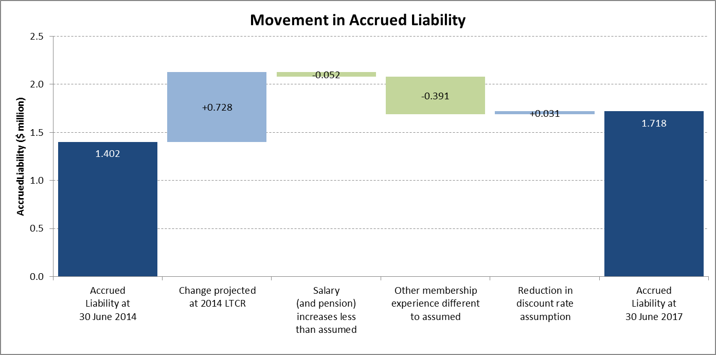

The most significant item is the membership experience, which includes both the number of incidents of death and invalidity and the age of members dying or retiring due to invalidity.

Further details are provided in Section 5.

Projected Outlays

The projected outlays of the Scheme for the next three years are as follows:

| Year Ending 30 June | Nominal Outlays ($’000s) |
| --- | --- |
| 2018 | 575 |
| 2019 | 684 |
| 2020 | 800 |

Further detail regarding the projected outlays is contained in Section 6.

Projected Premium Costs

Premium costs represent the estimated amount an insurance company would require each year in order to cover the claims that could arise in that year. Premium costs in the next 40 years are estimated to range between 2.8% and 3.3% of total annual salaries.

Further details are provided in Section 7.



# Scheme Information

The *Federal Circuit Court of Australia Act 1999* (the Act) was amended with effect from September 2007 to provide for lump sum death benefits and invalidity pensions for Judges of the Federal Circuit Court of Australia and a small number of other individuals. A summary of the benefits provided under the Scheme is set out in Appendix A.

The Scheme is open to new members. It is assumed that each member who leaves the Scheme is replaced with a new entrant.

Members do not contribute to the Scheme and the Australian Government meets all of the costs of benefits from Consolidated Revenue as they become due. This is an acceptable method of funding as the Scheme is effectively guaranteed by the Australian Government.

The Scheme is untaxed and no tax is levied on employer contributions. The Scheme is an exempt public sector superannuation scheme under the *Superannuation Industry (Supervision) Act 1993*.

We note that since 30 June 2017 the Federal Government has passed legislation enabling same sex marriages to be recognised. This did not impact the Scheme financially as same sex partners were already eligible to receive spouse benefits from the Scheme.

# Membership and Data

This report has been based on data supplied by the Department of Finance which carries out the administration of the Scheme.

We have conducted a range of validity data checks including internal consistency and general reasonableness, and a reconciliation of membership movements, but we have not verified or audited any of the information provided. However, we are satisfied that the data is sufficiently accurate for the purpose of this report. The Scheme’s administrator is ultimately responsible for the validity, accuracy and comprehensiveness of this information.

The membership of the Scheme as at 30 June 2017 is summarised below:

| Serving  Judges | Headcount | Average Age | Annual Salaries |
| --- | --- | --- | --- |
| Males | 38 | 58.4 | $14,495,903 |
| Females | 26 | 59.0 | $9,870,214 |
| **Total** | **64** | **58.7** | **$24,366,117** |

In addition, two retired Judges were each in receipt of an invalidity pension.

# Assumptions

In order to value the liabilities, it is necessary to make assumptions regarding the incidence, timing and amount of future benefits. These assumptions fall into two broad categories:

* + - * 1. economic assumptions: relating to the general economic environment and not directly to the membership of the Scheme; and
        2. demographic assumptions: relating to the experience of the membership of the Scheme.

This section sets out the assumptions used in this report and highlights any changes from those used for the 2014 LTCR. The assumptions are detailed in Appendix C.

In total, the changes in assumptions have resulted in an increase to the accrued liability of $0.035 million, or +2.1%, as at 30 June 2017.

Section 8 provides sensitivity analysis of the results under different individual assumptions.

Economic Assumptions

### Key Economic Assumptions

The key economic assumptions include:

* + - * 1. future increases in salaries, which also determines the level of pension increases; and
        2. a discount rate.

The relationships between the assumptions adopted for these factors have a greater bearing on the long term cost estimates of the Scheme than do the individual assumptions. This is due to the effect of one assumption being used to project the liability into the future (future salary and pension increases) and another assumption being used to discount that liability to current day values (discount rate).

The key economic assumptions are shown below together with the assumptions from the 2014 LTCR:

|  | Assumption as at 30 June 2017 | Assumption as at 30 June 2014 |
| --- | --- | --- |
| Salary and pension increases | 4% per annum | 4% per annum |
| Discount rate | 5% per annum | 6% per annum |

The discount rate assumption is consistent with that adopted for the PSS and CSS Long Term Cost Report 2017, which covers the Australian Government’s main civilian superannuation schemes, the Public Sector Superannuation Scheme (PSS) and the Commonwealth Superannuation Scheme (CSS). The salary and pension increase assumption is 0.5% per annum higher than the salary increase assumption adopted for the PSS and CSS Long Term Cost Report 2017, as discussed below.

### Salary and Pension Increases

The assumed rate for long term future salary and pension increases has been determined having regard to the average expected long term outlook for national wage inflation.

This approach differs slightly from the approach used to determine the salary increase assumption for the PSS and CSS Long Term Cost Report 2017. For those Schemes, consideration was also given to shorter term expectations for national wage growth, given the relatively short duration of salary linked liabilities. This resulted in a lower average salary increase assumption than that adopted for this Scheme.

### Discount Rate

The discount rate is used to calculate the present value of projected future benefit payments and provide a summary measure of those cash flows. The accrued liability represents the present value of the estimated future benefit payments in respect of service already rendered. A lower discount rate leads to a higher estimate of the unfunded liability, and vice versa.

The present value does not change the ultimate benefit payments, as these are dictated by actual experience, but does however provide a manageable way to assess and compare the value of expected future cash flows, expressed in today’s dollars.

The discount rate has been determined based on the expected return on Government bonds over the long term, as this would be the cost to the Australian Government were it to fund future benefit payments via borrowings. This contrasts to a funded scheme where a discount rate is typically based on an assumption for the investment earning rate on the scheme’s assets.

Consistent with the PSS and CSS Long Term Cost Report 2017, we believe a long term rate of 5% per annum is appropriate to assume as a discount rate.

Demographic Assumptions

As the Scheme is relatively small the demographic assumptions are, for the most part, based on the assumptions adopted for the Judges’ Pensions Scheme 2017 Long Term Cost Report.

An analysis of recent experience compared with the previous assumptions is set out in Appendix B. Details of the updated demographic assumptions are set out in Appendix C.

### Retirement

Assumed rates of retirement are unchanged from the 2014 LTCR.

### Invalidity

Rates of invalidity retirement are assumed to be the same as those used in the PSS and CSS Long Term Cost Report 2017, extended to age 70. These rates are unchanged from the 2014 LTCR.

### Death

Rates of death are assumed to be the same as the mortality assumptions used in the PSS and CSS Long Term Cost Report 2017. These rates are unchanged from the 2014 LTCR.

### Spouse Assumptions

Assumptions regarding the proportion of members with a spouse, and the age of their spouse, are unchanged from the 2014 LTCR.

### Future New Entrants

Each departing Judge is assumed to be replaced by a new entrant. The assumed distribution and characteristics of new entrants is similar to that adopted for the 2014 LTCR but in a simplified form.

# Accrued Liability

The accrued liability represents an estimate of the present value of the benefit entitlements currently in payment. The present value represents the amount which would need to be set aside at the valuation date to provide for these benefits at the time they are payable, assuming the valuation assumptions were borne out in practice.

It should be noted that the above measure of accrued liabilities does not include any amount for currently serving Judges. This is consistent with the “insurance premium” approach adopted at the 2014 LTCR and the approach adopted in the Australian Government financial statements.

Valuation Methodology

The valuation method for the liability in respect of currently serving Judges is consistent with an “insurance premium” approach. The cost of providing benefits in any given period is calculated as the expected value of all benefits payable in relation to deaths and invalidities occurring in that period. An insurance company would require this amount (plus a margin to allow for administrative expenses and profit) as the premium to cover claims that could arise in that year, and would then be responsible for any claims that actually arise.

In our view, the “insurance premium”’ approach is an appropriate method of allocating the expected costs associated with this Scheme between different periods.

However, we note that it is different to the standard approach for allocating the cost of death and invalidity benefits of the other Australian Government defined benefit superannuation schemes. Under the standard approach, it is assumed the potential future death and invalidity benefits are accrued uniformly over the period of service to the expected date of death or invalidity. This standard method then evaluates, for each member, expected future benefit payments for each future year multiplied by the probability that the benefit will be payable in that year. The accrued liability would be determined as the part of the total benefit which has accrued to the valuation date. The present value of the accrued liability is then determined by discounting these expected payments back to the valuation date.

The use of the standard method would result in a greater accrued liability as it would include an amount in respect of currently serving Judges.

Results

The total accrued liability of the Scheme at 30 June 2017 was $1.718 million.

Analysis of Change Compared with previous report

The 2014 LTCR projected that the accrued liability would be $2.130 million as at 30 June 2017, $0.412 million more than the actual accrued liability.

The factors leading to the difference in the previously projected accrued liability are quantified in the following chart:



The most significant item is the membership experience, which includes both the number of incidents of death and invalidity and the age of members dying or retiring due to invalidity.

# Projected Outlays

The projected outlays represent the future cost of Scheme benefits paid each year. The expected (nominal) outlays for the next 40 years are:

| Year Ending 30 June | Nominal Outlays ($’000s) |
| --- | --- |
| 2018 | 576 |
| 2019 | 685 |
| 2020 | 801 |
| 2021 | 892 |
| 2022 | 505 |
| 2023 | 588 |
| 2024 | 637 |
| 2025 | 658 |
| 2026 | 701 |
| 2027 | 785 |
| 2028 | 795 |
| 2029 | 802 |
| 2030 | 786 |
| 2031 | 818 |
| 2032 | 952 |
| 2033 | 1,043 |
| 2034 | 1,159 |
| 2035 | 1,188 |
| 2036 | 1,226 |
| 2037 | 1,291 |
| 2038 | 1,369 |
| 2039 | 1,469 |
| 2040 | 1,540 |
| 2041 | 1,534 |
| 2042 | 1,585 |
| 2043 | 1,707 |
| 2044 | 1,766 |
| 2045 | 1,827 |
| 2046 | 1,877 |
| 2047 | 1,960 |
| 2048 | 2,068 |
| 2049 | 2,118 |
| 2050 | 2,173 |
| 2051 | 2,158 |
| 2052 | 2,266 |
| 2053 | 2,485 |
| 2054 | 2,566 |
| 2055 | 2,752 |
| 2056 | 2,869 |
| 2057 | 2,947 |

# Projected Premium Costs

The projected premium costs represent the estimated amount an insurance company would require each year in order to cover the claims that could arise in that year (excluding any administrative expenses or profit margins). The costs are also shown as a percentage of projected annual salaries.

| Year Ending 30 June | Premium Costs ($’000s) | Premium Costs (% of Salary) |
| --- | --- | --- |
| 2018 | 772 | 3.3 |
| 2019 | 768 | 3.2 |
| 2020 | 763 | 3.0 |
| 2021 | 749 | 3.0 |
| 2022 | 769 | 2.9 |
| 2023 | 767 | 2.8 |
| 2024 | 782 | 2.8 |
| 2025 | 823 | 2.8 |
| 2026 | 875 | 2.9 |
| 2027 | 925 | 2.9 |
| 2028 | 974 | 3.0 |
| 2029 | 1,056 | 3.1 |
| 2030 | 1,131 | 3.1 |
| 2031 | 1,209 | 3.1 |
| 2032 | 1,252 | 3.1 |
| 2033 | 1,280 | 3.1 |
| 2034 | 1,303 | 3.0 |
| 2035 | 1,334 | 3.0 |
| 2036 | 1,390 | 3.0 |
| 2037 | 1,431 | 3.0 |
| 2038 | 1,496 | 3.0 |
| 2039 | 1,601 | 3.0 |
| 2040 | 1,652 | 3.0 |
| 2041 | 1,712 | 3.0 |
| 2042 | 1,824 | 3.0 |
| 2043 | 1,896 | 3.0 |
| 2044 | 1,961 | 3.0 |
| 2045 | 2,019 | 3.0 |
| 2046 | 2,076 | 2.9 |
| 2047 | 2,136 | 2.9 |
| 2048 | 2,206 | 2.9 |
| 2049 | 2,313 | 2.9 |
| 2050 | 2,397 | 3.0 |
| 2051 | 2,552 | 3.0 |
| 2052 | 2,705 | 3.0 |
| 2053 | 2,818 | 3.0 |
| 2054 | 2,864 | 3.0 |
| 2055 | 2,994 | 3.0 |
| 2056 | 3,020 | 2.9 |
| 2057 | 3,164 | 3.0 |

# Sensitivity Analysis

For this Scheme, the most significant assumptions are the assumed rates of invalidity. These assumptions are also subject to uncertainty, particularly at older ages where there is little comparable experience from similar schemes.

To provide an indication of the sensitivity to variation in invalidity rates, we have measured the effect on the projected outlays and premium costs of varying the invalidity assumption whilst keeping all other assumptions unchanged. The base assumptions have been altered using a multiple of 1.3 for serving Judges under age 60, increasing to a multiple of 5 times the base assumptions at age 69, as per the 2014 LTCR.

| Period Ending 30 June | Change in Nominal Outlays (‘000s) | | Change in Premium Costs (‘000s) | |
| --- | --- | --- | --- | --- |
| Base case assumptions | Alternative invalidity assumptions | Base case assumptions | Alternative invalidity assumptions |
| 2018 | 576 | +121 | 772 | +584 |
| 2019 | 685 | +255 | 768 | +670 |
| 2020 | 801 | +422 | 763 | +761 |
| 2021 | 892 | +499 | 749 | +821 |
| 2022 | 505 | +663 | 769 | +865 |
| 2023 – 27 | 3,367 | +4,156 | 4,173 | +4,346 |
| 2028 – 32 | 4,153 | +3,812 | 5,622 | +4,343 |
| 2033 – 37 | 5,906 | +5,695 | 6,739 | +5,846 |
| 2038 – 42 | 7,497 | +6,328 | 8,285 | +7,353 |
| 2043 – 47 | 9,137 | +9,041 | 10,088 | +8,991 |
| 2048 – 52 | 10,782 | +10,160 | 12,173 | +10,536 |
| 2053 – 57 | 13,619 | +11,163 | 14,860 | +12,726 |

Please note that the alternative results shown above are illustrations only, and show what may occur under assumed future experiences which differ from our baseline assumptions. These scenarios do not, in any way, constitute upper or lower bounds and the results may differ significantly from the ranges shown above, depending on actual future experience.

# Actuary’s Certification

Professional standards and scope

This report satisfies the requirements of Professional Standard No. 400 of The Institute of Actuaries of Australia. Professional Standard No. 400 relates to the preparation of reports commenting on the financial condition of defined benefit superannuation funds.

Use of report

This investigation report should not be relied upon for any other purpose or by any party other than the Australian Government. Mercer is not responsible for the consequences of any other use. This report should be considered in its entirety and not distributed in parts.

The advice contained in this report is given in the context of Australian law and practice. No allowance has been made for taxation, accountancy or other requirements in any other country.

Actuarial Uncertainty and Assumptions

An actuarial investigation provides a snapshot of a scheme’s financial condition at a particular point in time, and projections of a scheme’s estimated future financial position based on certain assumptions. It does not provide certainty in relation to a scheme’s future financial condition or its ability to pay benefits in the future.

Future funding and actual costs relating to a scheme are primarily driven by the scheme’s benefit design, the actual rate of salary inflation and any discretions exercised by the Australian Government. The scheme’s actuary does not directly control or influence any of these factors in the context of an actuarial investigation.

A scheme’s future financial position and the estimated long term cost depend on a number of factors, including the amount of benefits the scheme pays, the cause and timing of member withdrawals, plan expenses, the level of taxation and the amount earned on any assets invested to pay the benefits. These amounts and others are uncertain and unknowable at the valuation date, but are predicted to fall within a reasonable range of possibilities.

To prepare this report, assumptions, as described in Section 4, are used to select a single scenario from the range of possibilities. The results of that single scenario are included in this report.

However, the future is uncertain and a scheme’s actual experience will differ from those assumptions; these differences may be significant or material. In addition, differentassumptions or scenarios may also be within the reasonable range and results based on those assumptions would be different. For this reason this report also shows the impact on the results of certain changes in assumptions.

Actuarial assumptions may also be changed from one valuation to the next because of mandated requirements, scheme experience, changes in expectations about the future and other factors. We did not perform, and thus do not present, an analysis of the potential range of future possibilities and scenarios.

Because actual scheme experience will differ from the assumptions, decisions about benefit changes, investment policy, funding amounts, benefit security and/or benefit related issues should be made only after careful consideration of alternative future financial conditions and scenarios, and not solely on the basis of a set of results.

Prepared by:

|  |
| --- |
| signature |
| **Esther Conway**  Fellow of the Institute of Actuaries of Australia  Principal |

Peer Reviewed by:

|  |
| --- |
| DAS - signature |
| **David Scott**  Fellow of the Institute of Actuaries of Australia  Principal |

29 June 2018

Summary of Benefits

This report covers liabilities relating to members of the Scheme. Provisions relating to the Scheme are set down in the *Federal Circuit Court of Australia Act 1999*. The provisions of the Scheme are complex and a **summary** of the principal provisions is set out below. It should not be used to calculate benefits for individuals.

Member Contributions

Members are not required to contribute to the Scheme. The Australian Government meets the whole cost of the Scheme.

Invalidity Benefit

The benefit payable for a Judge who is certified by the Finance Minister as having retired on the grounds of invalidity, is a pension until the earlier of age 70 or death. The annual pension amount is 60% of the salary currently paid in respect of an equivalent appointment to that of the Judge at the time of invalidity.

Pensioners also receive employer superannuation contributions of 15.4% of their base salary until the age of 65.

Death Benefit

A death benefit is paid to the spouse (or child) of a serving Judge if they die before 65. The death benefit is a lump sum equal to the amount of the employer superannuation contributions that the Judge would have been entitled to had they not died, up to age 65. This benefit is also payable to eligible spouse (or children) of a Judge in receipt of an invalidity pension, if they die before 65.

Experience of the Scheme

Reconciliation of Membership

|  | Serving Judges | Invalidity Pensioners |
| --- | --- | --- |
| **As at 30/06/14** | **65** | **1** |
| New Members | +17 | n/a |
| Age Retirement | -17 | 0 |
| Invalidity Retirement | -1 | +1 |
| Death | 0 | n/a |
| **As at 30/06/17** | **64** | **2** |

Salary and Pension Increases

The death and invalidity benefits for a former Judge are based on the salary the Judge would have been entitled to if they had not died or become disabled. At 30 June 2017, the full time office base salary was $372,180. The Remuneration Tribunal’s determination 2017/09 provided a 2% salary increase to $379,630 with effect from 1 July 2017. Our results incorporate this increase. The average increase over the three years since the 2014 LTCR was 2.9%, which is lower than the 4% per annum increase previously assumed.

Resignation/Retirement Rates

The number of Judges leaving the Scheme due to age retirement or resignation was 17 compared with 16 expected. However, the majority of these were Judges leaving at (or close to) age 70.

The number of Judges leaving the Scheme due resignation prior to age 69 was 7 compared with 4 expected (and 3 during the previous review period). Given the small size of the Scheme, we would expect to see significant variations in the number of resignations between different periods.

Invalidity Retirement

There was one invalidity retirement during the period compared with 0.95 assumed.

Mortality

No Judges died in service during the review period compared with 0.34 assumed.

Pensioner Mortality and Marital Status

The number of pensioners is too small to conduct any meaningful analysis of pensioner mortality or marital status.

New Entrant Age distribution

In the previous investigation, the adopted new entrant distribution specified an assumed percentage for each age from 39 to 65. In order to fit within the Mercer valuation system we have simplified this to an assumed percentage for each 5 year age interval. As can be seen in the graph below, the age and gender distribution of new entrants has been broadly consistent with this (simplified) distribution.

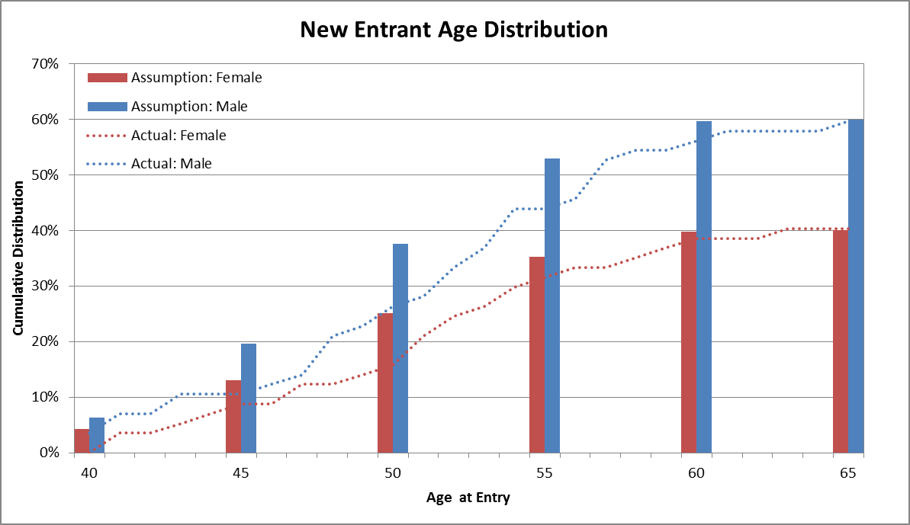

Details of Actuarial Assumptions

Economic Assumptions

### Discount Rate

The assumed long term average discount rate is 5% per annum.

### Salary and Pension Increases

The assumed long term rate of increase in salaries and pensions is 4% per annum.

### Taxation

In determining the projected outlays, no adjustment is made for any tax payable by members on receipt of a benefit.

Demographic Assumptions

### Resignation/Retirement Rates

| Age | Resignation/  Retirement |
| --- | --- |
| <60 | 0.5% |
| 60 | 1.0% |
| 61 | 1.5% |
| 62 | 2.0% |
| 63 | 2.5% |
| 64 | 3.0% |
| 65 | 5.0% |
| 66 | 7.5% |
| 67 | 10.0% |
| 68 | 15.0% |
| 69 | 20.0% |
| 70 | 100.0% |

### Death and Invalidity Retirement Rates

| Age | Death | | Invalidity | |
| --- | --- | --- | --- | --- |
| Male | Female | Male | Female |
| 50 | 0.088% | 0.062% | 0.194% | 0.255% |
| 55 | 0.124% | 0.106% | 0.305% | 0.426% |
| 60 | 0.183% | 0.173% | 0.601% | 0.646% |
| 65 | 0.274% | 0.269% | 0.704% | 0.851% |
| 66 | 0.298% | 0.297% | 0.715% | 0.898% |
| 67 | 0.323% | 0.329% | 0.726% | 0.944% |
| 68 | 0.350% | 0.365% | 0.737% | 0.991% |
| 69 | 0.379% | 0.405% | 0.748% | 1.038% |
| 70 | 0.411% | 0.450% | - | - |

### Invalidity Pensioner Mortality Rates

| Age | Male | Female |
| --- | --- | --- |
| 50 | 0.185% | 0.191% |
| 55 | 0.291% | 0.325% |
| 60 | 0.519% | 0.530% |
| 65 | 0.973% | 0.874% |

### Proportion Married

| Age | Male | Female |
| --- | --- | --- |
| 60 | 95.0% | 95.0% |
| 70 | 94.4% | 88.5% |
| 80 | 84.4% | 58.5% |
| 90 | 57.6% | 13.5% |
| 100 | 15.4% | 0.9% |

The above rates include allowance for same sex marriages.

### Age Difference between Member and Spouse

It is assumed that male members are five years older than their spouse, and that female members are three years younger than their spouse.

### Future New Entrants

Each Judge exiting the Scheme is assumed to be replaced by a new entrant. The ages at which new entrants join are assumed based on the following distribution:

| Age | Male | Female |
| --- | --- | --- |
| 40 | 6.4% | 4.3% |
| 45 | 13.2% | 8.8% |
| 50 | 18.0% | 12.0% |
| 55 | 15.3% | 10.2% |
| 60 | 6.7% | 4.5% |
| 65 | 0.4% | 0.2% |
| **Total** | **60.0%** | **40.0%** |

Mercer Consulting (Australia) Pty Ltd

ABN 55 153 168 140

Collins Square

727 Collins Street Melbourne VIC 3008

GPO Box 9946 Melbourne VIC 3001

www.mercer.com.au